UNITED STATES

SECURITIES AND EXCHANGE COMMISSION
Washington, D.C. 20549

FORM 8-K

CURRENT REPORT

Pursuant to Section 13 or 15(d) of

the Securities Exchange Act of 1934

Date of Report (Date of earliest event reported): October 20, 2022

South Plains Financial, Inc.

(Exact name of registrant as specified in its charter)

Texas

(State or other jurisdiction of incorporation)

001-38895

(Commission File Number)

75-2453320

(IRS Employer Identification No.)

5219 City Bank Parkway

Lubbock, Texas

(Address of principal executive offices)

79407

(Zip Code)

(806) 792-7101

(Registrant’s telephone number, including area code)

Check the appropriate box below if the Form 8-K filing is intended to simultaneously satisfy the filing obligation of the registrant under any of the following provisions:

- Written communications pursuant to Rule 425 under the Securities Act (17 CFR 230.425)

- Soliciting material pursuant to Rule 14a-12 under the Exchange Act (17 CFR 240.14a-12)

- Pre-commencement communications pursuant to Rule 14d-2(b) under the Exchange Act (17 CFR 240.14d-2(b))

- Pre-commencement communications pursuant to Rule 13e-4(c) under the Exchange Act (17 CFR 240.13e-4(c)) Securities registered pursuant to Section 12(b) of the Act:
Title of each class | Trading Symbol(s) | Name of each exchange on which registered
Common Stock, par value $1.00 per share | SPFI | The Nasdaq Stock Market LLC

Indicate by check mark whether the registrant is an emerging growth company as defined in Rule 405 of the Securities Act of 1933 (§230.405 of this chapter) or Rule 12b-2 of the Securities Exchange Act of 1934 (§240.12b-2 of this chapter).

Emerging growth company ☒

If an emerging growth company, indicate by check mark if the registrant has elected not to use the extended transition period for complying with any new or revised financial accounting standards provided pursuant to Section 13(a) of the Exchange Act. ☐

Item 2.02 Results of Operations and Financial Condition.

On October 21, 2022, South Plains Financial, Inc. (the “Company”) issued a press release announcing its financial results for the third quarter ended September 30, 2022. A copy of the Company’s press release covering such announcement and certain other matters is furnished as Exhibit 99.1 to this Current Report on Form 8-K.

Item 7.01 Regulation FD Disclosure.

On October 21, 2022, officers of the Company will have a conference call with respect to the Company’s financial results for the third quarter ended September 30, 2022. An earnings release slide presentation highlighting the Company’s financial results for the third quarter ended September 30, 2022 is furnished as Exhibit 99.2 to this Current Report on Form 8-K. This earnings release slide presentation will also be available on the Company’s website, www.spfi.bank, under the “News & Events” section.

In accordance with General Instruction B.2 of Form 8-K, the information in Items 2.02 and 7.01 of this Current Report on Form 8-K, including Exhibit 99.1 and Exhibit 99.2 hereto, shall not be deemed “filed” for the purposes of Section 18 of the Securities Exchange Act of 1934, as amended (the “Exchange Act”), or otherwise subject to the liabilities of that section. The information in Items 2.02 and 7.01 of this Current Report on Form 8-K, including Exhibit 99.1 and Exhibit 99.2 hereto, shall not be incorporated by reference into any filing or other document pursuant to the Exchange Act or the Securities Act of 1933, as amended, except as shall be expressly set forth by specific reference in such filing or document.

Item 8.01 Other Events.

Settlement of Previously-Disclosed Litigation

As previously disclosed, in response to a Notice of Termination received from Kasasa, Ltd. f/k/a Moneyvue Financial, Inc., Bankvue Financial, Inc., and BancVue, Ltd. (“Kasasa”) purporting to terminate a Software License and Maintenance Agreement (the “Software License Agreement”), Trademark License Agreement (the “Trademark License Agreement”), and Addendum to Software License Agreement (“Addendum”) between the Company’s wholly-owned banking subsidiary City Bank (the “Bank”) and Kasasa, the Bank filed suit against Kasasa in Travis County, Texas, styled City Bank v. Kasasa, Ltd., Cause No. D-1-GN-20-003630, 53rd Judicial District, Travis County, Texas.

On or about September 23, 2022, the parties entered into a Settlement Agreement and Mutual Release (the “Settlement Agreement”), pursuant to which the parties agreed to the settlement and release of all claims related to the Software License Agreement, Trademark License Agreement, and Addendum, including all claims and counterclaims in the lawsuit. Thereafter, the parties filed a joint motion to dismiss with prejudice and the court formally dismissed the case by order dated October 7, 2022.

Quarterly Dividend

On July 21, 2022, South Plains Financial, Inc. issued a press release announcing the declaration of a quarterly cash dividend of $0.12 per share on its outstanding common stock. The dividend will be paid on November 15, 2022 to shareholders of record as of the close of business on October 31, 2022. A copy of the press release is attached hereto as Exhibit 99.1 and is incorporated herein by reference.

Item 9.01 Financial Statements and Exhibits.

- Exhibits.

99.1 Press release, dated October 21, 2022, announcing third quarter 2022 financial results of South Plains Financial, Inc.

99.2 Earnings release slide presentation, dated October 21, 2022.

99.3 Press release, dated October 20, 2022, announcing South Plains Financial, Inc. quarterly cash dividend.

104 Cover Page Interactive Data File (formatted as Inline XBRL).

SIGNATURES

Pursuant to the requirements of the Securities Exchange Act of 1934, the registrant has duly caused this report to be signed on its behalf by the undersigned hereunto duly authorized.

SOUTH PLAINS FINANCIAL, INC.

Dated: October 21, 2022 By: /s/ Steven B. Crockett

Steven B. Crockett

Chief Financial Officer and Treasurer

Exhibit 99.1


South Plains Financial, Inc. Reports Third Quarter 2022 Financial Results

LUBBOCK, Texas, October 21, 2022 (GLOBE NEWSWIRE) – South Plains Financial, Inc. (NASDAQ:SPFI) (“South Plains” or the “Company”), the parent company of City Bank (“City Bank” or the “Bank”), today reported its financial results for the quarter ended September 30, 2022.

Third Quarter 2022 Highlights

- Net income for the third quarter of 2022 was $15.5 million, compared to $15.9 million for the second quarter of 2022 and $15.2 million for the third quarter of 2021.

- Diluted earnings per share for the third quarter of 2022 was $0.86, compared to $0.88 for the second quarter of 2022 and $0.82 for the third quarter of 2021.

- Loans held for investment grew $109.9 million, or 17.0% annualized, during the third quarter of 2022 as compared to June 30, 2022.

- Average cost of deposits for the third quarter of 2022 was 52 basis points, compared to 27 basis points for the second quarter of 2022 and 25 basis points for the third quarter of 2021.

- The Company recorded a negative provision for loan losses of $782,000 in the third quarter of 2022, compared to no provisions for loan losses for the second quarter of 2022 and for the third quarter of 2021.
- Nonperforming assets to total assets were 0.19% at September 30, 2022, compared to 0.20% at June 30, 2022 and 0.32% at September 30, 2021.

- Return on average assets for the third quarter of 2022 was 1.53% annualized, compared to 1.60% annualized for the second quarter of 2022 and 1.61% annualized for the third quarter of 2021.

- Tangible book value (non-GAAP) per share was $18.61 as of September 30, 2022, compared to $19.50 per share as of June 30, 2022 and $20.90 per share as of September 30, 2021.

- The Company repurchased 366 thousand shares of common stock in the third quarter of 2022 as compared to 257 thousand shares in the second quarter of 2022.

Curtis Griffith, South Plains’ Chairman and Chief Executive Officer, commented, “Our business continued to perform well through the third quarter of 2022, highlighted by 17.0% annualized loan growth during the period driven by strength in both our community markets and major metropolitan markets of Dallas, Houston and El Paso. The expansion in our loan portfolio is contributing to strong underlying earnings growth, which has been masked by large recoveries, negative provisions for loan losses, and fair value increases in our mortgage servicing rights portfolio over the last three quarters. These items totaled $0.24 per share of income, net of tax, in the second quarter of 2022 and $0.10 per share of income, net of tax, in the third quarter of 2022. The investments that we have made to expand our lending platform and increase our presence in our metropolitan markets has provided an acceleration to our growth and is contributing to the building earnings power of the Company. Importantly, our mortgage banking business has reached a level where we believe it is no longer a headwind to our financial results, as we highlighted last quarter. While we are delivering improved loan growth, we are also maintaining our strict credit culture and underwriting standards, including not sacrificing credit quality for growth. Overall, our Company continues to perform well, and we believe this performance has not been reflected in our share price. As a result, we further accelerated the pace of our share repurchases in the third quarter having bought back 366 thousand shares as compared to 257 thousand shares and 106 thousand shares in the second and first quarter of 2022, respectively.”

Results of Operations, Quarter Ended September 30, 2022

Net Interest Income

Net interest income was $35.1 million for the third quarter of 2022, compared to $37.1 million for the second quarter of 2022 and $31.2 million for the third quarter of 2021. Net interest margin, calculated on a tax-equivalent basis, was 3.70% for the third quarter of 2022, compared to 4.02% for the second quarter of 2022 and 3.58% for the third quarter of 2021. The average yield on loans was 5.12% for the third quarter of 2022, compared to 5.57% for the second quarter of 2022 and 4.99% for the third quarter of 2021. The average cost of deposits was 52 basis points for the third quarter of 2022, which is 25 basis points higher than the second quarter of 2022 and 27 basis points higher than the third quarter of 2021.

Interest income was $41.1 million for the third quarter of 2022, compared to $40.8 million for the second quarter of 2022 and $34.4 million for the third quarter of 2021. Interest income increased $356 thousand in the third quarter of 2022 from the second quarter of 2022, which was comprised of an increase of $1.3 million in interest income from securities and other interest-earning assets, partially offset by a decrease of $1.0 million in loan interest income. The increase in interest income on securities and other interest-earning assets was primarily due to continued rising market interest rates. The decrease in loan interest income was primarily due to $4.4 million of interest income received related to four credits for the recovery of interest on previously charged-off credits, purchase discount principal recovery, and prepayment penalties during the second quarter of 2022, partially offset by an increase of $121.9 million in average loans outstanding, and the rising interest rate environment. Excluding the $4.4 million of large loan recoveries and prepayment penalties, the yield on loans was 4.88% during the second quarter of 2022, as compared to 5.12% in the third quarter of 2022, while net interest margin, on a tax-equivalent basis, was 3.54% during the second quarter of 2022, as compared to 3.70% for the third quarter of 2022. Interest income increased $6.7 million in the third quarter of 2022 compared to the third quarter of 2021. This increase was primarily due to an increase of average loans of $219.5 million, securities purchases, and rising market interest rates during the period.

Interest expense was $6.0 million for the third quarter of 2022, compared to $3.6 million for the second quarter of 2022 and $3.3 million for the third quarter of 2021. Interest expense increased $2.4 million compared to the second quarter of 2022 and $2.7 million compared to the third quarter of 2021 primarily as a result of rising interest rates on interest-bearing liabilities, with the increase being mainly comprised of interest expense on deposits.

Noninterest Income and Noninterest Expense

Noninterest income was $20.9 million for the third quarter of 2022, compared to $18.8 million for the second quarter of 2022 and $25.8 million for the third quarter of 2021. The increase from the second quarter of 2022 was primarily due to $2.1 million of income in legal settlements and the seasonal increase of $3.3 million in income from insurance activities, partially offset by a decrease of $2.4 million in mortgage banking activities revenue. This decrease in mortgage banking revenues was mainly the result of mortgage loan originations declining $55.1 million, or 26.6%, as the residential mortgage market continued to slow during the third quarter of 2022 as a result of rising market interest rates and seasonality. The decrease in noninterest income for the third quarter of 2022 as compared to the third quarter of 2021 was primarily due to a decline of $8.5 million in mortgage banking activities revenue as mortgage loan originations declined $222.2 million, or 59.4%, as high-volume refinance activity experienced during 2020 and 2021 has slowed as a result of rising market interest rates. This decrease was partially offset by the growth in income from insurance activities and the income from legal settlements noted previously.

Noninterest expense was $37.4 million for the third quarter of 2022, compared to $36.1 million for the second quarter of 2022 and $38.1 million for the third quarter of 2021. The increase from the second quarter of 2022 was primarily the result of an increase of $937 thousand in personnel expense due to the payment of an additional $1.8 million in commissions on insurance activities, partially offset by a decrease in mortgage commissions expense and related supporting personnel expense from the decline in mortgage loan originations and a decrease of $265 thousand in legal expenses. The decrease in noninterest expense for the third quarter of 2022 as compared to the third quarter of 2021 was primarily driven by lower mortgage commissions and other variable mortgage-based expenses due to the reduction in mortgage loan originations, partially offset by additional commercial lenders hired as part of a planned initiative, and an increase of $731 thousand in legal expenses.

Loan Portfolio and Composition

Loans held for investment were $2.69 billion as of September 30, 2022, compared to $2.58 billion as of June 30, 2022 and $2.43 billion as of September 30, 2021. The $109.9 million, or 17.0% annualized, increase during the third quarter of 2022 as compared to the second quarter of 2022 was primarily the result of organic net loan growth. This loan growth remained relationship-focused and occurred primarily in commercial real estate loans, residential mortgage loans, and consumer auto loans, partially offset by a decrease in hotel loans. As of September 30, 2022, loans held for investment increased $261.3 million, or 10.8% year over year, from September 30, 2021, attributable to strong organic loan growth.

Agricultural production loans were $94.1 million as of September 30, 2022, compared to $88.8 million as of June 30, 2022 and $119.3 million as of September 30, 2021. The typical seasonal funding of these agricultural production loans during the third quarter of 2022 was below normal based on drought conditions experienced across the State of Texas.

Deposits and Borrowings

Deposits totaled $3.46 billion as of September 30, 2022, compared to $3.43 billion as of June 30, 2022 and $3.21 billion as of September 30, 2021. Deposits increased by $34.7 million, or 1.0%, in the third quarter of 2022 from June 30, 2022. As of September 30, 2022, deposits increased $248.3 million, or 7.7% year over year, from September 30, 2021. Noninterest-bearing deposits were $1.26 billion as of September 30, 2022, compared to $1.20 billion as of June 30, 2022 and $1.05 billion as of September 30, 2021. Noninterest-bearing deposits represented 36.5% of total deposits as of September 30, 2022. The increase in deposits noted above is primarily a result of organic growth.

Asset Quality

The Company recorded a negative provision for loan losses in the third quarter of 2022 of $782 thousand, compared to no provisions for loan losses in the second quarter of 2022 or for the third quarter of 2021. There was a loan loss recovery of $822 thousand of a direct energy credit during the third quarter of 2022. Overall, the Company continued to experience improving credit metrics in the loan portfolio during the third quarter of 2022. These improvements were specifically noted in the hotel segment, which had a net reduction in outstanding principal of $19.6 million during the quarter. The loan loss recovery noted above and improving credit metrics, offset by the organic growth in the loan portfolio, resulted in the negative provision for the third quarter of 2022. Nevertheless, concerns regarding forecasted economic conditions continue to worsen due to the rising interest rate environment and persistent high inflation levels in the United States, and provisions for loan losses may be necessary in future periods.

The ratio of allowance for loan losses to loans held for investment was 1.47% as of September 30, 2022, compared to 1.54% as of June 30, 2022 and 1.76% as of September 30, 2021.

The ratio of nonperforming assets to total assets as of September 30, 2022 was 0.19%, compared to 0.20% as of June 30, 2022 and 0.32% at September 30, 2021. Annualized net charge-offs were (0.10)% for the third quarter of 2022, compared to (0.02)% for the second quarter of 2022 and 0.03% for the third quarter of 2021.

Capital

Book value per share decreased to $20.03 at September 30, 2022, compared to $20.91 at June 30, 2022. The decline was mainly driven by a $26.7 million dollar decrease in accumulated other comprehensive income (“AOCI”), partially offset by an increase of $13.4 million of net income after dividends paid. The decrease in AOCI was attributed to the decline in fair value of our available for sale securities and fair value hedges, net of tax, as a result of the rising interest rate environment.

Conference Call

South Plains will host a conference call to discuss its third quarter 2022 financial results today, October 21, 2022, at 11:00 a.m., Eastern Time. Investors and analysts interested in participating in the call are invited to dial 1-877-407-9716 (international callers please dial 1-201-493-6779) approximately 10 minutes prior to the start of the call. A live audio webcast of the conference call and conference materials will be available on the Company’s website at https://www.spfi.bank/news-events/events.

A replay of the conference call will be available within two hours of the conclusion of the call and can be accessed on the investor section of the Company’s website as well as by dialing 1-844-512-2921 (international callers please dial 1-412-317-6671). The pin to access the telephone replay is 13733502. The replay will be available until November 4, 2022.

About South Plains Financial, Inc.

South Plains is the bank holding company for City Bank, a Texas state-chartered bank headquartered in Lubbock, Texas. City Bank is one of the largest independent banks in West Texas and has additional banking operations in the Dallas, El Paso, Greater Houston, the Permian Basin, and College Station, Texas markets, and the Ruidoso, New Mexico market. South Plains provides a wide range of commercial and consumer financial services to small and medium-sized businesses and individuals in its market areas. Its principal business activities include commercial and retail banking, along with insurance, investment, trust and mortgage services. Please visit https://www.spfi.bank for more information.

Non-GAAP Financial Measures

Some of the financial measures included in this press release are not measures of financial performance recognized in accordance with generally accepted accounting principles in the United States (“GAAP”). These non-GAAP financial measures include Tangible Book Value Per Common Share, Tangible Common Equity to Tangible Assets, and Pre-Tax, Pre-Provision Income. The Company believes these non-GAAP financial measures provide both management and investors a more complete understanding of the Company’s financial position and performance. These non-GAAP financial measures are supplemental and are not a substitute for any analysis based on GAAP financial measures.

We classify a financial measure as being a non-GAAP financial measure if that financial measure excludes or includes amounts, or is subject to adjustments that have the effect of excluding or including amounts, that are included or excluded, as the case may be, in the most directly comparable measure calculated and presented in accordance with GAAP as in effect from time to time in the United States in our statements of income, balance sheets or statements of cash flows. Not all companies use the same calculation of these measures; therefore, this presentation may not be comparable to other similarly titled measures as presented by other companies.

A reconciliation of non-GAAP financial measures to GAAP financial measures is provided at the end of this press release.

Available Information

The Company routinely posts important information for investors on its web site (under www.spfi.bank and, more specifically, under the News & Events tab at www.spfi.bank/news-events/press-releases). The Company intends to use its web site as a means of disclosing material non-public information and for complying with its disclosure obligations under Regulation FD (Fair Disclosure) promulgated by the U.S. Securities and Exchange Commission (the “SEC”). Accordingly, investors should monitor the Company’s web site, in addition to following the Company’s press releases, SEC filings, public conference calls, presentations and webcasts.

The information contained on, or that may be accessed through, the Company’s web site is not incorporated by reference into, and is not a part of, this document.

Forward Looking Statements

This press release contains forward-looking statements within the meaning of the Private Securities Litigation Reform Act of 1995. These forward-looking statements reflect South Plains’ current views with respect to future events. Any statements about South Plains’ expectations, beliefs, plans, predictions, forecasts, objectives, assumptions or future events or performance are not historical facts and may be forward-looking. These statements are often, but not always, made through the use of words or phrases such as “anticipate,” “believes,” “can,” “could,” “may,” “predicts,” “potential,” “should,” “will,” “estimate,” “plans,” “projects,” “continuing,” “ongoing,” “expects,” “intends” and similar words or phrases. South Plains cautions that the forward-looking statements in this press release are based largely on South Plains’ expectations and are subject to a number of known and unknown risks and uncertainties that are subject to change based on factors which are, in many instances, beyond South Plains’ control. Factors that could cause such changes include, but are not limited to, general economic conditions, the extent of the impact of the COVID-19 pandemic (and any current or future variants thereof) on our customers, changes in market interest rates, the persistence of the current inflationary environment in the United States and our market areas, the uncertain impacts of quantitative tightening and current and future monetary policies of the Federal Reserve, regulatory considerations, competition and market expansion opportunities, changes in non-interest expenditures or in the anticipated benefits of such expenditures, and changes in applicable laws and regulations. Additional information regarding these risks and uncertainties to which South Plains’ business and future financial performance are subject is contained in South Plains’ most recent Annual Report on Form 10-K and Quarterly Reports on Form 10-Q on file with the SEC, and other documents South Plains files with the SEC from time to time. South Plains urges readers of this press release to review the “Risk Factors” section of our most recent Annual Report on Form 10-K, as well as the “Risk Factors” section of other documents South Plains files or furnishes with the SEC from time to time, which are available on the SEC’s website, www.sec.gov. Actual results, performance or achievements could differ materially from those contemplated, expressed, or implied by the forward-looking statements due to additional risks and uncertainties of which South Plains is not currently aware or which it does not currently view as, but in the future may become, material to its business or operating results. Due to these and other possible uncertainties and risks, the Company can give no assurance that the results contemplated in the forward-looking statements will be realized and readers are cautioned not to place undue reliance on the forward-looking statements contained in this press release. Any forward-looking statements presented herein are made only as of the date of this press release, and South Plains does not undertake any obligation to update or revise any forward-looking statements to reflect changes in assumptions, new information, the occurrence of unanticipated events, or otherwise, except as required by law. All forward-looking statements, express or implied, included in the press release are qualified in their entirety by this cautionary statement.

Contact: Mikella Newsom, Chief Risk Officer and Secretary

- 771-3347 investors@city.bank

Source: South Plains Financial, Inc.

South Plains Financial, Inc.

Consolidated Financial Highlights - (Unaudited)

(Dollars in thousands, except share data)

 |  |  |  |  | As of and for the quarter ended
 |  |  | September 30, |  | June 30, |  | March 31, |  | December 31, |  | September 30,
 |  |  | 2022 |  | 2022 |  | 2022 |  | 2021 |  | 2021
Selected Income Statement Data:
Interest income | $ |  | 41,108 | $ | 40,752 | $ | 33,080 | $ | 34,600 | $ | 34,438
Interest expense |  |  | 6,006 |  | 3,647 |  | 3,133 |  | 3,151 |  | 3,260
Net interest income |  |  | 35,102 |  | 37,105 |  | 29,947 |  | 31,449 |  | 31,178
Provision for loan losses |  |  | (782) |  | - |  | (2,085) |  | - |  | -
Noninterest income |  |  | 20,937 |  | 18,835 |  | 23,697 |  | 22,928 |  | 25,791
Noninterest expense |  |  | 37,401 |  | 36,056 |  | 37,924 |  | 36,132 |  | 38,063
Income tax expense |  |  | 3,962 |  | 4,001 |  | 3,527 |  | 3,631 |  | 3,716
Net income |  |  | 15,458 |  | 15,883 |  | 14,278 |  | 14,614 |  | 15,190
Per Share Data (Common Stock):
Net earnings, basic |  |  | 0.89 |  | 0.91 |  | 0.81 |  | 0.82 |  | 0.85
Net earnings, diluted |  |  | 0.86 |  | 0.88 |  | 0.78 |  | 0.79 |  | 0.82
Cash dividends declared and paid |  |  | 0.12 |  | 0.11 |  | 0.11 |  | 0.09 |  | 0.09
Book value |  |  | 20.03 |  | 20.91 |  | 21.90 |  | 22.94 |  | 22.34
Tangible book value (non-GAAP) |  |  | 18.61 |  | 19.50 |  | 20.49 |  | 21.51 |  | 20.90
Weighted average shares outstanding, basic |  |  | 17,286,531 |  | 17,490,706 |  | 17,716,136 |  | 17,777,542 |  | 17,931,174
Weighted average shares outstanding, dilutive |  |  | 17,901,899 |  | 18,020,548 |  | 18,392,397 |  | 18,433,038 |  | 18,463,697
Shares outstanding at end of period |  |  | 17,064,640 |  | 17,417,094 |  | 17,673,407 |  | 17,760,243 |  | 17,824,094
Selected Period End Balance Sheet Data:
Cash and cash equivalents |  |  | 329,962 |  | 375,690 |  | 528,612 |  | 486,821 |  | 327,600
Investment securities |  |  | 711,412 |  | 763,943 |  | 793,404 |  | 724,504 |  | 752,562
Total loans held for investment |  |  | 2,690,366 |  | 2,580,493 |  | 2,453,631 |  | 2,437,577 |  | 2,429,041
Allowance for loan losses |  |  | 39,657 |  | 39,785 |  | 39,649 |  | 42,098 |  | 42,768
Total assets |  |  | 3,992,690 |  | 3,974,724 |  | 3,999,744 |  | 3,901,855 |  | 3,774,175
Interest-bearing deposits |  |  | 2,198,464 |  | 2,230,105 |  | 2,318,942 |  | 2,269,855 |  | 2,157,981
Noninterest-bearing deposits |  |  | 1,262,072 |  | 1,195,732 |  | 1,131,215 |  | 1,071,367 |  | 1,054,264
Total deposits |  |  | 3,460,536 |  | 3,425,837 |  | 3,450,157 |  | 3,341,222 |  | 3,212,245
Borrowings |  |  | 122,307 |  | 122,261 |  | 122,214 |  | 122,168 |  | 122,121
Total stockholders’ equity |  |  | 341,799 |  | 364,222 |  | 387,068 |  | 407,427 |  | 398,276
Summary Performance Ratios:
Return on average assets |  |  | 1.53% |  | 1.60% |  | 1.47% |  | 1.50% |  | 1.61%
Return on average equity |  |  | 17.37% |  | 16.96% |  | 14.58% |  | 14.39% |  | 15.24%
Net interest margin ⁽¹⁾ |  |  | 3.70% |  | 4.02% |  | 3.33% |  | 3.50% |  | 3.58%
Yield on loans |  |  | 5.12% |  | 5.57% |  | 4.80% |  | 4.90% |  | 4.99%
Cost of interest-bearing deposits |  |  | 0.82% |  | 0.42% |  | 0.34% |  | 0.35% |  | 0.37%
Efficiency ratio |  |  | 66.38% |  | 64.11% |  | 70.30% |  | 66.07% |  | 66.45%
Summary Credit Quality Data:
Nonperforming loans |  |  | 7,733 |  | 7,889 |  | 12,141 |  | 10,598 |  | 10,895
Nonperforming loans to total loans held for investment |  |  | 0.29% |  | 0.31% |  | 0.49% |  | 0.43% |  | 0.45%
Other real estate owned |  |  | 37 |  | 59 |  | 1,141 |  | 1,032 |  | 1,081
Nonperforming assets to total assets |  |  | 0.19% |  | 0.20% |  | 0.33% |  | 0.30% |  | 0.32%
Allowance for loan losses to total loans held for investment |  |  | 1.47% |  | 1.54% |  | 1.62% |  | 1.73% |  | 1.76%
Net charge-offs to average loans outstanding (annualized) |  |  | (0.10)% |  | (0.02)% |  | 0.06% |  | 0.11% |  | 0.03%

 |  | As of and for the quarter ended
 | September 30 | June 30, | March 31, | December 31, | September 30,
 | 2022 | 2022 | 2022 | 2021 | 2021
Capital Ratios:
Total stockholders’ equity to total assets | 8.56% | 9.16% | 9.68% | 10.44% | 10.55%
Tangible common equity to tangible assets (non-GAAP) | 8.00% | 8.60% | 9.11% | 9.85% | 9.94%
Common equity tier 1 to risk-weighted assets | 11.67% | 12.24% | 12.86% | 12.91% | 12.68%
Tier 1 capital to average assets | 10.95% | 10.93% | 10.78% | 10.77% | 10.83%
Total capital to risk-weighted assets | 16.46% | 17.32% | 18.22% | 18.40% | 18.21%

(1) Net interest margin is calculated as the annual net interest income, on a fully tax-equivalent basis, divided by average interest-earning assets.

South Plains Financial, Inc.

Average Balances and Yields - (Unaudited)

(Dollars in thousands)

 |  |  |  |  |  |  |  |  |  | For the Three Months Ended
 |  |  |  |  |  | September 30, 2022 |  |  |  |  |  |  |  |  | September 30, 2021
 |  |  |  |  |  |  |  | Interest |  |  |  |  |  |  |  |  | Interest
 |  |  |  | Average |  |  |  | Income |  |  |  |  | Average |  |  |  | Income
 |  |  |  | Balance |  |  |  | Expense |  | Yield |  |  | Balance |  |  |  | Expense |  | Yield
Assets
 | Loans, excluding PPP ⁽¹⁾ | $ |  | 2,666,429 |  | $ |  | 34,176 |  | 5.09% |  | $ | 2,365,010 |  | $ |  | 28,947 |  | 4.86%
 | Loans - PPP |  |  | 4,754 |  |  |  | 288 |  | 24.03% |  |  | 86,645 |  |  |  | 1,872 |  | 8.57%
 | Debt securities - taxable |  |  | 617,722 |  |  |  | 4,166 |  | 2.68% |  |  | 531,620 |  |  |  | 2,309 |  | 1.72%
 | Debt securities - nontaxable |  |  | 215,508 |  |  |  | 1,428 |  | 2.63% |  |  | 221,026 |  |  |  | 1,468 |  | 2.64%
 | Other interest-bearing assets |  |  | 293,636 |  |  |  | 1,351 |  | 1.83% |  |  | 284,369 |  |  |  | 151 |  | 0.21%
 | Total interest-earning assets |  |  | 3,798,049 |  |  |  | 41,409 |  | 4.33% |  |  | 3,488,670 |  |  |  | 34,747 |  | 3.95%
 | Noninterest-earning assets |  |  | 208,135 |  |  |  |  |  |  |  |  | 259,641
 | Total assets | $ |  | 4,006,184 |  |  |  |  |  |  |  | $ | 3,748,311
 | Liabilities & stockholders’ equity
 | NOW, Savings, MMA’s | $ |  | 1,873,786 |  |  |  | 3,514 |  | 0.74% |  | $ | 1,820,677 |  |  |  | 1,005 |  | 0.22%
 | Time deposits |  |  | 330,133 |  |  |  | 1,023 |  | 1.23% |  |  | 330,161 |  |  |  | 1,025 |  | 1.23%
 | Short-term borrowings |  |  | 4 |  |  |  | - |  | 0.00% |  |  | 725 |  |  |  | - |  | 0.00%
 | Notes payable & other long-term borrowings |  |  | - |  |  |  | - |  | 0.00% |  |  | - |  |  |  | - |  | 0.00%
 | Subordinated debt securities |  |  | 75,914 |  |  |  | 1,012 |  | 5.29% |  |  | 75,728 |  |  |  | 1,013 |  | 5.31%
 | Junior subordinated deferrable interest debentures |  |  | 46,393 |  |  |  | 457 |  | 3.91% |  |  | 46,393 |  |  |  | 217 |  | 1.86%
 | Total interest-bearing liabilities |  |  | 2,326,230 |  |  |  | 6,006 |  | 1.02% |  |  | 2,273,684 |  |  |  | 3,260 |  | 0.57%
 | Demand deposits |  |  | 1,248,804 |  |  |  |  |  |  |  |  | 1,035,910
 | Other liabilities |  |  | 78,139 |  |  |  |  |  |  |  |  | 43,171
 | Stockholders’ equity |  |  | 353,011 |  |  |  |  |  |  |  |  | 395,546
 | Total liabilities & stockholders’ equity | $ |  | 4,006,184 |  |  |  |  |  |  |  | $ | 3,748,311
 | Net interest income |  |  |  |  | $ |  | 35,403 |  |  |  |  |  |  | $ |  | 31,487
 | Net interest margin ⁽²⁾ |  |  |  |  |  |  |  |  | 3.70% |  |  |  |  |  |  |  |  | 3.58%

- Average loan balances include nonaccrual loans and loans held for sale.

- Net interest margin is calculated as the annualized net income, on a fully tax-equivalent basis, divided by average interest-earning assets. PPP - Small Business Administration Paycheck Protection Program

South Plains Financial, Inc.

Average Balances and Yields - (Unaudited)

(Dollars in thousands)

 |  |  |  |  |  |  |  |  |  | For the Nine Months Ended
 |  |  |  |  |  | September 30, 2022 |  |  |  |  |  |  |  |  | September 30, 2021
 |  |  |  |  |  |  |  | Interest |  |  |  |  |  |  |  |  | Interest
 |  |  |  | Average |  |  |  | Income |  |  |  |  | Average |  |  |  | Income
 |  |  |  | Balance |  |  |  | Expense |  | Yield |  |  | Balance |  |  |  | Expense |  | Yield
Assets
 | Loans, excluding PPP ⁽¹⁾ | $ |  | 2,548,174 |  | $ |  | 97,321 |  | 5.11% |  | $ | 2,246,650 |  | $ |  | 82,314 |  | 4.90%
 | Loans - PPP |  |  | 19,509 |  |  |  | 1,941 |  | 13.30% |  |  | 141,040 |  |  |  | 7,147 |  | 6.78%
 | Debt securities - taxable |  |  | 592,069 |  |  |  | 10,058 |  | 2.27% |  |  | 540,380 |  |  |  | 7,118 |  | 1.76%
 | Debt securities - nontaxable |  |  | 216,951 |  |  |  | 4,315 |  | 2.66% |  |  | 219,242 |  |  |  | 4,414 |  | 2.69%
 | Other interest-bearing assets |  |  | 363,659 |  |  |  | 2,213 |  | 0.81% |  |  | 328,412 |  |  |  | 373 |  | 0.15%
 | Total interest-earning assets |  |  | 3,740,362 |  |  |  | 115,848 |  | 4.14% |  |  | 3,475,724 |  |  |  | 101,366 |  | 3.90%
 | Noninterest-earning assets |  |  | 236,296 |  |  |  |  |  |  |  |  | 261,449
 | Total assets | $ |  | 3,976,658 |  |  |  |  |  |  |  | $ | 3,737,173
 | Liabilities & stockholders’ equity
 | NOW, Savings, MMA’s | $ |  | 1,905,000 |  |  |  | 5,782 |  | 0.41% |  | $ | 1,834,113 |  |  |  | 3,259 |  | 0.24%
 | Time deposits |  |  | 334,686 |  |  |  | 2,962 |  | 1.18% |  |  | 326,862 |  |  |  | 3,114 |  | 1.27%
 | Short-term borrowings |  |  | 4 |  |  |  | - |  | 0.00% |  |  | 10,725 |  |  |  | 5 |  | 0.06%
 | Notes payable & other long-term borrowings |  |  | - |  |  |  | - |  | 0.00% |  |  | 26,188 |  |  |  | 38 |  | 0.19%
 | Subordinated debt securities |  |  | 75,852 |  |  |  | 3,037 |  | 5.35% |  |  | 75,682 |  |  |  | 3,044 |  | 5.38%
 | Junior subordinated deferrable interest debentures |  |  | 46,393 |  |  |  | 1,005 |  | 2.90% |  |  | 46,393 |  |  |  | 661 |  | 1.90%
 | Total interest-bearing liabilities |  |  | 2,361,935 |  |  |  | 12,786 |  | 0.72% |  |  | 2,319,963 |  |  |  | 10,121 |  | 0.58%
 | Demand deposits |  |  | 1,174,783 |  |  |  |  |  |  |  |  | 991,331
 | Other liabilities |  |  | 64,639 |  |  |  |  |  |  |  |  | 41,996
 | Stockholders’ equity |  |  | 375,301 |  |  |  |  |  |  |  |  | 383,883
 | Total liabilities & stockholders’ equity | $ |  | 3,976,658 |  |  |  |  |  |  |  | $ | 3,737,173
 | Net interest income |  |  |  |  | $ |  | 103,062 |  |  |  |  |  |  | $ |  | 91,245
 | Net interest margin ⁽²⁾ |  |  |  |  |  |  |  |  | 3.68% |  |  |  |  |  |  |  |  | 3.51%

- Average loan balances include nonaccrual loans and loans held for sale.

- Net interest margin is calculated as the annualized net income, on a fully tax-equivalent basis, divided by average interest-earning assets. PPP - Small Business Administration Paycheck Protection Program

South Plains Financial, Inc.

Consolidated Balance Sheets

(Unaudited)

(Dollars in thousands)

 |  |  |  | As of
 |  |  |  | September 30, |  |  | December 31,
 |  |  |  | 2022 |  |  | 2021
Assets
 | Cash and due from banks | $ |  | 52,749 |  | $ | 68,425
 | Interest-bearing deposits in banks |  |  | 277,213 |  |  | 418,396
 | Federal funds sold |  |  | — |  |  | —
 | Investment securities |  |  | 711,412 |  |  | 724,504
 | Loans held for sale |  |  | 26,922 |  |  | 76,507
 | Loans held for investment |  |  | 2,690,366 |  |  | 2,437,577
 | Less: Allowance for loan losses |  |  | (39,657) |  |  | (42,098)
 | Net loans held for investment |  |  | 2,650,709 |  |  | 2,395,479
 | Premises and equipment, net |  |  | 56,532 |  |  | 57,699
 | Goodwill |  |  | 19,508 |  |  | 19,508
 | Intangible assets |  |  | 4,720 |  |  | 5,895
 | Mortgage servicing assets |  |  | 28,424 |  |  | 19,700
 | Other assets |  |  | 164,501 |  |  | 115,742
 | Total assets | $ |  | 3,992,690 |  | $ | 3,901,855
 | Liabilities and Stockholders’ Equity Liabilities
 | Noninterest bearing deposits | $ |  | 1,262,072 |  | $ | 1,071,367
 | Interest-bearing deposits |  |  | 2,198,464 |  |  | 2,269,855
 | Total deposits |  |  | 3,460,536 |  |  | 3,341,222
 | Other borrowings |  |  | - |  |  | -
 | Subordinated debt securities |  |  | 75,914 |  |  | 75,775
 | Trust preferred subordinated debentures |  |  | 46,393 |  |  | 46,393
 | Other liabilities |  |  | 68,048 |  |  | 31,038
 | Total liabilities |  |  | 3,650,891 |  |  | 3,494,428
 | Stockholders’ Equity
 | Common stock |  |  | 17,065 |  |  | 17,760
 | Additional paid-in capital |  |  | 116,565 |  |  | 133,215
 | Retained earnings |  |  | 281,679 |  |  | 242,750
 | Accumulated other comprehensive income (loss) |  |  | (73,510) |  |  | 13,702
 | Total stockholders’ equity |  |  | 341,799 |  |  | 407,427
 | Total liabilities and stockholders’ equity |  | $ | 3,992,690 |  | $ | 3,901,855

South Plains Financial, Inc.

Consolidated Statements of Income

(Unaudited)

(Dollars in thousands)

 |  |  |  | Three Months Ended |  |  |  |  |  | Nine Months Ended
 |  |  |  | September 30, |  |  | September 30, |  |  | September 30, |  |  | September 30,
 |  |  |  | 2022 |  |  | 2021 |  |  | 2022 |  |  | 2021
Interest income:
 | Loans, including fees | $ |  | 34,463 |  | $ | 30,818 |  | $ | 99,260 |  | $ | 89,458
 | Other |  |  | 6,645 |  |  | 3,620 |  |  | 15,680 |  |  | 10,978
 | Total Interest income |  |  | 41,108 |  |  | 34,438 |  |  | 114,940 |  |  | 100,436
 | Interest expense:
 | Deposits |  |  | 4,537 |  |  | 2,030 |  |  | 8,744 |  |  | 6,373
 | Subordinated debt securities |  |  | 1,012 |  |  | 1,013 |  |  | 3,037 |  |  | 3,044
 | Trust preferred subordinated debentures |  |  | 457 |  |  | 217 |  |  | 1,005 |  |  | 661
 | Other |  |  | - |  |  | - |  |  | - |  |  | 43
 | Total Interest expense |  |  | 6,006 |  |  | 3,260 |  |  | 12,786 |  |  | 10,121
 | Net interest income |  |  | 35,102 |  |  | 31,178 |  |  | 102,154 |  |  | 90,315
 | Provision for loan losses |  |  | (782) |  |  | - |  |  | (2,867) |  |  | (1,918)
 | Net interest income after provision for loan losses |  |  | 35,884 |  |  | 31,178 |  |  | 105,021 |  |  | 92,233
 | Noninterest income:
 | Service charges on deposits |  |  | 1,764 |  |  | 1,851 |  |  | 5,149 |  |  | 5,023
 | Income from insurance activities |  |  | 4,856 |  |  | 3,794 |  |  | 8,003 |  |  | 6,146
 | Mortgage banking activities |  |  | 6,287 |  |  | 14,802 |  |  | 28,593 |  |  | 47,329
 | Bank card services and interchange fees |  |  | 3,156 |  |  | 3,045 |  |  | 9,856 |  |  | 8,760
 | Other |  |  | 4,874 |  |  | 2,299 |  |  | 11,868 |  |  | 7,283
 | Total Noninterest income |  |  | 20,937 |  |  | 25,791 |  |  | 63,469 |  |  | 74,541
 | Noninterest expense:
 | Salaries and employee benefits |  |  | 22,927 |  |  | 24,116 |  |  | 67,620 |  |  | 71,811
 | Net occupancy expense |  |  | 4,132 |  |  | 3,896 |  |  | 11,902 |  |  | 10,960
 | Professional services |  |  | 2,523 |  |  | 1,388 |  |  | 7,795 |  |  | 4,483
 | Marketing and development |  |  | 913 |  |  | 777 |  |  | 2,391 |  |  | 2,157
 | Other |  |  | 6,906 |  |  | 7,886 |  |  | 21,673 |  |  | 22,487
 | Total noninterest expense |  |  | 37,401 |  |  | 38,063 |  |  | 111,381 |  |  | 111,898
 | Income before income taxes |  |  | 19,420 |  |  | 18,906 |  |  | 57,109 |  |  | 54,876
 | Income tax expense |  |  | 3,962 |  |  | 3,716 |  |  | 11,490 |  |  | 10,876
 | Net income |  | $ | 15,458 |  | $ | 15,190 |  | $ | 45,619 |  | $ | 44,000

South Plains Financial, Inc.

Loan Composition

(Unaudited)

(Dollars in thousands)

 |  |  |  | As of
 |  |  |  | September 30, |  |  | December 31,
 |  |  |  | 2022 |  |  | 2021
Loans:
 | Commercial Real Estate | $ |  | 869,231 |  | $ | 755,444
 | Commercial - Specialized |  |  | 368,204 |  |  | 378,725
 | Commercial - General |  |  | 477,209 |  |  | 460,024
 | Consumer:
 | 1-4 Family Residential |  |  | 424,802 |  |  | 387,690
 | Auto Loans |  |  | 309,110 |  |  | 240,719
 | Other Consumer |  |  | 80,524 |  |  | 68,113
 | Construction |  |  | 161,286 |  |  | 146,862
 | Total loans held for investment |  | $ | 2,690,366 |  | $ | 2,437,577
South Plains Financial, Inc.
Deposit Composition
(Unaudited)
(Dollars in thousands)
 |  |  |  | As of
 |  |  |  | September 30, |  |  | December 31,
 |  |  |  | 2022 |  |  | 2021
Deposits:
 | Noninterest-bearing demand deposits | $ |  | 1,262,072 |  | $ | 1,071,367
 | NOW & other transaction accounts |  |  | 353,871 |  |  | 395,322
 | MMDA & other savings |  |  | 1,518,485 |  |  | 1,534,795
 | Time deposits |  |  | 326,108 |  |  | 339,738
 | Total deposits |  | $ | 3,460,536 |  | $ | 3,341,222

South Plains Financial, Inc.

Reconciliation of Non-GAAP Financial Measures (Unaudited)

(Dollars in thousands)

 |  |  |  |  |  |  |  |  | As of and for the quarter ended
 |  |  |  | September 30, |  |  |  |  | June 30, |  |  |  |  | March 31, |  |  | December 31, |  |  |  | September 30,
 |  |  |  | 2022 |  |  |  |  | 2022 |  |  |  |  | 2022 |  |  | 2021 |  |  |  | 2021
Pre-tax, pre-provision income
 | Net income | $ |  | 15,458 |  |  |  | $ | 15,883 |  |  | $ |  | 14,278 |  | $ | 14,614 |  | $ |  | 15,190
 | Income tax expense |  |  | 3,962 |  |  |  |  | 4,001 |  |  |  |  | 3,527 |  |  | 3,631 |  |  |  | 3,716
 | Provision for loan losses |  |  | (782) |  |  |  |  | - |  |  |  |  | (2,085) |  |  | - |  |  |  | -
 | Pre-tax, pre-provision income |  | $ | 18,638 |  |  |  | $ | 19,884 |  |  | $ |  | 15,720 |  | $ | 18,245 |  | $ |  | 18,906
South Plains Financial, Inc.
Reconciliation of Non-GAAP Financial Measures (Unaudited)
(Dollars in thousands)
 |  |  |  |  |  |  |  |  |  |  |  |  |  | As of
 |  |  |  | September 30, |  |  |  |  | June 30, |  |  |  |  | March 31, |  |  | December 31, |  |  |  | September 30,
 |  |  |  | 2022 |  |  |  |  | 2022 |  |  |  |  | 2022 |  |  | 2021 |  |  |  | 2021
Tangible common equity
 | Total common stockholders’ equity | $ |  | 341,799 |  |  |  | $ | 364,222 |  |  | $ |  | $ 387,068 |  | $ | $ 407,427 |  | $ |  | $ 398,276
 | Less: goodwill and other intangibles |  |  | (24,228) |  |  |  |  | (24,620) |  |  |  |  | (25,011) |  |  | (25,403) |  |  |  | (25,804)
 | Tangible common equity | $ |  | 317,571 |  |  |  | $ | 339,602 |  |  | $ |  | $ 362,057 |  | $ | $ 382,024 |  | $ |  | $ 372,472
 | Tangible assets
 | Total assets | $ |  | 3,992,690 |  |  |  | $ | 3,974,724 |  |  | $ |  | $ 3,999,744 |  | $ | $ 3,901,855 |  | $ |  | $ 3,774,175
 | Less: goodwill and other intangibles |  |  | (24,228) |  |  |  |  | (24,620) |  |  |  |  | (25,011) |  |  | (25,403) |  |  |  | (25,804)
 | Tangible assets | $ |  | 3,968,462 |  |  |  | $ | 3,950,104 |  |  | $ |  | $ 3,974,733 |  | $ | $ 3,876,452 |  | $ |  | $ 3,748,371
 | Shares outstanding |  |  | 17,064,640 |  |  |  |  | 17,417,094 |  |  |  |  | 17,673,407 |  |  | 17,760,243 |  |  |  | 17,824,094
 | Total stockholders’ equity to total assets |  |  | 8.56% |  |  |  |  | 9.16% |  |  |  |  | 9.68% |  |  | 10.44% |  |  |  | 10.55%
 | Tangible common equity to tangible assets |  |  | 8.00% |  |  |  |  | 8.60% |  |  |  |  | 9.11% |  |  | 9.85% |  |  |  | 9.94%
 | Book value per share | $ |  | 20.03 |  |  |  | $ | 20.91 |  |  | $ |  | 21.90 |  | $ | 22.94 |  | $ |  | 22.34
 | Tangible book value per share | $ |  | 18.61 |  |  |  | $ | 19.50 |  |  | $ |  | 20.49 |  | $ | 21.51 |  | $ |  | 20.90

Exhibit 99.2
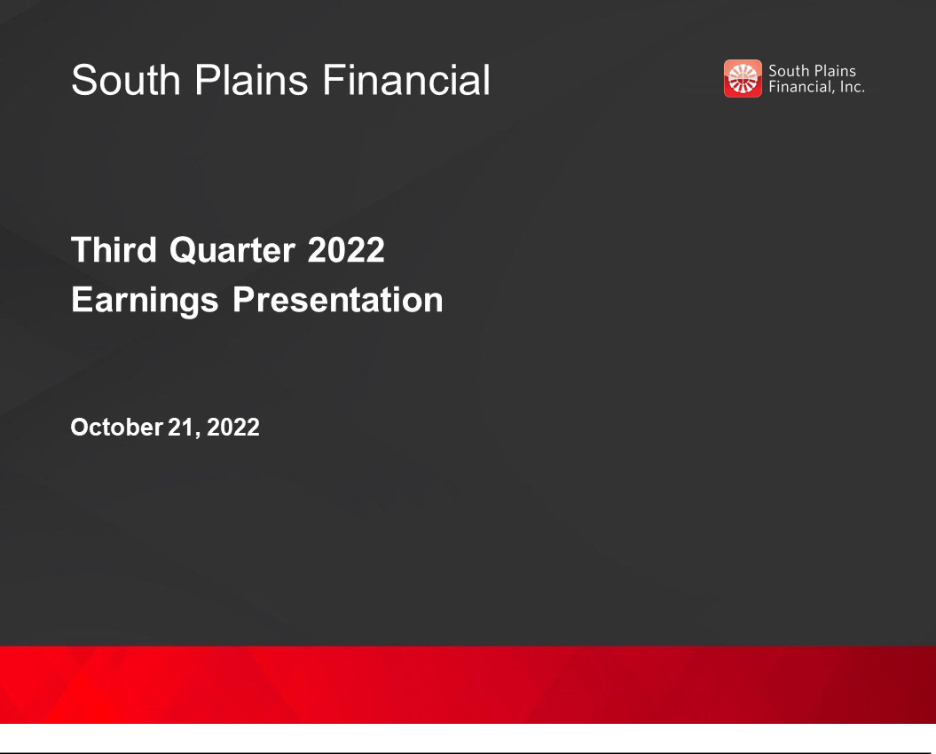

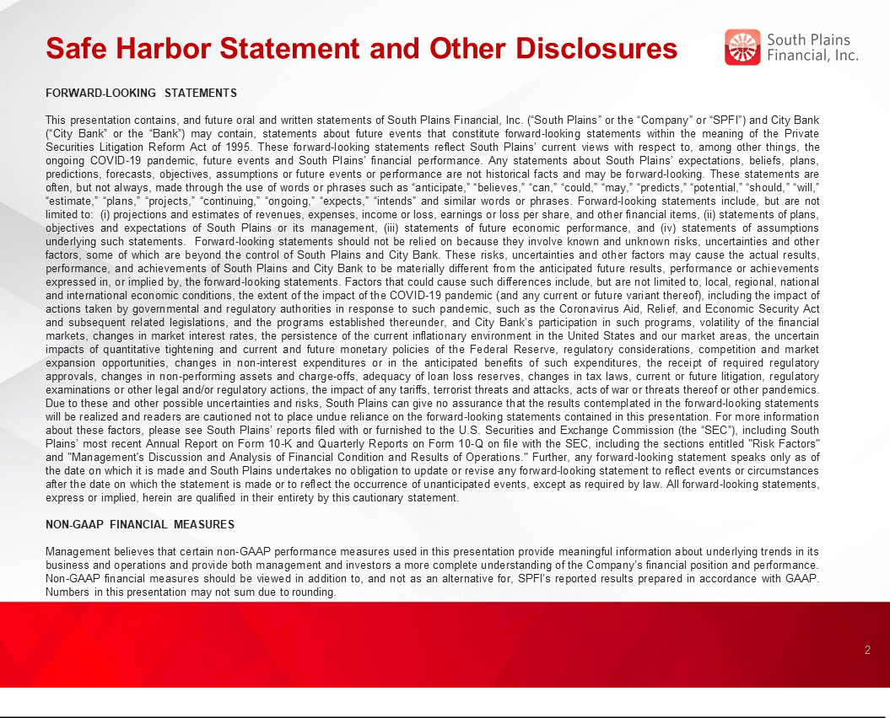

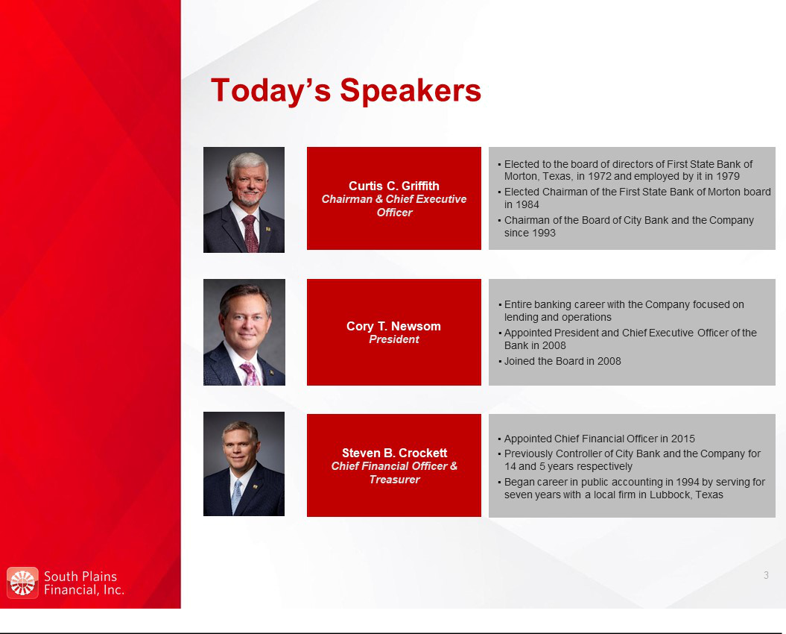

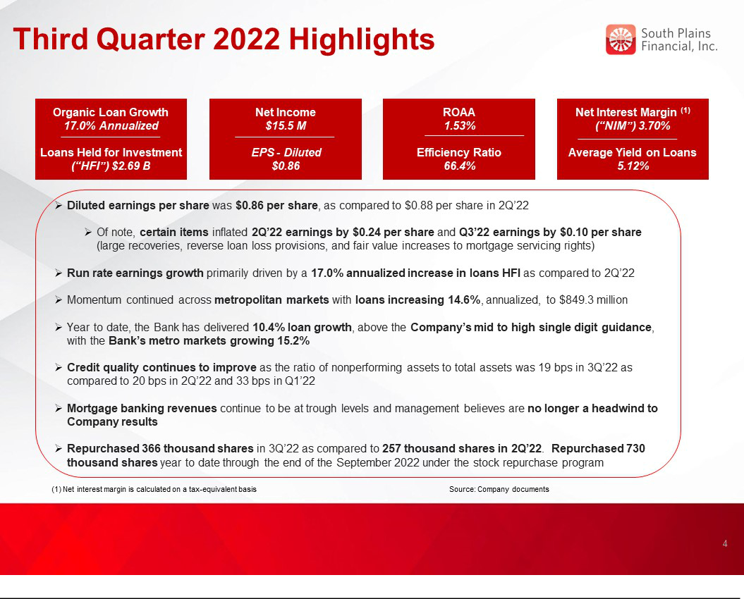

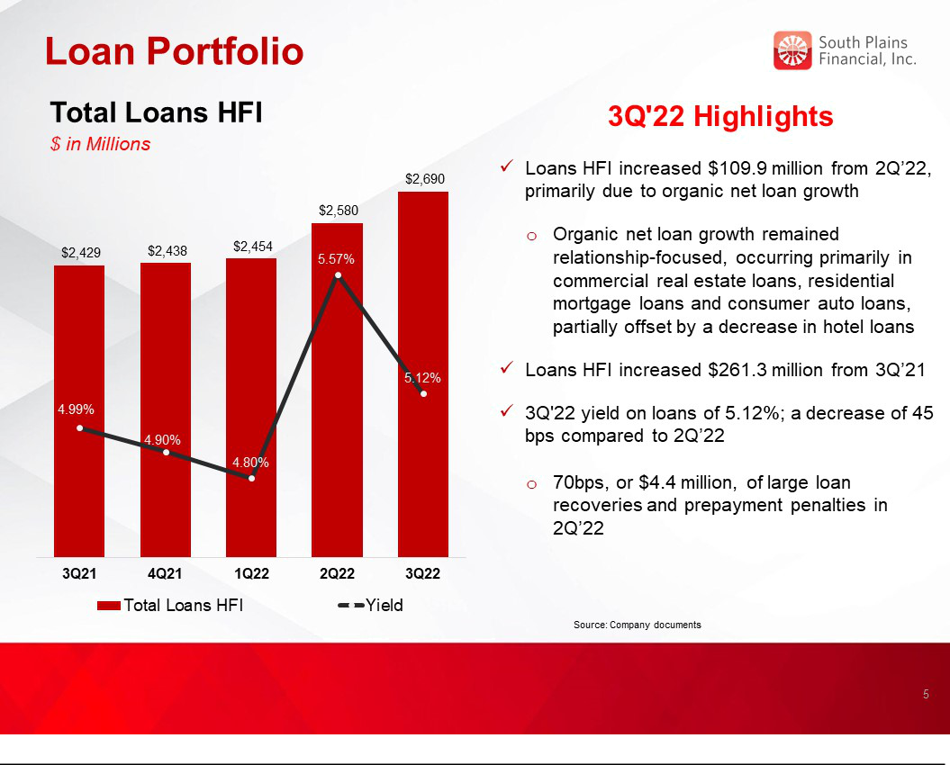

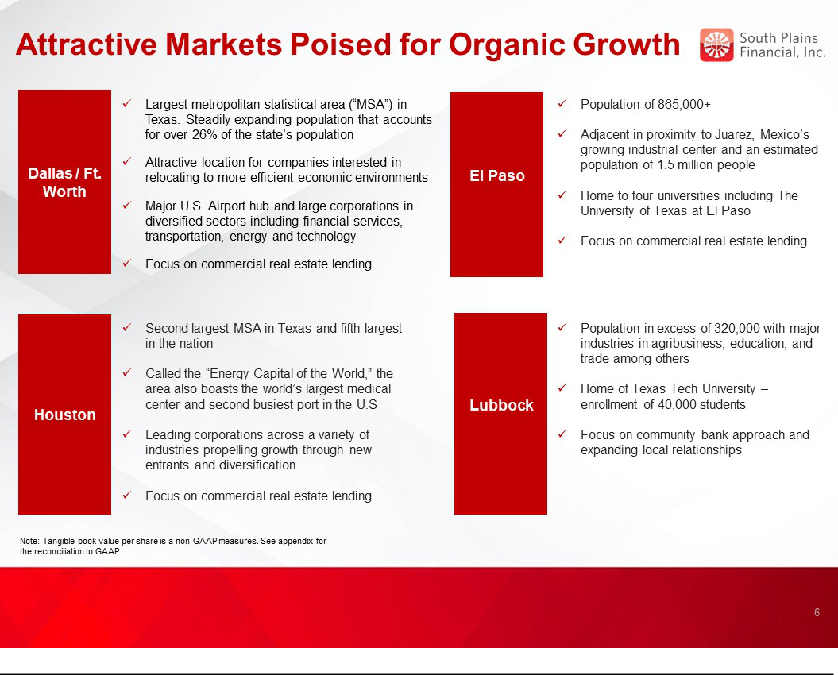

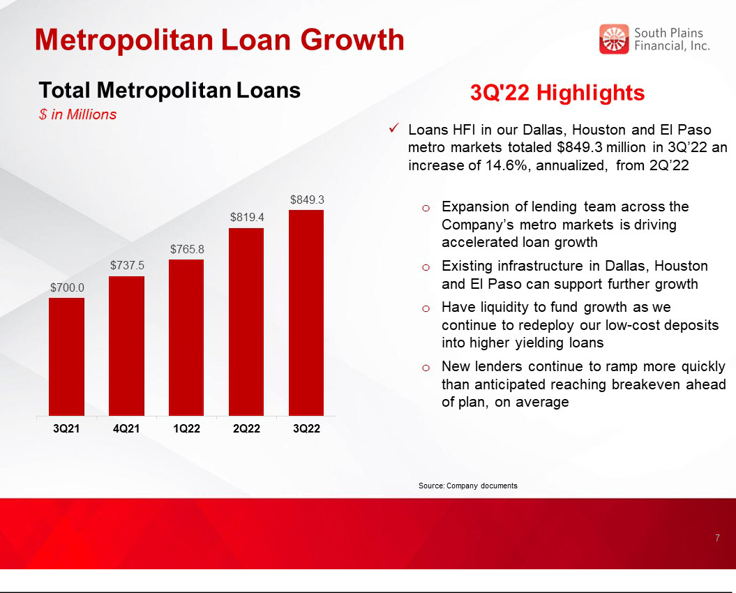

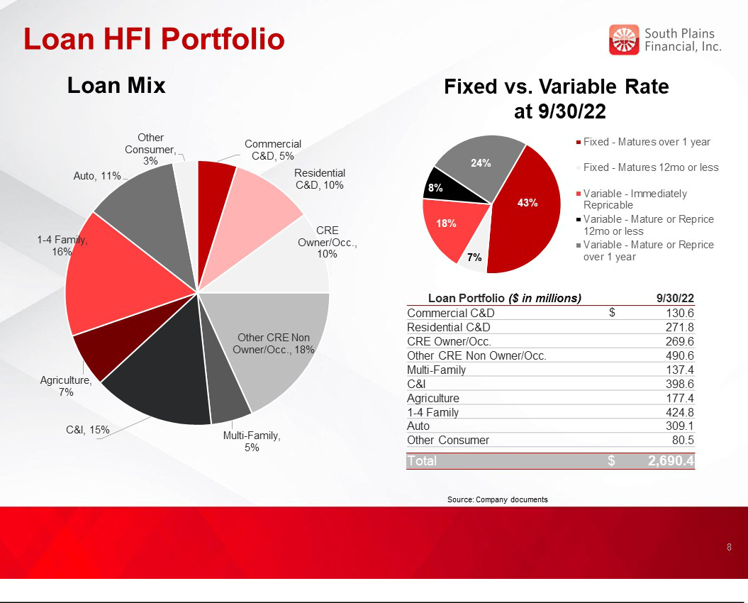

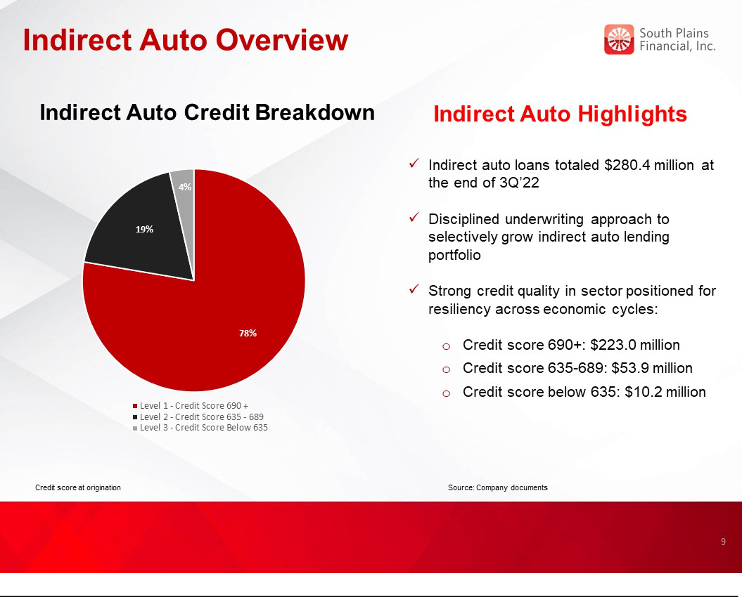

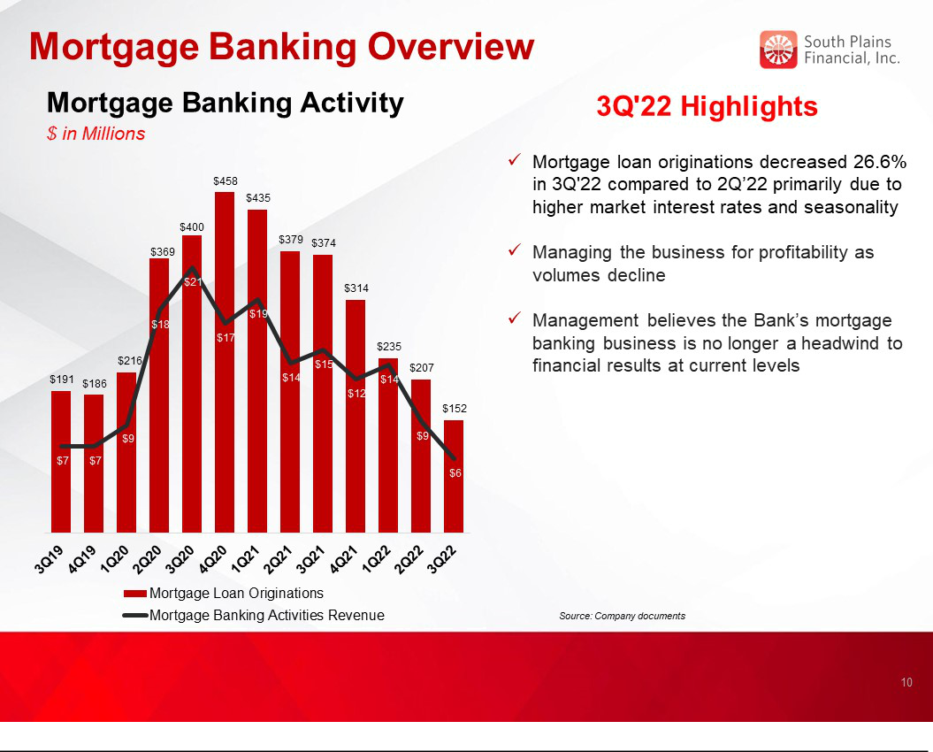

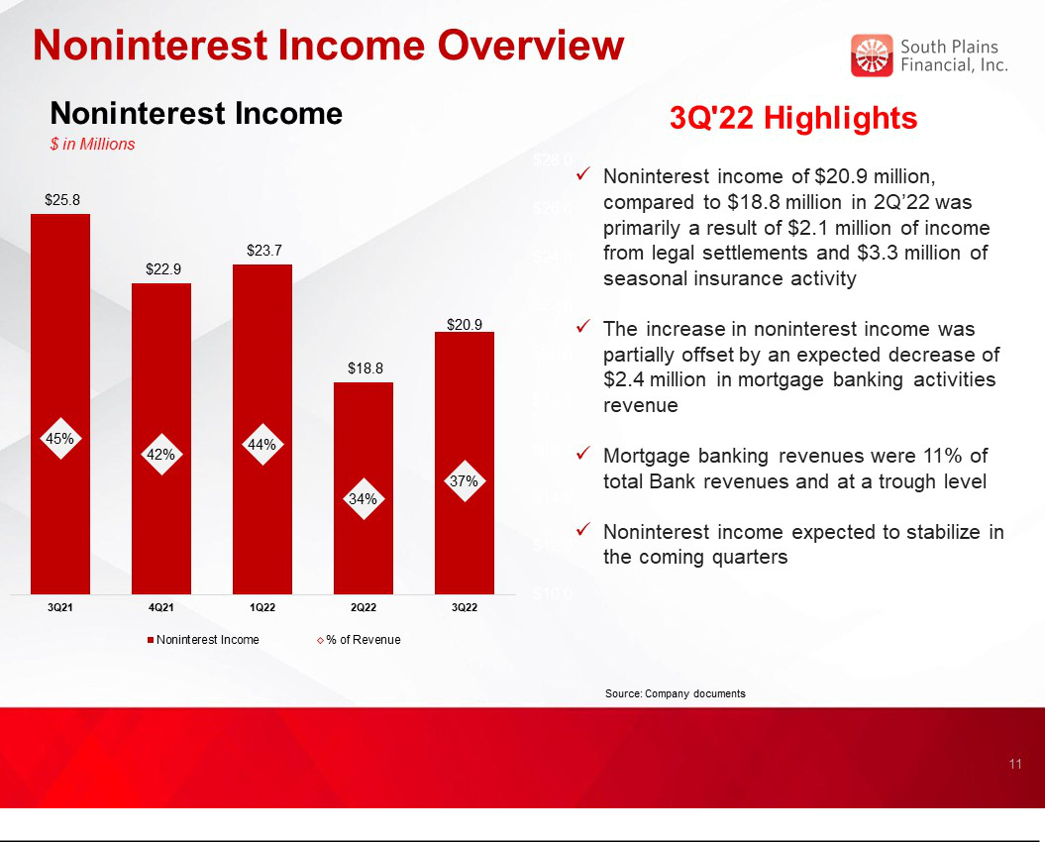

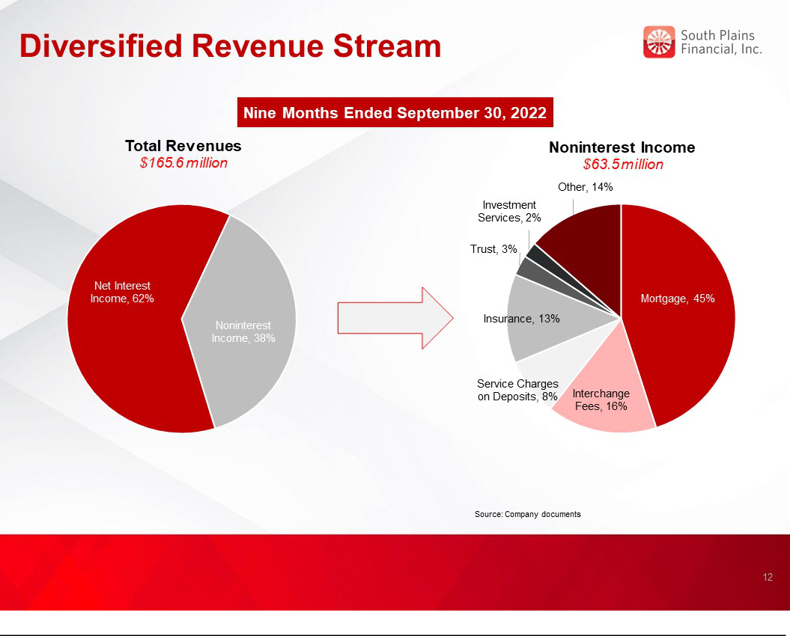

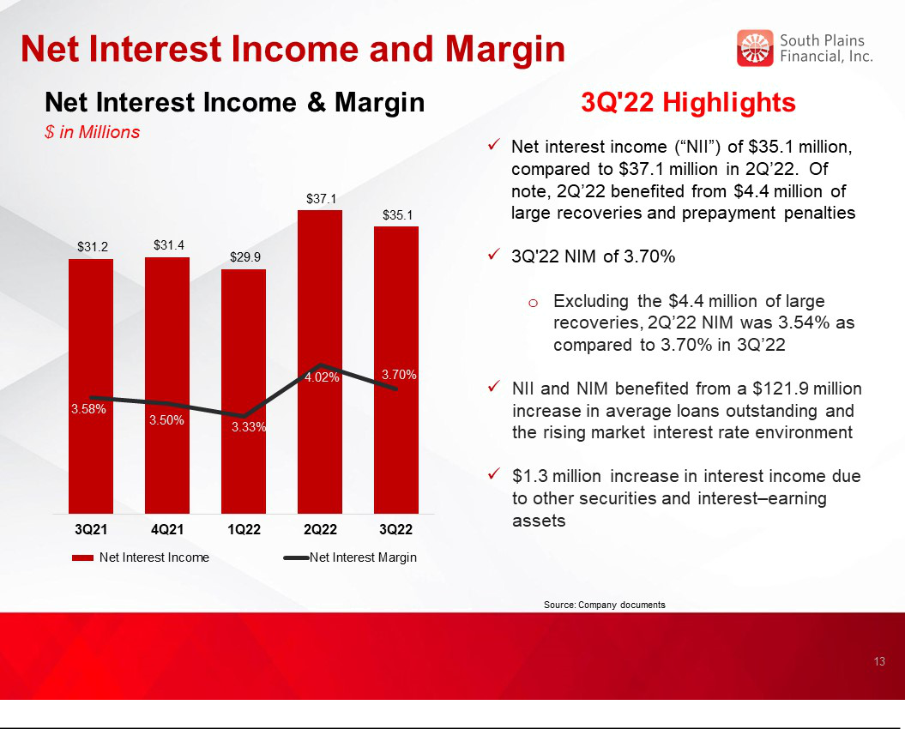

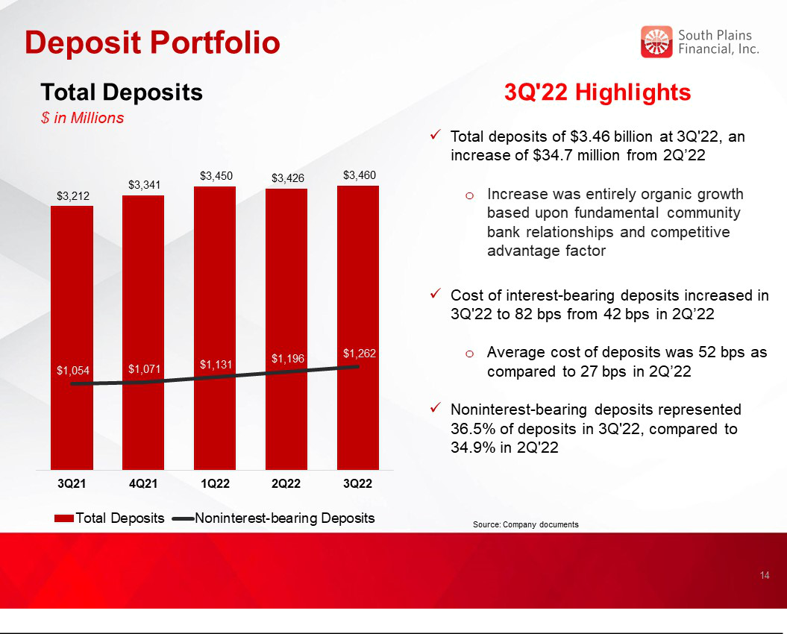

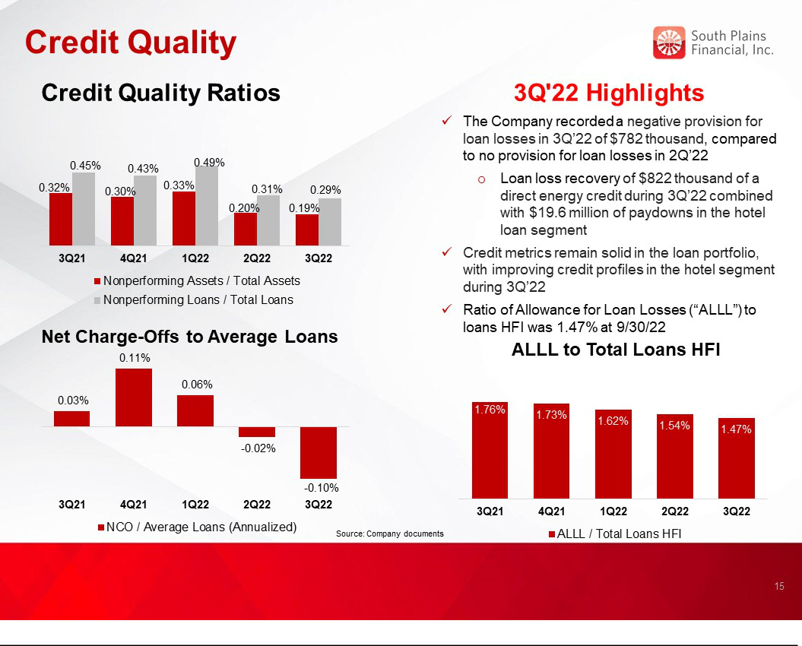

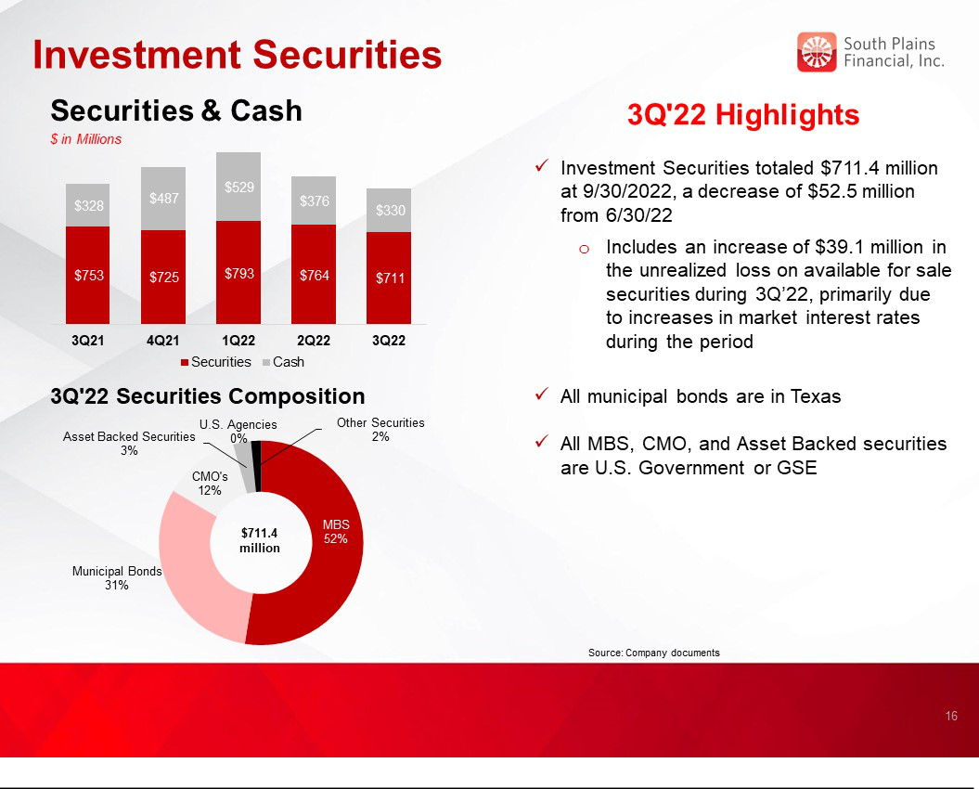

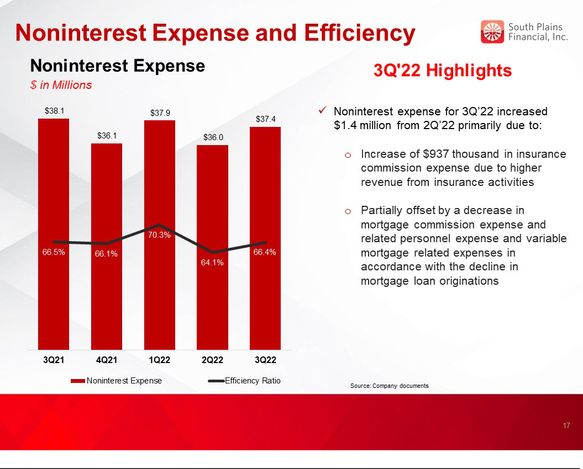

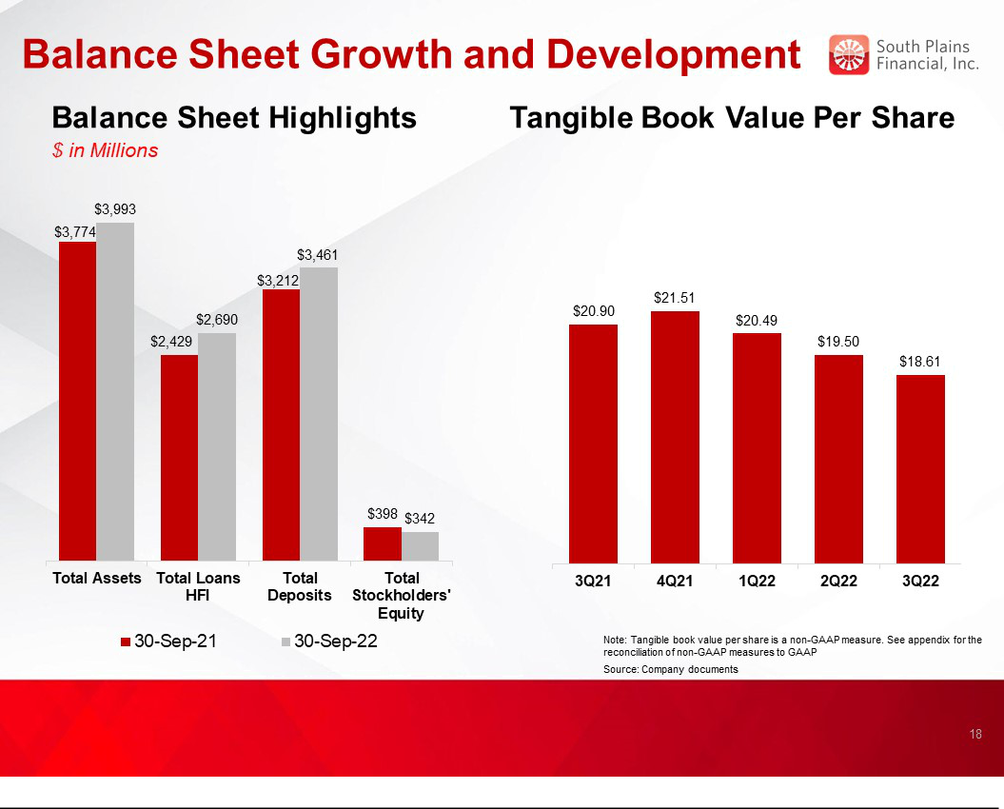

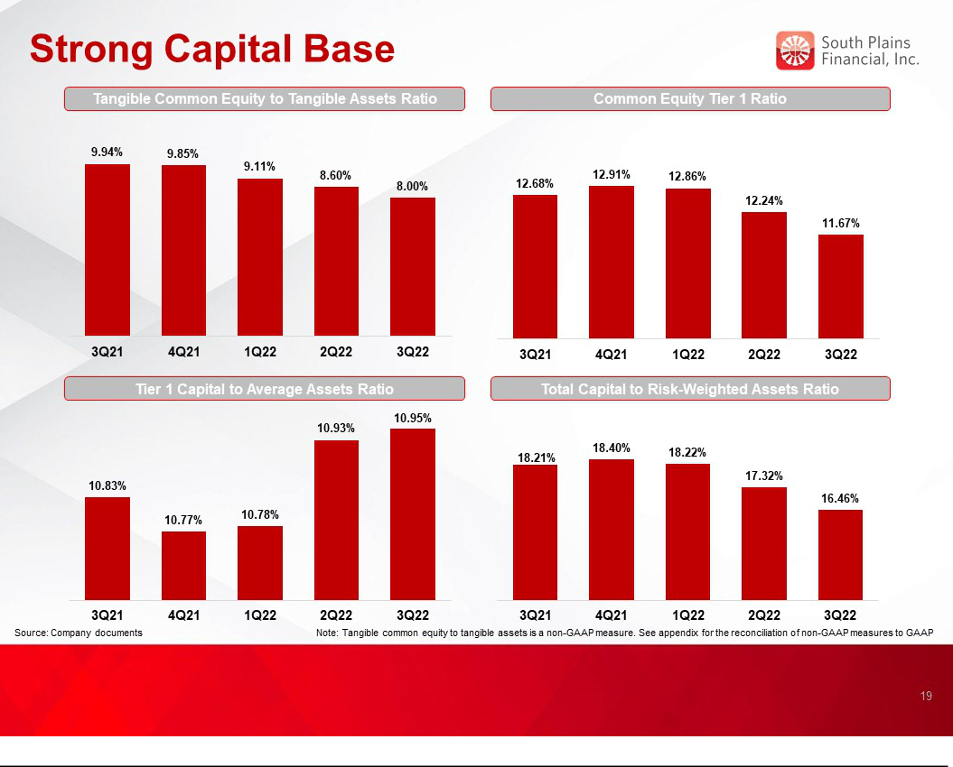



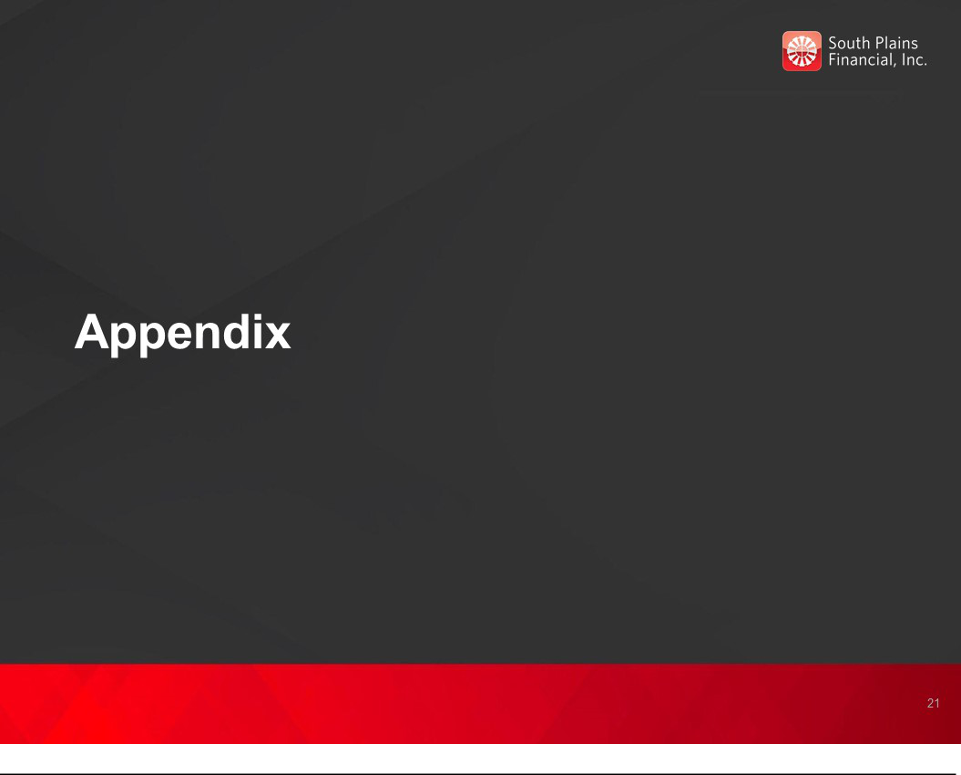

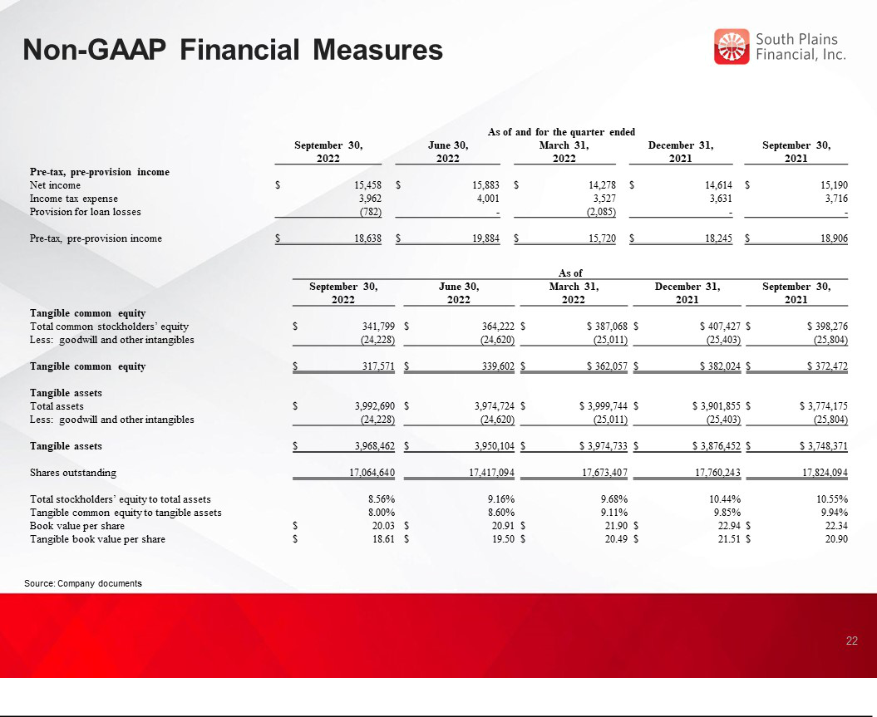

Exhibit 99.3

South Plains Financial, Inc. Declares Quarterly Cash Dividend

LUBBOCK, Texas, October 20, 2022 (GLOBE NEWSWIRE) – South Plains Financial, Inc. (NASDAQ:SPFI) (“South Plains”), the parent company of City Bank, today announced that its Board of Directors has declared a quarterly cash dividend of $0.12 per share of common stock. The dividend is payable on November 15, 2022 to shareholders of record as of the close of business on October 31, 2022.

About South Plains Financial, Inc.

South Plains is the bank holding company for City Bank, a Texas state-chartered bank headquartered in Lubbock, Texas. City Bank is one of the largest independent banks in West Texas and has additional banking operations in the Dallas, El Paso, Greater Houston, the Permian Basin, and College Station, Texas markets, and the Ruidoso, New Mexico market. South Plains provides a wide range of commercial and consumer financial services to small and medium-sized businesses and individuals in its market areas. Its principal business activities include commercial and retail banking, along with insurance, investment, trust and mortgage services. Please visit https://www.spfi.bank for more information.

Contact: | Mikella Newsom, Chief Risk Officer and Secretary
 | investors@city.bank

- 771-3347 Source: South Plains Financial, Inc.

