UNITED STATES
SECURITIES AND EXCHANGE COMMISSION
Washington, D.C. 20549

FORM 8-K

CURRENT REPORT
Pursuant to Section 13 or 15(d) of
the Securities Exchange Act of 1934

Date of Report (Date of earliest event reported): October 23, 2025

South Plains Financial, Inc.
(Exact name of registrant as specified in its charter)

Texas | 001-38895 | 75-2453320
(State or other jurisdiction of incorporation) | (Commission File Number) | (IRS Employer Identification No.)

5219 City Bank Parkway  Lubbock, Texas |  | 79407
(Address of principal executive offices) |  | (Zip Code)

(806) 792-7101
(Registrant’s telephone number, including area code)

Check the appropriate box below if the Form 8-K filing is intended to simultaneously satisfy the filing obligation of the registrant under any of the following provisions:

☐ | Written communications pursuant to Rule 425 under the Securities Act (17 CFR 230.425)

☐ | Soliciting material pursuant to Rule 14a-12 under the Exchange Act (17 CFR 240.14a-12)

☐ | Pre-commencement communications pursuant to Rule 14d-2(b) under the Exchange Act (17 CFR 240.14d-2(b))

☐ | Pre-commencement communications pursuant to Rule 13e-4(c) under the Exchange Act (17 CFR 240.13e-4(c))

Securities registered pursuant to Section 12(b) of the Act:

Title of each class | Trading Symbol(s) | Name of each exchange on which registered
Common Stock, par value $1.00 per share | SPFI | The Nasdaq Stock Market LLC

Indicate by check mark whether the registrant is an emerging growth company as defined in Rule 405 of the Securities Act of 1933 (§230.405 of this chapter) or Rule 12b-2 of the Securities Exchange Act of 1934 (§240.12b-2 of this chapter).

Emerging growth company ☐

If an emerging growth company, indicate by check mark if the registrant has elected not to use the extended transition period for complying with any new or revised financial accounting standards provided pursuant to Section 13(a) of the Exchange Act. ☐

Item 2.02 | Results of Operations and Financial Condition.

On October 23, 2025, South Plains Financial, Inc. (the “Company”) issued a press release announcing its financial results for the third quarter ended September 30, 2025. A copy of the Company’s press release covering such announcement and certain other matters is furnished as Exhibit 99.1 to this Current Report on Form 8-K.

Item 7.01 | Regulation FD Disclosure.

On October 23, 2025, officers of the Company will conduct a conference call at 5:00 p.m., Eastern Time, with respect to the Company’s financial results for the third quarter ended September 30, 2025. An earnings release slide presentation highlighting the Company’s financial results for the third quarter ended September 30, 2025 is furnished as Exhibit 99.2 to this Current Report on Form 8-K. This earnings release slide presentation will also be available on the Company’s website, www.spfi.bank, under the “News & Events” section.

In accordance with General Instruction B.2 of Form 8-K, the information in Items 2.02 and 7.01 of this Current Report on Form 8-K, including Exhibit 99.1 and Exhibit 99.2 furnished herewith, shall not be deemed “filed” for the purposes of Section 18 of the Securities Exchange Act of 1934, as amended (the “Exchange Act”), or otherwise subject to the liabilities of that section. The information in Items 2.02 and 7.01 of this Current Report on Form 8-K, including Exhibit 99.1 and Exhibit 99.2 furnished herewith, shall not be incorporated by reference into any filing or other document pursuant to the Exchange Act or the Securities Act of 1933, as amended, except as shall be expressly set forth by specific reference in such filing or document.

Item 9.01 | Financial Statements and Exhibits.

 | (d) | Exhibits.
 | 99.1 | Press release, dated October 23, 2025, announcing third quarter 2025 financial results of South Plains Financial, Inc.
 | 99.2 | Earnings release slide presentation, dated October 23, 2025.
 | 104 | Cover Page Interactive Data File (formatted as Inline XBRL).

SIGNATURES

Pursuant to the requirements of the Securities Exchange Act of 1934, the registrant has duly caused this report to be signed on its behalf by the undersigned hereunto duly authorized.

 | SOUTH PLAINS FINANCIAL, INC.
Date: October 23, 2025 | By: | /s/ Steven B. Crockett
Steven B. Crockett
Chief Financial Officer and Treasurer

Exhibit 99.1



South Plains Financial, Inc. Reports Third Quarter 2025 Financial Results

LUBBOCK, Texas, October 23, 2025 (GLOBE NEWSWIRE) – South Plains Financial, Inc. (NASDAQ:SPFI) (“South Plains” or the “Company”), the parent company of City Bank (“City Bank” or the “Bank”), today reported its financial results for the quarter ended September 30, 2025.

Third Quarter 2025 Highlights

 | ● | Net income for the third quarter of 2025 was $16.3 million, compared to $14.6 million for the second quarter of 2025 and $11.2 million for the third quarter of 2024.

 | ● | Diluted earnings per share for the third quarter of 2025 was $0.96, compared to $0.86 for the second quarter of 2025 and $0.66 for the third quarter of 2024.

 | ● | Average cost of deposits for the third quarter of 2025 was 210 basis points, compared to 214 basis points for the second quarter of 2025 and 247 basis points for the third quarter of 2024.

 | ● | Net interest margin, on a tax-equivalent basis, was 4.05% for the third quarter of 2025, compared to 4.07% for the second quarter of 2025 and 3.65% for the third quarter of 2024.

 | ● | Return on average assets for the third quarter of 2025 was 1.47%, compared to 1.34% for the second quarter of 2025 and 1.05% for the third quarter of 2024.

 | ● | Tangible book value (non-GAAP) per share was $28.14 as of September 30, 2025, compared to $26.70 as of June 30, 2025 and $25.75 as of September 30, 2024.

 | ● | The consolidated total risk-based capital ratio, common equity tier 1 risk-based capital ratio, and tier 1 leverage ratio at September 30, 2025 were 17.34%, 14.41%, and 12.37%, respectively.

Curtis Griffith, South Plains’ Chairman and Chief Executive Officer, commented, “We delivered strong third quarter results highlighted by solid earnings growth as we continued to experience net interest income expansion supported by our low cost, community-based deposit franchise. The credit quality of our loan portfolio also continued to improve as did our return on average assets. Our results demonstrate the strong foundation that we have purposefully built. We have added exceptional talent across the Bank while also making the necessary investments in our technology platform that positions South Plains to efficiently scale our operations as we grow. I believe the Bank is firmly positioned to accelerate our asset growth through both organic expansion and accretive M&A opportunities. While we have been experiencing higher than normal paydowns which has proved a headwind to loan growth, we expect an acceleration in growth next year aided by the expansion of our lending platform where we expect to further increase our lending team by up to 20%. We continue to engage in discussions with potential target banks in our core markets although we are only interested in acquiring a bank that fits our conservative nature and overall culture, and meets our strict criteria for a deal. As a result, we will only do a deal that makes sense for the Bank and our shareholders.”

Results of Operations, Quarter Ended September 30, 2025

Net Interest Income

Net interest income was $43.0 million for the third quarter of 2025, compared to $42.5 million for the second quarter of 2025 and $37.3 million for the third quarter of 2024. Net interest margin, calculated on a tax-equivalent basis, was 4.05% for the third quarter of 2025, compared to 4.07% for the second quarter of 2025 and 3.65% for the third quarter of 2024. The average yield on loans was 6.92% for the third quarter of 2025, compared to 6.99% for the second quarter of 2025 and 6.68% for the third quarter of 2024. The average cost of deposits was 210 basis points for the third quarter of 2025, which is 4 basis points lower than the second quarter of 2025 and 37 basis points lower than the third quarter of 2024. Loan interest income for the third quarter of 2025 included $640 thousand in interest and fees recognized related to the resolution of credit workouts. This amount positively impacted the net interest margin by 6 basis points and the loan yield by 8 basis points during the third quarter of 2025. There was a recovery of $1.7 million in interest during the second quarter of 2025, related to the full repayment of a loan that had previously been on nonaccrual. This recovery positively impacted the net interest margin by 17 basis points and the loan yield by 23 basis points during the second quarter of 2025.

Interest income was $64.5 million for the third quarter of 2025, compared to $64.1 million for the second quarter of 2025 and $61.6 million for the third quarter of 2024. Interest income increased $385 thousand in the third quarter of 2025 from the second quarter of 2025, which was primarily comprised of an increase of $343 thousand in interest income on other earning assets. The increase in interest income on other earning assets was mainly due to an increase of $32.8 million in average other interest-earning assets during the third quarter of 2025. Interest income increased $2.9 million in the third quarter of 2025 compared to the third quarter of 2024. This increase was primarily due to the $640 thousand of loan interest and fees and an increase of average loans of $23.6 million and higher loan interest rates during the period, resulting in growth of $2.4 million in loan interest income.

Interest expense was $21.5 million for the third quarter of 2025, compared to $21.6 million for the second quarter of 2025 and $24.3 million for the third quarter of 2024. Interest expense decreased $131 thousand compared to the second quarter of 2025 and decreased $2.8 million compared to the third quarter of 2024. The $2.8 million decrease was primarily a result of a 49 basis point decline in the cost of interest-bearing deposits, partially offset by an increase of $71.5 million in average interest-bearing deposits in the third quarter of 2025 as compared to the third quarter of 2024.

Noninterest Income and Noninterest Expense

Noninterest income was $11.2 million for the third quarter of 2025, compared to $12.2 million for the second quarter of 2025 and $10.6 million for the third quarter of 2024. The decrease from the second quarter of 2025 was primarily due to a decrease of $1.0 million in mortgage banking revenues, mainly as a result of the change in the fair value adjustment of the mortgage servicing rights assets – a write-down of $925 thousand in the third quarter of 2025 compared to a write-down of $156 thousand in the second quarter of 2025 – as interest rates that affect the value declined in the third quarter of 2025. The increase in noninterest income for the third quarter of 2025 as compared to the third quarter of 2024 was primarily due to an increase of $685 thousand in mortgage banking revenues, mainly as a result of the change in the fair value adjustment of the mortgage servicing rights assets – a write-down of $925 thousand in the third quarter of 2025 compared to a write-down of $2.1 million in the third quarter of 2024 – as interest rates that affect the value declined in the third quarter of 2025.

Noninterest expense was $33.0 million for the third quarter of 2025, compared to $33.5 million for the second quarter of 2025 and $33.1 million for the third quarter of 2024. The $519 thousand decrease from the second quarter of 2025 was largely the result of a decrease of $581 thousand in professional service expenses related primarily to consulting on technology projects and initiatives. The $104 thousand decrease in noninterest expense for the third quarter of 2025 as compared to the third quarter of 2024 was largely the result of a decrease in professional service expenses of $514 thousand and a decrease of $258 thousand in other noninterest expenses, partially offset by an increase of $616 thousand in personnel expenses, mainly a result of annual salary adjustments. The $514 thousand decrease in professional service expense was mainly due to higher legal expense as well as consulting related to technology projects in the third quarter of 2024.

Loan Portfolio and Composition

Loans held for investment were $3.05 billion as of September 30, 2025, compared to $3.10 billion as of June 30, 2025 and $3.04 billion as of September 30, 2024. The decrease of $45.5 million, or 1.5%, during the third quarter of 2025 as compared to the second quarter of 2025 occurred primarily as a result of a decrease of $46.5 million in multi-family property loans mainly due to the payoff of two loans totaling $39.6 million, partially offset by organic loan growth. As of September 30, 2025, loans held for investment were essentially unchanged as compared to September 30, 2024.

Deposits and Borrowings

Deposits totaled $3.88 billion as of September 30, 2025, compared to $3.74 billion as of June 30, 2025 and $3.72 billion as of September 30, 2024. Deposits increased by $142.2 million, or 3.8%, in the third quarter of 2025 from June 30, 2025. Deposits increased by $161.8 million, or 4.3%, at September 30, 2025 as compared to September 30, 2024. Noninterest-bearing deposits were $1.05 billion as of September 30, 2025, compared to $998.8 million as of June 30, 2025 and $998.5 million as of September 30, 2024. Noninterest-bearing deposits represented 27.0% of total deposits as of September 30, 2025. The quarterly and year-over-year changes in total deposits were due to organic growth in both retail and commercial deposits.

On September 30, 2025, the Company redeemed $50 million in subordinated debt. The subordinated debt was at the end of the initial five-year fixed rate period. After the expiration of the fixed rate period, the subordinated debt would have reset quarterly at a higher variable interest rate as well as being subject to a reduction in regulatory capital treatment.

Asset Quality

The Company recorded a provision for credit losses in the third quarter of 2025 of $500 thousand, compared to $2.5 million in the second quarter of 2025 and $495 thousand in the third quarter of 2024. The decrease in provision for the third quarter of 2025 as compared to the second quarter of 2025 was largely attributable to a decrease in specific reserves, decreased loan balances, and overall improved credit quality.

The ratio of allowance for credit losses to loans held for investment was 1.45% as of September 30, 2025, compared to 1.45% as of June 30, 2025 and 1.41% as of September 30, 2024.

The ratio of nonperforming assets to total assets was 0.26% as of September 30, 2025, compared to 0.25% as of June 30, 2025 and 0.59% as of September 30, 2024. Annualized net charge-offs were 0.16% for the third quarter of 2025, compared to 0.06% for the second quarter of 2025 and 0.11% for the third quarter of 2024.
Capital

Book value per share increased to $29.41 at September 30, 2025, compared to $27.98 at June 30, 2025. The change was primarily driven by $13.7 million of net income after dividends paid and by an increase in accumulated other comprehensive income of $9.1 million. The ratio of tangible common equity to tangible assets (non-GAAP) increased 27 basis points to 10.25% at September 30, 2025.

Conference Call

South Plains will host a conference call to discuss its third quarter 2025 financial results today, October 23, 2025, at 5:00 p.m., Eastern Time. Investors and analysts interested in participating in the call are invited to dial 1-877-407-9716 (international callers please dial 1-201-493-6779) approximately 10 minutes prior to the start of the call. A live audio webcast of the conference call and conference materials will be available on the Company’s website at https://www.spfi.bank/news-events/events.

A replay of the conference call will be available within two hours of the conclusion of the call and can be accessed on the investor section of the Company’s website as well as by dialing 1-844-512-2921 (international callers please dial 1-412-317-6671). The pin to access the telephone replay is 13756126. The replay will be available until November 6, 2025.

About South Plains Financial, Inc.

South Plains is the bank holding company for City Bank, a Texas state-chartered bank headquartered in Lubbock, Texas. City Bank is one of the largest independent banks in West Texas and has additional banking operations in the Dallas, El Paso, Greater Houston, the Permian Basin, and College Station, Texas markets, and the Ruidoso, New Mexico market. South Plains provides a wide range of commercial and consumer financial services to small and medium-sized businesses and individuals in its market areas. Its principal business activities include commercial and retail banking, along with investment, trust and mortgage services. Please visit https://www.spfi.bank for more information.

Non-GAAP Financial Measures

Some of the financial measures included in this press release are not measures of financial performance recognized in accordance with generally accepted accounting principles in the United States (“GAAP”). These non-GAAP financial measures include Tangible Book Value Per Share, Tangible Common Equity to Tangible Assets, and Pre-Tax, Pre-Provision Income. The Company believes these non-GAAP financial measures provide both management and investors a more complete understanding of the Company’s financial position and performance. These non-GAAP financial measures are supplemental and are not a substitute for any analysis based on GAAP financial measures.

We classify a financial measure as being a non-GAAP financial measure if that financial measure excludes or includes amounts, or is subject to adjustments that have the effect of excluding or including amounts, that are included or excluded, as the case may be, in the most directly comparable measure calculated and presented in accordance with GAAP as in effect from time to time in the United States in our statements of income, balance sheets or statements of cash flows. Not all companies use the same calculation of these measures; therefore, this presentation may not be comparable to other similarly titled measures as presented by other companies.

A reconciliation of non-GAAP financial measures to GAAP financial measures is provided at the end of this press release.

Available Information

The Company routinely posts important information for investors on its web site (under www.spfi.bank and, more specifically, under the News & Events tab at www.spfi.bank/news-events/press-releases). The Company intends to use its web site as a means of disclosing material non-public information and for complying with its disclosure obligations under Regulation FD (Fair Disclosure) promulgated by the U.S. Securities and Exchange Commission (the “SEC”). Accordingly, investors should monitor the Company’s web site, in addition to following the Company’s press releases, SEC filings, public conference calls, presentations and webcasts.

The information contained on, or that may be accessed through, the Company’s web site is not incorporated by reference into, and is not a part of, this document.

Forward Looking Statements

This press release contains forward-looking statements within the meaning of the Private Securities Litigation Reform Act of 1995. These forward-looking statements reflect South Plains’ current views with respect to future events and South Plains’ financial performance. Any statements about South Plains’ expectations, beliefs, plans, predictions, forecasts, objectives, assumptions or future events or performance are not historical facts and may be forward-looking. These statements are often, but not always, made through the use of words or phrases such as “anticipate,” “believes,” “can,” “could,” “may,” “predicts,” “potential,” “should,” “will,” “estimate,” “plans,” “projects,” “continuing,” “ongoing,” “expects,” “intends” and similar words or phrases. South Plains cautions that the forward-looking statements in this press release are based largely on South Plains’ expectations and are subject to a number of known and unknown risks and uncertainties that are subject to change based on factors which are, in many instances, beyond South Plains’ control. Factors that could cause such changes include, but are not limited to, the impact on us and our customers of a decline in general economic conditions and any regulatory responses thereto; slower economic growth rates or potential recession in the United States and our market areas; the impacts related to or resulting from uncertainty in the banking industry as a whole; increased competition for deposits in our market areas among traditional and nontraditional financial services companies, and related changes in deposit customer behavior; the impact of changes in market interest rates, whether due to a continuation of the elevated interest rate environment or further reductions in interest rates and a resulting decline in net interest income; the lingering inflationary pressures, and the risk of the resurgence of elevated levels of inflation, in the United States and our market areas; the uncertain impacts of ongoing quantitative tightening and current and future monetary policies of the Board of Governors of the Federal Reserve System; changes in unemployment rates in the United States and our market areas; adverse changes in customer spending, borrowing and savings habits; declines in commercial real estate values and prices; a deterioration of the credit rating for U.S. long-term sovereign debt or the impact of uncertain or changing political conditions, including federal government shutdowns and uncertainty regarding United States fiscal debt, deficit and budget matters; cyber incidents or other failures, disruptions or breaches of our operational or security systems or infrastructure, or those of our third-party vendors or other service providers, including as a result of cyber-attacks; severe weather, natural disasters, acts of war or terrorism, geopolitical instability or other external events, including as a result of the policies of the current U.S. presidential administration or Congress; the impacts of tariffs, sanctions and other trade policies of the United States and its global trading counterparts and the resulting impact on the Company and its customers; competition and market expansion opportunities; changes in non-interest expenditures or in the anticipated benefits of such expenditures; the risks related to the development, implementation, use and management of emerging technologies, including artificial intelligence and machine learnings; potential costs related to the impacts of climate change; current or future litigation, regulatory examinations or other legal and/or regulatory actions; and changes in applicable laws and regulations. Additional information regarding these risks and uncertainties to which South Plains’ business and future financial performance are subject is contained in South Plains’ most recent Annual Report on Form 10-K and Quarterly Reports on Form 10-Q on file with the SEC, including the sections entitled “Risk Factors” and “Management’s Discussion and Analysis of Financial Condition and Results of Operations” of such documents, and other documents South Plains files or furnishes with the SEC from time to time, which are available on the SEC’s website, www.sec.gov. Actual results, performance or achievements could differ materially from those contemplated, expressed, or implied by the forward-looking statements due to additional risks and uncertainties of which South Plains is not currently aware or which it does not currently view as, but in the future may become, material to its business or operating results. Due to these and other possible uncertainties and risks, the Company can give no assurance that the results contemplated in the forward-looking statements will be realized and readers are cautioned not to place undue reliance on the forward-looking statements contained in this press release. Any forward-looking statements presented herein are made only as of the date of this press release, and South Plains does not undertake any obligation to update or revise any forward-looking statements to reflect changes in assumptions, new information, the occurrence of unanticipated events, or otherwise, except as required by applicable law. All forward-looking statements, express or implied, included in the press release are qualified in their entirety by this cautionary statement.

Contact: | Mikella Newsom, Chief Risk Officer and Secretary
 | (866) 771-3347
 | investors@city.bank

Source: South Plains Financial, Inc.

South Plains Financial, Inc.
Consolidated Financial Highlights - (Unaudited)
(Dollars in thousands, except share data)

 |  | As of and for the quarter ended
 |  | September 30,  2025 |  |  |  | June 30,  2025 |  |  |  | March 31,  2025 |  |  |  | December 31,  2024 |  |  |  | September 30,  2024
Selected Income Statement Data:
Interest income |  | $ | 64,520 |  |  | $ | 64,135 |  |  | $ | 59,922 |  |  | $ | 61,324 |  |  | $ | 61,640
Interest expense |  |  | 21,501 |  |  |  | 21,632 |  |  |  | 21,395 |  |  |  | 22,776 |  |  |  | 24,346
Net interest income |  |  | 43,019 |  |  |  | 42,503 |  |  |  | 38,527 |  |  |  | 38,548 |  |  |  | 37,294
Provision for credit losses |  |  | 500 |  |  |  | 2,500 |  |  |  | 420 |  |  |  | 1,200 |  |  |  | 495
Noninterest income |  |  | 11,165 |  |  |  | 12,165 |  |  |  | 10,625 |  |  |  | 13,319 |  |  |  | 10,635
Noninterest expense |  |  | 33,024 |  |  |  | 33,543 |  |  |  | 33,030 |  |  |  | 29,948 |  |  |  | 33,128
Income tax expense |  |  | 4,342 |  |  |  | 4,020 |  |  |  | 3,408 |  |  |  | 4,222 |  |  |  | 3,094
Net income |  |  | 16,318 |  |  |  | 14,605 |  |  |  | 12,294 |  |  |  | 16,497 |  |  |  | 11,212
Per Share Data (Common Stock):
Net earnings, basic |  | $ | 1.00 |  |  | $ | 0.90 |  |  | $ | 0.75 |  |  | $ | 1.01 |  |  | $ | 0.68
Net earnings, diluted |  |  | 0.96 |  |  |  | 0.86 |  |  |  | 0.72 |  |  |  | 0.96 |  |  |  | 0.66
Cash dividends declared and paid |  |  | 0.16 |  |  |  | 0.15 |  |  |  | 0.15 |  |  |  | 0.15 |  |  |  | 0.14
Book value |  |  | 29.41 |  |  |  | 27.98 |  |  |  | 27.33 |  |  |  | 26.67 |  |  |  | 27.04
Tangible book value (non-GAAP) |  |  | 28.14 |  |  |  | 26.70 |  |  |  | 26.05 |  |  |  | 25.40 |  |  |  | 25.75
Weighted average shares outstanding, basic |  |  | 16,241,695 |  |  |  | 16,231,627 |  |  |  | 16,415,862 |  |  |  | 16,400,361 |  |  |  | 16,386,079
Weighted average shares outstanding, dilutive |  |  | 16,990,546 |  |  |  | 16,886,993 |  |  |  | 17,065,599 |  |  |  | 17,161,646 |  |  |  | 17,056,959
Shares outstanding at end of period |  |  | 16,247,839 |  |  |  | 16,230,475 |  |  |  | 16,235,647 |  |  |  | 16,455,826 |  |  |  | 16,386,627
Selected Period End Balance Sheet Data:
Cash and cash equivalents |  | $ | 635,046 |  |  | $ | 470,496 |  |  | $ | 536,300 |  |  | $ | 359,082 |  |  | $ | 471,167
Investment securities |  |  | 571,138 |  |  |  | 570,000 |  |  |  | 571,527 |  |  |  | 577,240 |  |  |  | 606,889
Total loans held for investment |  |  | 3,053,503 |  |  |  | 3,098,978 |  |  |  | 3,075,860 |  |  |  | 3,055,054 |  |  |  | 3,037,375
Allowance for credit losses |  |  | 44,125 |  |  |  | 45,010 |  |  |  | 42,968 |  |  |  | 43,237 |  |  |  | 42,886
Total assets |  |  | 4,479,437 |  |  |  | 4,363,674 |  |  |  | 4,405,209 |  |  |  | 4,232,239 |  |  |  | 4,337,659
Interest-bearing deposits |  |  | 2,831,642 |  |  |  | 2,740,179 |  |  |  | 2,826,055 |  |  |  | 2,685,366 |  |  |  | 2,720,880
Noninterest-bearing deposits |  |  | 1,049,501 |  |  |  | 998,759 |  |  |  | 966,464 |  |  |  | 935,510 |  |  |  | 998,480
Total deposits |  |  | 3,881,143 |  |  |  | 3,738,938 |  |  |  | 3,792,519 |  |  |  | 3,620,876 |  |  |  | 3,719,360
Borrowings |  |  | 60,493 |  |  |  | 111,799 |  |  |  | 110,400 |  |  |  | 110,354 |  |  |  | 110,307
Total stockholders’ equity |  |  | 477,802 |  |  |  | 454,074 |  |  |  | 443,743 |  |  |  | 438,949 |  |  |  | 443,122
Summary Performance Ratios:
Return on average assets (annualized) |  |  | 1.47% |  |  |  | 1.34% |  |  |  | 1.16% |  |  |  | 1.53% |  |  |  | 1.05%
Return on average equity (annualized) |  |  | 13.89% |  |  |  | 13.05% |  |  |  | 11.30% |  |  |  | 14.88% |  |  |  | 10.36%
Net interest margin (1) |  |  | 4.05% |  |  |  | 4.07% |  |  |  | 3.81% |  |  |  | 3.75% |  |  |  | 3.65%
Yield on loans |  |  | 6.92% |  |  |  | 6.99% |  |  |  | 6.67% |  |  |  | 6.69% |  |  |  | 6.68%
Cost of interest-bearing deposits |  |  | 2.87% |  |  |  | 2.91% |  |  |  | 2.93% |  |  |  | 3.12% |  |  |  | 3.36%
Efficiency ratio |  |  | 60.69% |  |  |  | 61.11% |  |  |  | 66.90% |  |  |  | 57.50% |  |  |  | 68.80%
Summary Credit Quality Data:
Nonperforming loans |  | $ | 9,709 |  |  | $ | 10,463 |  |  | $ | 6,467 |  |  | $ | 24,023 |  |  | $ | 24,693
Nonperforming loans to total loans held for investment |  |  | 0.32% |  |  |  | 0.34% |  |  |  | 0.21% |  |  |  | 0.79% |  |  |  | 0.81%
Other real estate owned |  | $ | 1,827 |  |  | $ | 535 |  |  | $ | 600 |  |  | $ | 530 |  |  | $ | 973
Nonperforming assets to total assets |  |  | 0.26% |  |  |  | 0.25% |  |  |  | 0.16% |  |  |  | 0.58% |  |  |  | 0.59%
Allowance for credit losses to total loans held for investment |  |  | 1.45% |  |  |  | 1.45% |  |  |  | 1.40% |  |  |  | 1.42% |  |  |  | 1.41%
Net charge-offs to average loans outstanding (annualized) |  |  | 0.16% |  |  |  | 0.06% |  |  |  | 0.07% |  |  |  | 0.11% |  |  |  | 0.11%

 |  | As of and for the quarter ended
 |  | September 30  2025 |  |  |  | June 30,  2025 |  |  |  | March 31,  2025 |  |  |  | December 31,  2024 |  |  |  | September 30,  2024
Capital Ratios:
Total stockholders’ equity to total assets |  |  | 10.67 | % |  |  | 10.41 | % |  |  | 10.07 | % |  |  | 10.37 | % |  |  | 10.22 | %
Tangible common equity to tangible assets (non-GAAP) |  |  | 10.25 | % |  |  | 9.98 | % |  |  | 9.64 | % |  |  | 9.92 | % |  |  | 9.77 | %
Common equity tier 1 to risk-weighted assets |  |  | 14.41 | % |  |  | 13.86 | % |  |  | 13.59 | % |  |  | 13.53 | % |  |  | 13.25 | %
Tier 1 capital to average assets |  |  | 12.37 | % |  |  | 12.12 | % |  |  | 12.04 | % |  |  | 12.04 | % |  |  | 11.76 | %
Total capital to risk-weighted assets |  |  | 17.34 | % |  |  | 18.17 | % |  |  | 17.93 | % |  |  | 17.86 | % |  |  | 17.61 | %

(1) | Net interest margin is calculated as the annual net interest income, on a fully tax-equivalent basis, divided by average interest-earning assets.

South Plains Financial, Inc.
Average Balances and Yields - (Unaudited)
(Dollars in thousands)

 |  | For the Three Months Ended
 |  | September 30, 2025 |  |  |  |  |  |  |  |  |  |  |  | September 30, 2024
 |  | Average  Balance |  |  |  | Interest |  |  |  | Yield/Rate |  |  |  | Average  Balance |  |  |  | Interest |  |  |  | Yield/Rate
Assets
Loans (1) |  | $ | 3,093,465 |  |  | $ | 53,935 |  |  |  | 6.92 | % |  | $ | 3,069,900 |  |  | $ | 51,513 |  |  |  | 6.68 | %
Debt securities - taxable |  |  | 498,302 |  |  |  | 4,638 |  |  |  | 3.69 | % |  |  | 524,641 |  |  |  | 5,300 |  |  |  | 4.02 | %
Debt securities - nontaxable |  |  | 155,028 |  |  |  | 1,080 |  |  |  | 2.76 | % |  |  | 154,806 |  |  |  | 1,016 |  |  |  | 2.61 | %
Other interest-bearing assets |  |  | 489,621 |  |  |  | 5,101 |  |  |  | 4.13 | % |  |  | 336,887 |  |  |  | 4,032 |  |  |  | 4.76 | %
Total interest-earning assets |  |  | 4,236,416 |  |  |  | 64,754 |  |  |  | 6.06 | % |  |  | 4,086,234 |  |  |  | 61,861 |  |  |  | 6.02 | %
Noninterest-earning assets |  |  | 167,437 |  |  |  |  |  |  |  |  |  |  |  | 172,922
Total assets |  | $ | 4,403,853 |  |  |  |  |  |  |  |  |  |  | $ | 4,259,156
Liabilities & stockholders’ equity
NOW, Savings, MMDA’s |  | $ | 2,325,281 |  |  |  | 16,007 |  |  |  | 2.73 | % |  | $ | 2,247,299 |  |  |  | 18,143 |  |  |  | 3.21 | %
Time deposits |  |  | 424,788 |  |  |  | 3,918 |  |  |  | 3.66 | % |  |  | 431,307 |  |  |  | 4,510 |  |  |  | 4.16 | %
Short-term borrowings |  |  | 7 |  |  |  | - |  |  |  | 0.00 | % |  |  | 3 |  |  |  | - |  |  |  | 0.00 | %
Notes payable & other long-term borrowings |  |  | - |  |  |  | - |  |  |  | 0.00 | % |  |  | - |  |  |  | - |  |  |  | 0.00 | %
Subordinated debt |  |  | 63,534 |  |  |  | 835 |  |  |  | 5.21 | % |  |  | 63,891 |  |  |  | 835 |  |  |  | 5.20 | %
Junior subordinated deferrable interest debentures |  |  | 46,393 |  |  |  | 741 |  |  |  | 6.34 | % |  |  | 46,393 |  |  |  | 858 |  |  |  | 7.36 | %
Total interest-bearing liabilities |  |  | 2,860,003 |  |  |  | 21,501 |  |  |  | 2.98 | % |  |  | 2,788,893 |  |  |  | 24,346 |  |  |  | 3.47 | %
Demand deposits |  |  | 1,010,159 |  |  |  |  |  |  |  |  |  |  |  | 976,048
Other liabilities |  |  | 67,753 |  |  |  |  |  |  |  |  |  |  |  | 63,661
Stockholders’ equity |  |  | 465,938 |  |  |  |  |  |  |  |  |  |  |  | 430,554
Total liabilities & stockholders’ equity |  | $ | 4,403,853 |  |  |  |  |  |  |  |  |  |  | $ | 4,259,156
Net interest income |  |  |  |  |  | $ | 43,253 |  |  |  |  |  |  |  |  |  |  | $ | 37,515
Net interest margin (2) |  |  |  |  |  |  |  |  |  |  | 4.05 | % |  |  |  |  |  |  |  |  |  |  | 3.65 | %

(1) | Average loan balances include nonaccrual loans and loans held for sale.

(2) | Net interest margin is calculated as the annualized net interest income, on a fully tax-equivalent basis, divided by average interest-earning assets.

South Plains Financial, Inc.
Average Balances and Yields - (Unaudited)
(Dollars in thousands)

 |  | For the Nine Months Ended
 |  | September 30, 2025 |  |  |  |  |  |  |  |  |  |  |  | September 30, 2024
 |  | Average  Balance |  |  |  | Interest |  |  |  | Yield/Rate |  |  |  | Average  Balance |  |  |  | Interest |  |  |  | Yield/Rate
Assets
Loans (1) |  | $ | 3,087,530 |  |  | $ | 158,406 |  |  |  | 6.86 | % |  | $ | 3,055,679 |  |  | $ | 151,031 |  |  |  | 6.60 | %
Debt securities - taxable |  |  | 505,721 |  |  |  | 14,030 |  |  |  | 3.71 | % |  |  | 537,425 |  |  |  | 16,096 |  |  |  | 4.00 | %
Debt securities - nontaxable |  |  | 153,486 |  |  |  | 3,109 |  |  |  | 2.71 | % |  |  | 155,489 |  |  |  | 3,062 |  |  |  | 2.63 | %
Other interest-bearing assets |  |  | 444,473 |  |  |  | 13,707 |  |  |  | 4.12 | % |  |  | 287,192 |  |  |  | 10,052 |  |  |  | 4.68 | %
Total interest-earning assets |  |  | 4,191,210 |  |  |  | 189,252 |  |  |  | 6.04 | % |  |  | 4,035,785 |  |  |  | 180,241 |  |  |  | 5.97 | %
Noninterest-earning assets |  |  | 168,628 |  |  |  |  |  |  |  |  |  |  |  | 176,230
Total assets |  | $ | 4,359,838 |  |  |  |  |  |  |  |  |  |  | $ | 4,212,015
Liabilities & stockholders’ equity
NOW, Savings, MMDA’s |  | $ | 2,318,134 |  |  |  | 47,408 |  |  |  | 2.73 | % |  | $ | 2,251,569 |  |  |  | 53,792 |  |  |  | 3.19 | %
Time deposits |  |  | 435,127 |  |  |  | 12,406 |  |  |  | 3.81 | % |  |  | 399,646 |  |  |  | 12,153 |  |  |  | 4.06 | %
Short-term borrowings |  |  | 9 |  |  |  | - |  |  |  | 0.00 | % |  |  | 3 |  |  |  | - |  |  |  | 0.00 | %
Notes payable & other long-term borrowings |  |  | - |  |  |  | - |  |  |  | 0.00 | % |  |  | - |  |  |  | - |  |  |  | 0.00 | %
Subordinated debt |  |  | 63,850 |  |  |  | 2,505 |  |  |  | 5.25 | % |  |  | 63,845 |  |  |  | 2,505 |  |  |  | 5.24 | %
Junior subordinated deferrable interest debentures |  |  | 46,393 |  |  |  | 2,209 |  |  |  | 6.37 | % |  |  | 46,393 |  |  |  | 2,575 |  |  |  | 7.41 | %
Total interest-bearing liabilities |  |  | 2,863,513 |  |  |  | 64,528 |  |  |  | 3.01 | % |  |  | 2,761,456 |  |  |  | 71,025 |  |  |  | 3.44 | %
Demand deposits |  |  | 978,426 |  |  |  |  |  |  |  |  |  |  |  | 964,829
Other liabilities |  |  | 65,835 |  |  |  |  |  |  |  |  |  |  |  | 68,458
Stockholders’ equity |  |  | 452,064 |  |  |  |  |  |  |  |  |  |  |  | 417,272
Total liabilities & stockholders’ equity |  | $ | 4,359,838 |  |  |  |  |  |  |  |  |  |  | $ | 4,212,015
Net interest income |  |  |  |  |  | $ | 124,724 |  |  |  |  |  |  |  |  |  |  | $ | 109,216
Net interest margin (2) |  |  |  |  |  |  |  |  |  |  | 3.98 | % |  |  |  |  |  |  |  |  |  |  | 3.61 | %

(1) | Average loan balances include nonaccrual loans and loans held for sale.

(2) | Net interest margin is calculated as the annualized net interest income, on a fully tax-equivalent basis, divided by average interest-earning assets.

South Plains Financial, Inc.
Consolidated Balance Sheets
(Unaudited)
(Dollars in thousands)

 |  | As of
 |  | September 30,  2025 |  |  |  | December 31,  2024
Assets
Cash and due from banks |  | $ | 56,071 |  |  | $ | 54,114
Interest-bearing deposits in banks |  |  | 578,975 |  |  |  | 304,968
Securities available for sale |  |  | 571,138 |  |  |  | 577,240
Loans held for sale |  |  | 13,046 |  |  |  | 20,542
Loans held for investment |  |  | 3,053,503 |  |  |  | 3,055,054
Less: Allowance for credit losses |  |  | (44,125 | ) |  |  | (43,237 | )
Net loans held for investment |  |  | 3,009,378 |  |  |  | 3,011,817
Premises and equipment, net |  |  | 51,809 |  |  |  | 52,951
Goodwill |  |  | 19,315 |  |  |  | 19,315
Intangible assets |  |  | 1,265 |  |  |  | 1,720
Mortgage servicing rights |  |  | 24,458 |  |  |  | 26,292
Other assets |  |  | 153,982 |  |  |  | 163,280
Total assets |  | $ | 4,479,437 |  |  | $ | 4,232,239
Liabilities and Stockholders’ Equity
Noninterest-bearing deposits |  | $ | 1,049,501 |  |  | $ | 935,510
Interest-bearing deposits |  |  | 2,831,642 |  |  |  | 2,685,366
Total deposits |  |  | 3,881,143 |  |  |  | 3,620,876
Short-term borrowings |  |  | - |  |  |  | —
Subordinated debt |  |  | 14,100 |  |  |  | 63,961
Junior subordinated deferrable interest debentures |  |  | 46,393 |  |  |  | 46,393
Other liabilities |  |  | 59,999 |  |  |  | 62,060
Total liabilities |  |  | 4,001,635 |  |  |  | 3,793,290
Stockholders’ Equity
Common stock |  |  | 16,248 |  |  |  | 16,456
Additional paid-in capital |  |  | 91,116 |  |  |  | 97,287
Retained earnings |  |  | 421,542 |  |  |  | 385,827
Accumulated other comprehensive income (loss) |  |  | (51,104 | ) |  |  | (60,621 | )
Total stockholders’ equity |  |  | 477,802 |  |  |  | 438,949
Total liabilities and stockholders’ equity |  | $ | 4,479,437 |  |  | $ | 4,232,239

South Plains Financial, Inc.
Consolidated Statements of Income
(Unaudited)
(Dollars in thousands)

 |  | Three Months Ended |  |  |  |  |  |  |  | Nine Months Ended
 |  | September 30,  2025 |  |  |  | September 30,  2024 |  |  |  | September 30,  2025 |  |  |  | September 30,  2024
Interest income:
Loans, including fees |  | $ | 53,928 |  |  | $ | 51,505 |  |  | $ | 158,384 |  |  | $ | 151,008
Other |  |  | 10,592 |  |  |  | 10,135 |  |  |  | 30,193 |  |  |  | 28,567
Total interest income |  |  | 64,520 |  |  |  | 61,640 |  |  |  | 188,577 |  |  |  | 179,575
Interest expense:
Deposits |  |  | 19,925 |  |  |  | 22,653 |  |  |  | 59,814 |  |  |  | 65,945
Subordinated debt |  |  | 835 |  |  |  | 835 |  |  |  | 2,505 |  |  |  | 2,505
Junior subordinated deferrable interest debentures |  |  | 741 |  |  |  | 858 |  |  |  | 2,209 |  |  |  | 2,575
Other |  |  | - |  |  |  | - |  |  |  | - |  |  |  | -
Total interest expense |  |  | 21,501 |  |  |  | 24,346 |  |  |  | 64,528 |  |  |  | 71,025
Net interest income |  |  | 43,019 |  |  |  | 37,294 |  |  |  | 124,049 |  |  |  | 108,550
Provision for credit losses |  |  | 500 |  |  |  | 495 |  |  |  | 3,420 |  |  |  | 3,100
Net interest income after provision for credit losses |  |  | 42,519 |  |  |  | 36,799 |  |  |  | 120,629 |  |  |  | 105,450
Noninterest income:
Service charges on deposits |  |  | 2,266 |  |  |  | 2,023 |  |  |  | 6,505 |  |  |  | 5,785
Mortgage banking activities |  |  | 2,575 |  |  |  | 1,890 |  |  |  | 8,294 |  |  |  | 9,232
Bank card services and interchange fees |  |  | 3,403 |  |  |  | 3,302 |  |  |  | 10,553 |  |  |  | 10,415
Other |  |  | 2,921 |  |  |  | 3,420 |  |  |  | 8,603 |  |  |  | 9,321
Total noninterest income |  |  | 11,165 |  |  |  | 10,635 |  |  |  | 33,955 |  |  |  | 34,753
Noninterest expense:
Salaries and employee benefits |  |  | 19,413 |  |  |  | 18,767 |  |  |  | 58,562 |  |  |  | 56,954
Net occupancy expense |  |  | 4,046 |  |  |  | 4,255 |  |  |  | 12,045 |  |  |  | 12,204
Professional services |  |  | 1,293 |  |  |  | 1,807 |  |  |  | 4,897 |  |  |  | 5,028
Marketing and development |  |  | 979 |  |  |  | 1,015 |  |  |  | 2,803 |  |  |  | 2,629
Other |  |  | 7,293 |  |  |  | 7,284 |  |  |  | 21,290 |  |  |  | 20,815
Total noninterest expense |  |  | 33,024 |  |  |  | 33,128 |  |  |  | 99,597 |  |  |  | 97,630
Income before income taxes |  |  | 20,660 |  |  |  | 14,306 |  |  |  | 54,987 |  |  |  | 42,573
Income tax expense |  |  | 4,342 |  |  |  | 3,094 |  |  |  | 11,770 |  |  |  | 9,353
Net income |  | $ | 16,318 |  |  | $ | 11,212 |  |  | $ | 43,217 |  |  | $ | 33,220

South Plains Financial, Inc.
Loan Composition
(Unaudited)
(Dollars in thousands)

 |  | As of
 |  | September 30,  2025 |  |  |  | December 31,  2024
Loans:
Commercial Real Estate |  | $ | 1,035,903 |  |  | $ | 1,119,063
Commercial - Specialized |  |  | 377,783 |  |  |  | 388,955
Commercial - General |  |  | 629,256 |  |  |  | 557,371
Consumer:
1-4 Family Residential |  |  | 592,578 |  |  |  | 566,400
Auto Loans |  |  | 256,281 |  |  |  | 254,474
Other Consumer |  |  | 63,727 |  |  |  | 64,936
Construction |  |  | 97,952 |  |  |  | 103,855
Total loans held for investment |  | $ | 3,053,480 |  |  | $ | 3,055,054

South Plains Financial, Inc.
Deposit Composition
(Unaudited)
(Dollars in thousands)

 |  | As of
 |  | September 30,  2025 |  |  |  | December 31,  2024
Deposits:
Noninterest-bearing deposits |  | $ | 1,049,501 |  |  | $ | 935,510
NOW & other transaction accounts |  |  | 1,291,756 |  |  |  | 498,718
MMDA & other savings |  |  | 1,114,945 |  |  |  | 1,741,988
Time deposits |  |  | 424,941 |  |  |  | 444,660
Total deposits |  | $ | 3,881,143 |  |  | $ | 3,620,876

South Plains Financial, Inc.
Reconciliation of Non-GAAP Financial Measures (Unaudited)
(Dollars in thousands)

 |  | For the quarter ended
 |  | September 30,  2025 |  |  |  | June 30,  2025 |  |  |  | March 31,  2025 |  |  |  | December 31,  2024 |  |  |  | September 30,  2024
Pre-tax, pre-provision income
Net income |  | $ | 16,318 |  |  | $ | 14,605 |  |  | $ | 12,294 |  |  | $ | 16,497 |  |  | $ | 11,212
Income tax expense |  |  | 4,342 |  |  |  | 4,020 |  |  |  | 3,408 |  |  |  | 4,222 |  |  |  | 3,094
Provision for credit losses |  |  | 500 |  |  |  | 2,500 |  |  |  | 420 |  |  |  | 1,200 |  |  |  | 495
Pre-tax, pre-provision income |  | $ | 21,160 |  |  | $ | 21,125 |  |  | $ | 16,122 |  |  | $ | 21,919 |  |  | $ | 14,801

 |  | As of
 |  | September 30,  2025 |  |  |  | June 30,  2025 |  |  |  | March 31,  2025 |  |  |  | December 31,  2024 |  |  |  | September 30,  2024
Tangible common equity
Total common stockholders’ equity |  | $ | 477,802 |  |  | $ | 454,074 |  |  | $ | $ 443,743 |  |  | $ | $ 438,949 |  |  | $ | $ 443,122
Less: goodwill and other intangibles |  |  | (20,580 | ) |  |  | (20,732 | ) |  |  | (20,884 | ) |  |  | (21,035 | ) |  |  | (21,197 | )
Tangible common equity |  | $ | 457,222 |  |  | $ | 433,342 |  |  | $ | $ 422,859 |  |  | $ | $ 417,914 |  |  | $ | $ 421,925
Tangible assets
Total assets |  | $ | 4,479,437 |  |  | $ | 4,363,674 |  |  | $ | $ 4,405,209 |  |  | $ | $ 4,232,239 |  |  | $ | $ 4,337,659
Less: goodwill and other intangibles |  |  | (20,580 | ) |  |  | (20,732 | ) |  |  | (20,884 | ) |  |  | (21,035 | ) |  |  | (21,197 | )
Tangible assets |  | $ | 4,458,857 |  |  | $ | 4,342,942 |  |  | $ | $ 4,384,325 |  |  | $ | $ 4,211,204 |  |  | $ | $ 4,316,462
Shares outstanding |  |  | 16,247,839 |  |  |  | 16,230,475 |  |  |  | 16,235,647 |  |  |  | 16,455,826 |  |  |  | 16,386,627
Total stockholders’ equity to total assets |  |  | 10.67% |  |  |  | 10.41% |  |  |  | 10.07% |  |  |  | 10.37% |  |  |  | 10.22%
Tangible common equity to tangible assets |  |  | 10.25% |  |  |  | 9.98% |  |  |  | 9.64% |  |  |  | 9.92% |  |  |  | 9.77%
Book value per share |  | $ | 29.41 |  |  | $ | 27.98 |  |  | $ | 27.33 |  |  | $ | 26.67 |  |  | $ | 27.04
Tangible book value per share |  | $ | 28.14 |  |  | $ | 26.70 |  |  | $ | 26.05 |  |  | $ | 25.40 |  |  | $ | 25.75

Exhibit 99.2

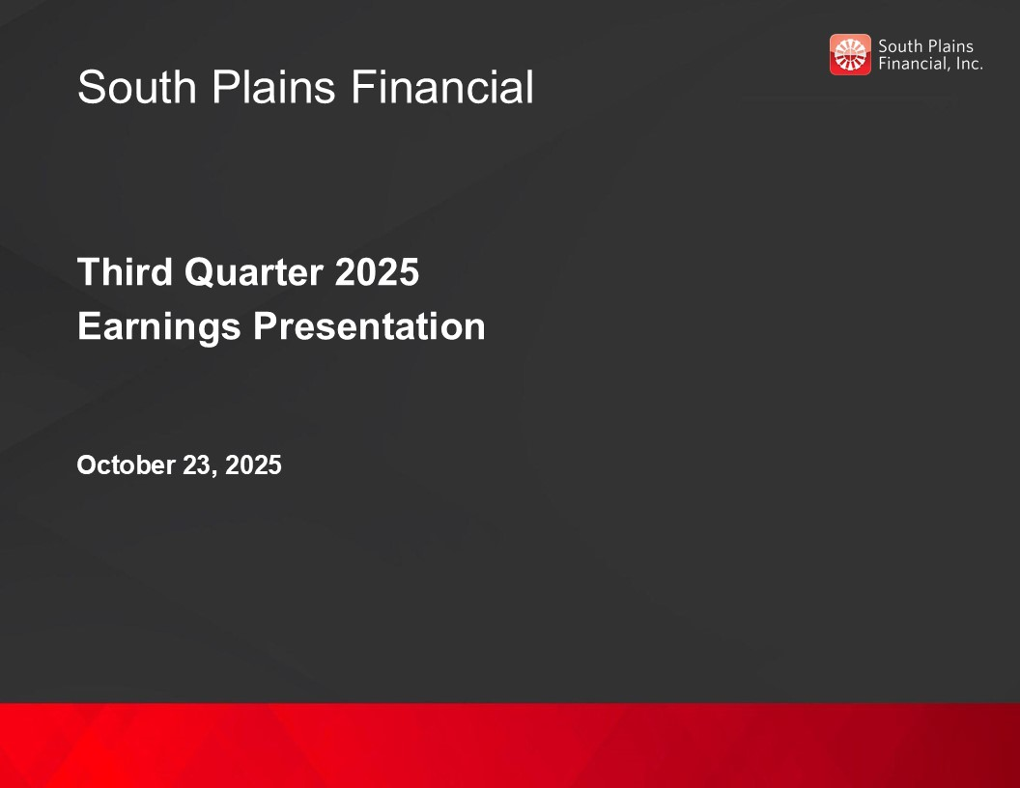
South Plains Financial Third Quarter 2025 Earnings Presentation October 23, 2025


Safe Harbor Statement and Other Disclosures FORWARD-LOOKING STATEMENTS This presentation contains, and future oral and written statements of South Plains Financial, Inc. (“South Plains”, “SPFI”, or the “Company”) and City Bank (“City Bank” or the “Bank”) may contain, forward-looking statements within the meaning of the Private Securities Litigation Reform Act of 1995. These forward-looking statements reflect South Plains’ current views with respect to future events and South Plains’ financial performance. Any statements about South Plains’ expectations, beliefs, plans, predictions, forecasts, objectives, assumptions or future events or performance are not historical facts and may be forward-looking. These statements are often, but not always, made through the use of words or phrases such as “anticipate,” “believes,” “can,” “could,” “may,” “predicts,” “potential,” “should,” “will,” “estimate,” “plans,” “projects,” “continuing,” “ongoing,” “expects,” “intends” and similar words or phrases. Forward-looking statements include, but are not limited to: (i) projections and estimates of revenues, expenses, income or loss, earnings or loss per share, and other financial items, (ii) statements of plans, objectives and expectations of South Plains or its management, (iii) statements of future economic performance, and (iv) statements of assumptions underlying such statements. Forward-looking statements should not be relied on because they involve known and unknown risks, uncertainties and other factors, some of which are beyond the control of South Plains and City Bank. These risks, uncertainties and other factors may cause the actual results, performance, and achievements of South Plains and City Bank to be materially different from the anticipated future results, performance or achievements expressed in, or implied by, the forward-looking statements. Factors that could cause such differences include, but are not limited to, the impact on us and our customers of a decline in general economic conditions and any regulatory responses thereto; slower economic growth rates or potential recession in the United States and our market areas; the impacts related to or resulting from uncertainty in the banking industry as a whole; increased competition for deposits in our market areas among traditional and nontraditional financial services companies, and related changes in deposit customer behavior; the impact of changes in market interest rates, whether due to a continuation of the elevated interest rate environment or further reductions in interest rates and a resulting decline in net interest income; the lingering inflationary pressures, and the risk of the resurgence of elevated levels of inflation, in the United States and our market areas; the uncertain impacts of ongoing quantitative tightening and current and future monetary policies of the Board of Governors of the Federal Reserve System; changes in unemployment rates in the United States and our market areas; adverse changes in customer spending, borrowing and savings habits; declines in commercial real estate values and prices; a deterioration of the credit rating for U.S. long-term sovereign debt or the impact of uncertain or changing political conditions, including federal government shutdowns and uncertainty regarding United States fiscal debt, deficit and budget matters; cyber incidents or other failures, disruptions or breaches of our operational or security systems or infrastructure, or those of our third-party vendors or other service providers, including as a result of cyber-attacks; severe weather, natural disasters, acts of war or terrorism, geopolitical instability or other external events, including as a result of the impact of the policies of the current U.S. presidential administration or Congress; the impacts of tariffs, sanctions, and other trade policies of the United States and its global trading counterparts and the resulting impact on the Company and its customers; competition and market expansion opportunities; changes in non-interest expenditures or in the anticipated benefits of such expenditures; the risks related to the development, implementation, use and management of emerging technologies, including artificial intelligence and machine learnings; potential costs related to the impacts of climate change; current or future litigation, regulatory examinations or other legal and/or regulatory actions; and changes in applicable laws and regulations. Due to these and other possible uncertainties and risks, South Plains can give no assurance that the results contemplated in the forward-looking statements will be realized and readers are cautioned not to place undue reliance on the forward-looking statements contained in this presentation. Additional information regarding these factors and uncertainties to which South Plains’ business and future financial performance are subject is contained in South Plains’ most recent Annual Report on Form 10-K and Quarterly Reports on Form 10-Q on file with the U.S. Securities and Exchange Commission (the “SEC”), including the sections entitled "Risk Factors" and "Management's Discussion and Analysis of Financial Condition and Results of Operations“ of such documents, and other documents South Plains files or furnishes with the SEC from time to time. Further, any forward-looking statement speaks only as of the date on which it is made and South Plains undertakes no obligation to update or revise any forward-looking statement to reflect events or circumstances after the date on which the statement is made or to reflect the occurrence of unanticipated events, except as required by applicable law. All forward-looking statements, express or implied, herein are qualified in their entirety by this cautionary statement. NON-GAAP FINANCIAL MEASURES Management believes that certain non-GAAP performance measures used in this presentation provide meaningful information about underlying trends in its business and operations and provide both management and investors a more complete understanding of the Company’s financial position and performance. Non-GAAP financial measures should be viewed in addition to, and not as an alternative for, SPFI’s reported results prepared in accordance with GAAP. Non-GAAP financial measures have limitations as analytical tools, and investors should not consider them in isolation or as a substitute for analysis of the results or financial condition of the Company as reported under GAAP. Numbers in this presentation may not sum due to rounding. 2

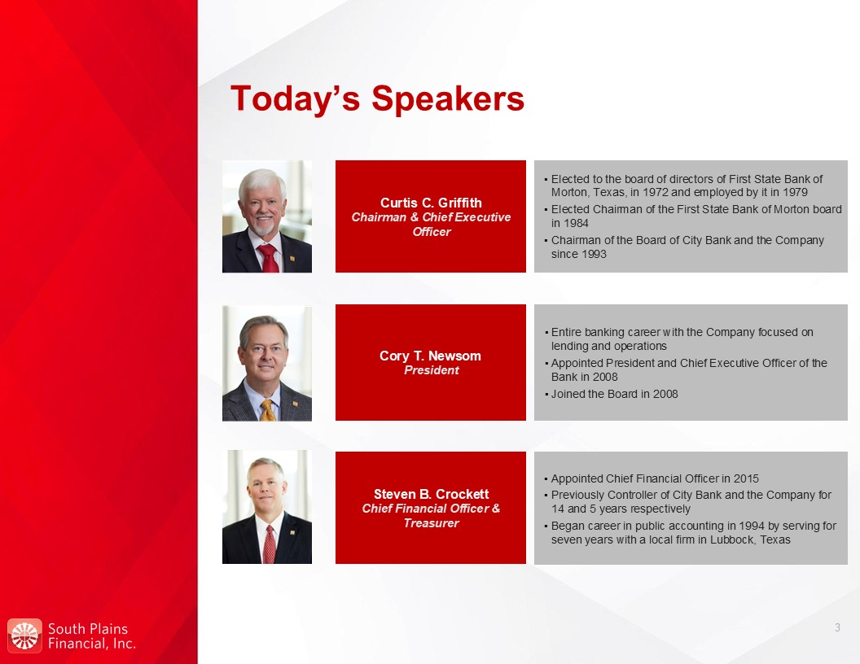
Today’s Speakers Curtis C. Griffith Chairman & Chief Executive Officer Elected to the board of directors of First State Bank of Morton, Texas, in 1972 and employed by it in 1979 Elected Chairman of the First State Bank of Morton board in 1984 Chairman of the Board of City Bank and the Company since 1993 Steven B. Crockett Chief Financial Officer & Treasurer Appointed Chief Financial Officer in 2015 Previously Controller of City Bank and the Company for 14 and 5 years respectively Began career in public accounting in 1994 by serving for seven years with a local firm in Lubbock, Texas Cory T. Newsom President Entire banking career with the Company focused on lending and operations Appointed President and Chief Executive Officer of the Bank in 2008 Joined the Board in 2008 3

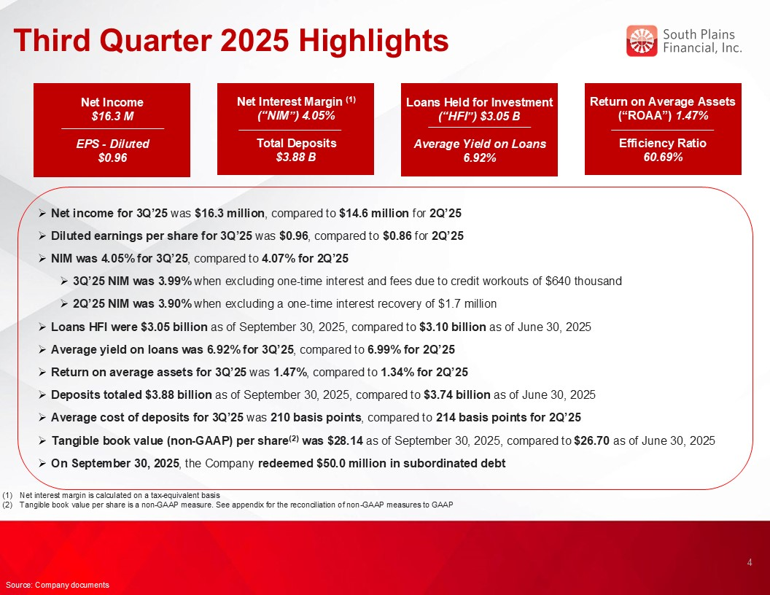
Third Quarter 2025 Highlights Net income for 3Q’25 was $16.3 million, compared to $14.6 million for 2Q’25 Diluted earnings per share for 3Q’25 was $0.96, compared to $0.86 for 2Q’25 NIM was 4.05% for 3Q’25, compared to 4.07% for 2Q’25 3Q’25 NIM was 3.99% when excluding one-time interest and fees due to credit workouts of $640 thousand 2Q’25 NIM was 3.90% when excluding a one-time interest recovery of $1.7 million Loans HFI were $3.05 billion as of September 30, 2025, compared to $3.10 billion as of June 30, 2025 Average yield on loans was 6.92% for 3Q’25, compared to 6.99% for 2Q’25 Return on average assets for 3Q’25 was 1.47%, compared to 1.34% for 2Q’25 Deposits totaled $3.88 billion as of September 30, 2025, compared to $3.74 billion as of June 30, 2025 Average cost of deposits for 3Q’25 was 210 basis points, compared to 214 basis points for 2Q’25 Tangible book value (non-GAAP) per share(2) was $28.14 as of September 30, 2025, compared to $26.70 as of June 30, 2025 On September 30, 2025, the Company redeemed $50.0 million in subordinated debt 4 Source: Company documents Net interest margin is calculated on a tax-equivalent basis Tangible book value per share is a non-GAAP measure. See appendix for the reconciliation of non-GAAP measures to GAAP Loans Held for Investment (“HFI”) $3.05 B Average Yield on Loans 6.92% Net Income $16.3 M EPS - Diluted $0.96 Net Interest Margin (1) (“NIM”) 4.05% Total Deposits $3.88 B Return on Average Assets (“ROAA”) 1.47% Efficiency Ratio 60.69%

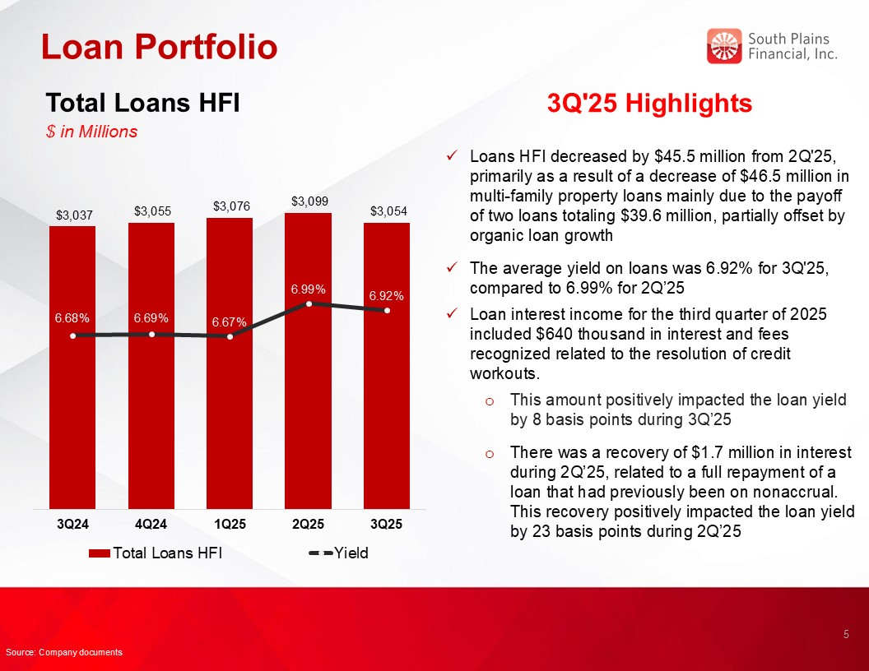
Loan Portfolio 3Q'25 Highlights Loans HFI decreased by $45.5 million from 2Q'25, primarily as a result of a decrease of $46.5 million in multi-family property loans mainly due to the payoff of two loans totaling $39.6 million, partially offset by organic loan growth The average yield on loans was 6.92% for 3Q'25, compared to 6.99% for 2Q’25 Loan interest income for the third quarter of 2025 included $640 thousand in interest and fees recognized related to the resolution of credit workouts. This amount positively impacted the loan yield by 8 basis points during 3Q’25 There was a recovery of $1.7 million in interest during 2Q’25, related to a full repayment of a loan that had previously been on nonaccrual. This recovery positively impacted the loan yield by 23 basis points during 2Q’25 Total Loans HFI $ in Millions 5 Source: Company documents

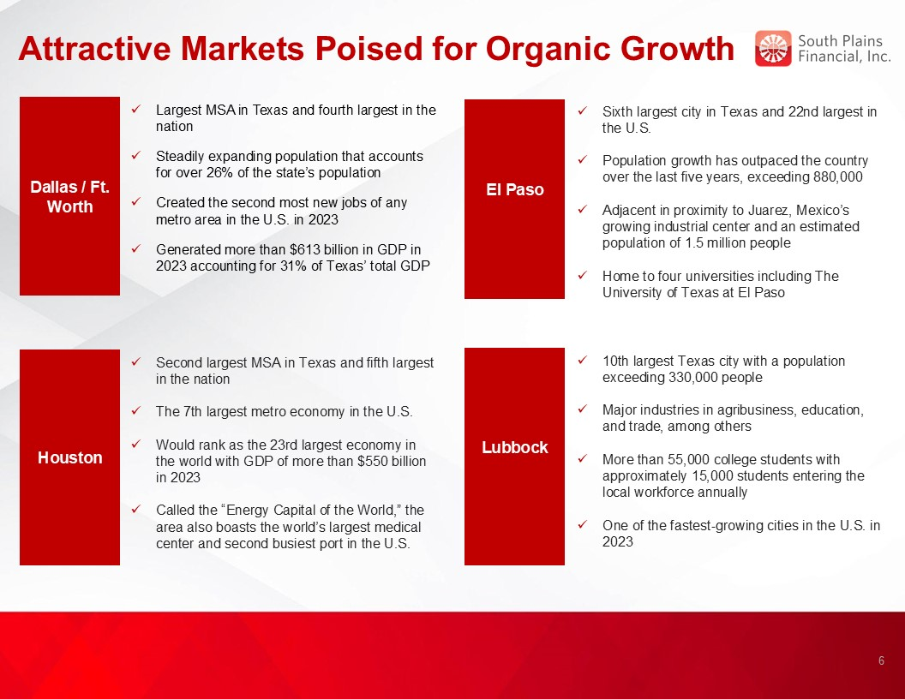
Attractive Markets Poised for Organic Growth El Paso Basin Dallas / Ft. Worth Sixth largest city in Texas and 22nd largest in the U.S. Population growth has outpaced the country over the last five years, exceeding 880,000 Adjacent in proximity to Juarez, Mexico’s growing industrial center and an estimated population of 1.5 million people Home to four universities including The University of Texas at El Paso Largest MSA in Texas and fourth largest in the nation Steadily expanding population that accounts for over 26% of the state’s population Created the second most new jobs of any metro area in the U.S. in 2023 Generated more than $613 billion in GDP in 2023 accounting for 31% of Texas’ total GDP Houston Second largest MSA in Texas and fifth largest in the nation The 7th largest metro economy in the U.S. Would rank as the 23rd largest economy in the world with GDP of more than $550 billion in 2023 Called the “Energy Capital of the World,” the area also boasts the world’s largest medical center and second busiest port in the U.S. Lubbock Basin 10th largest Texas city with a population exceeding 330,000 people Major industries in agribusiness, education, and trade, among others More than 55,000 college students with approximately 15,000 students entering the local workforce annually One of the fastest-growing cities in the U.S. in 2023 6

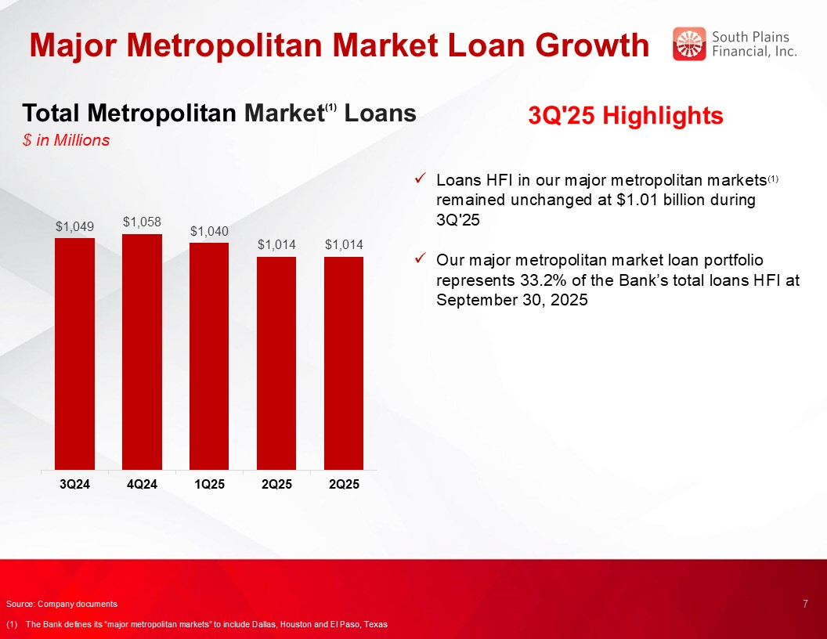
Major Metropolitan Market Loan Growth 3Q'25 Highlights Loans HFI in our major metropolitan markets(1) remained unchanged at $1.01 billion during 3Q'25 Our major metropolitan market loan portfolio represents 33.2% of the Bank’s total loans HFI at September 30, 2025 Total Metropolitan Market(1) Loans $ in Millions 7 5.00% Source: Company documents (1) The Bank defines its “major metropolitan markets” to include Dallas, Houston and El Paso, Texas

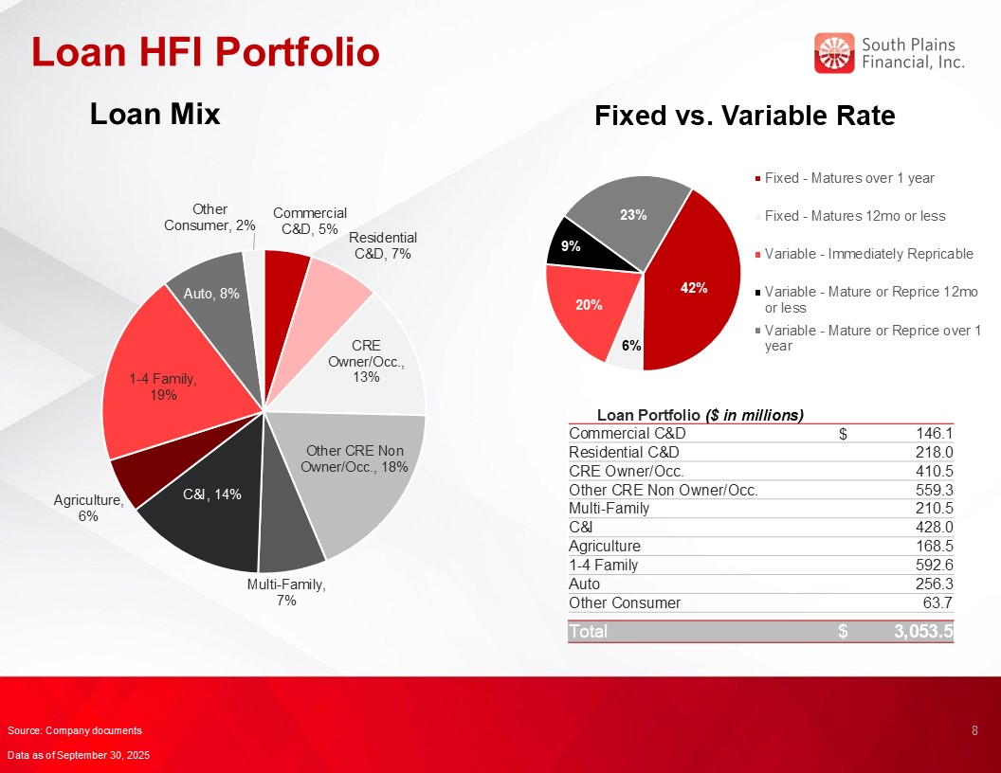
Loan HFI Portfolio Loan Mix Loan Portfolio ($ in millions) Commercial C&D $ 146.1 Residential C&D 218.0 CRE Owner/Occ. 410.5 Other CRE Non Owner/Occ. 559.3 Multi-Family 210.5 C&I 428.0 Agriculture 168.5 1-4 Family 592.6 Auto 256.3 Other Consumer 63.7 Total $ 3,053.5 Fixed vs. Variable Rate 8 Source: Company documents Data as of September 30, 2025

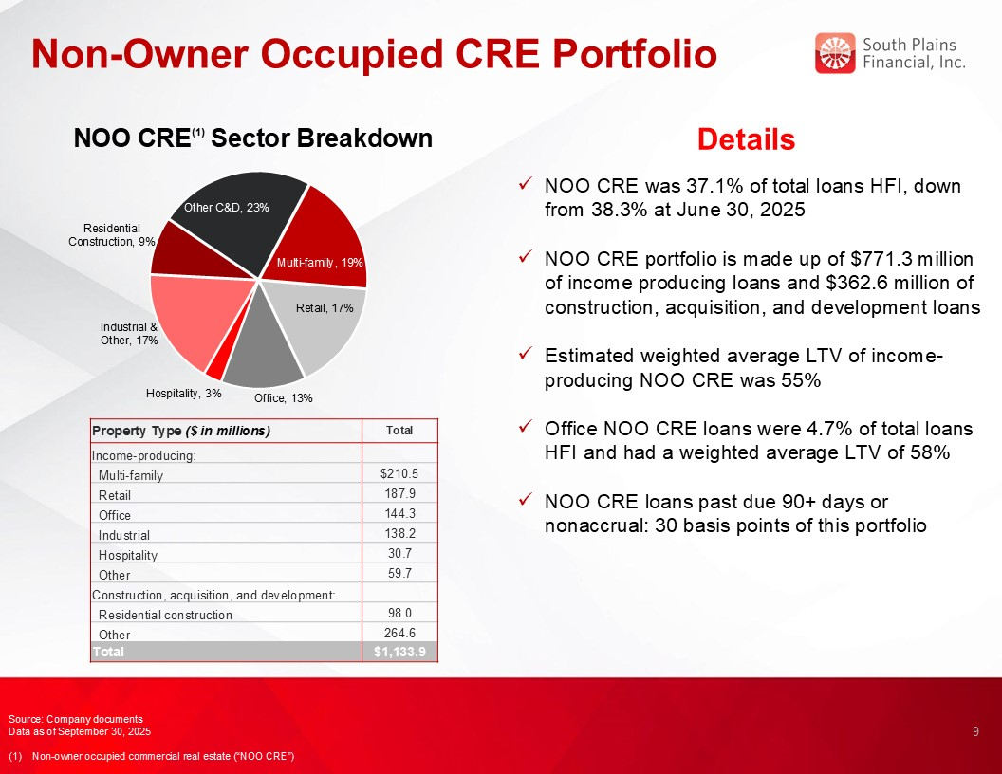
Non-Owner Occupied CRE Portfolio 9 Details NOO CRE was 37.1% of total loans HFI, down from 38.3% at June 30, 2025 NOO CRE portfolio is made up of $771.3 million of income producing loans and $362.6 million of construction, acquisition, and development loans Estimated weighted average LTV of income-producing NOO CRE was 55% Office NOO CRE loans were 4.7% of total loans HFI and had a weighted average LTV of 58% NOO CRE loans past due 90+ days or nonaccrual: 30 basis points of this portfolio NOO CRE(1) Sector Breakdown Source: Company documents Data as of September 30, 2025 (1) Non-owner occupied commercial real estate (“NOO CRE”) Property Type ($ in millions) Total Income-producing: Multi-family $210.5 Retail 187.9 Office 144.3 Industrial 138.2 Hospitality 30.7 Other 59.7 Construction, acquisition, and development: Residential construction 98.0 Other 264.6 Total $1,133.9

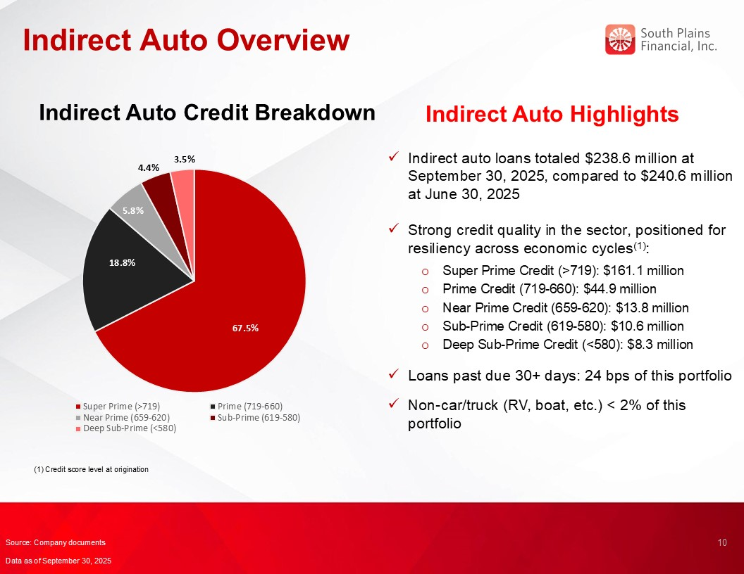
Indirect Auto Overview Indirect Auto Highlights Indirect auto loans totaled $238.6 million at September 30, 2025, compared to $240.6 million at June 30, 2025 Strong credit quality in the sector, positioned for resiliency across economic cycles(1): Super Prime Credit (>719): $161.1 million Prime Credit (719-660): $44.9 million Near Prime Credit (659-620): $13.8 million Sub-Prime Credit (619-580): $10.6 million Deep Sub-Prime Credit (<580): $8.3 million Loans past due 30+ days: 24 bps of this portfolio Non-car/truck (RV, boat, etc.) < 2% of this portfolio Indirect Auto Credit Breakdown 10 Source: Company documents Data as of September 30, 2025 (1) Credit score level at origination

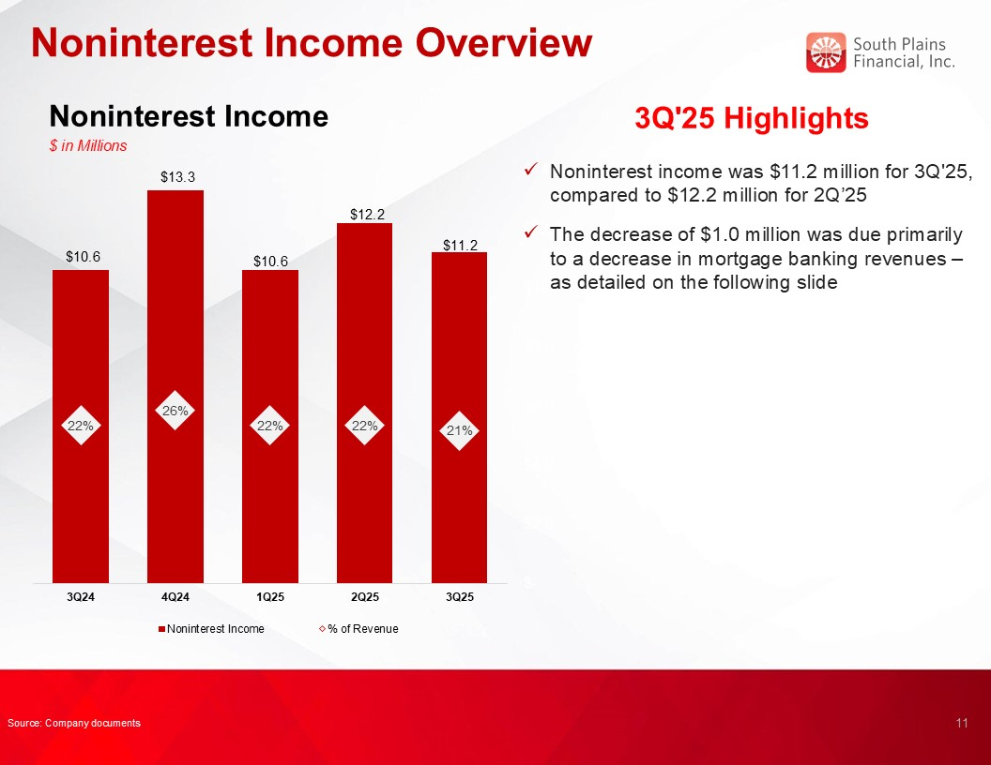
Noninterest Income Overview Noninterest Income $ in Millions 3Q'25 Highlights Noninterest income was $11.2 million for 3Q'25, compared to $12.2 million for 2Q’25 The decrease of $1.0 million was due primarily to a decrease in mortgage banking revenues – as detailed on the following slide 11 Source: Company documents

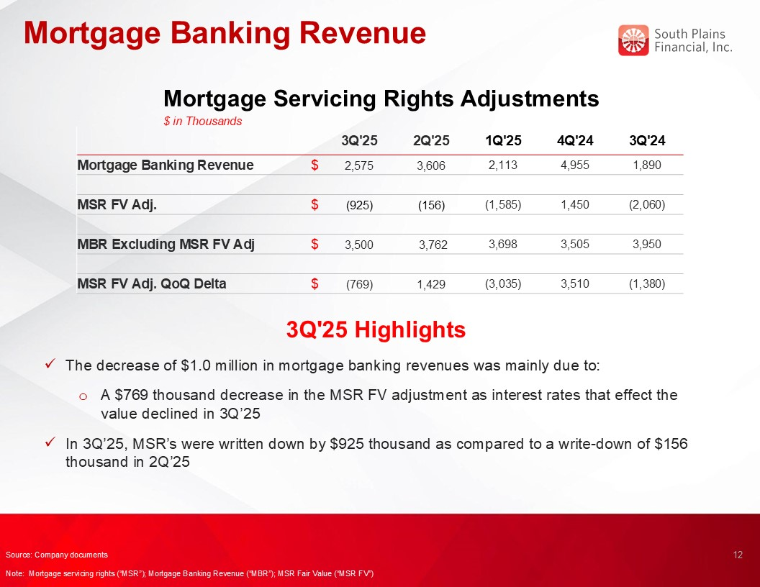
Mortgage Banking Revenue Mortgage Servicing Rights Adjustments $ in Thousands 3Q'25 Highlights The decrease of $1.0 million in mortgage banking revenues was mainly due to: A $769 thousand decrease in the MSR FV adjustment as interest rates that effect the value declined in 3Q’25 In 3Q’25, MSR’s were written down by $925 thousand as compared to a write-down of $156 thousand in 2Q’25 12 Source: Company documents Note: Mortgage servicing rights (“MSR”); Mortgage Banking Revenue (“MBR”); MSR Fair Value (“MSR FV”) 3Q'25 2Q'25 1Q'25 4Q'24 3Q'24 Mortgage Banking Revenue $ 2,575 3,606 2,113 4,955 1,890 MSR FV Adj. $ (925) (156) (1,585) 1,450 (2,060) MBR Excluding MSR FV Adj $ 3,500 3,762 3,698 3,505 3,950 MSR FV Adj. QoQ Delta $ (769) 1,429 (3,035) 3,510 (1,380)

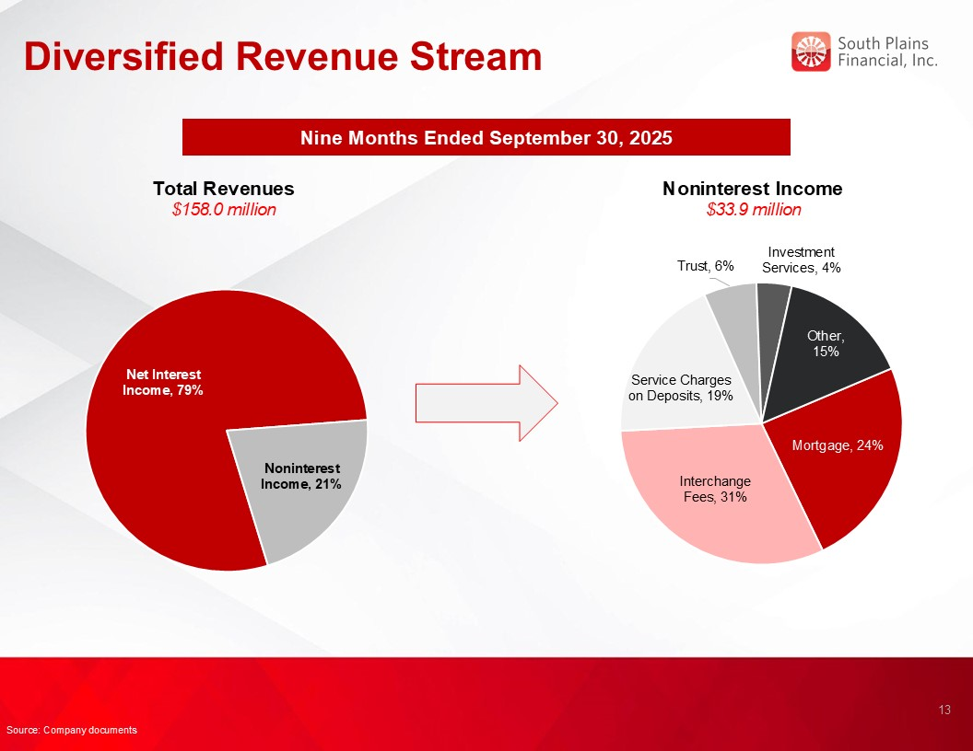
Diversified Revenue Stream Nine Months Ended September 30, 2025 Total Revenues $158.0 million Noninterest Income $33.9 million 13 Source: Company documents

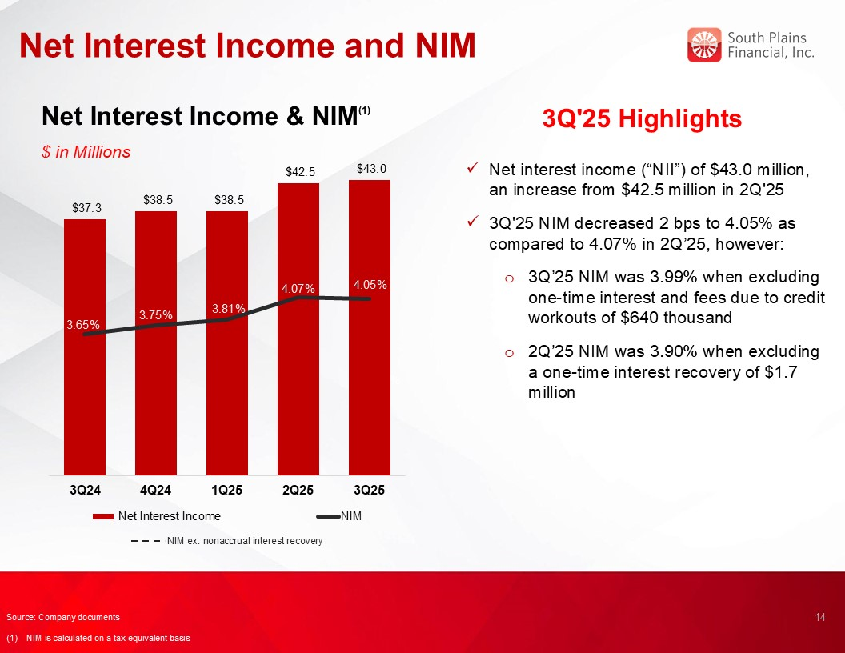
Net Interest Income and NIM Net Interest Income & NIM(1) $ in Millions 3Q'25 Highlights Net interest income (“NII”) of $43.0 million, an increase from $42.5 million in 2Q'25 3Q'25 NIM decreased 2 bps to 4.05% as compared to 4.07% in 2Q’25, however: 3Q’25 NIM was 3.99% when excluding one-time interest and fees due to credit workouts of $640 thousand 2Q’25 NIM was 3.90% when excluding a one-time interest recovery of $1.7 million 14 3.54% Source: Company documents (1) NIM is calculated on a tax-equivalent basis NIM ex. nonaccrual interest recovery

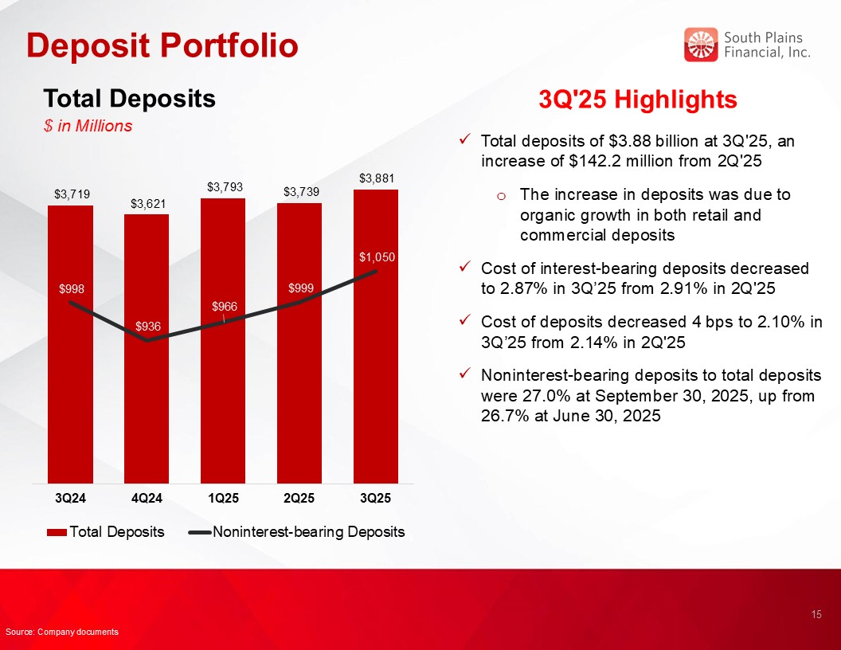
Deposit Portfolio Total Deposits $ in Millions 3Q'25 Highlights Total deposits of $3.88 billion at 3Q'25, an increase of $142.2 million from 2Q'25 The increase in deposits was due to organic growth in both retail and commercial deposits Cost of interest-bearing deposits decreased to 2.87% in 3Q’25 from 2.91% in 2Q'25 Cost of deposits decreased 4 bps to 2.10% in 3Q’25 from 2.14% in 2Q'25 Noninterest-bearing deposits to total deposits were 27.0% at September 30, 2025, up from 26.7% at June 30, 2025 15 Source: Company documents

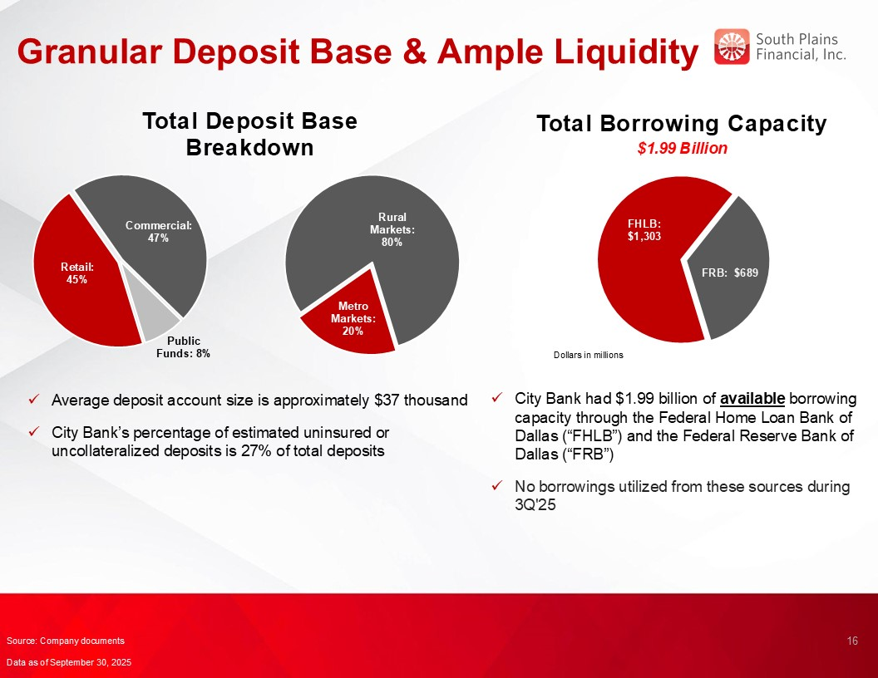
Granular Deposit Base & Ample Liquidity Total Borrowing Capacity $1.99 Billion 16 Total Deposit Base Breakdown Average deposit account size is approximately $37 thousand City Bank’s percentage of estimated uninsured or uncollateralized deposits is 27% of total deposits City Bank had $1.99 billion of available borrowing capacity through the Federal Home Loan Bank of Dallas (“FHLB”) and the Federal Reserve Bank of Dallas (“FRB”) No borrowings utilized from these sources during 3Q'25 Source: Company documents Data as of September 30, 2025

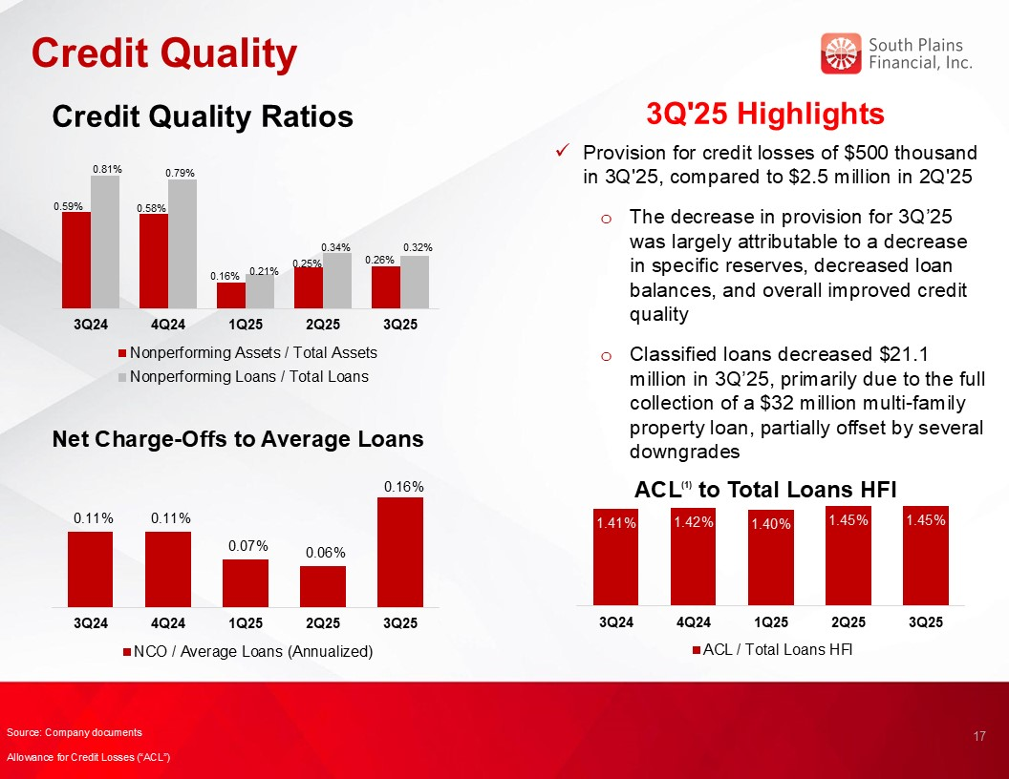
Credit Quality 3Q'25 Highlights Credit Quality Ratios Net Charge-Offs to Average Loans ACL(1) to Total Loans HFI 17 Provision for credit losses of $500 thousand in 3Q'25, compared to $2.5 million in 2Q'25 The decrease in provision for 3Q’25 was largely attributable to a decrease in specific reserves, decreased loan balances, and overall improved credit quality Classified loans decreased $21.1 million in 3Q’25, primarily due to the full collection of a $32 million multi-family property loan, partially offset by several downgrades Source: Company documents Allowance for Credit Losses (“ACL”)

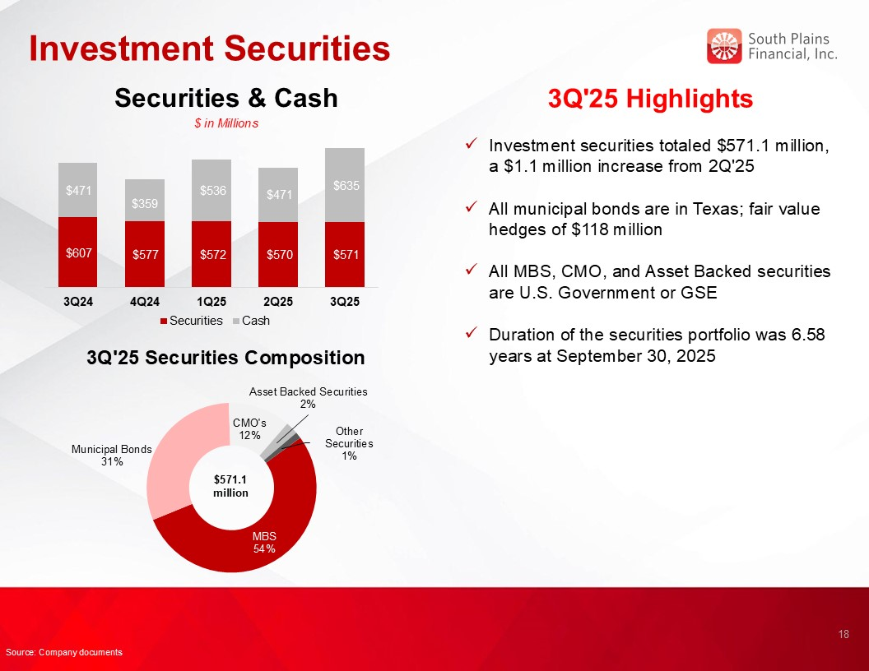
Investment Securities 3Q'25 Highlights Investment securities totaled $571.1 million, a $1.1 million increase from 2Q'25 All municipal bonds are in Texas; fair value hedges of $118 million All MBS, CMO, and Asset Backed securities are U.S. Government or GSE Duration of the securities portfolio was 6.58 years at September 30, 2025 3Q'25 Securities Composition $571.1 million Securities & Cash $ in Millions 18 Source: Company documents

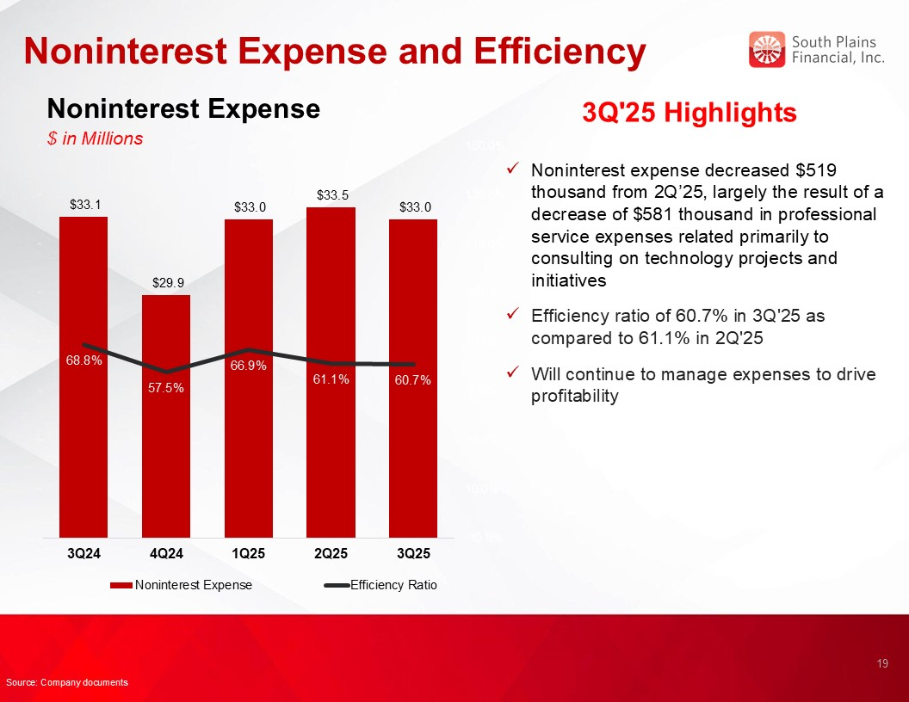
Noninterest Expense and Efficiency Noninterest Expense $ in Millions 3Q'25 Highlights Noninterest expense decreased $519 thousand from 2Q’25, largely the result of a decrease of $581 thousand in professional service expenses related primarily to consulting on technology projects and initiatives Efficiency ratio of 60.7% in 3Q'25 as compared to 61.1% in 2Q'25 Will continue to manage expenses to drive profitability 19 Source: Company documents

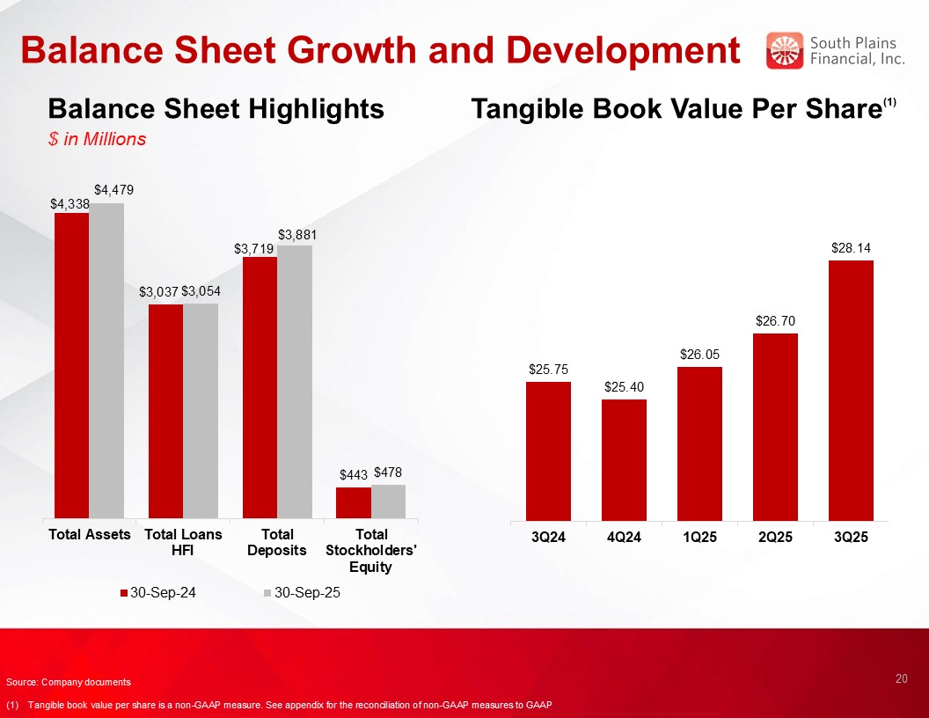
Balance Sheet Growth and Development Balance Sheet Highlights $ in Millions Tangible Book Value Per Share(1) 20 Source: Company documents (1) Tangible book value per share is a non-GAAP measure. See appendix for the reconciliation of non-GAAP measures to GAAP

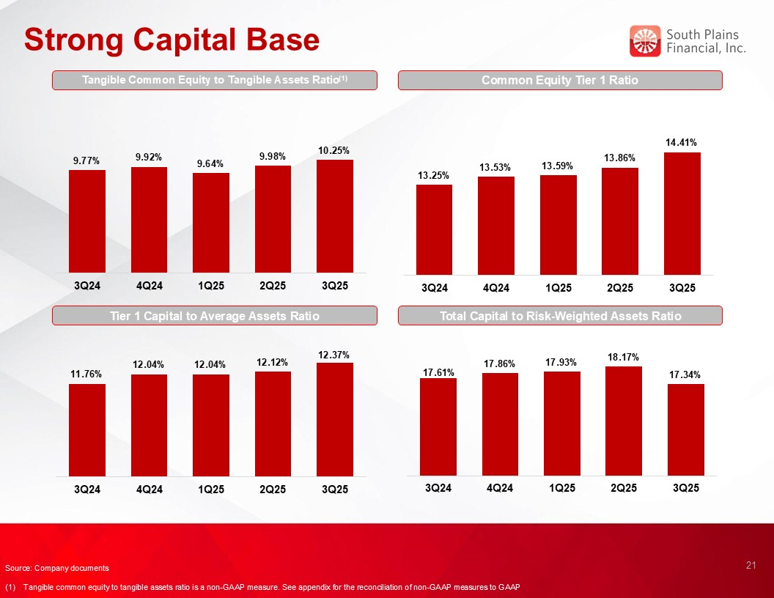
Strong Capital Base Common Equity Tier 1 Ratio Tier 1 Capital to Average Assets Ratio Total Capital to Risk-Weighted Assets Ratio 21 Source: Company documents (1) Tangible common equity to tangible assets ratio is a non-GAAP measure. See appendix for the reconciliation of non-GAAP measures to GAAP Tangible Common Equity to Tangible Assets Ratio(1)


SPFI’s Core Purpose and Values Align Centered on Relationship-Based Business Our Core Purpose is: To use the power of relationships to help people succeed and live better HELP ALL STAKEHOLDERS SUCCEED Employees → great benefits and opportunities to grow and make a difference. Customers → personalized advice and solutions to achieve their goals. Partners → responsive, trusted win-win partnerships enabling both parties to succeed together. Shareholders → share in the prosperity and performance of the Bank. THE POWER OF RELATIONSHIPS At SPFI, we build lifelong, trusted relationships so you know you always have someone in your corner that understands you, cares about you, and stands ready to help. LIVE BETTER We want to help everyone live better. At the end of the day, we do what we do to help enhance lives. We create a great place to work, help people achieve their goals, and invest generously in our communities because there’s nothing more rewarding than helping people succeed and live better. 22

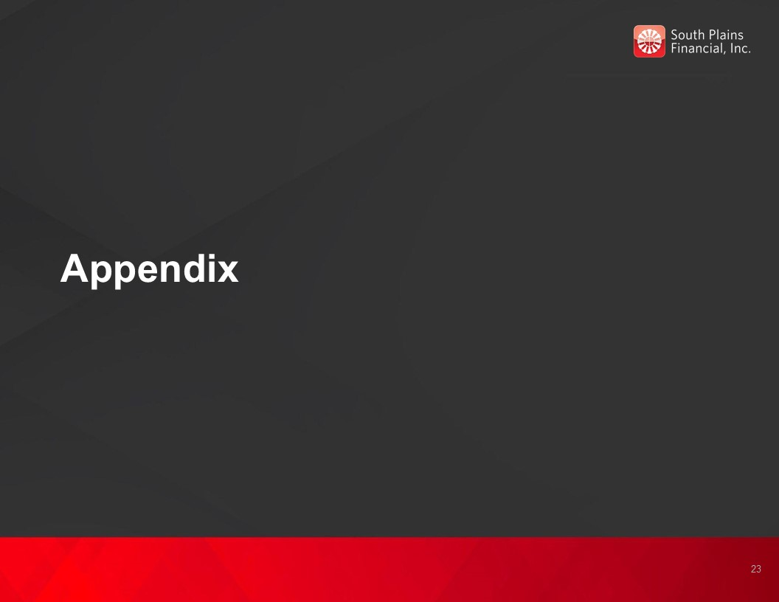
Appendix 23

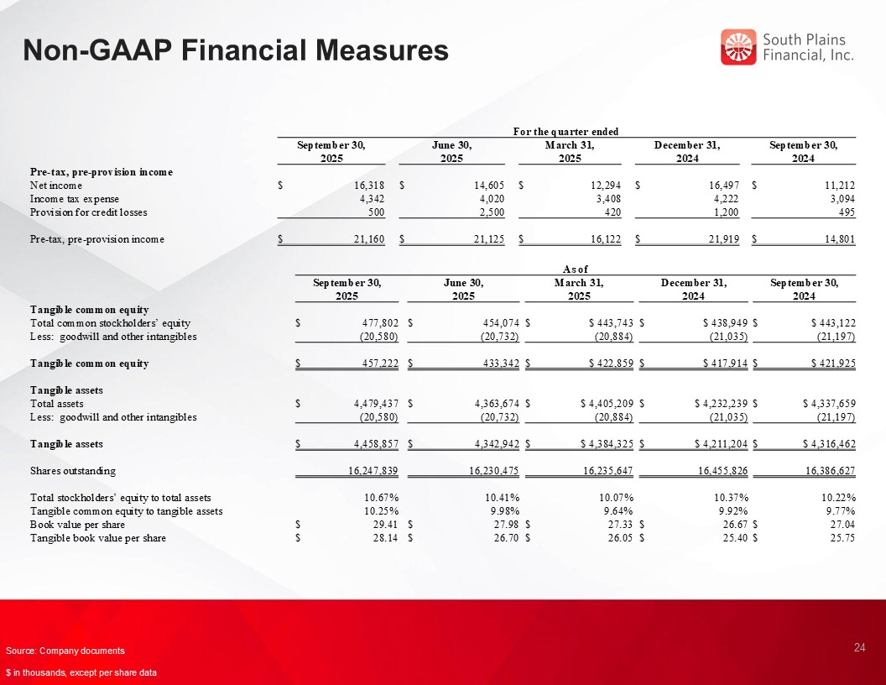
Non-GAAP Financial Measures 24 Source: Company documents $ in thousands, except per share data For the quarter ended September 30, 2025 June 30, 2025 March 31, 2025 December 31, 2024 September 30, 2024 Pre-tax, pre-provision income Net income $ 16,318 $ 14,605 $ 12,294 $ 16,497 $ 11,212 Income tax expense 4,342 4,020 3,408 4,222 3,094 Provision for credit losses 500 2,500 420 1,200 495 Pre-tax, pre-provision income $ 21,160 $ 21,125 $ 16,122 $ 21,919 $ 14,801 As of September 30, 2025 June 30, 2025 March 31, 2025 December 31, 2024 September 30, 2024 Tangible common equity Total common stockholders’ equity $ 477,802 $ 454,074 $ $ 443,743 $ $ 438,949 $ $ 443,122 Less: goodwill and other intangibles (20,580) (20,732) (20,884) (21,035) (21,197) Tangible common equity $ 457,222 $ 433,342 $ $ 422,859 $ $ 417,914 $ $ 421,925 Tangible assets Total assets $ 4,479,437 $ 4,363,674 $ $ 4,405,209 $ $ 4,232,239 $ $ 4,337,659 Less: goodwill and other intangibles (20,580) (20,732) (20,884) (21,035) (21,197) Tangible assets $ 4,458,857 $ 4,342,942 $ $ 4,384,325 $ $ 4,211,204 $ $ 4,316,462 Shares outstanding 16,247,839 16,230,475 16,235,647 16,455,826 16,386,627 Total stockholders’ equity to total assets 10.67% 10.41% 10.07% 10.37% 10.22% Tangible common equity to tangible assets 10.25% 9.98% 9.64% 9.92% 9.77% Book value per share $ 29.41 $ 27.98 $ 27.33 $ 26.67 $ 27.04 Tangible book value per share $ 28.14 $ 26.70 $ 26.05 $ 25.40 $ 25.75

