UNITED STATES
SECURITIES AND EXCHANGE COMMISSION
Washington, D.C. 20549

FORM 8-K

CURRENT REPORT
Pursuant to Section 13 or 15(d) of
the Securities Exchange Act of 1934

Date of Report (Date of earliest event reported): July 16, 2026

South Plains Financial, Inc.
(Exact name of registrant as specified in its charter)

Texas | 001-38895 | 75-2453320
(State or other jurisdiction of incorporation) | (Commission File Number) | (IRS Employer Identification No.)

5219 City Bank Parkway  Lubbock, Texas |  | 79407
(Address of principal executive offices) |  | (Zip Code)

(806) 792-7101
(Registrant’s telephone number, including area code)

Check the appropriate box below if the Form 8-K filing is intended to simultaneously satisfy the filing obligation of the registrant under any of the following provisions:

☐ | Written communications pursuant to Rule 425 under the Securities Act (17 CFR 230.425)

☐ | Soliciting material pursuant to Rule 14a-12 under the Exchange Act (17 CFR 240.14a-12)

☐ | Pre-commencement communications pursuant to Rule 14d-2(b) under the Exchange Act (17 CFR 240.14d-2(b))

☐ | Pre-commencement communications pursuant to Rule 13e-4(c) under the Exchange Act (17 CFR 240.13e-4(c))

Securities registered pursuant to Section 12(b) of the Act:

Title of each class | Trading Symbol(s) | Name of each exchange on which registered
Common Stock, par value $1.00 per share | SPFI | The Nasdaq Stock Market LLC

Indicate by check mark whether the registrant is an emerging growth company as defined in Rule 405 of the Securities Act of 1933 (§230.405 of this chapter) or Rule 12b-2 of the Securities Exchange Act of 1934 (§240.12b-2 of this chapter).

Emerging growth company ☐

If an emerging growth company, indicate by check mark if the registrant has elected not to use the extended transition period for complying with any new or revised financial accounting standards provided pursuant to Section 13(a) of the Exchange Act. ☐

Item 2.02 | Results of Operations and Financial Condition.

On July 17, 2026, South Plains Financial, Inc. (the “Company”) issued a press release announcing its financial results for the second quarter ended June 30, 2026. A copy of the Company’s press release covering such announcement and certain other matters is furnished as Exhibit 99.1 to this Current Report on Form 8-K.

Item 7.01 | Regulation FD Disclosure.

On July 17, 2026, officers of the Company will conduct a conference call at 8:30 p.m., Eastern Time, with respect to the Company’s financial results for the second quarter ended June 30, 2026. An earnings release slide presentation highlighting the Company’s financial results for the second quarter ended June 30, 2026 is furnished as Exhibit 99.2 to this Current Report on Form 8-K. This earnings release slide presentation will also be available on the Company’s website, www.spfi.bank, under the “News & Events” section.

In accordance with General Instruction B.2 of Form 8-K, the information in Items 2.02 and 7.01 of this Current Report on Form 8-K, including Exhibit 99.1 and Exhibit 99.2 furnished herewith, shall not be deemed “filed” for the purposes of Section 18 of the Securities Exchange Act of 1934, as amended (the “Exchange Act”), or otherwise subject to the liabilities of that section. The information in Items 2.02 and 7.01 of this Current Report on Form 8-K, including Exhibit 99.1 and Exhibit 99.2 furnished herewith, shall not be incorporated by reference into any filing or other document pursuant to the Exchange Act or the Securities Act of 1933, as amended, except as shall be expressly set forth by specific reference in such filing or document.

Item 8.01 | Other Events.

On July 16, 2026, the Company issued a press release announcing the declaration of a quarterly cash dividend of $0.18 per share on its outstanding common stock. The dividend will be paid on August 10, 2026 to shareholders of record as of the close of business on July 27, 2026. A copy of the Company’s press release covering such announcement is attached to this Current Report on Form 8-K as Exhibit 99.3 and is incorporated herein by reference.

Item 9.01 | Financial Statements and Exhibits.

 | (d) | Exhibits.

99.1 | Press release, dated July 17, 2026, announcing second quarter 2026 financial results of South Plains Financial, Inc.
99.2 | Earnings release slide presentation, dated July 17, 2026.
99.3 | Press release, dated July 16, 2026, announcing South Plains Financial, Inc. quarterly cash dividend.
104 | Cover Page Interactive Data File (formatted as Inline XBRL).

SIGNATURES

Pursuant to the requirements of the Securities Exchange Act of 1934, the registrant has duly caused this report to be signed on its behalf by the undersigned hereunto duly authorized.

 | SOUTH PLAINS FINANCIAL, INC.
Date: July 17, 2026 | By: | /s/ Steven B. Crockett
Steven B. Crockett
Chief Financial Officer and Treasurer

Exhibit 99.1



South Plains Financial, Inc. Reports Second Quarter 2026 Financial Results

LUBBOCK, Texas, July 17, 2026 (GLOBE NEWSWIRE) – South Plains Financial, Inc. (NASDAQ:SPFI) (“South Plains” or the “Company”), the parent company of City Bank (“City Bank” or the “Bank”), today reported its financial results for the quarter ended June 30, 2026.

Second Quarter 2026 Highlights

 | ● | Net income for the second quarter of 2026 was $19.0 million, compared to $14.5 million for the first quarter of 2026 and $14.6 million for the second quarter of 2025.

 | ● | Diluted earnings per share for the second quarter of 2026 was $0.96, compared to $0.85 for the first quarter of 2026 and $0.86 for the second quarter of 2025.

 | ● | Average cost of deposits for the second quarter of 2026 was 208 basis points, compared to 197 basis points for the first quarter of 2026 and 214 basis points for the second quarter of 2025.

 | ● | Net interest margin, on a tax-equivalent basis, was 4.00% for the second quarter of 2026, compared to 4.04% for the first quarter of 2026 and 4.07% for the second quarter of 2025.

 | ● | Return on average assets for the second quarter of 2026 was 1.44%, compared to 1.31% for the first quarter of 2026 and 1.34% for the second quarter of 2025.

 | ● | Tangible book value (non-GAAP) per share was $29.57 as of June 30, 2026, compared to $29.65 as of March 31, 2026 and $26.70 as of June 30, 2025.

 | ● | The consolidated total risk-based capital ratio, common equity tier 1 risk-based capital ratio, and tier 1 leverage ratio at June 30, 2026 were 16.53%, 14.10%, and 12.20%, respectively.

 | ● | As previously reported, the Company completed the merger of BOH Holdings, Inc. (“BOH”) with and into South Plains, with South Plains continuing as the surviving corporation, and the merger of BOH’s wholly-owned subsidiary, Bank of Houston, with and into City Bank, with City Bank continuing as the surviving bank, all effective on April 1, 2026. As of March 31, 2026, BOH had total assets of $685.0 million, total loans of $631.9 million, and total deposits of $595.6 million.

Curtis Griffith, South Plains’ Chairman and Chief Executive Officer, commented, “We delivered a strong second quarter highlighted by solid profitability, stable credit quality and the successful integration of Bank of Houston, which has strengthened our position in Houston, one of Texas’ most attractive banking markets. As I prepare to retire as Chief Executive Officer at year-end, I am incredibly proud of what our employees have accomplished and the Company we have built together over the past four decades. The Bank is in a position of strength, and our leadership transition reflects years of thoughtful planning designed to ensure continuity for our customers, employees and shareholders. I remain highly confident in South Plains’ future and believe Cory is the right leader to guide the organization as we continue to grow earnings, deepen customer relationships and build on the culture that has been central to our success. I look forward to continuing to serve as Chairman of South Plains and City Bank as Cory and our talented leadership team build on our momentum and execute the next phase of our growth strategy.”

Cory Newsom, South Plains’ President, added, “I am honored by the Board’s confidence and am excited to lead South Plains into its next chapter. Our second quarter results demonstrate the strength of our relationship-based banking model, disciplined credit culture and proven growth strategy. Looking ahead, we remain focused on expanding our lending platform in high-growth Texas markets, attracting experienced bankers who fit our culture, optimizing the Bank of Houston acquisition and pursuing disciplined growth opportunities that enhance long-term shareholder value. With a strong balance sheet, healthy loan pipeline and exceptional team, we believe South Plains is well positioned for continued success.”

Results of Operations, Quarter Ended June 30, 2026

Net Interest Income

Net interest income was $50.3 million for the second quarter of 2026, compared to $42.9 million for the first quarter of 2026 and $42.5 million for the second quarter of 2025. Net interest margin, calculated on a tax-equivalent basis, was 4.00% for the second quarter of 2026, compared to 4.04% for the first quarter of 2026 and 4.07% for the second quarter of 2025. The average yield on loans was 6.81% for the second quarter of 2026, compared to 6.83% for the first quarter of 2026 and 6.99% for the second quarter of 2025. The average cost of deposits was 208 basis points for the second quarter of 2026, which is 11 basis points higher than the first quarter of 2026 and 6 basis points lower than the second quarter of 2025. The increase from the first quarter of 2026 was due to the higher cost of deposits on the Bank of Houston acquired deposits.

Interest income was $75.0 million for the second quarter of 2026, compared to $62.6 million for the first quarter of 2026 and $64.1 million for the second quarter of 2025. Interest income in the second quarter of 2026 increased $12.4 million compared to the first quarter of 2026 and increased $10.9 million compared to the second quarter of 2025. These increases were primarily due to the acquisition of BOH’s approximately $667 million of interest-earning assets.

Interest expense was $24.7 million for the second quarter of 2026, compared to $19.8 million for the first quarter of 2026 and $21.6 million for the second quarter of 2025. Interest expense in the second quarter of 2026 increased $4.9 million compared to the first quarter of 2026 and increased $3.1 million compared to the second quarter of 2025. These increases were mainly attributable to the acquisition of BOH’s approximately $611 million of interest-bearing liabilities, with the year-over-year comparison being partially offset by interest-bearing deposit growth in the first quarter of 2026.

Noninterest Income and Noninterest Expense

Noninterest income was $14.1 million for the second quarter of 2026, compared to $11.3 million for the first quarter of 2026 and $12.2 million for the second quarter of 2025. The increase from the first quarter of 2026 was primarily due to an increase of $929 thousand in mortgage banking revenues, mainly as a result of improved mortgage originations during the quarter, and an increase of $894 thousand in bank card services and interchange revenue, mainly as a result of continued growth in customer card usage and incentives received during the period. Additionally, there was an $801 thousand loss in a Small Business Investment Company (“SBIC”) investment that lowered other noninterest income in the first quarter of 2026. The increase in noninterest income for the second quarter of 2026 as compared to the second quarter of 2025 was primarily due to an increase of $1.2 million in mortgage banking revenues, mainly as a result of the change in the fair value adjustment of the mortgage servicing rights assets – a write-up of $515 thousand in the second quarter of 2026 compared to a write-down of $156 thousand in the second quarter of 2025 – based on interest rate changes during the respective quarters.

Noninterest expense was $39.9 million for the second quarter of 2026, compared to $35.5 million for the first quarter of 2026 and $33.5 million for the second quarter of 2025. The $4.3 million increase from the first quarter of 2026 primarily resulted from an increase of $2.7 million in core operating expenses related to the recent acquisition and higher incentive-based compensation expense. There was approximately $1.1 million of acquisition-related expenses in the second quarter of 2026, of which $710 thousand was for personnel expenses, compared to $1.5 million in the first quarter of 2026, of which $1.2 million was for professional services. The $6.3 million increase in noninterest expense for the second quarter of 2026 as compared to the second quarter of 2025 was largely the result of the $2.7 million increase in core operating expenses related to the recent acquisition, annual salary adjustments and new lenders hired, and $1.1 million in acquisition-related expenses.

Loan Portfolio and Composition

Loans held for investment were $3.77 billion as of June 30, 2026, compared to $3.10 billion as of March 31, 2026 and $3.10 billion as of June 30, 2025. The increase of $667.3 million during the second quarter of 2026 as compared to the first quarter of 2026 occurred as a result of $631.9 million in loans from the recent acquisition and $35.4 million of organic loan growth during the quarter. The organic growth was net of two loan payoffs totaling $37.5 million during the quarter. As of June 30, 2026, loans held for investment increased $671.9 million as compared to June 30, 2025, primarily as a result of acquisition growth noted above.

Deposits and Borrowings

Deposits totaled $4.64 billion as of June 30, 2026, compared to $4.03 billion as of March 31, 2026 and $3.74 billion as of June 30, 2025. Deposits increased by $613.0 million in the second quarter of 2026 from March 31, 2026. Deposits increased by $901.7 million at June 30, 2026 as compared to June 30, 2025. Noninterest-bearing deposits were $1.15 billion as of June 30, 2026, compared to $1.03 billion as of March 31, 2026 and $998.8 million as of June 30, 2025. Noninterest-bearing deposits represented 24.8% of total deposits as of June 30, 2026. The quarterly and year-over-year change in total deposits was primarily due to $595.6 million in deposits from the recent acquisition. Additionally, the year-over-year change had $288.6 million in organic growth broadly across the deposit portfolio.

Asset Quality

The Company recorded a provision for credit losses in the second quarter of 2026 of $350 thousand, compared to $260 thousand in the first quarter of 2026 and $2.5 million in the second quarter of 2025. The decrease in provision for the year-over-year comparison was largely attributable to activity in the second quarter of 2025 which included an increase in specific reserves, increased loan balances, and several credit quality downgrades.

The ratio of allowance for credit losses to loans held for investment was 1.41% as of June 30, 2026, compared to 1.44% as of March 31, 2026 and 1.45% as of June 30, 2025.

The ratio of nonperforming assets to total assets was 0.19% as of June 30, 2026, compared to 0.13% as of March 31, 2026 and 0.25% as of June 30, 2025. Annualized net charge-offs were 0.06% for the second quarter of 2026, compared to 0.04% for the first quarter of 2026 and 0.06% for the second quarter of 2025.

Capital

Book value per share increased to $33.43 at June 30, 2026, compared to $30.90 at March 31, 2026. The change was primarily driven by the issuance of 2.8 million shares for the BOH acquisition at $41.90 per share. The increase was also the result of $15.7 million of net income after dividends paid during the second quarter of 2026. The ratio of tangible common equity to tangible assets (non-GAAP) stayed essentially flat at 10.47% at June 30, 2026.

Conference Call

South Plains will host a conference call to discuss its second quarter 2026 financial results today, July 17, 2026, at 8:30 a.m., Eastern Time. Investors and analysts interested in participating in the call are invited to dial 1-877-407-9716 (international callers please dial 1-201-493-6779) approximately 10 minutes prior to the start of the call. A live audio webcast of the conference call and conference materials will be available on the Company’s website at https://www.spfi.bank/news-events/events.

A replay of the conference call will be available within two hours of the conclusion of the call and can be accessed on the investor section of the Company’s website as well as by dialing 1-844-512-2921 (international callers please dial 1-412-317-6671). The pin to access the telephone replay is 13759880. The replay will be available until July 31, 2026.

About South Plains Financial, Inc.

South Plains is the bank holding company for City Bank, a Texas state-chartered bank headquartered in Lubbock, Texas. City Bank is one of the largest independent banks in West Texas and has additional banking operations in the Dallas, El Paso, Greater Houston, the Permian Basin, and College Station, Texas markets, and the Ruidoso, New Mexico market. South Plains provides a wide range of commercial and consumer financial services to small and medium-sized businesses and individuals in its market areas. Its principal business activities include commercial and retail banking, along with investment, trust and mortgage services. Please visit https://www.spfi.bank for more information.

Non-GAAP Financial Measures

Some of the financial measures included in this press release are not measures of financial performance recognized in accordance with generally accepted accounting principles in the United States (“GAAP”). These non-GAAP financial measures include Tangible Book Value Per Share, Tangible Common Equity to Tangible Assets, and Pre-Tax, Pre-Provision Income. The Company believes these non-GAAP financial measures provide both management and investors a more complete understanding of the Company’s financial position and performance. These non-GAAP financial measures are supplemental and are not a substitute for any analysis based on GAAP financial measures.

We classify a financial measure as being a non-GAAP financial measure if that financial measure excludes or includes amounts, or is subject to adjustments that have the effect of excluding or including amounts, that are included or excluded, as the case may be, in the most directly comparable measure calculated and presented in accordance with GAAP as in effect from time to time in the United States in our statements of income, balance sheets or statements of cash flows. Not all companies use the same calculation of these measures; therefore, this presentation may not be comparable to other similarly titled measures as presented by other companies.

A reconciliation of non-GAAP financial measures to GAAP financial measures is provided at the end of this press release.

Available Information

The Company routinely posts important information for investors on its web site (under www.spfi.bank and, more specifically, under the News & Events tab at www.spfi.bank/news-events/press-releases). The Company intends to use its web site as a means of disclosing material non-public information and for complying with its disclosure obligations under Regulation FD (Fair Disclosure) promulgated by the U.S. Securities and Exchange Commission (the “SEC”). Accordingly, investors should monitor the Company’s web site, in addition to following the Company’s press releases, SEC filings, public conference calls, presentations and webcasts.

The information contained on, or that may be accessed through, the Company’s web site is not incorporated by reference into, and is not a part of, this document.

Forward Looking Statements

This press release contains forward-looking statements within the meaning of the Private Securities Litigation Reform Act of 1995. These forward-looking statements reflect South Plains’ current views with respect to future events and South Plains’ financial performance. Any statements about South Plains’ expectations, beliefs, plans, predictions, forecasts, objectives, assumptions or future events or performance are not historical facts and may be forward-looking. These statements are often, but not always, made through the use of words or phrases such as “anticipate,” “believes,” “can,” “could,” “may,” “predicts,” “potential,” “should,” “will,” “estimate,” “plans,” “projects,” “continuing,” “ongoing,” “expects,” “intends” and similar words or phrases. South Plains cautions that the forward-looking statements in this press release are based largely on South Plains’ expectations and are subject to a number of known and unknown risks and uncertainties that are subject to change based on factors which are, in many instances, beyond South Plains’ control. Factors that could cause such changes include, but are not limited to, the impact on us and our customers of a decline in general economic conditions and any regulatory responses thereto; slower economic growth rates or potential recession in the United States and our market areas; uncertainty or perceived instability in the banking industry as a whole; increased competition for deposits in our market areas among traditional and nontraditional financial services companies, and related changes in deposit customer behavior; the impact of changes in market interest rates, whether due to a continuation of the elevated interest rate environment or future reductions in interest rates and a resulting decline in net interest income; the persistent inflationary pressures in the United States; the uncertain impacts of current and future monetary policies of the Board of Governors of the Federal Reserve System; changes in unemployment rates in the United States and our market areas; adverse changes in customer spending, borrowing and savings habits; elevated asset prices; declines in housing and commercial real estate values and prices; a deterioration of the credit rating for U.S. long-term sovereign debt or the impact of uncertain or changing political conditions, including federal government shutdowns and uncertainty regarding United States fiscal debt, deficit and budget matters; cyber incidents or other failures, disruptions or breaches of our operational or security systems or infrastructure, or those of our third-party vendors or other service providers, including as a result of cyber-attacks; severe weather, natural disasters, military conflicts (including the conflicts in the Middle East, the possible expansion of such conflicts and potential geopolitical and economic consequences), acts of terrorism, geopolitical instability, domestic civil unrest or other external events, including as a result of the impact of the policies of the current U.S. presidential administration or Congress; the impacts of tariffs, sanctions, and other trade policies of the United States and its global trading counterparts and the resulting impact on the Company and its customers; competition and market expansion opportunities; changes in non-interest expenditures or in the anticipated benefits of such expenditures; the risks related to the development, implementation, use and management of emerging technologies, including digital assets, artificial intelligence and machine learning; potential costs related to the impacts of climate change; current or future litigation, regulatory examinations or other legal and/or regulatory actions; our ability to recognize the expected benefits and synergies of our completed acquisitions; changes in accounting principles and standards, including those related to loan loss recognition under the current expected credit loss, or CECL, methodology; and changes in applicable laws, regulations, or policies in the United States. Additional information regarding these risks and uncertainties to which South Plains’ business and future financial performance are subject is contained in South Plains’ most recent Annual Report on Form 10-K and Quarterly Reports on Form 10-Q on file with the SEC, including the sections entitled “Risk Factors” and “Management’s Discussion and Analysis of Financial Condition and Results of Operations” of such documents, and other documents South Plains files or furnishes with the SEC from time to time, which are available on the SEC’s website, www.sec.gov. Actual results, performance or achievements could differ materially from those contemplated, expressed, or implied by the forward-looking statements due to additional risks and uncertainties of which South Plains is not currently aware or which it does not currently view as, but in the future may become, material to its business or operating results. Due to these and other possible uncertainties and risks, the Company can give no assurance that the results contemplated in the forward-looking statements will be realized and readers are cautioned not to place undue reliance on the forward-looking statements contained in this press release. Any forward-looking statements presented herein are made only as of the date of this press release, and South Plains does not undertake any obligation to update or revise any forward-looking statements to reflect changes in assumptions, new information, the occurrence of unanticipated events, or otherwise, except as required by applicable law. All forward-looking statements, express or implied, included in the press release are qualified in their entirety by this cautionary statement.

Contact: | Mikella Newsom, Chief Risk Officer and Secretary
 | (866) 771-3347
 | investors@city.bank

Source: South Plains Financial, Inc.

South Plains Financial, Inc.
Consolidated Financial Highlights - (Unaudited)
(Dollars in thousands, except share data)

 |  | As of and for the quarter ended
 |  | June 30,  2026 |  |  |  | March 31,  2026 |  |  |  | December 31,  2025 |  |  |  | September 30,  2025 |  |  |  | June 30,  2025
Selected Income Statement Data:
Interest income |  | $ | 75,003 |  |  | $ | 62,632 |  |  | $ | 63,421 |  |  | $ | 64,520 |  |  | $ | 64,135
Interest expense |  |  | 24,654 |  |  |  | 19,780 |  |  |  | 20,471 |  |  |  | 21,501 |  |  |  | 21,632
Net interest income |  |  | 50,349 |  |  |  | 42,852 |  |  |  | 42,950 |  |  |  | 43,019 |  |  |  | 42,503
Provision for credit losses |  |  | 350 |  |  |  | 260 |  |  |  | 1,775 |  |  |  | 500 |  |  |  | 2,500
Noninterest income |  |  | 14,143 |  |  |  | 11,295 |  |  |  | 10,934 |  |  |  | 11,165 |  |  |  | 12,165
Noninterest expense |  |  | 39,864 |  |  |  | 35,526 |  |  |  | 33,023 |  |  |  | 33,024 |  |  |  | 33,543
Income tax expense |  |  | 5,286 |  |  |  | 3,816 |  |  |  | 3,832 |  |  |  | 4,342 |  |  |  | 4,020
Net income |  |  | 18,992 |  |  |  | 14,545 |  |  |  | 15,254 |  |  |  | 16,318 |  |  |  | 14,605
Per Share Data (Common Stock):
Net earnings, basic |  | $ | 0.99 |  |  | $ | 0.89 |  |  | $ | 0.94 |  |  | $ | 1.00 |  |  | $ | 0.90
Net earnings, diluted |  |  | 0.96 |  |  |  | 0.85 |  |  |  | 0.90 |  |  |  | 0.96 |  |  |  | 0.86
Cash dividends declared and paid |  |  | 0.17 |  |  |  | 0.17 |  |  |  | 0.16 |  |  |  | 0.16 |  |  |  | 0.15
Book value |  |  | 33.43 |  |  |  | 30.90 |  |  |  | 30.31 |  |  |  | 29.41 |  |  |  | 27.98
Tangible book value (non-GAAP) |  |  | 29.57 |  |  |  | 29.65 |  |  |  | 29.05 |  |  |  | 28.14 |  |  |  | 26.70
Weighted average shares outstanding, basic |  |  | 19,100,893 |  |  |  | 16,318,570 |  |  |  | 16,248,336 |  |  |  | 16,241,695 |  |  |  | 16,231,627
Weighted average shares outstanding, dilutive |  |  | 19,809,801 |  |  |  | 17,036,334 |  |  |  | 16,996,517 |  |  |  | 16,990,546 |  |  |  | 16,886,993
Shares outstanding at end of period |  |  | 18,839,105 |  |  |  | 16,342,219 |  |  |  | 16,293,577 |  |  |  | 16,247,839 |  |  |  | 16,230,475
Selected Period End Balance Sheet Data:
Cash and cash equivalents |  | $ | 787,757 |  |  | $ | 722,000 |  |  | $ | 552,439 |  |  | $ | 635,046 |  |  | $ | 470,496
Investment securities |  |  | 555,427 |  |  |  | 602,852 |  |  |  | 567,540 |  |  |  | 571,138 |  |  |  | 570,000
Total loans held for investment |  |  | 3,770,829 |  |  |  | 3,103,529 |  |  |  | 3,144,502 |  |  |  | 3,053,503 |  |  |  | 3,098,978
Allowance for credit losses |  |  | 53,076 |  |  |  | 44,822 |  |  |  | 45,131 |  |  |  | 44,125 |  |  |  | 45,010
Total assets |  |  | 5,391,206 |  |  |  | 4,646,374 |  |  |  | 4,480,500 |  |  |  | 4,479,437 |  |  |  | 4,363,674
Interest-bearing deposits |  |  | 3,488,985 |  |  |  | 2,993,469 |  |  |  | 2,850,560 |  |  |  | 2,831,642 |  |  |  | 2,740,179
Noninterest-bearing deposits |  |  | 1,151,641 |  |  |  | 1,034,117 |  |  |  | 1,023,517 |  |  |  | 1,049,501 |  |  |  | 998,759
Total deposits |  |  | 4,640,626 |  |  |  | 4,027,586 |  |  |  | 3,874,077 |  |  |  | 3,881,143 |  |  |  | 3,738,938
Borrowings |  |  | 60,493 |  |  |  | 60,493 |  |  |  | 60,493 |  |  |  | 60,493 |  |  |  | 111,799
Total stockholders’ equity |  |  | 629,765 |  |  |  | 504,939 |  |  |  | 493,837 |  |  |  | 477,802 |  |  |  | 454,074
Summary Performance Ratios:
Return on average assets (annualized) |  |  | 1.44 | % |  |  | 1.31 | % |  |  | 1.36 | % |  |  | 1.47 | % |  |  | 1.34 | %
Return on average equity (annualized) |  |  | 12.17 | % |  |  | 11.81 | % |  |  | 12.46 | % |  |  | 13.89 | % |  |  | 13.05 | %
Net interest margin (1) |  |  | 4.00 | % |  |  | 4.04 | % |  |  | 4.00 | % |  |  | 4.05 | % |  |  | 4.07 | %
Yield on loans |  |  | 6.81 | % |  |  | 6.83 | % |  |  | 6.79 | % |  |  | 6.92 | % |  |  | 6.99 | %
Cost of interest-bearing deposits |  |  | 2.74 | % |  |  | 2.64 | % |  |  | 2.75 | % |  |  | 2.87 | % |  |  | 2.91 | %
Efficiency ratio |  |  | 61.59 | % |  |  | 65.33 | % |  |  | 61.02 | % |  |  | 60.69 | % |  |  | 61.11 | %
Summary Credit Quality Data:
Nonperforming loans |  | $ | 9,506 |  |  | $ | 5,093 |  |  | $ | 9,805 |  |  | $ | 9,709 |  |  | $ | 10,463
Nonperforming loans to total loans held for investment |  |  | 0.25 | % |  |  | 0.16 | % |  |  | 0.31 | % |  |  | 0.32 | % |  |  | 0.34 | %
Other real estate owned |  | $ | 790 |  |  | $ | 994 |  |  | $ | 1,749 |  |  | $ | 1,827 |  |  | $ | 535
Nonperforming assets to total assets |  |  | 0.19 | % |  |  | 0.13 | % |  |  | 0.26 | % |  |  | 0.26 | % |  |  | 0.25 | %
Allowance for credit losses to total loans held for investment |  |  | 1.41 | % |  |  | 1.44 | % |  |  | 1.44 | % |  |  | 1.45 | % |  |  | 1.45 | %
Net charge-offs to average loans outstanding (annualized) |  |  | 0.06 | % |  |  | 0.04 | % |  |  | 0.10 | % |  |  | 0.16 | % |  |  | 0.06 | %

 |  | As of and for the quarter ended
 |  | June 30  2026 |  |  |  | March 31,  2026 |  |  |  | December 31,  2025 |  |  |  | September 30,  2025 |  |  |  | June 30,  2025
Capital Ratios:
Total stockholders’ equity to total assets |  |  | 11.68 | % |  |  | 10.87 | % |  |  | 11.02 | % |  |  | 10.67 | % |  |  | 10.41 | %
Tangible common equity to tangible assets (non-GAAP) |  |  | 10.47 | % |  |  | 10.48 | % |  |  | 10.61 | % |  |  | 10.25 | % |  |  | 9.98 | %
Common equity tier 1 to risk-weighted assets |  |  | 14.10 | % |  |  | 14.80 | % |  |  | 14.45 | % |  |  | 14.41 | % |  |  | 13.86 | %
Tier 1 capital to average assets |  |  | 12.20 | % |  |  | 12.68 | % |  |  | 12.53 | % |  |  | 12.37 | % |  |  | 12.12 | %
Total capital to risk-weighted assets |  |  | 16.53 | % |  |  | 17.61 | % |  |  | 17.26 | % |  |  | 17.34 | % |  |  | 18.17 | %

(1) | Net interest margin is calculated as the annual net interest income, on a fully tax-equivalent basis, divided by average interest-earning assets.

South Plains Financial, Inc.
Average Balances and Yields - (Unaudited)
(Dollars in thousands)

 |  | For the Three Months Ended
 |  | June 30, 2026 |  |  |  |  |  |  |  |  |  |  |  | June 30, 2025
 |  | Average  Balance |  |  |  | Interest |  |  |  | Yield/Rate |  |  |  | Average  Balance |  |  |  | Interest |  |  |  | Yield/Rate
Assets
Loans (1) |  | $ | 3,777,590 |  |  | $ | 64,113 |  |  |  | 6.81 | % |  | $ | 3,094,558 |  |  | $ | 53,894 |  |  |  | 6.99 | %
Debt securities - taxable |  |  | 482,264 |  |  |  | 4,238 |  |  |  | 3.52 | % |  |  | 508,508 |  |  |  | 4,700 |  |  |  | 3.71 | %
Debt securities - nontaxable |  |  | 152,399 |  |  |  | 1,077 |  |  |  | 2.83 | % |  |  | 152,202 |  |  |  | 1,015 |  |  |  | 2.67 | %
Other interest-bearing assets |  |  | 660,395 |  |  |  | 5,808 |  |  |  | 3.53 | % |  |  | 456,818 |  |  |  | 4,747 |  |  |  | 4.17 | %
Total interest-earning assets |  |  | 5,072,648 |  |  |  | 75,236 |  |  |  | 5.95 | % |  |  | 4,212,086 |  |  |  | 64,356 |  |  |  | 6.13 | %
Noninterest-earning assets |  |  | 231,192 |  |  |  |  |  |  |  |  |  |  |  | 166,763
Total assets |  | $ | 5,303,840 |  |  |  |  |  |  |  |  |  |  | $ | 4,378,849
Liabilities & stockholders’ equity
NOW, Savings, MMDA’s |  | $ | 2,871,819 |  |  |  | 18,353 |  |  |  | 2.56 | % |  | $ | 2,326,779 |  |  |  | 15,890 |  |  |  | 2.74 | %
Time deposits |  |  | 602,818 |  |  |  | 5,363 |  |  |  | 3.57 | % |  |  | 438,697 |  |  |  | 4,172 |  |  |  | 3.81 | %
Short-term borrowings |  |  | 3,739 |  |  |  | 38 |  |  |  | 4.08 | % |  |  | 18 |  |  |  | — |  |  |  | 0.00 | %
Notes payable & other long-term borrowings |  |  | — |  |  |  | — |  |  |  | 0.00 | % |  |  | — |  |  |  | — |  |  |  | 0.00 | %
Subordinated debt |  |  | 14,100 |  |  |  | 238 |  |  |  | 6.77 | % |  |  | 64,031 |  |  |  | 835 |  |  |  | 5.23 | %
Junior subordinated deferrable interest debentures |  |  | 46,393 |  |  |  | 662 |  |  |  | 5.72 | % |  |  | 46,393 |  |  |  | 735 |  |  |  | 6.35 | %
Total interest-bearing liabilities |  |  | 3,538,869 |  |  |  | 24,654 |  |  |  | 2.79 | % |  |  | 2,875,918 |  |  |  | 21,632 |  |  |  | 3.02 | %
Demand deposits |  |  | 1,102,345 |  |  |  |  |  |  |  |  |  |  |  | 990,343
Other liabilities |  |  | 36,540 |  |  |  |  |  |  |  |  |  |  |  | 63,679
Stockholders’ equity |  |  | 626,086 |  |  |  |  |  |  |  |  |  |  |  | 448,909
Total liabilities & stockholders’ equity |  | $ | 5,303,840 |  |  |  |  |  |  |  |  |  |  | $ | 4,378,849
Net interest income |  |  |  |  |  | $ | 50,582 |  |  |  |  |  |  |  |  |  |  | $ | 42,724
Net interest margin (2) |  |  |  |  |  |  |  |  |  |  | 4.00 | % |  |  |  |  |  |  |  |  |  |  | 4.07 | %

(1) | Average loan balances include nonaccrual loans and loans held for sale.

(2) | Net interest margin is calculated as the annualized net interest income, on a fully tax-equivalent basis, divided by average interest-earning assets.

South Plains Financial, Inc.
Average Balances and Yields - (Unaudited)
(Dollars in thousands)

 |  | For the Six Months Ended
 |  | June 30, 2026 |  |  |  |  |  |  |  |  |  |  |  | June 30, 2025
 |  | Average  Balance |  |  |  | Interest |  |  |  | Yield/Rate |  |  |  | Average  Balance |  |  |  | Interest |  |  |  | Yield/Rate
Assets
Loans (1) |  | $ | 3,453,878 |  |  | $ | 116,797 |  |  |  | 6.82 | % |  | $ | 3,084,563 |  |  | $ | 104,471 |  |  |  | 6.83 | %
Debt securities - taxable |  |  | 486,188 |  |  |  | 8,523 |  |  |  | 3.54 | % |  |  | 509,431 |  |  |  | 9,392 |  |  |  | 3.72 | %
Debt securities - nontaxable |  |  | 152,832 |  |  |  | 2,157 |  |  |  | 2.85 | % |  |  | 152,716 |  |  |  | 2,029 |  |  |  | 2.68 | %
Other interest-bearing assets |  |  | 608,467 |  |  |  | 10,625 |  |  |  | 3.52 | % |  |  | 421,899 |  |  |  | 8,606 |  |  |  | 4.11 | %
Total interest-earning assets |  |  | 4,701,365 |  |  |  | 138,102 |  |  |  | 5.92 | % |  |  | 4,168,609 |  |  |  | 124,498 |  |  |  | 6.02 | %
Noninterest-earning assets |  |  | 206,067 |  |  |  |  |  |  |  |  |  |  |  | 169,222
Total assets |  | $ | 4,907,432 |  |  |  |  |  |  |  |  |  |  | $ | 4,337,831
Liabilities & stockholders’ equity
NOW, Savings, MMDA’s |  | $ | 2,669,649 |  |  |  | 33,407 |  |  |  | 2.52 | % |  | $ | 2,314,562 |  |  |  | 31,401 |  |  |  | 2.74 | %
Time deposits |  |  | 519,734 |  |  |  | 9,187 |  |  |  | 3.56 | % |  |  | 440,297 |  |  |  | 8,488 |  |  |  | 3.89 | %
Short-term borrowings |  |  | 1,871 |  |  |  | 38 |  |  |  | 4.10 | % |  |  | 11 |  |  |  | — |  |  |  | 0.00 | %
Notes payable & other long-term borrowings |  |  | — |  |  |  | — |  |  |  | 0.00 | % |  |  | — |  |  |  | — |  |  |  | 0.00 | %
Subordinated debt |  |  | 14,100 |  |  |  | 481 |  |  |  | 6.88 | % |  |  | 64,008 |  |  |  | 1,670 |  |  |  | 5.26 | %
Junior subordinated deferrable interest debentures |  |  | 46,393 |  |  |  | 1,321 |  |  |  | 5.74 | % |  |  | 46,393 |  |  |  | 1,468 |  |  |  | 6.38 | %
Total interest-bearing liabilities |  |  | 3,251,747 |  |  |  | 44,434 |  |  |  | 2.76 | % |  |  | 2,865,271 |  |  |  | 43,027 |  |  |  | 3.03 | %
Demand deposits |  |  | 1,045,930 |  |  |  |  |  |  |  |  |  |  |  | 962,557
Other liabilities |  |  | 46,948 |  |  |  |  |  |  |  |  |  |  |  | 64,875
Stockholders’ equity |  |  | 562,807 |  |  |  |  |  |  |  |  |  |  |  | 445,128
Total liabilities & stockholders’ equity |  | $ | 4,907,432 |  |  |  |  |  |  |  |  |  |  | $ | 4,337,831
Net interest income |  |  |  |  |  | $ | 93,668 |  |  |  |  |  |  |  |  |  |  | $ | 81,471
Net interest margin (2) |  |  |  |  |  |  |  |  |  |  | 4.02 | % |  |  |  |  |  |  |  |  |  |  | 3.94 | %

(1) | Average loan balances include nonaccrual loans and loans held for sale.

(2) | Net interest margin is calculated as the annualized net interest income, on a fully tax-equivalent basis, divided by average interest-earning assets.

South Plains Financial, Inc.
Consolidated Balance Sheets
(Unaudited)
(Dollars in thousands)

 |  | As of
 |  | June 30,  2026 |  |  |  | December 31,  2025
Assets
Cash and due from banks |  | $ | 61,177 |  |  | $ | 58,318
Interest-bearing deposits in banks |  |  | 726,580 |  |  |  | 494,121
Securities available for sale |  |  | 555,427 |  |  |  | 567,540
Loans held for sale |  |  | 11,622 |  |  |  | 9,993
Loans held for investment |  |  | 3,770,829 |  |  |  | 3,144,502
Less: Allowance for credit losses |  |  | (53,076 | ) |  |  | (45,131 | )
Net loans held for investment |  |  | 3,717,753 |  |  |  | 3,099,371
Premises and equipment, net |  |  | 52,132 |  |  |  | 51,563
Goodwill |  |  | 67,089 |  |  |  | 19,315
Intangible assets |  |  | 5,626 |  |  |  | 1,133
Mortgage servicing rights |  |  | 25,749 |  |  |  | 24,041
Other assets |  |  | 168,051 |  |  |  | 155,105
Total assets |  | $ | 5,391,206 |  |  | $ | 4,480,500
Liabilities and Stockholders’ Equity
Noninterest-bearing deposits |  | $ | 1,151,641 |  |  | $ | 1,023,517
Interest-bearing deposits |  |  | 3,488,985 |  |  |  | 2,850,560
Total deposits |  |  | 4,640,626 |  |  |  | 3,874,077
Short-term borrowings |  |  | — |  |  |  | —
Subordinated debt |  |  | 14,100 |  |  |  | 14,100
Junior subordinated deferrable interest debentures |  |  | 46,393 |  |  |  | 46,393
Other liabilities |  |  | 60,322 |  |  |  | 52,093
Total liabilities |  |  | 4,761,441 |  |  |  | 3,986,663
Stockholders’ Equity
Common stock |  |  | 18,839 |  |  |  | 16,294
Additional paid-in capital |  |  | 194,245 |  |  |  | 91,065
Retained earnings |  |  | 461,708 |  |  |  | 434,197
Accumulated other comprehensive income (loss) |  |  | (45,027 | ) |  |  | (47,719 | )
Total stockholders’ equity |  |  | 629,765 |  |  |  | 493,837
Total liabilities and stockholders’ equity |  | $ | 5,391,206 |  |  | $ | 4,480,500

South Plains Financial, Inc.
Consolidated Statements of Income
(Unaudited)
(Dollars in thousands)

 |  | Three Months Ended |  |  |  |  |  |  |  | Six Months Ended
 |  | June 30,  2026 |  |  |  | June 30,  2025 |  |  |  | June 30,  2026 |  |  |  | June 30,  2025
Interest income:
Loans, including fees |  | $ | 64,106 |  |  | $ | 53,886 |  |  | $ | 116,783 |  |  | $ | 104,456
Other |  |  | 10,897 |  |  |  | 10,249 |  |  |  | 20,852 |  |  |  | 19,601
Total interest income |  |  | 75,003 |  |  |  | 64,135 |  |  |  | 137,635 |  |  |  | 124,057
Interest expense:
Deposits |  |  | 23,716 |  |  |  | 20,062 |  |  |  | 42,594 |  |  |  | 39,889
Subordinated debt |  |  | 238 |  |  |  | 835 |  |  |  | 481 |  |  |  | 1,670
Junior subordinated deferrable interest debentures |  |  | 662 |  |  |  | 735 |  |  |  | 1,321 |  |  |  | 1,468
Other |  |  | 38 |  |  |  | — |  |  |  | 38 |  |  |  | —
Total interest expense |  |  | 24,654 |  |  |  | 21,632 |  |  |  | 44,434 |  |  |  | 43,027
Net interest income |  |  | 50,349 |  |  |  | 42,503 |  |  |  | 93,201 |  |  |  | 81,030
Provision for credit losses |  |  | 350 |  |  |  | 2,500 |  |  |  | 610 |  |  |  | 2,920
Net interest income after provision for credit losses |  |  | 49,999 |  |  |  | 40,003 |  |  |  | 92,591 |  |  |  | 78,110
Noninterest income:
Service charges on deposits |  |  | 2,366 |  |  |  | 2,098 |  |  |  | 4,621 |  |  |  | 4,239
Mortgage banking activities |  |  | 4,847 |  |  |  | 3,606 |  |  |  | 8,765 |  |  |  | 5,719
Bank card services and interchange fees |  |  | 4,110 |  |  |  | 3,771 |  |  |  | 7,326 |  |  |  | 7,150
Other |  |  | 2,820 |  |  |  | 2,690 |  |  |  | 4,726 |  |  |  | 5,682
Total noninterest income |  |  | 14,143 |  |  |  | 12,165 |  |  |  | 25,438 |  |  |  | 22,790
Noninterest expense:
Salaries and employee benefits |  |  | 23,517 |  |  |  | 19,708 |  |  |  | 43,671 |  |  |  | 39,149
Net occupancy expense |  |  | 4,551 |  |  |  | 3,972 |  |  |  | 8,504 |  |  |  | 7,999
Professional services |  |  | 1,850 |  |  |  | 1,874 |  |  |  | 4,805 |  |  |  | 3,604
Marketing and development |  |  | 1,032 |  |  |  | 919 |  |  |  | 2,033 |  |  |  | 1,824
Other |  |  | 8,914 |  |  |  | 7,070 |  |  |  | 16,377 |  |  |  | 13,997
Total noninterest expense |  |  | 39,864 |  |  |  | 33,543 |  |  |  | 75,390 |  |  |  | 66,573
Income before income taxes |  |  | 24,278 |  |  |  | 18,625 |  |  |  | 42,639 |  |  |  | 34,327
Income tax expense |  |  | 5,286 |  |  |  | 4,020 |  |  |  | 9,102 |  |  |  | 7,428
Net income |  | $ | 18,992 |  |  | $ | 14,605 |  |  | $ | 33,537 |  |  | $ | 26,899

South Plains Financial, Inc.
Loan Composition
(Unaudited)
(Dollars in thousands)

 |  | As of
 |  | June 30,  2026 |  |  |  | December 31,  2025
Loans:
Commercial Real Estate |  | $ | 1,331,915 |  |  | $ | 1,064,625
Commercial - Specialized |  |  | 429,380 |  |  |  | 409,351
Commercial - General |  |  | 827,452 |  |  |  | 659,323
Consumer:
1-4 Family Residential |  |  | 714,014 |  |  |  | 589,851
Auto Loans |  |  | 263,810 |  |  |  | 259,157
Other Consumer |  |  | 61,060 |  |  |  | 62,092
Construction |  |  | 143,198 |  |  |  | 100,103
Total loans held for investment |  | $ | 3,770,829 |  |  | $ | 3,144,502

South Plains Financial, Inc.
Deposit Composition
(Unaudited)
(Dollars in thousands)

 |  | As of
 |  | June 30,  2026 |  |  |  | December 31,  2025
Deposits:
Noninterest-bearing deposits |  | $ | 1,151,641 |  |  | $ | 1,023,517
NOW & other transaction accounts |  |  | 1,554,184 |  |  |  | 1,307,596
MMDA & other savings |  |  | 1,330,583 |  |  |  | 1,111,529
Time deposits |  |  | 604,218 |  |  |  | 431,435
Total deposits |  | $ | 4,640,626 |  |  | $ | 3,874,077

South Plains Financial, Inc.
Reconciliation of Non-GAAP Financial Measures (Unaudited)
(Dollars in thousands)

 |  | For the quarter ended
 |  | June 30,  2026 |  |  |  | March 31,  2026 |  |  |  | December 31,  2025 |  |  |  | September 30,  2025 |  |  |  | June 30,  2025
Pre-tax, pre-provision income
Net income |  | $ | 18,992 |  |  | $ | 14,545 |  |  | $ | 15,254 |  |  | $ | 16,318 |  |  | $ | 14,605
Income tax expense |  |  | 5,286 |  |  |  | 3,816 |  |  |  | 3,832 |  |  |  | 4,342 |  |  |  | 4,020
Provision for credit losses |  |  | 350 |  |  |  | 260 |  |  |  | 1,775 |  |  |  | 500 |  |  |  | 2,500
Pre-tax, pre-provision income |  | $ | 24,628 |  |  | $ | 18,621 |  |  | $ | 20,861 |  |  | $ | 21,160 |  |  | $ | 21,125

 |  | As of
 |  | June 30,  2026 |  |  |  | March 31,  2026 |  |  |  | December 31,  2025 |  |  |  | September 30,  2025 |  |  |  | June 30,  2025
Tangible common equity
Total common stockholders’ equity |  | $ | 629,765 |  |  | $ | 504,939 |  |  | $ | $ 493,837 |  |  | $ | $ 477,802 |  |  | $ | $ 454,074
Less: goodwill and other intangibles |  |  | (72,715 | ) |  |  | (20,327 | ) |  |  | (20,448 | ) |  |  | (20,580 | ) |  |  | (20,732 | )
Tangible common equity |  | $ | 557,050 |  |  | $ | 484,612 |  |  | $ | $ 473,389 |  |  | $ | $ 457,222 |  |  | $ | $ 433,342
Tangible assets
Total assets |  | $ | 5,391,206 |  |  | $ | 4,646,374 |  |  | $ | $ 4,480,500 |  |  | $ | $ 4,479,437 |  |  | $ | $ 4,363,674
Less: goodwill and other intangibles |  |  | (72,715 | ) |  |  | (20,327 | ) |  |  | (20,448 | ) |  |  | (20,580 | ) |  |  | (20,732 | )
Tangible assets |  | $ | 5,318,491 |  |  | $ | 4,626,047 |  |  | $ | $ 4,460,052 |  |  | $ | $ 4,458,857 |  |  | $ | $ 4,342,942
Shares outstanding |  |  | 18,839,105 |  |  |  | 16,342,219 |  |  |  | 16,293,577 |  |  |  | 16,247,839 |  |  |  | 16,230,475
Total stockholders’ equity to total assets |  |  | 11.68 | % |  |  | 10.87 | % |  |  | 11.02 | % |  |  | 10.67 | % |  |  | 10.41 | %
Tangible common equity to tangible assets |  |  | 10.47 | % |  |  | 10.48 | % |  |  | 10.61 | % |  |  | 10.25 | % |  |  | 9.98 | %
Book value per share |  | $ | 33.43 |  |  | $ | 30.90 |  |  | $ | 30.31 |  |  | $ | 29.41 |  |  | $ | 27.98
Tangible book value per share |  | $ | 29.57 |  |  | $ | 29.65 |  |  | $ | 29.05 |  |  | $ | 28.14 |  |  | $ | 26.70

Exhibit 99.2

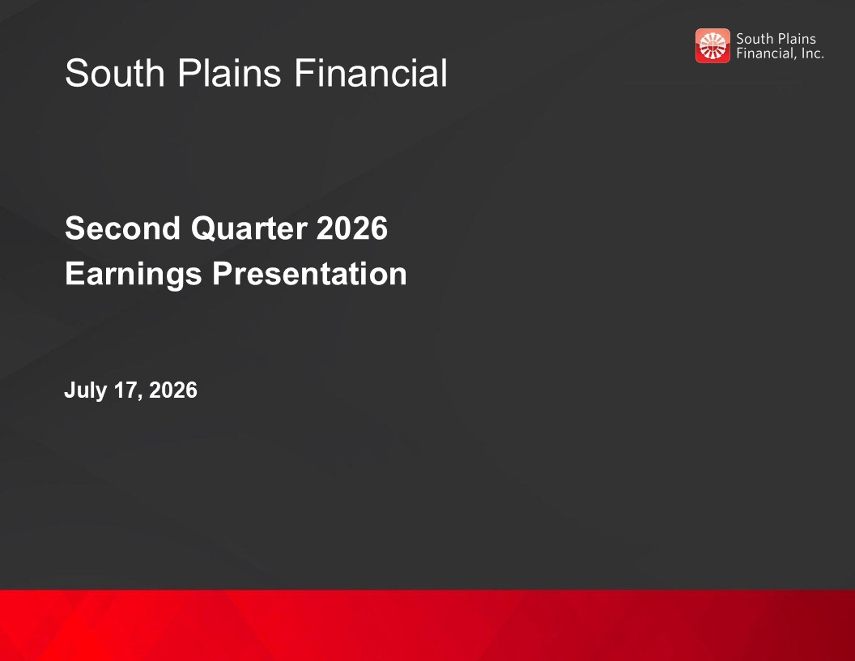
South Plains Financial Second Quarter 2026 Earnings Presentation July 17, 2026

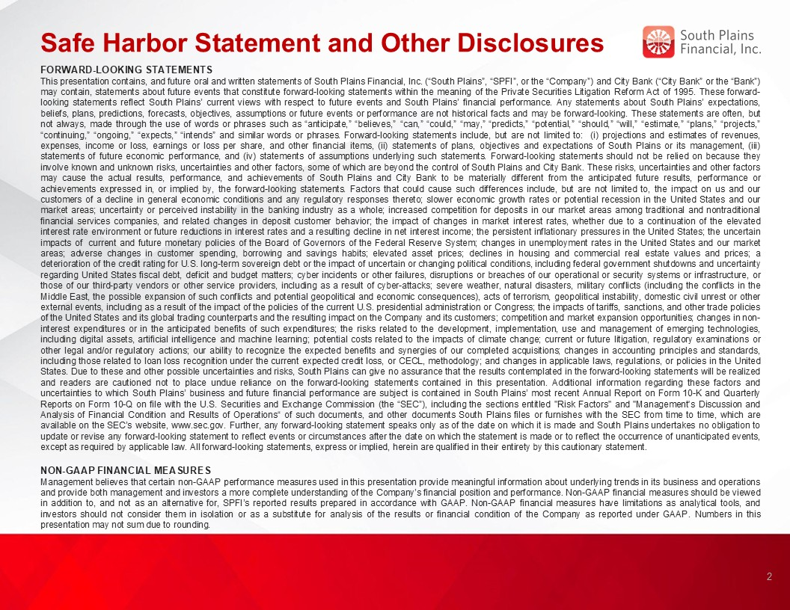
Safe Harbor Statement and Other Disclosures FORWARD-LOOKING STATEMENTS This presentation contains, and future oral and written statements of South Plains Financial, Inc. (“South Plains”, “SPFI”, or the “Company”) and City Bank (“City Bank” or the “Bank”) may contain, statements about future events that constitute forward-looking statements within the meaning of the Private Securities Litigation Reform Act of 1995. These forward-looking statements reflect South Plains’ current views with respect to future events and South Plains’ financial performance. Any statements about South Plains’ expectations, beliefs, plans, predictions, forecasts, objectives, assumptions or future events or performance are not historical facts and may be forward-looking. These statements are often, but not always, made through the use of words or phrases such as “anticipate,” “believes,” “can,” “could,” “may,” “predicts,” “potential,” “should,” “will,” “estimate,” “plans,” “projects,” “continuing,” “ongoing,” “expects,” “intends” and similar words or phrases. Forward-looking statements include, but are not limited to: (i) projections and estimates of revenues, expenses, income or loss, earnings or loss per share, and other financial items, (ii) statements of plans, objectives and expectations of South Plains or its management, (iii) statements of future economic performance, and (iv) statements of assumptions underlying such statements. Forward-looking statements should not be relied on because they involve known and unknown risks, uncertainties and other factors, some of which are beyond the control of South Plains and City Bank. These risks, uncertainties and other factors may cause the actual results, performance, and achievements of South Plains and City Bank to be materially different from the anticipated future results, performance or achievements expressed in, or implied by, the forward-looking statements. Factors that could cause such differences include, but are not limited to, the impact on us and our customers of a decline in general economic conditions and any regulatory responses thereto; slower economic growth rates or potential recession in the United States and our market areas; uncertainty or perceived instability in the banking industry as a whole; increased competition for deposits in our market areas among traditional and nontraditional financial services companies, and related changes in deposit customer behavior; the impact of changes in market interest rates, whether due to a continuation of the elevated interest rate environment or future reductions in interest rates and a resulting decline in net interest income; the persistent inflationary pressures in the United States; the uncertain impacts of current and future monetary policies of the Board of Governors of the Federal Reserve System; changes in unemployment rates in the United States and our market areas; adverse changes in customer spending, borrowing and savings habits; elevated asset prices; declines in housing and commercial real estate values and prices; a deterioration of the credit rating for U.S. long-term sovereign debt or the impact of uncertain or changing political conditions, including federal government shutdowns and uncertainty regarding United States fiscal debt, deficit and budget matters; cyber incidents or other failures, disruptions or breaches of our operational or security systems or infrastructure, or those of our third-party vendors or other service providers, including as a result of cyber-attacks; severe weather, natural disasters, military conflicts (including the conflicts in the Middle East, the possible expansion of such conflicts and potential geopolitical and economic consequences), acts of terrorism, geopolitical instability, domestic civil unrest or other external events, including as a result of the impact of the policies of the current U.S. presidential administration or Congress; the impacts of tariffs, sanctions, and other trade policies of the United States and its global trading counterparts and the resulting impact on the Company and its customers; competition and market expansion opportunities; changes in non-interest expenditures or in the anticipated benefits of such expenditures; the risks related to the development, implementation, use and management of emerging technologies, including digital assets, artificial intelligence and machine learning; potential costs related to the impacts of climate change; current or future litigation, regulatory examinations or other legal and/or regulatory actions; our ability to recognize the expected benefits and synergies of our completed acquisitions; changes in accounting principles and standards, including those related to loan loss recognition under the current expected credit loss, or CECL, methodology; and changes in applicable laws, regulations, or policies in the United States. Due to these and other possible uncertainties and risks, South Plains can give no assurance that the results contemplated in the forward-looking statements will be realized and readers are cautioned not to place undue reliance on the forward-looking statements contained in this presentation. Additional information regarding these factors and uncertainties to which South Plains’ business and future financial performance are subject is contained in South Plains’ most recent Annual Report on Form 10-K and Quarterly Reports on Form 10-Q on file with the U.S. Securities and Exchange Commission (the “SEC”), including the sections entitled "Risk Factors" and "Management's Discussion and Analysis of Financial Condition and Results of Operations“ of such documents, and other documents South Plains files or furnishes with the SEC from time to time, which are available on the SEC’s website, www.sec.gov. Further, any forward-looking statement speaks only as of the date on which it is made and South Plains undertakes no obligation to update or revise any forward-looking statement to reflect events or circumstances after the date on which the statement is made or to reflect the occurrence of unanticipated events, except as required by applicable law. All forward-looking statements, express or implied, herein are qualified in their entirety by this cautionary statement. NON-GAAP FINANCIAL MEASURES Management believes that certain non-GAAP performance measures used in this presentation provide meaningful information about underlying trends in its business and operations and provide both management and investors a more complete understanding of the Company’s financial position and performance. Non-GAAP financial measures should be viewed in addition to, and not as an alternative for, SPFI’s reported results prepared in accordance with GAAP. Non-GAAP financial measures have limitations as analytical tools, and investors should not consider them in isolation or as a substitute for analysis of the results or financial condition of the Company as reported under GAAP. Numbers in this presentation may not sum due to rounding. 2

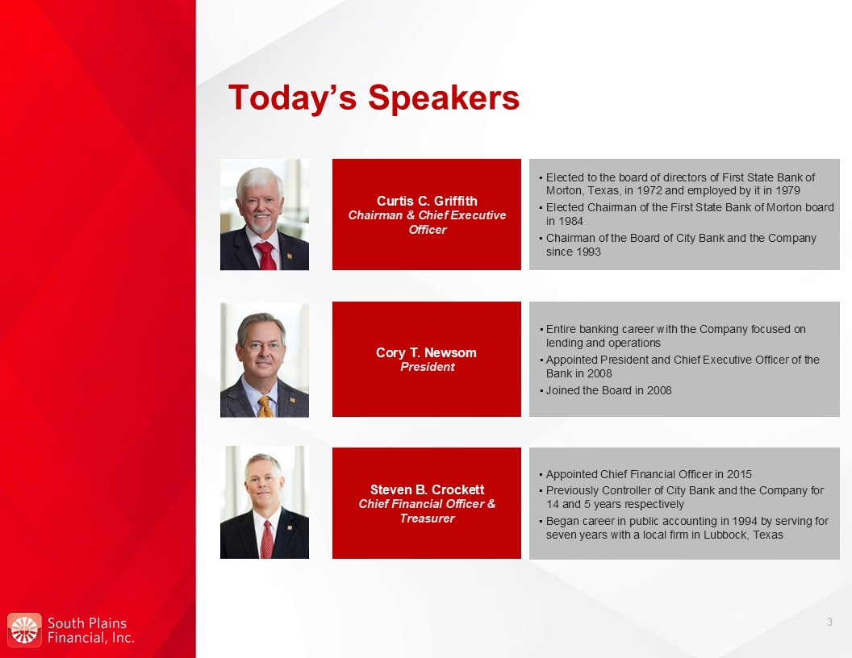
Today’s Speakers Curtis C. Griffith Chairman & Chief Executive Officer Elected to the board of directors of First State Bank of Morton, Texas, in 1972 and employed by it in 1979 Elected Chairman of the First State Bank of Morton board in 1984 Chairman of the Board of City Bank and the Company since 1993 Steven B. Crockett Chief Financial Officer & Treasurer Appointed Chief Financial Officer in 2015 Previously Controller of City Bank and the Company for 14 and 5 years respectively Began career in public accounting in 1994 by serving for seven years with a local firm in Lubbock, Texas Cory T. Newsom President Entire banking career with the Company focused on lending and operations Appointed President and Chief Executive Officer of the Bank in 2008 Joined the Board in 2008 3

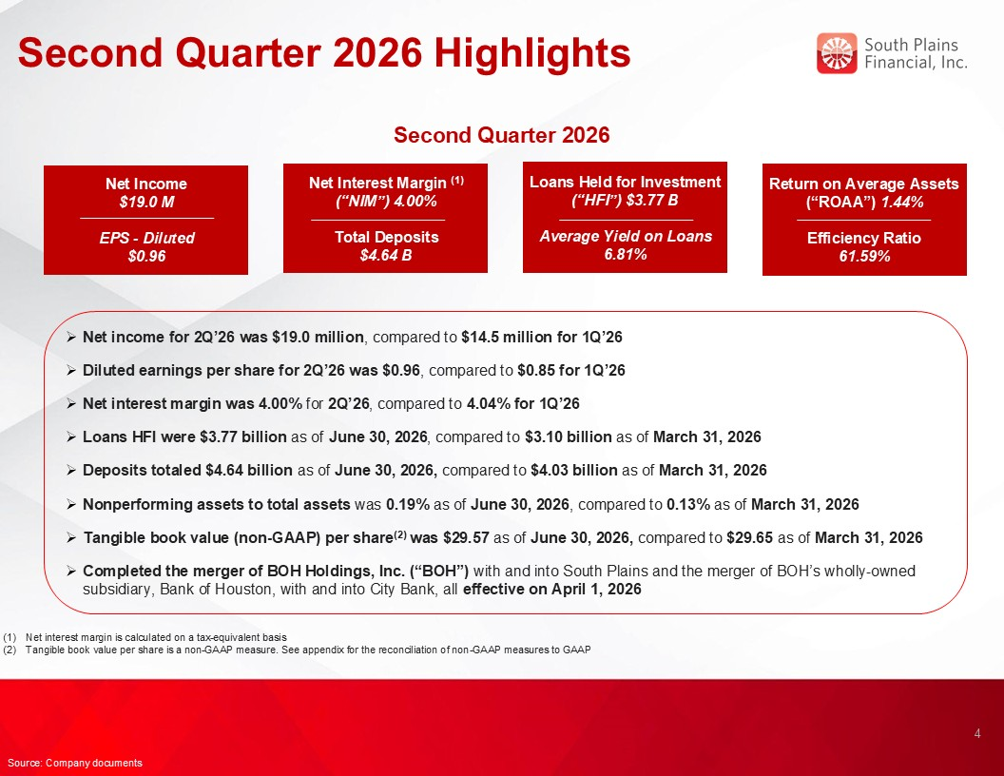
Second Quarter 2026 Highlights Net income for 2Q’26 was $19.0 million, compared to $14.5 million for 1Q’26 Diluted earnings per share for 2Q’26 was $0.96, compared to $0.85 for 1Q’26 Net interest margin was 4.00% for 2Q’26, compared to 4.04% for 1Q’26 Loans HFI were $3.77 billion as of June 30, 2026, compared to $3.10 billion as of March 31, 2026 Deposits totaled $4.64 billion as of June 30, 2026, compared to $4.03 billion as of March 31, 2026 Nonperforming assets to total assets was 0.19% as of June 30, 2026, compared to 0.13% as of March 31, 2026 Tangible book value (non-GAAP) per share(2) was $29.57 as of June 30, 2026, compared to $29.65 as of March 31, 2026 Completed the merger of BOH Holdings, Inc. (“BOH”) with and into South Plains and the merger of BOH’s wholly-owned subsidiary, Bank of Houston, with and into City Bank, all effective on April 1, 2026 4 Source: Company documents Net interest margin is calculated on a tax-equivalent basis Tangible book value per share is a non-GAAP measure. See appendix for the reconciliation of non-GAAP measures to GAAP Loans Held for Investment (“HFI”) $3.77 B Average Yield on Loans 6.81% Net Income $19.0 M EPS - Diluted $0.96 Net Interest Margin (1) (“NIM”) 4.00% Total Deposits $4.64 B Return on Average Assets (“ROAA”) 1.44% Efficiency Ratio 61.59% Second Quarter 2026

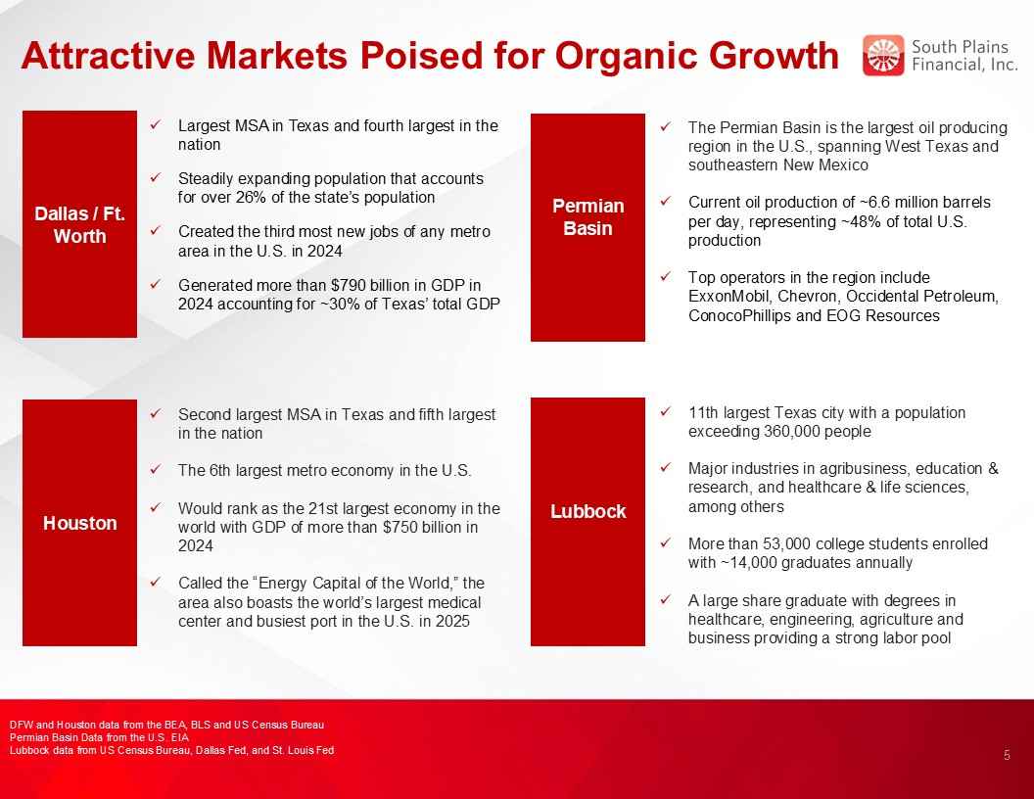
Attractive Markets Poised for Organic Growth Permian Basin Basin Dallas / Ft. Worth The Permian Basin is the largest oil producing region in the U.S., spanning West Texas and southeastern New Mexico Current oil production of ~6.6 million barrels per day, representing ~48% of total U.S. production Top operators in the region include ExxonMobil, Chevron, Occidental Petroleum, ConocoPhillips and EOG Resources Largest MSA in Texas and fourth largest in the nation Steadily expanding population that accounts for over 26% of the state’s population Created the third most new jobs of any metro area in the U.S. in 2024 Generated more than $790 billion in GDP in 2024 accounting for ~30% of Texas’ total GDP Houston Second largest MSA in Texas and fifth largest in the nation The 6th largest metro economy in the U.S. Would rank as the 21st largest economy in the world with GDP of more than $750 billion in 2024 Called the “Energy Capital of the World,” the area also boasts the world’s largest medical center and busiest port in the U.S. in 2025 Lubbock Basin 11th largest Texas city with a population exceeding 360,000 people Major industries in agribusiness, education & research, and healthcare & life sciences, among others More than 53,000 college students enrolled with ~14,000 graduates annually A large share graduate with degrees in healthcare, engineering, agriculture and business providing a strong labor pool 5 DFW and Houston data from the BEA, BLS and US Census Bureau Permian Basin Data from the U.S. EIA Lubbock data from US Census Bureau, Dallas Fed, and St. Louis Fed

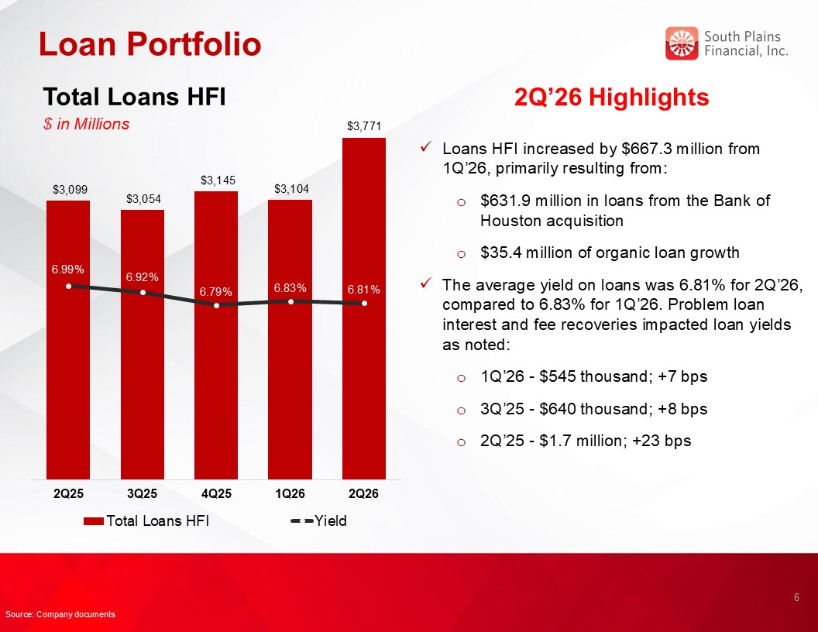
Loan Portfolio 2Q’26 Highlights Loans HFI increased by $667.3 million from 1Q’26, primarily resulting from: $631.9 million in loans from the Bank of Houston acquisition $35.4 million of organic loan growth The average yield on loans was 6.81% for 2Q’26, compared to 6.83% for 1Q’26. Problem loan interest and fee recoveries impacted loan yields as noted: 1Q’26 - $545 thousand; +7 bps 3Q’25 - $640 thousand; +8 bps 2Q’25 - $1.7 million; +23 bps Total Loans HFI $ in Millions 6 Source: Company documents $3,771

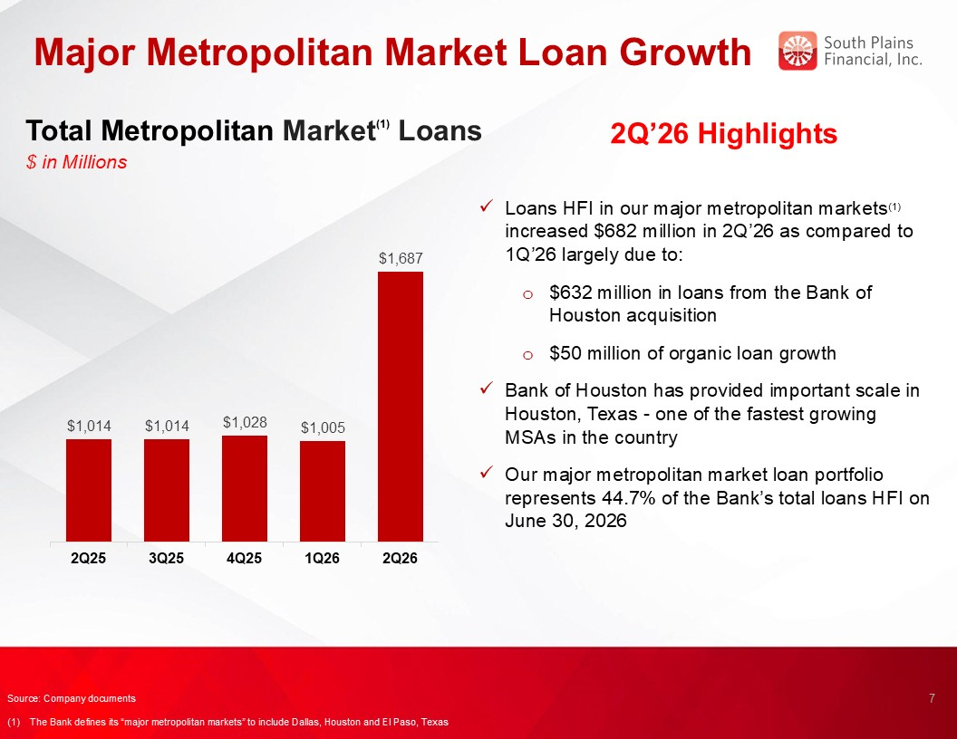
Major Metropolitan Market Loan Growth 2Q’26 Highlights Loans HFI in our major metropolitan markets(1) increased $682 million in 2Q’26 as compared to 1Q’26 largely due to: $632 million in loans from the Bank of Houston acquisition $50 million of organic loan growth Bank of Houston has provided important scale in Houston, Texas - one of the fastest growing MSAs in the country Our major metropolitan market loan portfolio represents 44.7% of the Bank’s total loans HFI on June 30, 2026 Total Metropolitan Market(1) Loans $ in Millions 7 5.00% Source: Company documents (1) The Bank defines its “major metropolitan markets” to include Dallas, Houston and El Paso, Texas

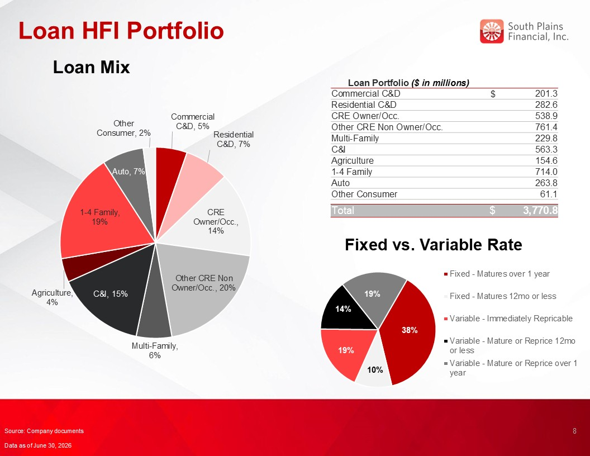
Loan HFI Portfolio Loan Mix Loan Portfolio ($ in millions) Commercial C&D $ 201.3 Residential C&D 282.6 CRE Owner/Occ. 538.9 Other CRE Non Owner/Occ. 761.4 Multi-Family 229.8 C&I 563.3 Agriculture 154.6 1-4 Family 714.0 Auto 263.8 Other Consumer 61.1 Total $ 3,770.8 Fixed vs. Variable Rate 8 Source: Company documents Data as of June 30, 2026

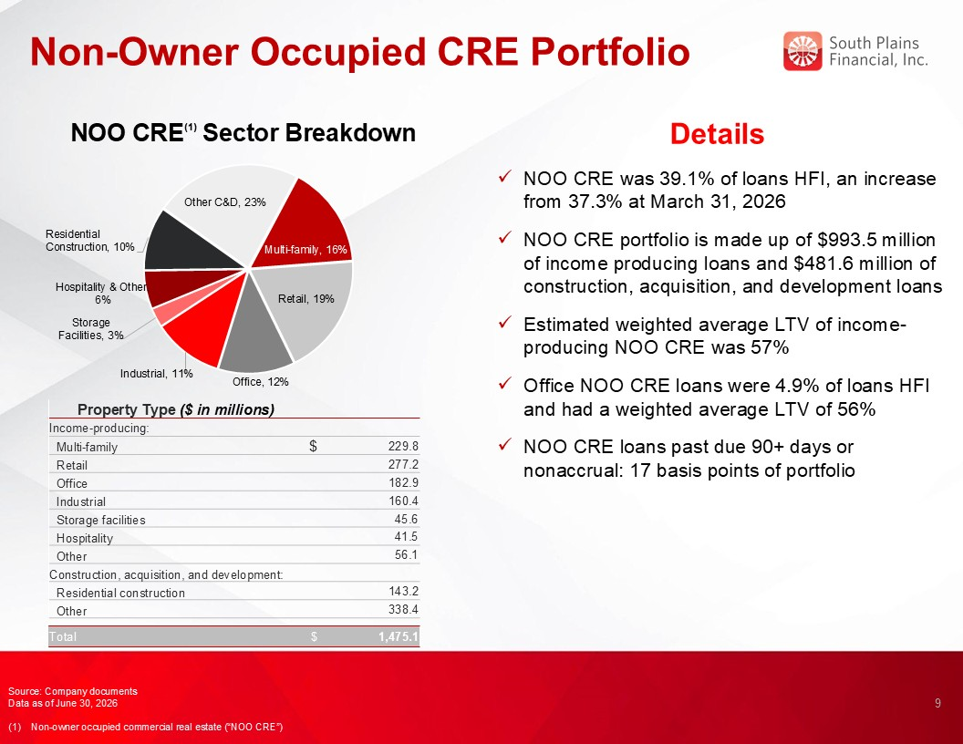
Non-Owner Occupied CRE Portfolio 9 Details NOO CRE was 39.1% of loans HFI, an increase from 37.3% at March 31, 2026 NOO CRE portfolio is made up of $993.5 million of income producing loans and $481.6 million of construction, acquisition, and development loans Estimated weighted average LTV of income-producing NOO CRE was 57% Office NOO CRE loans were 4.9% of loans HFI and had a weighted average LTV of 56% NOO CRE loans past due 90+ days or nonaccrual: 17 basis points of portfolio NOO CRE(1) Sector Breakdown Source: Company documents Data as of June 30, 2026 (1) Non-owner occupied commercial real estate (“NOO CRE”) Property Type ($ in millions) Income-producing: Multi-family $ 229.8 Retail 277.2 Office 182.9 Industrial 160.4 Storage facilities 45.6 Hospitality 41.5 Other 56.1 Construction, acquisition, and development: Residential construction 143.2 Other 338.4 Total $ 1,475.1

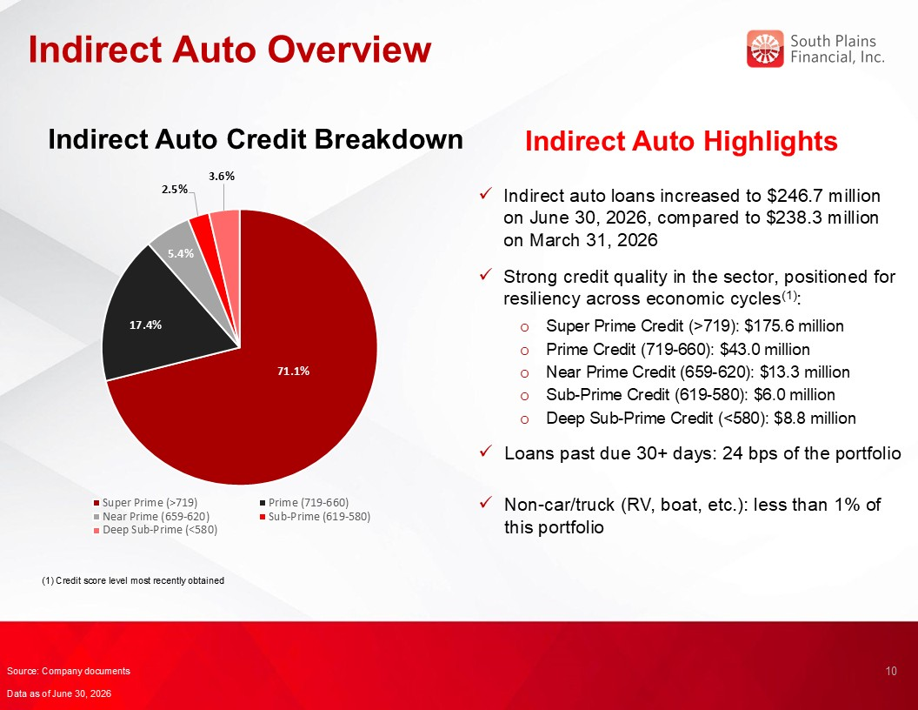
Indirect Auto Overview Indirect Auto Highlights Indirect auto loans increased to $246.7 million on June 30, 2026, compared to $238.3 million on March 31, 2026 Strong credit quality in the sector, positioned for resiliency across economic cycles(1): Super Prime Credit (>719): $175.6 million Prime Credit (719-660): $43.0 million Near Prime Credit (659-620): $13.3 million Sub-Prime Credit (619-580): $6.0 million Deep Sub-Prime Credit (<580): $8.8 million Loans past due 30+ days: 24 bps of the portfolio Non-car/truck (RV, boat, etc.): less than 1% of this portfolio Indirect Auto Credit Breakdown 10 Source: Company documents Data as of June 30, 2026 (1) Credit score level most recently obtained

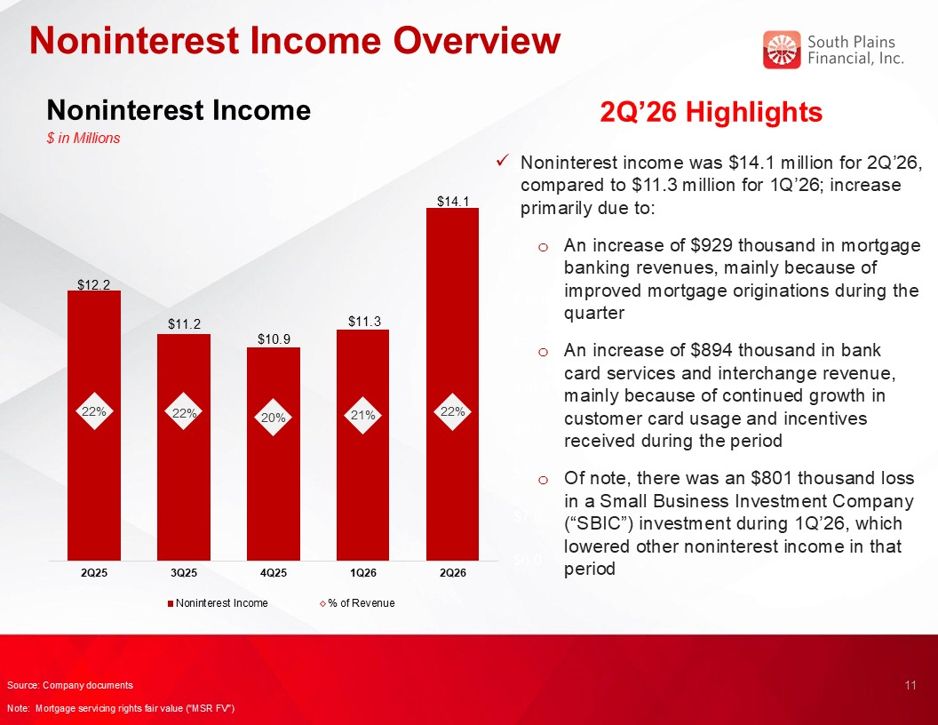
Noninterest Income Overview Noninterest Income $ in Millions 2Q’26 Highlights Noninterest income was $14.1 million for 2Q’26, compared to $11.3 million for 1Q’26; increase primarily due to: An increase of $929 thousand in mortgage banking revenues, mainly because of improved mortgage originations during the quarter An increase of $894 thousand in bank card services and interchange revenue, mainly because of continued growth in customer card usage and incentives received during the period Of note, there was an $801 thousand loss in a Small Business Investment Company (“SBIC”) investment during 1Q’26, which lowered other noninterest income in that period 11 Source: Company documents Note: Mortgage servicing rights fair value (“MSR FV”)

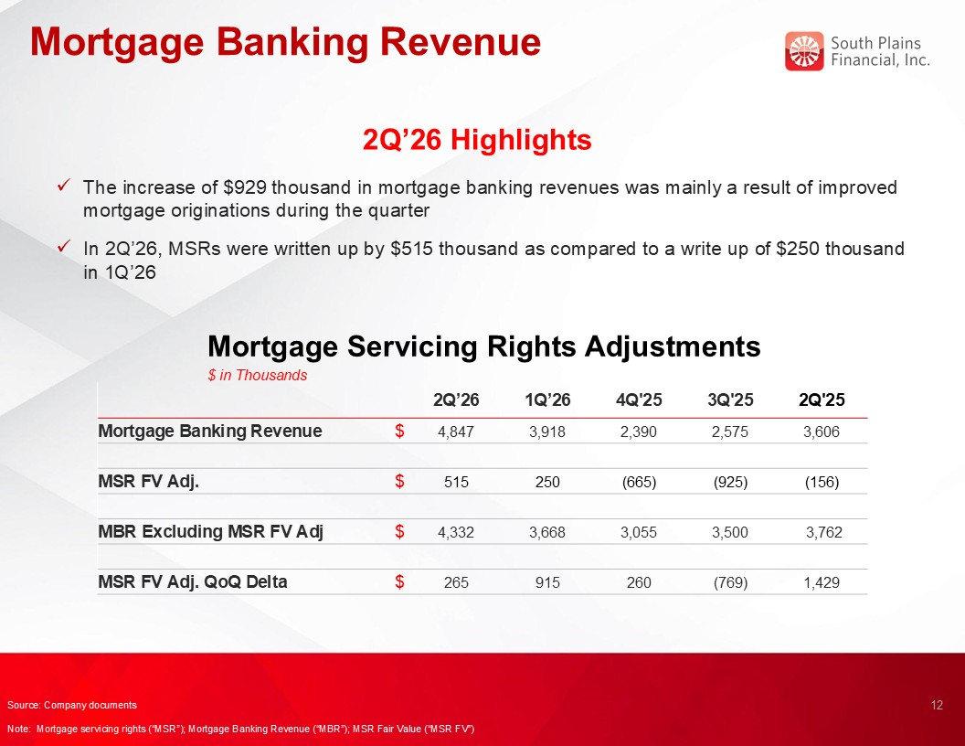
Mortgage Banking Revenue Mortgage Servicing Rights Adjustments $ in Thousands 2Q’26 Highlights The increase of $929 thousand in mortgage banking revenues was mainly a result of improved mortgage originations during the quarter In 2Q’26, MSRs were written up by $515 thousand as compared to a write up of $250 thousand in 1Q’26 12 Source: Company documents Note: Mortgage servicing rights (“MSR”); Mortgage Banking Revenue (“MBR”); MSR Fair Value (“MSR FV”) 2Q’26 1Q’26 4Q'25 3Q'25 2Q'25 Mortgage Banking Revenue $ 4,847 3,918 2,390 2,575 3,606 MSR FV Adj. $ 515 250 (665) (925) (156) MBR Excluding MSR FV Adj $ 4,332 3,668 3,055 3,500 3,762 MSR FV Adj. QoQ Delta $ 265 915 260 (769) 1,429

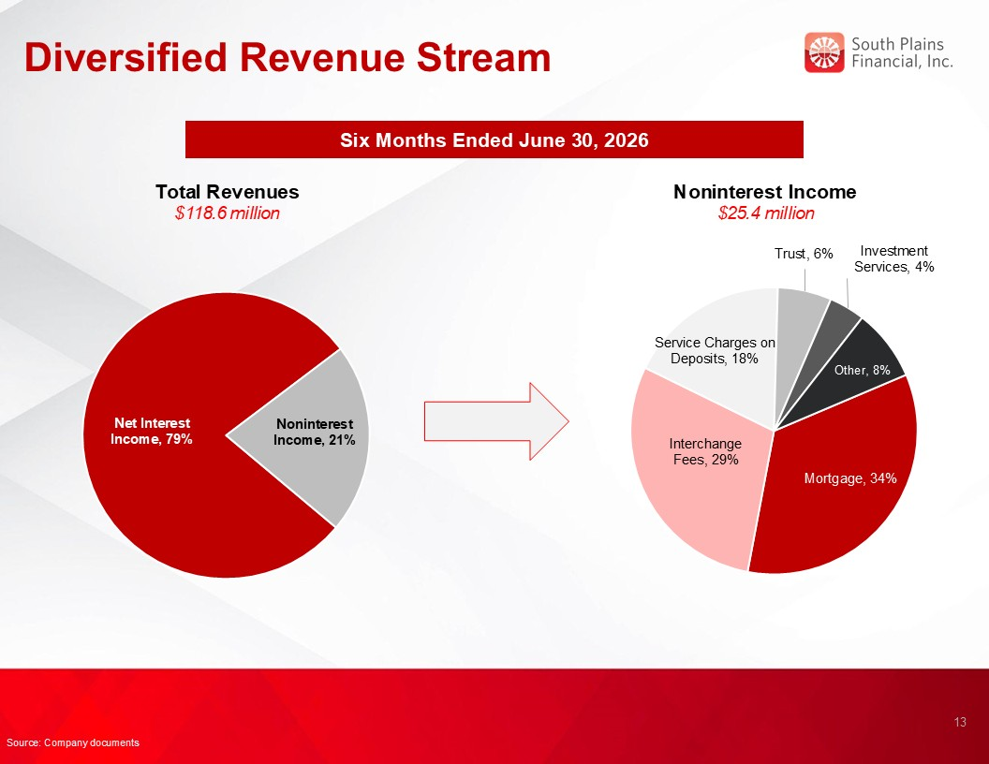
Diversified Revenue Stream Six Months Ended June 30, 2026 Total Revenues $118.6 million Noninterest Income $25.4 million 13 Source: Company documents

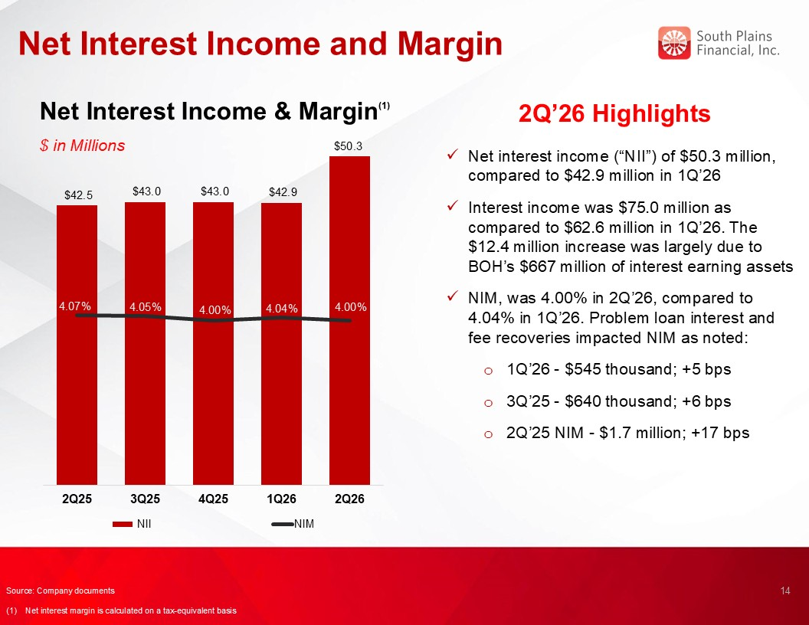
Net Interest Income and Margin Net Interest Income & Margin(1) $ in Millions 2Q’26 Highlights Net interest income (“NII”) of $50.3 million, compared to $42.9 million in 1Q’26 Interest income was $75.0 million as compared to $62.6 million in 1Q’26. The $12.4 million increase was largely due to BOH’s $667 million of interest earning assets NIM, was 4.00% in 2Q’26, compared to 4.04% in 1Q’26. Problem loan interest and fee recoveries impacted NIM as noted: 1Q’26 - $545 thousand; +5 bps 3Q’25 - $640 thousand; +6 bps 2Q’25 NIM - $1.7 million; +17 bps 14 3.54% Source: Company documents (1) Net interest margin is calculated on a tax-equivalent basis $50.3

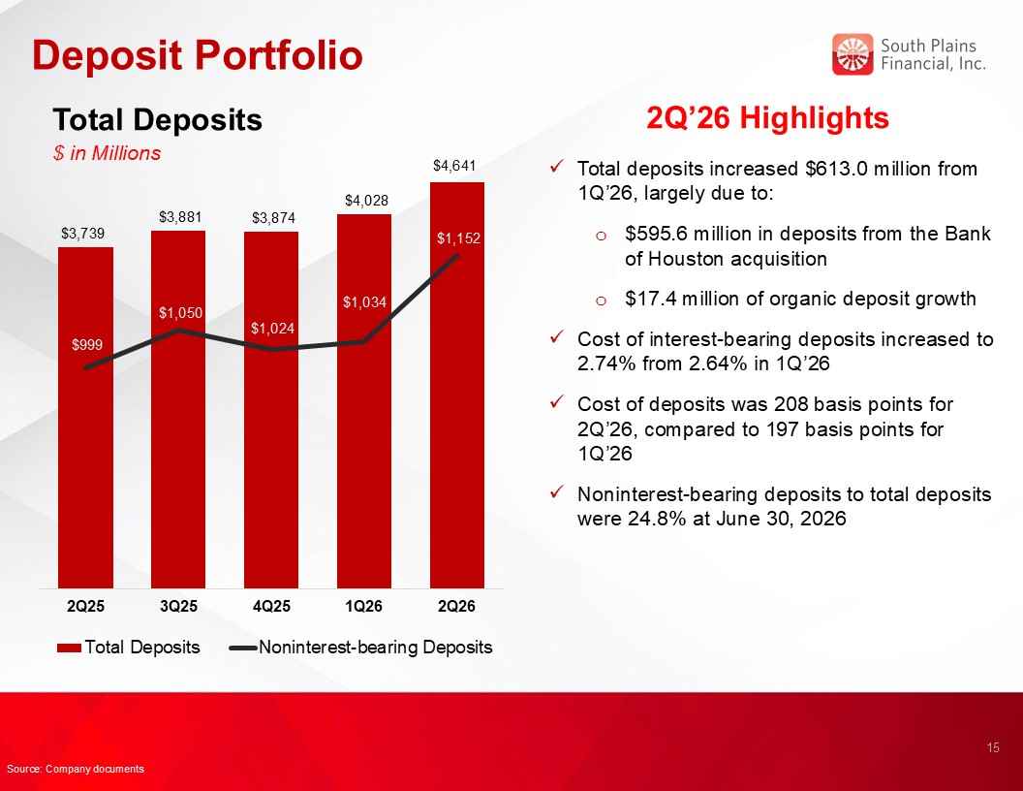
Deposit Portfolio Total Deposits $ in Millions 2Q’26 Highlights Total deposits increased $613.0 million from 1Q’26, largely due to: $595.6 million in deposits from the Bank of Houston acquisition $17.4 million of organic deposit growth Cost of interest-bearing deposits increased to 2.74% from 2.64% in 1Q’26 Cost of deposits was 208 basis points for 2Q’26, compared to 197 basis points for 1Q’26 Noninterest-bearing deposits to total deposits were 24.8% at June 30, 2026 15 Source: Company documents $4,641

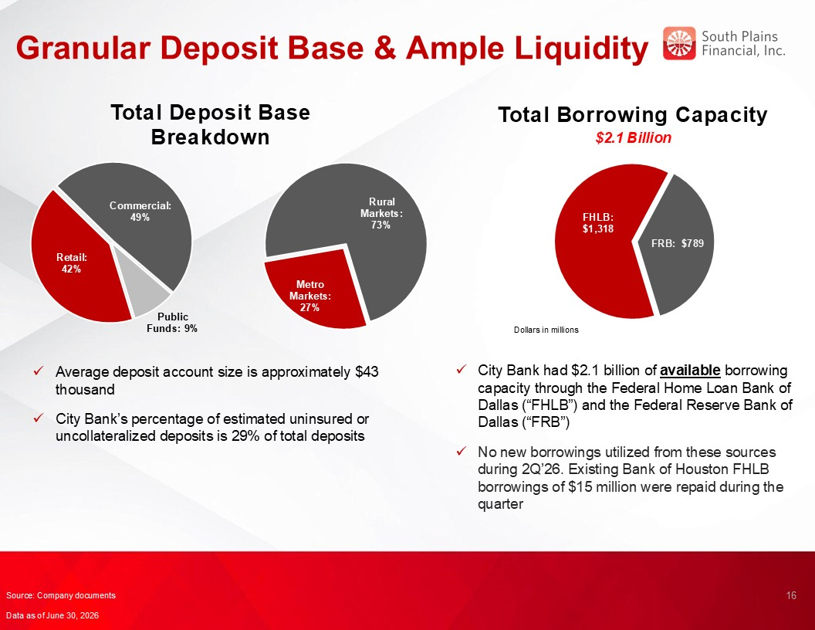
Granular Deposit Base & Ample Liquidity Total Borrowing Capacity $2.1 Billion 16 Total Deposit Base Breakdown Average deposit account size is approximately $43 thousand City Bank’s percentage of estimated uninsured or uncollateralized deposits is 29% of total deposits City Bank had $2.1 billion of available borrowing capacity through the Federal Home Loan Bank of Dallas (“FHLB”) and the Federal Reserve Bank of Dallas (“FRB”) No new borrowings utilized from these sources during 2Q’26. Existing Bank of Houston FHLB borrowings of $15 million were repaid during the quarter Source: Company documents Data as of June 30, 2026

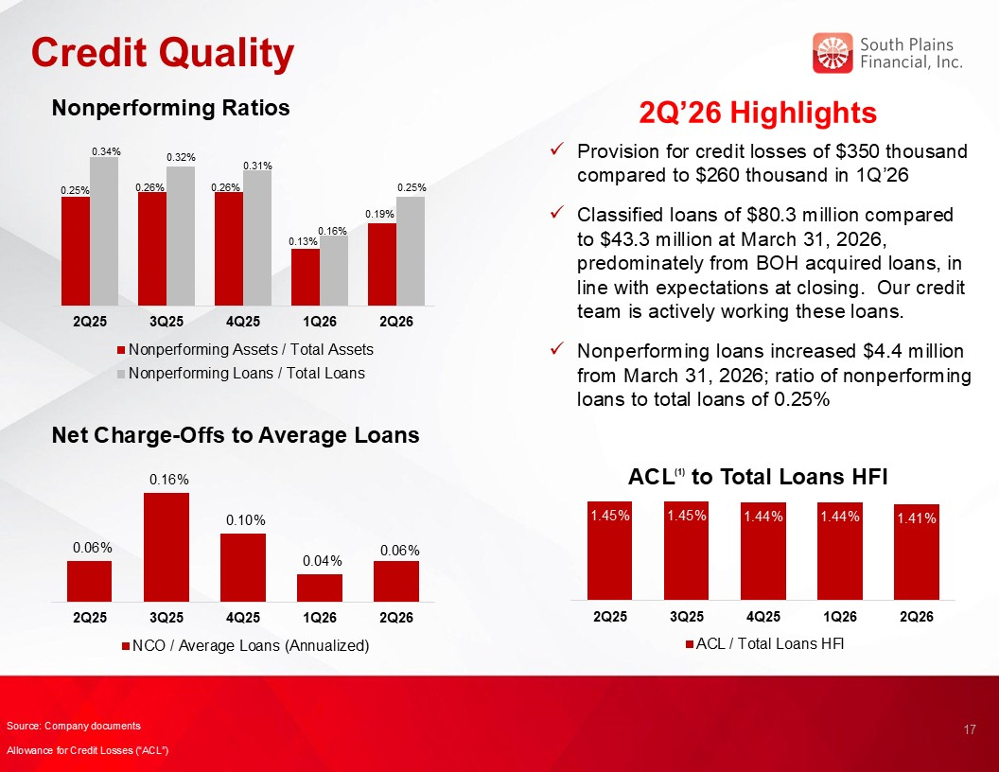
Credit Quality 2Q’26 Highlights Nonperforming Ratios Net Charge-Offs to Average Loans ACL(1) to Total Loans HFI 17 Provision for credit losses of $350 thousand compared to $260 thousand in 1Q’26 Classified loans of $80.3 million compared to $43.3 million at March 31, 2026, predominately from BOH acquired loans, in line with expectations at closing. Our credit team is actively working these loans. Nonperforming loans increased $4.4 million from March 31, 2026; ratio of nonperforming loans to total loans of 0.25% Source: Company documents Allowance for Credit Losses (“ACL”)

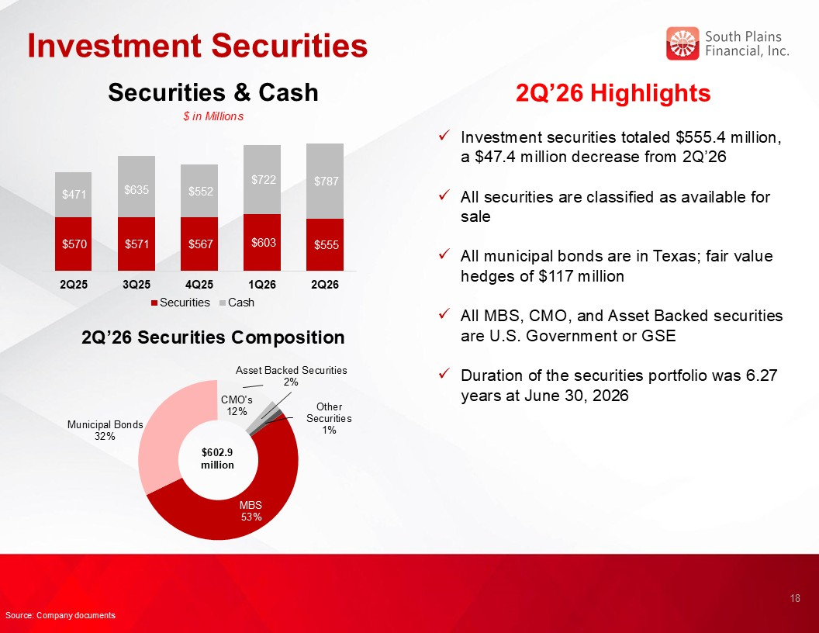
Investment Securities 2Q’26 Highlights Investment securities totaled $555.4 million, a $47.4 million decrease from 2Q’26 All securities are classified as available for sale All municipal bonds are in Texas; fair value hedges of $117 million All MBS, CMO, and Asset Backed securities are U.S. Government or GSE Duration of the securities portfolio was 6.27 years at June 30, 2026 2Q’26 Securities Composition $602.9 million Securities & Cash $ in Millions 18 Source: Company documents

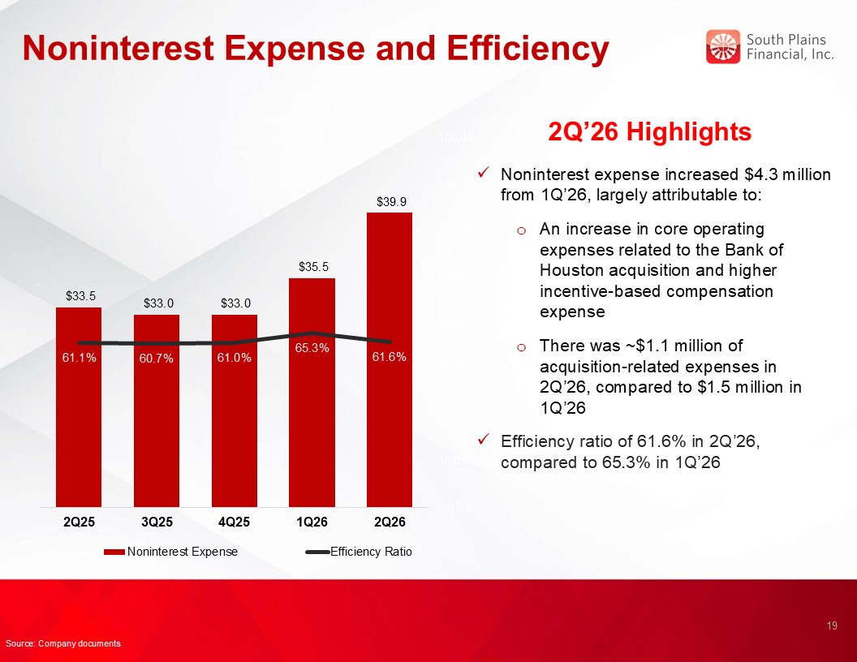
Noninterest Expense and Efficiency 2Q’26 Highlights Noninterest expense increased $4.3 million from 1Q’26, largely attributable to: An increase in core operating expenses related to the Bank of Houston acquisition and higher incentive-based compensation expense There was ~$1.1 million of acquisition-related expenses in 2Q’26, compared to $1.5 million in 1Q’26 Efficiency ratio of 61.6% in 2Q’26, compared to 65.3% in 1Q’26 19 Source: Company documents

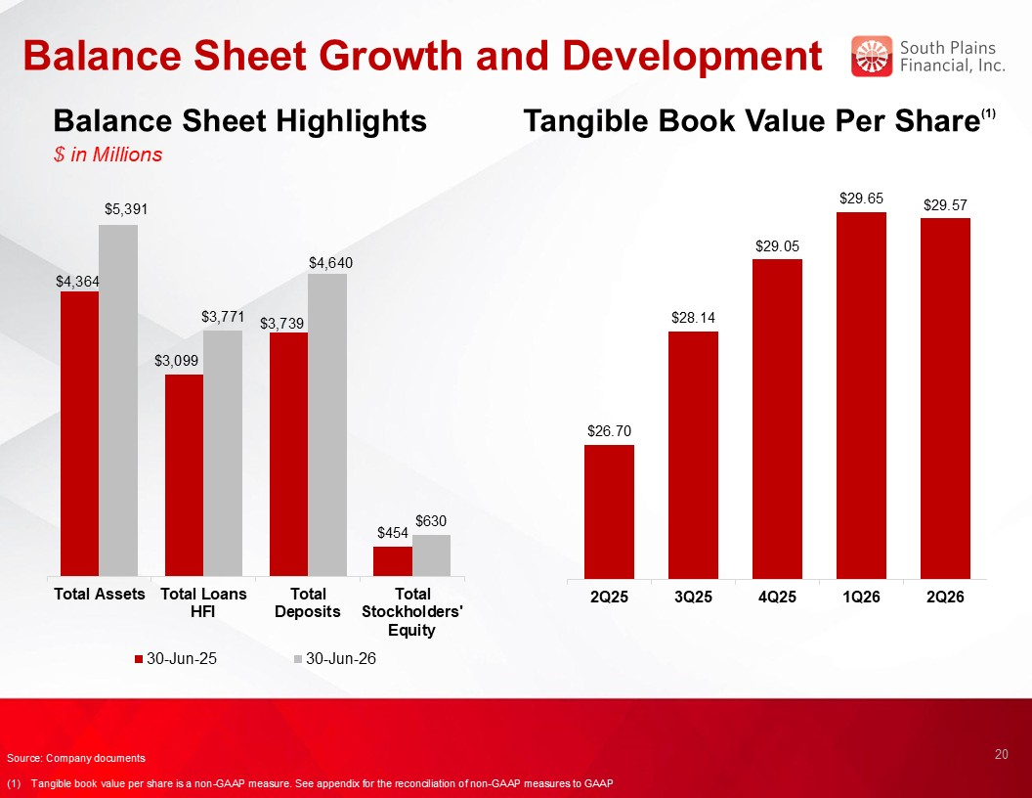
Balance Sheet Growth and Development Balance Sheet Highlights $ in Millions Tangible Book Value Per Share(1) 20 Source: Company documents (1) Tangible book value per share is a non-GAAP measure. See appendix for the reconciliation of non-GAAP measures to GAAP

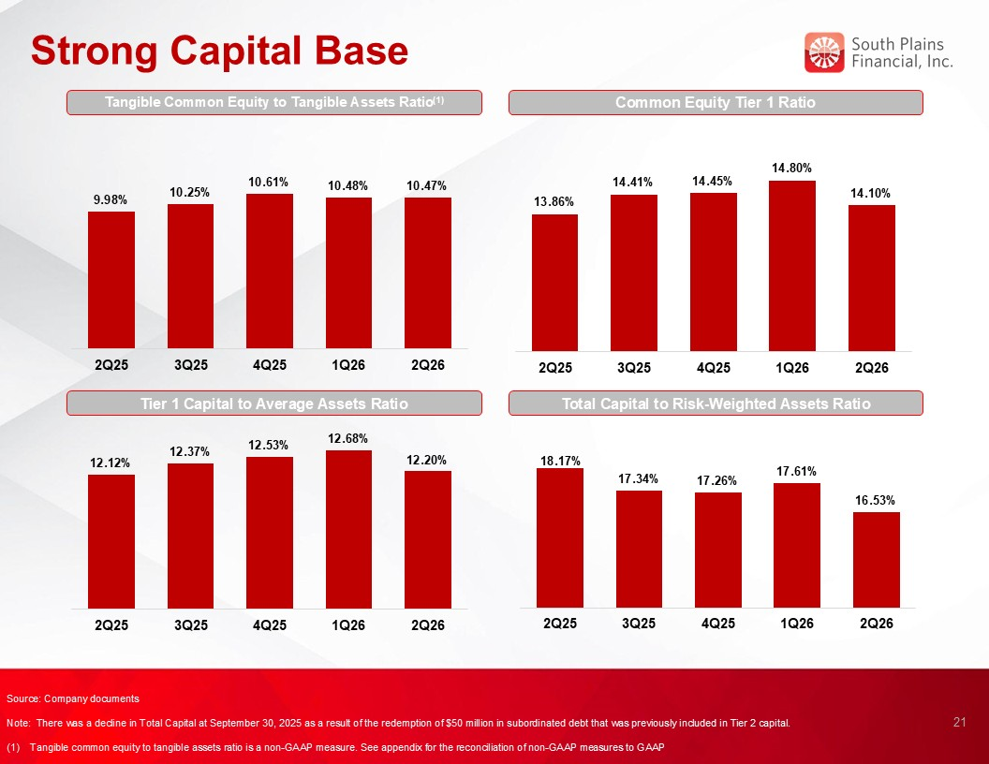
Strong Capital Base Common Equity Tier 1 Ratio Tier 1 Capital to Average Assets Ratio Total Capital to Risk-Weighted Assets Ratio 21 Source: Company documents Note: There was a decline in Total Capital at September 30, 2025 as a result of the redemption of $50 million in subordinated debt that was previously included in Tier 2 capital. (1) Tangible common equity to tangible assets ratio is a non-GAAP measure. See appendix for the reconciliation of non-GAAP measures to GAAP Tangible Common Equity to Tangible Assets Ratio(1)

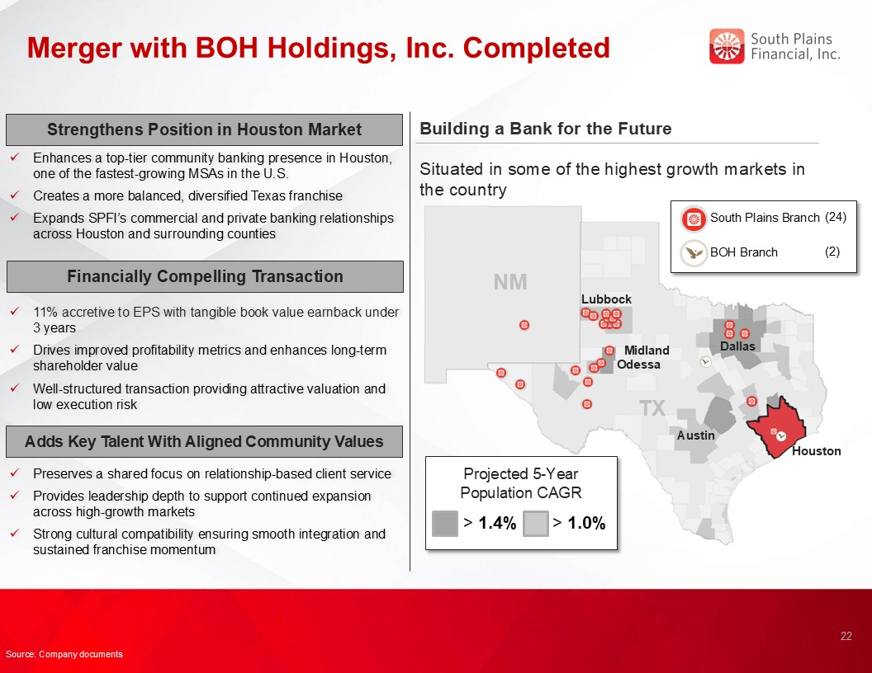
Merger with BOH Holdings, Inc. Completed Building a Bank for the Future Houston Odessa Austin Midland > 1.4% Situated in some of the highest growth markets in the country Projected 5-Year Population CAGR > 1.0% TX NM Lubbock Dallas South Plains Branch (24) BOH Branch (2) 22 Strengthens Position in Houston Market Enhances a top-tier community banking presence in Houston, one of the fastest-growing MSAs in the U.S. Creates a more balanced, diversified Texas franchise Expands SPFI’s commercial and private banking relationships across Houston and surrounding counties 11% accretive to EPS with tangible book value earnback under 3 years Drives improved profitability metrics and enhances long-term shareholder value Well-structured transaction providing attractive valuation and low execution risk Financially Compelling Transaction Preserves a shared focus on relationship-based client service Provides leadership depth to support continued expansion across high-growth markets Strong cultural compatibility ensuring smooth integration and sustained franchise momentum Adds Key Talent With Aligned Community Values Source: Company documents


SPFI’s Core Purpose and Values Align Centered on Relationship-Based Business Our Core Purpose is: To use the power of relationships to help people succeed and live better HELP ALL STAKEHOLDERS SUCCEED Employees → great benefits and opportunities to grow and make a difference. Customers → personalized advice and solutions to achieve their goals. Partners → responsive, trusted win-win partnerships enabling both parties to succeed together. Shareholders → share in the prosperity and performance of the Bank. THE POWER OF RELATIONSHIPS At SPFI, we build lifelong, trusted relationships so you know you always have someone in your corner that understands you, cares about you, and stands ready to help. LIVE BETTER We want to help everyone live better. At the end of the day, we do what we do to help enhance lives. We create a great place to work, help people achieve their goals, and invest generously in our communities because there’s nothing more rewarding than helping people succeed and live better. 23

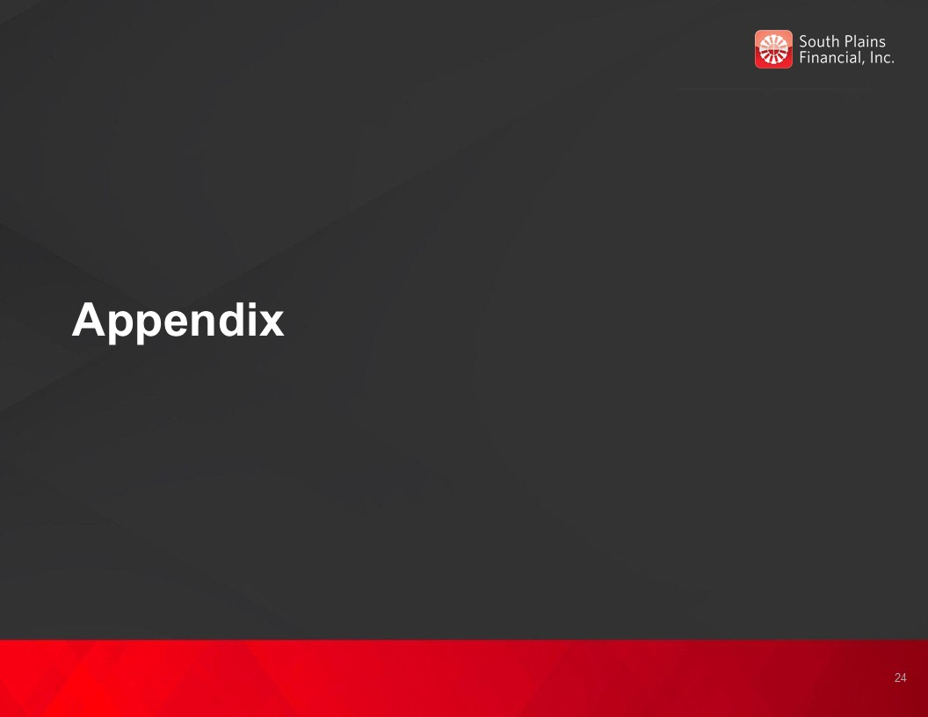
Appendix 24

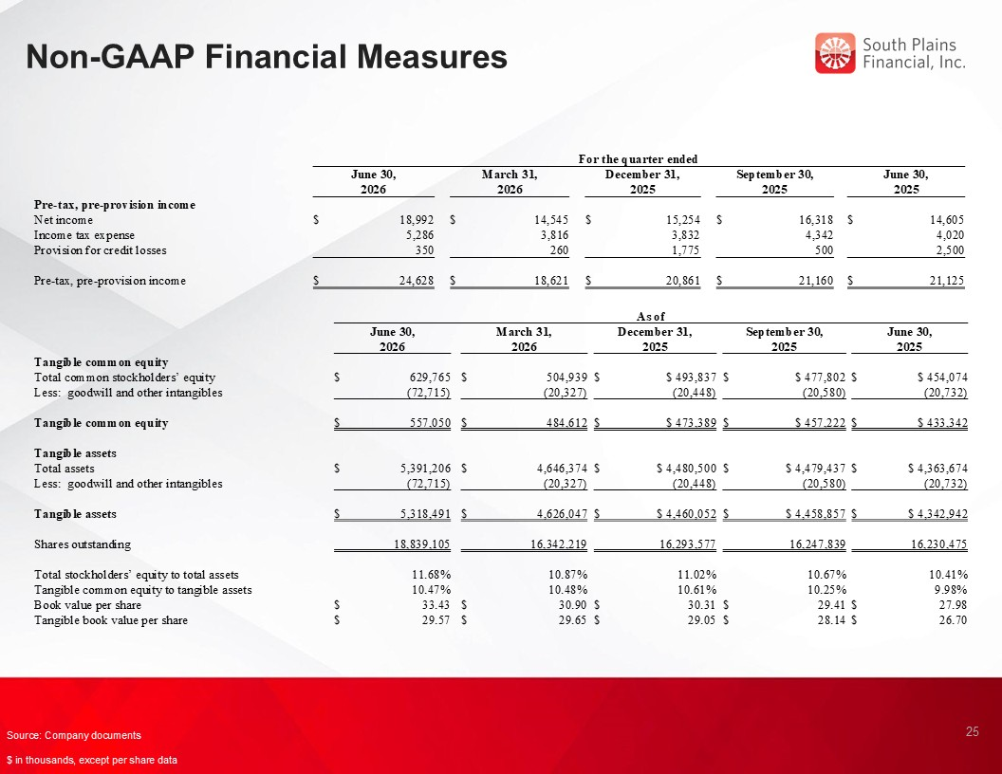
Non-GAAP Financial Measures 25 Source: Company documents $ in thousands, except per share data For the quarter ended June 30, 2026 March 31, 2026 December 31, 2025 September 30, 2025 June 30, 2025 Pre-tax, pre-provision income Net income $ 18,992 $ 14,545 $ 15,254 $ 16,318 $ 14,605 Income tax expense 5,286 3,816 3,832 4,342 4,020 Provision for credit losses 350 260 1,775 500 2,500 Pre-tax, pre-provision income $ 24,628 $ 18,621 $ 20,861 $ 21,160 $ 21,125 As of June 30, 2026 March 31, 2026 December 31, 2025 September 30, 2025 June 30, 2025 Tangible common equity Total common stockholders’ equity $ 629,765 $ 504,939 $ $ 493,837 $ $ 477,802 $ $ 454,074 Less: goodwill and other intangibles (72,715) (20,327) (20,448) (20,580) (20,732) Tangible common equity $ 557,050 $ 484,612 $ $ 473,389 $ $ 457,222 $ $ 433,342 Tangible assets Total assets $ 5,391,206 $ 4,646,374 $ $ 4,480,500 $ $ 4,479,437 $ $ 4,363,674 Less: goodwill and other intangibles (72,715) (20,327) (20,448) (20,580) (20,732) Tangible assets $ 5,318,491 $ 4,626,047 $ $ 4,460,052 $ $ 4,458,857 $ $ 4,342,942 Shares outstanding 18,839,105 16,342,219 16,293,577 16,247,839 16,230,475 Total stockholders’ equity to total assets 11.68% 10.87% 11.02% 10.67% 10.41% Tangible common equity to tangible assets 10.47% 10.48% 10.61% 10.25% 9.98% Book value per share $ 33.43 $ 30.90 $ 30.31 $ 29.41 $ 27.98 Tangible book value per share $ 29.57 $ 29.65 $ 29.05 $ 28.14 $ 26.70

Exhibit 99.3

South Plains Financial, Inc. Announces 6% Increase to Quarterly Cash Dividend

LUBBOCK, Texas, July 16, 2026 (GLOBE NEWSWIRE) -- South Plains Financial, Inc. (NASDAQ:SPFI) (“South Plains”), the parent company of City Bank, today announced that its Board of Directors has declared a quarterly cash dividend of $0.18 per share of common stock, a 6% increase from the most recent quarterly cash dividend declared in April 2026. The dividend is payable on August 10, 2026 to shareholders of record as of the close of business on July 27, 2026.

About South Plains Financial, Inc.
South Plains is the bank holding company for City Bank, a Texas state-chartered bank headquartered in Lubbock, Texas. City Bank is one of the largest independent banks in West Texas and has additional banking operations in the Dallas, El Paso, Greater Houston, the Permian Basin, and College Station, Texas markets, and the Ruidoso, New Mexico market. South Plains provides a wide range of commercial and consumer financial services to small and medium-sized businesses and individuals in its market areas. Its principal business activities include commercial and retail banking, along with investment, trust and mortgage services. Please visit https://www.spfi.bank for more information.

Contact
Mikella Newsom, Chief Risk Officer and Secretary
(866) 771-3347
investors@city.bank

Source: South Plains Financial, Inc.

