UNITED STATES
SECURITIES AND EXCHANGE COMMISSION
Washington, D.C. 20549

FORM 8-K

CURRENT REPORT
Pursuant to Section 13 or 15(d) of
the Securities Exchange Act of 1934

Date of Report (Date of earliest event reported): October 21, 2026

South Plains Financial, Inc.
(Exact name of registrant as specified in its charter)

Texas | 001-38895 | 75-2453320
(State or other jurisdiction of incorporation) | (Commission File Number) | (IRS Employer Identification No.)

5219 City Bank Parkway  Lubbock, Texas |  | 79407
(Address of principal executive offices) |  | (Zip Code)

(806) 792-7101
(Registrant’s telephone number, including area code)

Check the appropriate box below if the Form 8-K filing is intended to simultaneously satisfy the filing obligation of the registrant under any of the following provisions:

☐ | Written communications pursuant to Rule 425 under the Securities Act (17 CFR 230.425)

☐ | Soliciting material pursuant to Rule 14a-12 under the Exchange Act (17 CFR 240.14a-12)

☐ | Pre-commencement communications pursuant to Rule 14d-2(b) under the Exchange Act (17 CFR 240.14d-2(b))

☐ | Pre-commencement communications pursuant to Rule 13e-4(c) under the Exchange Act (17 CFR 240.13e-4(c))

Securities registered pursuant to Section 12(b) of the Act:

Title of each class | Trading Symbol(s) | Name of each exchange on which registered
Common Stock, par value $1.00 per share | SPFI | The Nasdaq Stock Market LLC

Indicate by check mark whether the registrant is an emerging growth company as defined in Rule 405 of the Securities Act of 1933 (§0.405 of this chapter) or Rule 12b-2 of the Securities Exchange Act of 1934 (§0.12b-2 of this chapter).

Emerging growth company ☐

If an emerging growth company, indicate by check mark if the registrant has elected not to use the extended transition period for complying with any new or revised financial accounting standards provided pursuant to Section 13(a) of the Exchange Act. ☐

Item 2.02 | Results of Operations and Financial Condition.

On October 22, 2026, South Plains Financial, Inc. (the “Company”) issued a press release announcing its financial results for the third quarter ended September 30, 2026. A copy of the Company’s press release covering such announcement and certain other matters is furnished as Exhibit 99.1 to this Current Report on Form 8-K.

Item 7.01 | Regulation FD Disclosure.

On October 22, 2026, officers of the Company will conduct a conference call at 5:00 p.m., Eastern Time, with respect to the Company’s financial results for the third quarter ended September 30, 2026. An earnings release slide presentation highlighting the Company’s financial results for the third quarter ended September 30, 2026 is furnished as Exhibit 99.2 to this Current Report on Form 8-K. This earnings release slide presentation will also be available on the Company’s website, www.spfi.bank, under the “News & Events” section.

In accordance with General Instruction B.2 of Form 8-K, the information in Items 2.02 and 7.01 of this Current Report on Form 8-K, including Exhibit 99.1 and Exhibit 99.2 furnished herewith, shall not be deemed “filed” for the purposes of Section 18 of the Securities Exchange Act of 1934, as amended (the “Exchange Act”), or otherwise subject to the liabilities of that section. The information in Items 2.02 and 7.01 of this Current Report on Form 8-K, including Exhibit 99.1 and Exhibit 99.2 furnished herewith, shall not be incorporated by reference into any filing or other document pursuant to the Exchange Act or the Securities Act of 1933, as amended, except as shall be expressly set forth by specific reference in such filing or document.

Item 8.01 | Other Events.

On October 22, 2026, the Company issued a press release announcing the declaration of a quarterly cash dividend of $0.19 per share on its outstanding common stock. The dividend will be paid on November 16, 2026 to shareholders of record as of the close of business on November 2, 2026. A copy of the Company’s press release covering such announcement is attached to this Current Report on Form 8-K as Exhibit 99.3 and is incorporated herein by reference.

Item 9.01 | Financial Statements and Exhibits.

 | (d) | Exhibits.

99.1 | Press release, dated October 22, 2026, announcing third quarter 2026 financial results of South Plains Financial, Inc.
99.2 | Earnings release slide presentation, dated October 22, 2026.
99.3 | Press release, dated October 22, 2026, announcing South Plains Financial, Inc. quarterly cash dividend.
104 | Cover Page Interactive Data File (formatted as Inline XBRL).

SIGNATURES

Pursuant to the requirements of the Securities Exchange Act of 1934, the registrant has duly caused this report to be signed on its behalf by the undersigned hereunto duly authorized.

 | SOUTH PLAINS FINANCIAL, INC.
Date: October 22, 2026 | By: | /s/ Steven B. Crockett
Steven B. Crockett
Chief Financial Officer and Treasurer


Exhibit 99.1

South Plains Financial, Inc. Reports Third Quarter 2026 Financial Results

LUBBOCK, Texas, October 22, 2026 (GLOBE NEWSWIRE) – South Plains Financial, Inc. (NASDAQ:SPFI) (“South Plains” or the “Company”), the parent company of City Bank (“City Bank” or the “Bank”), today reported its financial results for the quarter ended September 30, 2026.

Third Quarter 2026 Highlights

 | ● | Net income for the third quarter of 2026 was $20.8 million, compared to $19.0 million for the second quarter of 2026 and $16.3 million for the third quarter of 2025.
 | ● | Diluted earnings per share for the third quarter of 2026 was $1.06, compared to $0.96 for the second quarter of 2026 and $0.96 for the third quarter of 2025.
 | ● | Average cost of deposits for the third quarter of 2026 was 207 basis points, compared to 208 basis points for the second quarter of 2026 and 210 basis points for the third quarter of 2025.
 | ● | Net interest margin, on a tax-equivalent basis, was 4.00% for the third quarter of 2026, compared to 4.00% for the second quarter of 2026 and 4.05% for the third quarter of 2025.
 | ● | Return on average assets for the third quarter of 2026 was 1.53%, compared to 1.44% for the second quarter of 2026 and 1.47% for the third quarter of 2025.
 | ● | Tangible book value (non-GAAP) per share was $29.23 as of September 30, 2026, compared to $29.60 as of June 30, 2026 and $28.14 as of September 30, 2025.
 | ● | The consolidated total risk-based capital ratio, common equity tier 1 risk-based capital ratio, and tier 1 leverage ratio at September 30, 2026 were 16.61%, 14.20%, and 12.42%, respectively.

Curtis Griffith, South Plains’ Chairman and Chief Executive Officer, commented, “As I prepare to retire as Chief Executive Officer at the end of this year, I could not be prouder of what City Bank and South Plains have become. The strong results we delivered in the third quarter, including near-record earnings and solid organic loan growth, reflect the strength of our franchise and reinforce my confidence in the future of the Company. Our leadership transition reflects years of thoughtful planning, and I am confident that Cory and the rest of our experienced management team are well prepared to build on our success. I look forward to continuing my service as Chairman and helping guide the long-term strategy of the Company.”

Cory Newsom, South Plains’ President, added, “I am honored by the Board’s confidence in appointing me as South Plains’ next Chief Executive Officer and excited to build upon the strong foundation that our team has created. Our third quarter results reflect the investments that we have made to expand our lending platform across our high-growth Texas markets, with annualized loan growth accelerating to 6.3% during the quarter, consistent with our expectations. We believe our loan pipeline remains healthy, and we continue to see opportunities to recruit experienced bankers as industry consolidation creates disruption across our markets. With a strong balance sheet, stable profitability and attractive returns, we believe we are well positioned to continue growing the South Plains franchise, enhancing the long-term earning power of the Bank and creating value for our shareholders.”

Results of Operations, Quarter Ended September 30, 2026

Net Interest Income

Net interest income was $51.5 million for the third quarter of 2026, compared to $50.3 million for the second quarter of 2026 and $43.0 million for the third quarter of 2025. Net interest margin, calculated on a tax-equivalent basis, was 4.00% for the third quarter of 2026, compared to 4.00% for the second quarter of 2026 and 4.05% for the third quarter of 2025. The average yield on loans was 6.75% for the third quarter of 2026, compared to 6.81% for the second quarter of 2026 and 6.92% for the third quarter of 2025. The average cost of deposits was 207 basis points for the third quarter of 2026, which is 1 basis point lower than the second quarter of 2026 and 3 basis points lower than the third quarter of 2025.

Interest income was $76.4 million for the third quarter of 2026, compared to $75.0 million for the second quarter of 2026 and $64.5 million for the third quarter of 2025. Interest income in the third quarter of 2026 increased $1.4 million compared to the second quarter of 2026 and increased $11.9 million compared to the third quarter of 2025. The $1.4 million quarterly increase was mainly due to an increase of $53.4 million in average interest-bearing assets, while the year-over-year increase of $11.9 million was primarily due to the acquisition of BOH Holdings, Inc.’s (“BOH”) approximately $667 million of interest-earning assets in the second quarter of 2026 along with organic growth.

Interest expense was $24.9 million for the third quarter of 2026, compared to $24.7 million for the second quarter of 2026 and $21.5 million for the third quarter of 2025. Interest expense in the third quarter of 2026 increased $295 thousand compared to the second quarter of 2026 and increased $3.4 million compared to the third quarter of 2025. The year-over-year increase of $3.4 million was mainly attributable to the acquisition of BOH’s approximately $611 million of interest-bearing liabilities during the second quarter of 2026 along with organic growth.

Noninterest Income and Noninterest Expense

Noninterest income was $13.8 million for the third quarter of 2026, compared to $14.1 million for the second quarter of 2026 and $11.2 million for the third quarter of 2025. The decrease from the second quarter of 2026 was primarily due to a decrease of $568 thousand in bank card services and interchange revenue, mainly as a result of incentives received during the second quarter of 2026. The increase in noninterest income for the third quarter of 2026 as compared to the third quarter of 2025 was primarily due to an increase of $2.3 million in mortgage banking revenues, mainly as a result of the change in the fair value adjustment of the mortgage servicing rights assets – a write-up of $1.6 million in the third quarter of 2026 compared to a write-down of $925 thousand in the third quarter of 2025 – based on market interest rate changes during the respective quarters.

Noninterest expense was $38.1 million for the third quarter of 2026, compared to $39.9 million for the second quarter of 2026 and $33.0 million for the third quarter of 2025. The $1.8 million decrease from the second quarter of 2026 was primarily the result of a decrease of $1.1 million in personnel expenses, mainly as a result of $710 thousand of acquisition-related expenses in the second quarter and a decline of $326 thousand in mortgage commissions during the third quarter. There was also a decline in other noninterest expenses of $596 thousand, mainly due to $343 thousand in acquisition-related expenses in the second quarter of 2026. The $5.1 million increase in noninterest expense for the third quarter of 2026 as compared to the third quarter of 2025 was largely the result of an increase in core operating expenses from the BOH acquisition of approximately $2.5 million and annual salary adjustments.

Loan Portfolio and Composition

Loans held for investment were $3.83 billion as of September 30, 2026, compared to $3.77 billion as of June 30, 2026 and $3.05 billion as of September 30, 2025. The increase of $59.7 million, or 6.3% annualized, during the third quarter of 2026 as compared to the second quarter of 2026 occurred as a result of organic loan growth during the quarter. The organic growth was net of one early loan payoff of $25 million during the quarter, which was fully secured by the borrower’s deposit account. As of September 30, 2026, loans held for investment increased $777.6 million as compared to September 30, 2025, as a result of BOH acquisition-related growth of $631.9 million and organic growth during the period.

Deposits and Borrowings

Deposits totaled $4.66 billion as of September 30, 2026, compared to $4.64 billion as of June 30, 2026 and $3.88 billion as of September 30, 2025. Deposits increased by $20.1 million in the third quarter of 2026 from June 30, 2026. Deposits increased by $779.5 million at September 30, 2026 as compared to September 30, 2025. Noninterest-bearing deposits were $1.18 billion as of September 30, 2026, compared to $1.15 billion as of June 30, 2026 and $1.0 billion as of September 30, 2025. Noninterest-bearing deposits represented 25.3% of total deposits as of September 30, 2026. The year-over-year change in total deposits was due to $595.6 million in deposits acquired through the BOH acquisition and organic growth broadly across the deposit portfolio during the period.

Asset Quality

The Company recorded a provision for credit losses in the third quarter of 2026 of $830 thousand, compared to $350 thousand in the second quarter of 2026 and $500 thousand in the third quarter of 2025. The increase in provision for both comparisons was largely attributable to activity in the third quarter of 2026 which included higher net charge-offs and increased loan balances.

The ratio of allowance for credit losses to loans held for investment was 1.38% as of September 30, 2026, compared to 1.41% as of June 30, 2026 and 1.45% as of September 30, 2025.

The ratio of nonperforming assets to total assets was 0.31% as of September 30, 2026, compared to 0.19% as of June 30, 2026 and 0.26% as of September 30, 2025. Annualized net charge-offs were 0.13% for the third quarter of 2026, compared to 0.06% for the second quarter of 2026 and 0.16% for the third quarter of 2025.

Capital

Book value per share decreased to $33.04 at September 30, 2026, compared to $33.43 at June 30, 2026. The change was primarily driven by a decrease in accumulated other comprehensive income (“AOCI”) of $25.5 million, partially offset by $17.4 million of net income after dividends paid during the third quarter of 2026. The decrease in AOCI was attributed to the after-tax decrease in fair value of our securities available for sale, net of fair value hedges, as a result of increases in long-term market interest rates during the period. The ratio of tangible common equity to tangible assets (non-GAAP) declined 16 basis points to 10.32% at September 30, 2026.

Conference Call

South Plains will host a conference call to discuss its third quarter 2026 financial results today, October 22, 2026, at 5:00 p.m., Eastern Time. Investors and analysts interested in participating in the call are invited to dial 1-877-407-9716 (international callers please dial 1-201-493-6779) approximately 10 minutes prior to the start of the call. A live audio webcast of the conference call and conference materials will be available on the Company’s website at https://www.spfi.bank/news-events/events.

A replay of the conference call will be available within two hours of the conclusion of the call and can be accessed on the investor section of the Company’s website as well as by dialing 1-844-512-2921 (international callers please dial 1-412-317-6671). The pin to access the telephone replay is 13762814. The replay will be available until November 5, 2026.

About South Plains Financial, Inc.

South Plains is the bank holding company for City Bank, a Texas state-chartered bank headquartered in Lubbock, Texas. City Bank is one of the largest independent banks in West Texas and has additional banking operations in the Dallas, El Paso, Greater Houston, the Permian Basin, and College Station, Texas markets, and the Ruidoso, New Mexico market. South Plains provides a wide range of commercial and consumer financial services to small and medium-sized businesses and individuals in its market areas. Its principal business activities include commercial and retail banking, along with investment, trust and mortgage services. Please visit https://www.spfi.bank for more information.

Non-GAAP Financial Measures

Some of the financial measures included in this press release are not measures of financial performance recognized in accordance with generally accepted accounting principles in the United States (“GAAP”). These non-GAAP financial measures include Tangible Book Value Per Share, Tangible Common Equity to Tangible Assets, and Pre-Tax, Pre-Provision Income. The Company believes these non-GAAP financial measures provide both management and investors a more complete understanding of the Company’s financial position and performance. These non-GAAP financial measures are supplemental and are not a substitute for any analysis based on GAAP financial measures.

We classify a financial measure as being a non-GAAP financial measure if that financial measure excludes or includes amounts, or is subject to adjustments that have the effect of excluding or including amounts, that are included or excluded, as the case may be, in the most directly comparable measure calculated and presented in accordance with GAAP as in effect from time to time in the United States in our statements of income, balance sheets or statements of cash flows. Not all companies use the same calculation of these measures; therefore, this presentation may not be comparable to other similarly titled measures as presented by other companies.

A reconciliation of non-GAAP financial measures to GAAP financial measures is provided at the end of this press release.

Available Information

The Company routinely posts important information for investors on its web site (under www.spfi.bank and, more specifically, under the News & Events tab at www.spfi.bank/news-events/press-releases). The Company intends to use its web site as a means of disclosing material non-public information and for complying with its disclosure obligations under Regulation FD (Fair Disclosure) promulgated by the U.S. Securities and Exchange Commission (the “SEC”). Accordingly, investors should monitor the Company’s web site, in addition to following the Company’s press releases, SEC filings, public conference calls, presentations and webcasts.

The information contained on, or that may be accessed through, the Company’s web site is not incorporated by reference into, and is not a part of, this document.

Forward Looking Statements

This press release contains forward-looking statements within the meaning of the Private Securities Litigation Reform Act of 1995. These forward-looking statements reflect South Plains’ current views with respect to future events and South Plains’ financial performance. Any statements about South Plains’ expectations, beliefs, plans, predictions, forecasts, objectives, assumptions or future events or performance are not historical facts and may be forward-looking. These statements are often, but not always, made through the use of words or phrases such as “anticipate,” “believes,” “can,” “could,” “may,” “predicts,” “potential,” “should,” “will,” “estimate,” “plans,” “projects,” “continuing,” “ongoing,” “expects,” “intends” and similar words or phrases. South Plains cautions that the forward-looking statements in this press release are based largely on South Plains’ expectations and are subject to a number of known and unknown risks and uncertainties that are subject to change based on factors which are, in many instances, beyond South Plains’ control. Factors that could cause such changes include, but are not limited to, the impact on us and our customers of a decline in general economic conditions and any regulatory responses thereto; slower economic growth rates or potential recession in the United States and our market areas; uncertainty or perceived instability in the banking industry as a whole; increased competition for deposits in our market areas among traditional and nontraditional financial services companies, and related changes in deposit customer behavior; the impact of changes in market interest rates, whether due to a continuation of the elevated interest rate environment, further increases in interest rates, or future reductions in interest rates and a resulting decline in net interest income; the persistent inflationary pressures in the United States; the uncertain impacts of current and future monetary policies of the Board of Governors of the Federal Reserve System; a deterioration of credit quality; changes in unemployment rates in the United States and our market areas; adverse changes in customer sentiment, spending, borrowing and savings habits; elevated asset prices; declines in housing and commercial real estate values and prices; a deterioration of the credit rating for U.S. long-term sovereign debt or the impact of uncertain or changing political conditions, including federal government shutdowns and uncertainty regarding United States fiscal debt, deficit and budget matters; cyber incidents or other failures, disruptions or breaches of our operational or security systems or infrastructure, or those of our third-party vendors or other service providers, including as a result of cyber-attacks; severe weather, natural disasters, military conflicts (including the conflicts in the Middle East, the possible expansion of such conflicts and potential geopolitical and economic consequences), acts of terrorism, geopolitical instability, domestic civil unrest or other external events, including as a result of the impact of the policies of the current U.S. presidential administration or Congress; the impacts of tariffs, sanctions, and other trade policies of the United States and its global trading counterparts and the resulting impact on the Company and its customers; competition and market expansion opportunities; changes in non-interest expenditures or in the anticipated benefits of such expenditures; our ability to keep pace with changes in, and the risks related to the development, implementation, use and management of, emerging technologies, including digital assets, artificial intelligence and machine learning; potential costs related to the impacts of climate change; current or future litigation, regulatory examinations or other legal and/or regulatory actions; our ability to successfully make and integrate acquisitions, which may include regulatory approvals and conditions, and our ability to recognize the expected benefits and synergies of our completed acquisitions; changes in accounting principles and standards, including those related to loan loss recognition under the current expected credit loss, or CECL, methodology; and changes in applicable laws, regulations, or policies in the United States. Additional information regarding these risks and uncertainties to which South Plains’ business and future financial performance are subject is contained in South Plains’ most recent Annual Report on Form 10-K and Quarterly Reports on Form 10-Q on file with the SEC, including the sections entitled “Risk Factors” and “Management’s Discussion and Analysis of Financial Condition and Results of Operations” of such documents, and other documents South Plains files or furnishes with the SEC from time to time, which are available on the SEC’s website, www.sec.gov. Actual results, performance or achievements could differ materially from those contemplated, expressed, or implied by the forward-looking statements due to additional risks and uncertainties of which South Plains is not currently aware or which it does not currently view as, but in the future may become, material to its business or operating results. Due to these and other possible uncertainties and risks, the Company can give no assurance that the results contemplated in the forward-looking statements will be realized and readers are cautioned not to place undue reliance on the forward-looking statements contained in this press release. Any forward-looking statements presented herein are made only as of the date of this press release, and South Plains does not undertake any obligation to update or revise any forward-looking statements to reflect changes in assumptions, new information, the occurrence of unanticipated events, or otherwise, except as required by applicable law. All forward-looking statements, express or implied, included in the press release are qualified in their entirety by this cautionary statement.

Contact: | Mikella Newsom, Chief Risk Officer and Secretary
 | (866) 771-3347
 | investors@city.bank

Source: South Plains Financial, Inc.

South Plains Financial, Inc.
Consolidated Financial Highlights - (Unaudited)
(Dollars in thousands, except share data)

 | As of and for the quarter ended
 |  |  | September 30, 2026 |  |  |  | June 30, 2026 |  |  |  | March 31, 2026 |  |  |  | December 31, 2025 |  |  |  | September 30, 2025
Selected Income Statement Data:
Interest income |  | $ | 76,410 |  |  | $ | 75,003 |  |  | $ | 62,632 |  |  | $ | 63,421 |  |  | $ | 64,520
Interest expense |  |  | 24,949 |  |  |  | 24,654 |  |  |  | 19,780 |  |  |  | 20,471 |  |  |  | 21,501
Net interest income |  |  | 51,461 |  |  |  | 50,349 |  |  |  | 42,852 |  |  |  | 42,950 |  |  |  | 43,019
Provision for credit losses |  |  | 830 |  |  |  | 350 |  |  |  | 260 |  |  |  | 1,775 |  |  |  | 500
Noninterest income |  |  | 13,810 |  |  |  | 14,143 |  |  |  | 11,295 |  |  |  | 10,934 |  |  |  | 11,165
Noninterest expense |  |  | 38,074 |  |  |  | 39,864 |  |  |  | 35,526 |  |  |  | 33,023 |  |  |  | 33,024
Income tax expense |  |  | 5,602 |  |  |  | 5,286 |  |  |  | 3,816 |  |  |  | 3,832 |  |  |  | 4,342
Net income |  |  | 20,765 |  |  |  | 18,992 |  |  |  | 14,545 |  |  |  | 15,254 |  |  |  | 16,318
Per Share Data (Common Stock):
Net earnings, basic |  |  | 1.10 |  |  |  | 0.99 |  |  |  | 0.89 |  |  |  | 0.94 |  |  |  | 1.00
Net earnings, diluted |  |  | 1.06 |  |  |  | 0.96 |  |  |  | 0.85 |  |  |  | 0.90 |  |  |  | 0.96
Cash dividends declared and paid |  |  | 0.18 |  |  |  | 0.17 |  |  |  | 0.17 |  |  |  | 0.16 |  |  |  | 0.16
Book value |  |  | 33.04 |  |  |  | 33.43 |  |  |  | 30.90 |  |  |  | 30.31 |  |  |  | 29.41
Tangible book value (non-GAAP) |  |  | 29.23 |  |  |  | 29.60 |  |  |  | 29.65 |  |  |  | 29.05 |  |  |  | 28.14
Weighted average shares outstanding, basic |  |  | 18,844,259 |  |  |  | 19,100,893 |  |  |  | 16,318,570 |  |  |  | 16,248,336 |  |  |  | 16,241,695
Weighted average shares outstanding, dilutive |  |  | 19,601,363 |  |  |  | 19,809,801 |  |  |  | 17,036,334 |  |  |  | 16,996,517 |  |  |  | 16,990,546
Shares outstanding at end of period |  |  | 18,847,573 |  |  |  | 18,839,105 |  |  |  | 16,342,219 |  |  |  | 16,293,577 |  |  |  | 16,247,839
Selected Period End Balance Sheet Data:
Cash and cash equivalents |  |  | 776,735 |  |  |  | 787,757 |  |  |  | 722,000 |  |  |  | 552,439 |  |  |  | 635,046
Investment securities |  |  | 518,347 |  |  |  | 555,427 |  |  |  | 602,852 |  |  |  | 567,540 |  |  |  | 571,138
Total loans held for investment |  |  | 3,831,138 |  |  |  | 3,771,434 |  |  |  | 3,103,529 |  |  |  | 3,144,502 |  |  |  | 3,053,503
Allowance for credit losses |  |  | 52,768 |  |  |  | 53,076 |  |  |  | 44,822 |  |  |  | 45,131 |  |  |  | 44,125
Total assets |  |  | 5,410,874 |  |  |  | 5,391,206 |  |  |  | 4,646,374 |  |  |  | 4,480,500 |  |  |  | 4,479,437
Interest-bearing deposits |  |  | 3,481,584 |  |  |  | 3,488,985 |  |  |  | 2,993,469 |  |  |  | 2,850,560 |  |  |  | 2,831,642
Noninterest-bearing deposits |  |  | 1,179,107 |  |  |  | 1,151,641 |  |  |  | 1,034,117 |  |  |  | 1,023,517 |  |  |  | 1,049,501
Total deposits |  |  | 4,660,691 |  |  |  | 4,640,626 |  |  |  | 4,027,586 |  |  |  | 3,874,077 |  |  |  | 3,881,143
Borrowings |  |  | 60,493 |  |  |  | 60,493 |  |  |  | 60,493 |  |  |  | 60,493 |  |  |  | 60,493
Total stockholders’ equity |  |  | 622,756 |  |  |  | 629,765 |  |  |  | 504,939 |  |  |  | 493,837 |  |  |  | 477,802
Summary Performance Ratios:
Return on average assets (annualized) |  |  | 1.53 | % |  |  | 1.44 | % |  |  | 1.31 | % |  |  | 1.36 | % |  |  | 1.47 | %
Return on average equity (annualized) |  |  | 13.15 | % |  |  | 12.17 | % |  |  | 11.81 | % |  |  | 12.46 | % |  |  | 13.89 | %
Net interest margin(1) |  |  | 4.00 | % |  |  | 4.00 | % |  |  | 4.04 | % |  |  | 4.00 | % |  |  | 4.05 | %
Yield on loans |  |  | 6.75 | % |  |  | 6.81 | % |  |  | 6.83 | % |  |  | 6.79 | % |  |  | 6.92 | %
Cost of interest-bearing deposits |  |  | 2.73 | % |  |  | 2.74 | % |  |  | 2.64 | % |  |  | 2.75 | % |  |  | 2.87 | %
Efficiency ratio |  |  | 58.12 | % |  |  | 61.59 | % |  |  | 65.33 | % |  |  | 61.02 | % |  |  | 60.69 | %
Summary Credit Quality Data:
Nonperforming loans |  |  | 15,313 |  |  |  | 9,506 |  |  |  | 5,093 |  |  |  | 9,805 |  |  |  | 9,709
Nonperforming loans to total loans held for investment |  |  | 0.40 | % |  |  | 0.25 | % |  |  | 0.16 | % |  |  | 0.31 | % |  |  | 0.32 | %
Other real estate owned |  |  | 1,722 |  |  |  | 790 |  |  |  | 994 |  |  |  | 1,749 |  |  |  | 1,827
Nonperforming assets to total assets |  |  | 0.31 | % |  |  | 0.19 | % |  |  | 0.13 | % |  |  | 0.26 | % |  |  | 0.26 | %
Allowance for credit losses to total loans held for investment |  |  | 1.38 | % |  |  | 1.41 | % |  |  | 1.44 | % |  |  | 1.44 | % |  |  | 1.45 | %
Net charge-offs to average loans outstanding (annualized) |  |  | 0.13 | % |  |  | 0.06 | % |  |  | 0.04 | % |  |  | 0.10 | % |  |  | 0.16 | %

 | As of and for the quarter ended
 |  |  | September 30, 2026 |  |  |  | June 30, 2026 |  |  |  | March 31, 2026 |  |  |  | December 31, 2025 |  |  |  | September 30, 2025
Capital Ratios:
Total stockholders’ equity to total assets |  |  | 11.51 | % |  |  | 11.68 | % |  |  | 10.87 | % |  |  | 11.02 | % |  |  | 10.67 | %
Tangible common equity to tangible assets (non-GAAP) |  |  | 10.32 | % |  |  | 10.48 | % |  |  | 10.48 | % |  |  | 10.61 | % |  |  | 10.25 | %
Common equity tier 1 to risk-weighted assets |  |  | 14.20 | % |  |  | 14.11 | % |  |  | 14.80 | % |  |  | 14.45 | % |  |  | 14.41 | %
Tier 1 capital to average assets |  |  | 12.42 | % |  |  | 12.21 | % |  |  | 12.68 | % |  |  | 12.53 | % |  |  | 12.37 | %
Total capital to risk-weighted assets |  |  | 16.61 | % |  |  | 16.54 | % |  |  | 17.61 | % |  |  | 17.26 | % |  |  | 17.34 | %
(1) | Net interest margin is calculated as the annual net interest income, on a fully tax-equivalent basis, divided by average interest-earning assets.

South Plains Financial, Inc.
Average Balances and Yields - (Unaudited)
(Dollars in thousands)

 |  | For the Three Months Ended
 |  | September 30, 2026 |  |  |  |  |  |  |  |  |  |  |  |  |  |  | September 30, 2025
 |  |  |  | Average |  |  |  |  |  |  |  |  |  |  |  |  |  |  | Average
 |  |  |  | Balance |  |  |  |  | Interest |  |  |  |  | Yield/Rate |  |  |  |  | Balance |  |  |  |  | Interest |  |  |  |  | Yield/Rate
Assets
Loans(1) |  |  | $ | 3,847,368 |  |  |  | $ | 65,502 |  |  |  |  | 6.75 | % |  |  | $ | 3,093,465 |  |  |  | $ | 53,935 |  |  |  |  | 6.92 | %
Debt securities - taxable |  |  |  | 468,562 |  |  |  |  | 4,166 |  |  |  |  | 3.53 | % |  |  |  | 498,302 |  |  |  |  | 4,638 |  |  |  |  | 3.69 | %
Debt securities - nontaxable |  |  |  | 151,800 |  |  |  |  | 1,075 |  |  |  |  | 2.81 | % |  |  |  | 155,028 |  |  |  |  | 1,080 |  |  |  |  | 2.76 | %
Other interest-bearing assets |  |  |  | 658,298 |  |  |  |  | 5,900 |  |  |  |  | 3.56 | % |  |  |  | 489,621 |  |  |  |  | 5,101 |  |  |  |  | 4.13 | %
Total interest-earning assets |  |  |  | 5,126,028 |  |  |  |  | 76,643 |  |  |  |  | 5.93 | % |  |  |  | 4,236,416 |  |  |  |  | 64,754 |  |  |  |  | 6.06 | %
Noninterest-earning assets |  |  |  | 243,848 |  |  |  |  |  |  |  |  |  |  |  |  |  |  | 169,345
Total assets |  |  | $ | 5,369,876 |  |  |  |  |  |  |  |  |  |  |  |  |  | $ | 4,405,761
Liabilities & stockholders’ equity
NOW, Savings, MMDA’s |  |  | $ | 2,899,510 |  |  |  |  | 18,784 |  |  |  |  | 2.57 | % |  |  | $ | 2,325,281 |  |  |  |  | 16,007 |  |  |  |  | 2.73 | %
Time deposits |  |  |  | 594,664 |  |  |  |  | 5,254 |  |  |  |  | 3.51 | % |  |  |  | 424,788 |  |  |  |  | 3,918 |  |  |  |  | 3.66 | %
Short-term borrowings |  |  |  | 7 |  |  |  |  | - |  |  |  |  | 0.00 | % |  |  |  | 7 |  |  |  |  | - |  |  |  |  | 0.00 | %
Notes payable & other long-term borrowings |  |  |  | - |  |  |  |  | - |  |  |  |  | 0.00 | % |  |  |  | - |  |  |  |  | - |  |  |  |  | 0.00 | %
Subordinated debt |  |  |  | 14,100 |  |  |  |  | 238 |  |  |  |  | 6.70 | % |  |  |  | 63,534 |  |  |  |  | 835 |  |  |  |  | 5.21 | %
Junior subordinated deferrable interest debentures |  |  |  | 46,393 |  |  |  |  | 673 |  |  |  |  | 5.76 | % |  |  |  | 46,393 |  |  |  |  | 741 |  |  |  |  | 6.34 | %
Total interest-bearing liabilities |  |  |  | 3,554,674 |  |  |  |  | 24,949 |  |  |  |  | 2.78 | % |  |  |  | 2,860,003 |  |  |  |  | 21,501 |  |  |  |  | 2.98 | %
Demand deposits |  |  |  | 1,109,748 |  |  |  |  |  |  |  |  |  |  |  |  |  |  | 1,010,159
Other liabilities |  |  |  | 79,193 |  |  |  |  |  |  |  |  |  |  |  |  |  |  | 69,661
Stockholders’ equity |  |  |  | 626,261 |  |  |  |  |  |  |  |  |  |  |  |  |  |  | 465,938
Total liabilities & stockholders’ equity |  |  | $ | 5,369,876 |  |  |  |  |  |  |  |  |  |  |  |  |  | $ | 4,405,761
Net interest income |  |  |  |  |  |  |  | $ | 51,694 |  |  |  |  |  |  |  |  |  |  |  |  |  | $ | 43,253
Net interest margin(2) |  |  |  |  |  |  |  |  |  |  |  |  |  | 4.00 | % |  |  |  |  |  |  |  |  |  |  |  |  |  | 4.05 | %
(1) | Average loan balances include nonaccrual loans and loans held for sale.
(2) | Net interest margin is calculated as the annualized net interest income, on a fully tax-equivalent basis, divided by average interest-earning assets.

South Plains Financial, Inc.
Average Balances and Yields - (Unaudited)
(Dollars in thousands)

 |  | For the Nine Months Ended
 |  | September 30, 2026 |  |  |  |  |  |  |  |  |  |  |  |  |  |  | September 30, 2025
 |  |  |  | Average |  |  |  |  |  |  |  |  |  |  |  |  |  |  | Average
 |  |  |  | Balance |  |  |  |  | Interest |  |  |  |  | Yield/Rate |  |  |  |  | Balance |  |  |  |  | Interest |  |  |  |  | Yield/Rate
Assets
Loans(1) |  |  | $ | 3,585,041 |  |  |  | $ | 182,298 |  |  |  |  | 6.80 | % |  |  | $ | 3,087,530 |  |  |  | $ | 158,406 |  |  |  |  | 6.86 | %
Debt securities - taxable |  |  |  | 480,312 |  |  |  |  | 12,689 |  |  |  |  | 3.53 | % |  |  |  | 505,721 |  |  |  |  | 14,030 |  |  |  |  | 3.71 | %
Debt securities - nontaxable |  |  |  | 152,488 |  |  |  |  | 3,232 |  |  |  |  | 2.83 | % |  |  |  | 153,486 |  |  |  |  | 3,109 |  |  |  |  | 2.71 | %
Other interest-bearing assets |  |  |  | 625,077 |  |  |  |  | 16,525 |  |  |  |  | 3.53 | % |  |  |  | 444,473 |  |  |  |  | 13,707 |  |  |  |  | 4.12 | %
Total interest-earning assets |  |  |  | 4,842,918 |  |  |  |  | 214,744 |  |  |  |  | 5.93 | % |  |  |  | 4,191,210 |  |  |  |  | 189,252 |  |  |  |  | 6.04 | %
Noninterest-earning assets |  |  |  | 218,662 |  |  |  |  |  |  |  |  |  |  |  |  |  |  | 169,264
Total assets |  |  | $ | 5,061,580 |  |  |  |  |  |  |  |  |  |  |  |  |  | $ | 4,360,474
Liabilities & stockholders’ equity
NOW, Savings, MMDA’s |  |  | $ | 2,746,269 |  |  |  |  | 52,191 |  |  |  |  | 2.54 | % |  |  | $ | 2,318,134 |  |  |  |  | 47,408 |  |  |  |  | 2.73 | %
Time deposits |  |  |  | 544,710 |  |  |  |  | 14,441 |  |  |  |  | 3.54 | % |  |  |  | 435,127 |  |  |  |  | 12,406 |  |  |  |  | 3.81 | %
Short-term borrowings |  |  |  | 1,250 |  |  |  |  | 38 |  |  |  |  | 4.06 | % |  |  |  | 9 |  |  |  |  | - |  |  |  |  | 0.00 | %
Notes payable & other long-term borrowings |  |  |  | - |  |  |  |  | - |  |  |  |  | 0.00 | % |  |  |  | - |  |  |  |  | - |  |  |  |  | 0.00 | %
Subordinated debt |  |  |  | 14,100 |  |  |  |  | 719 |  |  |  |  | 6.82 | % |  |  |  | 63,850 |  |  |  |  | 2,505 |  |  |  |  | 5.25 | %
Junior subordinated deferrable interest debentures |  |  |  | 46,393 |  |  |  |  | 1,994 |  |  |  |  | 5.75 | % |  |  |  | 46,393 |  |  |  |  | 2,209 |  |  |  |  | 6.37 | %
Total interest-bearing liabilities |  |  |  | 3,352,722 |  |  |  |  | 69,383 |  |  |  |  | 2.77 | % |  |  |  | 2,863,513 |  |  |  |  | 64,528 |  |  |  |  | 3.01 | %
Demand deposits |  |  |  | 1,067,204 |  |  |  |  |  |  |  |  |  |  |  |  |  |  | 978,426
Other liabilities |  |  |  | 57,696 |  |  |  |  |  |  |  |  |  |  |  |  |  |  | 66,471
Stockholders’ equity |  |  |  | 583,958 |  |  |  |  |  |  |  |  |  |  |  |  |  |  | 452,064
Total liabilities & stockholders’ equity |  |  | $ | 5,061,580 |  |  |  |  |  |  |  |  |  |  |  |  |  | $ | 4,360,474
Net interest income |  |  |  |  |  |  |  | $ | 145,361 |  |  |  |  |  |  |  |  |  |  |  |  |  | $ | 124,724
Net interest margin(2) |  |  |  |  |  |  |  |  |  |  |  |  |  | 4.01 | % |  |  |  |  |  |  |  |  |  |  |  |  |  | 3.98 | %

(1) | Average loan balances include nonaccrual loans and loans held for sale.
(2) | Net interest margin is calculated as the annualized net interest income, on a fully tax-equivalent basis, divided by average interest-earning assets.

South Plains Financial, Inc.
Consolidated Balance Sheets
(Unaudited)
(Dollars in thousands)

 |  | As of
 |  |  |  | September 30, 2026 |  |  |  |  | December 31, 2025
Assets
Cash and due from banks |  |  | $ | 48,735 |  |  |  | $ | 58,318
Interest-bearing deposits in banks |  |  |  | 728,000 |  |  |  |  | 494,121
Securities available for sale |  |  |  | 518,347 |  |  |  |  | 567,540
Loans held for sale |  |  |  | 10,451 |  |  |  |  | 9,993
Loans held for investment |  |  |  | 3,831,138 |  |  |  |  | 3,144,502
Less: Allowance for credit losses |  |  |  | (52,768 | ) |  |  |  | (45,131 | )
Net loans held for investment |  |  |  | 3,778,370 |  |  |  |  | 3,099,371
Premises and equipment, net |  |  |  | 51,154 |  |  |  |  | 51,563
Goodwill |  |  |  | 66,592 |  |  |  |  | 19,315
Intangible assets |  |  |  | 5,265 |  |  |  |  | 1,133
Mortgage servicing rights |  |  |  | 27,616 |  |  |  |  | 24,041
Other assets |  |  |  | 176,344 |  |  |  |  | 155,105
Total assets |  |  | $ | 5,410,874 |  |  |  | $ | 4,480,500
Liabilities and Stockholders’ Equity
Noninterest bearing deposits |  |  | $ | 1,179,107 |  |  |  | $ | 1,023,517
Interest-bearing deposits |  |  |  | 3,481,584 |  |  |  |  | 2,850,560
Total deposits |  |  |  | 4,660,691 |  |  |  |  | 3,874,077
Short-term borrowings |  |  |  | - |  |  |  |  | -
Subordinated debt |  |  |  | 14,100 |  |  |  |  | 14,100
Junior subordinated deferrable interest debentures |  |  |  | 46,393 |  |  |  |  | 46,393
Other liabilities |  |  |  | 66,934 |  |  |  |  | 52,093
Total liabilities |  |  |  | 4,788,118 |  |  |  |  | 3,986,663
Stockholders’ Equity
Common stock |  |  |  | 18,848 |  |  |  |  | 16,294
Additional paid-in capital |  |  |  | 195,307 |  |  |  |  | 91,065
Retained earnings |  |  |  | 479,082 |  |  |  |  | 434,197
Accumulated other comprehensive income (loss) |  |  |  | (70,481 | ) |  |  |  | (47,719 | )
Total stockholders’ equity |  |  |  | 622,756 |  |  |  |  | 493,837
Total liabilities and stockholders’ equity |  |  | $ | 5,410,874 |  |  |  | $ | 4,480,500

South Plains Financial, Inc.
Consolidated Statements of Income
(Unaudited)
(Dollars in thousands)

 | Three Months Ended |  |  |  |  |  |  |  |  |  | Nine Months Ended
 |  |  | September 30, 2026 |  |  |  |  | September 30, 2025 |  |  |  |  | September 30, 2026 |  |  |  |  | September 30, 2025
Interest income:
Loans, including fees |  | $ | 65,495 |  |  |  | $ | 53,928 |  |  |  | $ | 182,278 |  |  |  | $ | 158,384
Other |  |  | 10,915 |  |  |  |  | 10,592 |  |  |  |  | 31,767 |  |  |  |  | 30,193
Total interest income |  |  | 76,410 |  |  |  |  | 64,520 |  |  |  |  | 214,045 |  |  |  |  | 188,577
Interest expense:
Deposits |  |  | 24,038 |  |  |  |  | 19,925 |  |  |  |  | 66,632 |  |  |  |  | 59,814
Subordinated debt |  |  | 238 |  |  |  |  | 835 |  |  |  |  | 719 |  |  |  |  | 2,505
Junior subordinated deferrable interest debentures |  |  | 673 |  |  |  |  | 741 |  |  |  |  | 1,994 |  |  |  |  | 2,209
Other |  |  | - |  |  |  |  | - |  |  |  |  | 38 |  |  |  |  | -
Total interest expense |  |  | 24,949 |  |  |  |  | 21,501 |  |  |  |  | 69,383 |  |  |  |  | 64,528
Net interest income |  |  | 51,461 |  |  |  |  | 43,019 |  |  |  |  | 144,662 |  |  |  |  | 124,049
Provision for credit losses |  |  | 830 |  |  |  |  | 500 |  |  |  |  | 1,440 |  |  |  |  | 3,420
Net interest income after provision for credit losses |  |  | 50,631 |  |  |  |  | 42,519 |  |  |  |  | 143,222 |  |  |  |  | 120,629
Noninterest income:
Service charges on deposits |  |  | 2,531 |  |  |  |  | 2,266 |  |  |  |  | 7,152 |  |  |  |  | 6,505
Mortgage banking activities |  |  | 4,878 |  |  |  |  | 2,575 |  |  |  |  | 13,643 |  |  |  |  | 8,294
Bank card services and interchange fees |  |  | 3,542 |  |  |  |  | 3,403 |  |  |  |  | 10,868 |  |  |  |  | 10,553
Other |  |  | 2,859 |  |  |  |  | 2,921 |  |  |  |  | 7,585 |  |  |  |  | 8,603
Total noninterest income |  |  | 13,810 |  |  |  |  | 11,165 |  |  |  |  | 39,248 |  |  |  |  | 33,955
Noninterest expense:
Salaries and employee benefits |  |  | 22,388 |  |  |  |  | 19,413 |  |  |  |  | 66,059 |  |  |  |  | 58,562
Net occupancy expense |  |  | 4,390 |  |  |  |  | 4,046 |  |  |  |  | 12,673 |  |  |  |  | 12,045
Professional services |  |  | 1,940 |  |  |  |  | 1,293 |  |  |  |  | 6,745 |  |  |  |  | 4,897
Marketing and development |  |  | 1,028 |  |  |  |  | 979 |  |  |  |  | 3,061 |  |  |  |  | 2,803
Other |  |  | 8,328 |  |  |  |  | 7,293 |  |  |  |  | 24,926 |  |  |  |  | 21,290
Total noninterest expense |  |  | 38,074 |  |  |  |  | 33,024 |  |  |  |  | 113,464 |  |  |  |  | 99,597
Income before income taxes |  |  | 26,367 |  |  |  |  | 20,660 |  |  |  |  | 69,006 |  |  |  |  | 54,987
Income tax expense |  |  | 5,602 |  |  |  |  | 4,342 |  |  |  |  | 14,704 |  |  |  |  | 11,770
Net income |  | $ | 20,765 |  |  |  | $ | 16,318 |  |  |  | $ | 54,302 |  |  |  | $ | 43,217

South Plains Financial, Inc.
Loan and Deposit Composition
(Unaudited)
(Dollars in thousands)

 | As of
 |  |  | September 30, 2026 |  |  |  |  | December 31, 2025 |  |  |  |  | September 30, 2025
Loans:
Commercial Real Estate |  | $ | 1,364,396 |  |  |  | $ | 1,064,625 |  |  |  | $ | 1,035,926
Commercial - Specialized |  |  | 435,051 |  |  |  |  | 409,351 |  |  |  |  | 377,783
Commercial - General |  |  | 835,328 |  |  |  |  | 659,323 |  |  |  |  | 629,256
Consumer:
1-4 Family Residential |  |  | 711,700 |  |  |  |  | 589,851 |  |  |  |  | 592,578
Auto Loans |  |  | 270,688 |  |  |  |  | 259,157 |  |  |  |  | 256,281
Other Consumer |  |  | 60,262 |  |  |  |  | 62,092 |  |  |  |  | 63,727
Construction |  |  | 153,713 |  |  |  |  | 100,103 |  |  |  |  | 97,952
Total loans held for investment |  | $ | 3,831,138 |  |  |  | $ | 3,144,502 |  |  |  | $ | 3,053,503
Deposits:
Noninterest-bearing deposits |  | $ | 1,179,107 |  |  |  | $ | 1,023,517 |  |  |  | $ | 1,049,501
NOW & other transaction accounts |  |  | 1,453,376 |  |  |  |  | 1,307,596 |  |  |  |  | 1,291,756
MMDA & other savings |  |  | 1,462,222 |  |  |  |  | 1,111,529 |  |  |  |  | 1,114,945
Time deposits |  |  | 565,986 |  |  |  |  | 431,435 |  |  |  |  | 424,941
Total deposits |  | $ | 4,660,691 |  |  |  | $ | 3,874,077 |  |  |  | $ | 3,881,143

South Plains Financial, Inc.
Reconciliation of Non-GAAP Financial Measures (Unaudited)
(Dollars in thousands)

 | For the three months ended
 |  |  | September 30, 2026 |  |  |  | June 30, 2026 |  |  |  | March 31, 2026 |  |  |  | December 31, 2025 |  |  |  | September 30, 2025
Pre-tax, pre-provision income
Net income |  | $ | 20,765 |  |  | $ | 18,992 |  |  | $ | 14,545 |  |  | $ | 15,254 |  |  | $ | 16,318
Income tax expense |  |  | 5,602 |  |  |  | 5,286 |  |  |  | 3,816 |  |  |  | 3,832 |  |  |  | 4,342
Provision for credit losses |  |  | 830 |  |  |  | 350 |  |  |  | 260 |  |  |  | 1,775 |  |  |  | 500
Pre-tax, pre-provision income |  | $ | 27,197 |  |  | $ | 24,628 |  |  | $ | 18,621 |  |  | $ | 20,861 |  |  | $ | 21,160

 | As of
 |  |  | September 30, 2026 |  |  |  | June 30, 2026 |  |  |  | March 31, 2026 |  |  |  | December 31, 2025 |  |  |  | September 30, 2025
Tangible common equity
Total common stockholders’ equity |  | $ | 622,756 |  |  | $ | 629,765 |  |  | $ | 504,939 |  |  | $ | 493,837 |  |  | $ | 477,802
Less: goodwill and other intangibles |  |  | (71,857 | ) |  |  | (72,218 | ) |  |  | (20,327 | ) |  |  | (20,448 | ) |  |  | (20,580 | )
Tangible common equity |  | $ | 550,899 |  |  | $ | 557,547 |  |  | $ | 484,612 |  |  | $ | 473,389 |  |  | $ | 457,222
Tangible assets
Total assets |  | $ | 5,410,874 |  |  | $ | 5,391,206 |  |  | $ | 4,646,374 |  |  | $ | 4,480,500 |  |  | $ | 4,479,437
Less: goodwill and other intangibles |  |  | (71,857 | ) |  |  | (72,218 | ) |  |  | (20,327 | ) |  |  | (20,448 | ) |  |  | (20,580 | )
Tangible assets |  | $ | 5,339,017 |  |  | $ | 5,318,988 |  |  | $ | 4,626,047 |  |  | $ | 4,460,052 |  |  | $ | 4,458,857
Shares outstanding |  |  | 18,847,573 |  |  |  | 18,839,105 |  |  |  | 16,342,219 |  |  |  | 16,293,577 |  |  |  | 16,247,839
Total stockholders’ equity to total assets |  |  | 11.51 | % |  |  | 11.68 | % |  |  | 10.87 | % |  |  | 11.02 | % |  |  | 10.67 | %
Tangible common equity to tangible assets |  |  | 10.32 | % |  |  | 10.48 | % |  |  | 10.48 | % |  |  | 10.61 | % |  |  | 10.25 | %
Book value per share |  | $ | 33.04 |  |  | $ | 33.43 |  |  | $ | 30.90 |  |  | $ | 30.31 |  |  | $ | 29.41
Tangible book value per share |  | $ | 29.23 |  |  | $ | 29.60 |  |  | $ | 29.65 |  |  | $ | 29.05 |  |  | $ | 28.14

Exhibit 99.2

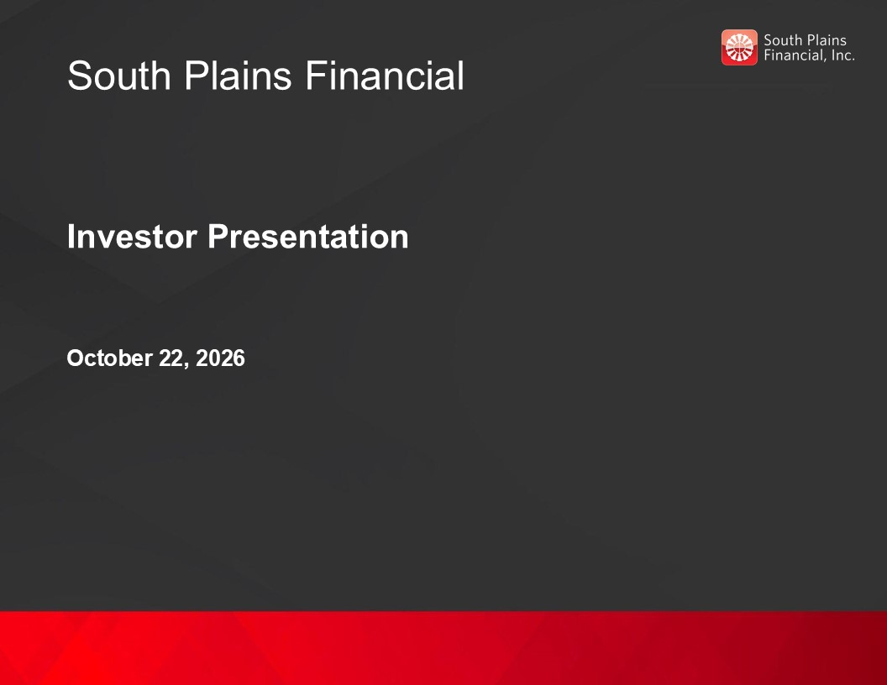
South Plains Financial Investor Presentation October 22, 2026

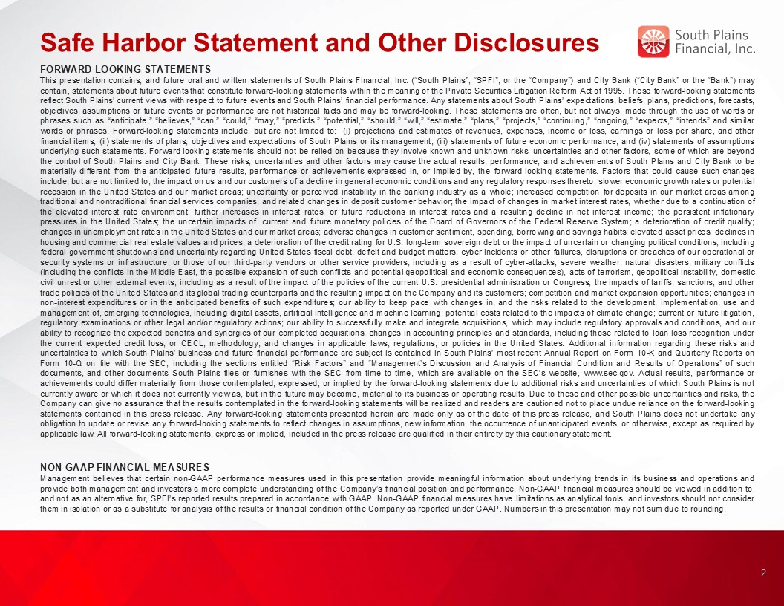
Safe Harbor Statement and Other Disclosures FORWARD-LOOKING STATEMENTS This presentation contains, and future oral and written statements of South Plains Financial, Inc. (“South Plains”, “SPFI”, or the “Company”) and City Bank (“City Bank” or the “Bank”) may contain, statements about future events that constitute forward-looking statements within the meaning of the Private Securities Litigation Reform Act of 1995. These forward-looking statements reflect South Plains’ current views with respect to future events and South Plains’ financial performance. Any statements about South Plains’ expectations, beliefs, plans, predictions, forecasts, objectives, assumptions or future events or performance are not historical facts and may be forward-looking. These statements are often, but not always, made through the use of words or phrases such as “anticipate,” “believes,” “can,” “could,” “may,” “predicts,” “potential,” “should,” “will,” “estimate,” “plans,” “projects,” “continuing,” “ongoing,” “expects,” “intends” and similar words or phrases. Forward-looking statements include, but are not limited to: (i) projections and estimates of revenues, expenses, income or loss, earnings or loss per share, and other financial items, (ii) statements of plans, objectives and expectations of South Plains or its management, (iii) statements of future economic performance, and (iv) statements of assumptions underlying such statements. Forward-looking statements should not be relied on because they involve known and unknown risks, uncertainties and other factors, some of which are beyond the control of South Plains and City Bank. These risks, uncertainties and other factors may cause the actual results, performance, and achievements of South Plains and City Bank to be materially different from the anticipated future results, performance or achievements expressed in, or implied by, the forward-looking statements. Factors that could cause such changes include, but are not limited to, the impact on us and our customers of a decline in general economic conditions and any regulatory responses thereto; slower economic growth rates or potential recession in the United States and our market areas; uncertainty or perceived instability in the banking industry as a whole; increased competition for deposits in our market areas among traditional and nontraditional financial services companies, and related changes in deposit customer behavior; the impact of changes in market interest rates, whether due to a continuation of the elevated interest rate environment, further increases in interest rates, or future reductions in interest rates and a resulting decline in net interest income; the persistent inflationary pressures in the United States; the uncertain impacts of current and future monetary policies of the Board of Governors of the Federal Reserve System; a deterioration of credit quality; changes in unemployment rates in the United States and our market areas; adverse changes in customer sentiment, spending, borrowing and savings habits; elevated asset prices; declines in housing and commercial real estate values and prices; a deterioration of the credit rating for U.S. long-term sovereign debt or the impact of uncertain or changing political conditions, including federal government shutdowns and uncertainty regarding United States fiscal debt, deficit and budget matters; cyber incidents or other failures, disruptions or breaches of our operational or security systems or infrastructure, or those of our third-party vendors or other service providers, including as a result of cyber-attacks; severe weather, natural disasters, military conflicts (including the conflicts in the Middle East, the possible expansion of such conflicts and potential geopolitical and economic consequences), acts of terrorism, geopolitical instability, domestic civil unrest or other external events, including as a result of the impact of the policies of the current U.S. presidential administration or Congress; the impacts of tariffs, sanctions, and other trade policies of the United States and its global trading counterparts and the resulting impact on the Company and its customers; competition and market expansion opportunities; changes in non-interest expenditures or in the anticipated benefits of such expenditures; our ability to keep pace with changes in, and the risks related to the development, implementation, use and management of, emerging technologies, including digital assets, artificial intelligence and machine learning; potential costs related to the impacts of climate change; current or future litigation, regulatory examinations or other legal and/or regulatory actions; our ability to successfully make and integrate acquisitions, which may include regulatory approvals and conditions, and our ability to recognize the expected benefits and synergies of our completed acquisitions; changes in accounting principles and standards, including those related to loan loss recognition under the current expected credit loss, or CECL, methodology; and changes in applicable laws, regulations, or policies in the United States. Additional information regarding these risks and uncertainties to which South Plains’ business and future financial performance are subject is contained in South Plains’ most recent Annual Report on Form 10-K and Quarterly Reports on Form 10-Q on file with the SEC, including the sections entitled “Risk Factors” and “Management’s Discussion and Analysis of Financial Condition and Results of Operations” of such documents, and other documents South Plains files or furnishes with the SEC from time to time, which are available on the SEC’s website, www.sec.gov. Actual results, performance or achievements could differ materially from those contemplated, expressed, or implied by the forward-looking statements due to additional risks and uncertainties of which South Plains is not currently aware or which it does not currently view as, but in the future may become, material to its business or operating results. Due to these and other possible uncertainties and risks, the Company can give no assurance that the results contemplated in the forward-looking statements will be realized and readers are cautioned not to place undue reliance on the forward-looking statements contained in this press release. Any forward-looking statements presented herein are made only as of the date of this press release, and South Plains does not undertake any obligation to update or revise any forward-looking statements to reflect changes in assumptions, new information, the occurrence of unanticipated events, or otherwise, except as required by applicable law. All forward-looking statements, express or implied, included in the press release are qualified in their entirety by this cautionary statement. NON-GAAP FINANCIAL MEASURES Management believes that certain non-GAAP performance measures used in this presentation provide meaningful information about underlying trends in its business and operations and provide both management and investors a more complete understanding of the Company’s financial position and performance. Non-GAAP financial measures should be viewed in addition to, and not as an alternative for, SPFI’s reported results prepared in accordance with GAAP. Non-GAAP financial measures have limitations as analytical tools, and investors should not consider them in isolation or as a substitute for analysis of the results or financial condition of the Company as reported under GAAP. Numbers in this presentation may not sum due to rounding. 2

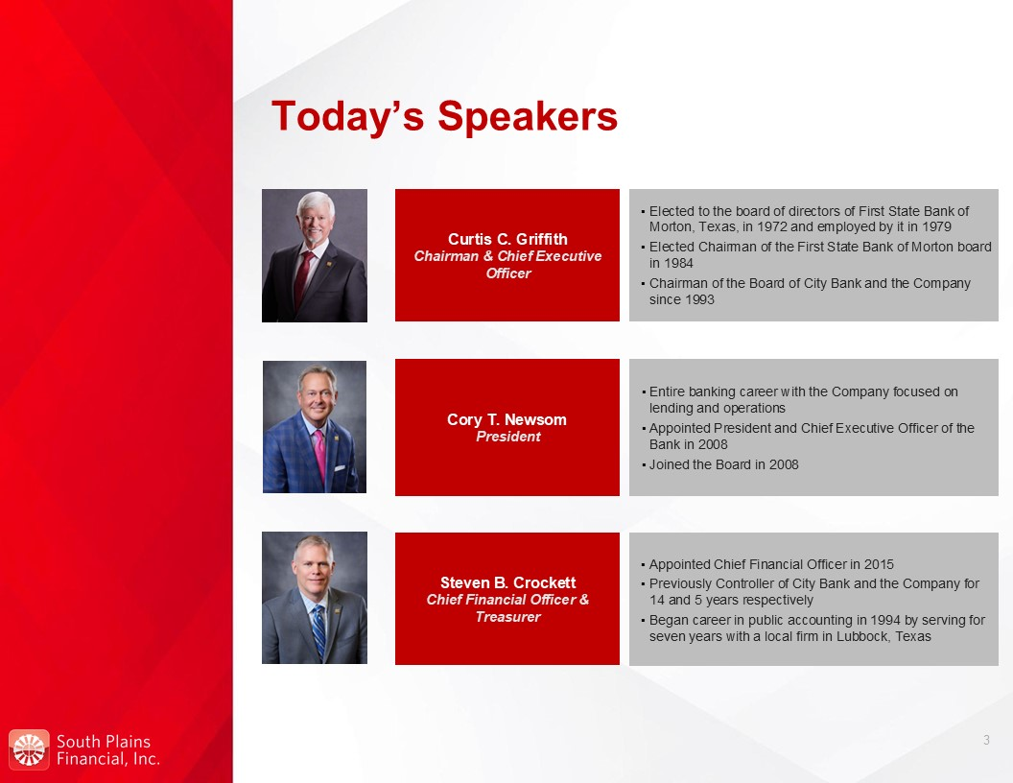
Today’s Speakers Curtis C. Griffith Chairman & Chief Executive Officer Elected to the board of directors of First State Bank of Morton, Texas, in 1972 and employed by it in 1979 Elected Chairman of the First State Bank of Morton board in 1984 Chairman of the Board of City Bank and the Company since 1993 Steven B. Crockett Chief Financial Officer & Treasurer Appointed Chief Financial Officer in 2015 Previously Controller of City Bank and the Company for 14 and 5 years respectively Began career in public accounting in 1994 by serving for seven years with a local firm in Lubbock, Texas Cory T. Newsom President Entire banking career with the Company focused on lending and operations Appointed President and Chief Executive Officer of the Bank in 2008 Joined the Board in 2008 3

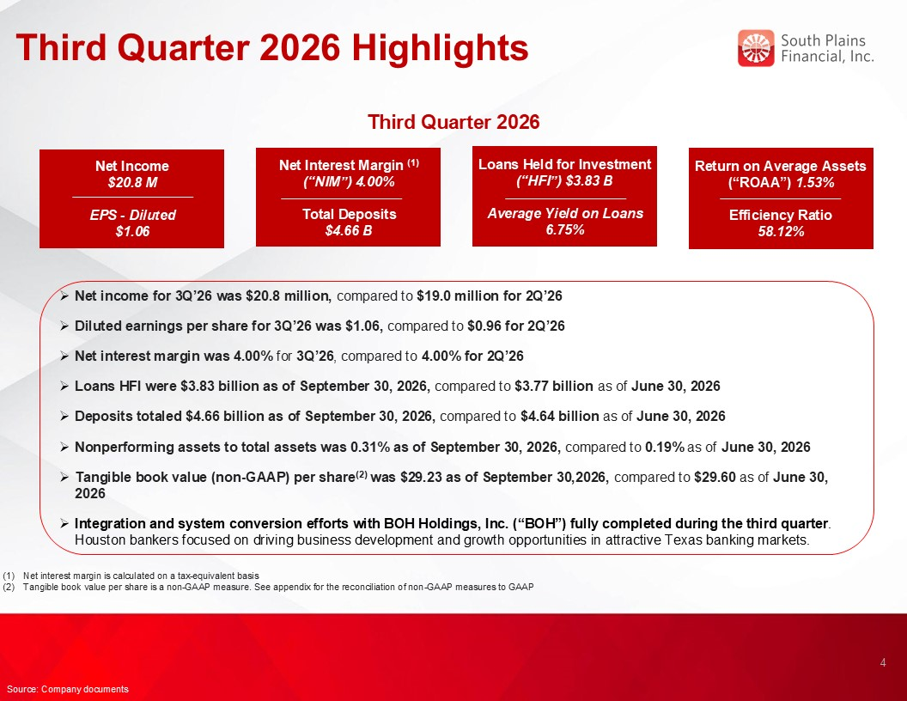
Third Quarter 2026 Highlights Net income for 3Q’26 was $20.8 million, compared to $19.0 million for 2Q’26 Diluted earnings per share for 3Q’26 was $1.06, compared to $0.96 for 2Q’26 Net interest margin was 4.00% for 3Q’26, compared to 4.00% for 2Q’26 Loans HFI were $3.83 billion as of September 30, 2026, compared to $3.77 billion as of June 30, 2026 Deposits totaled $4.66 billion as of September 30, 2026, compared to $4.64 billion as of June 30, 2026 Nonperforming assets to total assets was 0.31% as of September 30, 2026, compared to 0.19% as of June 30, 2026 Tangible book value (non-GAAP) per share(2) was $29.23 as of September 30,2026, compared to $29.60 as of June 30, 2026 Integration and system conversion efforts with BOH Holdings, Inc. (“BOH”) fully completed during the third quarter. Houston bankers focused on driving business development and growth opportunities in attractive Texas banking markets. 4 Source: Company documents Net interest margin is calculated on a tax-equivalent basis Tangible book value per share is a non-GAAP measure. See appendix for the reconciliation of non-GAAP measures to GAAP Loans Held for Investment (“HFI”) $3.83 B Average Yield on Loans 6.75% Net Income $20.8 M EPS - Diluted $1.06 Net Interest Margin (1) (“NIM”) 4.00% Total Deposits $4.66 B Return on Average Assets (“ROAA”) 1.53% Efficiency Ratio 58.12% Third Quarter 2026

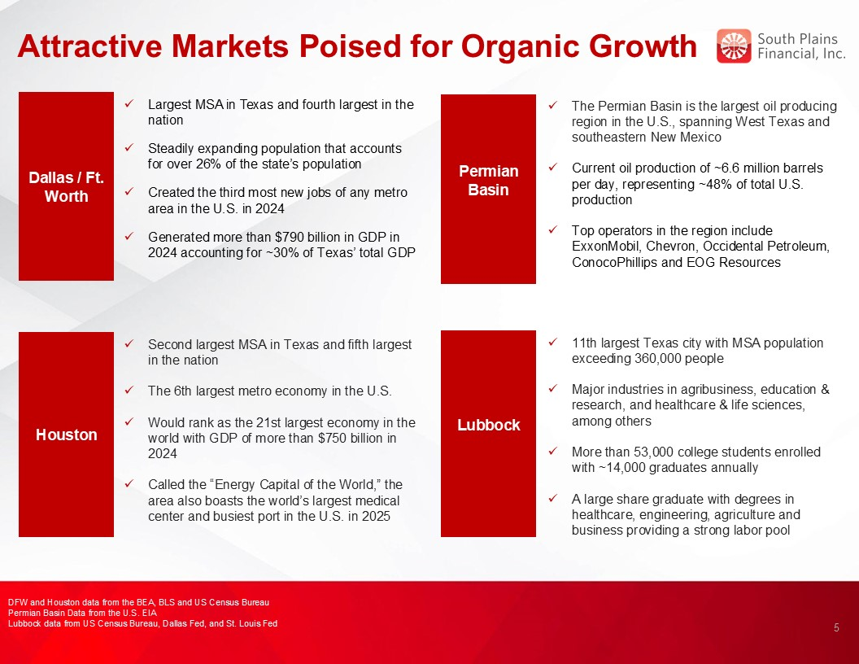
Attractive Markets Poised for Organic Growth Permian Basin Basin Dallas / Ft. Worth The Permian Basin is the largest oil producing region in the U.S., spanning West Texas and southeastern New Mexico Current oil production of ~6.6 million barrels per day, representing ~48% of total U.S. production Top operators in the region include ExxonMobil, Chevron, Occidental Petroleum, ConocoPhillips and EOG Resources Largest MSA in Texas and fourth largest in the nation Steadily expanding population that accounts for over 26% of the state’s population Created the third most new jobs of any metro area in the U.S. in 2024 Generated more than $790 billion in GDP in 2024 accounting for ~30% of Texas’ total GDP Houston Second largest MSA in Texas and fifth largest in the nation The 6th largest metro economy in the U.S. Would rank as the 21st largest economy in the world with GDP of more than $750 billion in 2024 Called the “Energy Capital of the World,” the area also boasts the world’s largest medical center and busiest port in the U.S. in 2025 Lubbock Basin 11th largest Texas city with MSA population exceeding 360,000 people Major industries in agribusiness, education & research, and healthcare & life sciences, among others More than 53,000 college students enrolled with ~14,000 graduates annually A large share graduate with degrees in healthcare, engineering, agriculture and business providing a strong labor pool 5 DFW and Houston data from the BEA, BLS and US Census Bureau Permian Basin Data from the U.S. EIA Lubbock data from US Census Bureau, Dallas Fed, and St. Louis Fed

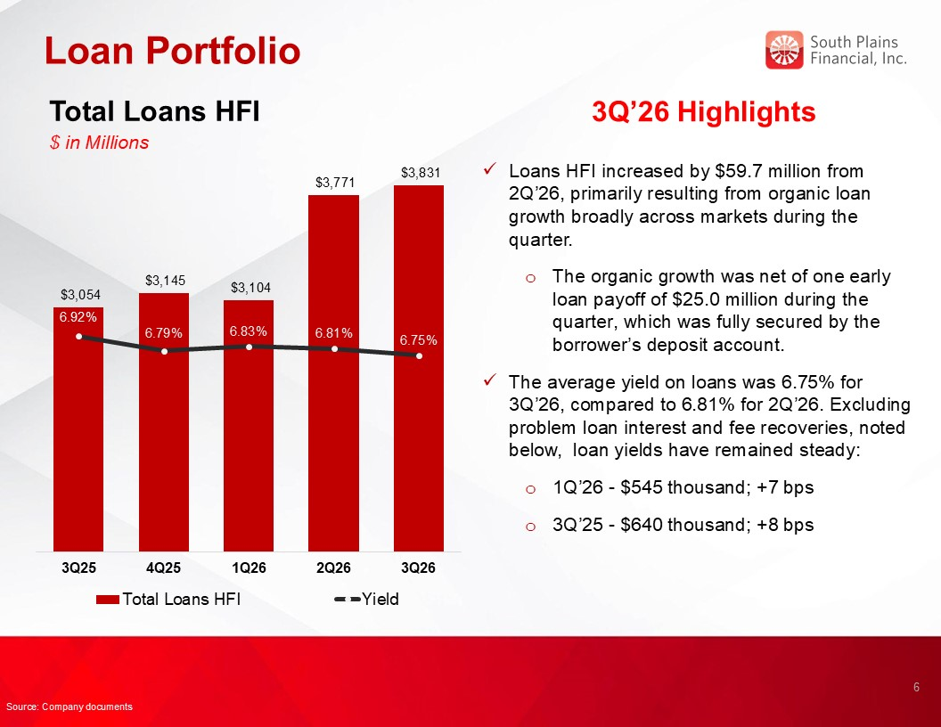
Loan Portfolio 3Q’26 Highlights Loans HFI increased by $59.7 million from 2Q’26, primarily resulting from organic loan growth broadly across markets during the quarter. The organic growth was net of one early loan payoff of $25.0 million during the quarter, which was fully secured by the borrower’s deposit account. The average yield on loans was 6.75% for 3Q’26, compared to 6.81% for 2Q’26. Excluding problem loan interest and fee recoveries, noted below, loan yields have remained steady: 1Q’26 - $545 thousand; +7 bps 3Q’25 - $640 thousand; +8 bps Total Loans HFI $ in Millions 6 Source: Company documents

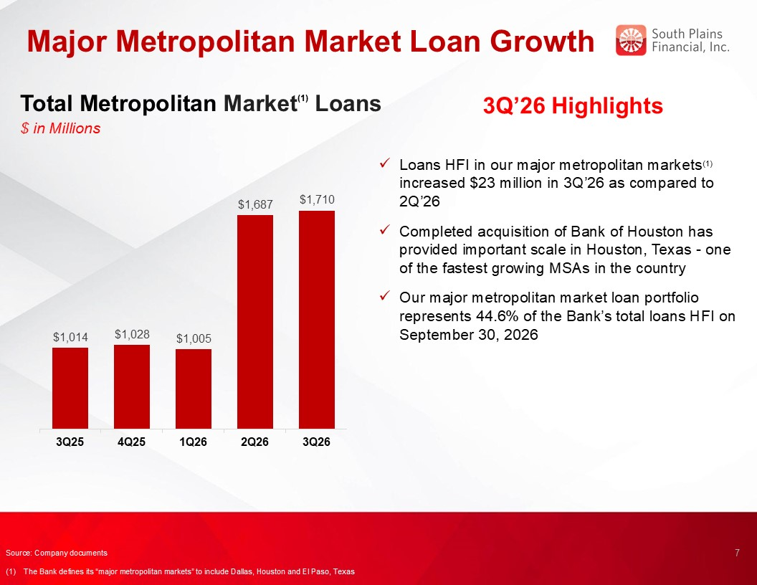
Major Metropolitan Market Loan Growth 3Q’26 Highlights Loans HFI in our major metropolitan markets(1) increased $23 million in 3Q’26 as compared to 2Q’26 Completed acquisition of Bank of Houston has provided important scale in Houston, Texas - one of the fastest growing MSAs in the country Our major metropolitan market loan portfolio represents 44.6% of the Bank’s total loans HFI on September 30, 2026 Total Metropolitan Market(1) Loans $ in Millions 7 5.00% Source: Company documents (1) The Bank defines its “major metropolitan markets” to include Dallas, Houston and El Paso, Texas

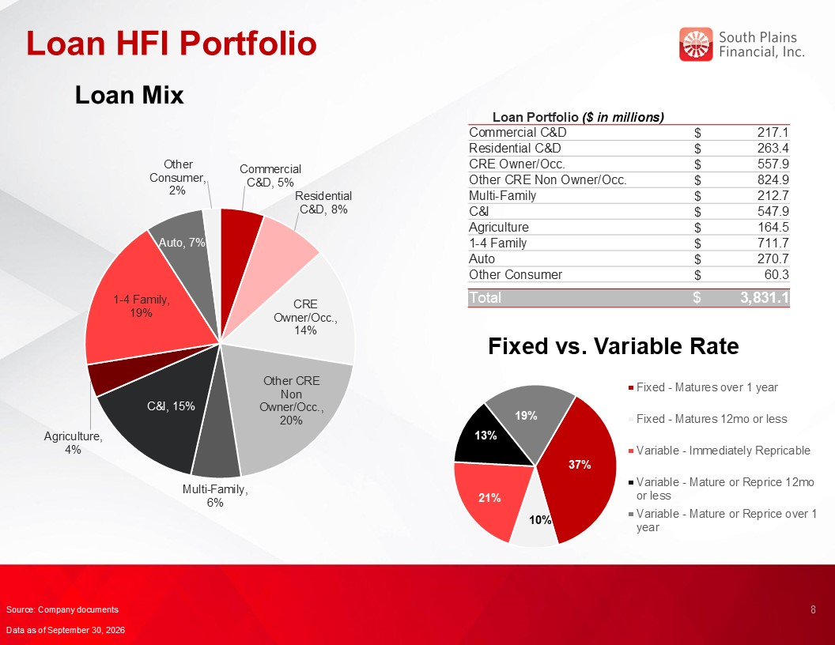
Loan HFI Portfolio Loan Mix Loan Portfolio ($ in millions) Commercial C&D $ 217.1 Residential C&D $ 263.4 CRE Owner/Occ. $ 557.9 Other CRE Non Owner/Occ. $ 824.9 Multi-Family $ 212.7 C&I $ 547.9 Agriculture $ 164.5 1-4 Family $ 711.7 Auto $ 270.7 Other Consumer $ 60.3 Total $ 3,831.1 Fixed vs. Variable Rate 8 Source: Company documents Data as of September 30, 2026

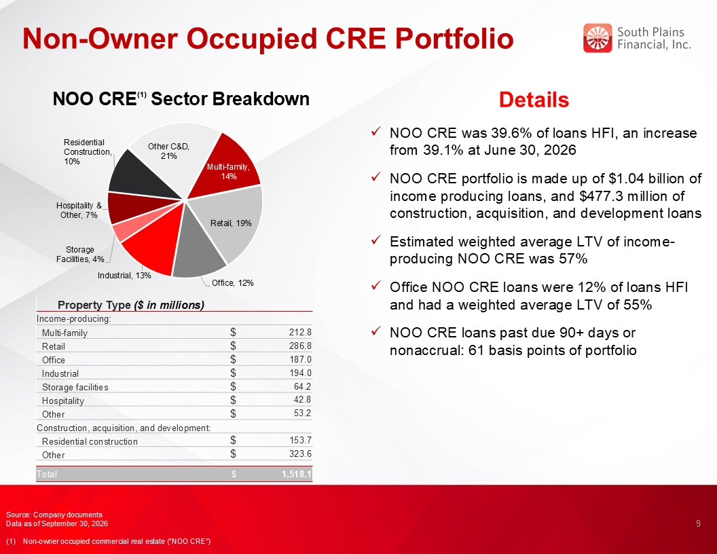
Non-Owner Occupied CRE Portfolio 9 Details NOO CRE was 39.6% of loans HFI, an increase from 39.1% at June 30, 2026 NOO CRE portfolio is made up of $1.04 billion of income producing loans, and $477.3 million of construction, acquisition, and development loans Estimated weighted average LTV of income-producing NOO CRE was 57% Office NOO CRE loans were 12% of loans HFI and had a weighted average LTV of 55% NOO CRE loans past due 90+ days or nonaccrual: 61 basis points of portfolio NOO CRE(1) Sector Breakdown Source: Company documents Data as of September 30, 2026 (1) Non-owner occupied commercial real estate (“NOO CRE”) Property Type ($ in millions) Income-producing: Multi-family $ 212.8 Retail $ 286.8 Office $ 187.0 Industrial $ 194.0 Storage facilities $ 64.2 Hospitality $ 42.8 Other $ 53.2 Construction, acquisition, and development: Residential construction $ 153.7 Other $ 323.6 Total $ 1,518.1

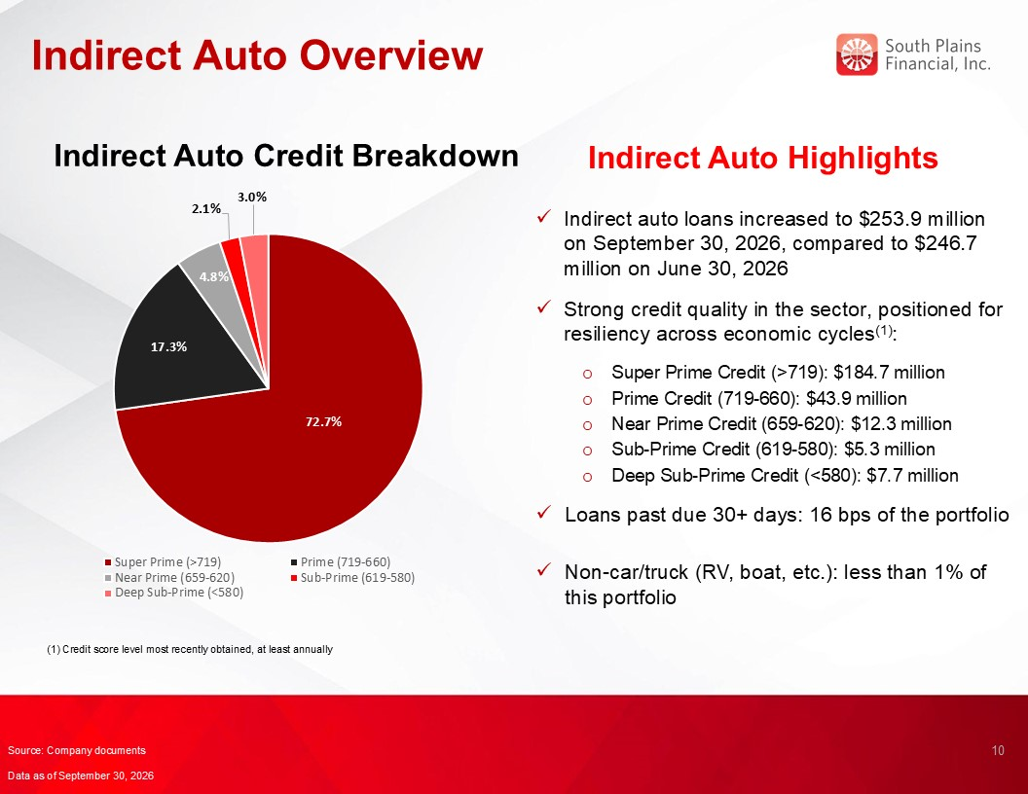
Indirect Auto Overview Indirect Auto Highlights Indirect auto loans increased to $253.9 million on September 30, 2026, compared to $246.7 million on June 30, 2026 Strong credit quality in the sector, positioned for resiliency across economic cycles(1): Super Prime Credit (>719): $184.7 million Prime Credit (719-660): $43.9 million Near Prime Credit (659-620): $12.3 million Sub-Prime Credit (619-580): $5.3 million Deep Sub-Prime Credit (<580): $7.7 million Loans past due 30+ days: 16 bps of the portfolio Non-car/truck (RV, boat, etc.): less than 1% of this portfolio Indirect Auto Credit Breakdown 10 Source: Company documents Data as of September 30, 2026 (1) Credit score level most recently obtained, at least annually

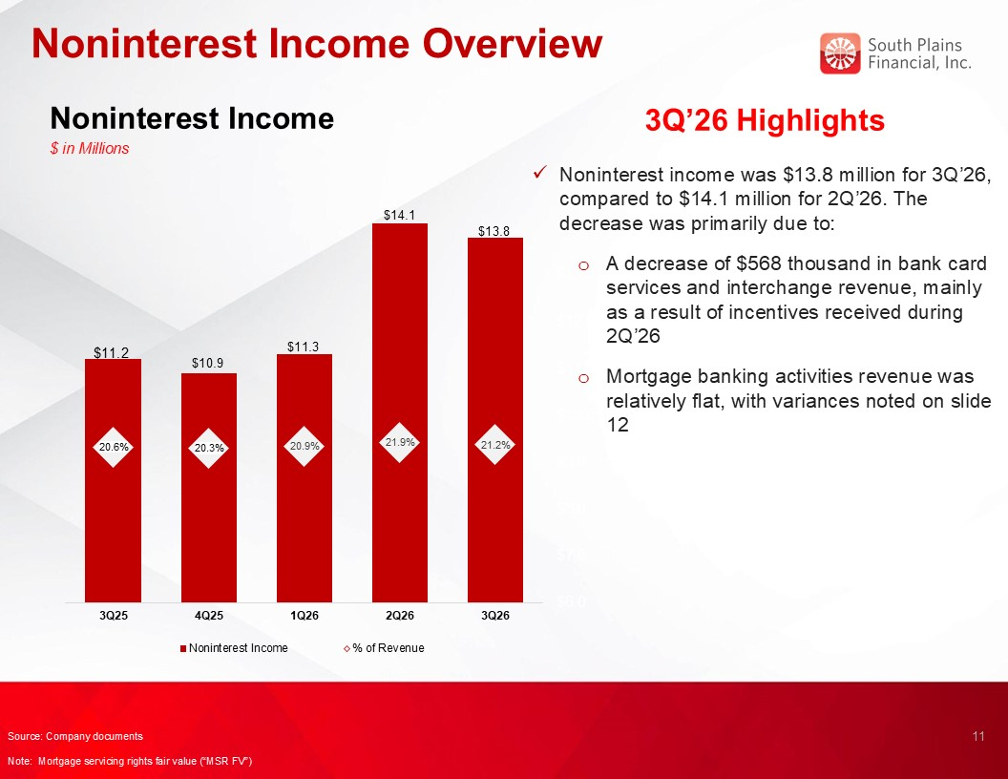
Noninterest Income Overview Noninterest Income $ in Millions 3Q’26 Highlights Noninterest income was $13.8 million for 3Q’26, compared to $14.1 million for 2Q’26. The decrease was primarily due to: A decrease of $568 thousand in bank card services and interchange revenue, mainly as a result of incentives received during 2Q’26 Mortgage banking activities revenue was relatively flat, with variances noted on slide 12 11 Source: Company documents Note: Mortgage servicing rights fair value (“MSR FV”)

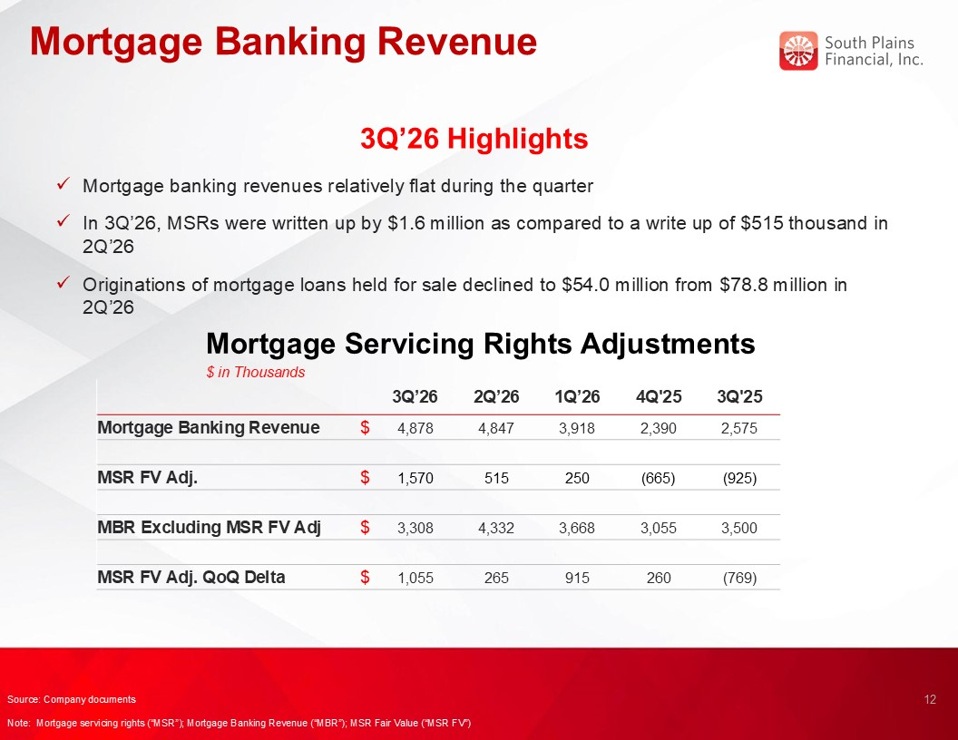
Mortgage Banking Revenue Mortgage Servicing Rights Adjustments $ in Thousands 3Q’26 Highlights Mortgage banking revenues relatively flat during the quarter In 3Q’26, MSRs were written up by $1.6 million as compared to a write up of $515 thousand in 2Q’26 Originations of mortgage loans held for sale declined to $54.0 million from $78.8 million in 2Q’26 12 Source: Company documents Note: Mortgage servicing rights (“MSR”); Mortgage Banking Revenue (“MBR”); MSR Fair Value (“MSR FV”) 3Q’26 2Q’26 1Q’26 4Q'25 3Q'25 Mortgage Banking Revenue $ 4,878 4,847 3,918 2,390 2,575 MSR FV Adj. $ 1,570 515 250 (665) (925) MBR Excluding MSR FV Adj $ 3,308 4,332 3,668 3,055 3,500 MSR FV Adj. QoQ Delta $ 1,055 265 915 260 (769)

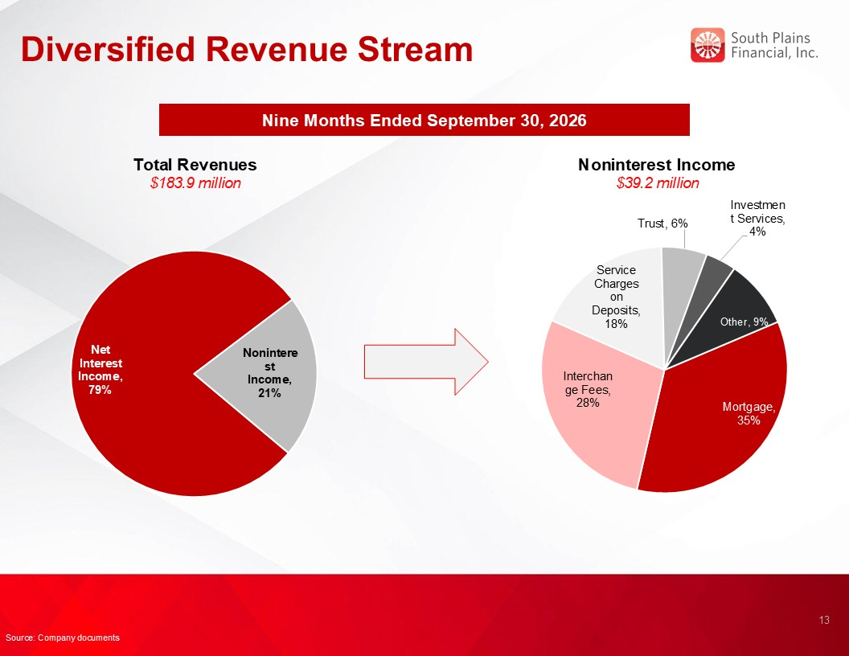
Diversified Revenue Stream Nine Months Ended September 30, 2026 Total Revenues $183.9 million Noninterest Income $39.2 million 13 Source: Company documents

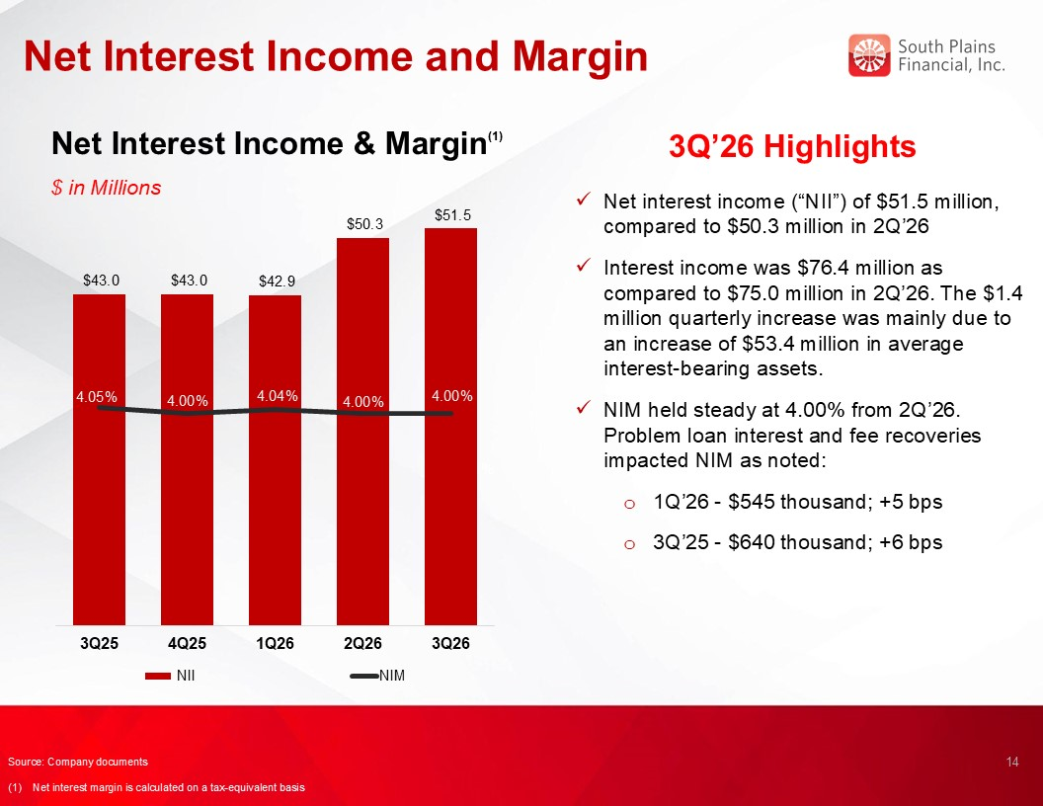
Net Interest Income and Margin Net Interest Income & Margin(1) $ in Millions 3Q’26 Highlights Net interest income (“NII”) of $51.5 million, compared to $50.3 million in 2Q’26 Interest income was $76.4 million as compared to $75.0 million in 2Q’26. The $1.4 million quarterly increase was mainly due to an increase of $53.4 million in average interest-bearing assets. NIM held steady at 4.00% from 2Q’26. Problem loan interest and fee recoveries impacted NIM as noted: 1Q’26 - $545 thousand; +5 bps 3Q’25 - $640 thousand; +6 bps 14 3.54% Source: Company documents (1) Net interest margin is calculated on a tax-equivalent basis

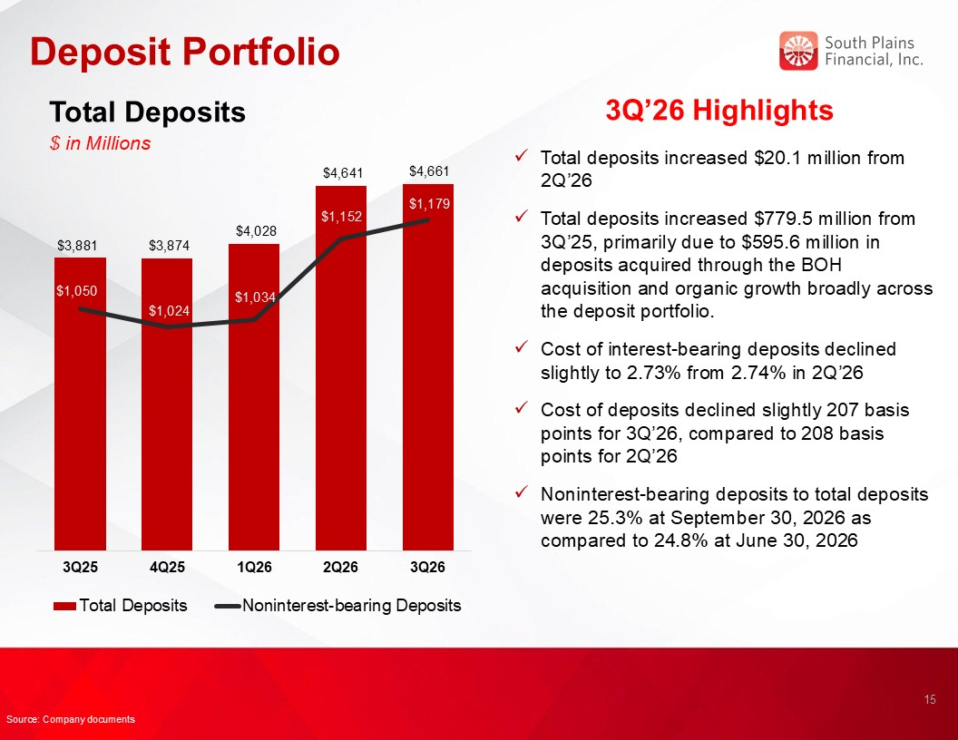
Deposit Portfolio Total Deposits $ in Millions 3Q’26 Highlights Total deposits increased $20.1 million from 2Q’26 Total deposits increased $779.5 million from 3Q’25, primarily due to $595.6 million in deposits acquired through the BOH acquisition and organic growth broadly across the deposit portfolio. Cost of interest-bearing deposits declined slightly to 2.73% from 2.74% in 2Q’26 Cost of deposits declined slightly 207 basis points for 3Q’26, compared to 208 basis points for 2Q’26 Noninterest-bearing deposits to total deposits were 25.3% at September 30, 2026 as compared to 24.8% at June 30, 2026 15 Source: Company documents

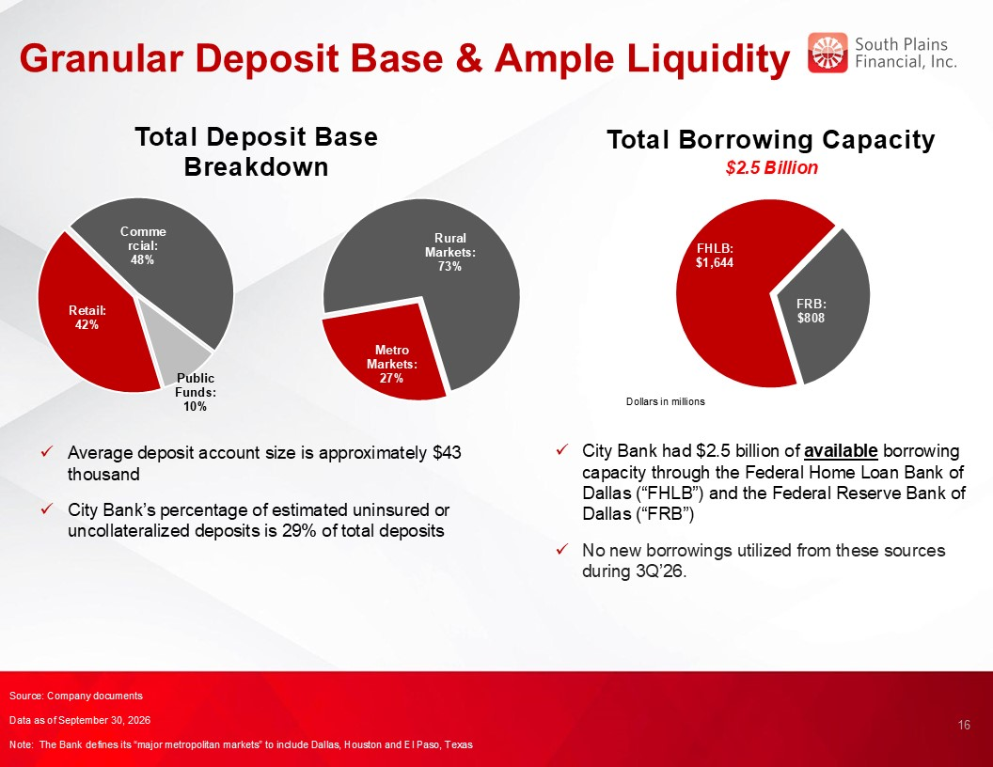
Granular Deposit Base & Ample Liquidity Total Borrowing Capacity $2.5 Billion 16 Total Deposit Base Breakdown Average deposit account size is approximately $43 thousand City Bank’s percentage of estimated uninsured or uncollateralized deposits is 29% of total deposits City Bank had $2.5 billion of available borrowing capacity through the Federal Home Loan Bank of Dallas (“FHLB”) and the Federal Reserve Bank of Dallas (“FRB”) No new borrowings utilized from these sources during 3Q’26. Source: Company documents Data as of September 30, 2026 Note: The Bank defines its “major metropolitan markets” to include Dallas, Houston and El Paso, Texas

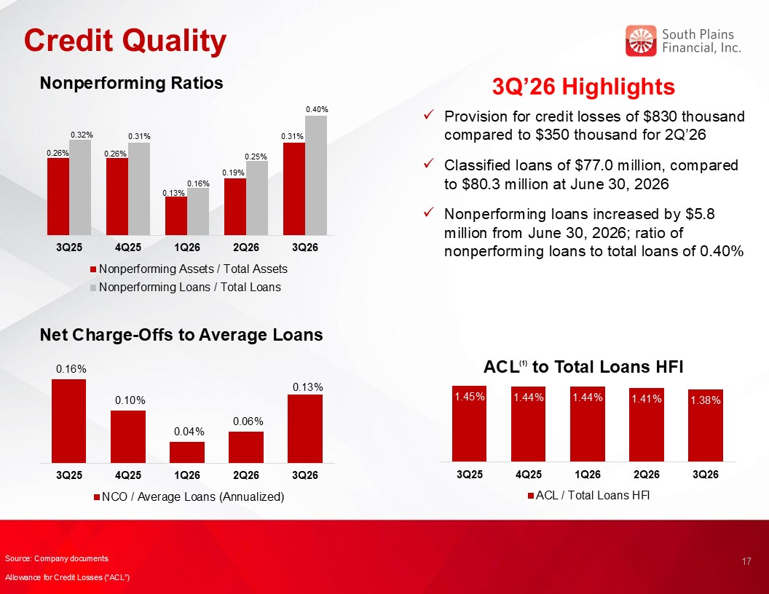
Credit Quality 3Q’26 Highlights Nonperforming Ratios Net Charge-Offs to Average Loans ACL(1) to Total Loans HFI 17 Provision for credit losses of $830 thousand compared to $350 thousand for 2Q’26 Classified loans of $77.0 million, compared to $80.3 million at June 30, 2026 Nonperforming loans increased by $5.8 million from June 30, 2026; ratio of nonperforming loans to total loans of 0.40% Source: Company documents Allowance for Credit Losses (“ACL”)

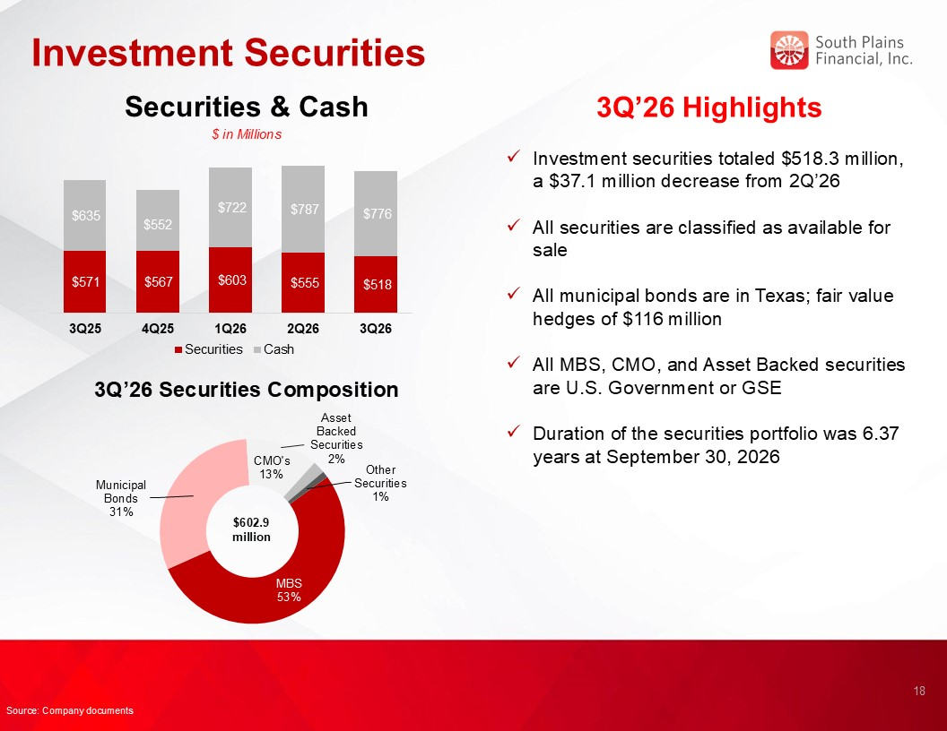
Investment Securities 3Q’26 Highlights Investment securities totaled $518.3 million, a $37.1 million decrease from 2Q’26 All securities are classified as available for sale All municipal bonds are in Texas; fair value hedges of $116 million All MBS, CMO, and Asset Backed securities are U.S. Government or GSE Duration of the securities portfolio was 6.37 years at September 30, 2026 3Q’26 Securities Composition $602.9 million Securities & Cash $ in Millions 18 Source: Company documents

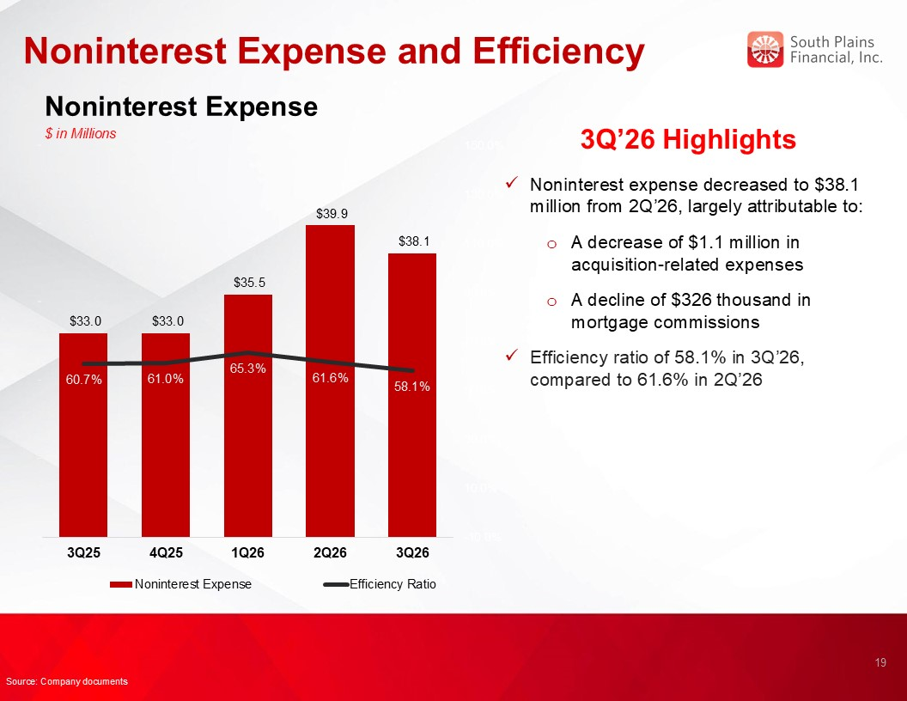
Noninterest Expense and Efficiency 3Q’26 Highlights Noninterest expense decreased to $38.1 million from 2Q’26, largely attributable to: A decrease of $1.1 million in acquisition-related expenses A decline of $326 thousand in mortgage commissions Efficiency ratio of 58.1% in 3Q’26, compared to 61.6% in 2Q’26 19 Source: Company documents Noninterest Expense $ in Millions

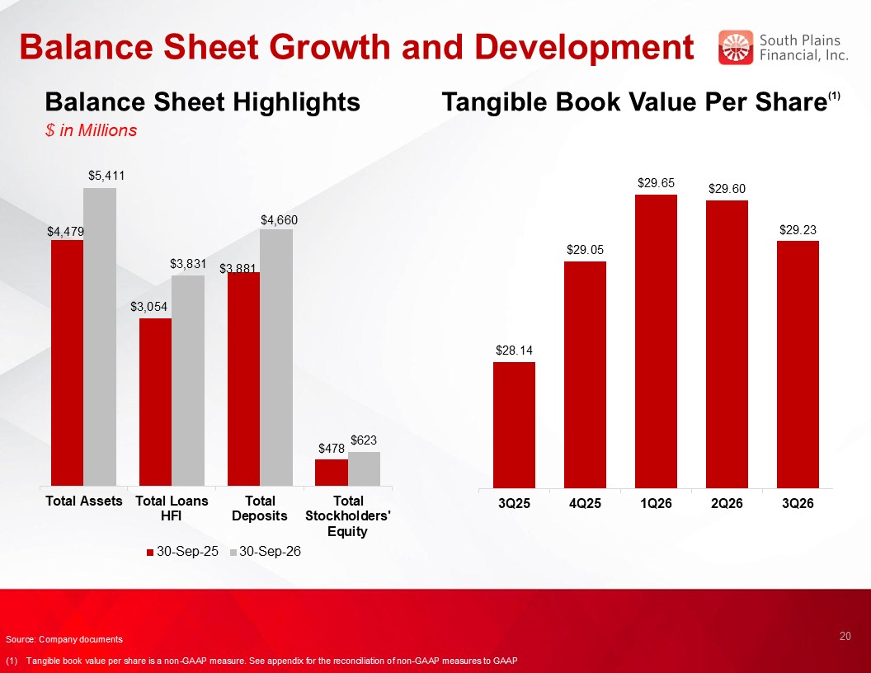
Balance Sheet Growth and Development Balance Sheet Highlights $ in Millions Tangible Book Value Per Share(1) 20 Source: Company documents (1) Tangible book value per share is a non-GAAP measure. See appendix for the reconciliation of non-GAAP measures to GAAP

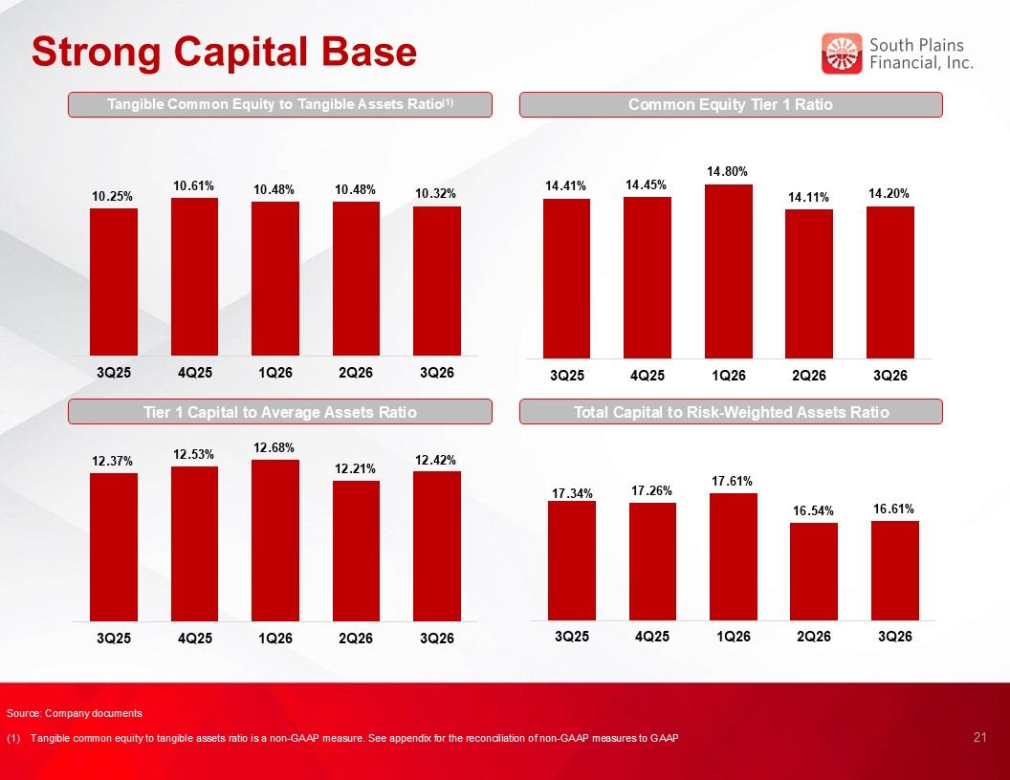
Strong Capital Base Common Equity Tier 1 Ratio Tier 1 Capital to Average Assets Ratio Total Capital to Risk-Weighted Assets Ratio 21 Source: Company documents (1) Tangible common equity to tangible assets ratio is a non-GAAP measure. See appendix for the reconciliation of non-GAAP measures to GAAP Tangible Common Equity to Tangible Assets Ratio(1)


SPFI’s Core Purpose and Values Align Centered on Relationship-Based Business Our Core Purpose is: To use the power of relationships to help people succeed and live better HELP ALL STAKEHOLDERS SUCCEED Employees → great benefits and opportunities to grow and make a difference. Customers → personalized advice and solutions to achieve their goals. Partners → responsive, trusted win-win partnerships enabling both parties to succeed together. Shareholders → share in the prosperity and performance of the Bank. THE POWER OF RELATIONSHIPS At SPFI, we build lifelong, trusted relationships so you know you always have someone in your corner that understands you, cares about you, and stands ready to help. LIVE BETTER We want to help everyone live better. At the end of the day, we do what we do to help enhance lives. We create a great place to work, help people achieve their goals, and invest generously in our communities because there’s nothing more rewarding than helping people succeed and live better. 22

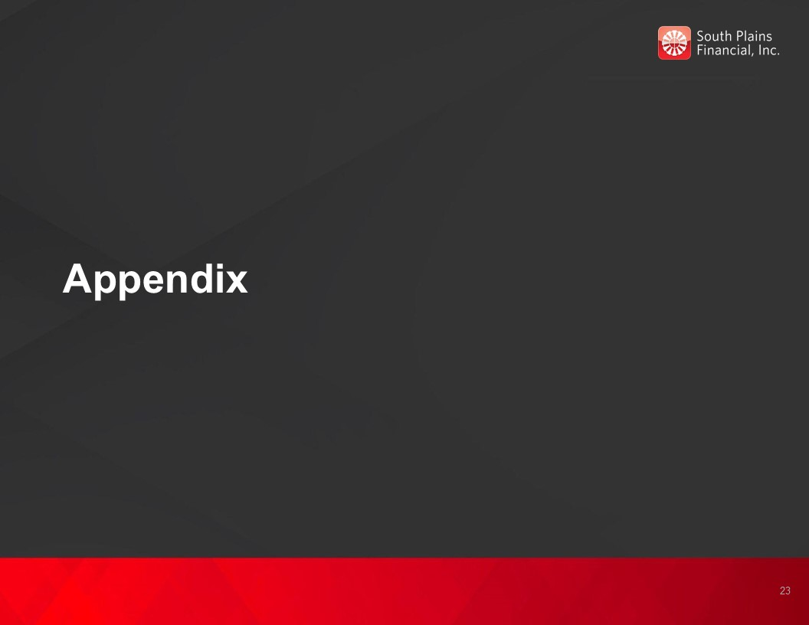
Appendix 23

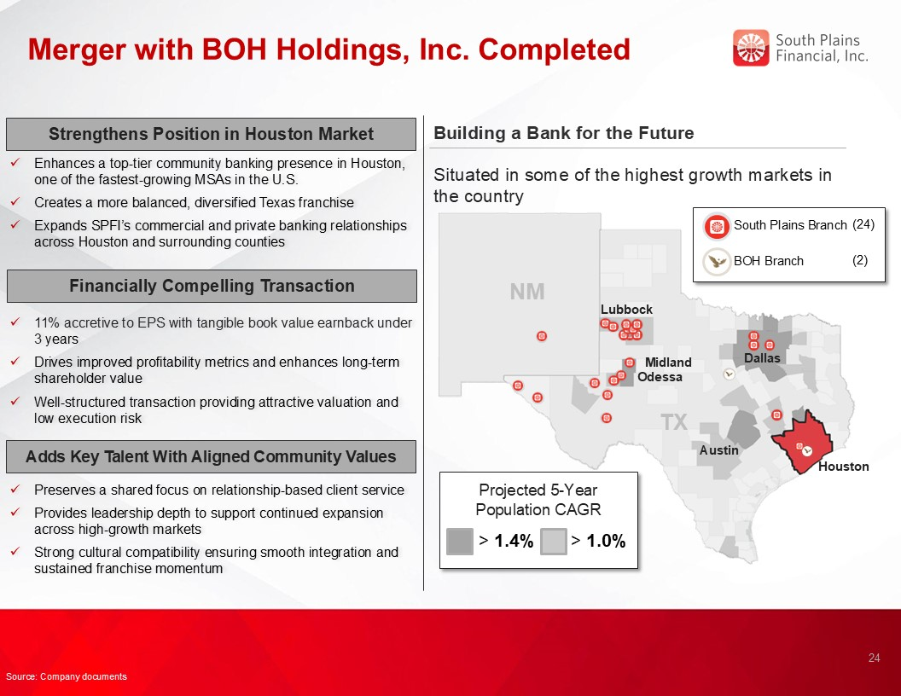
Merger with BOH Holdings, Inc. Completed Building a Bank for the Future Houston Odessa Austin Midland > 1.4% Situated in some of the highest growth markets in the country Projected 5-Year Population CAGR > 1.0% TX NM Lubbock Dallas South Plains Branch (24) BOH Branch (2) 24 Strengthens Position in Houston Market Enhances a top-tier community banking presence in Houston, one of the fastest-growing MSAs in the U.S. Creates a more balanced, diversified Texas franchise Expands SPFI’s commercial and private banking relationships across Houston and surrounding counties 11% accretive to EPS with tangible book value earnback under 3 years Drives improved profitability metrics and enhances long-term shareholder value Well-structured transaction providing attractive valuation and low execution risk Financially Compelling Transaction Preserves a shared focus on relationship-based client service Provides leadership depth to support continued expansion across high-growth markets Strong cultural compatibility ensuring smooth integration and sustained franchise momentum Adds Key Talent With Aligned Community Values Source: Company documents

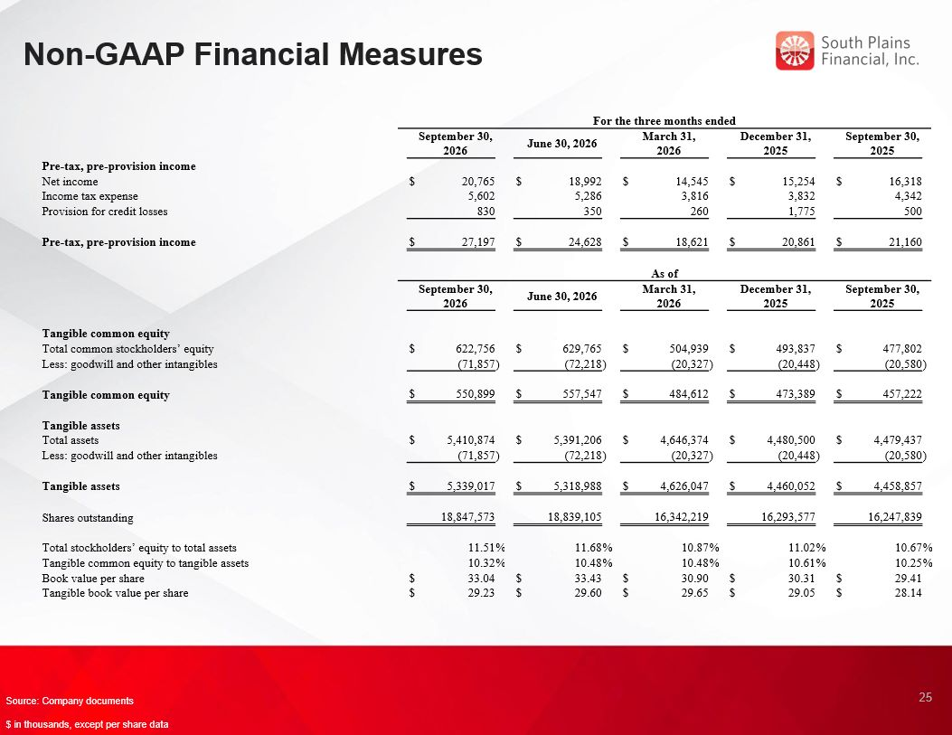
Non-GAAP Financial Measures 25 Source: Company documents $ in thousands, except per share data For the three months ended September 30, 2026 June 30, 2026 March 31, 2026 December 31, 2025 September 30, 2025 Pre-tax, pre-provision income Net income $ 20,765 $ 18,992 $ 14,545 $ 15,254 $ 16,318 Income tax expense 5,602 5,286 3,816 3,832 4,342 Provision for credit losses 830 350 260 1,775 500 Pre-tax, pre-provision income $ 27,197 $ 24,628 $ 18,621 $ 20,861 $ 21,160 As of September 30, 2026 June 30, 2026 March 31, 2026 December 31, 2025 September 30, 2025 Tangible common equity Total common stockholders’ equity $ 622,756 $ 629,765 $ 504,939 $ 493,837 $ 477,802 Less: goodwill and other intangibles (71,857 ) (72,218 ) (20,327 ) (20,448 ) (20,580 ) Tangible common equity $ 550,899 $ 557,547 $ 484,612 $ 473,389 $ 457,222 Tangible assets Total assets $ 5,410,874 $ 5,391,206 $ 4,646,374 $ 4,480,500 $ 4,479,437 Less: goodwill and other intangibles (71,857 ) (72,218 ) (20,327 ) (20,448 ) (20,580 ) Tangible assets $ 5,339,017 $ 5,318,988 $ 4,626,047 $ 4,460,052 $ 4,458,857 Shares outstanding 18,847,573 18,839,105 16,342,219 16,293,577 16,247,839 Total stockholders’ equity to total assets 11.51 % 11.68 % 10.87 % 11.02 % 10.67 % Tangible common equity to tangible assets 10.32 % 10.48 % 10.48 % 10.61 % 10.25 % Book value per share $ 33.04 $ 33.43 $ 30.90 $ 30.31 $ 29.41 Tangible book value per share $ 29.23 $ 29.60 $ 29.65 $ 29.05 $ 28.14

Exhibit 99.3



South Plains Financial, Inc. Announces 6% Increase to Quarterly Cash Dividend

LUBBOCK, Texas, October 22, 2026 (GLOBE NEWSWIRE) -- South Plains Financial, Inc. (NASDAQ:SPFI) (“South Plains”), the parent company of City Bank, today announced that its Board of Directors has declared a quarterly cash dividend of $0.19 per share of common stock, a 6% increase from the most recent quarterly cash dividend declared in July 2026. The dividend is payable on November 16, 2026 to shareholders of record as of the close of business on November 2, 2026.

About South Plains Financial, Inc.
South Plains is the bank holding company for City Bank, a Texas state-chartered bank headquartered in Lubbock, Texas. City Bank is one of the largest independent banks in West Texas and has additional banking operations in the Dallas, El Paso, Greater Houston, the Permian Basin, and College Station, Texas markets, and the Ruidoso, New Mexico market. South Plains provides a wide range of commercial and consumer financial services to small and medium-sized businesses and individuals in its market areas. Its principal business activities include commercial and retail banking, along with investment, trust and mortgage services. Please visit https://www.spfi.bank for more information.

Contact
Mikella Newsom, Chief Risk Officer and Secretary
(866) 771-3347
investors@city.bank

Source: South Plains Financial, Inc.

