UNITED STATES

SECURITIES AND EXCHANGE COMMISSION
Washington, D.C. 20549

FORM 8-K

CURRENT REPORT

Pursuant to Section 13 or 15(d) of

the Securities Exchange Act of 1934

Date of Report (Date of earliest event reported): July 18, 2024

South Plains Financial, Inc.

(Exact name of registrant as specified in its charter)

Texas

(State or other jurisdiction of incorporation)

001-38895

(Commission File Number)

75-2453320

(IRS Employer Identification No.)

5219 City Bank Parkway

Lubbock, Texas

(Address of principal executive offices)

79407

(Zip Code)

(806) 792-7101

(Registrant’s telephone number, including area code)

Check the appropriate box below if the Form 8-K filing is intended to simultaneously satisfy the filing obligation of the registrant under any of the following provisions:

- Written communications pursuant to Rule 425 under the Securities Act (17 CFR 230.425)

- Soliciting material pursuant to Rule 14a-12 under the Exchange Act (17 CFR 240.14a-12)

- Pre-commencement communications pursuant to Rule 14d-2(b) under the Exchange Act (17 CFR 240.14d-2(b))

- Pre-commencement communications pursuant to Rule 13e-4(c) under the Exchange Act (17 CFR 240.13e-4(c)) Securities registered pursuant to Section 12(b) of the Act:
Title of each class | Trading Symbol(s) | Name of each exchange on which registered
Common Stock, par value $1.00 per share | SPFI | The Nasdaq Stock Market LLC

Indicate by check mark whether the registrant is an emerging growth company as defined in Rule 405 of the Securities Act of 1933 (§230.405 of this chapter) or Rule 12b-2 of the Securities Exchange Act of 1934 (§240.12b-2 of this chapter).

Emerging growth company ☒

If an emerging growth company, indicate by check mark if the registrant has elected not to use the extended transition period for complying with any new or revised financial accounting standards provided pursuant to Section 13(a) of the Exchange Act. ☐

Item 2.02 Results of Operations and Financial Condition.

On July 18, 2024, South Plains Financial, Inc. (the “Company”) issued a press release announcing its financial results for the second quarter ended June 30, 2024. A copy of the Company’s press release covering such announcement and certain other matters is furnished as Exhibit 99.1 to this Current Report on Form 8-K.

Item 7.01 Regulation FD Disclosure.

On July 18, 2024, officers of the Company will have a conference call with respect to the Company’s financial results for the second quarter ended June 30, 2024. An earnings release slide presentation highlighting the Company’s financial results for the second quarter ended June 30, 2024 is furnished as Exhibit 99.2 to this Current Report on Form 8-K. This earnings release slide presentation will also be available on the Company’s website, www.spfi.bank, under the “News & Events” section.

In accordance with General Instruction B.2 of Form 8-K, the information in Items 2.02 and 7.01 of this Current Report on Form 8-K, including Exhibit 99.1 and Exhibit 99.2 furnished herewith, shall not be deemed “filed” for the purposes of Section 18 of the Securities Exchange Act of 1934, as amended (the “Exchange Act”), or otherwise subject to the liabilities of that section. The information in Items 2.02 and 7.01 of this Current Report on Form 8-K, including Exhibit 99.1 and Exhibit 99.2 furnished herewith, shall not be incorporated by reference into any filing or other document pursuant to the Exchange Act or the Securities Act of 1933, as amended, except as shall be expressly set forth by specific reference in such filing or document.

Item 8.01 Other Events.

On July 18, 2024, South Plains Financial, Inc. issued a press release announcing the declaration of a quarterly cash dividend of $0.14 per share on its outstanding common stock. The dividend will be paid on August 12, 2024 to shareholders of record as of the close of business on July 29, 2024. A copy of the press release is attached hereto as Exhibit 99.3 and is incorporated herein by reference.

Item 9.01 Financial Statements and Exhibits.

- Exhibits.

99.1 Press release, dated July 18, 2024, announcing second quarter 2024 financial results of South Plains Financial, Inc.

99.2 Earnings release slide presentation, dated July 18, 2024.

99.3 Press release, dated July 18, 2024, announcing South Plains Financial, Inc. quarterly cash dividend.

104 Cover Page Interactive Data File (formatted as Inline XBRL).

SIGNATURES

Pursuant to the requirements of the Securities Exchange Act of 1934, the registrant has duly caused this report to be signed on its behalf by the undersigned hereunto duly authorized.

SOUTH PLAINS FINANCIAL, INC.

Date: July 18, 2024 By: /s/ Steven B. Crockett

Steven B. Crockett

Chief Financial Officer and Treasurer

Exhibit 99.1


South Plains Financial, Inc. Reports Second Quarter 2024 Financial Results

LUBBOCK, Texas, July 18, 2024 (GLOBE NEWSWIRE) – South Plains Financial, Inc. (NASDAQ:SPFI) (“South Plains” or the “Company”), the parent company of City Bank (“City Bank” or the “Bank”), today reported its financial results for the quarter ended June 30, 2024.

Second Quarter 2024 Highlights

- Net income for the second quarter of 2024 was $11.1 million, compared to $10.9 million for the first quarter of 2024 and $29.7 million for the second quarter of 2023. The decrease in net income for the second quarter of 2024 as compared to the second quarter of 2023 was primarily due to the sale of Windmark Insurance Agency, Inc. (“Windmark”) in the second quarter of 2023, which resulted in a gain of $33.5 million before taxes and related expenses.
- Diluted earnings per share for the second quarter of 2024 was $0.66, compared to $0.64 for the first quarter of 2024 and $1.71 for the second quarter of 2023.

- Average cost of deposits for the second quarter of 2024 was 243 basis points, compared to 241 basis points for the first quarter of 2024 and 169 basis points for the second quarter of 2023.

- Net interest margin, calculated on a tax-equivalent basis, was 3.63% for the second quarter of 2024, compared to 3.56% for the first quarter of 2024 and 3.65% for the second quarter of 2023.

- Nonperforming assets to total assets were 0.57% at June 30, 2024, compared to 0.10% at March 31, 2024 and 0.51% at June 30, 2023.

- Return on average assets for the second quarter of 2024 was 1.07% annualized, compared to 1.04% annualized for the first quarter of 2024 and 2.97% annualized for the second quarter of 2023.
- Tangible book value (non-GAAP) per share was $24.15 as of June 30, 2024, compared to $23.56 as of March 31, 2024 and $21.82 as of June 30, 2023.

- The consolidated total risk-based capital ratio, Common Equity Tier 1 risk-based capital ratio, and Tier 1 leverage ratio at June 30, 2024 were 16.86%, 12.61%, and 11.81%, respectively. These ratios significantly exceeded the minimum regulatory levels necessary to be deemed “well-capitalized”.

Curtis Griffith, South Plains’ Chairman and Chief Executive Officer, commented, “Our second quarter results demonstrate our successful efforts to drive profitability and returns as we continue to strive to be a high performing bank. Strength in the quarter came from robust loan growth which lifted the yield on our loan portfolio and contributed to our net interest margin expansion. We also continued to closely manage our liquidity with a focus on maximizing the profitability and returns of the Bank. This led to a modest reduction in customer deposits as we worked to keep deposit costs steady through the quarter. Importantly, we believe competitive pressures for deposits have started to ease while new loan yields have remained robust, leading to our solid net interest margin expansion in the quarter. We also continue to aggressively manage the credit quality of our loan portfolio, having moved a multi-family property loan to nonaccrual during the period. This is a loan that we have had rated substandard since June of last year and have been closely monitoring and proactively working on the credit over that time period. Our actions demonstrate our credit culture, which is focused on identifying problems early, working with our borrowers and taking the appropriate steps to resolve challenges. Looking forward, we believe we are in a solid position as the credit quality of our loan portfolio is strong, we have ample opportunities to drive organic growth across our markets, and we continue to significantly exceed the minimum regulatory levels necessary for the Company and the Bank to be deemed well capitalized.”

Results of Operations, Quarter Ended June 30, 2024

Net Interest Income

Net interest income was $35.9 million for the second quarter of 2024, compared to $35.4 million for the first quarter of 2024 and $34.6 million for the second quarter of 2023. Net interest margin, calculated on a tax-equivalent basis, was 3.63% for the second quarter of 2024, compared to 3.56% for the first quarter of 2024 and 3.65% for the second quarter of 2023. The average yield on loans was 6.60% for the second quarter of 2024, compared to 6.53% for the first quarter of 2024 and 5.94% for the second quarter of 2023. The average cost of deposits was 243 basis points for the second quarter of 2024, which is 2 basis points higher than the first quarter of 2024 and 74 basis points higher than the second quarter of 2023.

Interest income was $59.2 million for the second quarter of 2024, compared to $58.7 million for the first quarter of 2024 and $50.8 million for the second quarter of 2023. Interest income increased $481 thousand in the second quarter of 2024 from the first quarter of 2024, which was primarily comprised of an increase of $1.6 million in loan interest income and a decrease of $930 thousand in interest income on other interest-earning assets. The growth in loan interest income was due to an increase in average loans of $68.1 million and a rise of 7 basis points in the yield on loans. The decrease in interest income on other interest-earning assets was predominately a result of deploying liquidity into loans during the quarter. Interest income increased $8.4 million in the second quarter of 2024 compared to the second quarter of 2023. This increase was primarily due to an increase of average loans of $188.5 million and higher market interest rates during the period, resulting in growth of $7.7 million in loan interest income, and a higher liquidity level year over year.

Interest expense was $23.3 million for the second quarter of 2024, compared to $23.4 million for the first quarter of 2024 and $16.2 million for the second quarter of 2023. Interest expense was flat compared to the first quarter of 2024 and increased $7.1 million compared to the second quarter of 2023. The $7.1 million increase was primarily as a result of significantly higher short-term interest rates on interest-bearing liabilities, with the increase being mainly comprised of interest expense on deposits. Additionally, interest-bearing deposits were higher during the second quarter of 2024 compared to the second quarter of 2023, which also contributed to the higher interest expense.

Noninterest Income and Noninterest Expense

Noninterest income was $12.7 million for the second quarter of 2024, compared to $11.4 million for the first quarter of 2024 and $47.1 million for the second quarter of 2023. The increase from the first quarter of 2024 was primarily due to increases of $1.0 million in bank card services and interchange revenue mainly as a result of continued growth in customer card usage and incentives received during the period and $408 thousand in income from investments in Small Business Investment Companies. These increases were partially offset by a decrease of $548 thousand in mortgage banking revenues, mainly from a decrease of $735 thousand in the fair value adjustment of the mortgage servicing rights assets as interest rates that affect the value were relatively flat after rising modestly in the first quarter of 2024. The decrease in noninterest income for the second quarter of 2024 as compared to the second quarter of 2023 was primarily due to the $33.5 million gain on sale of Windmark in the second quarter of 2023 and a decrease of $1.9 million in mortgage banking activities revenue. The decrease of $1.9 million in mortgage banking revenues was mainly from a decline of $1.1 million in the fair value adjustment of the mortgage servicing rights assets as interest rates that affect the value were relatively flat after rising modestly in the second quarter of 2023 and an increase of $14.3 million in originations of mortgage loans held for sale due to typical seasonality.

Noninterest expense was $32.6 million for the second quarter of 2024, compared to $31.9 million for the first quarter of 2024 and $40.5 million for the second quarter of 2023. The $642 thousand increase from the first quarter of 2024 was largely the result of a rise of $436 thousand in mortgage commission expense as mortgage loan originations increased. The decrease in noninterest expense for the second quarter of 2024 as compared to the second quarter of 2023 was largely the result of second quarter 2023 activities of $4.5 million in personnel and transaction expenses as part of the aforementioned Windmark sale plus related incentive compensation and a $3.4 million loss on the sale of securities.

Loan Portfolio and Composition

Loans held for investment were $3.09 billion as of June 30, 2024, compared to $3.01 billion as of March 31, 2024 and $2.98 billion as of June 30, 2023. The $82.5 million, or 2.7%, increase during the second quarter of 2024 as compared to the first quarter of 2024 remained relationship-focused and occurred primarily in direct-energy loans, seasonal agricultural-related loans, and single-family property loans, partially offset by decreases in consumer auto loans. As of June 30, 2024, loans held for investment increased $115.2 million, or 3.9%, from June 30, 2023, primarily attributable to strong organic loan growth, occurring mainly in multi-family property loans, direct-energy loans, and single-family property loans, partially offset by decreases in consumer auto loans.

Deposits and Borrowings

Deposits totaled $3.62 billion as of June 30, 2024, compared to $3.64 billion as of March 31, 2024 and $3.57 billion as of June 30, 2023. Deposits decreased by $14.1 million, or 0.4%, in the second quarter of 2024 from March 31, 2024. As of June 30, 2024, deposits increased $50.0 million, or 1.4%, from June 30, 2023. Noninterest-bearing deposits were $951.6 million as of June 30, 2024, compared to $974.2 million as of March 31, 2024 and $1.10 billion as of June 30, 2023. Noninterest-bearing deposits represented 26.3% of total deposits as of June 30, 2024. The quarterly change in total deposits was mainly due to a modest decrease in noninterest-bearing deposits. The year-over-year increase in total deposits was primarily the result of growth of $71 million in brokered deposits in the third quarter of 2023 given the overall focus in the banking industry on improving liquidity.

Asset Quality

The Company recorded a provision for credit losses in the second quarter of 2024 of $1.8 million, compared to $830 thousand in the first quarter of 2024 and $3.7 million in the second quarter of 2023. The provision during the first quarter of 2024 was largely attributable to net charge-off activity, increased loan balances, and higher nonperforming loans during the quarter.

The ratio of allowance for credit losses to loans held for investment was 1.40% as of June 30, 2024, compared to 1.40% as of March 31, 2024 and 1.45% as of June 30, 2023.

The ratio of nonperforming assets to total assets was 0.57% as of June 30, 2024, compared to 0.10% as of March 31, 2024 and 0.51% as of June 30, 2023. A previously classified $20.6 million multi-family property credit was placed on nonaccrual status in the second quarter of 2024 after the maturity date was accelerated. Annualized net charge-offs were 0.10% for the second quarter of 2024, compared to 0.13% for the first quarter of 2024 and 0.05% for the second quarter of 2023.

Capital

Book value per share increased to $25.45 at June 30, 2024, compared to $24.87 at March 31, 2024. The change was primarily driven by $8.8 million of net income after dividends paid. Tangible common equity to tangible assets (non-GAAP) increased 22 basis points to 9.44% in the second quarter of 2024.

Conference Call

South Plains will host a conference call to discuss its second quarter 2024 financial results today, July 18, 2024, at 5:00 p.m., Eastern Time. Investors and analysts interested in participating in the call are invited to dial 1-877-407-9716 (international callers please dial 1-201-493-6779) approximately 10 minutes prior to the start of the call. A live audio webcast of the conference call and conference materials will be available on the Company’s website at https://www.spfi.bank/news-events/events.

A replay of the conference call will be available within two hours of the conclusion of the call and can be accessed on the investor section of the Company’s website as well as by dialing 1-844-512-2921 (international callers please dial 1-412-317-6671). The pin to access the telephone replay is 13747117. The replay will be available until August 1, 2024.

About South Plains Financial, Inc.

South Plains is the bank holding company for City Bank, a Texas state-chartered bank headquartered in Lubbock, Texas. City Bank is one of the largest independent banks in West Texas and has additional banking operations in the Dallas, El Paso, Greater Houston, the Permian Basin, and College Station, Texas markets, and the Ruidoso, New Mexico market. South Plains provides a wide range of commercial and consumer financial services to small and medium-sized businesses and individuals in its market areas. Its principal business activities include commercial and retail banking, along with investment, trust and mortgage services. Please visit https://www.spfi.bank for more information.

Non-GAAP Financial Measures

Some of the financial measures included in this press release are not measures of financial performance recognized in accordance with generally accepted accounting principles in the United States (“GAAP”). These non-GAAP financial measures include Tangible Book Value Per Share, Tangible Common Equity to Tangible Assets, and Pre-Tax, Pre-Provision Income. The Company believes these non-GAAP financial measures provide both management and investors a more complete understanding of the Company’s financial position and performance. These non-GAAP financial measures are supplemental and are not a substitute for any analysis based on GAAP financial measures.

We classify a financial measure as being a non-GAAP financial measure if that financial measure excludes or includes amounts, or is subject to adjustments that have the effect of excluding or including amounts, that are included or excluded, as the case may be, in the most directly comparable measure calculated and presented in accordance with GAAP as in effect from time to time in the United States in our statements of income, balance sheets or statements of cash flows. Not all companies use the same calculation of these measures; therefore, this presentation may not be comparable to other similarly titled measures as presented by other companies.

A reconciliation of non-GAAP financial measures to GAAP financial measures is provided at the end of this press release.

Available Information

The Company routinely posts important information for investors on its web site (under www.spfi.bank and, more specifically, under the News & Events tab at www.spfi.bank/news-events/press-releases). The Company intends to use its web site as a means of disclosing material non-public information and for complying with its disclosure obligations under Regulation FD (Fair Disclosure) promulgated by the U.S. Securities and Exchange Commission (the “SEC”). Accordingly, investors should monitor the Company’s web site, in addition to following the Company’s press releases, SEC filings, public conference calls, presentations and webcasts.

The information contained on, or that may be accessed through, the Company’s web site is not incorporated by reference into, and is not a part of, this document.

Forward Looking Statements

This press release contains forward-looking statements within the meaning of the Private Securities Litigation Reform Act of 1995. These forward-looking statements reflect South Plains’ current views with respect to future events and South Plains’ financial performance. Any statements about South Plains’ expectations, beliefs, plans, predictions, forecasts, objectives, assumptions or future events or performance are not historical facts and may be forward-looking. These statements are often, but not always, made through the use of words or phrases such as “anticipate,” “believes,” “can,” “could,” “may,” “predicts,” “potential,” “should,” “will,” “estimate,” “plans,” “projects,” “continuing,” “ongoing,” “expects,” “intends” and similar words or phrases. South Plains cautions that the forward-looking statements in this press release are based largely on South Plains’ expectations and are subject to a number of known and unknown risks and uncertainties that are subject to change based on factors which are, in many instances, beyond South Plains’ control. Factors that could cause such changes include, but are not limited to, the impact on us and our customers of a decline in general economic conditions and any regulatory responses thereto; potential recession in the United States and our market areas; the impacts related to or resulting from bank failures and any continuation of uncertainty in the banking industry, including the associated impact to the Company and other financial institutions of any regulatory changes or other mitigation efforts taken by government agencies in response thereto; increased competition for deposits in our market areas and related changes in deposit customer behavior; the impact of changes in market interest rates, whether due to continued elevated interest rates or potential reduction in interest rates and a resulting decline in net interest income; the persistence of the current inflationary pressures, or the resurgence of elevated levels of inflation, in the United States and our market areas; the uncertain impacts of ongoing quantitative tightening and current and future monetary policies of the Board of Governors of the Federal Reserve System; increases in unemployment rates in the United States and our market areas; declines in commercial real estate values and prices; uncertainty regarding United States fiscal debt and budget matters; cyber incidents or other failures, disruptions or breaches of our operational or security systems or infrastructure, or those of our third-party vendors or other service providers, including as a result of cyber attacks; severe weather, natural disasters, acts of war or terrorism, geopolitical instability or other external events; competition and market expansion opportunities; changes in non-interest expenditures or in the anticipated benefits of such expenditures; the risks related to the development, implementation, use and management of emerging technologies, including artificial intelligence and machine learnings; potential increased regulatory requirements and costs related to the transition and physical impacts of climate change; current or future litigation, regulatory examinations or other legal and/or regulatory actions; and changes in applicable laws and regulations. Additional information regarding these risks and uncertainties to which South Plains’ business and future financial performance are subject is contained in South Plains’ most recent Annual Report on Form 10-K and Quarterly Reports on Form 10-Q on file with the SEC, including the sections entitled “Risk Factors” and “Management’s Discussion and Analysis of Financial Condition and Results of Operations” of such documents, and other documents South Plains files or furnishes with the SEC from time to time, which are available on the SEC’s website, www.sec.gov. Actual results, performance or achievements could differ materially from those contemplated, expressed, or implied by the forward-looking statements due to additional risks and uncertainties of which South Plains is not currently aware or which it does not currently view as, but in the future may become, material to its business or operating results. Due to these and other possible uncertainties and risks, the Company can give no assurance that the results contemplated in the forward-looking statements will be realized and readers are cautioned not to place undue reliance on the forward-looking statements contained in this press release. Any forward-looking statements presented herein are made only as of the date of this press release, and South Plains does not undertake any obligation to update or revise any forward-looking statements to reflect changes in assumptions, new information, the occurrence of unanticipated events, or otherwise, except as required by applicable law. All forward-looking statements, express or implied, included in the press release are qualified in their entirety by this cautionary statement.

Contact: Mikella Newsom, Chief Risk Officer and Secretary

- 771-3347 investors@city.bank

Source: South Plains Financial, Inc.

South Plains Financial, Inc.

Consolidated Financial Highlights - (Unaudited)

(Dollars in thousands, except share data)

 |  |  |  |  | As of and for the quarter ended
 |  |  | June 30, |  | March 31, |  | December 31, |  | September 30, |  | June 30,
 |  |  | 2024 |  | 2024 |  | 2023 |  | 2023 |  | 2023
Selected Income Statement Data:
Interest income | $ |  | 59,208 | $ | 58,727 | $ | 57,236 | $ | 56,528 | $ | 50,821
Interest expense |  |  | 23,320 |  | 23,359 |  | 22,074 |  | 20,839 |  | 16,240
Net interest income |  |  | 35,888 |  | 35,368 |  | 35,162 |  | 35,689 |  | 34,581
Provision for credit losses |  |  | 1,775 |  | 830 |  | 600 |  | (700) |  | 3,700
Noninterest income |  |  | 12,709 |  | 11,409 |  | 9,146 |  | 12,277 |  | 47,112
Noninterest expense |  |  | 32,572 |  | 31,930 |  | 30,597 |  | 31,489 |  | 40,499
Income tax expense |  |  | 3,116 |  | 3,143 |  | 2,787 |  | 3,683 |  | 7,811
Net income |  |  | 11,134 |  | 10,874 |  | 10,324 |  | 13,494 |  | 29,683
Per Share Data (Common Stock):
Net earnings, basic |  |  | 0.68 |  | 0.66 |  | 0.63 |  | 0.80 |  | 1.74
Net earnings, diluted |  |  | 0.66 |  | 0.64 |  | 0.61 |  | 0.78 |  | 1.71
Cash dividends declared and paid |  |  | 0.14 |  | 0.13 |  | 0.13 |  | 0.13 |  | 0.13
Book value |  |  | 25.45 |  | 24.87 |  | 24.80 |  | 22.39 |  | 23.13
Tangible book value (non-GAAP) |  |  | 24.15 |  | 23.56 |  | 23.47 |  | 21.07 |  | 21.82
Weighted average shares outstanding, basic |  |  | 16,425,360 |  | 16,429,919 |  | 16,443,908 |  | 16,842,594 |  | 17,048,432
Weighted average shares outstanding, dilutive |  |  | 16,932,077 |  | 16,938,857 |  | 17,008,892 |  | 17,354,182 |  | 17,386,515
Shares outstanding at end of period |  |  | 16,424,021 |  | 16,431,755 |  | 16,417,099 |  | 16,600,442 |  | 16,952,072
Selected Period End Balance Sheet Data:
Cash and cash equivalents |  |  | 298,006 |  | 371,939 |  | 330,158 |  | 352,424 |  | 295,581
Investment securities |  |  | 591,031 |  | 599,869 |  | 622,762 |  | 584,969 |  | 628,093
Total loans held for investment |  |  | 3,094,273 |  | 3,011,799 |  | 3,014,153 |  | 2,993,563 |  | 2,979,063
Allowance for credit losses |  |  | 43,173 |  | 42,174 |  | 42,356 |  | 42,075 |  | 43,137
Total assets |  |  | 4,220,936 |  | 4,218,993 |  | 4,204,793 |  | 4,186,440 |  | 4,150,129
Interest-bearing deposits |  |  | 2,672,948 |  | 2,664,397 |  | 2,651,952 |  | 2,574,361 |  | 2,473,755
Noninterest-bearing deposits |  |  | 951,565 |  | 974,174 |  | 974,201 |  | 1,046,253 |  | 1,100,767
Total deposits |  |  | 3,624,513 |  | 3,638,571 |  | 3,626,153 |  | 3,620,614 |  | 3,574,522
Borrowings |  |  | 110,261 |  | 110,214 |  | 110,168 |  | 122,493 |  | 122,447
Total stockholders’ equity |  |  | 417,985 |  | 408,712 |  | 407,114 |  | 371,716 |  | 392,029
Summary Performance Ratios:
Return on average assets (annualized) |  |  | 1.07% |  | 1.04% |  | 0.99% |  | 1.27% |  | 2.97%
Return on average equity (annualized) |  |  | 10.83% |  | 10.72% |  | 10.52% |  | 14.01% |  | 31.33%
Net interest margin ⁽¹⁾ |  |  | 3.63% |  | 3.56% |  | 3.52% |  | 3.52% |  | 3.65%
Yield on loans |  |  | 6.60% |  | 6.53% |  | 6.29% |  | 6.10% |  | 5.94%
Cost of interest-bearing deposits |  |  | 3.33% |  | 3.27% |  | 3.14% |  | 2.93% |  | 2.45%
Efficiency ratio |  |  | 66.72% |  | 67.94% |  | 68.71% |  | 65.34% |  | 49.39%
Summary Credit Quality Data:
Nonperforming loans |  |  | 23,452 |  | 3,380 |  | 5,178 |  | 4,783 |  | 21,039
Nonperforming loans to total loans held for investment |  |  | 0.76% |  | 0.11% |  | 0.17% |  | 0.16% |  | 0.71%
Other real estate owned |  |  | 755 |  | 862 |  | 912 |  | 242 |  | 249
Nonperforming assets to total assets |  |  | 0.57% |  | 0.10% |  | 0.14% |  | 0.12% |  | 0.51%
Allowance for credit losses to total loans held for investment |  |  | 1.40% |  | 1.40% |  | 1.41% |  | 1.41% |  | 1.45%
Net charge-offs to average loans outstanding (annualized) |  |  | 0.10% |  | 0.13% |  | 0.08% |  | 0.05% |  | 0.05%

 |  |  | As of and for the quarter ended
 | June 30 |  | March 31, | December 31, | September 30, | June 30,
2024 |  |  | 2024 | 2023 | 2023 | 2023
Capital Ratios:
Total stockholders’ equity to total assets |  | 9.90% | 9.69% | 9.68% | 8.88% | 9.45%
Tangible common equity to tangible assets (non-GAAP) |  | 9.44% | 9.22% | 9.21% | 8.40% | 8.96%
Common equity tier 1 to risk-weighted assets |  | 12.61% | 12.67% | 12.41% | 12.19% | 12.11%
Tier 1 capital to average assets |  | 11.81% | 11.51% | 11.33% | 11.13% | 11.67%
Total capital to risk-weighted assets |  | 16.86% | 17.00% | 16.74% | 16.82% | 16.75%

(1) Net interest margin is calculated as the annual net interest income, on a fully tax-equivalent basis, divided by average interest-earning assets.

South Plains Financial, Inc.

Average Balances and Yields - (Unaudited)

(Dollars in thousands)

 |  |  |  |  |  |  |  |  |  | For the Three Months Ended
 |  |  |  |  |  |  |  | June 30, 2024 |  |  |  |  |  |  |  |  | June 30, 2023
 |  |  |  | Average |  |  |  |  |  |  |  |  | Average
 |  |  |  | Balance |  |  |  | Interest |  | Yield/Rate |  |  | Balance |  |  |  | Interest |  | Yield/Rate
Assets
 | Loans | $ |  | 3,082,601 |  | $ |  | 50,579 |  | 6.60% |  | $ | 2,894,087 |  | $ |  | 42,872 |  | 5.94%
 | Debt securities - taxable |  |  | 533,553 |  |  |  | 5,285 |  | 3.98% |  |  | 575,983 |  |  |  | 5,365 |  | 3.74%
 | Debt securities - nontaxable |  |  | 155,408 |  |  |  | 1,022 |  | 2.64% |  |  | 210,709 |  |  |  | 1,403 |  | 2.67%
 | Other interest-bearing assets |  |  | 225,720 |  |  |  | 2,545 |  | 4.53% |  |  | 149,996 |  |  |  | 1,484 |  | 3.97%
 | Total interest-earning assets |  |  | 3,997,282 |  |  |  | 59,431 |  | 5.98% |  |  | 3,830,775 |  |  |  | 51,124 |  | 5.35%
 | Noninterest-earning assets |  |  | 171,472 |  |  |  |  |  |  |  |  | 182,752
 | Total assets | $ |  | 4,168,754 |  |  |  |  |  |  |  | $ | 4,013,527
 | Liabilities & stockholders’ equity
 | NOW, Savings, MMDA’s | $ |  | 2,221,427 |  |  |  | 17,652 |  | 3.20% |  | $ | 2,059,182 |  |  |  | 12,484 |  | 2.43%
 | Time deposits |  |  | 392,778 |  |  |  | 3,977 |  | 4.07% |  |  | 299,358 |  |  |  | 1,949 |  | 2.61%
 | Short-term borrowings |  |  | 3 |  |  |  | - |  | 0.00% |  |  | 325 |  |  |  | 5 |  | 6.17%
 | Notes payable & other long-term borrowings |  |  | - |  |  |  | - |  | 0.00% |  |  | - |  |  |  | - |  | 0.00%
 | Subordinated debt |  |  | 63,845 |  |  |  | 835 |  | 5.26% |  |  | 76,031 |  |  |  | 1,013 |  | 5.34%
 | Junior subordinated deferrable interest debentures |  |  | 46,393 |  |  |  | 856 |  | 7.42% |  |  | 46,393 |  |  |  | 789 |  | 6.82%
 | Total interest-bearing liabilities |  |  | 2,724,446 |  |  |  | 23,320 |  | 3.44% |  |  | 2,481,289 |  |  |  | 16,240 |  | 2.63%
 | Demand deposits |  |  | 960,106 |  |  |  |  |  |  |  |  | 1,075,514
 | Other liabilities |  |  | 70,854 |  |  |  |  |  |  |  |  | 76,727
 | Stockholders’ equity |  |  | 413,348 |  |  |  |  |  |  |  |  | 379,997
 | Total liabilities & stockholders’ equity | $ |  | 4,168,754 |  |  |  |  |  |  |  | $ | 4,013,527
 | Net interest income |  |  |  |  | $ |  | 36,111 |  |  |  |  |  |  | $ |  | 34,884
 | Net interest margin ⁽²⁾ |  |  |  |  |  |  |  |  | 3.63% |  |  |  |  |  |  |  |  | 3.65%

- Average loan balances include nonaccrual loans and loans held for sale.

- Net interest margin is calculated as the annualized net interest income, on a fully tax-equivalent basis, divided by average interest-earning assets.

South Plains Financial, Inc.

Consolidated Balance Sheets

(Unaudited)

(Dollars in thousands)

 |  |  |  | As of
 |  |  |  | June 30, |  |  | December 31,
 |  |  |  | 2024 |  |  | 2023
Assets
 | Cash and due from banks | $ |  | 46,024 |  | $ | 62,821
 | Interest-bearing deposits in banks |  |  | 251,982 |  |  | 267,337
 | Securities available for sale |  |  | 591,031 |  |  | 622,762
 | Loans held for sale |  |  | 16,585 |  |  | 14,499
 | Loans held for investment |  |  | 3,094,273 |  |  | 3,014,153
 | Less: Allowance for credit losses |  |  | (43,173) |  |  | (42,356)
 | Net loans held for investment |  |  | 3,051,100 |  |  | 2,971,797
 | Premises and equipment, net |  |  | 53,952 |  |  | 55,070
 | Goodwill |  |  | 19,315 |  |  | 19,315
 | Intangible assets |  |  | 2,064 |  |  | 2,429
 | Mortgage servicing rights |  |  | 26,426 |  |  | 26,569
 | Other assets |  |  | 162,457 |  |  | 162,194
 | Total assets |  | $ | 4,220,936 |  | $ | 4,204,793
 | Liabilities and Stockholders’ Equity
 | Noninterest-bearing deposits | $ |  | 951,565 |  | $ | 974,201
 | Interest-bearing deposits |  |  | 2,672,948 |  |  | 2,651,952
 | Total deposits |  |  | 3,624,513 |  |  | 3,626,153
 | Subordinated debt |  |  | 63,868 |  |  | 63,775
 | Junior subordinated deferrable interest debentures |  |  | 46,393 |  |  | 46,393
 | Other liabilities |  |  | 68,177 |  |  | 61,358
 | Total liabilities |  |  | 3,802,951 |  |  | 3,797,679
 | Stockholders’ Equity
 | Common stock |  |  | 16,424 |  |  | 16,417
 | Additional paid-in capital |  |  | 97,766 |  |  | 97,107
 | Retained earnings |  |  | 362,855 |  |  | 345,264
 | Accumulated other comprehensive income (loss) |  |  | (59,060) |  |  | (51,674)
 | Total stockholders’ equity |  |  | 417,985 |  |  | 407,114
 | Total liabilities and stockholders’ equity |  | $ | 4,220,936 |  | $ | 4,204,793

South Plains Financial, Inc.

Consolidated Statements of Income

(Unaudited)

(Dollars in thousands)

 |  |  | Three Months Ended |  |  |  |  |  | Six Months Ended
 |  |  | June 30, |  |  | June 30, |  |  | June 30, |  |  | June 30,
 |  |  | 2024 |  |  | 2023 |  |  | 2024 |  |  | 2023
Interest income:
 | Loans, including fees | $ | 50,571 |  | $ | 42,864 |  | $ | 99,503 |  | $ | 82,461
 | Other |  | 8,637 |  |  | 7,957 |  |  | 18,432 |  |  | 15,808
 | Total interest income |  | 59,208 |  |  | 50,821 |  |  | 117,935 |  |  | 98,269
 | Interest expense:
 | Deposits |  | 21,629 |  |  | 14,433 |  |  | 43,292 |  |  | 25,803
 | Subordinated debt |  | 835 |  |  | 1,013 |  |  | 1,670 |  |  | 2,025
 | Junior subordinated deferrable interest debentures |  | 856 |  |  | 789 |  |  | 1,717 |  |  | 1,540
 | Other |  | - |  |  | 5 |  |  | - |  |  | 5
 | Total interest expense |  | 23,320 |  |  | 16,240 |  |  | 46,679 |  |  | 29,373
 | Net interest income |  | 35,888 |  |  | 34,581 |  |  | 71,256 |  |  | 68,896
 | Provision for credit losses |  | 1,775 |  |  | 3,700 |  |  | 2,605 |  |  | 4,710
 | Net interest income after provision for credit losses |  | 34,113 |  |  | 30,881 |  |  | 68,651 |  |  | 64,186
 | Noninterest income:
 | Service charges on deposits |  | 1,949 |  |  | 1,745 |  |  | 3,762 |  |  | 3,446
 | Income from insurance activities |  | 30 |  |  | 37 |  |  | 64 |  |  | 1,448
 | Mortgage banking activities |  | 3,397 |  |  | 5,258 |  |  | 7,342 |  |  | 7,544
 | Bank card services and interchange fees |  | 4,052 |  |  | 4,043 |  |  | 7,113 |  |  | 6,999
 | Gain on sale of subsidiary |  | — |  |  | 33,488 |  |  | — |  |  | 33,488
 | Other |  | 3,281 |  |  | 2,541 |  |  | 5,837 |  |  | 4,878
 | Total noninterest income |  | 12,709 |  |  | 47,112 |  |  | 24,118 |  |  | 57,803
 | Noninterest expense:
 | Salaries and employee benefits |  | 19,199 |  |  | 23,437 |  |  | 38,187 |  |  | 42,691
 | Net occupancy expense |  | 4,029 |  |  | 4,303 |  |  | 7,949 |  |  | 8,135
 | Professional services |  | 1,738 |  |  | 1,716 |  |  | 3,221 |  |  | 3,364
 | Marketing and development |  | 860 |  |  | 784 |  |  | 1,614 |  |  | 1,720
 | Other |  | 6,746 |  |  | 10,259 |  |  | 13,531 |  |  | 16,950
 | Total noninterest expense |  | 32,572 |  |  | 40,499 |  |  | 64,502 |  |  | 72,860
 | Income before income taxes |  | 14,250 |  |  | 37,494 |  |  | 28,267 |  |  | 49,129
 | Income tax expense |  | 3,116 |  |  | 7,811 |  |  | 6,259 |  |  | 10,202
 | Net income | $ | 11,134 |  | $ | 29,683 |  | $ | 22,008 |  | $ | 38,927

South Plains Financial, Inc.

Reconciliation of Non-GAAP Financial Measures (Unaudited)

(Dollars in thousands)

 |  |  |  |  |  |  |  | For the quarter ended
 |  |  |  | June 30, |  |  | March 31, |  |  | December 31, |  |  | September 30, |  |  | June 30,
 |  |  |  | 2024 |  |  | 2024 |  |  | 2023 |  |  | 2023 |  |  | 2023
Pre-tax, pre-provision income
 | Net income | $ |  | 11,134 |  | $ | 10,874 |  | $ | 10,324 |  | $ | 13,494 |  | $ | 29,683
 | Income tax expense |  |  | 3,116 |  |  | 3,143 |  |  | 2,787 |  |  | 3,683 |  |  | 7,811
 | Provision for credit losses |  |  | 1,775 |  |  | 830 |  |  | 600 |  |  | (700) |  |  | 3,700
 | Pre-tax, pre-provision income | $ |  | 16,025 |  | $ | 14,847 |  | $ | 13,711 |  | $ | 16,477 |  | $ | 41,194
 | Efficiency Ratio
 | Noninterest expense | $ |  | 32,572 |  | $ | 31,930 |  | $ | 30,597 |  | $ | 31,489 |  | $ | 40,499
 | Net interest income |  |  | 35,888 |  |  | 35,368 |  |  | 35,162 |  |  | 35,689 |  |  | 34,581
 | Tax equivalent yield adjustment |  |  | 223 |  |  | 223 |  |  | 225 |  |  | 229 |  |  | 303
 | Noninterest income |  |  | 12,709 |  |  | 11,409 |  |  | 9,146 |  |  | 12,277 |  |  | 47,112
 | Total income |  |  | 48,820 |  |  | 47,000 |  |  | 44,533 |  |  | 48,195 |  |  | 81,996
 | Efficiency ratio |  |  | 66.72% |  |  | 67.94% |  |  | 68.71% |  |  | 65.34% |  |  | 49.39%
 | Noninterest expense | $ |  | 32,572 |  | $ | 31,930 |  | $ | 30,597 |  | $ | 31,489 |  | $ | 40,499
 | Less: Subsidiary transaction and related expenses |  |  | — |  |  | — |  |  | — |  |  | — |  |  | (4,532)
 | Less: net loss on sale of securities |  |  | — |  |  | — |  |  | — |  |  | — |  |  | (3,409)
 | Adjusted noninterest expense |  |  | 32,572 |  |  | 31,930 |  |  | 30,597 |  |  | 31,489 |  |  | 32,558
 | Total income |  |  | 48,820 |  |  | 47,000 |  |  | 44,533 |  |  | 48,195 |  |  | 81,996
 | Less: gain on sale of subsidiary |  |  | — |  |  | — |  |  | — |  |  | (290) |  |  | (33,488)
 | Adjusted total income |  |  | 48,820 |  |  | 47,000 |  |  | 44,533 |  |  | 47,905 |  |  | 48,508
 | Adjusted efficiency ratio |  |  | 66.72% |  |  | 67.94% |  |  | 68.71% |  |  | 65.73% |  |  | 67.12%
 |  |  |  |  |  |  |  |  |  | As of
 |  |  |  | June 30, |  |  | March 31, |  |  | December 31, |  |  | September 30, |  |  | June 30,
 |  |  |  | 2024 |  |  | 2024 |  |  | 2023 |  |  | 2023 |  |  | 2023
Tangible common equity
 | Total common stockholders’ equity | $ |  | 417,985 |  | $ | 408,712 |  | $ | $ 407,114 |  | $ | $ 371,716 |  | $ | $ 392,029
 | Less: goodwill and other intangibles |  |  | (21,379) |  |  | (21,562) |  |  | (21,744) |  |  | (21,936) |  |  | (22,149)
 | Tangible common equity | $ |  | 396,606 |  | $ | 387,150 |  | $ | $ 385,370 |  | $ | $ 349,780 |  | $ | $ 369,880
 | Tangible assets
 | Total assets | $ |  | 4,220,936 |  | $ | 4,218,993 |  | $ | $ 4,204,793 |  | $ | $ 4,186,440 |  | $ | $ 4,150,129
 | Less: goodwill and other intangibles |  |  | (21,379) |  |  | (21,562) |  |  | (21,744) |  |  | (21,936) |  |  | (22,149)
 | Tangible assets | $ |  | 4,199,557 |  | $ | 4,197,431 |  | $ | $ 4,183,049 |  | $ | $ 4,164,504 |  | $ | $ 4,127,980
 | Shares outstanding |  |  | 16,424,021 |  |  | 16,431,755 |  |  | 16,417,099 |  |  | 16,600,442 |  |  | 16,952,072
 | Total stockholders’ equity to total assets |  |  | 9.90% |  |  | 9.69% |  |  | 9.68% |  |  | 8.88% |  |  | 9.45%
 | Tangible common equity to tangible assets |  |  | 9.44% |  |  | 9.22% |  |  | 9.21% |  |  | 8.40% |  |  | 8.96%
 | Book value per share | $ |  | 25.45 |  | $ | 24.87 |  | $ | 24.80 |  | $ | 22.39 |  | $ | 23.13
 | Tangible book value per share | $ |  | 24.15 |  | $ | 23.56 |  | $ | 23.47 |  | $ | 21.07 |  | $ | 21.82

Exhibit 99.2
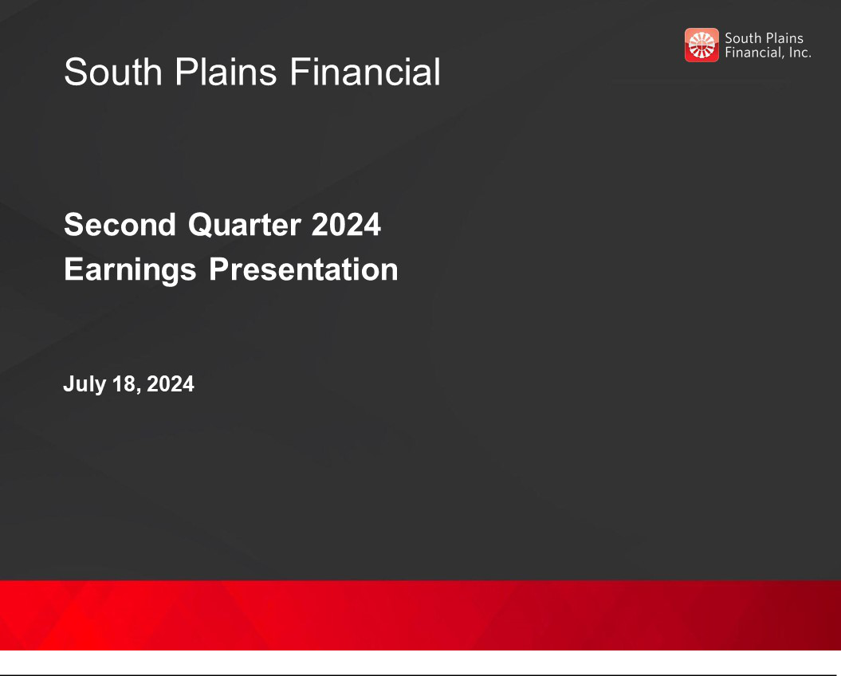

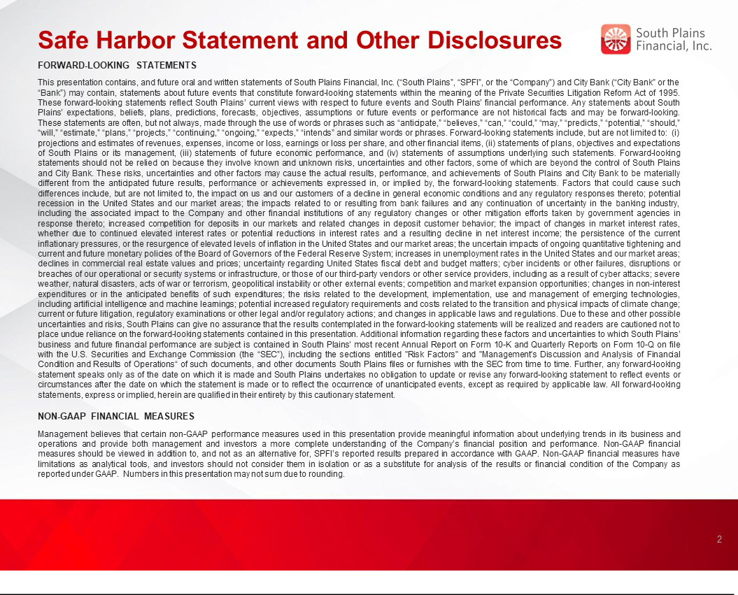



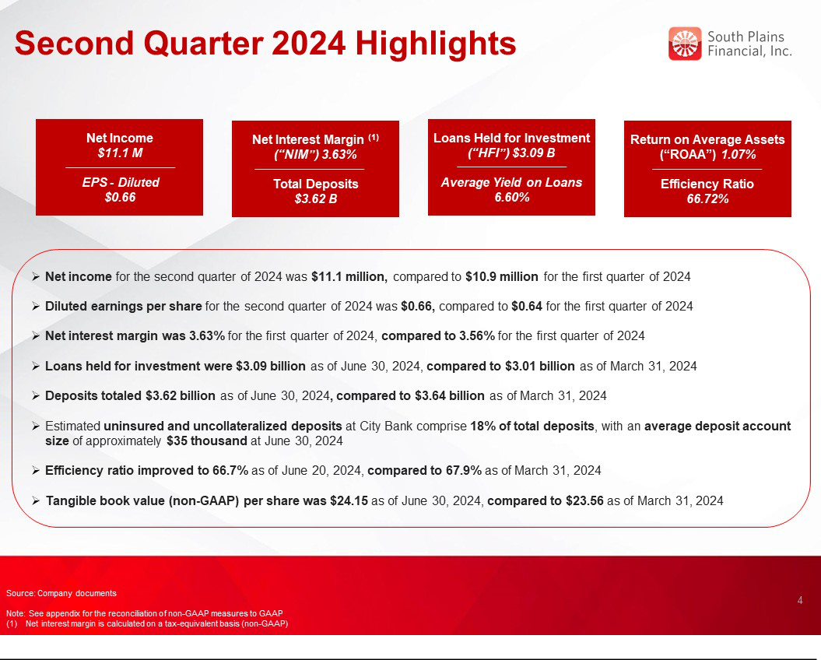

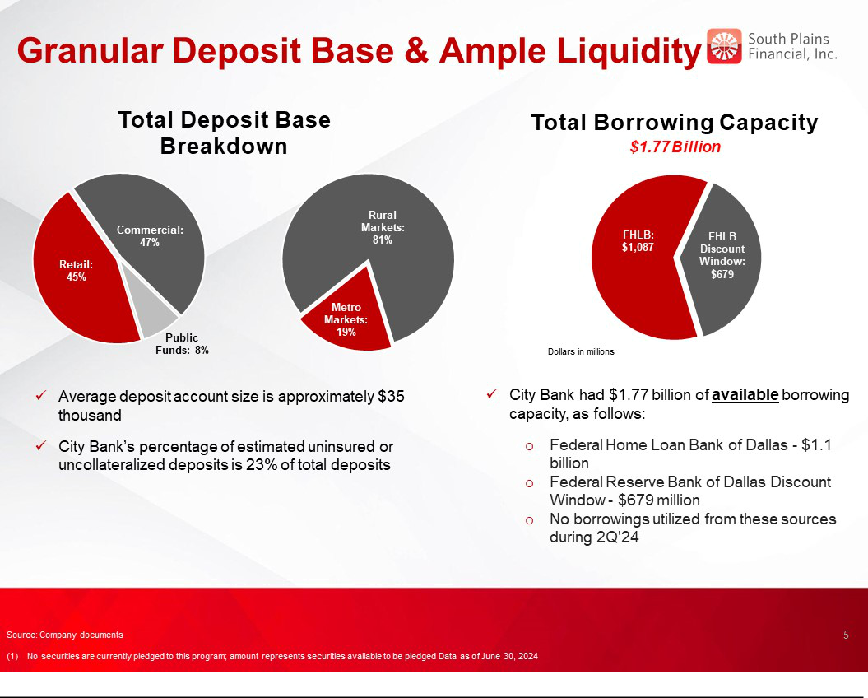

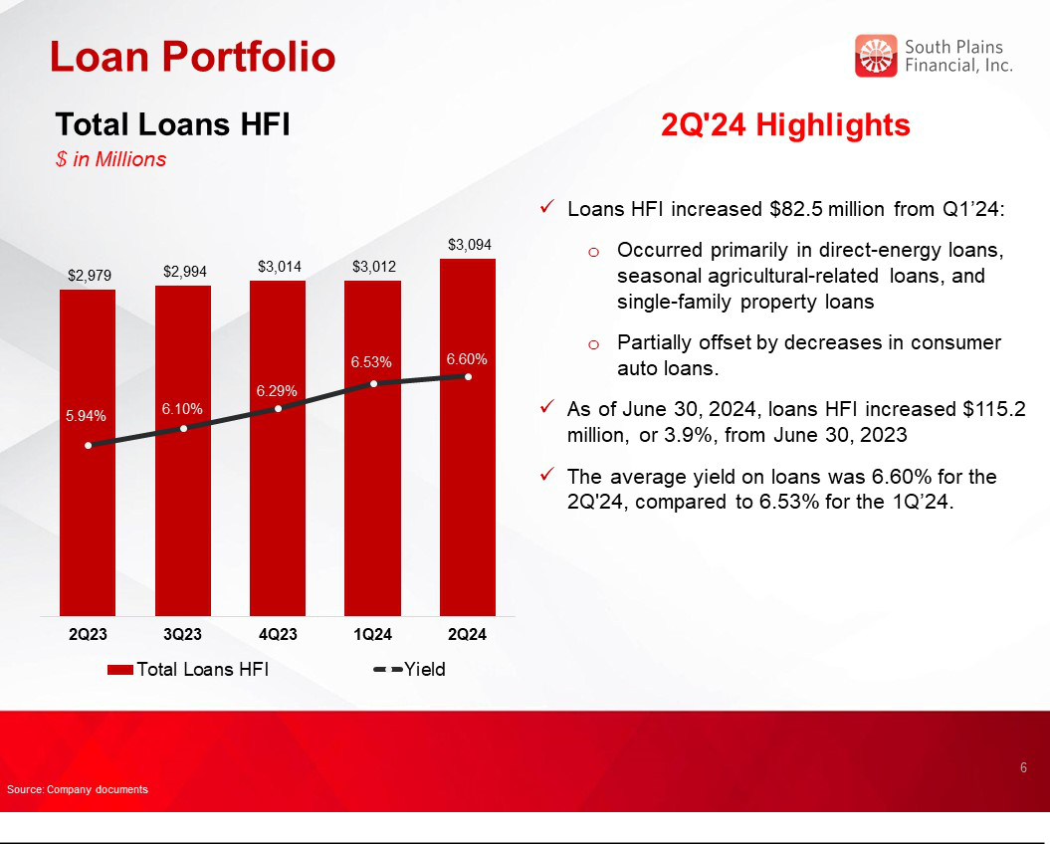

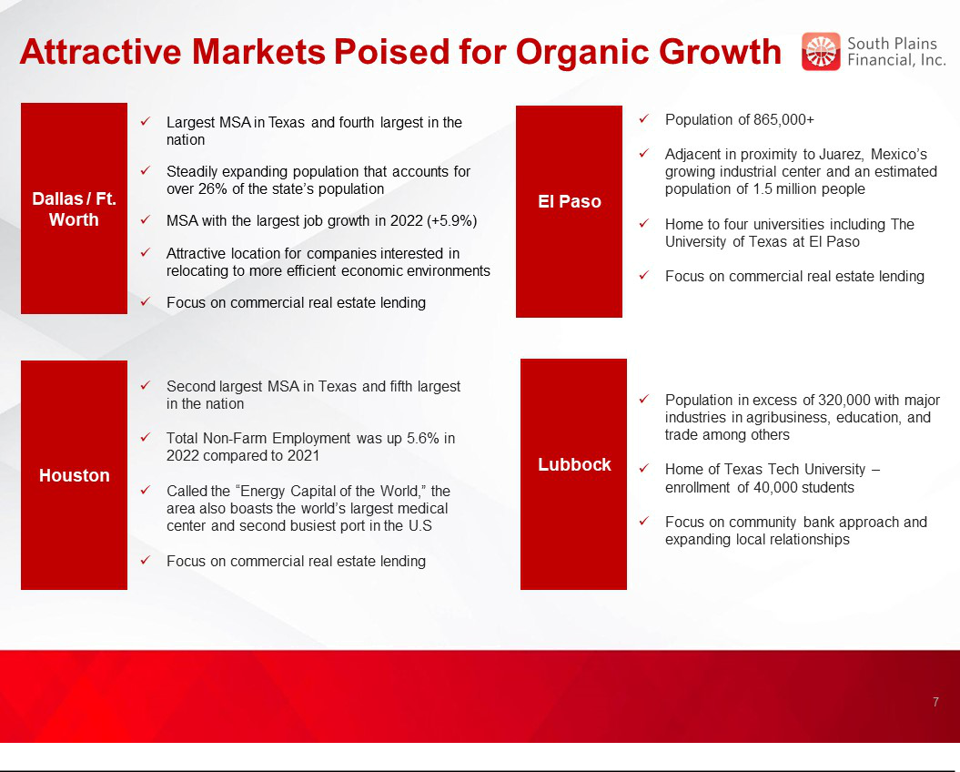

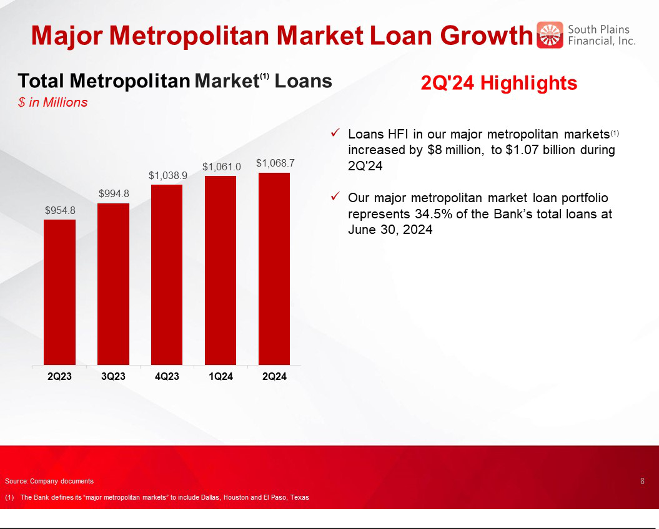

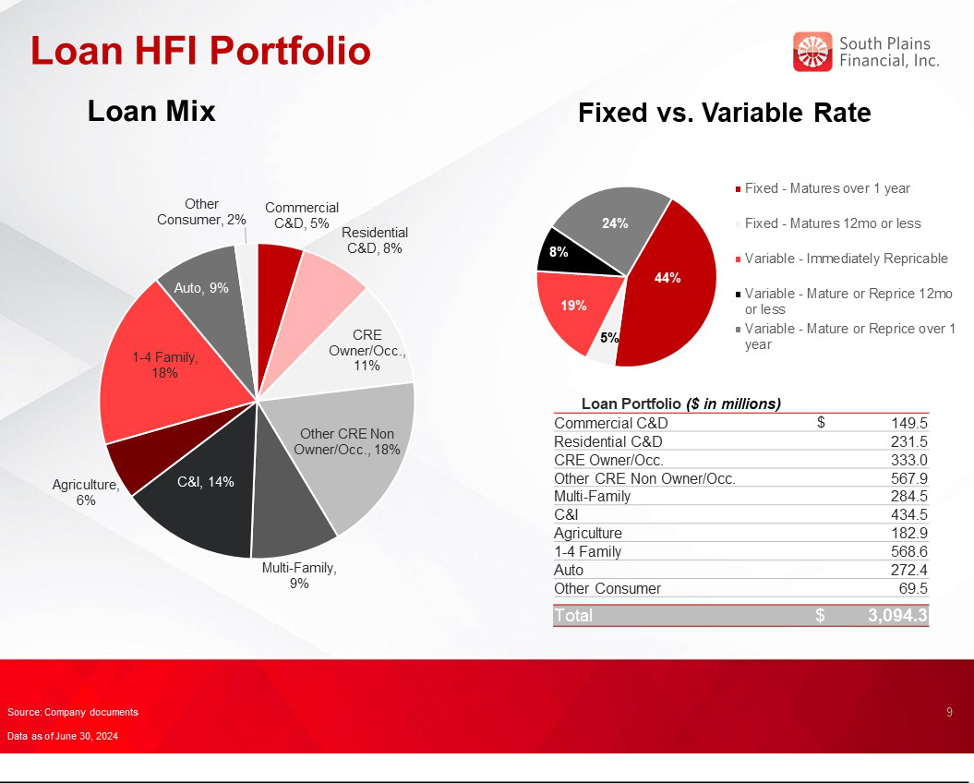

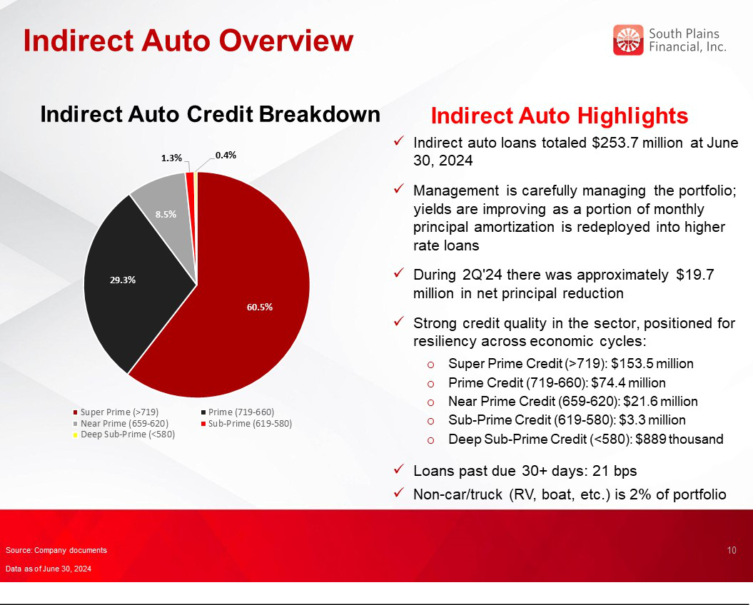

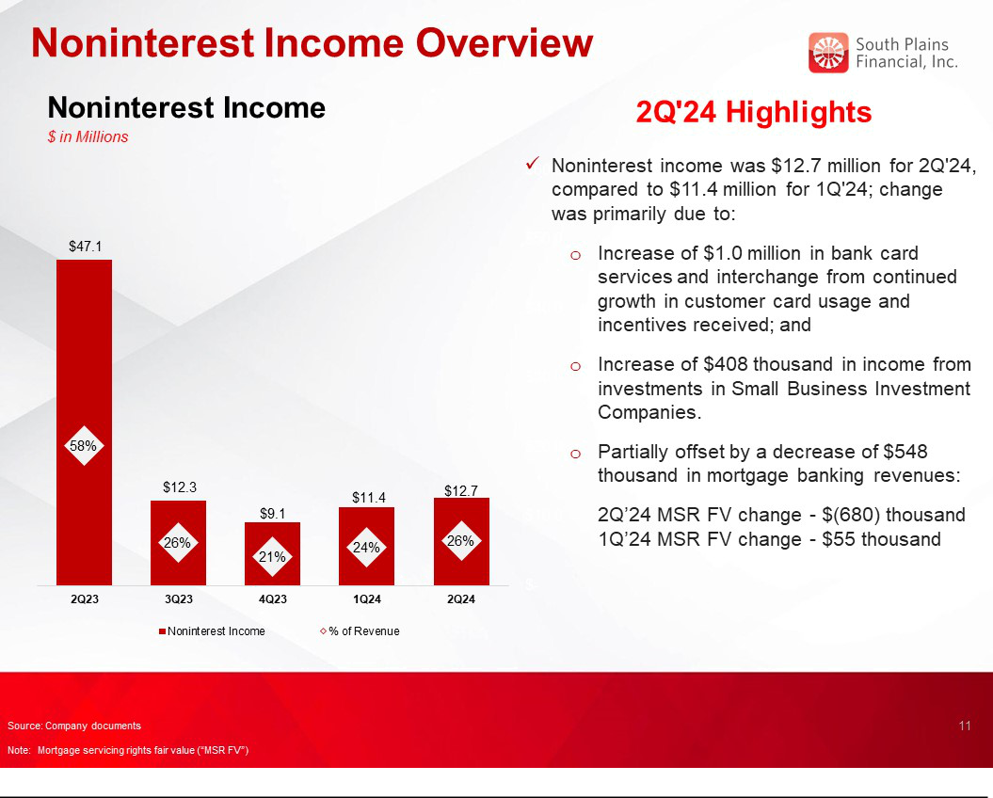

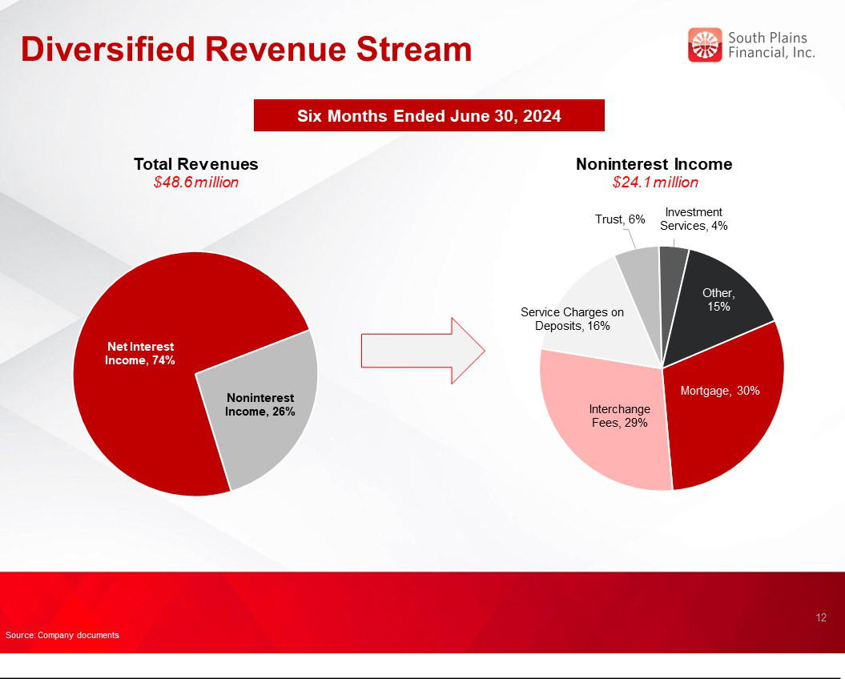

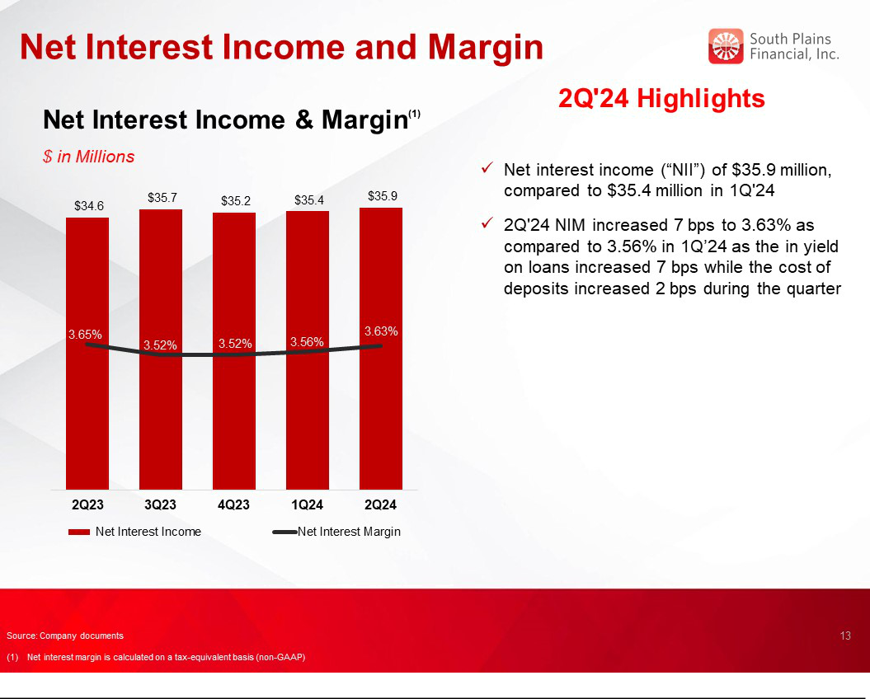

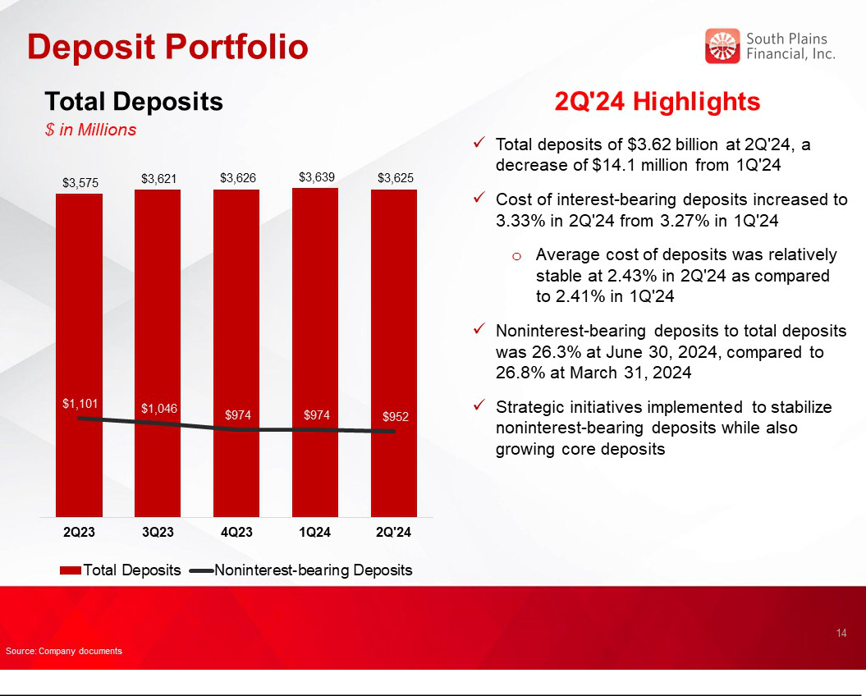

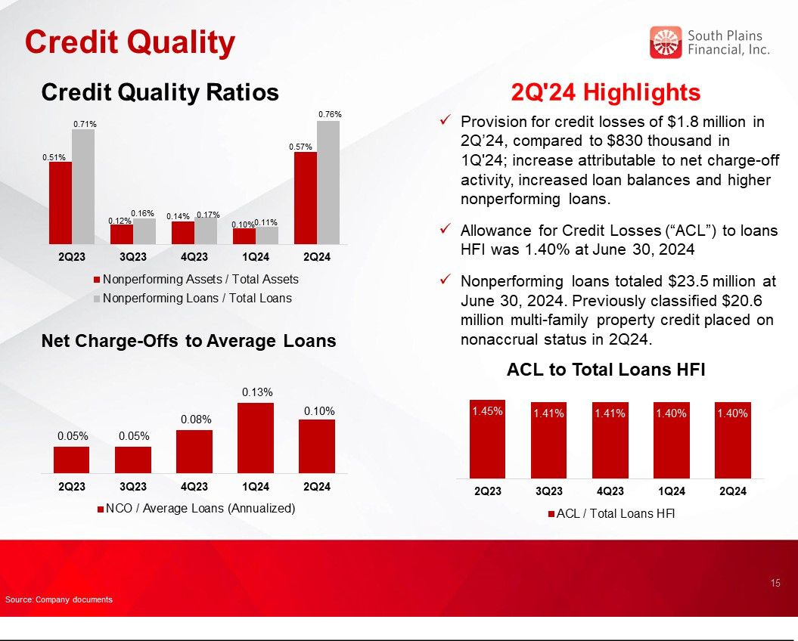

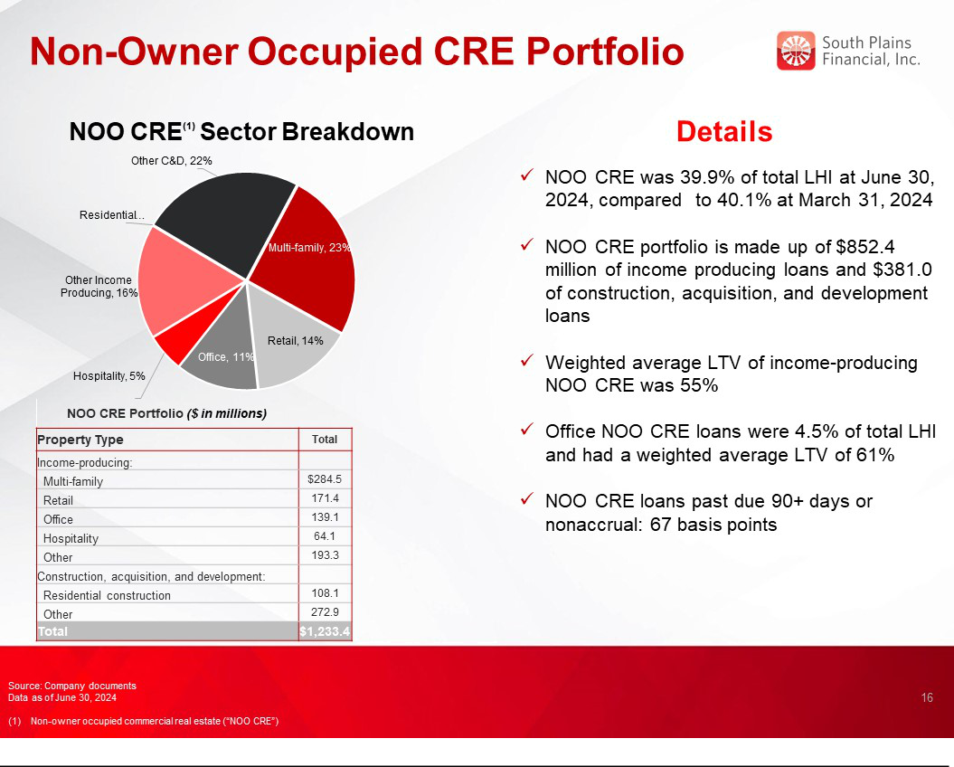

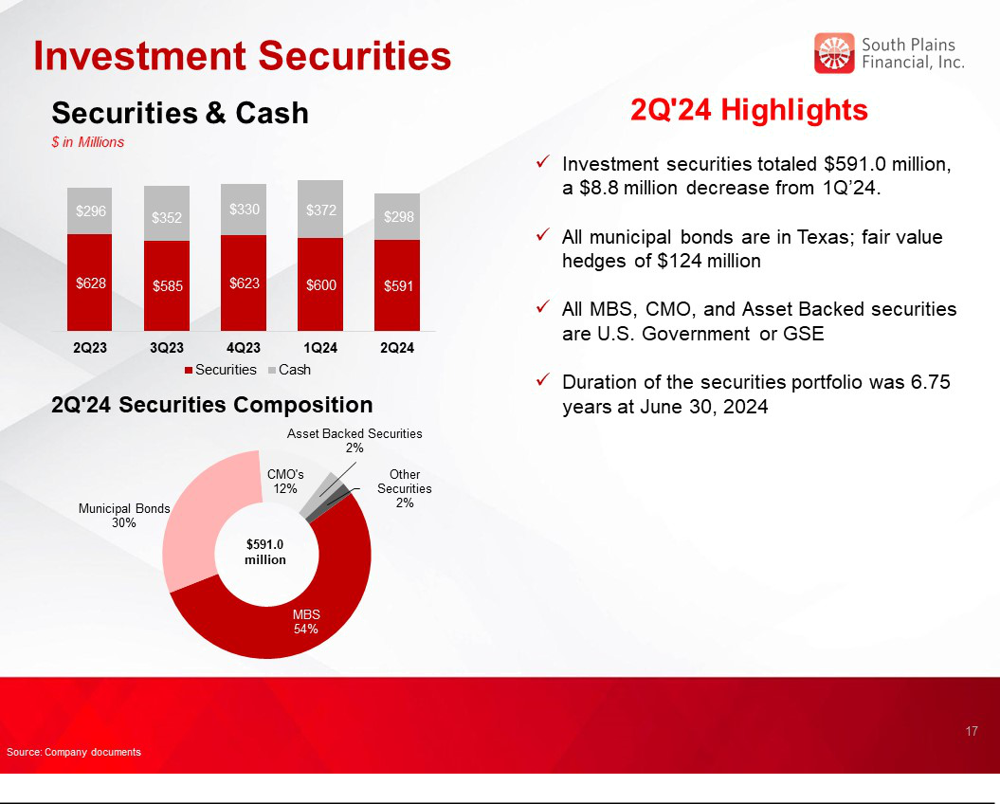

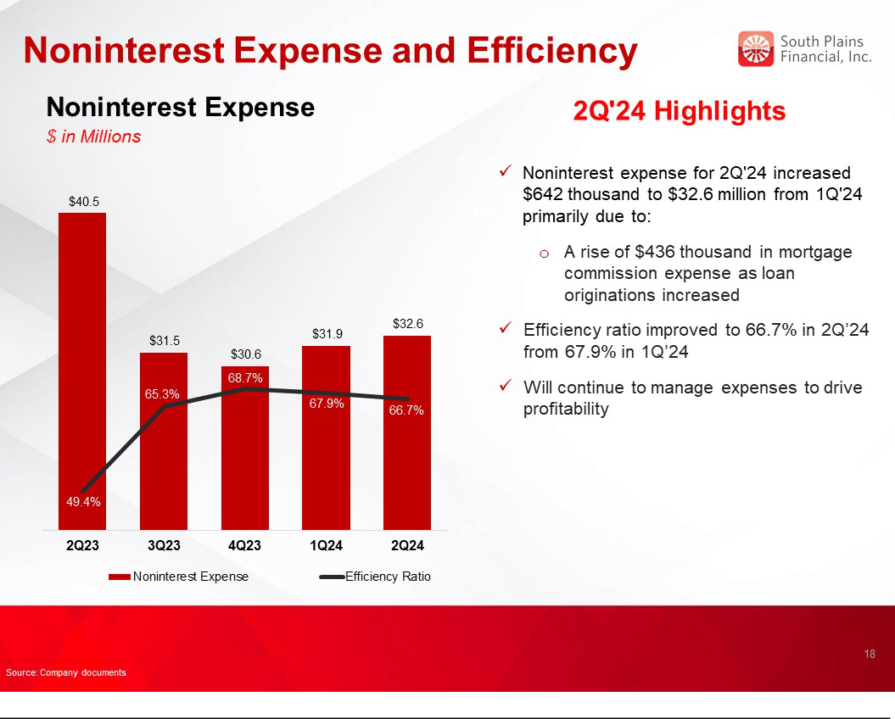

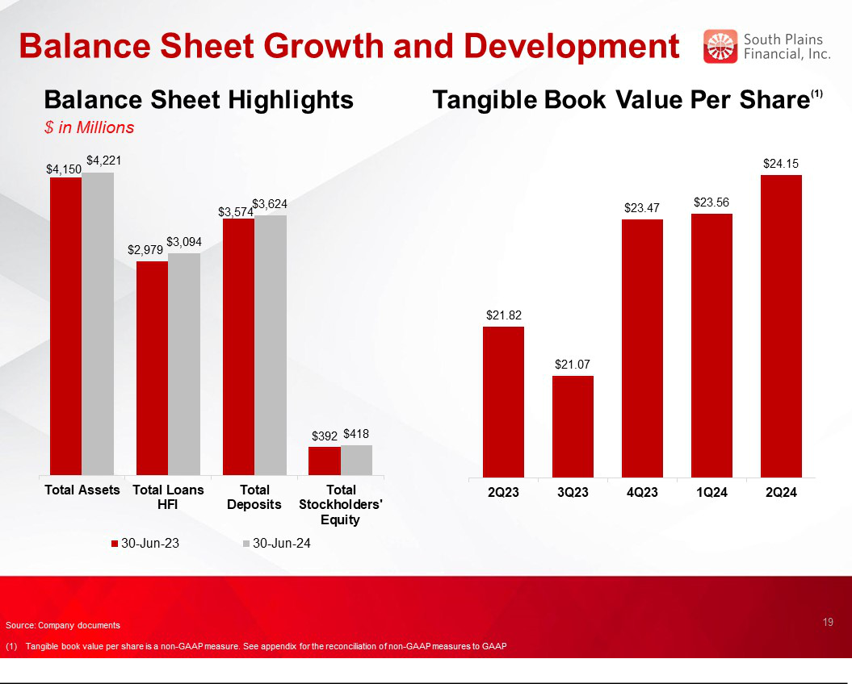

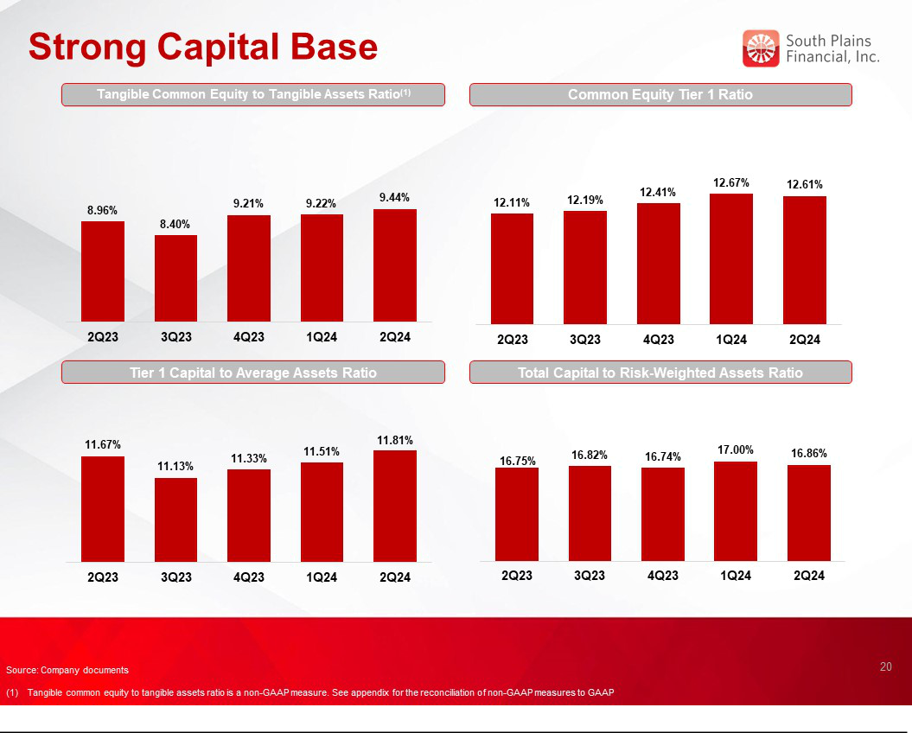



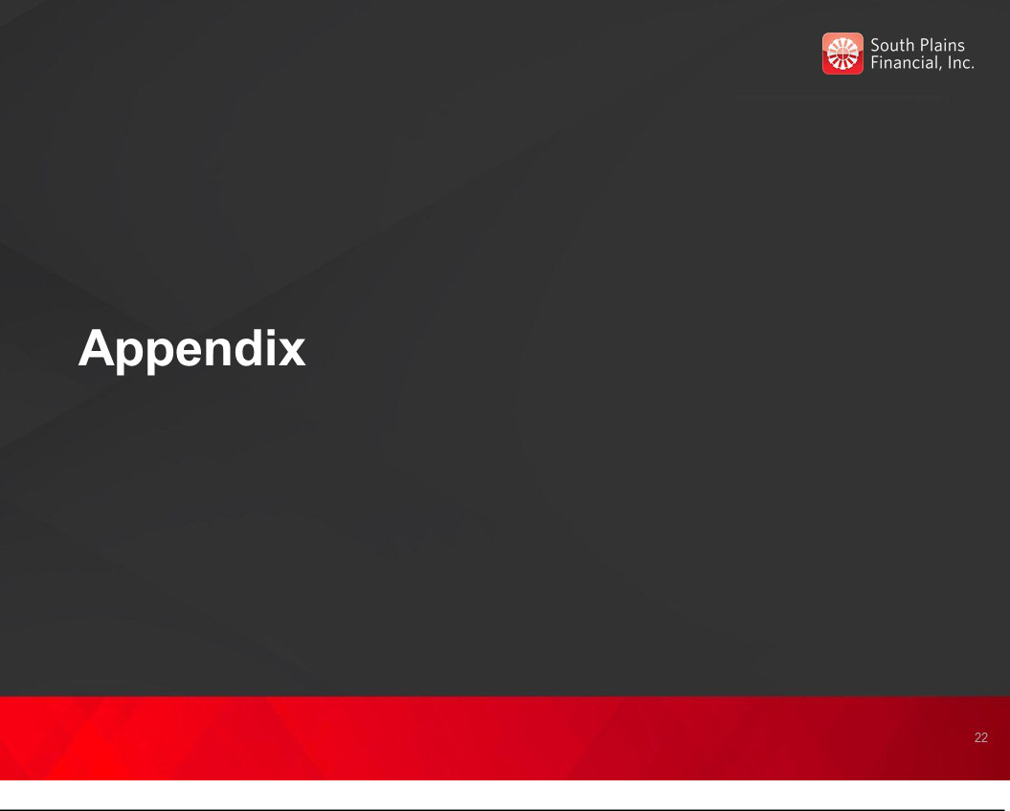

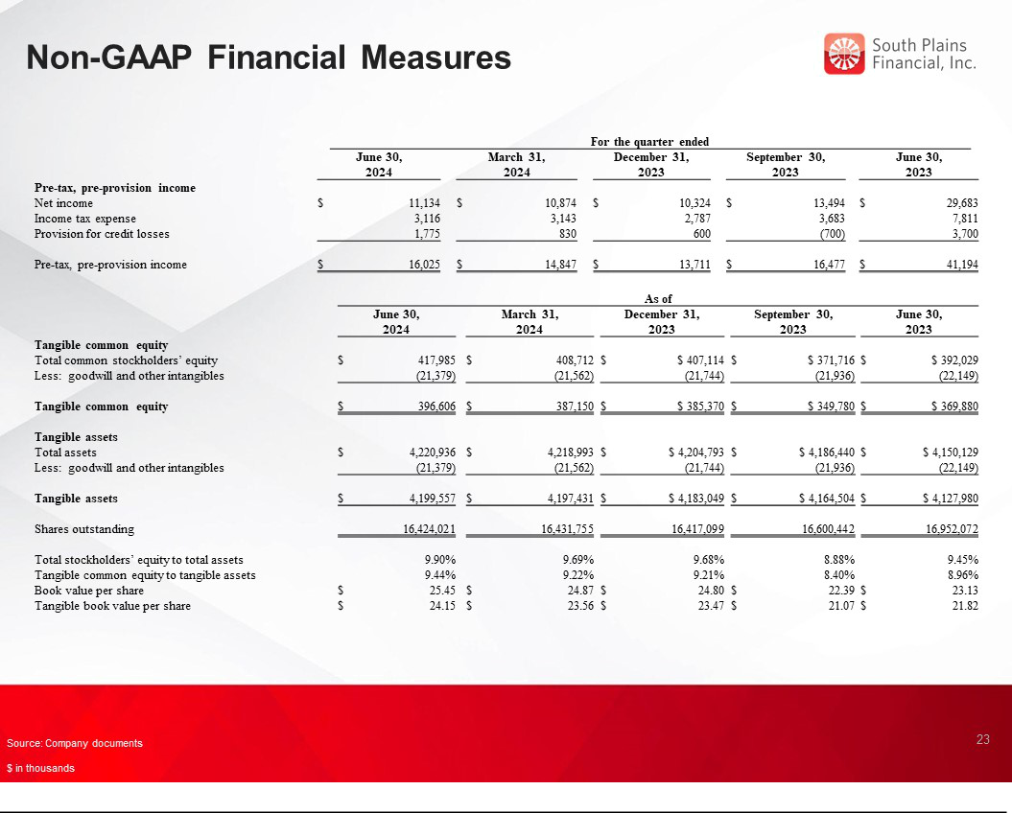

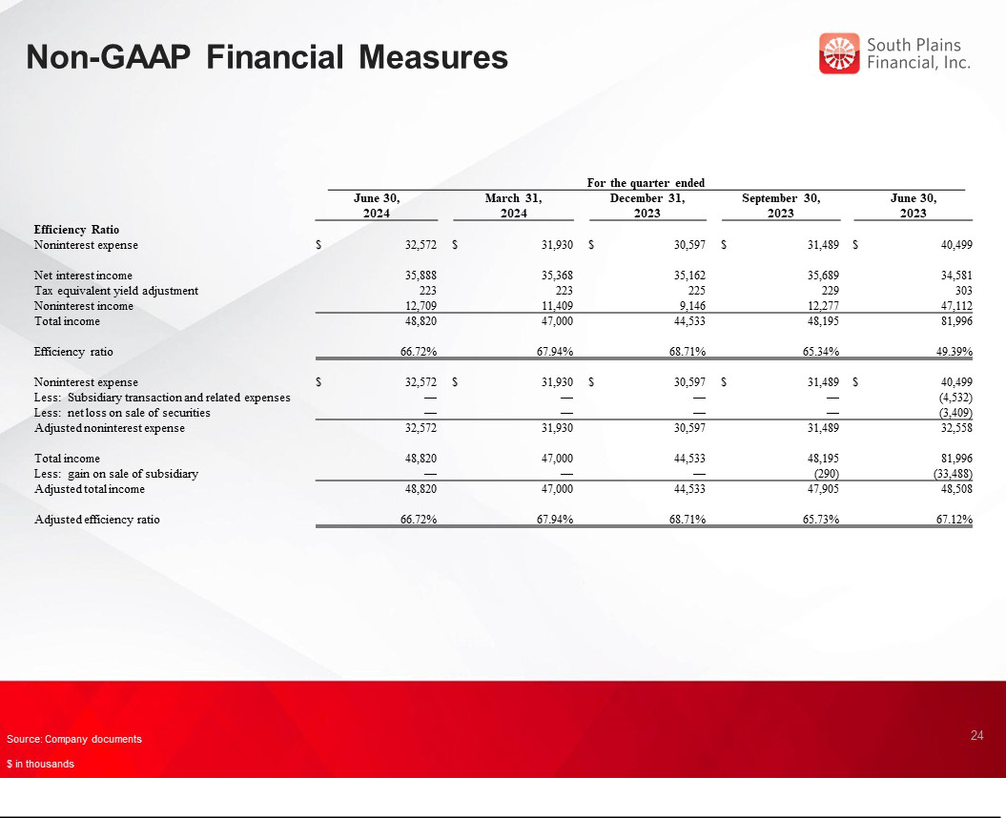

Exhbit 99.3


South Plains Financial, Inc. Declares Quarterly Cash Dividend

LUBBOCK, Texas, July 18, 2024 (GLOBE NEWSWIRE) – South Plains Financial, Inc. (NASDAQ:SPFI) (“South Plains”), the parent company of City Bank, today announced that its Board of Directors has declared a quarterly cash dividend of $0.14 per share of common stock. The dividend is payable on August 12, 2024 to shareholders of record as of the close of business on July 29, 2024.

About South Plains Financial, Inc.

South Plains is the bank holding company for City Bank, a Texas state-chartered bank headquartered in Lubbock, Texas. City Bank is one of the largest independent banks in West Texas and has additional banking operations in the Dallas, El Paso, Greater Houston, the Permian Basin, and College Station, Texas markets, and the Ruidoso, New Mexico market. South Plains provides a wide range of commercial and consumer financial services to small and medium-sized businesses and individuals in its market areas. Its principal business activities include commercial and retail banking, along with investment, trust and mortgage services. Please visit https://www.spfi.bank for more information.

Contact: | Mikella Newsom, Chief Risk Officer and Secretary
 | investors@city.bank

- 771-3347 Source: South Plains Financial, Inc.

