UNITED STATES
SECURITIES AND EXCHANGE COMMISSION
Washington, D.C. 20549

FORM 8-K

CURRENT REPORT
Pursuant to Section 13 or 15(d) of
the Securities Exchange Act of 1934

Date of Report (Date of earliest event reported): April 25, 2024

South Plains Financial, Inc.
(Exact name of registrant as specified in its charter)

Texas | 001-38895 | 75-2453320
(State or other jurisdiction of incorporation) | (Commission File Number) | (IRS Employer Identification No.)

5219 City Bank Parkway  Lubbock, Texas |  | 79407
(Address of principal executive offices) |  | (Zip Code)

(806) 792-7101
(Registrant’s telephone number, including area code)

Check the appropriate box below if the Form 8-K filing is intended to simultaneously satisfy the filing obligation of the registrant under any of the following provisions:

☐ | Written communications pursuant to Rule 425 under the Securities Act (17 CFR 230.425)

☐ | Soliciting material pursuant to Rule 14a-12 under the Exchange Act (17 CFR 240.14a-12)

☐ | Pre-commencement communications pursuant to Rule 14d-2(b) under the Exchange Act (17 CFR 240.14d-2(b))

☐ | Pre-commencement communications pursuant to Rule 13e-4(c) under the Exchange Act (17 CFR 240.13e-4(c))

Securities registered pursuant to Section 12(b) of the Act:

Title of each class | Trading Symbol(s) | Name of each exchange on which registered
Common Stock, par value $1.00 per share | SPFI | The Nasdaq Stock Market LLC

Indicate by check mark whether the registrant is an emerging growth company as defined in Rule 405 of the Securities Act of 1933 (§230.405 of this chapter) or Rule 12b-2 of the Securities Exchange Act of 1934 (§240.12b-2 of this chapter).

Emerging growth company ☒

If an emerging growth company, indicate by check mark if the registrant has elected not to use the extended transition period for complying with any new or revised financial accounting standards provided pursuant to Section 13(a) of the Exchange Act. ☐

Item 2.02 | Results of Operations and Financial Condition.

On April 25, 2024, South Plains Financial, Inc. (the “Company”) issued a press release announcing its financial results for the first quarter ended March 31, 2024. A copy of the Company’s press release covering such announcement and certain other matters is furnished as Exhibit 99.1 to this Current Report on Form 8-K.

Item 7.01 | Regulation FD Disclosure.

On April 25, 2024, officers of the Company will have a conference call with respect to the Company’s financial results for the first quarter ended March 31, 2024. An earnings release slide presentation highlighting the Company’s financial results for the first quarter ended March 31, 2024 is furnished as Exhibit 99.2 to this Current Report on Form 8-K. This earnings release slide presentation will also be available on the Company’s website, www.spfi.bank, under the “News & Events” section.

In accordance with General Instruction B.2 of Form 8-K, the information in Items 2.02 and 7.01 of this Current Report on Form 8-K, including Exhibit 99.1 and Exhibit 99.2 furnished herewith, shall not be deemed “filed” for the purposes of Section 18 of the Securities Exchange Act of 1934, as amended (the “Exchange Act”), or otherwise subject to the liabilities of that section. The information in Items 2.02 and 7.01 of this Current Report on Form 8-K, including Exhibit 99.1 and Exhibit 99.2 furnished herewith, shall not be incorporated by reference into any filing or other document pursuant to the Exchange Act or the Securities Act of 1933, as amended, except as shall be expressly set forth by specific reference in such filing or document.

Item 9.01 | Financial Statements and Exhibits.

 | (d) | Exhibits.
 | 99.1 | Press release, dated April 25, 2024, announcing first quarter 2024 financial results of South Plains Financial, Inc.
 | 99.2 | Earnings release slide presentation, dated April 25, 2024.
 | 104 | Cover Page Interactive Data File (formatted as Inline XBRL).

SIGNATURES

Pursuant to the requirements of the Securities Exchange Act of 1934, the registrant has duly caused this report to be signed on its behalf by the undersigned hereunto duly authorized.

 | SOUTH PLAINS FINANCIAL, INC.
Date: April 25, 2024 | By: | /s/ Steven B. Crockett
Steven B. Crockett
Chief Financial Officer and Treasurer

Exhibit 99.1



South Plains Financial, Inc. Reports First Quarter 2024 Financial Results

LUBBOCK, Texas, April 25, 2024 (GLOBE NEWSWIRE) – South Plains Financial, Inc. (NASDAQ:SPFI) (“South Plains” or the “Company”), the parent company of City Bank (“City Bank” or the “Bank”), today reported its financial results for the quarter ended March 31, 2024.

First Quarter 2024 Highlights

 | ● | Net income for the first quarter of 2024 was $10.9 million, compared to $10.3 million for the fourth quarter of 2023 and $9.2 million for the first quarter of 2023.

 | ● | Diluted earnings per share for the first quarter of 2024 was $0.64, compared to $0.61 for the fourth quarter of 2023 and $0.53 for the first quarter of 2023.

 | ● | Average cost of deposits for the first quarter of 2024 was 241 basis points, compared to 224 basis points for the fourth quarter of 2023 and 136 basis points for the first quarter of 2023.

 | ● | Net interest margin, calculated on a tax-equivalent basis, was 3.56% for the first quarter of 2024, compared to 3.52% for the fourth quarter of 2023.

 | ● | Nonperforming assets to total assets were 0.10% at March 31, 2024, compared to 0.14% at December 31, 2023 and 0.19% at March 31, 2023.

 | ● | Return on average assets for the first quarter of 2024 was 1.04% annualized, compared to 0.99% annualized for the fourth quarter of 2023 and 0.95% annualized for the first quarter of 2023.

 | ● | Tangible book value (non-GAAP) per share was $23.56 as of March 31, 2024, compared to $23.47 as of December 31, 2023 and $20.19 as of March 31, 2023.

 | ● | The consolidated total risk-based capital ratio, Common Equity Tier 1 risk-based capital ratio, and Tier 1 leverage ratio at March 31, 2024 were 17.00%, 12.67%, and 11.51%, respectively. These ratios significantly exceeded the minimum regulatory levels necessary to be deemed “well-capitalized”.

Curtis Griffith, South Plains’ Chairman and Chief Executive Officer, commented, “I am pleased with our first quarter results as we have started to see our net interest margin stabilize driven by improved loan yields and the very early signs of deposit cost pressures starting to ease. Additionally, our loan production was strong through the first quarter though it was largely offset by our typical seasonal agricultural paydowns as well as the early payoffs of several loans that we have been working to move out of the Bank. We continue to aggressively manage the credit quality of our loan portfolio which can be seen by our ratio of nonperforming assets to total assets which was 10 basis points at the end of the first quarter. Lastly, while competition for deposits remains a challenge in the current banking environment, we delivered modest deposit growth as our community-based deposit franchise remains a competitive advantage and we believe provides adequate liquidity to fund loan growth as we move through the year.”

Results of Operations, Quarter Ended March 31, 2024

Net Interest Income

Net interest income was $35.4 million for the first quarter of 2024, compared to $35.2 million for the fourth quarter of 2023 and $34.3 million for the first quarter of 2023. Net interest margin, calculated on a tax-equivalent basis, was 3.56% for the first quarter of 2024, compared to 3.52% for the fourth quarter of 2023 and 3.75% for the first quarter of 2023. The average yield on loans was 6.53% for the first quarter of 2024, compared to 6.29% for the fourth quarter of 2023 and 5.78% for the first quarter of 2023. The average cost of deposits was 241 basis points for the first quarter of 2024, which is 17 basis points higher than the fourth quarter of 2023 and 105 basis points higher than the first quarter of 2023.

Interest income was $58.7 million for the first quarter of 2024, compared to $57.2 million for the fourth quarter of 2023 and $47.4 million for the first quarter of 2023. Interest income increased $1.5 million in the first quarter of 2024 from the fourth quarter of 2023, which was comprised of increases of $1.0 million in loan interest income and $454 thousand in interest income on other interest-earning assets. The growth in loan interest income was primarily due to a rise of 24 basis points in the yield on loans, which includes approximately $667 thousand in recoveries of interest on loans that had previously been maintained on nonaccrual. The increase in interest income on other interest-earning assets was predominately a result of increased liquidity maintained at the Federal Reserve Bank of Dallas. Interest income increased $11.3 million in the first quarter of 2024 compared to the first quarter of 2023. This increase was primarily due to an increase of average loans of $235.7 million and higher market interest rates during the period, resulting in growth of $9.3 million in loan interest income, and a higher liquidity level year over year.

Interest expense was $23.4 million for the first quarter of 2024, compared to $22.1 million for the fourth quarter of 2023 and $13.1 million for the first quarter of 2023. Interest expense increased $1.3 million compared to the fourth quarter of 2023 and $10.2 million compared to the first quarter of 2023, primarily as a result of significantly higher short-term interest rates on interest-bearing liabilities, with the increase being mainly comprised of interest expense on deposits. Additionally, interest-bearing deposits grew during the first quarter of 2024 versus the compared periods, which also contributed to the higher interest expense.

Noninterest Income and Noninterest Expense

Noninterest income was $11.4 million for the first quarter of 2024, compared to $9.1 million for the fourth quarter of 2023 and $10.7 million for the first quarter of 2023. The increase from the fourth quarter of 2023 was primarily due to an increase of $2.3 million in mortgage banking revenues, mainly from an increase of $1.5 million in the fair value adjustment of the mortgage servicing rights assets as interest rates that affect the value rose modestly in the first quarter after falling late in the fourth quarter of 2023. Additionally, originations of mortgage loans held for sale increased $8.6 million due to typical seasonality. The increase in noninterest income for the first quarter of 2024 as compared to the first quarter of 2023 was primarily due to an increase of $1.7 million in mortgage banking revenues, mainly from an increase of $2.0 million in the fair value adjustment of the mortgage servicing rights assets as interest rates that affect the value rose modestly in the first quarter of 2024 compared to falling in the first quarter of 2023, partially offset by a reduction of $1.4 million in income from insurance activities due to the sale of the Bank’s insurance subsidiary in April 2023.

Noninterest expense was $31.9 million for the first quarter of 2024, compared to $30.6 million for the fourth quarter of 2023 and $32.4 million for the first quarter of 2023. The $1.3 million increase from the fourth quarter of 2023 was largely the result of a rise of $1.0 million in personnel costs, which predominately came from higher health care insurance costs and an increase in incentive-based compensation. The decrease in noninterest expense for the first quarter of 2024 as compared to the first quarter of 2023 was primarily driven by a reduction of $1.9 million in expenses from the Bank’s former insurance subsidiary, partially offset by an increase in incentive-based compensation.

Loan Portfolio and Composition

Loans held for investment were $3.01 billion as of March 31, 2024, compared to $3.01 billion as of December 31, 2023 and $2.79 billion as of March 31, 2023. Loans were flat during the first quarter of 2024 as compared to the fourth quarter of 2023 with growth primarily in multi-family and single-family property loans, offset by decreases in seasonal agricultural-related loans, residential construction loans, and consumer auto loans. As of March 31, 2024, loans held for investment increased $223.2 million, or 8.0%, from March 31, 2023, primarily attributable to strong organic loan growth, occurring mainly in commercial real estate loans.

Deposits and Borrowings

Deposits totaled $3.64 billion as of March 31, 2024, compared to $3.63 billion as of December 31, 2023 and $3.51 billion as of March 31, 2023. Deposits increased by $12.4 million, or 1.4% annualized, in the first quarter of 2024 from December 31, 2023. As of March 31, 2024, deposits increased $130.5 million, or 3.7%, from March 31, 2023. Noninterest-bearing deposits were $974.2 million as of March 31, 2024, compared to $974.2 million as of December 31, 2023 and $1.11 billion as of March 31, 2023. Noninterest-bearing deposits represented 26.8% of total deposits as of March 31, 2024. The quarterly change in total deposits was due to a modest increase in interest-bearing deposits. The year-over-year increase in total deposits was primarily the result of growth of $152 million in brokered deposits in the second and third quarters of 2023 given the overall focus in the banking industry on improving liquidity, as well as organic deposit growth.

Asset Quality

The Company recorded a provision for credit losses in the first quarter of 2024 of $830 thousand, compared to $600 thousand in the fourth quarter of 2023 and $1.0 million in the first quarter of 2023. The provision during the first quarter of 2024 was largely attributable to net charge-off activity during the quarter.

The ratio of allowance for credit losses to loans held for investment was 1.40% as of March 31, 2024, compared to 1.41% as of December 31, 2023 and 1.42% as of March 31, 2023.

The ratio of nonperforming assets to total assets was 0.10% as of March 31, 2024, compared to 0.14% as of December 31, 2023 and 0.19% as of March 31, 2023. Annualized net charge-offs were 0.13% for the first quarter of 2024, compared to 0.08% for the fourth quarter of 2023 and 0.09% for the first quarter of 2023.

Capital

Book value per share increased to $24.87 at March 31, 2024, compared to $24.80 at December 31, 2023. The change was primarily driven by $8.7 million of net income after dividends paid, partially offset by a decrease in accumulated other comprehensive income (“AOCI”) of $7.5 million. The decrease in AOCI was attributed to the after-tax decrease in fair value of our available for sale securities, net of fair value hedges, as a result of increases in long-term market interest rates during the period.

Conference Call

South Plains will host a conference call to discuss its first quarter 2024 financial results today, April 25, 2024, at 5:00 p.m., Eastern Time. Investors and analysts interested in participating in the call are invited to dial 1-877-407-9716 (international callers please dial 1-201-493-6779) approximately 10 minutes prior to the start of the call. A live audio webcast of the conference call and conference materials will be available on the Company’s website at https://www.spfi.bank/news-events/events.

A replay of the conference call will be available within two hours of the conclusion of the call and can be accessed on the investor section of the Company’s website as well as by dialing 1-844-512-2921 (international callers please dial 1-412-317-6671). The pin to access the telephone replay is 13745782. The replay will be available until May 9, 2024.

About South Plains Financial, Inc.

South Plains is the bank holding company for City Bank, a Texas state-chartered bank headquartered in Lubbock, Texas. City Bank is one of the largest independent banks in West Texas and has additional banking operations in the Dallas, El Paso, Greater Houston, the Permian Basin, and College Station, Texas markets, and the Ruidoso, New Mexico market. South Plains provides a wide range of commercial and consumer financial services to small and medium-sized businesses and individuals in its market areas. Its principal business activities include commercial and retail banking, along with investment, trust and mortgage services. Please visit https://www.spfi.bank for more information.

Non-GAAP Financial Measures

Some of the financial measures included in this press release are not measures of financial performance recognized in accordance with generally accepted accounting principles in the United States (“GAAP”). These non-GAAP financial measures include Tangible Book Value Per Share, Tangible Common Equity to Tangible Assets, and Pre-Tax, Pre-Provision Income. The Company believes these non-GAAP financial measures provide both management and investors a more complete understanding of the Company’s financial position and performance. These non-GAAP financial measures are supplemental and are not a substitute for any analysis based on GAAP financial measures.

We classify a financial measure as being a non-GAAP financial measure if that financial measure excludes or includes amounts, or is subject to adjustments that have the effect of excluding or including amounts, that are included or excluded, as the case may be, in the most directly comparable measure calculated and presented in accordance with GAAP as in effect from time to time in the United States in our statements of income, balance sheets or statements of cash flows. Not all companies use the same calculation of these measures; therefore, this presentation may not be comparable to other similarly titled measures as presented by other companies.

A reconciliation of non-GAAP financial measures to GAAP financial measures is provided at the end of this press release.

Available Information

The Company routinely posts important information for investors on its web site (under www.spfi.bank and, more specifically, under the News & Events tab at www.spfi.bank/news-events/press-releases). The Company intends to use its web site as a means of disclosing material non-public information and for complying with its disclosure obligations under Regulation FD (Fair Disclosure) promulgated by the U.S. Securities and Exchange Commission (the “SEC”). Accordingly, investors should monitor the Company’s web site, in addition to following the Company’s press releases, SEC filings, public conference calls, presentations and webcasts.

The information contained on, or that may be accessed through, the Company’s web site is not incorporated by reference into, and is not a part of, this document.

Forward Looking Statements

This press release contains forward-looking statements within the meaning of the Private Securities Litigation Reform Act of 1995. These forward-looking statements reflect South Plains’ current views with respect to future events and South Plains’ financial performance. Any statements about South Plains’ expectations, beliefs, plans, predictions, forecasts, objectives, assumptions or future events or performance are not historical facts and may be forward-looking. These statements are often, but not always, made through the use of words or phrases such as “anticipate,” “believes,” “can,” “could,” “may,” “predicts,” “potential,” “should,” “will,” “estimate,” “plans,” “projects,” “continuing,” “ongoing,” “expects,” “intends” and similar words or phrases. South Plains cautions that the forward-looking statements in this press release are based largely on South Plains’ expectations and are subject to a number of known and unknown risks and uncertainties that are subject to change based on factors which are, in many instances, beyond South Plains’ control. Factors that could cause such changes include, but are not limited to, the impact on us and our customers of a decline in general economic conditions and any regulatory responses thereto; potential recession in the United States and our market areas; the impacts related to or resulting from bank failures and any continuation of uncertainty in the banking industry, including the associated impact to the Company and other financial institutions of any regulatory changes or other mitigation efforts taken by government agencies in response thereto; increased competition for deposits and related changes in deposit customer behavior; the impact of changes in market interest rates, whether due to continued elevated interest rates or potential reduction in interest rates and a resulting decline in net interest income; the persistence of the current inflationary pressures, or the resurgence of elevated levels of inflation, in the United States and our market areas; the uncertain impacts of ongoing quantitative tightening and current and future monetary policies of the Board of Governors of the Federal Reserve System; the effects of declines in housing prices in the United States and our market areas; increases in unemployment rates in the United States and our market areas; declines in commercial real estate values and prices; uncertainty regarding United States fiscal debt and budget matters; cyber incidents or other failures, disruptions or breaches of our operational or security systems or infrastructure, or those of our third-party vendors or other service providers, including as a result of cyber attacks; severe weather, natural disasters, acts of war or terrorism, geopolitical instability or other external events; competition and market expansion opportunities; changes in non-interest expenditures or in the anticipated benefits of such expenditures; the risks related to the development, implementation, use and management of emerging technologies, including artificial intelligence and machine learnings; potential increased regulatory requirements and costs related to the transition and physical impacts of climate change; current or future litigation, regulatory examinations or other legal and/or regulatory actions; and changes in applicable laws and regulations. Additional information regarding these risks and uncertainties to which South Plains’ business and future financial performance are subject is contained in South Plains’ most recent Annual Report on Form 10-K and Quarterly Reports on Form 10-Q on file with the SEC, including the sections entitled “Risk Factors” and “Management’s Discussion and Analysis of Financial Condition and Results of Operations” of such documents, and other documents South Plains files or furnishes with the SEC from time to time, which are available on the SEC’s website, www.sec.gov. Actual results, performance or achievements could differ materially from those contemplated, expressed, or implied by the forward-looking statements due to additional risks and uncertainties of which South Plains is not currently aware or which it does not currently view as, but in the future may become, material to its business or operating results. Due to these and other possible uncertainties and risks, the Company can give no assurance that the results contemplated in the forward-looking statements will be realized and readers are cautioned not to place undue reliance on the forward-looking statements contained in this press release. Any forward-looking statements presented herein are made only as of the date of this press release, and South Plains does not undertake any obligation to update or revise any forward-looking statements to reflect changes in assumptions, new information, the occurrence of unanticipated events, or otherwise, except as required by applicable law. All forward-looking statements, express or implied, included in the press release are qualified in their entirety by this cautionary statement.

Contact: | Mikella Newsom, Chief Risk Officer and Secretary
 | (866) 771-3347
 | investors@city.bank

Source: South Plains Financial, Inc.

South Plains Financial, Inc.
Consolidated Financial Highlights - (Unaudited)
(Dollars in thousands, except share data)

 |  | As of and for the quarter ended
 |  | March 31,  2024 |  |  |  | December 31,  2023 |  |  |  | September 30,  2023 |  |  |  | June 30,  2023 |  |  |  | March 31,  2023
Selected Income Statement Data:
Interest income |  | $ | 58,727 |  |  | $ | 57,236 |  |  | $ | 56,528 |  |  | $ | 50,821 |  |  | $ | 47,448
Interest expense |  |  | 23,359 |  |  |  | 22,074 |  |  |  | 20,839 |  |  |  | 16,240 |  |  |  | 13,133
Net interest income |  |  | 35,368 |  |  |  | 35,162 |  |  |  | 35,689 |  |  |  | 34,581 |  |  |  | 34,315
Provision for credit losses |  |  | 830 |  |  |  | 600 |  |  |  | (700 | ) |  |  | 3,700 |  |  |  | 1,010
Noninterest income |  |  | 11,409 |  |  |  | 9,146 |  |  |  | 12,277 |  |  |  | 47,112 |  |  |  | 10,691
Noninterest expense |  |  | 31,930 |  |  |  | 30,597 |  |  |  | 31,489 |  |  |  | 40,499 |  |  |  | 32,361
Income tax expense |  |  | 3,143 |  |  |  | 2,787 |  |  |  | 3,683 |  |  |  | 7,811 |  |  |  | 2,391
Net income |  |  | 10,874 |  |  |  | 10,324 |  |  |  | 13,494 |  |  |  | 29,683 |  |  |  | 9,244
Per Share Data (Common Stock):
Net earnings, basic |  |  | 0.66 |  |  |  | 0.63 |  |  |  | 0.80 |  |  |  | 1.74 |  |  |  | 0.54
Net earnings, diluted |  |  | 0.64 |  |  |  | 0.61 |  |  |  | 0.78 |  |  |  | 1.71 |  |  |  | 0.53
Cash dividends declared and paid |  |  | 0.13 |  |  |  | 0.13 |  |  |  | 0.13 |  |  |  | 0.13 |  |  |  | 0.13
Book value |  |  | 24.87 |  |  |  | 24.80 |  |  |  | 22.39 |  |  |  | 23.13 |  |  |  | 21.57
Tangible book value (non-GAAP) |  |  | 23.56 |  |  |  | 23.47 |  |  |  | 21.07 |  |  |  | 21.82 |  |  |  | 20.19
Weighted average shares outstanding, basic |  |  | 16,429,919 |  |  |  | 16,443,908 |  |  |  | 16,842,594 |  |  |  | 17,048,432 |  |  |  | 17,046,713
Weighted average shares outstanding, dilutive |  |  | 16,938,857 |  |  |  | 17,008,892 |  |  |  | 17,354,182 |  |  |  | 17,386,515 |  |  |  | 17,560,756
Shares outstanding at end of period |  |  | 16,431,755 |  |  |  | 16,417,099 |  |  |  | 16,600,442 |  |  |  | 16,952,072 |  |  |  | 17,062,572
Selected Period End Balance Sheet Data:
Cash and cash equivalents |  |  | 371,939 |  |  |  | 330,158 |  |  |  | 352,424 |  |  |  | 295,581 |  |  |  | 328,002
Investment securities |  |  | 599,869 |  |  |  | 622,762 |  |  |  | 584,969 |  |  |  | 628,093 |  |  |  | 698,579
Total loans held for investment |  |  | 3,011,799 |  |  |  | 3,014,153 |  |  |  | 2,993,563 |  |  |  | 2,979,063 |  |  |  | 2,788,640
Allowance for credit losses |  |  | 42,174 |  |  |  | 42,356 |  |  |  | 42,075 |  |  |  | 43,137 |  |  |  | 39,560
Total assets |  |  | 4,218,993 |  |  |  | 4,204,793 |  |  |  | 4,186,440 |  |  |  | 4,150,129 |  |  |  | 4,058,049
Interest-bearing deposits |  |  | 2,664,397 |  |  |  | 2,651,952 |  |  |  | 2,574,361 |  |  |  | 2,473,755 |  |  |  | 2,397,115
Noninterest-bearing deposits |  |  | 974,174 |  |  |  | 974,201 |  |  |  | 1,046,253 |  |  |  | 1,100,767 |  |  |  | 1,110,939
Total deposits |  |  | 3,638,571 |  |  |  | 3,626,153 |  |  |  | 3,620,614 |  |  |  | 3,574,522 |  |  |  | 3,508,054
Borrowings |  |  | 110,214 |  |  |  | 110,168 |  |  |  | 122,493 |  |  |  | 122,447 |  |  |  | 122,400
Total stockholders’ equity |  |  | 408,712 |  |  |  | 407,114 |  |  |  | 371,716 |  |  |  | 392,029 |  |  |  | 367,964
Summary Performance Ratios:
Return on average assets (annualized) |  |  | 1.04 | % |  |  | 0.99 | % |  |  | 1.27 | % |  |  | 2.97 | % |  |  | 0.95 | %
Return on average equity (annualized) |  |  | 10.72 | % |  |  | 10.52 | % |  |  | 14.01 | % |  |  | 31.33 | % |  |  | 10.34 | %
Net interest margin (1) |  |  | 3.56 | % |  |  | 3.52 | % |  |  | 3.52 | % |  |  | 3.65 | % |  |  | 3.75 | %
Yield on loans |  |  | 6.53 | % |  |  | 6.29 | % |  |  | 6.10 | % |  |  | 5.94 | % |  |  | 5.78 | %
Cost of interest-bearing deposits |  |  | 3.27 | % |  |  | 3.14 | % |  |  | 2.93 | % |  |  | 2.45 | % |  |  | 2.03 | %
Efficiency ratio |  |  | 67.94 | % |  |  | 68.71 | % |  |  | 65.34 | % |  |  | 49.39 | % |  |  | 71.42 | %
Summary Credit Quality Data:
Nonperforming loans |  |  | 3,380 |  |  |  | 5,178 |  |  |  | 4,783 |  |  |  | 21,039 |  |  |  | 7,579
Nonperforming loans to total loans held for investment |  |  | 0.11 | % |  |  | 0.17 | % |  |  | 0.16 | % |  |  | 0.71 | % |  |  | 0.27 | %
Other real estate owned |  |  | 862 |  |  |  | 912 |  |  |  | 242 |  |  |  | 249 |  |  |  | 202
Nonperforming assets to total assets |  |  | 0.10 | % |  |  | 0.14 | % |  |  | 0.12 | % |  |  | 0.51 | % |  |  | 0.19 | %
Allowance for credit losses to total loans held for investment |  |  | 1.40 | % |  |  | 1.41 | % |  |  | 1.41 | % |  |  | 1.45 | % |  |  | 1.42 | %
Net charge-offs to average loans outstanding (annualized) |  |  | 0.13 | % |  |  | 0.08 | % |  |  | 0.05 | % |  |  | 0.05 | % |  |  | 0.09 | %

 |  | As of and for the quarter ended
 |  | March 31,  2024 |  |  |  | December 31,  2023 |  |  |  | September 30,  2023 |  |  |  | June 30,  2023 |  |  |  | March 31,  2023
Capital Ratios:
Total stockholders’ equity to total assets |  |  | 9.69 | % |  |  | 9.68 | % |  |  | 8.88 | % |  |  | 9.45 | % |  |  | 9.07 | %
Tangible common equity to tangible assets (non-GAAP) |  |  | 9.22 | % |  |  | 9.21 | % |  |  | 8.40 | % |  |  | 8.96 | % |  |  | 8.54 | %
Common equity tier 1 to risk-weighted assets |  |  | 12.67 | % |  |  | 12.41 | % |  |  | 12.19 | % |  |  | 12.11 | % |  |  | 11.92 | %
Tier 1 capital to average assets |  |  | 11.51 | % |  |  | 11.33 | % |  |  | 11.13 | % |  |  | 11.67 | % |  |  | 11.22 | %
Total capital to risk-weighted assets |  |  | 17.00 | % |  |  | 16.74 | % |  |  | 16.82 | % |  |  | 16.75 | % |  |  | 16.70 | %

(1) | Net interest margin is calculated as the annual net interest income, on a fully tax-equivalent basis, divided by average interest-earning assets.

South Plains Financial, Inc.
Average Balances and Yields - (Unaudited)
(Dollars in thousands)

 |  | For the Three Months Ended
 |  | March 31, 2024 |  |  |  |  |  |  |  |  |  |  |  | March 31, 2023
 |  | Average  Balance |  |  |  | Interest |  |  |  | Yield/Rate |  |  |  | Average  Balance |  |  |  | Interest |  |  |  | Yield/Rate
Assets
Loans |  | $ | 3,014,537 |  |  | $ | 48,940 |  |  |  | 6.53 | % |  | $ | 2,778,876 |  |  | $ | 39,602 |  |  |  | 5.78 | %
Debt securities - taxable |  |  | 554,081 |  |  |  | 5,511 |  |  |  | 4.00 | % |  |  | 585,427 |  |  |  | 5,240 |  |  |  | 3.63 | %
Debt securities - nontaxable |  |  | 156,254 |  |  |  | 1,024 |  |  |  | 2.64 | % |  |  | 213,191 |  |  |  | 1,413 |  |  |  | 2.69 | %
Other interest-bearing assets |  |  | 298,969 |  |  |  | 3,475 |  |  |  | 4.67 | % |  |  | 161,955 |  |  |  | 1,495 |  |  |  | 3.74 | %
Total interest-earning assets |  |  | 4,023,841 |  |  |  | 58,950 |  |  |  | 5.89 | % |  |  | 3,739,449 |  |  |  | 47,750 |  |  |  | 5.18 | %
Noninterest-earning assets |  |  | 184,293 |  |  |  |  |  |  |  |  |  |  |  | 189,477
Total assets |  | $ | 4,208,134 |  |  |  |  |  |  |  |  |  |  | $ | 3,928,926
Liabilities & stockholders’ equity
NOW, Savings, MMDA’s |  | $ | 2,285,981 |  |  |  | 17,997 |  |  |  | 3.17 | % |  | $ | 1,988,555 |  |  |  | 9,984 |  |  |  | 2.04 | %
Time deposits |  |  | 374,852 |  |  |  | 3,666 |  |  |  | 3.93 | % |  |  | 283,997 |  |  |  | 1,386 |  |  |  | 1.98 | %
Short-term borrowings |  |  | 3 |  |  |  | - |  |  |  | 0.00 | % |  |  | 4 |  |  |  | - |  |  |  | 0.00 | %
Notes payable & other long-term borrowings |  |  | - |  |  |  | - |  |  |  | 0.00 | % |  |  | - |  |  |  | - |  |  |  | 0.00 | %
Subordinated debt |  |  | 63,798 |  |  |  | 835 |  |  |  | 5.26 | % |  |  | 75,984 |  |  |  | 1,012 |  |  |  | 5.40 | %
Junior subordinated deferrable interest debentures |  |  | 46,393 |  |  |  | 861 |  |  |  | 7.46 | % |  |  | 46,393 |  |  |  | 751 |  |  |  | 6.57 | %
Total interest-bearing liabilities |  |  | 2,771,027 |  |  |  | 23,359 |  |  |  | 3.39 | % |  |  | 2,394,933 |  |  |  | 13,133 |  |  |  | 2.22 | %
Demand deposits |  |  | 958,334 |  |  |  |  |  |  |  |  |  |  |  | 1,109,344
Other liabilities |  |  | 70,860 |  |  |  |  |  |  |  |  |  |  |  | 62,160
Stockholders’ equity |  |  | 407,913 |  |  |  |  |  |  |  |  |  |  |  | 362,489
Total liabilities & stockholders’ equity |  | $ | 4,208,134 |  |  |  |  |  |  |  |  |  |  | $ | 3,928,926
Net interest income |  |  |  |  |  | $ | 35,591 |  |  |  |  |  |  |  |  |  |  | $ | 34,617
Net interest margin (2) |  |  |  |  |  |  |  |  |  |  | 3.56 | % |  |  |  |  |  |  |  |  |  |  | 3.75 | %

(1) | Average loan balances include nonaccrual loans and loans held for sale.

(2) | Net interest margin is calculated as the annualized net interest income, on a fully tax-equivalent basis, divided by average interest-earning assets.

South Plains Financial, Inc.
Consolidated Balance Sheets
(Unaudited)
(Dollars in thousands)

 |  | As of
 |  | March 31,  2024 |  |  |  | December 31,  2023
Assets
Cash and due from banks |  | $ | 41,273 |  |  | $ | 62,821
Interest-bearing deposits in banks |  |  | 330,666 |  |  |  | 267,337
Securities available for sale |  |  | 599,869 |  |  |  | 622,762
Loans held for sale |  |  | 15,751 |  |  |  | 14,499
Loans held for investment |  |  | 3,011,799 |  |  |  | 3,014,153
Less: Allowance for credit losses |  |  | (42,174 | ) |  |  | (42,356 | )
Net loans held for investment |  |  | 2,969,625 |  |  |  | 2,971,797
Premises and equipment, net |  |  | 54,221 |  |  |  | 55,070
Goodwill |  |  | 19,315 |  |  |  | 19,315
Intangible assets |  |  | 2,247 |  |  |  | 2,429
Mortgage servicing rights |  |  | 26,843 |  |  |  | 26,569
Other assets |  |  | 159,183 |  |  |  | 162,194
Total assets |  | $ | 4,218,993 |  |  | $ | 4,204,793
Liabilities and Stockholders’ Equity
Noninterest-bearing deposits |  | $ | 974,174 |  |  | $ | 974,201
Interest-bearing deposits |  |  | 2,664,397 |  |  |  | 2,651,952
Total deposits |  |  | 3,638,571 |  |  |  | 3,626,153
Subordinated debt |  |  | 63,821 |  |  |  | 63,775
Junior subordinated deferrable interest debentures |  |  | 46,393 |  |  |  | 46,393
Other liabilities |  |  | 61,496 |  |  |  | 61,358
Total liabilities |  |  | 3,810,281 |  |  |  | 3,797,679
Stockholders’ Equity
Common stock |  |  | 16,432 |  |  |  | 16,417
Additional paid-in capital |  |  | 97,406 |  |  |  | 97,107
Retained earnings |  |  | 354,011 |  |  |  | 345,264
Accumulated other comprehensive income (loss) |  |  | (59,137 | ) |  |  | (51,674 | )
Total stockholders’ equity |  |  | 408,712 |  |  |  | 407,114
Total liabilities and stockholders’ equity |  | $ | 4,218,993 |  |  | $ | 4,204,793

South Plains Financial, Inc.
Consolidated Statements of Income
(Unaudited)
(Dollars in thousands)

 |  | Three Months Ended
 |  | March 31,  2024 |  |  |  | March 31,  2023
Interest income:
Loans, including fees |  | $ | 48,932 |  |  | $ | 39,597
Other |  |  | 9,795 |  |  |  | 7,851
Total interest income |  |  | 58,727 |  |  |  | 47,448
Interest expense:
Deposits |  |  | 21,663 |  |  |  | 11,370
Subordinated debt |  |  | 835 |  |  |  | 1,012
Junior subordinated deferrable interest debentures |  |  | 861 |  |  |  | 751
Other |  |  | - |  |  |  | -
Total interest expense |  |  | 23,359 |  |  |  | 13,133
Net interest income |  |  | 35,368 |  |  |  | 34,315
Provision for credit losses |  |  | 830 |  |  |  | 1,010
Net interest income after provision for credit losses |  |  | 34,538 |  |  |  | 33,305
Noninterest income:
Service charges on deposits |  |  | 1,813 |  |  |  | 1,701
Income from insurance activities |  |  | 34 |  |  |  | 1,411
Mortgage banking activities |  |  | 3,945 |  |  |  | 2,286
Bank card services and interchange fees |  |  | 3,061 |  |  |  | 2,956
Gain on sale of subsidiary |  |  | - |  |  |  | -
Other |  |  | 2,556 |  |  |  | 2,337
Total noninterest income |  |  | 11,409 |  |  |  | 10,691
Noninterest expense:
Salaries and employee benefits |  |  | 18,988 |  |  |  | 19,254
Net occupancy expense |  |  | 3,920 |  |  |  | 3,832
Professional services |  |  | 1,483 |  |  |  | 1,648
Marketing and development |  |  | 754 |  |  |  | 936
Other |  |  | 6,785 |  |  |  | 6,691
Total noninterest expense |  |  | 31,930 |  |  |  | 32,361
Income before income taxes |  |  | 14,017 |  |  |  | 11,635
Income tax expense |  |  | 3,143 |  |  |  | 2,391
Net income |  | $ | 10,874 |  |  | $ | 9,244

South Plains Financial, Inc.
Loan Composition
(Unaudited)
(Dollars in thousands)

 |  | As of
 |  | March 31,  2024 |  |  |  | December 31,  2023
Loans:
Commercial Real Estate |  | $ | 1,110,283 |  |  | $ | 1,081,056
Commercial - Specialized |  |  | 351,546 |  |  |  | 372,376
Commercial - General |  |  | 527,576 |  |  |  | 517,361
Consumer:
1-4 Family Residential |  |  | 545,116 |  |  |  | 534,731
Auto Loans |  |  | 292,389 |  |  |  | 305,271
Other Consumer |  |  | 71,698 |  |  |  | 74,168
Construction |  |  | 113,191 |  |  |  | 129,190
Total loans held for investment |  | $ | 3,011,799 |  |  | $ | 3,014,153

South Plains Financial, Inc.
Deposit Composition
(Unaudited)
(Dollars in thousands)

 |  | As of
 |  | March 31,  2024 |  |  |  | December 31,  2023
Deposits:
Noninterest-bearing deposits |  | $ | 974,174 |  |  | $ | 974,201
NOW & other transaction accounts |  |  | 518,804 |  |  |  | 562,066
MMDA & other savings |  |  | 1,764,627 |  |  |  | 1,722,170
Time deposits |  |  | 380,966 |  |  |  | 367,716
Total deposits |  | $ | 3,638,571 |  |  | $ | 3,626,153

South Plains Financial, Inc.
Reconciliation of Non-GAAP Financial Measures (Unaudited)
(Dollars in thousands)

 |  | For the quarter ended
 |  | March 31,  2024 |  |  |  | December 31,  2023 |  |  |  | September 30,  2023 |  |  |  | June 30,  2023 |  |  |  | March 31,  2023
Pre-tax, pre-provision income
Net income |  | $ | 10,874 |  |  | $ | 10,324 |  |  | $ | 13,494 |  |  | $ | 29,683 |  |  | $ | 9,244
Income tax expense |  |  | 3,143 |  |  |  | 2,787 |  |  |  | 3,683 |  |  |  | 7,811 |  |  |  | 2,391
Provision for credit losses |  |  | 830 |  |  |  | 600 |  |  |  | (700 | ) |  |  | 3,700 |  |  |  | 1,010
Pre-tax, pre-provision income |  | $ | 14,847 |  |  | $ | 13,711 |  |  | $ | 16,477 |  |  | $ | 41,194 |  |  | $ | 12,645

Efficiency Ratio
Noninterest expense |  | $ | 31,930 |  |  | $ | 30,597 |  |  | $ | 31,489 |  |  | $ | 40,499 |  |  | $ | 32,361
Net interest income |  |  | 35,368 |  |  |  | 35,162 |  |  |  | 35,689 |  |  |  | 34,581 |  |  |  | 34,315
Tax equivalent yield adjustment |  |  | 223 |  |  |  | 225 |  |  |  | 229 |  |  |  | 303 |  |  |  | 302
Noninterest income |  |  | 11,409 |  |  |  | 9,146 |  |  |  | 12,277 |  |  |  | 47,112 |  |  |  | 10,691
Total income |  |  | 47,000 |  |  |  | 44,533 |  |  |  | 48,195 |  |  |  | 81,996 |  |  |  | 45,308
Efficiency ratio |  |  | 67.94 | % |  |  | 68.71 | % |  |  | 65.34 | % |  |  | 49.39 | % |  |  | 71.42 | %
Noninterest expense |  | $ | 31,930 |  |  | $ | 30,597 |  |  | $ | 31,489 |  |  | $ | 40,499 |  |  | $ | 32,361
Less: Subsidiary transaction and related expenses |  |  | — |  |  |  | — |  |  |  | — |  |  |  | (4,532 | ) |  |  | —
Less: net loss on sale of securities |  |  | — |  |  |  | — |  |  |  | — |  |  |  | (3,409 | ) |  |  | —
Adjusted noninterest expense |  |  | 31,930 |  |  |  | 30,597 |  |  |  | 31,489 |  |  |  | 32,558 |  |  |  | 32,361
Total income |  |  | 47,000 |  |  |  | 44,533 |  |  |  | 48,195 |  |  |  | 81,996 |  |  |  | 45,308
Less: gain on sale of subsidiary |  |  | — |  |  |  | — |  |  |  | (290 | ) |  |  | (33,488 | ) |  |  | —
Adjusted total income |  |  | 47,000 |  |  |  | 44,533 |  |  |  | 47,905 |  |  |  | 48,508 |  |  |  | 45,308
Adjusted efficiency ratio |  |  | 67.94 | % |  |  | 68.71 | % |  |  | 65.73 | % |  |  | 67.12 | % |  |  | 71.42 | %

 |  | As of
 |  | March 31,  2024 |  |  |  | December 31,  2023 |  |  |  | September 30,  2023 |  |  |  | June 30,  2023 |  |  |  | March 31,  2023
Tangible common equity
Total common stockholders’ equity |  | $ | 408,712 |  |  | $ | 407,114 |  |  | $ | $ 371,716 |  |  | $ | $ 392,029 |  |  | $ | $ 367,964
Less: goodwill and other intangibles |  |  | (21,562 | ) |  |  | (21,744 | ) |  |  | (21,936 | ) |  |  | (22,149 | ) |  |  | (23,496 | )
Tangible common equity |  | $ | 387,150 |  |  | $ | 385,370 |  |  | $ | $ 349,780 |  |  | $ | $ 369,880 |  |  | $ | $ 344,468
Tangible assets
Total assets |  | $ | 4,218,993 |  |  | $ | 4,204,793 |  |  | $ | $ 4,186,440 |  |  | $ | $ 4,150,129 |  |  | $ | $ 4,058,049
Less: goodwill and other intangibles |  |  | (21,562 | ) |  |  | (21,744 | ) |  |  | (21,936 | ) |  |  | (22,149 | ) |  |  | (23,496 | )
Tangible assets |  | $ | 4,197,431 |  |  | $ | 4,183,049 |  |  | $ | $ 4,164,504 |  |  | $ | $ 4,127,980 |  |  | $ | $ 4,034,553
Shares outstanding |  |  | 16,431,755 |  |  |  | 16,417,099 |  |  |  | 16,600,442 |  |  |  | 16,952,072 |  |  |  | 17,062,572
Total stockholders’ equity to total assets |  |  | 9.69 | % |  |  | 9.68 | % |  |  | 8.88 | % |  |  | 9.45 | % |  |  | 9.07 | %
Tangible common equity to tangible assets |  |  | 9.22 | % |  |  | 9.21 | % |  |  | 8.40 | % |  |  | 8.96 | % |  |  | 8.54 | %
Book value per share |  | $ | 24.87 |  |  | $ | 24.80 |  |  | $ | 22.39 |  |  | $ | 23.13 |  |  | $ | 21.57
Tangible book value per share |  | $ | 23.56 |  |  | $ | 23.47 |  |  | $ | 21.07 |  |  | $ | 21.82 |  |  | $ | 20.19

Exhibit 99.2

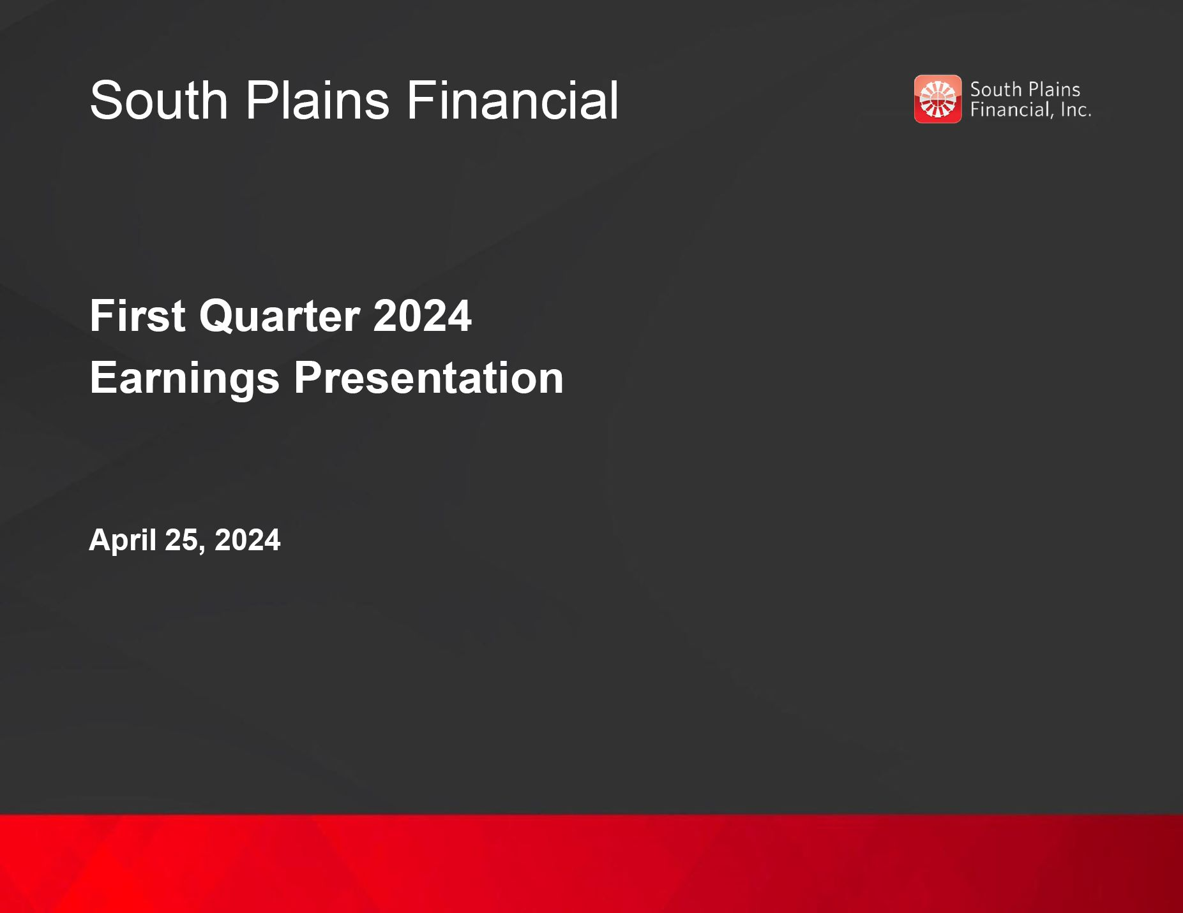
South Plains Financial First Quarter 2024 Earnings Presentation April 25, 2024


Safe Harbor Statement and Other Disclosures FORWARD-LOOKING STATEMENTS This presentation contains, and future oral and written statements of South Plains Financial, Inc. (“South Plains”, “SPFI”, or the “Company”) and City Bank (“City Bank” or the “Bank”) may contain, statements about future events that constitute forward-looking statements within the meaning of the Private Securities Litigation Reform Act of 1995. These forward-looking statements reflect South Plains’ current views with respect to future events and South Plains’ financial performance. Any statements about South Plains’ expectations, beliefs, plans, predictions, forecasts, objectives, assumptions or future events or performance are not historical facts and may be forward-looking. These statements are often, but not always, made through the use of words or phrases such as “anticipate,” “believes,” “can,” “could,” “may,” “predicts,” “potential,” “should,” “will,” “estimate,” “plans,” “projects,” “continuing,” “ongoing,” “expects,” “intends” and similar words or phrases. Forward-looking statements include, but are not limited to: (i) projections and estimates of revenues, expenses, income or loss, earnings or loss per share, and other financial items, (ii) statements of plans, objectives and expectations of South Plains or its management, (iii) statements of future economic performance, and (iv) statements of assumptions underlying such statements. Forward-looking statements should not be relied on because they involve known and unknown risks, uncertainties and other factors, some of which are beyond the control of South Plains and City Bank. These risks, uncertainties and other factors may cause the actual results, performance, and achievements of South Plains and City Bank to be materially different from the anticipated future results, performance or achievements expressed in, or implied by, the forward-looking statements. Factors that could cause such differences include, but are not limited to, the impact on us and our customers of a decline in general economic conditions and any regulatory responses thereto; potential recession in the United States and our market areas; the impacts related to or resulting from bank failures and any continuation of uncertainty in the banking industry, including the associated impact to the Company and other financial institutions of any regulatory changes or other mitigation efforts taken by government agencies in response thereto; increased competition for deposits and related changes in deposit customer behavior; the impact of changes in market interest rates, whether due to continued elevated interest rates or potential reductions in interest rates and a resulting decline in net interest income; the persistence of the current inflationary pressures, or the resurgence of elevated levels of inflation in the United States and our market areas; the uncertain impacts of ongoing quantitative tightening and current and future monetary policies of the Board of Governors of the Federal Reserve System; the effects of declines in housing prices in the Unites States and our market areas; increases in unemployment rates in the United States and our market areas; declines in commercial real estate values and prices; uncertainty regarding United States fiscal debt and budget matters; cyber incidents or other failures, disruptions or breaches of our operational or security systems or infrastructure, or those of our third-party vendors or other service providers, including as a result of cyber attacks; severe weather, natural disasters, acts of war or terrorism, geopolitical instability or other external events; competition and market expansion opportunities; changes in non-interest expenditures or in the anticipated benefits of such expenditures; the risks related to the development, implementation, use and management of emerging technologies, including artificial intelligence and machine learnings; potential increased regulatory requirements and costs related to the transition and physical impacts of climate change; current or future litigation, regulatory examinations or other legal and/or regulatory actions; and changes in applicable laws and regulations. Due to these and other possible uncertainties and risks, South Plains can give no assurance that the results contemplated in the forward-looking statements will be realized and readers are cautioned not to place undue reliance on the forward-looking statements contained in this presentation. Additional information regarding these factors and uncertainties to which South Plains’ business and future financial performance are subject is contained in South Plains’ most recent Annual Report on Form 10-K and Quarterly Reports on Form 10-Q on file with the U.S. Securities and Exchange Commission (the “SEC”), including the sections entitled "Risk Factors" and "Management's Discussion and Analysis of Financial Condition and Results of Operations“ of such documents, and other documents South Plains files or furnishes with the SEC from time to time. Further, any forward-looking statement speaks only as of the date on which it is made and South Plains undertakes no obligation to update or revise any forward-looking statement to reflect events or circumstances after the date on which the statement is made or to reflect the occurrence of unanticipated events, except as required by applicable law. All forward-looking statements, express or implied, herein are qualified in their entirety by this cautionary statement. NON-GAAP FINANCIAL MEASURES Management believes that certain non-GAAP performance measures used in this presentation provide meaningful information about underlying trends in its business and operations and provide both management and investors a more complete understanding of the Company’s financial position and performance. Non-GAAP financial measures should be viewed in addition to, and not as an alternative for, SPFI’s reported results prepared in accordance with GAAP. Non-GAAP financial measures have limitations as analytical tools, and investors should not consider them in isolation or as a substitute for analysis of the results or financial condition of the Company as reported under GAAP. Numbers in this presentation may not sum due to rounding. 2

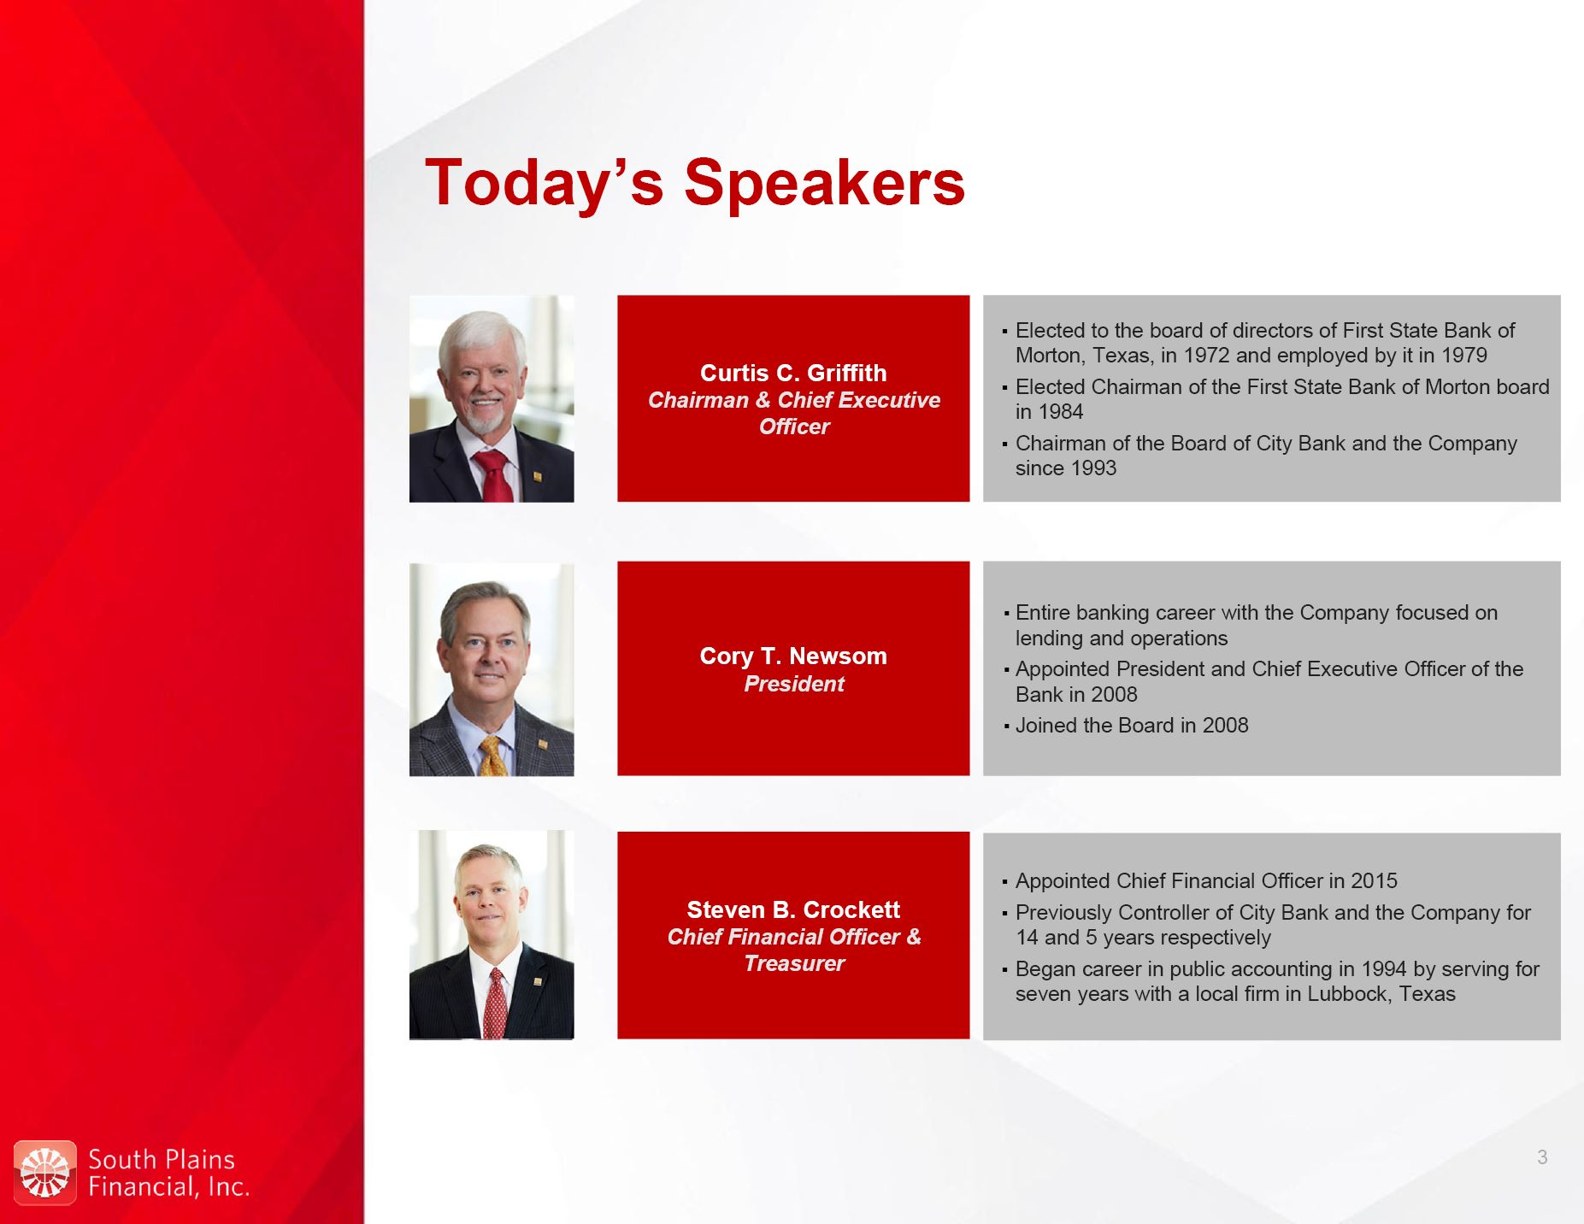
Today’s Speakers Curtis C. Griffith Chairman & Chief Executive Officer Elected to the board of directors of First State Bank of Morton, Texas, in 1972 and employed by it in 1979 Elected Chairman of the First State Bank of Morton board in 1984 Chairman of the Board of City Bank and the Company since 1993 Steven B. Crockett Chief Financial Officer & Treasurer Appointed Chief Financial Officer in 2015 Previously Controller of City Bank and the Company for 14 and 5 years respectively Began career in public accounting in 1994 by serving for seven years with a local firm in Lubbock, Texas Cory T. Newsom President Entire banking career with the Company focused on lending and operations Appointed President and Chief Executive Officer of the Bank in 2008 Joined the Board in 2008 3

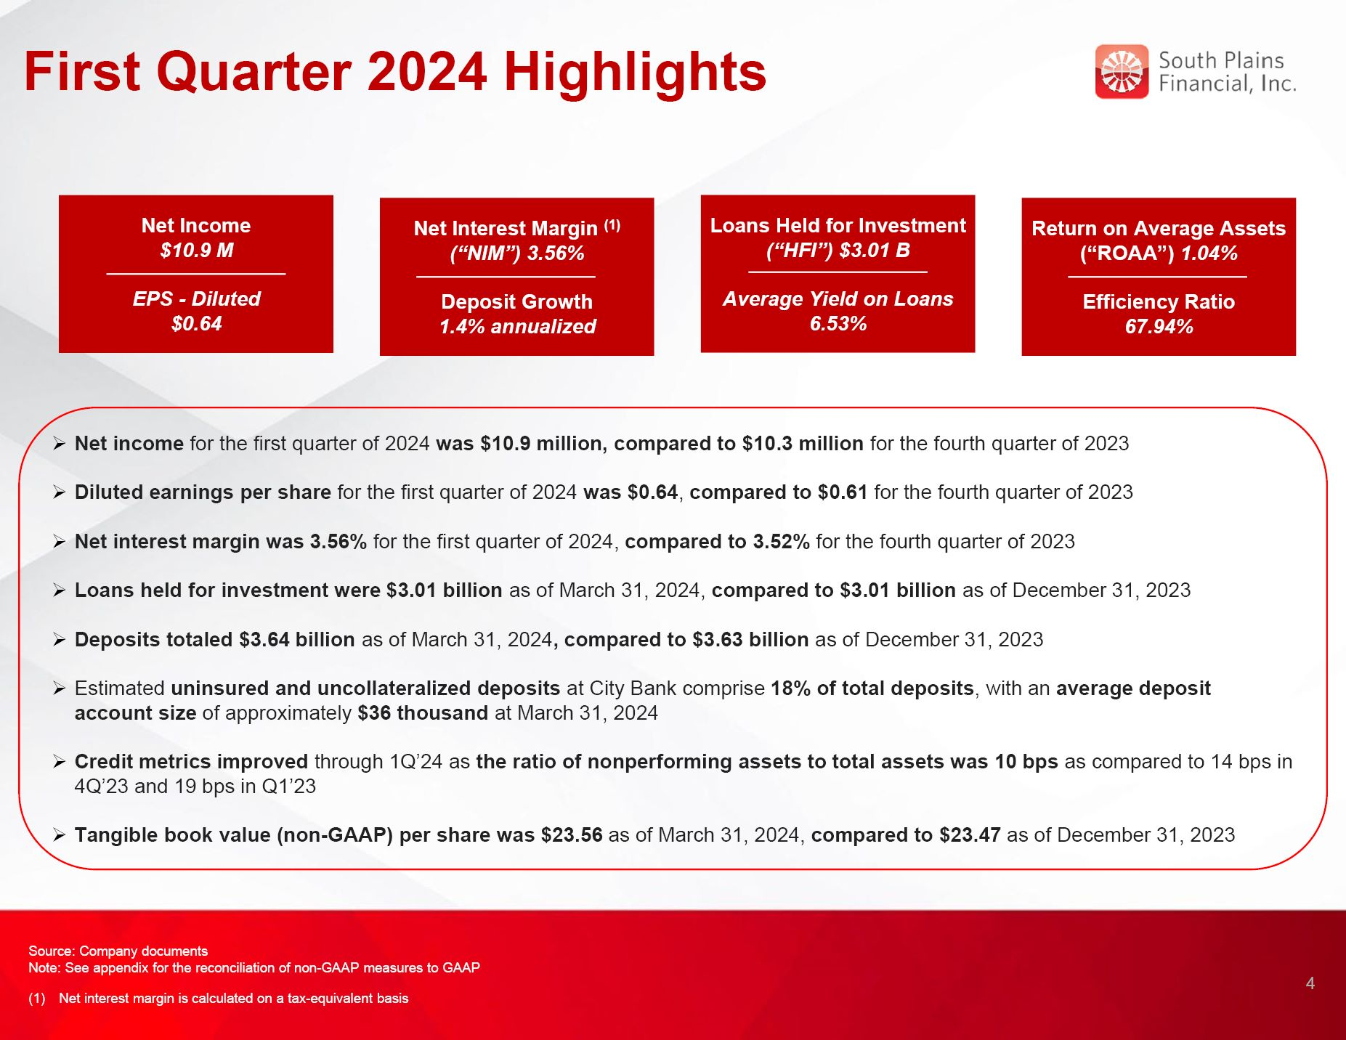
First Quarter 2024 Highlights Net income for the first quarter of 2024 was $10.9 million, compared to $10.3 million for the fourth quarter of 2023 Diluted earnings per share for the first quarter of 2024 was $0.64, compared to $0.61 for the fourth quarter of 2023 Net interest margin was 3.56% for the first quarter of 2024, compared to 3.52% for the fourth quarter of 2023 Loans held for investment were $3.01 billion as of March 31, 2024, compared to $3.01 billion as of December 31, 2023 Deposits totaled $3.64 billion as of March 31, 2024, compared to $3.63 billion as of December 31, 2023 Estimated uninsured and uncollateralized deposits at City Bank comprise 18% of total deposits, with an average deposit account size of approximately $36 thousand at March 31, 2024 Credit metrics improved through 1Q’24 as the ratio of nonperforming assets to total assets was 10 bps as compared to 14 bps in 4Q’23 and 19 bps in Q1’23 Tangible book value (non-GAAP) per share was $23.56 as of March 31, 2024, compared to $23.47 as of December 31, 2023 4 Source: Company documents Note: See appendix for the reconciliation of non-GAAP measures to GAAP Net interest margin is calculated on a tax-equivalent basis Loans Held for Investment (“HFI”) $3.01 B Average Yield on Loans 6.53% Net Income $10.9 M EPS - Diluted $0.64 Net Interest Margin (1) (“NIM”) 3.56% Deposit Growth 1.4% annualized Return on Average Assets (“ROAA”) 1.04% Efficiency Ratio 67.94%

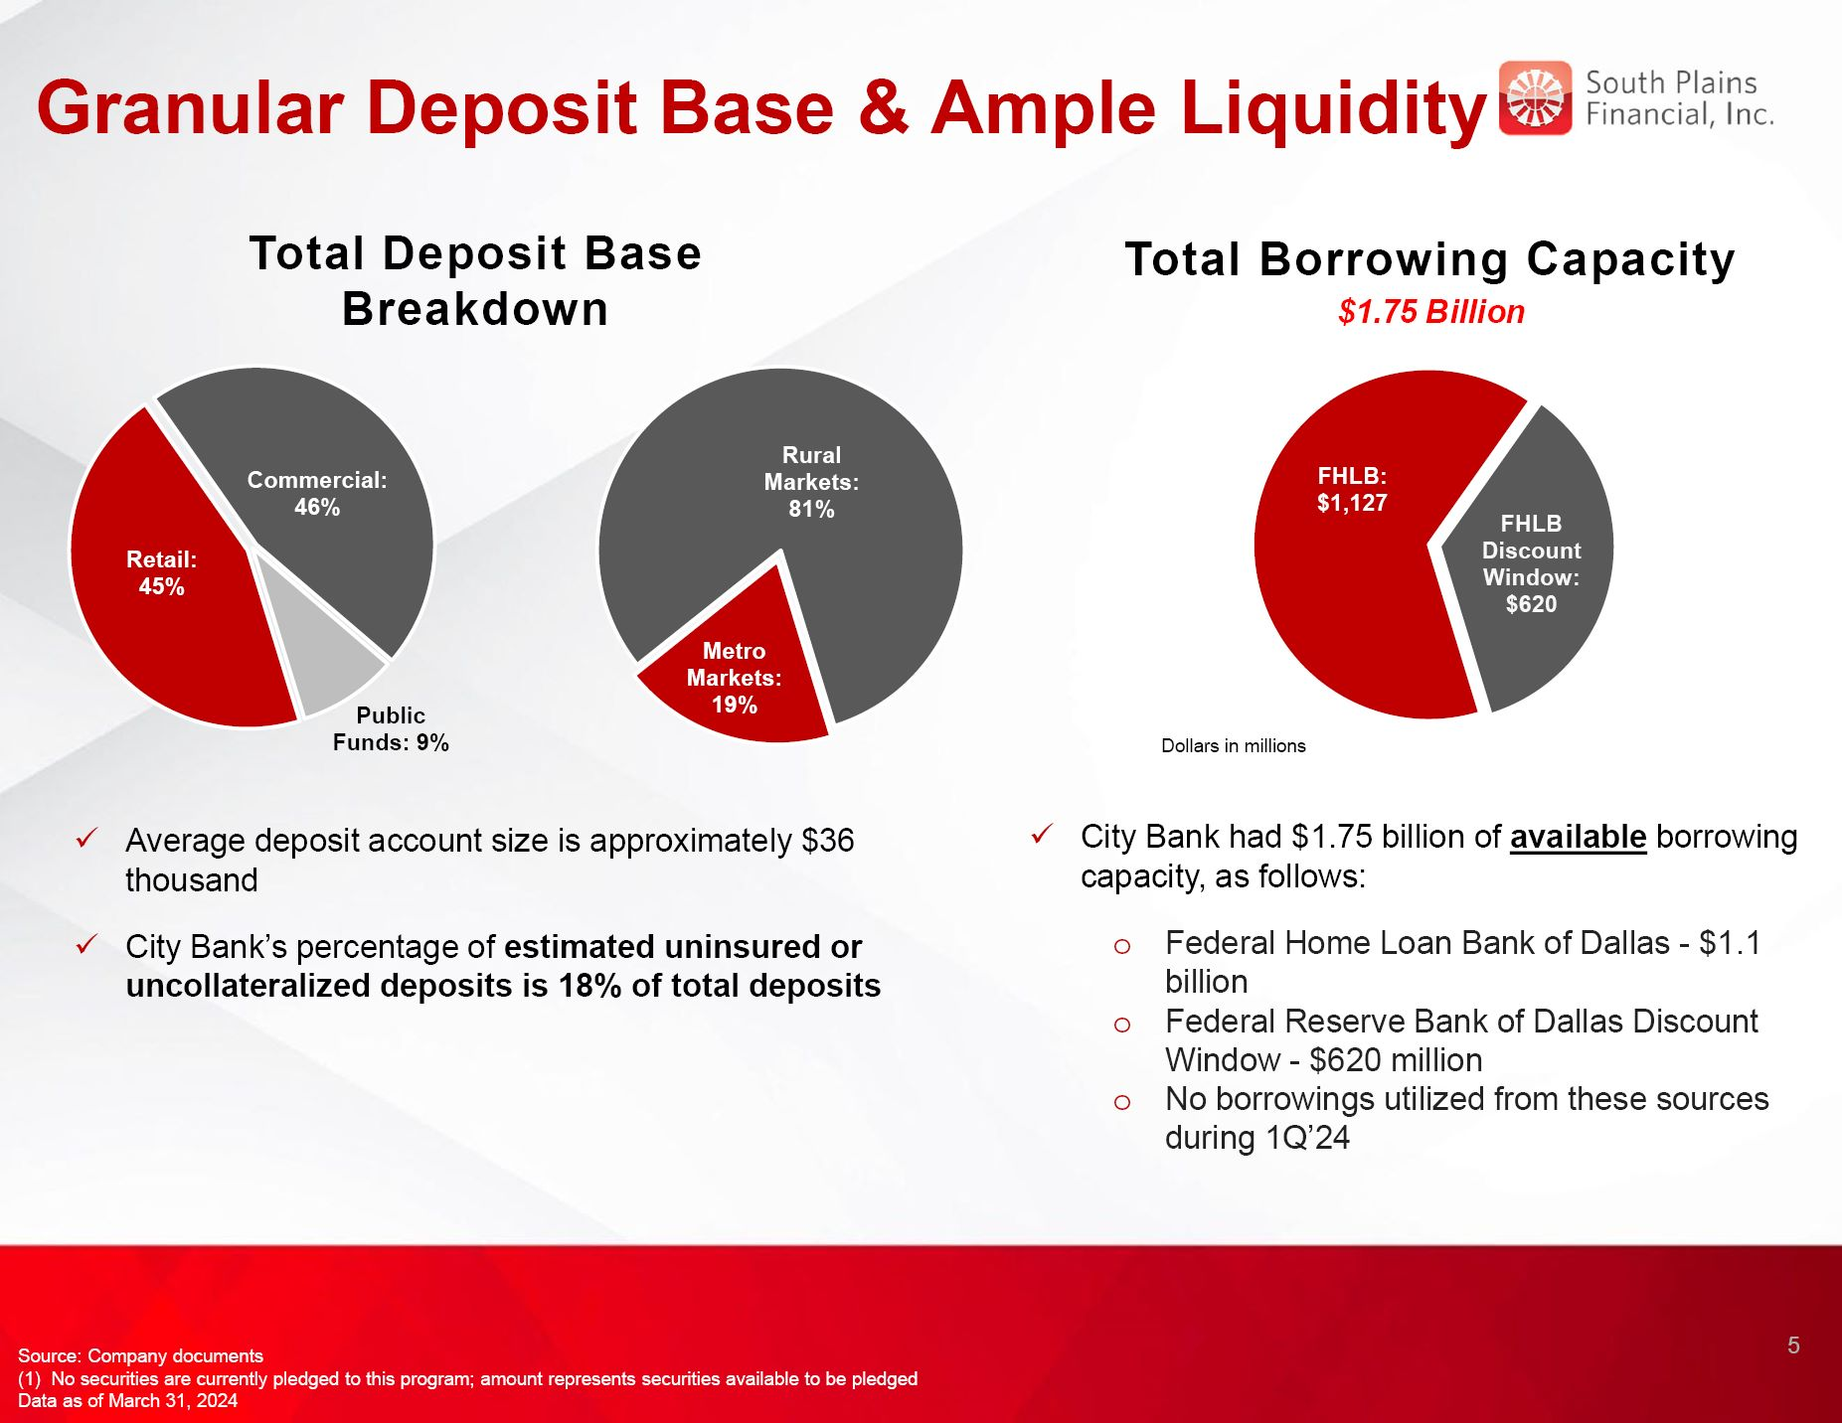
Granular Deposit Base & Ample Liquidity Total Borrowing Capacity $1.75 Billion Source: Company documents (1) No securities are currently pledged to this program; amount represents securities available to be pledged Data as of March 31, 2024 5 Total Deposit Base Breakdown Average deposit account size is approximately $36 thousand City Bank’s percentage of estimated uninsured or uncollateralized deposits is 18% of total deposits City Bank had $1.75 billion of available borrowing capacity, as follows: Federal Home Loan Bank of Dallas - $1.1 billion Federal Reserve Bank of Dallas Discount Window - $620 million No borrowings utilized from these sources during 1Q’24

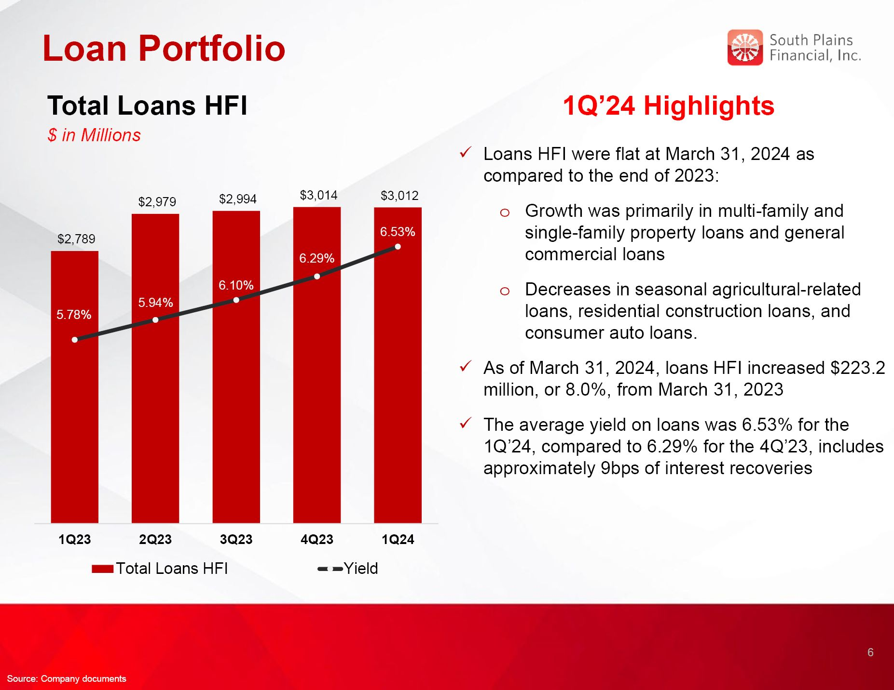
Loan Portfolio 1Q’24 Highlights Loans HFI were flat at March 31, 2024 as compared to the end of 2023: Growth was primarily in multi-family and single-family property loans and general commercial loans Decreases in seasonal agricultural-related loans, residential construction loans, and consumer auto loans. As of March 31, 2024, loans HFI increased $223.2 million, or 8.0%, from March 31, 2023 The average yield on loans was 6.53% for the 1Q’24, compared to 6.29% for the 4Q’23, includes approximately 9bps of interest recoveries Total Loans HFI $ in Millions 6 Source: Company documents

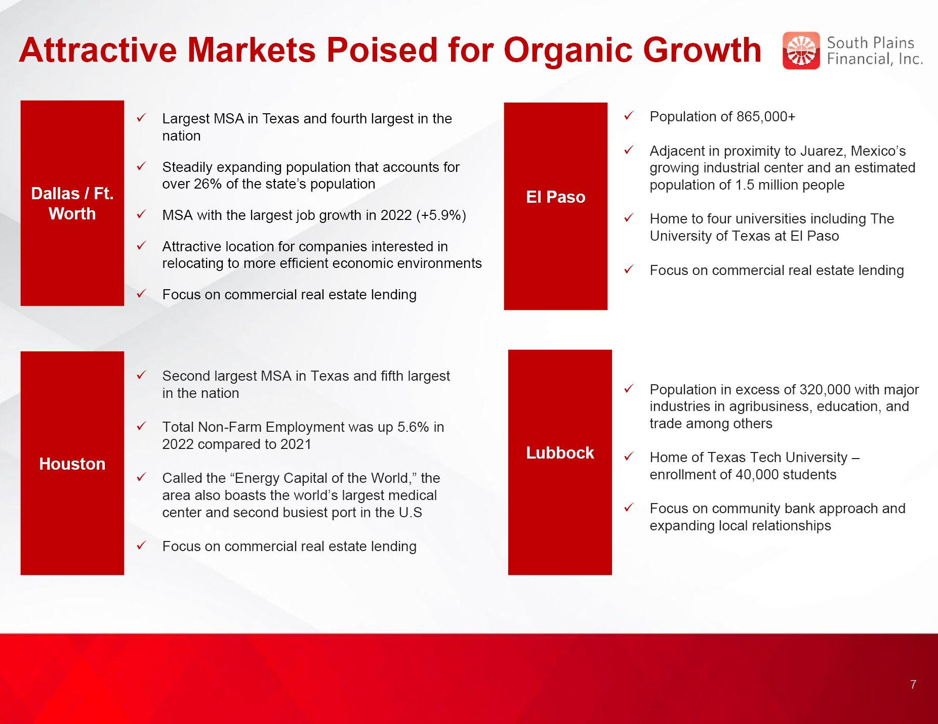
Attractive Markets Poised for Organic Growth El Paso Basin Dallas / Ft. Worth Population of 865,000+ Adjacent in proximity to Juarez, Mexico’s growing industrial center and an estimated population of 1.5 million people Home to four universities including The University of Texas at El Paso Focus on commercial real estate lending Largest MSA in Texas and fourth largest in the nation Steadily expanding population that accounts for over 26% of the state’s population MSA with the largest job growth in 2022 (+5.9%) Attractive location for companies interested in relocating to more efficient economic environments Focus on commercial real estate lending Houston Second largest MSA in Texas and fifth largest in the nation Total Non-Farm Employment was up 5.6% in 2022 compared to 2021 Called the “Energy Capital of the World,” the area also boasts the world’s largest medical center and second busiest port in the U.S Focus on commercial real estate lending Lubbock Basin Population in excess of 320,000 with major industries in agribusiness, education, and trade among others Home of Texas Tech University – enrollment of 40,000 students Focus on community bank approach and expanding local relationships 7

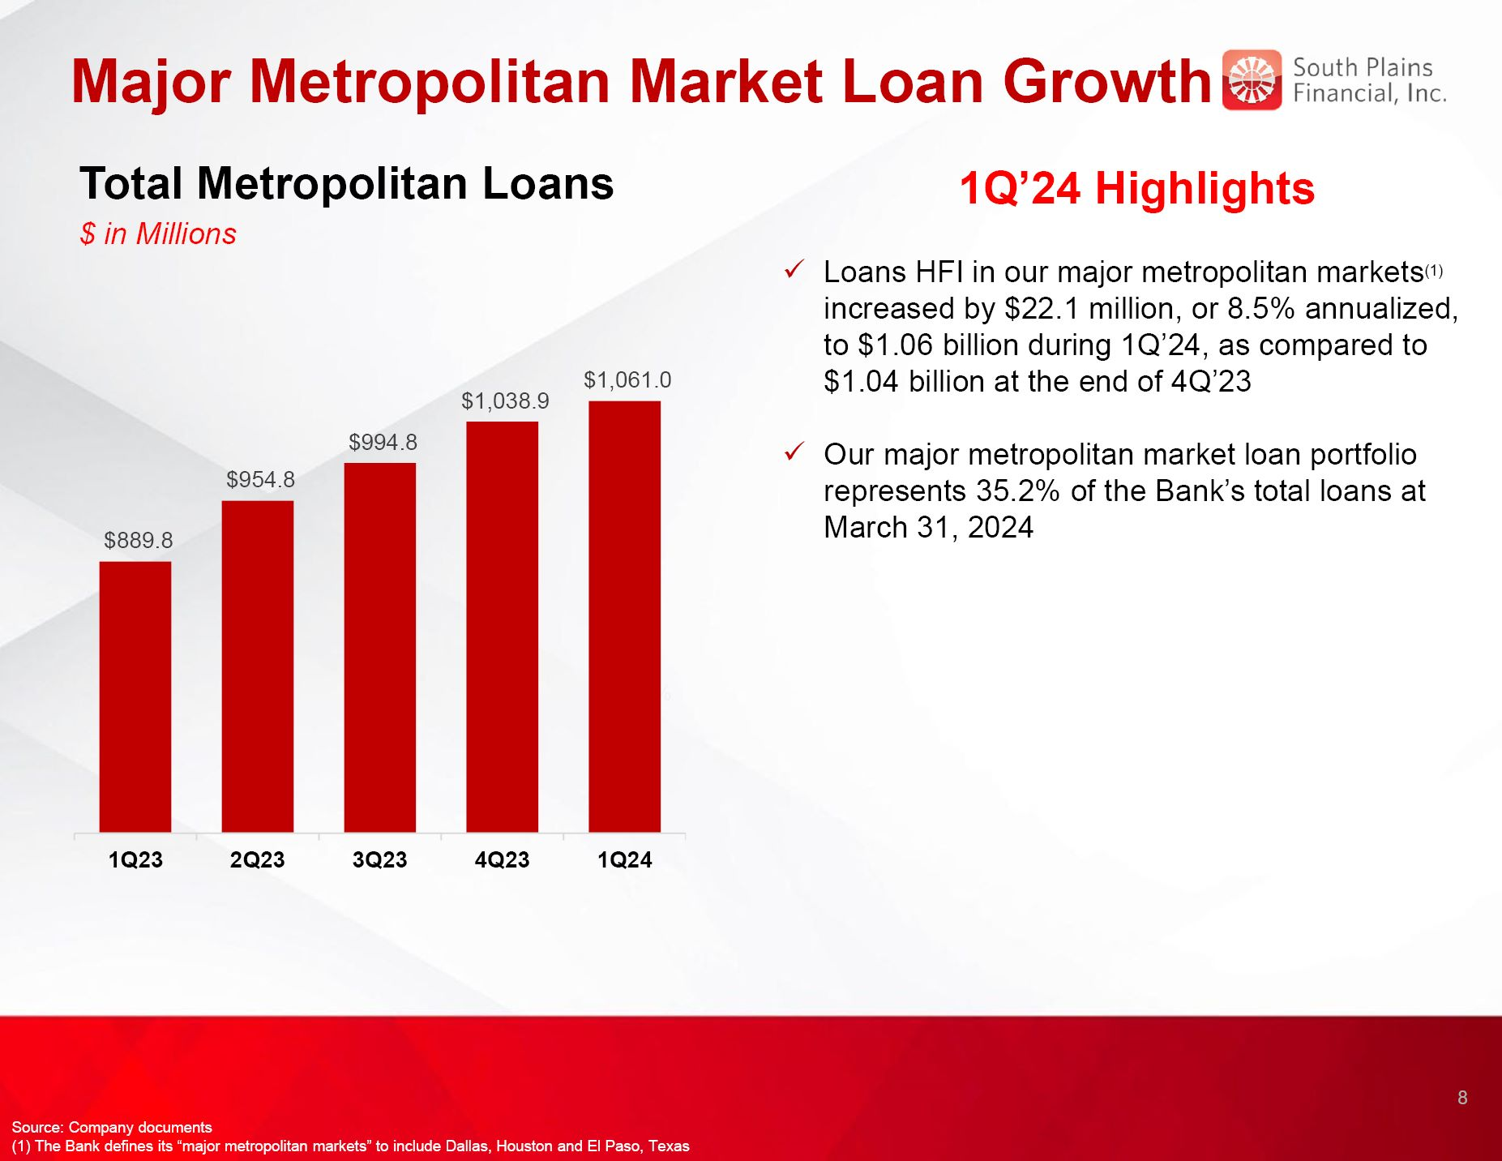
Major Metropolitan Market Loan Growth 1Q’24 Highlights Loans HFI in our major metropolitan markets(1) increased by $22.1 million, or 8.5% annualized, to $1.06 billion during 1Q’24, as compared to $1.04 billion at the end of 4Q’23 Our major metropolitan market loan portfolio represents 35.2% of the Bank’s total loans at March 31, 2024 Total Metropolitan Loans $ in Millions 8 5.00% Source: Company documents (1) The Bank defines its “major metropolitan markets” to include Dallas, Houston and El Paso, Texas

Loan HFI Portfolio Loan Mix Loan Portfolio ($ in millions) Commercial C&D $ 199.3 Residential C&D 234.7 CRE Owner/Occ. 337.8 Other CRE Non Owner/Occ. 549.5 Multi-Family 240.0 C&I 382.9 Agriculture 158.4 1-4 Family 545.1 Auto 292.4 Other Consumer 71.7 Total $ 3,011.8 Fixed vs. Variable Rate 9 Source: Company documents Data as of March 31, 2024

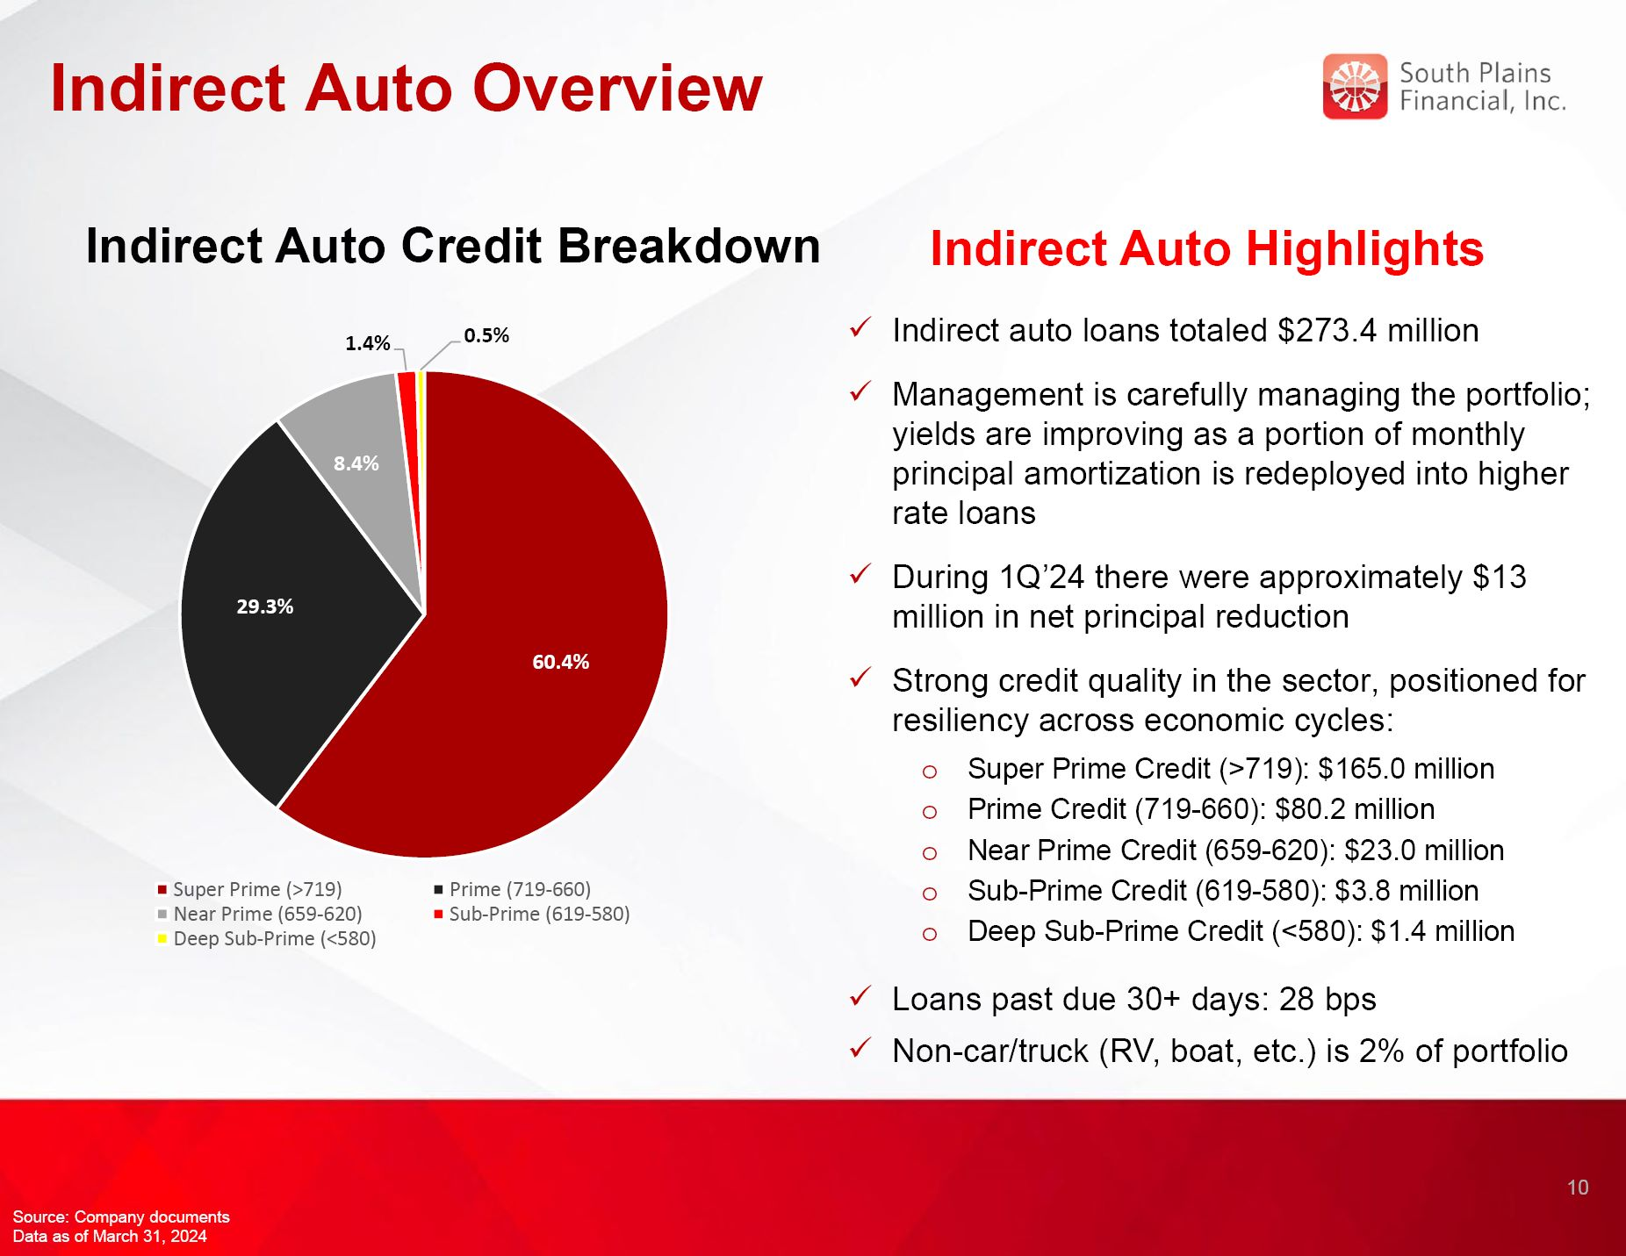
Indirect Auto Overview Indirect Auto Highlights Indirect auto loans totaled $273.4 million Management is carefully managing the portfolio; yields are improving as a portion of monthly principal amortization is redeployed into higher rate loans During 1Q’24 there were approximately $13 million in net principal reduction Strong credit quality in the sector, positioned for resiliency across economic cycles: Super Prime Credit (>719): $165.0 million Prime Credit (719-660): $80.2 million Near Prime Credit (659-620): $23.0 million Sub-Prime Credit (619-580): $3.8 million Deep Sub-Prime Credit (<580): $1.4 million Loans past due 30+ days: 28 bps Non-car/truck (RV, boat, etc.) is 2% of portfolio Indirect Auto Credit Breakdown 10 Source: Company documents Data as of March 31, 2024

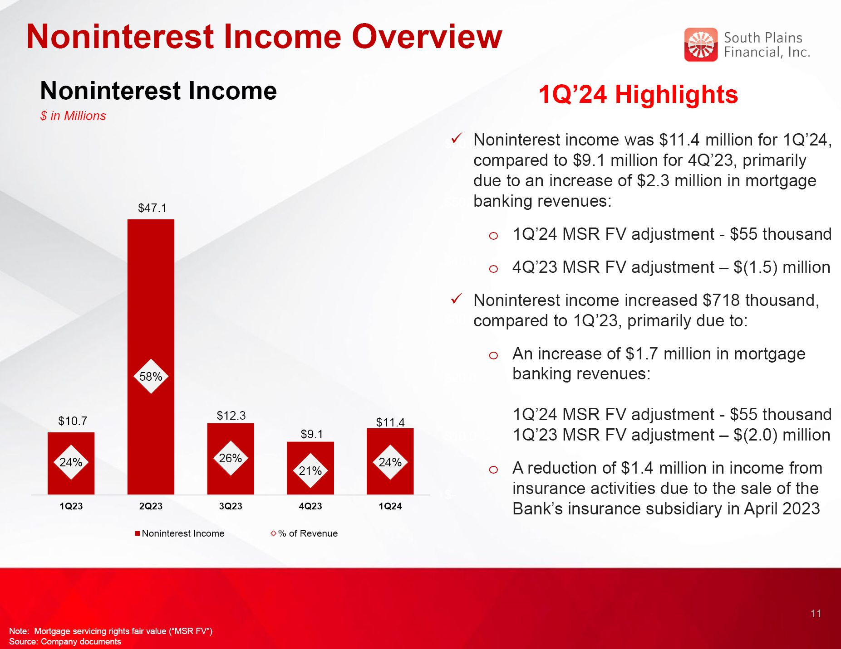
Noninterest Income Overview Noninterest Income $ in Millions 1Q’24 Highlights Noninterest income was $11.4 million for 1Q’24, compared to $9.1 million for 4Q’23, primarily due to an increase of $2.3 million in mortgage banking revenues: 1Q’24 MSR FV adjustment - $55 thousand 4Q’23 MSR FV adjustment – $(1.5) million Noninterest income increased $718 thousand, compared to 1Q’23, primarily due to: An increase of $1.7 million in mortgage banking revenues:1Q’24 MSR FV adjustment - $55 thousand1Q’23 MSR FV adjustment – $(2.0) million A reduction of $1.4 million in income from insurance activities due to the sale of the Bank’s insurance subsidiary in April 2023 11 Note: Mortgage servicing rights fair value (“MSR FV”) Source: Company documents

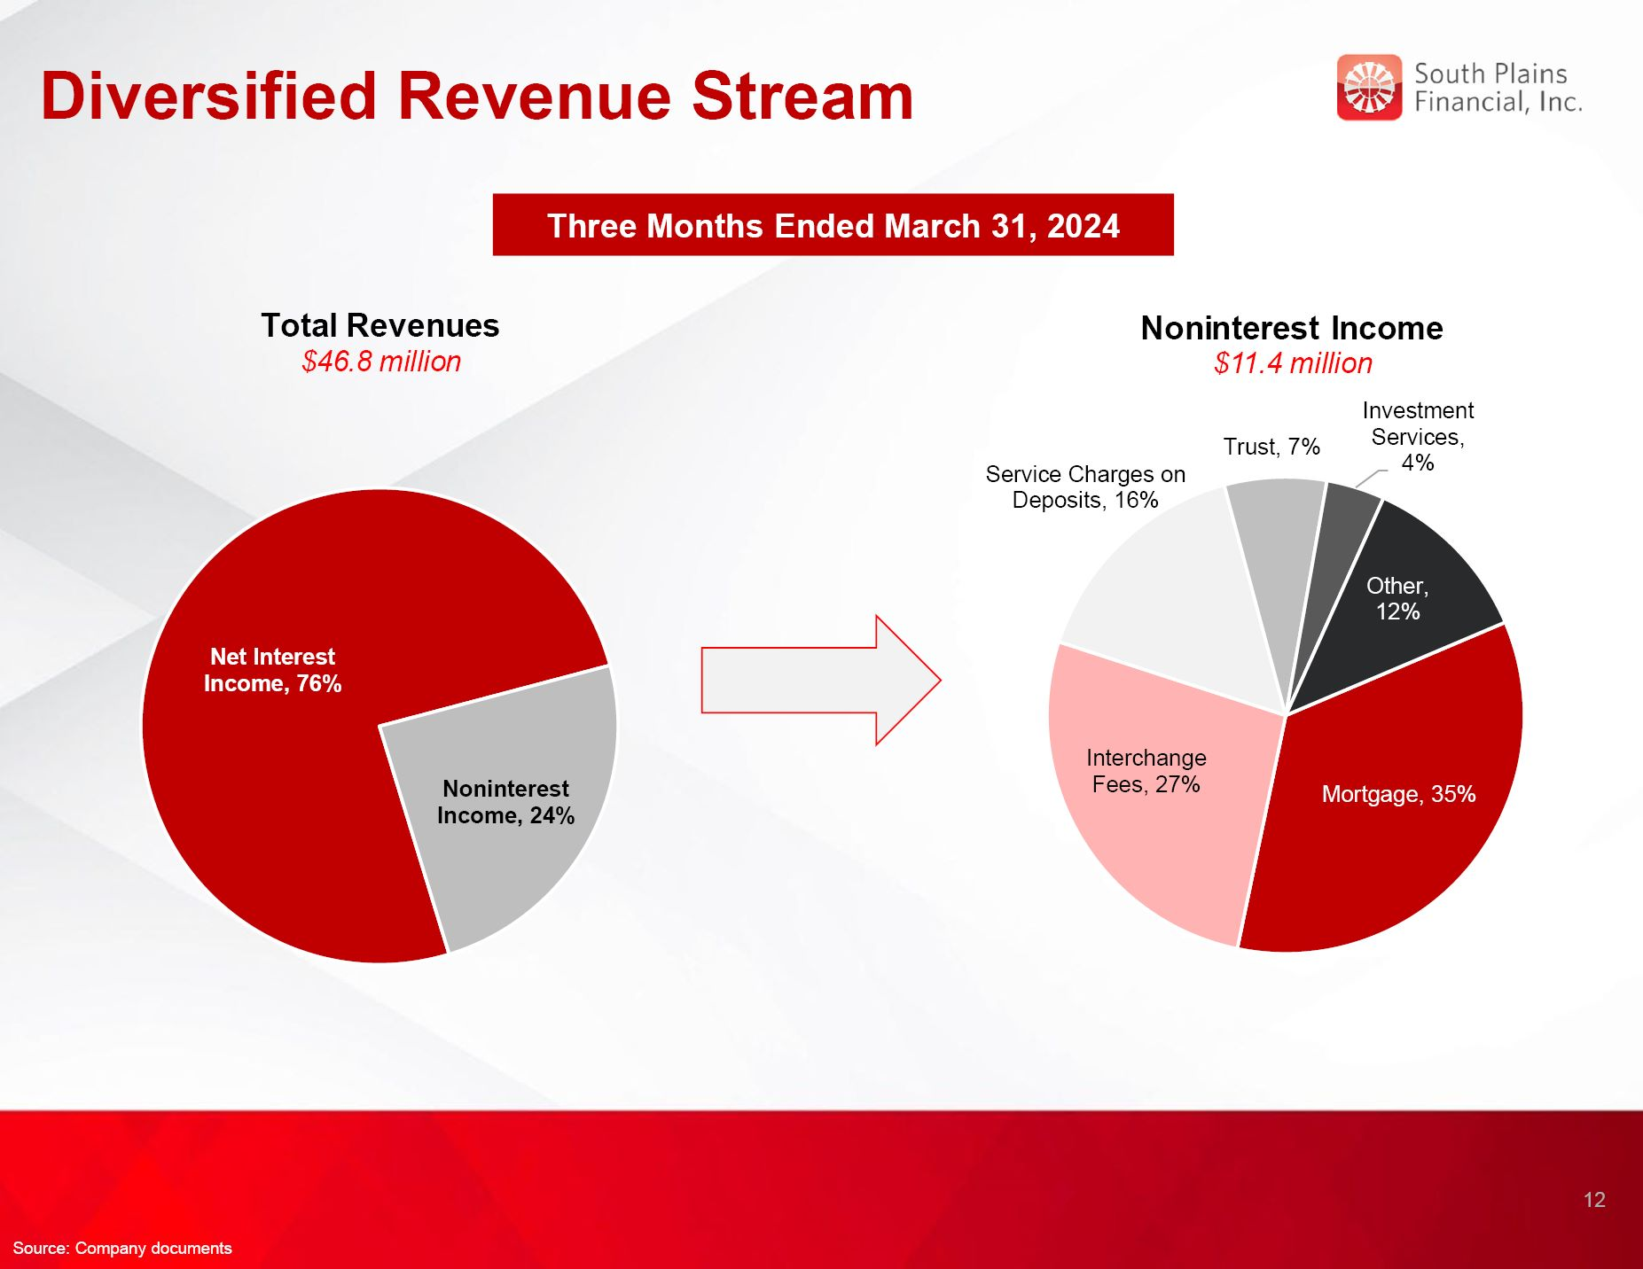
Diversified Revenue Stream Three Months Ended March 31, 2024 Total Revenues $46.8 million Noninterest Income $11.4 million 12 Source: Company documents

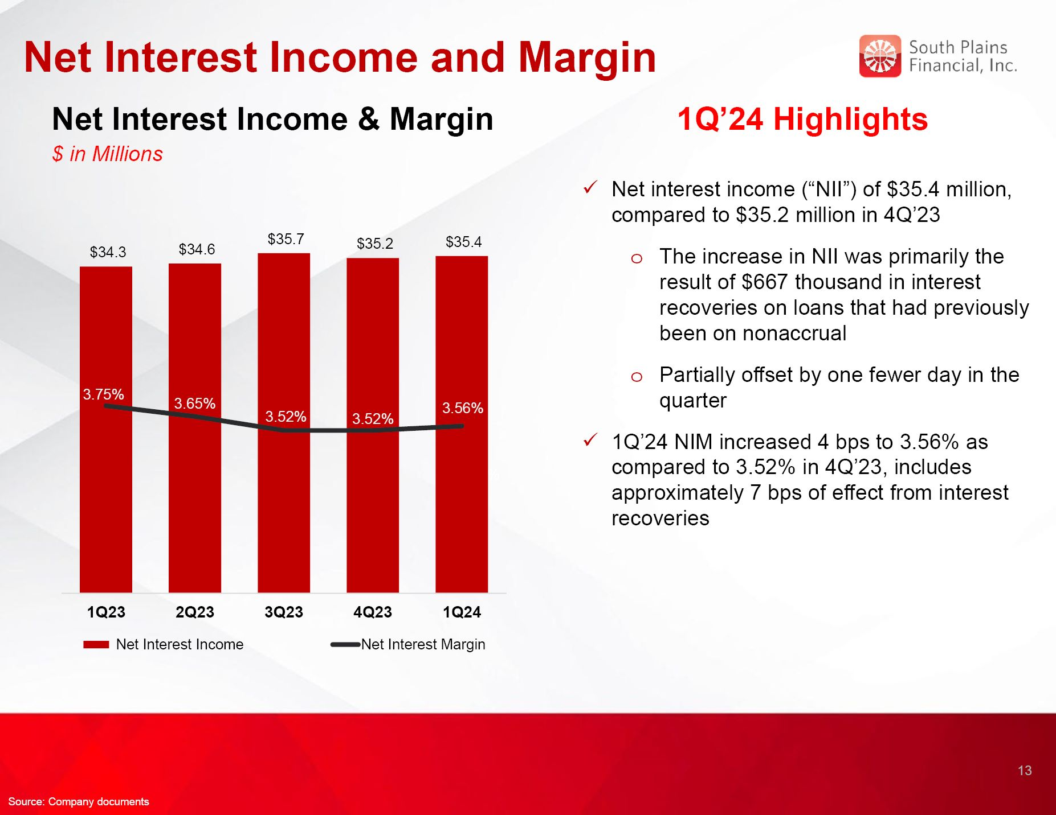
Net Interest Income and Margin Net Interest Income & Margin $ in Millions 1Q’24 Highlights Net interest income (“NII”) of $35.4 million, compared to $35.2 million in 4Q’23 The increase in NII was primarily the result of $667 thousand in interest recoveries on loans that had previously been on nonaccrual Partially offset by one fewer day in the quarter 1Q’24 NIM increased 4 bps to 3.56% as compared to 3.52% in 4Q’23, includes approximately 7 bps of effect from interest recoveries 13 3.54% Source: Company documents

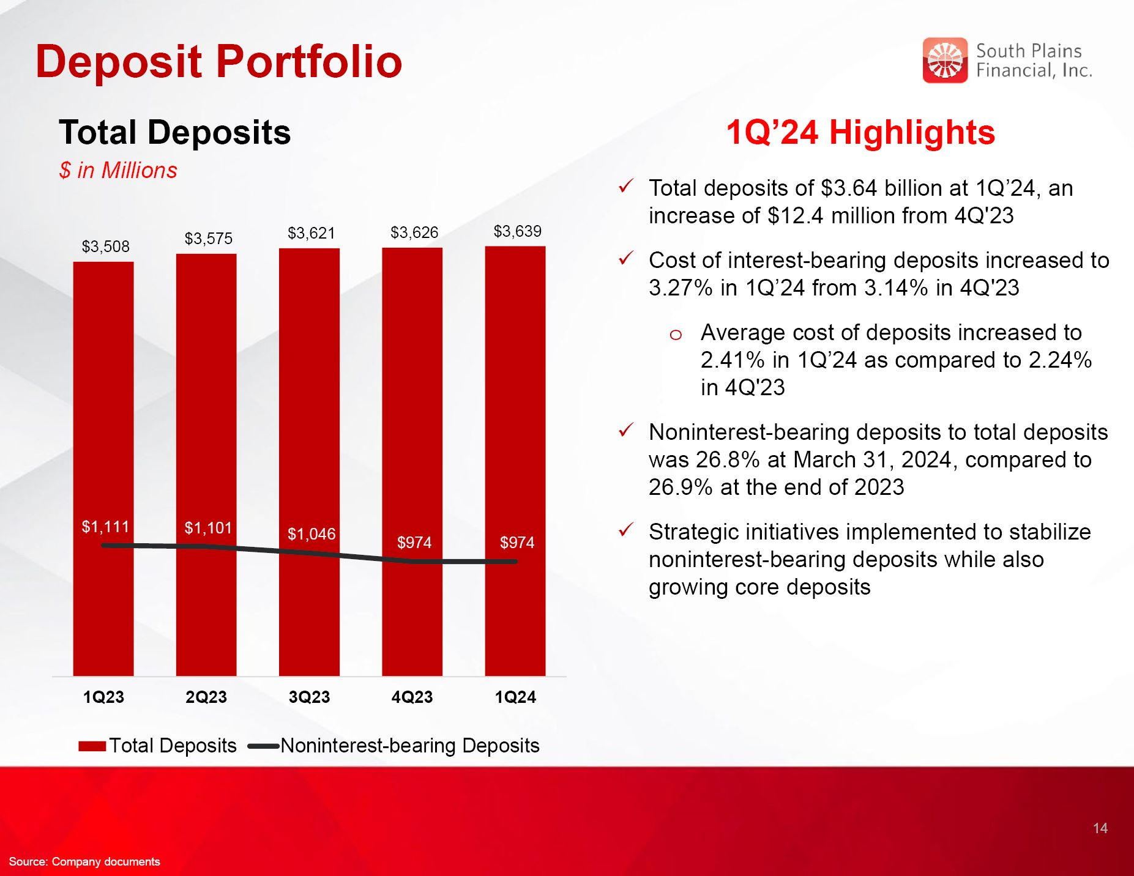
Deposit Portfolio Total Deposits $ in Millions 1Q’24 Highlights Total deposits of $3.64 billion at 1Q’24, an increase of $12.4 million from 4Q'23 Cost of interest-bearing deposits increased to 3.27% in 1Q’24 from 3.14% in 4Q'23 Average cost of deposits increased to 2.41% in 1Q’24 as compared to 2.24% in 4Q'23 Noninterest-bearing deposits to total deposits was 26.8% at March 31, 2024, compared to 26.9% at the end of 2023 Strategic initiatives implemented to stabilize noninterest-bearing deposits while also growing core deposits 14 Source: Company documents

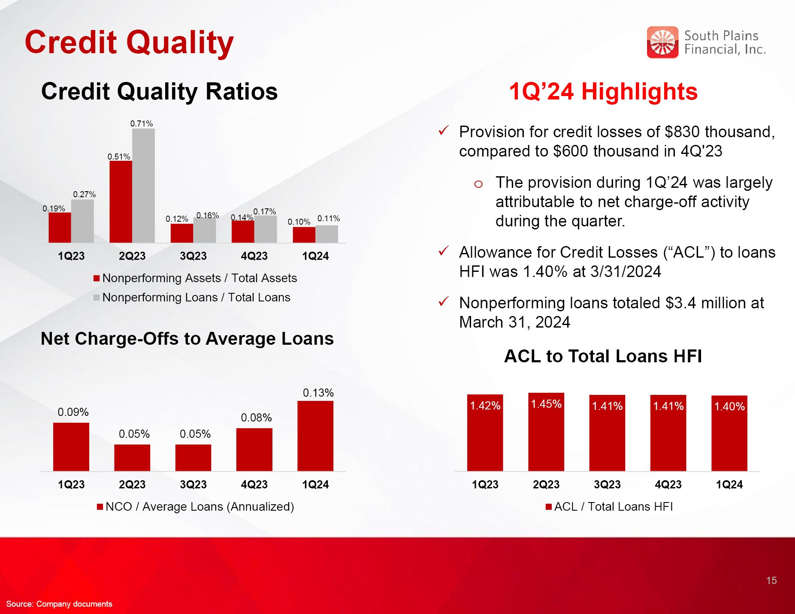
Credit Quality 1Q’24 Highlights Credit Quality Ratios Net Charge-Offs to Average Loans ACL to Total Loans HFI 15 Provision for credit losses of $830 thousand, compared to $600 thousand in 4Q'23 The provision during 1Q’24 was largely attributable to net charge-off activity during the quarter. Allowance for Credit Losses (“ACL”) to loans HFI was 1.40% at 3/31/2024 Nonperforming loans totaled $3.4 million at March 31, 2024 Source: Company documents

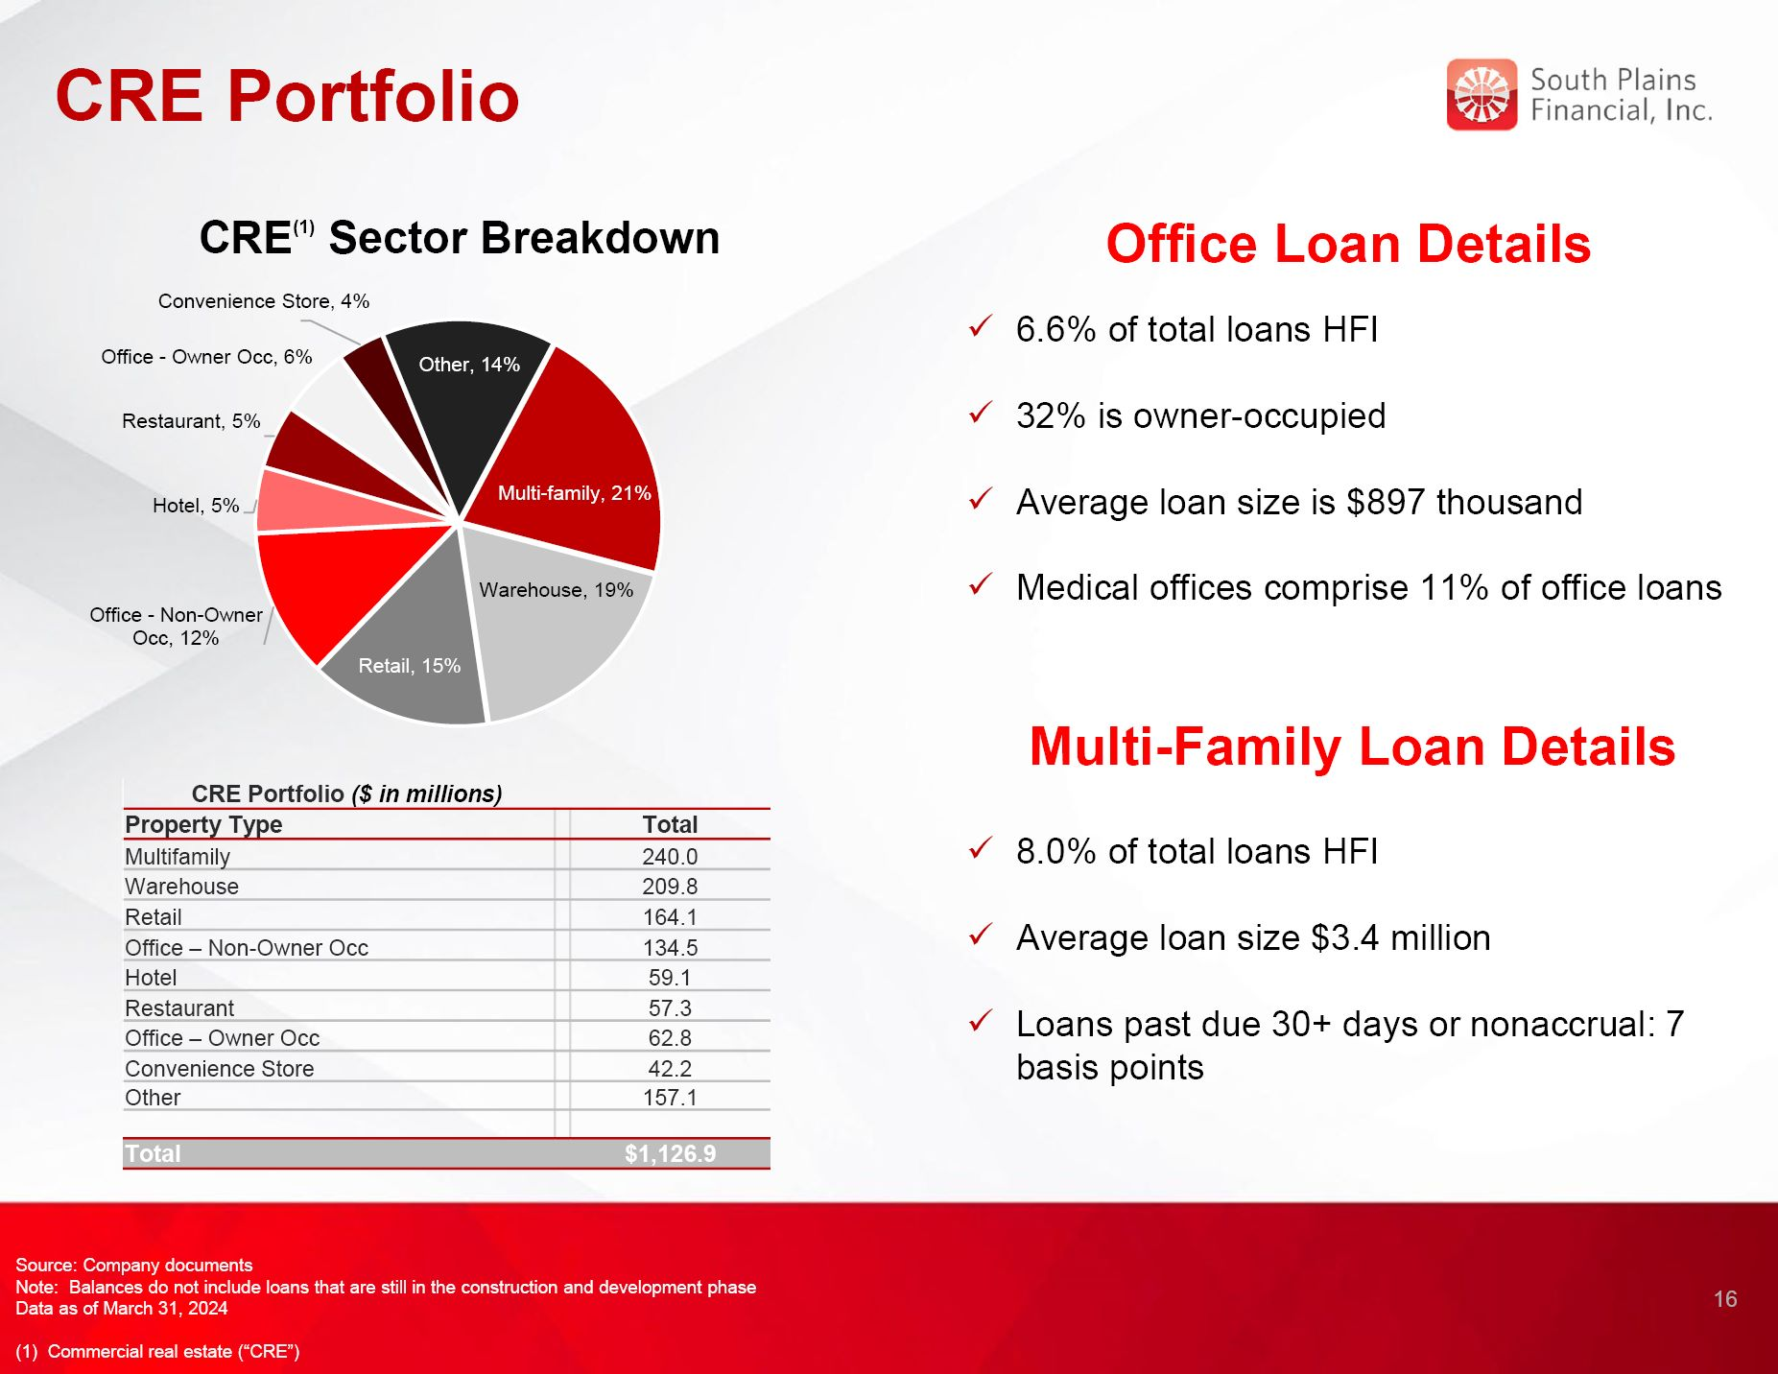
CRE Portfolio 16 Office Loan Details 6.6% of total loans HFI 32% is owner-occupied Average loan size is $897 thousand Medical offices comprise 11% of office loans CRE Portfolio ($ in millions) Property Type Total Multifamily 240.0 Warehouse 209.8 Retail 164.1 Office – Non-Owner Occ 134.5 Hotel 59.1 Restaurant 57.3 Office – Owner Occ 62.8 Convenience Store 42.2 Other 157.1 Total $1,126.9 CRE(1) Sector Breakdown Source: Company documents Note: Balances do not include loans that are still in the construction and development phase Data as of March 31, 2024 (1) Commercial real estate (“CRE”) Multi-Family Loan Details 8.0% of total loans HFI Average loan size $3.4 million Loans past due 30+ days or nonaccrual: 7 basis points

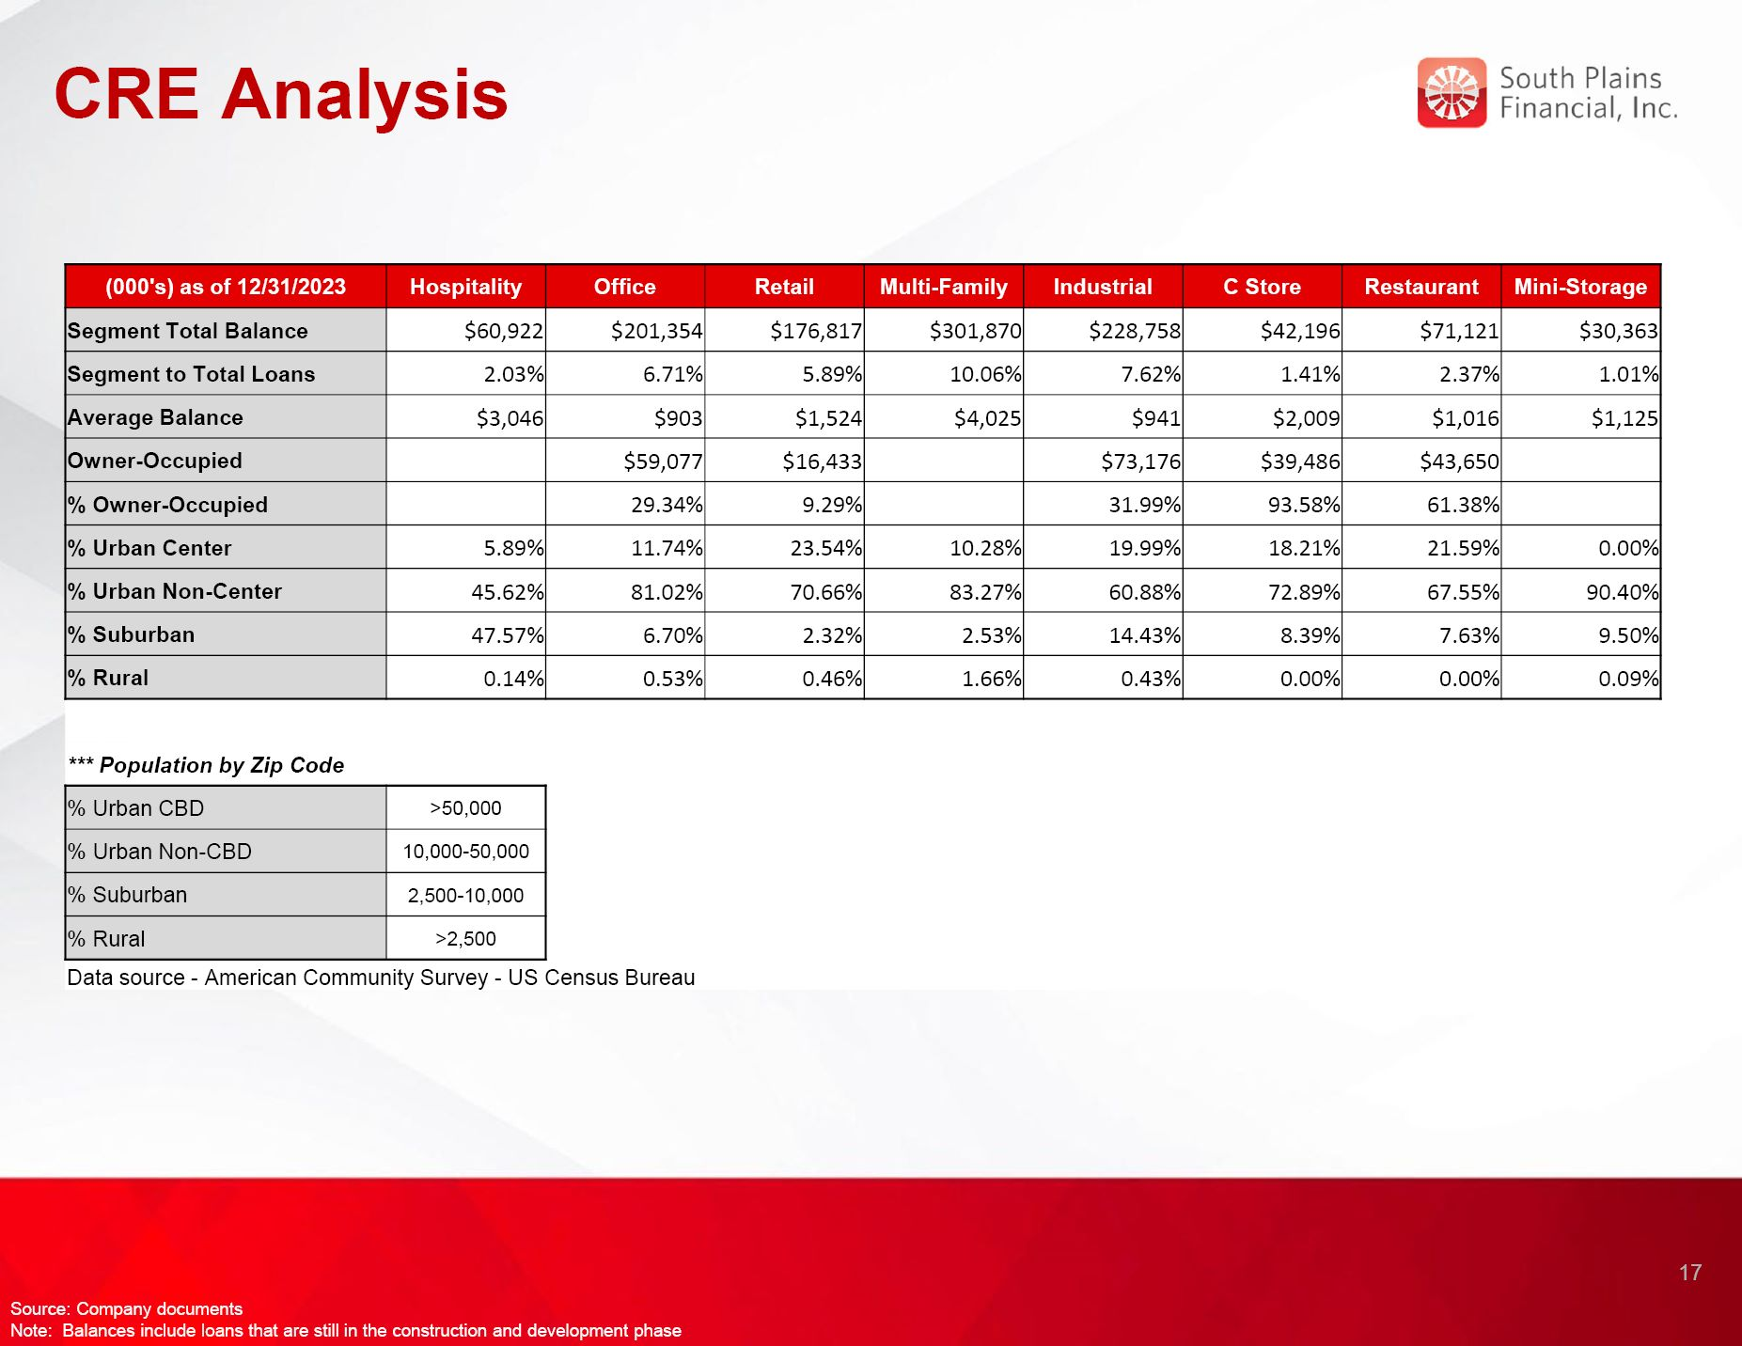
CRE Analysis 17 Source: Company documents Note: Balances include loans that are still in the construction and development phase (000's) as of 12/31/2023 Hospitality Office Retail Multi-Family Industrial C Store Restaurant Mini-Storage Segment Total Balance $60,922 $201,354 $176,817 $301,870 $228,758 $42,196 $71,121 $30,363 Segment to Total Loans 2.03% 6.71% 5.89% 10.06% 7.62% 1.41% 2.37% 1.01% Average Balance $3,046 $903 $1,524 $4,025 $941 $2,009 $1,016 $1,125 Owner-Occupied $59,077 $16,433 $73,176 $39,486 $43,650 % Owner-Occupied 29.34% 9.29% 31.99% 93.58% 61.38% % Urban Center 5.89% 11.74% 23.54% 10.28% 19.99% 18.21% 21.59% 0.00% % Urban Non-Center 45.62% 81.02% 70.66% 83.27% 60.88% 72.89% 67.55% 90.40% % Suburban 47.57% 6.70% 2.32% 2.53% 14.43% 8.39% 7.63% 9.50% % Rural 0.14% 0.53% 0.46% 1.66% 0.43% 0.00% 0.00% 0.09% *** Population by Zip Code % Urban CBD >50,000 % Urban Non-CBD 10,000-50,000 % Suburban 2,500-10,000 % Rural >2,500 Data source - American Community Survey - US Census Bureau

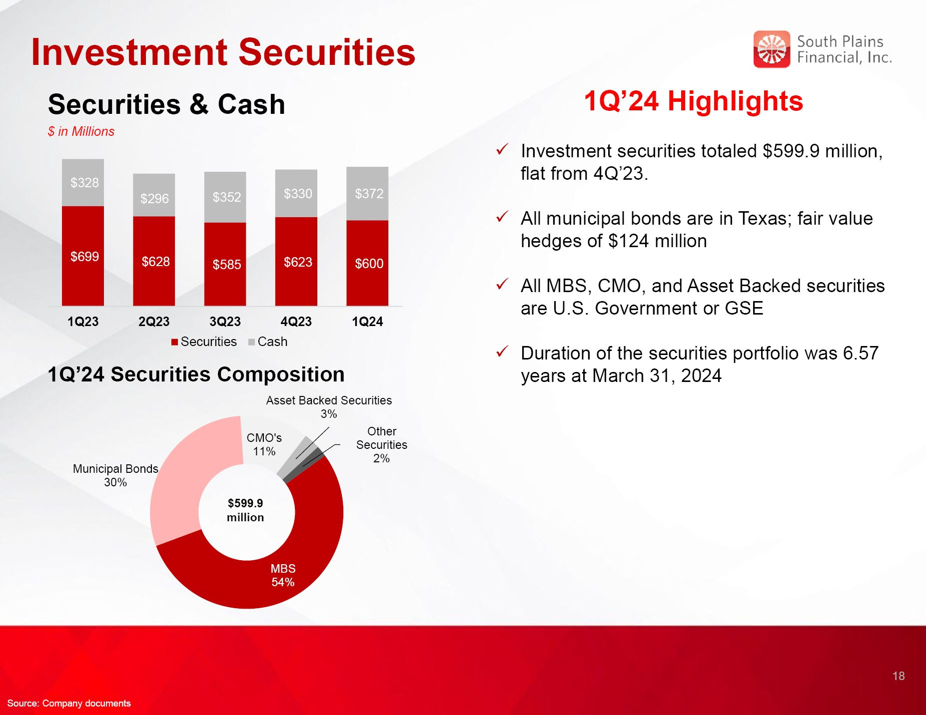
Investment Securities 1Q’24 Highlights Investment securities totaled $599.9 million, flat from 4Q’23. All municipal bonds are in Texas; fair value hedges of $124 million All MBS, CMO, and Asset Backed securities are U.S. Government or GSE Duration of the securities portfolio was 6.57 years at March 31, 2024 1Q’24 Securities Composition $599.9 million Securities & Cash $ in Millions 18 Source: Company documents

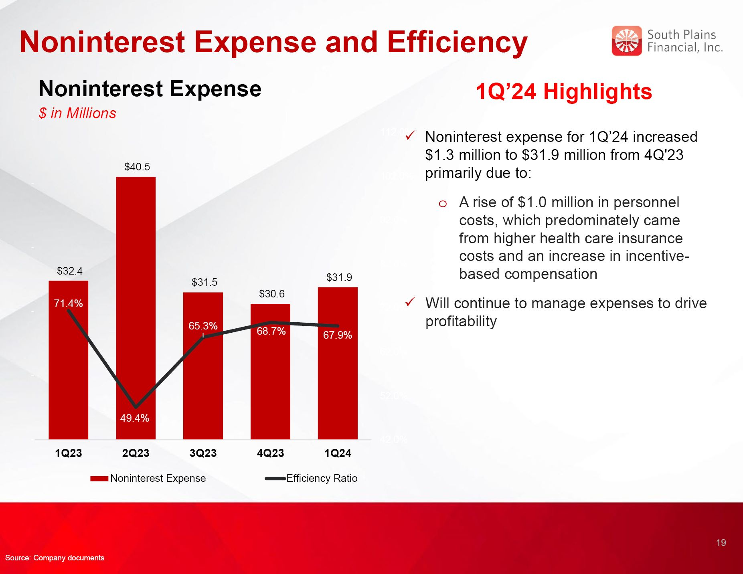
Noninterest Expense and Efficiency Noninterest Expense $ in Millions 1Q’24 Highlights Noninterest expense for 1Q’24 increased $1.3 million to $31.9 million from 4Q'23 primarily due to: A rise of $1.0 million in personnel costs, which predominately came from higher health care insurance costs and an increase in incentive-based compensation Will continue to manage expenses to drive profitability 19 Source: Company documents

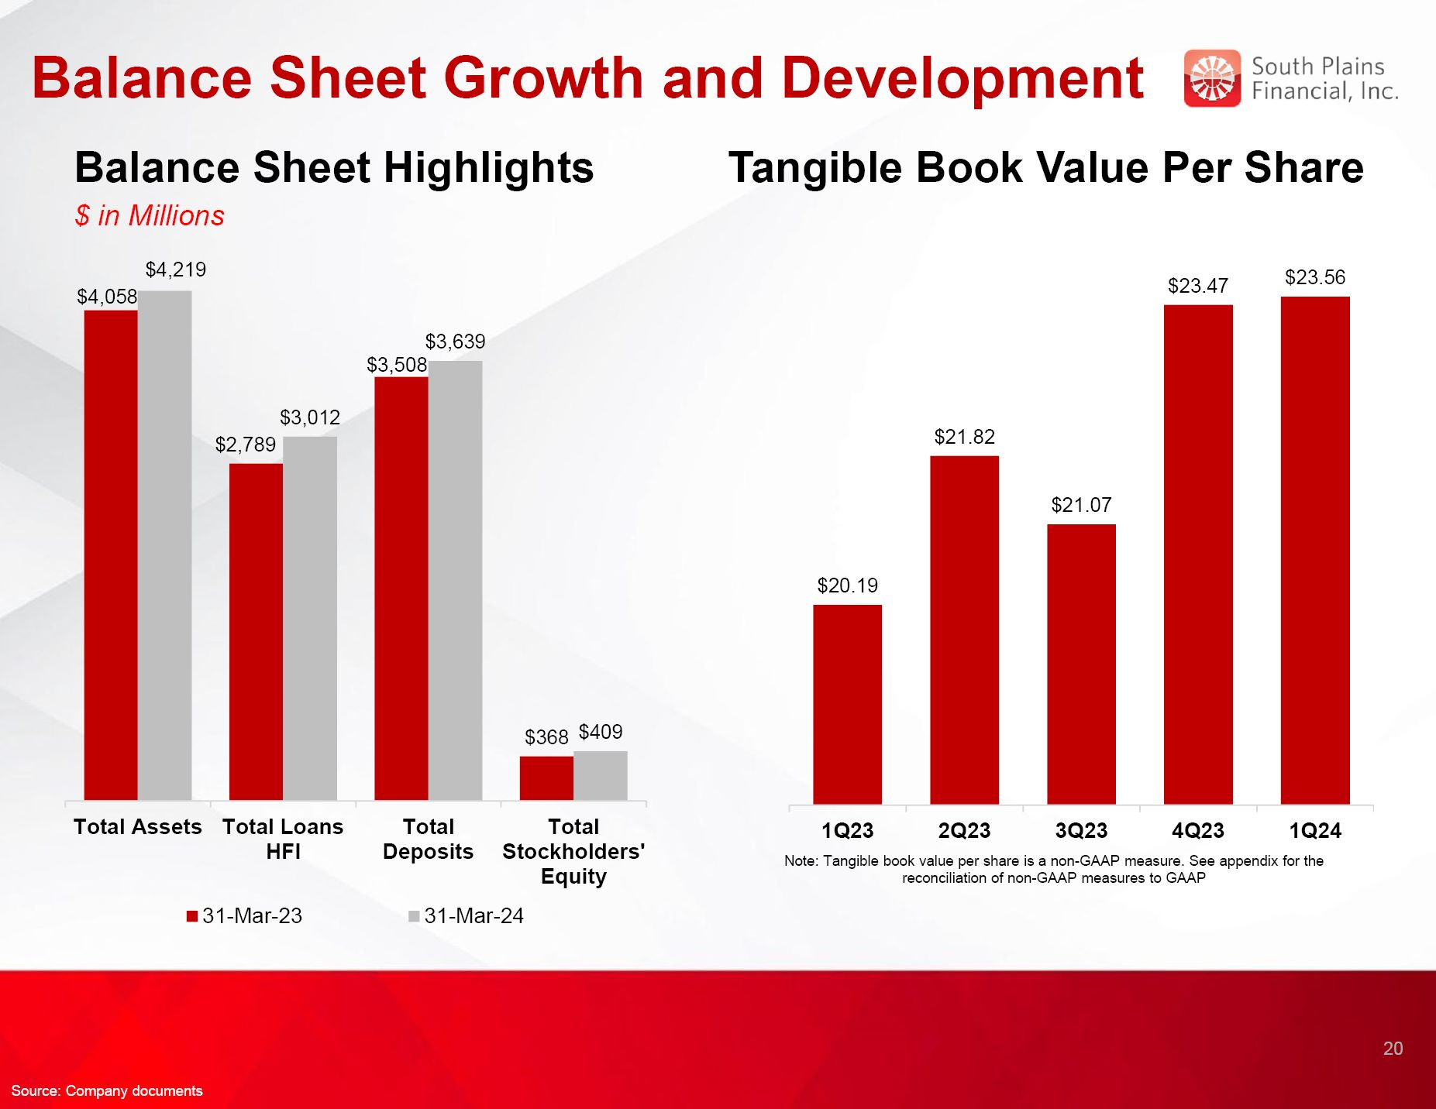
Balance Sheet Growth and Development Balance Sheet Highlights $ in Millions Tangible Book Value Per Share Note: Tangible book value per share is a non-GAAP measure. See appendix for the reconciliation of non-GAAP measures to GAAP 20 Source: Company documents

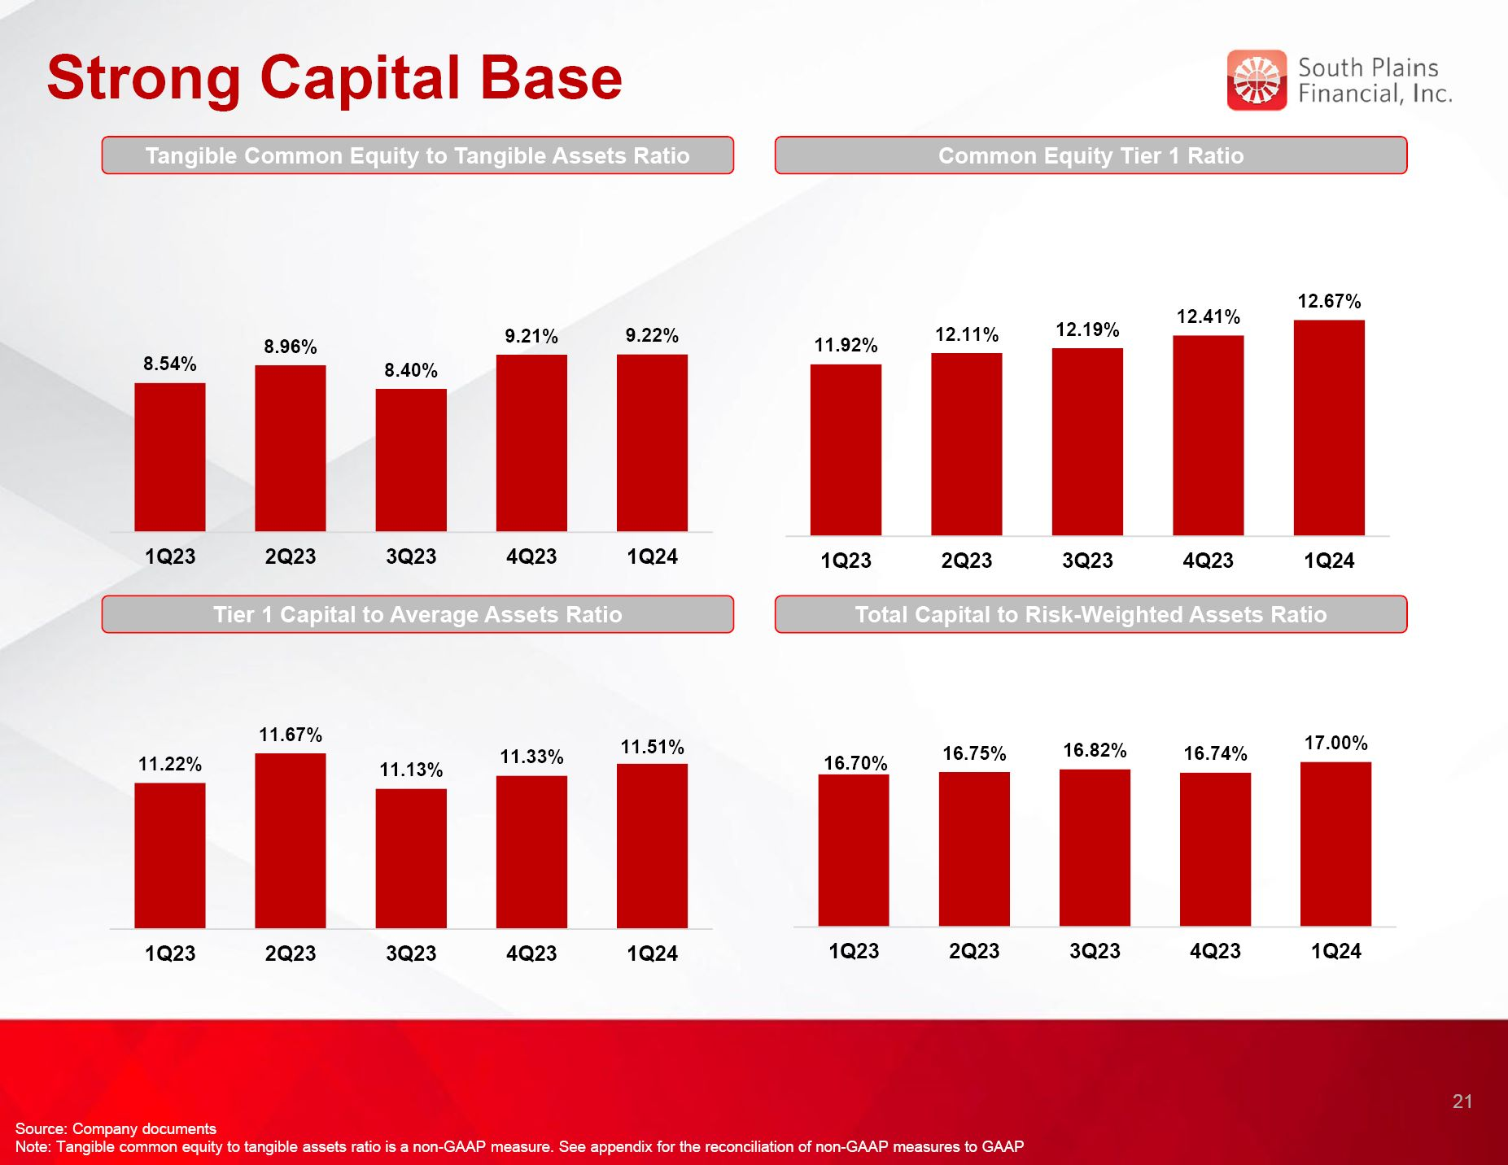
Strong Capital Base Tangible Common Equity to Tangible Assets Ratio Common Equity Tier 1 Ratio Tier 1 Capital to Average Assets Ratio Total Capital to Risk-Weighted Assets Ratio 21 Source: Company documents Note: Tangible common equity to tangible assets ratio is a non-GAAP measure. See appendix for the reconciliation of non-GAAP measures to GAAP


SPFI’s Core Purpose and Values Align Centered on Relationship-Based Business Our Core Purpose is: To use the power of relationships to help people succeed and live better HELP ALL STAKEHOLDERS SUCCEED Employees → great benefits and opportunities to grow and make a difference. Customers → personalized advice and solutions to achieve their goals. Partners → responsive, trusted win-win partnerships enabling both parties to succeed together. Shareholders → share in the prosperity and performance of the Bank. THE POWER OF RELATIONSHIPS At SPFI, we build lifelong, trusted relationships so you know you always have someone in your corner that understands you, cares about you, and stands ready to help. LIVE BETTER We want to help everyone live better. At the end of the day, we do what we do to help enhance lives. We create a great place to work, help people achieve their goals, and invest generously in our communities because there’s nothing more rewarding than helping people succeed and live better. 22

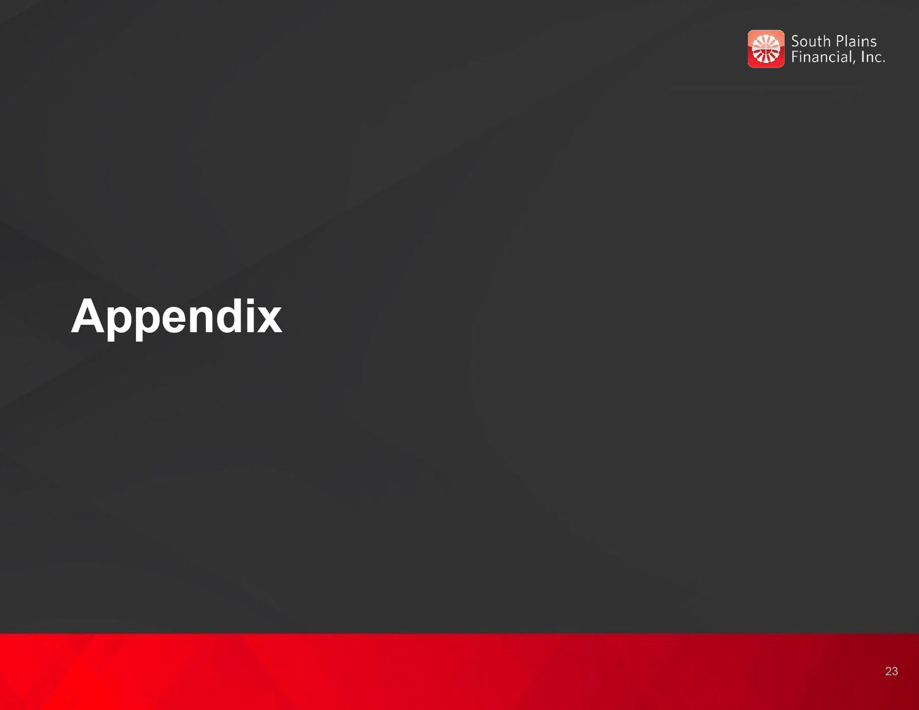
Appendix 23

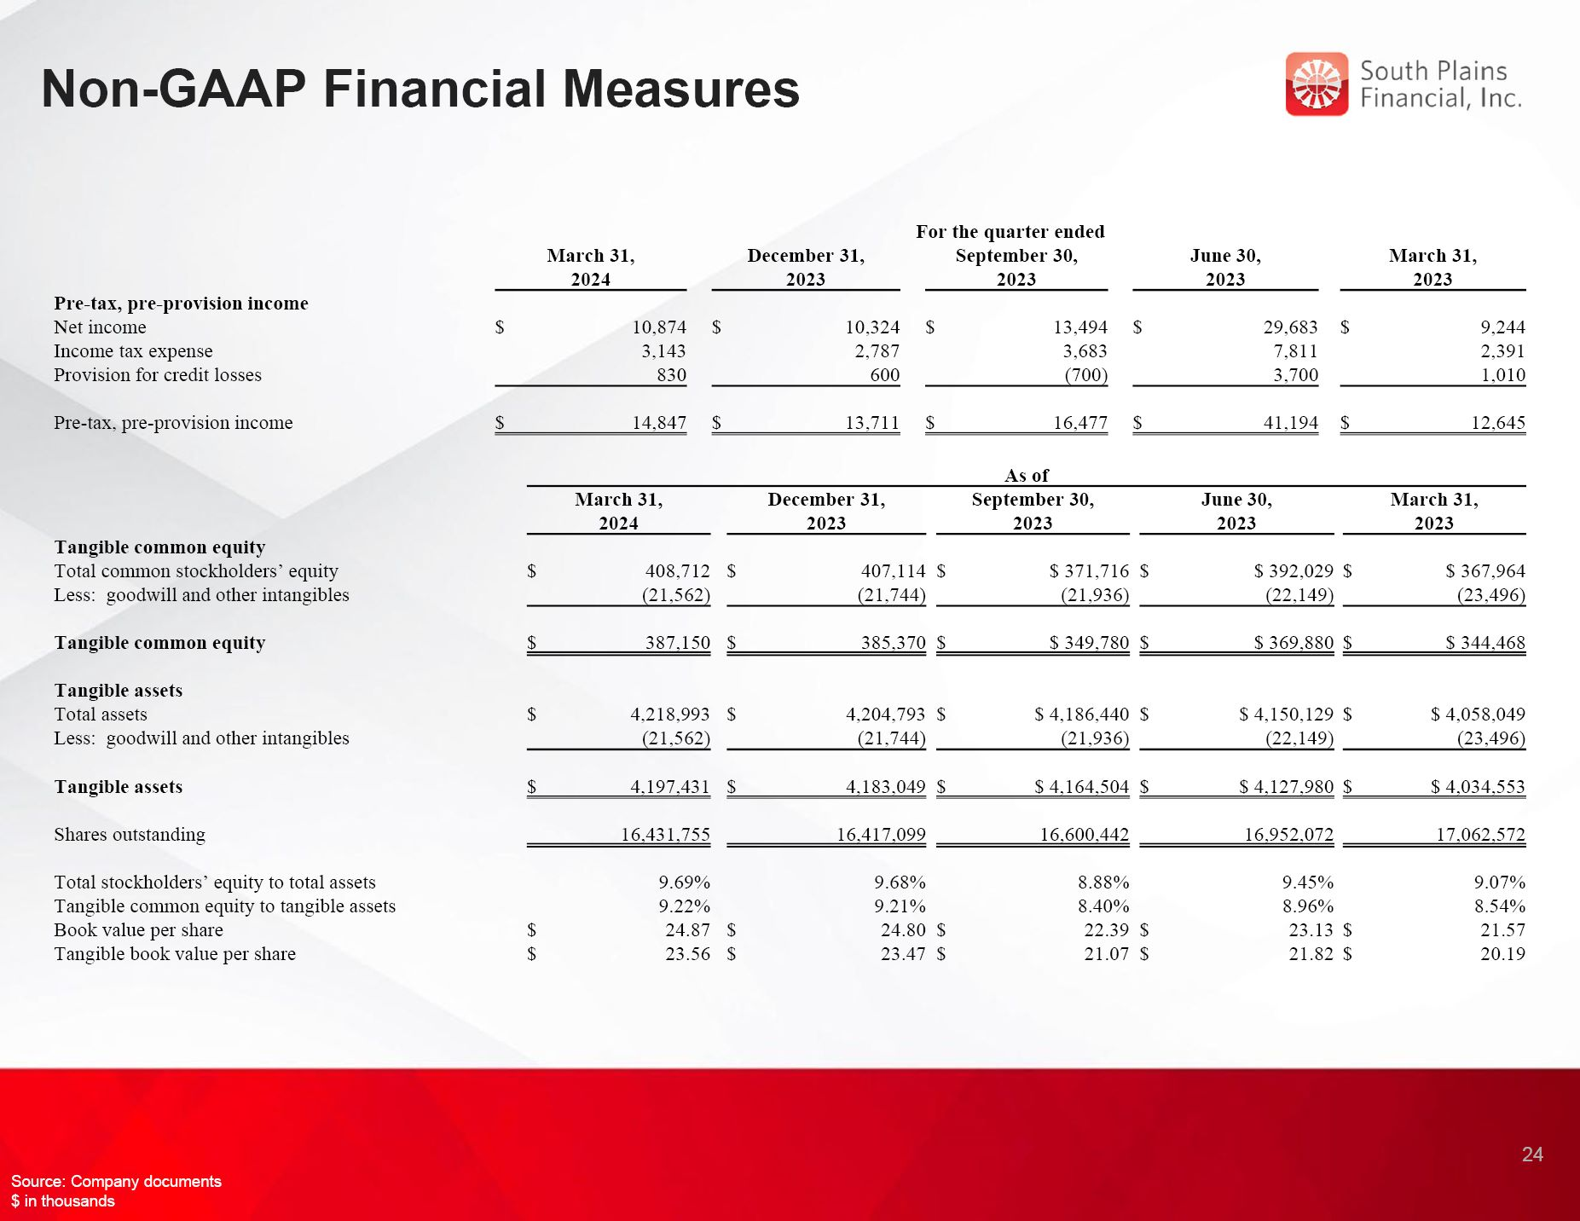
Non-GAAP Financial Measures Source: Company documents $ in thousands 24 For the quarter ended March 31, 2024 December 31, 2023 September 30, 2023 June 30, 2023 March 31, 2023 Pre-tax, pre-provision income Net income $ 10,874 $ 10,324 $ 13,494 $ 29,683 $ 9,244 Income tax expense 3,143 2,787 3,683 7,811 2,391 Provision for credit losses 830 600 (700) 3,700 1,010 Pre-tax, pre-provision income $ 14,847 $ 13,711 $ 16,477 $ 41,194 $ 12,645 As of March 31, 2024 December 31, 2023 September 30, 2023 June 30, 2023 March 31, 2023 Tangible common equity Total common stockholders’ equity $ 408,712 $ 407,114 $ $ 371,716 $ $ 392,029 $ $ 367,964 Less: goodwill and other intangibles (21,562) (21,744) (21,936) (22,149) (23,496) Tangible common equity $ 387,150 $ 385,370 $ $ 349,780 $ $ 369,880 $ $ 344,468 Tangible assets Total assets $ 4,218,993 $ 4,204,793 $ $ 4,186,440 $ $ 4,150,129 $ $ 4,058,049 Less: goodwill and other intangibles (21,562) (21,744) (21,936) (22,149) (23,496) Tangible assets $ 4,197,431 $ 4,183,049 $ $ 4,164,504 $ $ 4,127,980 $ $ 4,034,553 Shares outstanding 16,431,755 16,417,099 16,600,442 16,952,072 17,062,572 Total stockholders’ equity to total assets 9.69% 9.68% 8.88% 9.45% 9.07% Tangible common equity to tangible assets 9.22% 9.21% 8.40% 8.96% 8.54% Book value per share $ 24.87 $ 24.80 $ 22.39 $ 23.13 $ 21.57 Tangible book value per share $ 23.56 $ 23.47 $ 21.07 $ 21.82 $ 20.19

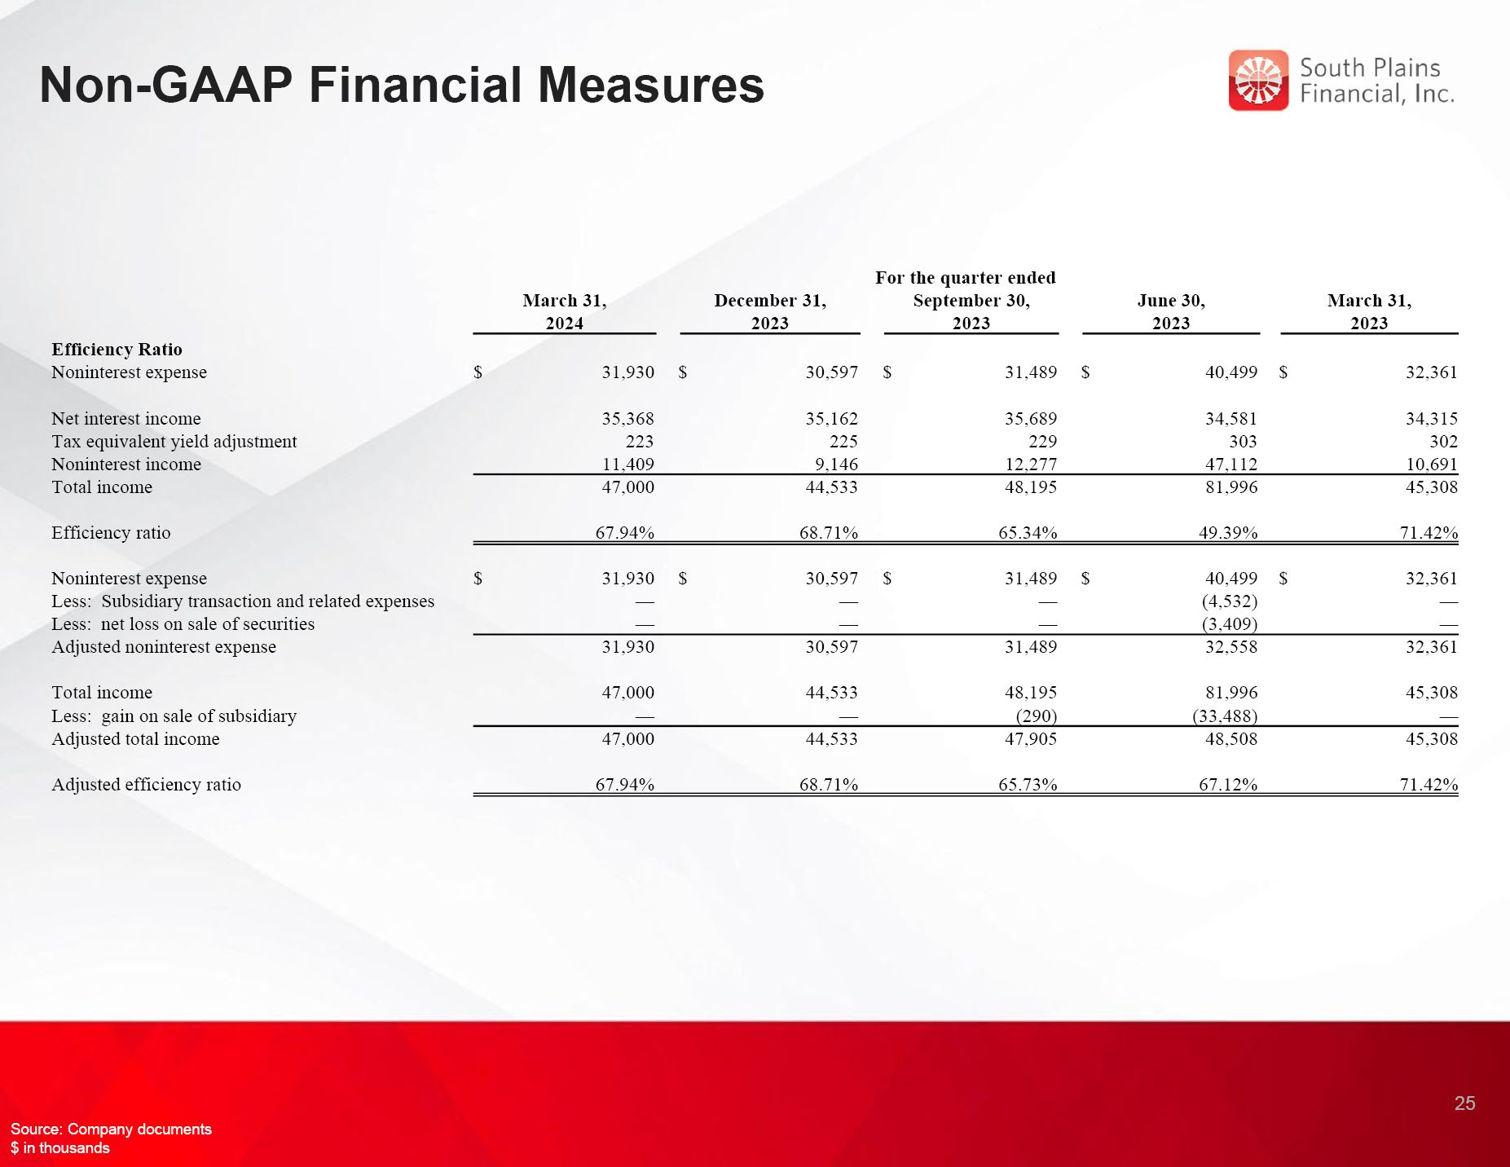
Non-GAAP Financial Measures 25 Source: Company documents $ in thousands Efficiency Ratio Noninterest expense $ 31,930 $ 30,597 $ 31,489 $ 40,499 $ 32,361 Net interest income 35,368 35,162 35,689 34,581 34,315 Tax equivalent yield adjustment 223 225 229 303 302 Noninterest income 11,409 9,146 12,277 47,112 10,691 Total income 47,000 44,533 48,195 81,996 45,308 Efficiency ratio 67.94% 68.71% 65.34% 49.39% 71.42% Noninterest expense $ 31,930 $ 30,597 $ 31,489 $ 40,499 $ 32,361 Less: Subsidiary transaction and related expenses — — — (4,532) — Less: net loss on sale of securities — — — (3,409) — Adjusted noninterest expense 31,930 30,597 31,489 32,558 32,361 Total income 47,000 44,533 48,195 81,996 45,308 Less: gain on sale of subsidiary — — (290) (33,488) — Adjusted total income 47,000 44,533 47,905 48,508 45,308 Adjusted efficiency ratio 67.94% 68.71% 65.73% 67.12% 71.42% For the quarter ended March 31, 2024 December 31, 2023 September 30, 2023 June 30, 2023 March 31, 2023

