UNITED STATES
SECURITIES AND EXCHANGE COMMISSION
Washington, D.C. 20549

FORM 8-K

CURRENT REPORT
Pursuant to Section 13 or 15(d) of
the Securities Exchange Act of 1934

Date of Report (Date of earliest event reported): April 27, 2023

South Plains Financial, Inc.
(Exact name of registrant as specified in its charter)

Texas | 001-38895 | 75-2453320
(State or other jurisdiction of incorporation) | (Commission File Number) | (IRS Employer Identification No.)

5219 City Bank Parkway  Lubbock, Texas |  | 79407
(Address of principal executive offices) |  | (Zip Code)

(806) 792-7101
(Registrant’s telephone number, including area code)

Check the appropriate box below if the Form 8-K filing is intended to simultaneously satisfy the filing obligation of the registrant under any of the following provisions:

☐ | Written communications pursuant to Rule 425 under the Securities Act (17 CFR 230.425)

☐ | Soliciting material pursuant to Rule 14a-12 under the Exchange Act (17 CFR 240.14a-12)

☐ | Pre-commencement communications pursuant to Rule 14d-2(b) under the Exchange Act (17 CFR 240.14d-2(b))

☐ | Pre-commencement communications pursuant to Rule 13e-4(c) under the Exchange Act (17 CFR 240.13e-4(c))

Securities registered pursuant to Section 12(b) of the Act:

Title of each class | Trading Symbol(s) | Name of each exchange on which registered
Common Stock, par value $1.00 per share | SPFI | The Nasdaq Stock Market LLC

Indicate by check mark whether the registrant is an emerging growth company as defined in Rule 405 of the Securities Act of 1933 (§230.405 of this chapter) or Rule 12b-2 of the Securities Exchange Act of 1934 (§240.12b-2 of this chapter).

Emerging growth company ☒

If an emerging growth company, indicate by check mark if the registrant has elected not to use the extended transition period for complying with any new or revised financial accounting standards provided pursuant to Section 13(a) of the Exchange Act. ☐

Item 2.02 | Results of Operations and Financial Condition.

On April 27, 2023, South Plains Financial, Inc. (the “Company”) issued a press release announcing its financial results for the first quarter ended March 31, 2023. A copy of the Company’s press release covering such announcement and certain other matters is furnished as Exhibit 99.1 to this Current Report on Form 8-K.

Item 7.01 | Regulation FD Disclosure.

On April 27, 2023, officers of the Company will have a conference call with respect to the Company’s financial results for the first quarter ended March 31, 2023. An earnings release slide presentation highlighting the Company’s financial results for the first quarter ended March 31, 2023 is furnished as Exhibit 99.2 to this Current Report on Form 8-K. This earnings release slide presentation will also be available on the Company’s website, www.spfi.bank, under the “News & Events” section.

In accordance with General Instruction B.2 of Form 8-K, the information in Items 2.02 and 7.01 of this Current Report on Form 8-K, including Exhibit 99.1 and Exhibit 99.2 furnished herewith, shall not be deemed “filed” for the purposes of Section 18 of the Securities Exchange Act of 1934, as amended (the “Exchange Act”), or otherwise subject to the liabilities of that section. The information in Items 2.02 and 7.01 of this Current Report on Form 8-K, including Exhibit 99.1 and Exhibit 99.2 furnished herewith, shall not be incorporated by reference into any filing or other document pursuant to the Exchange Act or the Securities Act of 1933, as amended, except as shall be expressly set forth by specific reference in such filing or document.

Item 9.01 | Financial Statements and Exhibits.

 | (d) | Exhibits.
 | 99.1 | Press release, dated April 27, 2023, announcing first quarter 2023 financial results of South Plains Financial, Inc.
 | 99.2 | Earnings release slide presentation, dated April 27, 2023.
 | 104 | Cover Page Interactive Data File (formatted as Inline XBRL).

SIGNATURES

Pursuant to the requirements of the Securities Exchange Act of 1934, the registrant has duly caused this report to be signed on its behalf by the undersigned hereunto duly authorized.

 | SOUTH PLAINS FINANCIAL, INC.
Dated: April 27, 2023 | By: | /s/ Steven B. Crockett
Steven B. Crockett
Chief Financial Officer and Treasurer

Exhibit 99.1



South Plains Financial, Inc. Reports First Quarter 2023 Financial Results

LUBBOCK, Texas, April 27, 2023 (GLOBE NEWSWIRE) – South Plains Financial, Inc. (NASDAQ:SPFI) (“South Plains” or the “Company”), the parent company of City Bank (“City Bank” or the “Bank”), today reported its financial results for the quarter ended March 31, 2023.

First Quarter 2023 Highlights

 | ● | Net income for the first quarter of 2023 was $9.2 million, compared to $12.6 million for the fourth quarter of 2022 and $14.3 million for the first quarter of 2022.

 | ● | Diluted earnings per share for the first quarter of 2023 was $0.53, compared to $0.71 for the fourth quarter of 2022 and $0.78 for the first quarter of 2022.

 | ● | Deposits grew $101.6 million, or 12% annualized, to $3.51 billion during the first quarter of 2023, as compared to December 31, 2022; an estimated 17% of quarter end deposits were uninsured or uncollateralized.

 | ● | Average cost of deposits for the first quarter of 2023 was 136 basis points, compared to 97 basis points for the fourth quarter of 2022 and 23 basis points for the first quarter of 2022.

 | ● | Net interest margin, calculated on a tax-equivalent basis, was 3.75% for the first quarter of 2023, compared to 3.88% for the fourth quarter of 2022.

 | ● | Loans held for investment grew $40.6 million, or 5.9% annualized, during the first quarter of 2023, compared to December 31, 2022.

 | ● | The Company recorded a provision for credit losses of $1.0 million in the first quarter of 2023, compared to $248 thousand in the fourth quarter of 2022 and a negative provision of $2.1 million for the first quarter of 2022.

 | ● | Nonperforming assets to total assets were 0.19% at March 31, 2023, compared to 0.20% at December 31, 2022 and 0.33% at March 31, 2022.

 | ● | Return on average assets for the first quarter of 2023 was 0.95% annualized, compared to 1.27% annualized for the fourth quarter of 2022 and 1.47% annualized for the first quarter of 2022.

 | ● | Tangible book value (non-GAAP) per share was $20.19 as of March 31, 2023, compared to $19.57 per share as of December 31, 2022 and $20.49 per share as of March 31, 2022.

 | ● | Liquidity - The Company had available borrowing capacity of $1.75 billion through the Federal Home Loan Bank of Dallas, the Federal Reserve’s Discount Window, and access to the Federal Reserve’s Bank Term Funding Program at March 31, 2023.

 | ● | Capital - total risk-based capital ratio – 16.70%, Tier 1 risk-based capital ratio – 13.24%, Common Equity Tier 1 risk-based capital ratio – 11.92%, and Tier 1 leverage ratio - 11.22%, all at March 31, 2023 and significantly exceeding the minimum regulatory levels necessary to be deemed “well-capitalized.”

Subsequent Events

 | ● | As previously announced, on April 1, 2023, the Company completed the sale of City Bank’s wholly owned subsidiary, Windmark Insurance Agency, Inc. (“Windmark”) to Alliant Insurance Services in an all cash transaction.

Curtis Griffith, South Plains’ Chairman and Chief Executive Officer, commented, “Our results this quarter speak directly to the strength and financial soundness of City Bank as well as the customer relationships that we have developed over many years as we grew our deposit base 12% annualized, as compared to the fourth quarter of 2022, and ended the first quarter with an estimated 17% uninsured or uncollateralized deposits, an improvement from year end 2022 of 26%. We are also in a strong liquidity position with $1.75 billion of available borrowing capacity at quarter end from the FHLB Dallas and the Federal Reserve’s discount window and Bank Term Funding Program. Additionally, the sale of Windmark on April 1st has provided significant additional capital to augment our already strong capital position. In this time of economic uncertainty and unexpected difficulties in the banking sector, we believe it is prudent to maintain our capital well above the regulatory requirements and to also maintain our strict credit culture because we will not sacrifice credit quality in our loan portfolio for growth.”

Results of Operations, Quarter Ended March 31, 2023

Net Interest Income

Net interest income was $34.3 million for the first quarter of 2023, compared to $36.3 million for the fourth quarter of 2022 and $29.9 million for the first quarter of 2022. Net interest margin, calculated on a tax-equivalent basis, was 3.75% for the first quarter of 2023, compared to 3.88% for the fourth quarter of 2022 and 3.33% for the first quarter of 2022. The average yield on loans was 5.78% for the first quarter of 2023, compared to 5.59% for the fourth quarter of 2022 and 4.80% for the first quarter of 2022. The average cost of deposits was 136 basis points for the first quarter of 2023, which is 39 basis points higher than the fourth quarter of 2022 and 113 basis points higher than the first quarter of 2022.

Interest income was $47.4 million for the first quarter of 2023, compared to $46.2 million for the fourth quarter of 2022 and $33.1 million for the first quarter of 2022. Interest income increased $1.2 million in the first quarter of 2023 from the fourth quarter of 2022, which was comprised of increases of $903 thousand in loan interest income and $317 thousand in interest income from securities and other interest-earning assets. The growth in loan interest income was primarily due to an increase of $33.3 million in average loans outstanding and the rising short-term interest rate environment, partially offset by a $0.9 million purchase discount principal and interest recovery recorded in the fourth quarter of 2022. The increase in interest income on securities and other interest-earning assets was primarily due to continued rising market short-term interest rates. Interest income increased $14.4 million in the first quarter of 2023 compared to the first quarter of 2022. This increase was primarily due to an increase of average loans of $296.3 million, securities purchases, and higher market interest rates during the period.

Interest expense was $13.1 million for the first quarter of 2023, compared to $9.9 million for the fourth quarter of 2022 and $3.1 million for the first quarter of 2022. Interest expense increased $3.2 million compared to the fourth quarter of 2022 and $10.0 million compared to the first quarter of 2022, primarily as a result of significantly rising short-term interest rates on interest-bearing liabilities, with the increase being mainly comprised of interest expense on deposits.

Noninterest Income and Noninterest Expense

Noninterest income was $10.7 million for the first quarter of 2023, compared to $12.7 million for the fourth quarter of 2022 and $23.7 million for the first quarter of 2022. The decrease from the fourth quarter of 2022 was primarily due to the seasonal decrease of $1.4 million in income from insurance activities and a decrease of $491 thousand in mortgage banking activities revenue. The decrease in mortgage banking activities revenues was mainly the result of a $2.0 million fair value write-down of the mortgage servicing rights portfolio compared to the write-down of $1.3 million in the fourth quarter of 2022, partially offset by an increase of $14.8 million in interest rate lock commitments, as the residential mortgage market experienced overall lower market interest rates compared to the fourth quarter of 2022. The decrease in noninterest income for the first quarter of 2023 as compared to the first quarter of 2022 was primarily due to a decline of $11.4 million in mortgage banking activities revenue as mortgage loan originations declined $148.5 million as a result of higher market interest rates and a reduction in the number of mortgage loan originators.

Noninterest expense was $32.4 million for the first quarter of 2023, compared to $32.7 million for the fourth quarter of 2022 and $37.9 million for the first quarter of 2022. The 1.1% decrease from the fourth quarter of 2022 was largely the result of declines in legal, marketing, and property repair and maintenance expense, partially offset by an increase in personnel expense. The decrease in noninterest expense for the first quarter of 2023 as compared to the first quarter of 2022 was primarily driven by a reduction of $3.0 million in mortgage personnel costs and $830 thousand in other variable mortgage-based expenses due to the decline in mortgage loan originations, in addition to a decrease of $789 thousand in legal expenses.

Loan Portfolio and Composition

Loans held for investment were $2.79 billion as of March 31, 2023, compared to $2.75 billion as of December 31, 2022 and $2.45 billion as of March 31, 2022. The $40.6 million, or 1.5%, increase during the first quarter of 2023 as compared to the fourth quarter of 2022 remained relationship-focused and occurred primarily in commercial real estate loans and residential mortgage loans, partially offset by a decrease in residential construction loans. As of March 31, 2023, loans held for investment increased $335.0 million, or 13.7% year over year, from March 31, 2022, primarily attributable to strong organic loan growth.

Deposits and Borrowings

Deposits totaled $3.51 billion as of March 31, 2023, compared to $3.41 billion as of December 31, 2022 and $3.45 billion as of March 31, 2022. Deposits increased by $101.6 million, or 3.0%, in the first quarter of 2023 from December 31, 2022. As of March 31, 2023, deposits increased $57.9 million, or 1.7% year over year, from March 31, 2022. Noninterest-bearing deposits were $1.11 billion as of March 31, 2023, compared to $1.15 billion as of December 31, 2022 and $1.13 billion as of March 31, 2022. Noninterest-bearing deposits represented 31.7% of total deposits as of March 31, 2023. The quarterly growth in deposits was mainly the result of increased focus on liquidity and occurred predominately in our public fund deposits. The year-over-year increase in deposits is primarily a result of the noted growth in the first quarter of 2023, partially offset by deposit outflows experienced in the fourth quarter of 2022.

Asset Quality

The Company recorded a provision for credit losses in the first quarter of 2023 of $1.0 million, compared to $248 thousand in the fourth quarter of 2022 and a negative provision of $2.1 million in the first quarter of 2022. The Company continued to largely experience stable credit metrics in the loan portfolio during the first quarter of 2023. The provision during the first quarter of 2023 was largely attributable to growth in loans held for investment and unfunded loan commitments. Forecasted economic conditions continue to remain uncertain due to the interest rate environment and persistent high inflation levels in the United States, and provisions for credit losses may be necessary in future periods.

The ratio of allowance for credit losses to loans held for investment was 1.42% as of March 31, 2023, compared to 1.43% as of December 31, 2022 and 1.62% as of March 31, 2022.

The ratio of nonperforming assets to total assets as of March 31, 2023 was 0.19%, compared to 0.20% as of December 31, 2022 and 0.33% at March 31, 2022. Annualized net charge-offs (recoveries) were 0.09% for the first quarter of 2023, compared to 0.09% for the fourth quarter of 2022 and 0.06% for the first quarter of 2022.

Capital

Book value per share increased to $21.57 at March 31, 2023, compared to $20.97 at December 31, 2022. The growth was mainly driven by an increase of $7.0 million of net income after dividends paid and a $4.7 million dollar increase in accumulated other comprehensive income (“AOCI”). The increase in AOCI was attributed to the rise in fair value of our available for sale securities and fair value hedges, net of tax, as a result of decreases in longer-term market interest rates during the period.

Conference Call

South Plains will host a conference call to discuss its first quarter 2023 financial results today, April 27, 2023, at 5:00 p.m., Eastern Time. Investors and analysts interested in participating in the call are invited to dial 1-877-300-8521 (international callers please dial 1-412-317-6026) approximately 10 minutes prior to the start of the call. A live audio webcast of the conference call and conference materials will be available on the Company’s website at https://www.spfi.bank/news-events/events.

A replay of the conference call will be available within two hours of the conclusion of the call and can be accessed on the investor section of the Company’s website as well as by dialing 1-844-512-2921 (international callers please dial 1-412-317-6671). The pin to access the telephone replay is 10177523. The replay will be available until May 11, 2023.

About South Plains Financial, Inc.

South Plains is the bank holding company for City Bank, a Texas state-chartered bank headquartered in Lubbock, Texas. City Bank is one of the largest independent banks in West Texas and has additional banking operations in the Dallas, El Paso, Greater Houston, the Permian Basin, and College Station, Texas markets, and the Ruidoso, New Mexico market. South Plains provides a wide range of commercial and consumer financial services to small and medium-sized businesses and individuals in its market areas. Its principal business activities include commercial and retail banking, along with insurance, investment, trust and mortgage services. Please visit https://www.spfi.bank for more information.
Non-GAAP Financial Measures

Some of the financial measures included in this press release are not measures of financial performance recognized in accordance with generally accepted accounting principles in the United States (“GAAP”). These non-GAAP financial measures include Tangible Book Value Per Share, Tangible Common Equity to Tangible Assets, and Pre-Tax, Pre-Provision Income. The Company believes these non-GAAP financial measures provide both management and investors a more complete understanding of the Company’s financial position and performance. These non-GAAP financial measures are supplemental and are not a substitute for any analysis based on GAAP financial measures.

We classify a financial measure as being a non-GAAP financial measure if that financial measure excludes or includes amounts, or is subject to adjustments that have the effect of excluding or including amounts, that are included or excluded, as the case may be, in the most directly comparable measure calculated and presented in accordance with GAAP as in effect from time to time in the United States in our statements of income, balance sheets or statements of cash flows. Not all companies use the same calculation of these measures; therefore, this presentation may not be comparable to other similarly titled measures as presented by other companies.

A reconciliation of non-GAAP financial measures to GAAP financial measures is provided at the end of this press release.

Available Information

The Company routinely posts important information for investors on its web site (under www.spfi.bank and, more specifically, under the News & Events tab at www.spfi.bank/news-events/press-releases). The Company intends to use its web site as a means of disclosing material non-public information and for complying with its disclosure obligations under Regulation FD (Fair Disclosure) promulgated by the U.S. Securities and Exchange Commission (the “SEC”). Accordingly, investors should monitor the Company’s web site, in addition to following the Company’s press releases, SEC filings, public conference calls, presentations and webcasts.

The information contained on, or that may be accessed through, the Company’s web site is not incorporated by reference into, and is not a part of, this document.

Forward Looking Statements

This press release contains forward-looking statements within the meaning of the Private Securities Litigation Reform Act of 1995. These forward-looking statements reflect South Plains’ current views with respect to future events. Any statements about South Plains’ expectations, beliefs, plans, predictions, forecasts, objectives, assumptions or future events or performance are not historical facts and may be forward-looking. These statements are often, but not always, made through the use of words or phrases such as “anticipate,” “believes,” “can,” “could,” “may,” “predicts,” “potential,” “should,” “will,” “estimate,” “plans,” “projects,” “continuing,” “ongoing,” “expects,” “intends” and similar words or phrases. South Plains cautions that the forward-looking statements in this press release are based largely on South Plains’ expectations and are subject to a number of known and unknown risks and uncertainties that are subject to change based on factors which are, in many instances, beyond South Plains’ control. Factors that could cause such changes include, but are not limited to, general economic conditions, potential recession in the United States and our market areas, the impacts related to or resulting from recent bank failures and any continuation of the recent uncertainty in the banking industry, including the associated impact to the Company and other financial institutions of any regulatory changes or other mitigation efforts taken by government agencies in response thereto, increased competition for deposits and related changes in deposit customer behavior, changes in market interest rates, the persistence of the current inflationary environment in the United States and our market areas, the uncertain impacts of quantitative tightening and current and future monetary policies of the Board of Governors of the Federal Reserve System, regulatory considerations, the extent of the impact of the COVID-19 pandemic (and any current or future variants thereof), competition and market expansion opportunities, changes in non-interest expenditures or in the anticipated benefits of such expenditures, and changes in applicable laws and regulations. Additional information regarding these risks and uncertainties to which South Plains’ business and future financial performance are subject is contained in South Plains’ most recent Annual Report on Form 10-K and Quarterly Reports on Form 10-Q on file with the SEC, and other documents South Plains files with the SEC from time to time. South Plains urges readers of this press release to review the “Risk Factors” section of our most recent Annual Report on Form 10-K, as well as the “Risk Factors” section of other documents South Plains files or furnishes with the SEC from time to time, which are available on the SEC’s website, www.sec.gov. Actual results, performance or achievements could differ materially from those contemplated, expressed, or implied by the forward-looking statements due to additional risks and uncertainties of which South Plains is not currently aware or which it does not currently view as, but in the future may become, material to its business or operating results. Due to these and other possible uncertainties and risks, the Company can give no assurance that the results contemplated in the forward-looking statements will be realized and readers are cautioned not to place undue reliance on the forward-looking statements contained in this press release. Any forward-looking statements presented herein are made only as of the date of this press release, and South Plains does not undertake any obligation to update or revise any forward-looking statements to reflect changes in assumptions, new information, the occurrence of unanticipated events, or otherwise, except as required by law. All forward-looking statements, express or implied, included in the press release are qualified in their entirety by this cautionary statement.

Contact: | Mikella Newsom, Chief Risk Officer and Secretary
 | (866) 771-3347
 | investors@city.bank

Source: South Plains Financial, Inc.

South Plains Financial, Inc.
Consolidated Financial Highlights - (Unaudited)
(Dollars in thousands, except share data)

 |  | As of and for the quarter ended
 |  | March 31,  2023 |  |  |  | December 31,  2022 |  |  |  | September 30,  2022 |  |  |  | June 30,  2022 |  |  |  | March 31,  2022
Selected Income Statement Data:
Interest income |  | $ | 47,448 |  |  | $ | 46,228 |  |  | $ | 41,108 |  |  | $ | 40,752 |  |  | $ | 33,080
Interest expense |  |  | 13,133 |  |  |  | 9,906 |  |  |  | 6,006 |  |  |  | 3,647 |  |  |  | 3,133
Net interest income |  |  | 34,315 |  |  |  | 36,322 |  |  |  | 35,102 |  |  |  | 37,105 |  |  |  | 29,947
Provision for credit losses |  |  | 1,010 |  |  |  | 248 |  |  |  | (782 | ) |  |  | - |  |  |  | (2,085 | )
Noninterest income |  |  | 10,691 |  |  |  | 12,676 |  |  |  | 20,937 |  |  |  | 18,835 |  |  |  | 23,697
Noninterest expense |  |  | 32,361 |  |  |  | 32,708 |  |  |  | 37,401 |  |  |  | 36,056 |  |  |  | 37,924
Income tax expense |  |  | 2,391 |  |  |  | 3,421 |  |  |  | 3,962 |  |  |  | 4,001 |  |  |  | 3,527
Net income |  |  | 9,244 |  |  |  | 12,621 |  |  |  | 15,458 |  |  |  | 15,883 |  |  |  | 14,278
Per Share Data (Common Stock):
Net earnings, basic |  |  | 0.54 |  |  |  | 0.74 |  |  |  | 0.89 |  |  |  | 0.91 |  |  |  | 0.81
Net earnings, diluted |  |  | 0.53 |  |  |  | 0.71 |  |  |  | 0.86 |  |  |  | 0.88 |  |  |  | 0.78
Cash dividends declared and paid |  |  | 0.13 |  |  |  | 0.12 |  |  |  | 0.12 |  |  |  | 0.11 |  |  |  | 0.11
Book value |  |  | 21.57 |  |  |  | 20.97 |  |  |  | 20.03 |  |  |  | 20.91 |  |  |  | 21.90
Tangible book value (non-GAAP) |  |  | 20.19 |  |  |  | 19.57 |  |  |  | 18.61 |  |  |  | 19.50 |  |  |  | 20.49
Weighted average shares outstanding, basic |  |  | 17,046,713 |  |  |  | 17,007,914 |  |  |  | 17,286,531 |  |  |  | 17,490,706 |  |  |  | 17,716,136
Weighted average shares outstanding, dilutive |  |  | 17,560,756 |  |  |  | 17,751,674 |  |  |  | 17,901,899 |  |  |  | 18,020,548 |  |  |  | 18,392,397
Shares outstanding at end of period |  |  | 17,062,572 |  |  |  | 17,027,197 |  |  |  | 17,064,640 |  |  |  | 17,417,094 |  |  |  | 17,673,407
Selected Period End Balance Sheet Data:
Cash and cash equivalents |  |  | 328,002 |  |  |  | 234,883 |  |  |  | 329,962 |  |  |  | 375,690 |  |  |  | 528,612
Investment securities |  |  | 698,579 |  |  |  | 701,711 |  |  |  | 711,412 |  |  |  | 763,943 |  |  |  | 793,404
Total loans held for investment |  |  | 2,788,640 |  |  |  | 2,748,081 |  |  |  | 2,690,366 |  |  |  | 2,580,493 |  |  |  | 2,453,631
Allowance for credit losses |  |  | 39,560 |  |  |  | 39,288 |  |  |  | 39,657 |  |  |  | 39,785 |  |  |  | 39,649
Total assets |  |  | 4,058,049 |  |  |  | 3,944,063 |  |  |  | 3,992,690 |  |  |  | 3,974,724 |  |  |  | 3,999,744
Interest-bearing deposits |  |  | 2,397,115 |  |  |  | 2,255,942 |  |  |  | 2,198,464 |  |  |  | 2,230,105 |  |  |  | 2,318,942
Noninterest-bearing deposits |  |  | 1,110,939 |  |  |  | 1,150,488 |  |  |  | 1,262,072 |  |  |  | 1,195,732 |  |  |  | 1,131,215
Total deposits |  |  | 3,508,054 |  |  |  | 3,406,430 |  |  |  | 3,460,536 |  |  |  | 3,425,837 |  |  |  | 3,450,157
Borrowings |  |  | 122,400 |  |  |  | 122,354 |  |  |  | 122,307 |  |  |  | 122,261 |  |  |  | 122,214
Total stockholders’ equity |  |  | 367,964 |  |  |  | 357,014 |  |  |  | 341,799 |  |  |  | 364,222 |  |  |  | 387,068
Summary Performance Ratios:
Return on average assets |  |  | 0.95 | % |  |  | 1.27 | % |  |  | 1.53 | % |  |  | 1.60 | % |  |  | 1.47 | %
Return on average equity |  |  | 10.34 | % |  |  | 14.33 | % |  |  | 17.37 | % |  |  | 16.96 | % |  |  | 14.58 | %
Net interest margin (1) |  |  | 3.75 | % |  |  | 3.88 | % |  |  | 3.70 | % |  |  | 4.02 | % |  |  | 3.33 | %
Yield on loans |  |  | 5.78 | % |  |  | 5.59 | % |  |  | 5.12 | % |  |  | 5.57 | % |  |  | 4.80 | %
Cost of interest-bearing deposits |  |  | 2.03 | % |  |  | 1.52 | % |  |  | 0.82 | % |  |  | 0.42 | % |  |  | 0.34 | %
Efficiency ratio |  |  | 71.42 | % |  |  | 66.35 | % |  |  | 66.38 | % |  |  | 64.11 | % |  |  | 70.30 | %
Summary Credit Quality Data:
Nonperforming loans |  |  | 7,579 |  |  |  | 7,790 |  |  |  | 7,834 |  |  |  | 7,889 |  |  |  | 12,141
Nonperforming loans to total loans held for investment |  |  | 0.27 | % |  |  | 0.28 | % |  |  | 0.29 | % |  |  | 0.31 | % |  |  | 0.49 | %
Other real estate owned |  |  | 202 |  |  |  | 169 |  |  |  | 37 |  |  |  | 59 |  |  |  | 1,141
Nonperforming assets to total assets |  |  | 0.19 | % |  |  | 0.20 | % |  |  | 0.20 | % |  |  | 0.20 | % |  |  | 0.33 | %
Allowance for credit losses to total loans held for investment |  |  | 1.42 | % |  |  | 1.43 | % |  |  | 1.47 | % |  |  | 1.54 | % |  |  | 1.62 | %
Net charge-offs to average loans outstanding (annualized) |  |  | 0.09 | % |  |  | 0.09 | % |  |  | (0.10 | )% |  |  | (0.02 | )% |  |  | 0.06 | %

 |  | As of and for the quarter ended
 |  | March 31  2023 |  |  |  | December 31,  2022 |  |  |  | September 30,  2022 |  |  |  | June 30,  2022 |  |  |  | March 31,  2022
Capital Ratios:
Total stockholders’ equity to total assets |  |  | 9.07 | % |  |  | 9.05 | % |  |  | 8.56 | % |  |  | 9.16 | % |  |  | 9.68 | %
Tangible common equity to tangible assets (non-GAAP) |  |  | 8.54 | % |  |  | 8.50 | % |  |  | 8.00 | % |  |  | 8.60 | % |  |  | 9.11 | %
Common equity tier 1 to risk-weighted assets |  |  | 11.92 | % |  |  | 11.81 | % |  |  | 11.67 | % |  |  | 12.24 | % |  |  | 12.86 | %
Tier 1 capital to average assets |  |  | 11.22 | % |  |  | 11.03 | % |  |  | 10.95 | % |  |  | 10.93 | % |  |  | 10.78 | %
Total capital to risk-weighted assets |  |  | 16.70 | % |  |  | 16.58 | % |  |  | 16.46 | % |  |  | 17.32 | % |  |  | 18.22 | %

(1) | Net interest margin is calculated as the annual net interest income, on a fully tax-equivalent basis, divided by average interest-earning assets.

South Plains Financial, Inc.
Average Balances and Yields - (Unaudited)
(Dollars in thousands)

 |  | For the Three Months Ended
 |  | March 31, 2023 |  |  |  |  |  |  |  |  |  |  |  | March 31, 2022
 |  | Average  Balance |  |  |  | Interest |  |  |  | Yield/Rate |  |  |  | Average  Balance |  |  |  | Interest |  |  |  | Yield/Rate
Assets
Loans |  | $ | 2,778,876 |  |  | $ | 39,602 |  |  |  | 5.78 | % |  | $ | 2,482,603 |  |  | $ | 29,379 |  |  |  | 4.80 | %
Debt securities - taxable |  |  | 585,427 |  |  |  | 5,240 |  |  |  | 3.63 | % |  |  | 520,672 |  |  |  | 2,354 |  |  |  | 1.83 | %
Debt securities - nontaxable |  |  | 213,191 |  |  |  | 1,413 |  |  |  | 2.69 | % |  |  | 218,321 |  |  |  | 1,448 |  |  |  | 2.69 | %
Other interest-bearing assets |  |  | 161,955 |  |  |  | 1,495 |  |  |  | 3.74 | % |  |  | 467,471 |  |  |  | 204 |  |  |  | 0.18 | %
Total interest-earning assets |  |  | 3,739,449 |  |  |  | 47,750 |  |  |  | 5.18 | % |  |  | 3,689,067 |  |  |  | 33,385 |  |  |  | 3.67 | %
Noninterest-earning assets |  |  | 189,477 |  |  |  |  |  |  |  |  |  |  |  | 262,178
Total assets |  | $ | 3,928,926 |  |  |  |  |  |  |  |  |  |  | $ | 3,951,245
Liabilities & stockholders’ equity
NOW, Savings, MMDA’s |  | $ | 1,988,555 |  |  |  | 9,984 |  |  |  | 2.04 | % |  | $ | 1,937,764 |  |  |  | 911 |  |  |  | 0.19 | %
Time deposits |  |  | 283,997 |  |  |  | 1,386 |  |  |  | 1.98 | % |  |  | 339,104 |  |  |  | 979 |  |  |  | 1.17 | %
Short-term borrowings |  |  | 4 |  |  |  | - |  |  |  | 0.00 | % |  |  | 4 |  |  |  | - |  |  |  | 0.00 | %
Notes payable & other long-term borrowings |  |  | - |  |  |  | - |  |  |  | 0.00 | % |  |  | - |  |  |  | - |  |  |  | 0.00 | %
Subordinated debt |  |  | 75,984 |  |  |  | 1,012 |  |  |  | 5.40 | % |  |  | 75,798 |  |  |  | 1,012 |  |  |  | 5.41 | %
Junior subordinated deferrable interest debentures |  |  | 46,393 |  |  |  | 751 |  |  |  | 6.57 | % |  |  | 46,393 |  |  |  | 231 |  |  |  | 2.02 | %
Total interest-bearing liabilities |  |  | 2,394,933 |  |  |  | 13,133 |  |  |  | 2.22 | % |  |  | 2,399,063 |  |  |  | 3,133 |  |  |  | 0.53 | %
Demand deposits |  |  | 1,109,344 |  |  |  |  |  |  |  |  |  |  |  | 1,104,091
Other liabilities |  |  | 62,160 |  |  |  |  |  |  |  |  |  |  |  | 50,843
Stockholders’ equity |  |  | 362,489 |  |  |  |  |  |  |  |  |  |  |  | 397,248
Total liabilities & stockholders’ equity |  | $ | 3,928,926 |  |  |  |  |  |  |  |  |  |  | $ | 3,951,245
Net interest income |  |  |  |  |  | $ | 34,617 |  |  |  |  |  |  |  |  |  |  | $ | 30,252
Net interest margin (2) |  |  |  |  |  |  |  |  |  |  | 3.75 | % |  |  |  |  |  |  |  |  |  |  | 3.33 | %

(1) | Average loan balances include nonaccrual loans and loans held for sale.

(2) | Net interest margin is calculated as the annualized net interest income, on a fully tax-equivalent basis, divided by average interest-earning assets.

South Plains Financial, Inc.
Consolidated Balance Sheets
(Unaudited)
(Dollars in thousands)

 |  | As of
 |  | March 31,  2023 |  |  |  | December 31,  2022
Assets
Cash and due from banks |  | $ | 51,186 |  |  | $ | 61,613
Interest-bearing deposits in banks |  |  | 276,816 |  |  |  | 173,270
Federal funds sold |  |  | — |  |  |  | —
Securities available for sale |  |  | 698,579 |  |  |  | 701,711
Loans held for sale |  |  | 20,448 |  |  |  | 30,403
Loans held for investment |  |  | 2,788,640 |  |  |  | 2,748,081
Less: Allowance for credit losses |  |  | (39,560 | ) |  |  | (39,288 | )
Net loans held for investment |  |  | 2,749,080 |  |  |  | 2,708,793
Premises and equipment, net |  |  | 56,079 |  |  |  | 56,337
Goodwill |  |  | 19,508 |  |  |  | 19,508
Intangible assets |  |  | 3,988 |  |  |  | 4,349
Mortgage servicing assets |  |  | 25,795 |  |  |  | 27,474
Other assets |  |  | 156,570 |  |  |  | 160,605
Total assets |  | $ | 4,058,049 |  |  | $ | 3,944,063
Liabilities and Stockholders’ Equity Liabilities
Noninterest-bearing deposits |  | $ | 1,110,939 |  |  | $ | 1,150,488
Interest-bearing deposits |  |  | 2,397,115 |  |  |  | 2,255,942
Total deposits |  |  | 3,508,054 |  |  |  | 3,406,430
Other borrowings |  |  | - |  |  |  | -
Subordinated debt |  |  | 76,007 |  |  |  | 75,961
Junior subordinated deferrable interest debentures |  |  | 46,393 |  |  |  | 46,393
Other liabilities |  |  | 59,631 |  |  |  | 58,265
Total liabilities |  |  | 3,690,085 |  |  |  | 3,587,049
Stockholders’ Equity
Common stock |  |  | 17,063 |  |  |  | 17,027
Additional paid-in capital |  |  | 112,981 |  |  |  | 112,834
Retained earnings |  |  | 298,299 |  |  |  | 292,261
Accumulated other comprehensive income (loss) |  |  | (60,379 | ) |  |  | (65,108 | )
Total stockholders’ equity |  |  | 367,964 |  |  |  | 357,014
Total liabilities and stockholders’ equity |  | $ | 4,058,049 |  |  | $ | 3,944,063

South Plains Financial, Inc.
Consolidated Statements of Income
(Unaudited)
(Dollars in thousands)

 |  | Three Months Ended
 |  | March 31,  2023 |  |  |  | March 31,  2022
Interest income:
Loans, including fees |  | $ | 39,597 |  |  | $ | 29,378
Other |  |  | 7,851 |  |  |  | 3,702
Total interest income |  |  | 47,448 |  |  |  | 33,080
Interest expense:
Deposits |  |  | 11,370 |  |  |  | 1,890
Subordinated debt |  |  | 1,012 |  |  |  | 1,012
Junior subordinated deferrable interest debentures |  |  | 751 |  |  |  | 231
Other |  |  | - |  |  |  | -
Total interest expense |  |  | 13,133 |  |  |  | 3,133
Net interest income |  |  | 34,315 |  |  |  | 29,947
Provision for credit losses |  |  | 1,010 |  |  |  | (2,085 | )
Net interest income after provision for credit losses |  |  | 33,305 |  |  |  | 32,032
Noninterest income:
Service charges on deposits |  |  | 1,701 |  |  |  | 1,773
Income from insurance activities |  |  | 1,411 |  |  |  | 1,570
Mortgage banking activities |  |  | 2,286 |  |  |  | 13,637
Bank card services and interchange fees |  |  | 2,956 |  |  |  | 3,222
Net gain on sale of securities |  |  | - |  |  |  | -
Other |  |  | 2,337 |  |  |  | 3,495
Total noninterest income |  |  | 10,691 |  |  |  | 23,697
Noninterest expense:
Salaries and employee benefits |  |  | 19,254 |  |  |  | 22,703
Net occupancy expense |  |  | 3,832 |  |  |  | 3,737
Professional services |  |  | 1,648 |  |  |  | 2,625
Marketing and development |  |  | 936 |  |  |  | 720
Other |  |  | 6,691 |  |  |  | 8,139
Total noninterest expense |  |  | 32,361 |  |  |  | 37,924
Income before income taxes |  |  | 11,635 |  |  |  | 17,805
Income tax expense |  |  | 2,391 |  |  |  | 3,527
Net income |  | $ | 9,244 |  |  | $ | 14,278

South Plains Financial, Inc.
Loan Composition
(Unaudited)
(Dollars in thousands)

 |  | As of
 |  | March 31,  2023 |  |  |  | December 31,  2022
Loans:
Commercial Real Estate |  | $ | 926,018 |  |  | $ | 919,358
Commercial - Specialized |  |  | 315,473 |  |  |  | 327,513
Commercial - General |  |  | 510,917 |  |  |  | 484,783
Consumer:
1-4 Family Residential |  |  | 485,396 |  |  |  | 460,124
Auto Loans |  |  | 321,309 |  |  |  | 321,476
Other Consumer |  |  | 81,413 |  |  |  | 81,308
Construction |  |  | 148,114 |  |  |  | 153,519
Total loans held for investment |  | $ | 2,788,640 |  |  | $ | 2,748,081

South Plains Financial, Inc.
Deposit Composition
(Unaudited)
(Dollars in thousands)

 |  | As of
 |  | March 31,  2023 |  |  |  | December 31,  2022
Deposits:
Noninterest-bearing deposits |  | $ | 1,110,939 |  |  | $ | 1,150,488
NOW & other transaction accounts |  |  | 321,644 |  |  |  | 350,910
MMDA & other savings |  |  | 1,787,621 |  |  |  | 1,618,833
Time deposits |  |  | 287,850 |  |  |  | 286,199
Total deposits |  | $ | 3,508,054 |  |  | $ | 3,406,430

South Plains Financial, Inc.
Reconciliation of Non-GAAP Financial Measures (Unaudited)
(Dollars in thousands)

 |  | For the quarter ended
 |  | March 31,  2023 |  |  |  | December 31,  2022 |  |  |  | September 30,  2022 |  |  |  | June 30,  2022 |  |  |  | March 31,  2022
Pre-tax, pre-provision income
Net income |  | $ | 9,244 |  |  | $ | 12,621 |  |  | $ | 15,458 |  |  | $ | 15,883 |  |  | $ | 14,278
Income tax expense |  |  | 2,391 |  |  |  | 3,421 |  |  |  | 3,962 |  |  |  | 4,001 |  |  |  | 3,527
Provision for credit losses |  |  | 1,010 |  |  |  | 248 |  |  |  | (782 | ) |  |  | - |  |  |  | (2,085 | )
Pre-tax, pre-provision income |  | $ | 12,645 |  |  | $ | 16,290 |  |  | $ | 18,638 |  |  | $ | 19,884 |  |  | $ | 15,720

South Plains Financial, Inc.
Reconciliation of Non-GAAP Financial Measures (Unaudited)
(Dollars in thousands)

 |  | As of
 |  | March 31,  2023 |  |  |  | December 31,  2022 |  |  |  | September 30,  2022 |  |  |  | June 30,  2022 |  |  |  | March 31,  2022
Tangible common equity
Total common stockholders’ equity |  | $ | 367,964 |  |  | $ | 357,014 |  |  | $ | $ 341,799 |  |  | $ | $ 364,222 |  |  | $ | $ 387,068
Less: goodwill and other intangibles |  |  | (23,496 | ) |  |  | (23,857 | ) |  |  | (24,228 | ) |  |  | (24,620 | ) |  |  | (25,011 | )
Tangible common equity |  | $ | 344,468 |  |  | $ | 333,157 |  |  | $ | $ 317,571 |  |  | $ | $ 339,602 |  |  | $ | $ 362,057
Tangible assets
Total assets |  | $ | 4,058,049 |  |  | $ | 3,944,063 |  |  | $ | $ 3,992,690 |  |  | $ | $ 3,974,724 |  |  | $ | $ 3,999,744
Less: goodwill and other intangibles |  |  | (23,496 | ) |  |  | (23,857 | ) |  |  | (24,228 | ) |  |  | (24,620 | ) |  |  | (25,011 | )
Tangible assets |  | $ | 4,034,553 |  |  | $ | 3,920,206 |  |  | $ | $ 3,968,462 |  |  | $ | $ 3,950,104 |  |  | $ | $ 3,974,733
Shares outstanding |  |  | 17,062,572 |  |  |  | 17,027,197 |  |  |  | 17,064,640 |  |  |  | 17,417,094 |  |  |  | 17,673,407
Total stockholders’ equity to total assets |  |  | 9.07 | % |  |  | 9.05 | % |  |  | 8.56 | % |  |  | 9.16 | % |  |  | 9.68 | %
Tangible common equity to tangible assets |  |  | 8.54 | % |  |  | 8.50 | % |  |  | 8.00 | % |  |  | 8.60 | % |  |  | 9.11 | %
Book value per share |  | $ | 21.57 |  |  | $ | 20.97 |  |  | $ | 20.03 |  |  | $ | 20.91 |  |  | $ | 21.90
Tangible book value per share |  | $ | 20.19 |  |  | $ | 19.57 |  |  | $ | 18.61 |  |  | $ | 19.50 |  |  | $ | 20.49

Exhibit 99.2

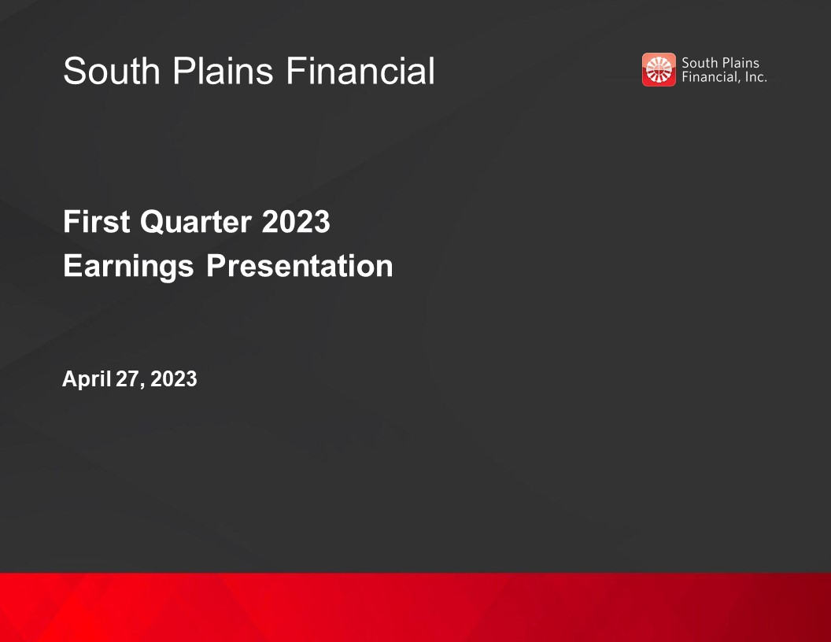
South Plains Financial First Quarter 2023 Earnings Presentation April 27, 2023

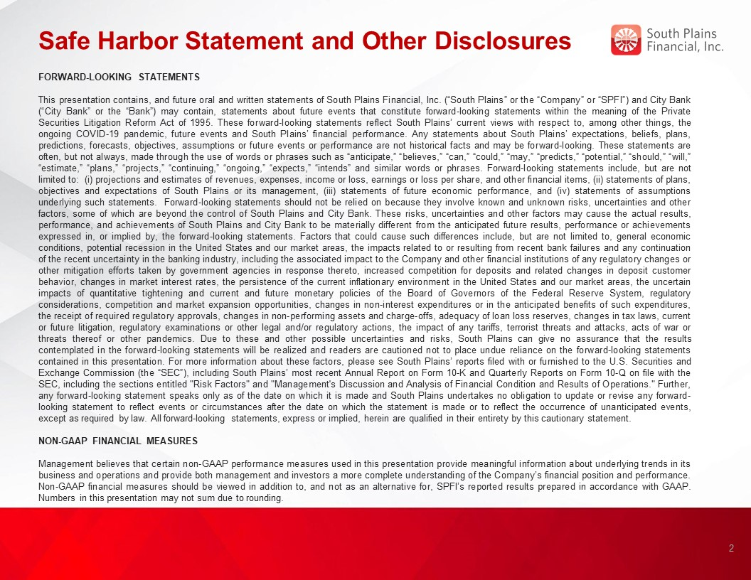
Safe Harbor Statement and Other Disclosures FORWARD-LOOKING STATEMENTS This presentation contains, and future oral and written statements of South Plains Financial, Inc. (“South Plains” or the “Company” or “SPFI”) and City Bank (“City Bank” or the “Bank”) may contain, statements about future events that constitute forward-looking statements within the meaning of the Private Securities Litigation Reform Act of 1995. These forward-looking statements reflect South Plains’ current views with respect to, among other things, the ongoing COVID-19 pandemic, future events and South Plains’ financial performance. Any statements about South Plains’ expectations, beliefs, plans, predictions, forecasts, objectives, assumptions or future events or performance are not historical facts and may be forward-looking. These statements are often, but not always, made through the use of words or phrases such as “anticipate,” “believes,” “can,” “could,” “may,” “predicts,” “potential,” “should,” “will,” “estimate,” “plans,” “projects,” “continuing,” “ongoing,” “expects,” “intends” and similar words or phrases. Forward-looking statements include, but are not limited to: (i) projections and estimates of revenues, expenses, income or loss, earnings or loss per share, and other financial items, (ii) statements of plans, objectives and expectations of South Plains or its management, (iii) statements of future economic performance, and (iv) statements of assumptions underlying such statements. Forward-looking statements should not be relied on because they involve known and unknown risks, uncertainties and other factors, some of which are beyond the control of South Plains and City Bank. These risks, uncertainties and other factors may cause the actual results, performance, and achievements of South Plains and City Bank to be materially different from the anticipated future results, performance or achievements expressed in, or implied by, the forward-looking statements. Factors that could cause such differences include, but are not limited to, general economic conditions, potential recession in the United States and our market areas, the impacts related to or resulting from recent bank failures and any continuation of the recent uncertainty in the banking industry, including the associated impact to the Company and other financial institutions of any regulatory changes or other mitigation efforts taken by government agencies in response thereto, increased competition for deposits and related changes in deposit customer behavior, changes in market interest rates, the persistence of the current inflationary environment in the United States and our market areas, the uncertain impacts of quantitative tightening and current and future monetary policies of the Board of Governors of the Federal Reserve System, regulatory considerations, competition and market expansion opportunities, changes in non-interest expenditures or in the anticipated benefits of such expenditures, the receipt of required regulatory approvals, changes in non-performing assets and charge-offs, adequacy of loan loss reserves, changes in tax laws, current or future litigation, regulatory examinations or other legal and/or regulatory actions, the impact of any tariffs, terrorist threats and attacks, acts of war or threats thereof or other pandemics. Due to these and other possible uncertainties and risks, South Plains can give no assurance that the results contemplated in the forward-looking statements will be realized and readers are cautioned not to place undue reliance on the forward-looking statements contained in this presentation. For more information about these factors, please see South Plains’ reports filed with or furnished to the U.S. Securities and Exchange Commission (the “SEC”), including South Plains’ most recent Annual Report on Form 10-K and Quarterly Reports on Form 10-Q on file with the SEC, including the sections entitled "Risk Factors" and "Management's Discussion and Analysis of Financial Condition and Results of Operations." Further, any forward-looking statement speaks only as of the date on which it is made and South Plains undertakes no obligation to update or revise any forward-looking statement to reflect events or circumstances after the date on which the statement is made or to reflect the occurrence of unanticipated events, except as required by law. All forward-looking statements, express or implied, herein are qualified in their entirety by this cautionary statement. NON-GAAP FINANCIAL MEASURES Management believes that certain non-GAAP performance measures used in this presentation provide meaningful information about underlying trends in its business and operations and provide both management and investors a more complete understanding of the Company’s financial position and performance. Non-GAAP financial measures should be viewed in addition to, and not as an alternative for, SPFI’s reported results prepared in accordance with GAAP. Numbers in this presentation may not sum due to rounding. 2

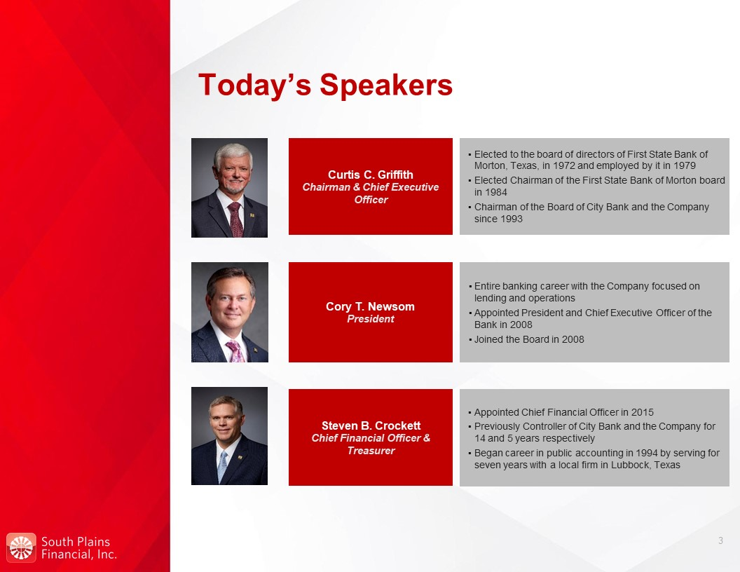
Today’s Speakers Curtis C. Griffith Chairman & Chief Executive Officer Elected to the board of directors of First State Bank of Morton, Texas, in 1972 and employed by it in 1979 Elected Chairman of the First State Bank of Morton board in 1984 Chairman of the Board of City Bank and the Company since 1993 Steven B. Crockett Chief Financial Officer & Treasurer Appointed Chief Financial Officer in 2015 Previously Controller of City Bank and the Company for 14 and 5 years respectively Began career in public accounting in 1994 by serving for seven years with a local firm in Lubbock, Texas Cory T. Newsom President Entire banking career with the Company focused on lending and operations Appointed President and Chief Executive Officer of the Bank in 2008 Joined the Board in 2008 3

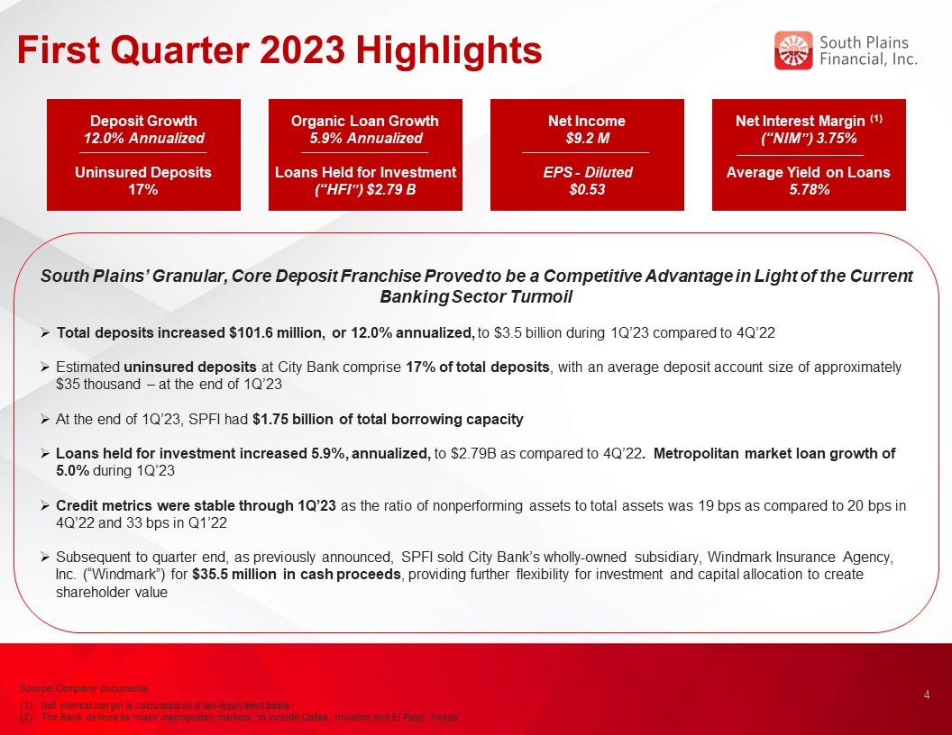
First Quarter 2023 Highlights South Plains’ Granular, Core Deposit Franchise Proved to be a Competitive Advantage in Light of the Current Banking Sector Turmoil Total deposits increased $101.6 million, or 12.0% annualized, to $3.5 billion during 1Q’23 compared to 4Q’22 Estimated uninsured deposits at City Bank comprise 17% of total deposits, with an average deposit account size of approximately $35 thousand – at the end of 1Q’23 At the end of 1Q’23, SPFI had $1.75 billion of total borrowing capacity Loans held for investment increased 5.9%, annualized, to $2.79B as compared to 4Q’22. Metropolitan market loan growth of 5.0% during 1Q’23 Credit metrics were stable through 1Q’23 as the ratio of nonperforming assets to total assets was 19 bps as compared to 20 bps in 4Q’22 and 33 bps in Q1’22 Subsequent to quarter end, as previously announced, SPFI sold City Bank’s wholly-owned subsidiary, Windmark Insurance Agency, Inc. (“Windmark”) for $35.5 million in cash proceeds, providing further flexibility for investment and capital allocation to create shareholder value Deposit Growth 12.0% Annualized Uninsured Deposits 17% Net Income $9.2 M EPS - Diluted $0.53 Net Interest Margin (1) (“NIM”) 3.75% Average Yield on Loans 5.78% 4 Source: Company documents Net interest margin is calculated on a tax-equivalent basis The Bank defines its “major metropolitan markets” to include Dallas, Houston and El Paso, Texas Organic Loan Growth 5.9% Annualized Loans Held for Investment (“HFI”) $2.79 B

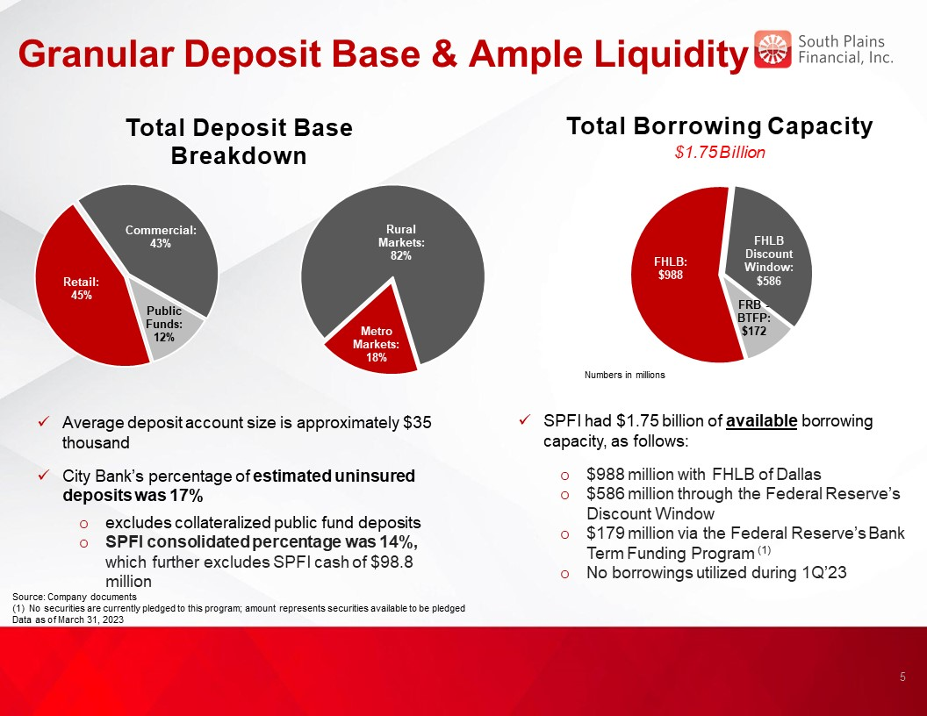
Granular Deposit Base & Ample Liquidity Total Borrowing Capacity $1.75 Billion Source: Company documents (1) No securities are currently pledged to this program; amount represents securities available to be pledged Data as of March 31, 2023 5 Total Deposit Base Breakdown Average deposit account size is approximately $35 thousand City Bank’s percentage of estimated uninsured deposits was 17% excludes collateralized public fund deposits SPFI consolidated percentage was 14%, which further excludes SPFI cash of $98.8 million SPFI had $1.75 billion of available borrowing capacity, as follows: $988 million with FHLB of Dallas $586 million through the Federal Reserve’s Discount Window $179 million via the Federal Reserve’s Bank Term Funding Program (1) No borrowings utilized during 1Q’23

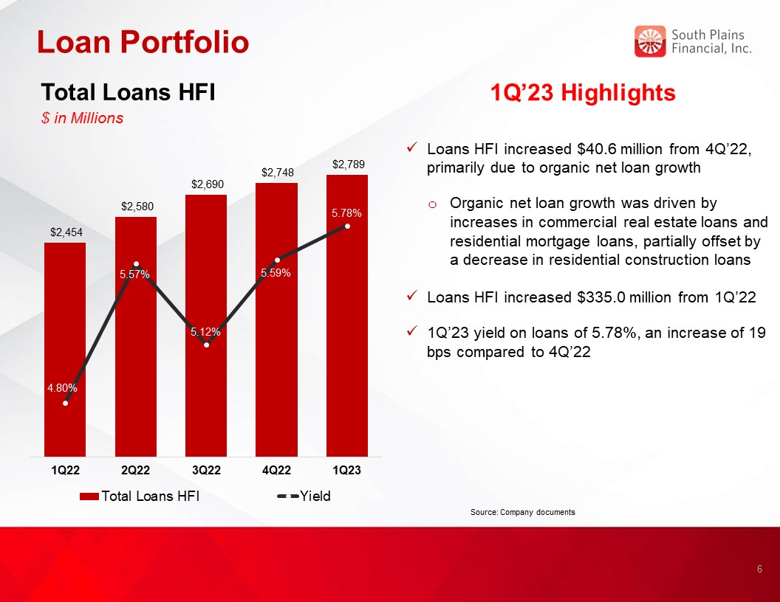
Loan Portfolio 1Q’23 Highlights Loans HFI increased $40.6 million from 4Q’22, primarily due to organic net loan growth Organic net loan growth was driven by increases in commercial real estate loans and residential mortgage loans, partially offset by a decrease in residential construction loans Loans HFI increased $335.0 million from 1Q’22 1Q’23 yield on loans of 5.78%, an increase of 19 bps compared to 4Q’22 Total Loans HFI $ in Millions Source: Company documents 6

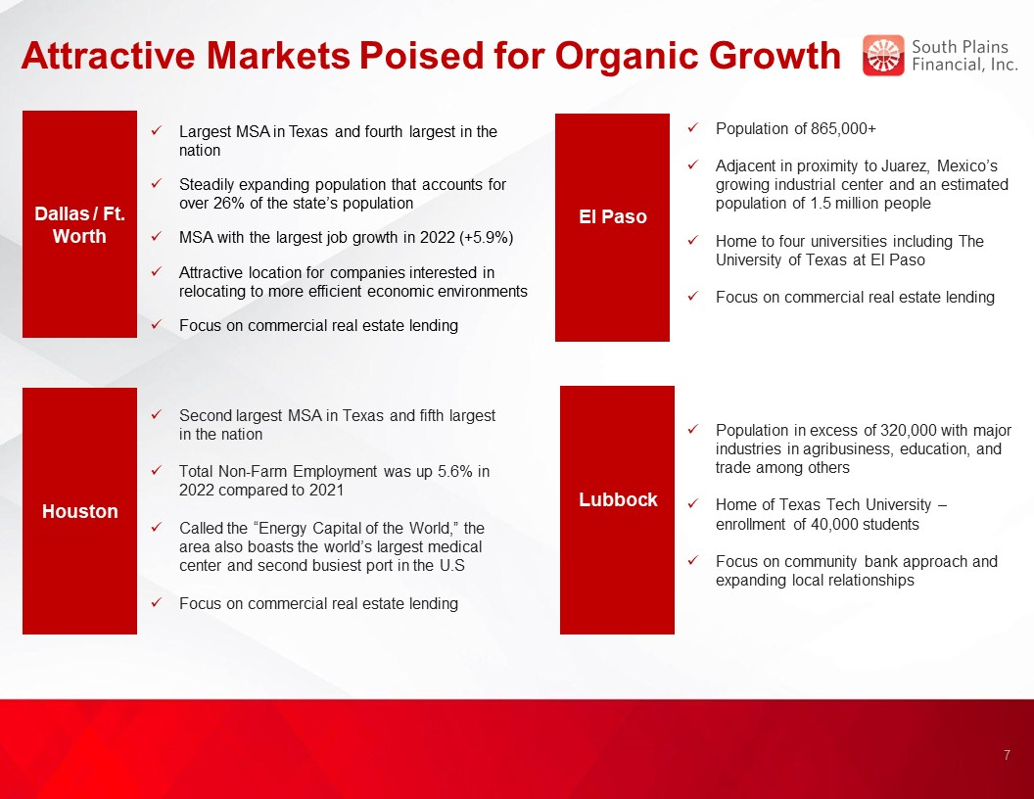
Attractive Markets Poised for Organic Growth El Paso Basin Dallas / Ft. Worth Population of 865,000+ Adjacent in proximity to Juarez, Mexico’s growing industrial center and an estimated population of 1.5 million people Home to four universities including The University of Texas at El Paso Focus on commercial real estate lending Largest MSA in Texas and fourth largest in the nation Steadily expanding population that accounts for over 26% of the state’s population MSA with the largest job growth in 2022 (+5.9%) Attractive location for companies interested in relocating to more efficient economic environments Focus on commercial real estate lending Houston Second largest MSA in Texas and fifth largest in the nation Total Non-Farm Employment was up 5.6% in 2022 compared to 2021 Called the “Energy Capital of the World,” the area also boasts the world’s largest medical center and second busiest port in the U.S Focus on commercial real estate lending Lubbock Basin Population in excess of 320,000 with major industries in agribusiness, education, and trade among others Home of Texas Tech University – enrollment of 40,000 students Focus on community bank approach and expanding local relationships 7

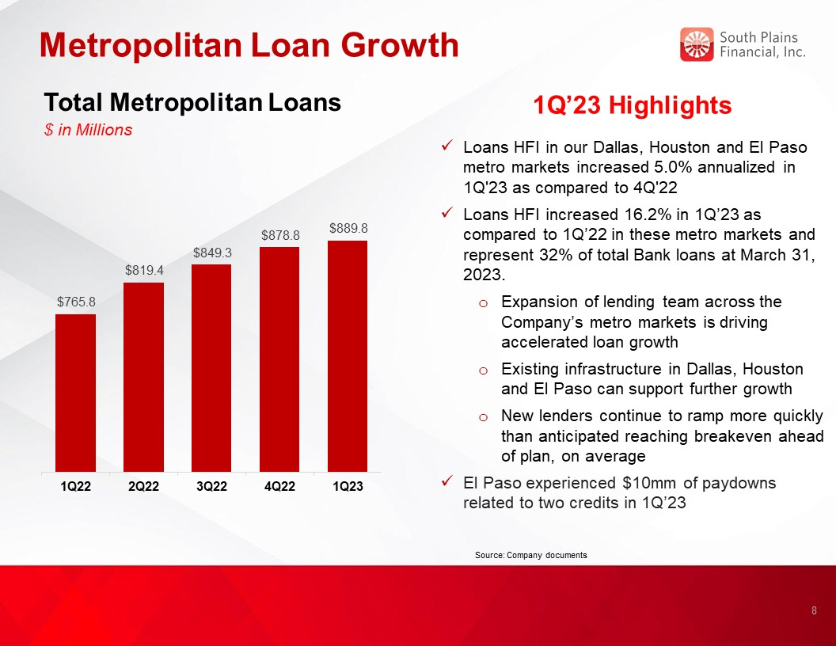
Metropolitan Loan Growth 1Q’23 Highlights Loans HFI in our Dallas, Houston and El Paso metro markets increased 5.0% annualized in 1Q'23 as compared to 4Q'22 Loans HFI increased 16.2% in 1Q’23 as compared to 1Q’22 in these metro markets and represent 32% of total Bank loans at March 31, 2023. Expansion of lending team across the Company’s metro markets is driving accelerated loan growth Existing infrastructure in Dallas, Houston and El Paso can support further growth New lenders continue to ramp more quickly than anticipated reaching breakeven ahead of plan, on average El Paso experienced $10mm of paydowns related to two credits in 1Q’23 Total Metropolitan Loans $ in Millions Source: Company documents 8 5.00%

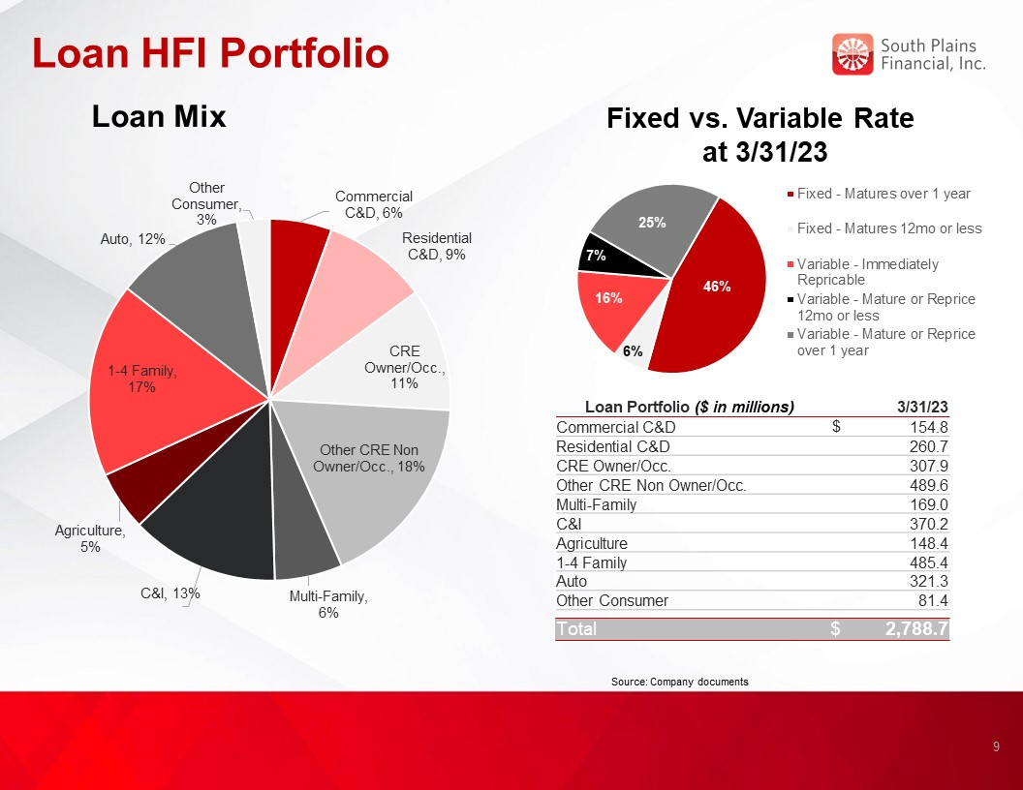
Loan HFI Portfolio Loan Mix Loan Portfolio ($ in millions) 3/31/23 Commercial C&D $ 154.8 Residential C&D 260.7 CRE Owner/Occ. 307.9 Other CRE Non Owner/Occ. 489.6 Multi-Family 169.0 C&I 370.2 Agriculture 148.4 1-4 Family 485.4 Auto 321.3 Other Consumer 81.4 Total $ 2,788.7 Source: Company documents Fixed vs. Variable Rate at 3/31/23 9

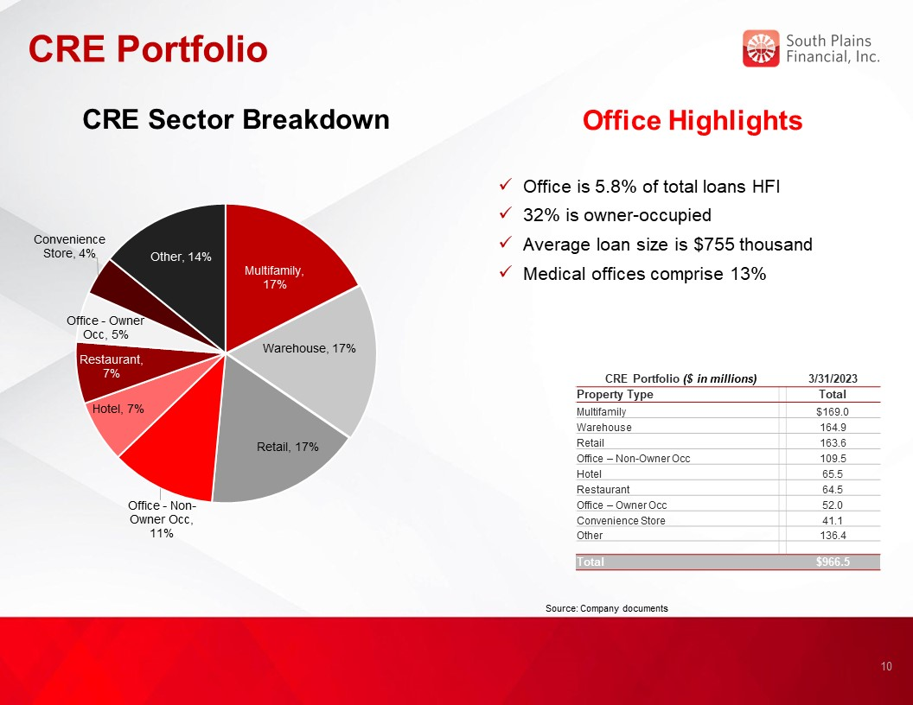
CRE Portfolio 10 Office Highlights Office is 5.8% of total loans HFI 32% is owner-occupied Average loan size is $755 thousand Medical offices comprise 13% CRE Portfolio ($ in millions) 3/31/2023 Property Type Total Multifamily $169.0 Warehouse 164.9 Retail 163.6 Office – Non-Owner Occ 109.5 Hotel 65.5 Restaurant 64.5 Office – Owner Occ 52.0 Convenience Store 41.1 Other 136.4 Total $966.5 Source: Company documents CRE Sector Breakdown

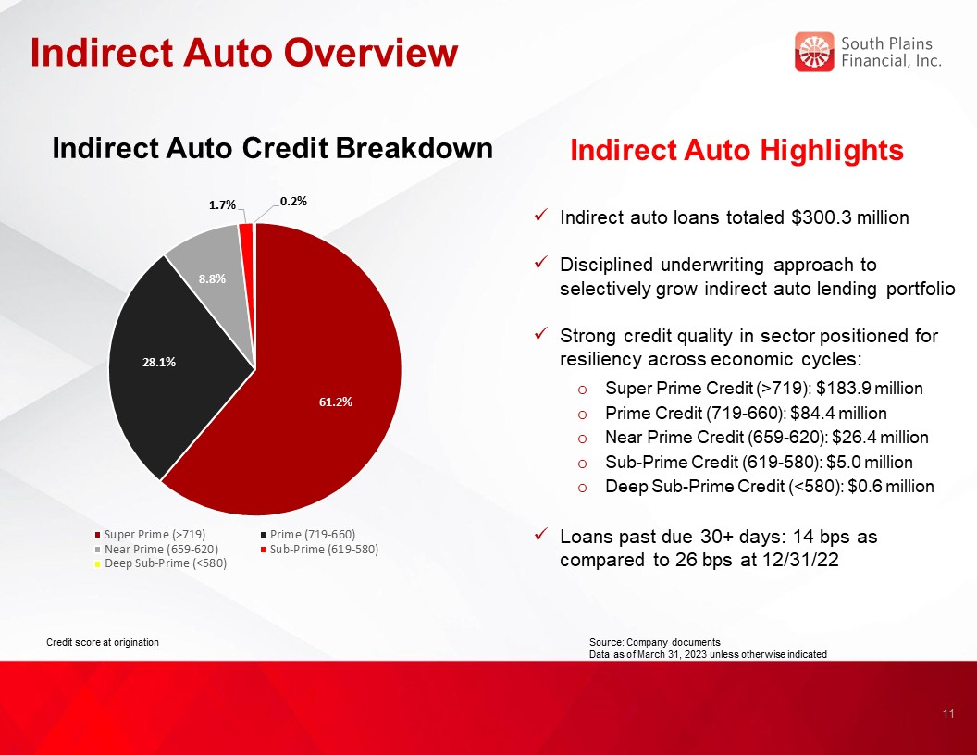
Indirect Auto Overview Indirect Auto Highlights Indirect auto loans totaled $300.3 million Disciplined underwriting approach to selectively grow indirect auto lending portfolio Strong credit quality in sector positioned for resiliency across economic cycles: Super Prime Credit (>719): $183.9 million Prime Credit (719-660): $84.4 million Near Prime Credit (659-620): $26.4 million Sub-Prime Credit (619-580): $5.0 million Deep Sub-Prime Credit (<580): $0.6 million Loans past due 30+ days: 14 bps as compared to 26 bps at 12/31/22 Indirect Auto Credit Breakdown Source: Company documents Data as of March 31, 2023 unless otherwise indicated 11 Credit score at origination

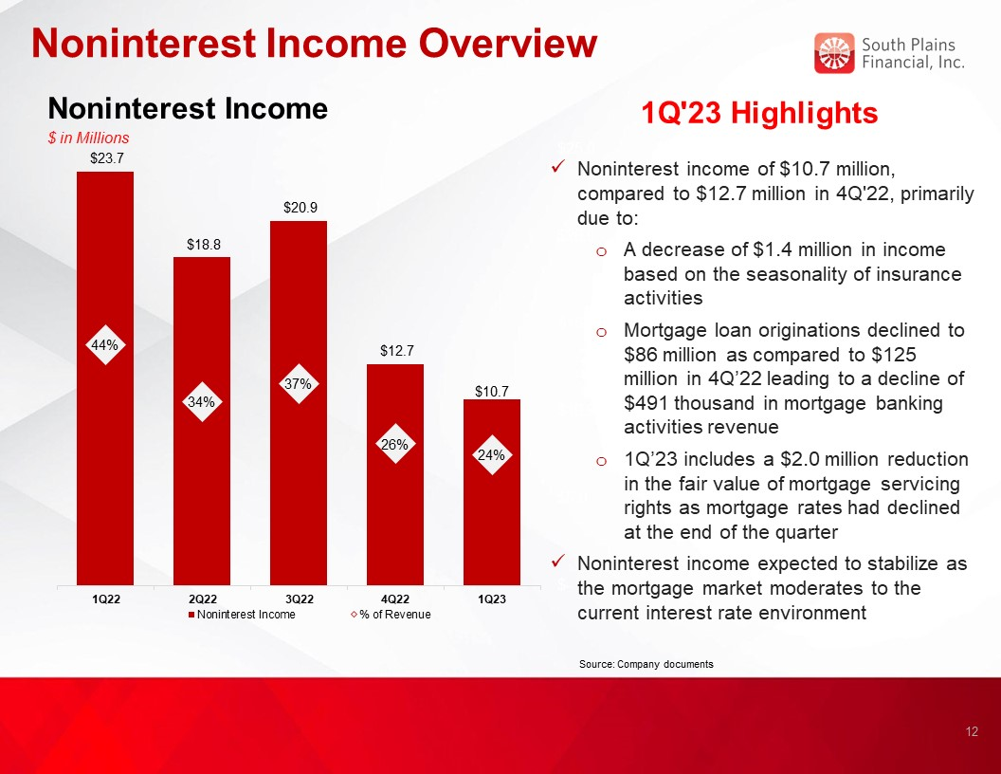
Noninterest Income Overview Noninterest Income $ in Millions 1Q'23 Highlights Noninterest income of $10.7 million, compared to $12.7 million in 4Q'22, primarily due to: A decrease of $1.4 million in income based on the seasonality of insurance activities Mortgage loan originations declined to $86 million as compared to $125 million in 4Q’22 leading to a decline of $491 thousand in mortgage banking activities revenue 1Q’23 includes a $2.0 million reduction in the fair value of mortgage servicing rights as mortgage rates had declined at the end of the quarter Noninterest income expected to stabilize as the mortgage market moderates to the current interest rate environment Source: Company documents 12

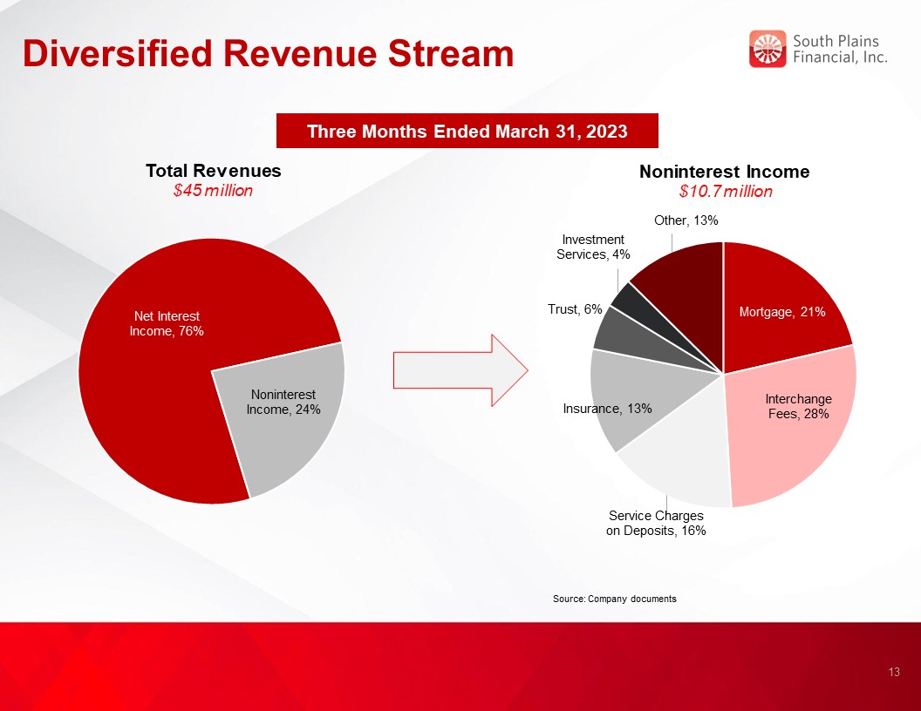
Diversified Revenue Stream Three Months Ended March 31, 2023 Total Revenues $45 million Noninterest Income $10.7 million Source: Company documents 13

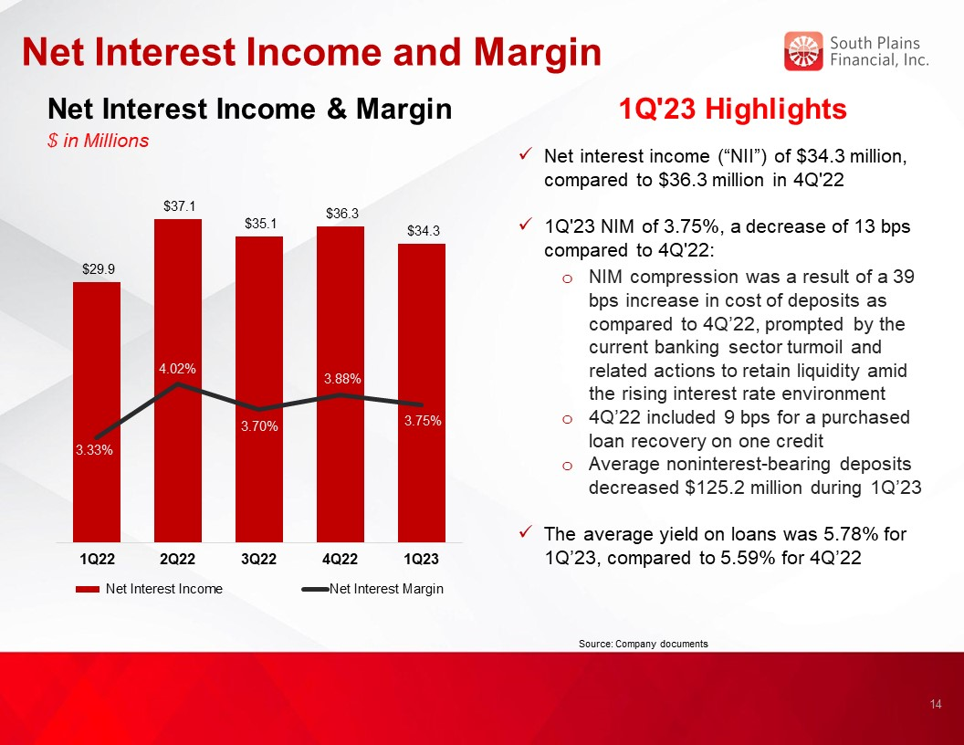
Net Interest Income and Margin Net Interest Income & Margin $ in Millions 1Q'23 Highlights Net interest income (“NII”) of $34.3 million, compared to $36.3 million in 4Q'22 1Q'23 NIM of 3.75%, a decrease of 13 bps compared to 4Q'22: NIM compression was a result of a 39 bps increase in cost of deposits as compared to 4Q’22, prompted by the current banking sector turmoil and related actions to retain liquidity amid the rising interest rate environment 4Q’22 included 9 bps for a purchased loan recovery on one credit Average noninterest-bearing deposits decreased $125.2 million during 1Q’23 The average yield on loans was 5.78% for 1Q’23, compared to 5.59% for 4Q’22 Source: Company documents 14 3.54%

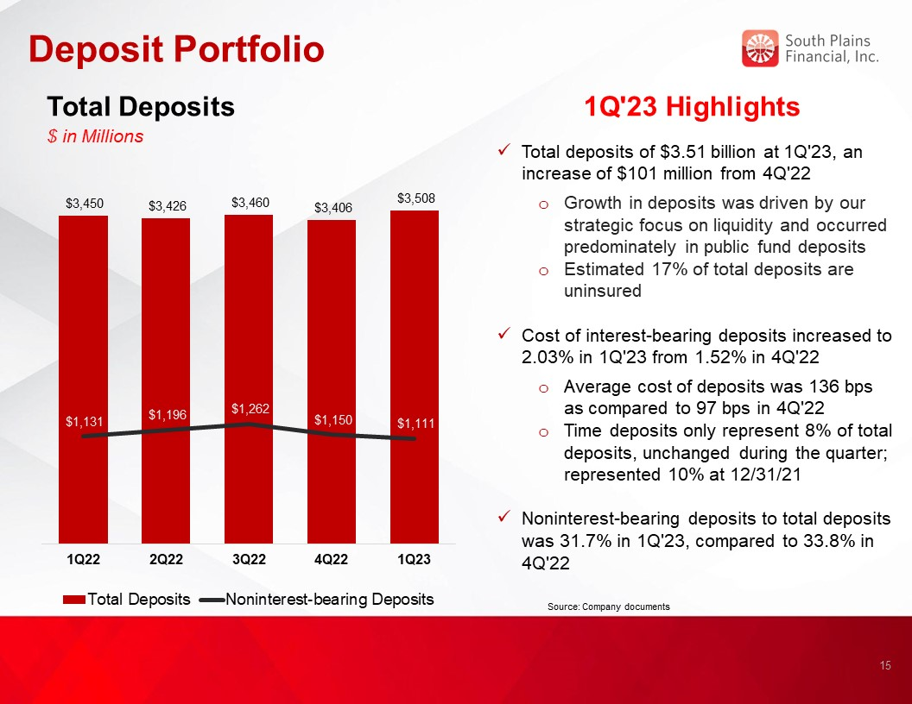
Deposit Portfolio Total Deposits $ in Millions 1Q'23 Highlights Total deposits of $3.51 billion at 1Q'23, an increase of $101 million from 4Q'22 Growth in deposits was driven by our strategic focus on liquidity and occurred predominately in public fund deposits Estimated 17% of total deposits are uninsured Cost of interest-bearing deposits increased to 2.03% in 1Q'23 from 1.52% in 4Q'22 Average cost of deposits was 136 bps as compared to 97 bps in 4Q'22 Time deposits only represent 8% of total deposits, unchanged during the quarter; represented 10% at 12/31/21 Noninterest-bearing deposits to total deposits was 31.7% in 1Q'23, compared to 33.8% in 4Q'22 Source: Company documents 15

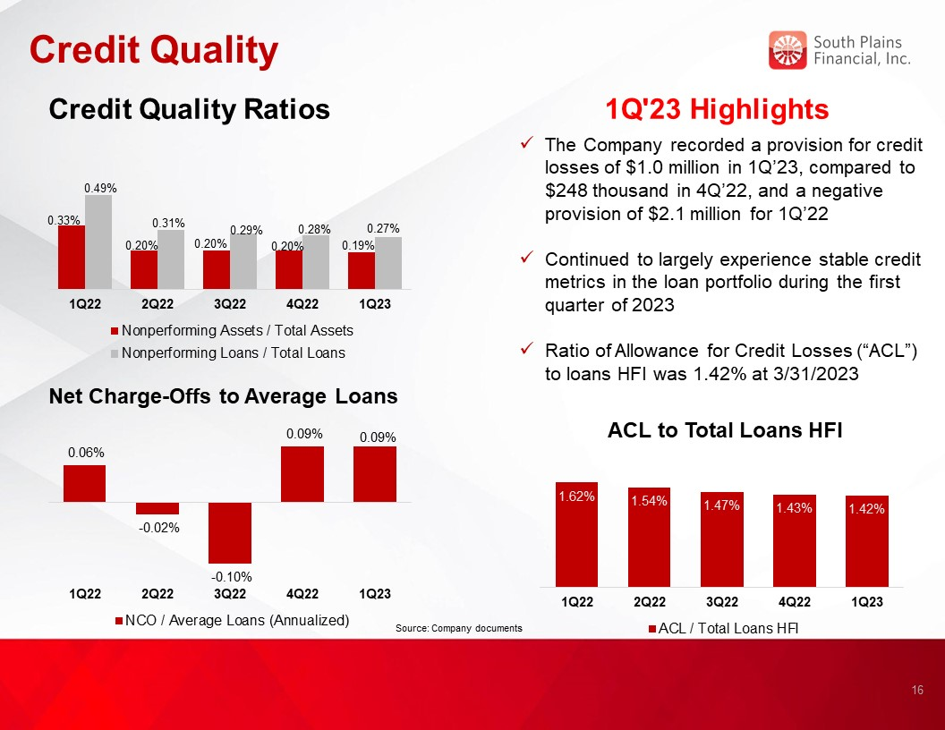
Credit Quality 1Q'23 Highlights Credit Quality Ratios Net Charge-Offs to Average Loans ACL to Total Loans HFI Source: Company documents 16 The Company recorded a provision for credit losses of $1.0 million in 1Q’23, compared to $248 thousand in 4Q’22, and a negative provision of $2.1 million for 1Q’22 Continued to largely experience stable credit metrics in the loan portfolio during the first quarter of 2023 Ratio of Allowance for Credit Losses (“ACL”) to loans HFI was 1.42% at 3/31/2023

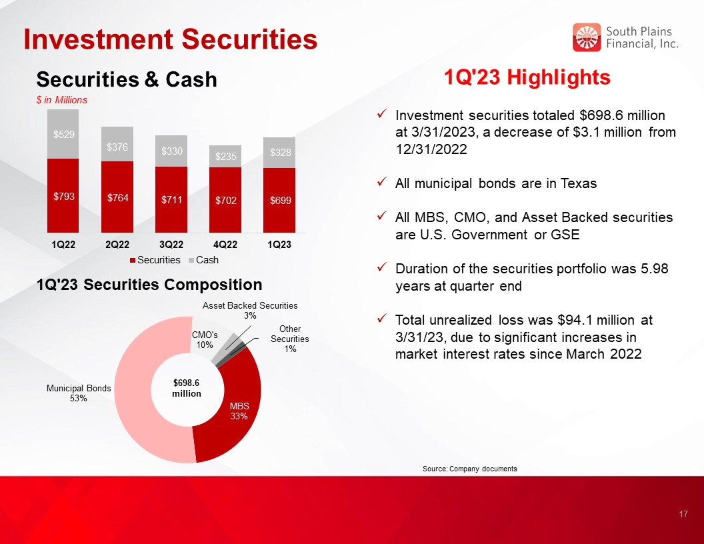
Investment Securities 1Q'23 Highlights Investment securities totaled $698.6 million at 3/31/2023, a decrease of $3.1 million from 12/31/2022 All municipal bonds are in Texas All MBS, CMO, and Asset Backed securities are U.S. Government or GSE Duration of the securities portfolio was 5.98 years at quarter end Total unrealized loss was $94.1 million at 3/31/23, due to significant increases in market interest rates since March 2022 1Q'23 Securities Composition $698.6 million Securities & Cash $ in Millions Source: Company documents 17

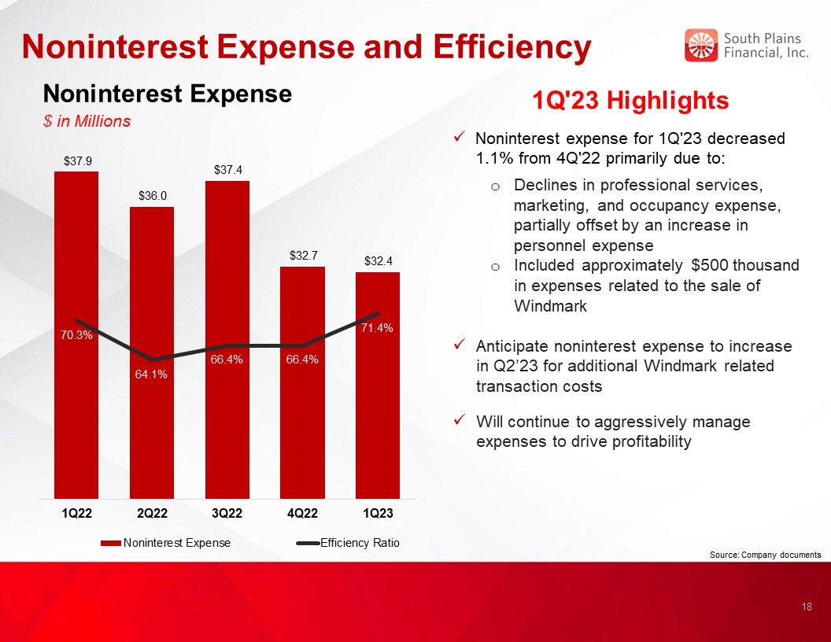
Noninterest Expense and Efficiency Noninterest Expense $ in Millions 1Q'23 Highlights Noninterest expense for 1Q'23 decreased 1.1% from 4Q'22 primarily due to: Declines in professional services, marketing, and occupancy expense, partially offset by an increase in personnel expense Included approximately $500 thousand in expenses related to the sale of Windmark Anticipate noninterest expense to increase in Q2’23 for additional Windmark related transaction costs Will continue to aggressively manage expenses to drive profitability Source: Company documents 18

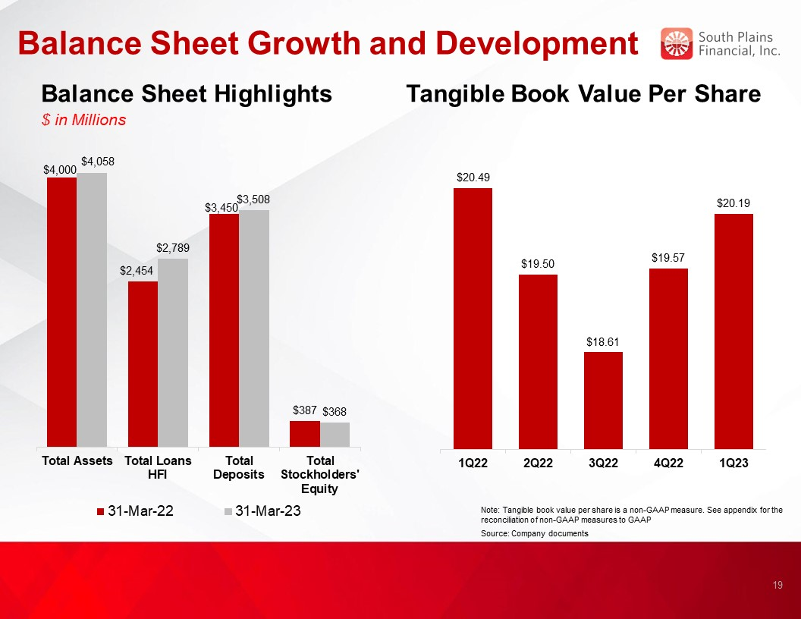
Balance Sheet Growth and Development Balance Sheet Highlights $ in Millions Tangible Book Value Per Share Note: Tangible book value per share is a non-GAAP measure. See appendix for the reconciliation of non-GAAP measures to GAAP Source: Company documents 19

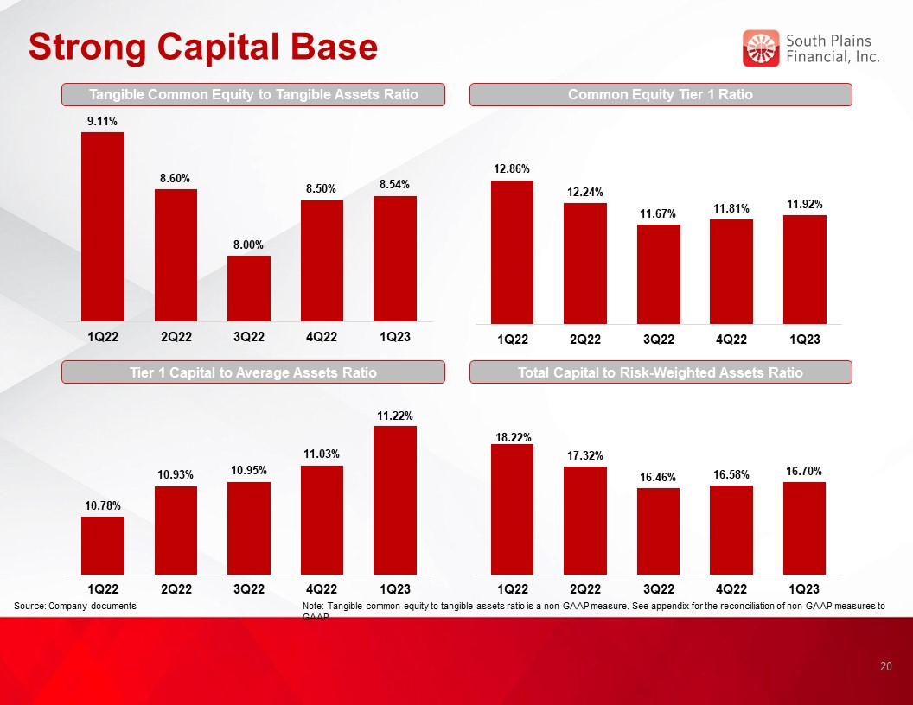
Strong Capital Base Tangible Common Equity to Tangible Assets Ratio Common Equity Tier 1 Ratio Tier 1 Capital to Average Assets Ratio Total Capital to Risk-Weighted Assets Ratio Source: Company documents Note: Tangible common equity to tangible assets ratio is a non-GAAP measure. See appendix for the reconciliation of non-GAAP measures to GAAP 20


SPFI’s Core Purpose and Values Align: Centered on Relationship-Based Business Our Core Purpose is: To use the power of relationships to help people succeed and live better HELP [ALL STAKEHOLDERS] SUCCEED Employees → great benefits and opportunities to grow and make a difference. Customers → personalized advice and solutions to achieve their goals. Partners → responsive, trusted win-win partnerships enabling both parties to succeed together. Shareholders → share in the prosperity and performance of the Bank. THE POWER OF RELATIONSHIPS At SPFI, we build lifelong, trusted relationships so you know you always have someone in your corner that understands you, cares about you, and stands ready to help. LIVE BETTER We want to help everyone live better. At the end of the day, we do what we do to help enhance lives. We create a great place to work, help people achieve their goals, and invest generously in our communities because there’s nothing more rewarding then helping people succeed and live better. 21

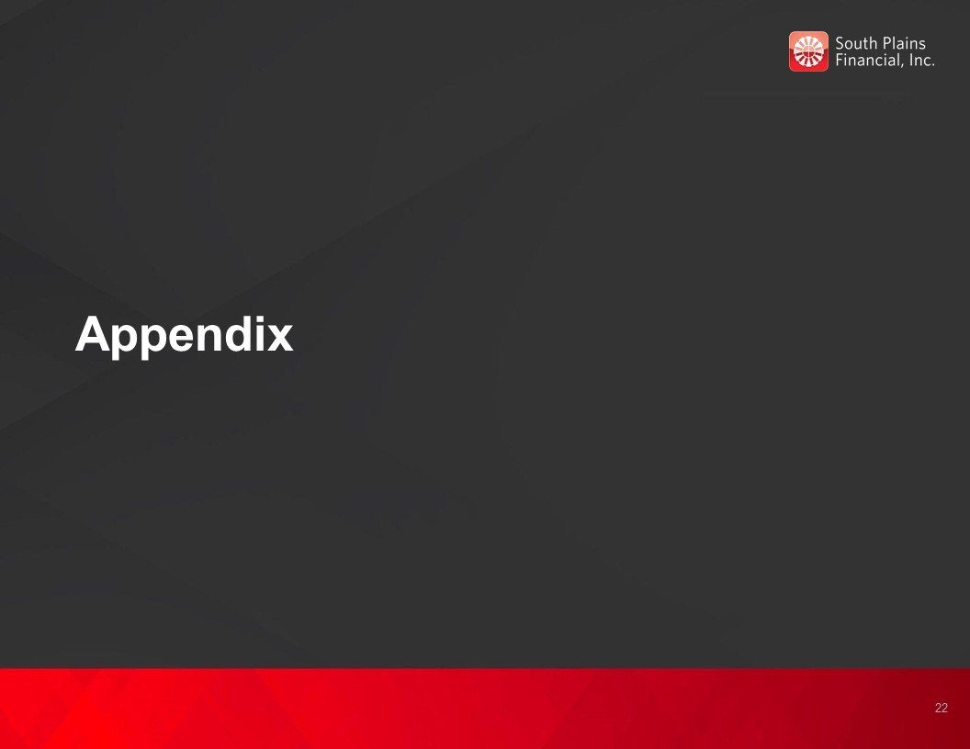
Appendix 22

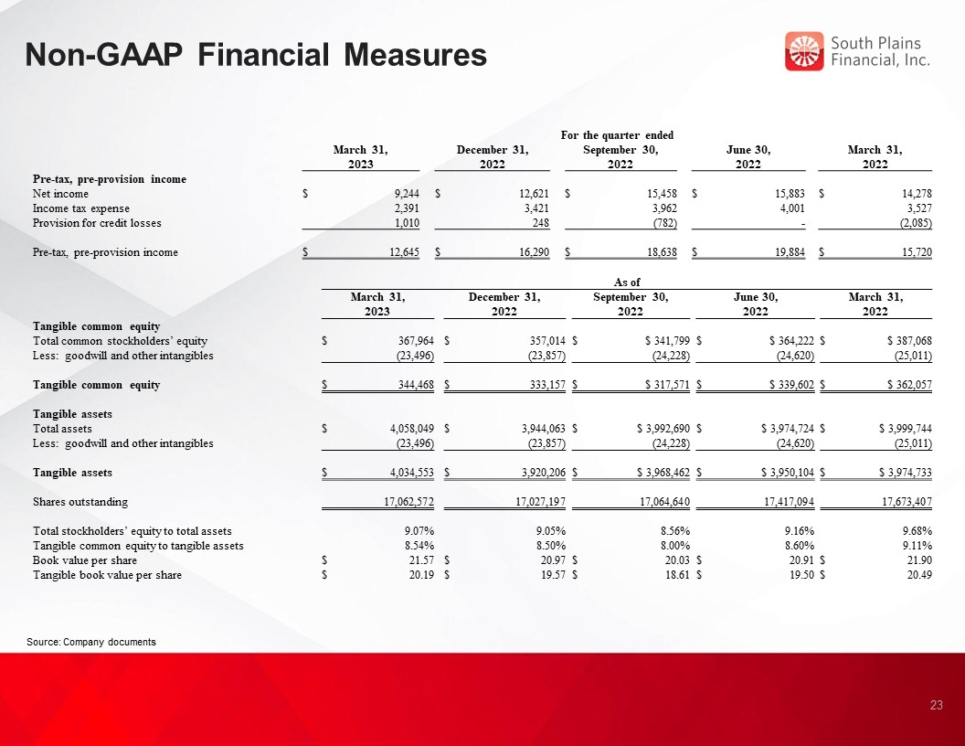
Non-GAAP Financial Measures Source: Company documents 23 For the quarter ended March 31, 2023 December 31, 2022 September 30, 2022 June 30, 2022 March 31, 2022 Pre-tax, pre-provision income Net income $ 9,244 $ 12,621 $ 15,458 $ 15,883 $ 14,278 Income tax expense 2,391 3,421 3,962 4,001 3,527 Provision for credit losses 1,010 248 (782) - (2,085) Pre-tax, pre-provision income $ 12,645 $ 16,290 $ 18,638 $ 19,884 $ 15,720 As of March 31, 2023 December 31, 2022 September 30, 2022 June 30, 2022 March 31, 2022 Tangible common equity Total common stockholders’ equity $ 367,964 $ 357,014 $ $ 341,799 $ $ 364,222 $ $ 387,068 Less: goodwill and other intangibles (23,496) (23,857) (24,228) (24,620) (25,011) Tangible common equity $ 344,468 $ 333,157 $ $ 317,571 $ $ 339,602 $ $ 362,057 Tangible assets Total assets $ 4,058,049 $ 3,944,063 $ $ 3,992,690 $ $ 3,974,724 $ $ 3,999,744 Less: goodwill and other intangibles (23,496) (23,857) (24,228) (24,620) (25,011) Tangible assets $ 4,034,553 $ 3,920,206 $ $ 3,968,462 $ $ 3,950,104 $ $ 3,974,733 Shares outstanding 17,062,572 17,027,197 17,064,640 17,417,094 17,673,407 Total stockholders’ equity to total assets 9.07% 9.05% 8.56% 9.16% 9.68% Tangible common equity to tangible assets 8.54% 8.50% 8.00% 8.60% 9.11% Book value per share $ 21.57 $ 20.97 $ 20.03 $ 20.91 $ 21.90 Tangible book value per share $ 20.19 $ 19.57 $ 18.61 $ 19.50 $ 20.49

