UNITED STATES

SECURITIES AND EXCHANGE COMMISSION
Washington, D.C. 20549

FORM 8-K

CURRENT REPORT

Pursuant to Section 13 or 15(d) of
the Securities Exchange Act of 1934

Date of Report (Date of earliest event reported): September 29, 2020

South Plains Financial, Inc.

(Exact name of registrant as specified in its charter)

Texas

001-38895

75-2453320

(State or other jurisdiction of incorporation)

(Commission File Number)

(IRS Employer Identification No.)

5219 City Bank Parkway Lubbock, Texas

79407

(Address of principal executive offices)

(Zip Code)

(806) 792-7101

(Registrant’s telephone number, including area code)

Check the appropriate box below if the Form 8-K filing is intended to simultaneously satisfy the filing obligation of the registrant under any of the following provisions:

- Written communications pursuant to Rule 425 under the Securities Act (17 CFR 230.425)

- Soliciting material pursuant to Rule 14a-12 under the Exchange Act (17 CFR 240.14a-12)

- Pre-commencement communications pursuant to Rule 14d-2(b) under the Exchange Act (17 CFR 240.14d-2(b))

- Pre-commencement communications pursuant to Rule 13e-4(c) under the Exchange Act (17 CFR 240.13e-4(c))

Securities registered pursuant to Section 12(b) of the Act:

Title of each class | Trading Symbol(s) | Name of each exchange on which registered
Common Stock, par value $1.00 per share | SPFI | The Nasdaq Stock Market LLC

Indicate by check mark whether the registrant is an emerging growth company as defined in Rule 405 of the Securities Act of 1933 (§230.405 of this chapter) or Rule 12b-2 of the Securities Exchange Act of 1934 (§240.12b-2 of this chapter).

Emerging growth company ☒

If an emerging growth company, indicate by check mark if the registrant has elected not to use the extended transition period for complying with any new or revised financial accounting standards provided pursuant to Section 13(a) of the Exchange Act. ☐

Item 1.01 Entry into a Material Definitive Agreement.

On September 29, 2020, South Plains Financial, Inc. (the “Company”) entered into a Subordinated Note Purchase Agreement (the “Purchase Agreement”) with certain institutional “accredited investors,” as such term is defined in Rule 501 of Regulation D promulgated by the Securities and Exchange Commission (the “SEC”) under the Securities Act of 1933, as amended (the “Securities Act”), and “qualified institutional buyers,” as defined in Rule 144A promulgated by the SEC under the Securities Act (collectively, the “Purchasers”). Under the terms of the Purchase Agreement with the Purchasers, the Company issued and sold $50.0 million in aggregate principal amount of its 4.50% Fixed-to-Floating Rate Subordinated Notes due 2030 (the “Notes”). The Notes were issued by the Company to the Purchasers at a price equal to 100% of their face amount.

The Notes were offered and sold by the Company in a private placement transaction in reliance on exemptions from the registration requirements of the Securities Act, pursuant to Section 4(a)(2) of the Securities Act and Rule 506(b) of Regulation D promulgated by the SEC thereunder. The Company intends to use the net proceeds it received from the sale of the Notes for general corporate purposes, including investing in the Company’s wholly-owned banking subsidiary, City Bank, Lubbock, Texas (the “Bank”). The Purchase Agreement contains certain customary representations, warranties and covenants made by the Company, on the one hand, and the Purchasers, severally and not jointly, on the other hand.

The Notes mature on September 30, 2030 and bear interest at a fixed rate of 4.50% per year, from September 29, 2020 to, but excluding, September 30, 2025, payable semi-annually in arrears. From and including September 30, 2025 to, but excluding, the maturity date or early redemption date, the interest rate will reset quarterly at a variable rate equal to the then current three-month Secured Overnight Financing Rate (“SOFR”), as published by the Federal Reserve Bank of New York, plus 438 basis points, payable quarterly in arrears. As provided in the Notes, the interest rate on the Notes during the applicable floating rate period may be determined based on a rate other than three-month term SOFR.

Prior to September 30, 2025, the Company may redeem the Notes, in whole but not in part, only under certain limited circumstances set forth in the Indenture. On or after September 30, 2025, the Company may redeem the Notes, in whole or in part, at its option, on any interest payment date. Any redemption by the Company would be at a redemption price equal to 100% of the principal amount of the Notes being redeemed, together with any accrued and unpaid interest on the Notes being redeemed to but excluding the date of redemption. The Notes are not subject to redemption at the option of the holder.

Principal and interest on the Notes are subject to acceleration only in limited circumstances in the case of certain bankruptcy and insolvency-related events with respect to the Company. The Notes are unsecured, subordinated obligations of the Company, are not obligations of, and are not guaranteed by, any subsidiary of the Company, and rank junior in right of payment to the Company’s current and future senior indebtedness. The Notes are intended to qualify as Tier 2 capital of the Company for regulatory capital purposes.

The Notes were issued under an Indenture, dated September 29, 2020 (the “Indenture”), by and between the Company and UMB Bank, National Association, as trustee (the “Trustee”). The Notes are not subject to any sinking fund and are not convertible into or exchangeable, other than pursuant to the Exchange Offer (as defined below), for any other securities or assets of the Company or any of its subsidiaries.

On September 29, 2020, in connection with the sale and issuance of the Notes, the Company entered into a Registration Rights Agreement (the “Registration Rights Agreement”) with the Purchasers. Under the terms of the Registration Rights Agreement, the Company has agreed to take certain actions to provide for the exchange of the Notes for subordinated notes that are registered under the Securities Act and have substantially the same terms as the Notes (the “Exchange Offer”). Under certain circumstances, if the Company fails to meet its obligations under the Registration Rights Agreement, it would be required to pay additional interest to the holders of the Notes.

The forms of the Purchase Agreement, Registration Rights Agreement, the Indenture and the Note are attached as Exhibits 10.1, 10.2, 4.1 and 4.2, respectively, to this Current Report on Form 8-K (this “Form 8-K”) and are incorporated herein by reference. The foregoing descriptions of the Purchase Agreement, the Registration Rights Agreement, the Indenture and the Notes are summaries and are qualified in their entirety by reference to the full text of such documents.

Item 2.03 Creation of a Direct Financial Obligation or an Obligation under an Off-Balance Sheet Arrangement of a Registrant.

The information set forth under Item 1.01 and the full text of the Indenture and form of Note, which are attached hereto as Exhibits 4.1 and 4.2, respectively, are incorporated by reference into this Item 2.03.

Item 7.01 Regulation FD Disclosure.

On September 29, 2020, the Company issued a press release announcing the completion of the offering of the Notes, a copy of which is furnished herewith as Exhibit 99.1 to this Form 8-K.

In connection with the offering of the Notes, the Company delivered an investor presentation to potential investors on a confidential basis, a copy of which is furnished herewith as Exhibit 99.2 to this Form 8-K.

In accordance with General Instruction B.2 of Form 8-K, the information in Item 7.01 of this Form 8-K, including Exhibits 99.1 and 99.2 furnished herewith, shall not be deemed “filed” for the purposes of Section 18 of the Securities Exchange Act of 1934, as amended (the “Exchange Act”), or otherwise subject to the liabilities of that section. The information in Item 7.01 of this Form 8-K, including Exhibits 99.1 and 99.2 furnished herewith, shall not be incorporated by reference into any filing or other document pursuant to the Securities Act, except as shall be expressly set forth by specific reference in such filing or document.

Item 8.01 Other Events.

As previously disclosed, in connection with the recent acquisition of West Texas State Bank (“WTSB”), the Company and the Bank filed a lawsuit in the 72nd Judicial District Court of Lubbock County, Texas: South Plains Financial, Inc. and City Bank v. R. Jay Phillips and West Texas State Bank, Case No. 202053938, on April 8, 2020 (as amended). The petition named as defendants Mr. R. Jay Phillips (“Phillips”) and WTSB. On September 4, 2020, the parties entered into a Settlement Agreement and Full and Final Mutual Release (the “Settlement Agreement”), pursuant to which the parties resolved the claims and issues in the lawsuit and agreed to file a joint motion to dismiss with prejudice, which was granted by order dated September 17, 2020. Under the terms of the Settlement Agreement, Phillips agreed to make a single payment equaling a total sum of $1,000,000 for the benefit of the Company. In addition, the parties agreed in the Settlement Agreement to mutually release, acquit, and forever discharge, on behalf of themselves and their predecessors, successors and assigns, any and all claims and potential claims of any kind related to the Company’s acquisition of WTSB.

A copy of the Settlement Agreement is filed with this Form 8-K and attached hereto as Exhibit 99.3 and incorporated by reference herein. The foregoing description of the Settlement Agreement is qualified in its entirety by reference to the full text of the Settlement Agreement.

Cautionary Note Regarding Forward-Looking Statements

This Form 8-K includes “forward-looking statements” within the meanings of the Private Securities Litigation Reform Act of 1995, Section 27A of the Securities Act, and Section 21E of the Exchange Act, including but not limited to statements about the anticipated use of net proceeds from the offering, the Exchange Offer and other matters. Forward-looking statements are subject to known and unknown risks and uncertainties, many of which may be beyond the Company’s control. The Company cautions you that the forward-looking statements presented in this Form 8-K are not a guarantee of future events, and that actual events may differ materially from those made in or suggested by the forward-looking information contained in this Form 8-K. Forward-looking statements generally can be identified by the use of forward-looking terminology such as “may,” “plan,” “seek,” “will,” “expect,” “intend,” “estimate,” “anticipate,” “believe” or “continue” or the negative thereof or variations thereon or similar terminology. Factors that may cause actual results to differ materially from those made or suggested by the forward-looking statements contained in this Form 8-K include those identified in the Company’s most recent annual report on Form 10‑K, quarterly report on Form 10-Q, and subsequent filings with the SEC. Any forward-looking statements presented herein are made only as of the date of this Form 8-K, and the Company does not undertake any obligation to update or revise any forward-looking statements to reflect changes in assumptions, the occurrence of unanticipated events, or otherwise.

Item 9.01 Financial Statements and Exhibits.

- Exhibits.

4.1 | Indenture, dated as of September 29, 2020, by and between South Plains Financial, Inc. and UMB Bank, National Association, as Trustee
4.2 | Form of 4.50% Fixed to Floating Rate Subordinated Note due 2030 (included as Exhibit A-2 to the Indenture filed as Exhibit 4.1 hereto)
10.1* | Form of Note Purchase Agreement, dated as of September 29, 2020, by and among South Plains Financial, Inc. and the Purchasers
10.2 | Form of Registration Rights Agreement, dated as of September 29, 2020, by and among South Plains Financial, Inc. and the Purchasers
99.1 | Press Release issued by South Plains Financial, Inc. on September 29, 2020
99.2 | Investor Presentation of South Plains Financial, Inc.
99.3 | Settlement Agreement and Full and Final Mutual Release, dated as of September 4, 2020, by and between South Plains Financial, Inc., City Bank, and R. Jay Phillips

- Certain schedules (or similar attachments) have been omitted pursuant to Item 601(a)(5) of Regulation S-K. The Company hereby undertakes to furnish copies of any of the omitted schedules upon request by the SEC; provided, however, that the Company may request confidential treatment pursuant to Rule 24b-2 of the Exchange Act for any schedules so furnished.

SIGNATURES

Pursuant to the requirements of the Securities Exchange Act of 1934, the registrant has duly caused this report to be signed on its behalf by the undersigned hereunto duly authorized.

SOUTH PLAINS FINANCIAL, INC.

Dated: September 29, 2020 By:/s/ Curtis C. Griffith

Curtis C. Griffith

Chairman and Chief Executive Officer

Exhibit 4.1

SOUTH PLAINS FINANCIAL, INC.

As Issuer,

and

UMB BANK, NATIONAL ASSOCIATION

As Trustee

INDENTURE

Dated as of September 29, 2020

4.50% Subordinated Notes due 2030

 |  |  | TABLE OF CONTENTS
 | ARTICLE I DEFINITIONS AND INCORPORATION BY REFERENCE |  |  | 1
 | Section 1.01 | Definitions |  | 1
 | Section 1.02 | Compliance Certificates and Opinions |  | 13
 | Section 1.03 | Form of Documents Delivered to Trustee |  | 13
 | Section 1.04 | Acts of Holders |  | 14
 | Section 1.05 | Required Notices or Demands |  | 15
 | Section 1.06 | Language of Notices |  | 17
 | Section 1.07 | Incorporation by Reference of Trust Indenture Act; Conflicts |  | 17
 | Section 1.08 | Effect of Headings and Table of Contents |  | 17
 | Section 1.09 | Successors and Assigns |  | 17
 | Section 1.10 | Severability |  | 17
 | Section 1.11 | Benefits of Indenture |  | 18
 | Section 1.12 | Governing Law |  | 18
 | Section 1.13 | Legal Holidays |  | 18
 | Section 1.14 | Counterparts; Electronic Transmission |  | 18
 | Section 1.15 | Immunity of Certain Persons |  | 18
 | Section 1.16 | Waiver of Jury Trial |  | 18
 | Section 1.17 | Force Majeure |  | 19
 | Section 1.18 | USA Patriot Act |  | 19
 | Section 1.19 | No Sinking Fund |  | 19
 | Section 1.20 | Rules of Construction |  | 19
 | ARTICLE II THE SUBORDINATED NOTES |  |  | 20
 | Section 2.01 | Forms Generally |  | 20
 | Section 2.02 | Definitive Subordinated Notes |  | 20
 | Section 2.03 | Global Subordinated Notes |  | 20
 | Section 2.04 | Restricted Subordinated Notes |  | 20
 | Section 2.05 | Execution and Authentication |  | 21
 | Section 2.06 | Registrar and Paying Agent |  | 22
 | Section 2.07 | Registration of Transfer and Exchange |  | 22
 | Section 2.08 | Exchange Offer |  | 26
 | Section 2.09 | Mutilated, Destroyed, Lost and Stolen Subordinated Notes |  | 27
 | Section 2.10 | Payment of Interest; Rights to Interest Preserved |  | 28
 | Section 2.11 | Persons Deemed Owners |  | 29
 | Section 2.12 | Cancellation |  | 29
 | Section 2.13 | Computation of Interest |  | 30
 | Section 2.14 | CUSIP Numbers |  | 32
 | ARTICLE III SATISFACTION AND DISCHARGE OF INDENTURE |  |  | 32
 | Section 3.01 | Satisfaction and Discharge |  | 32
 | Section 3.02 | Defeasance and Covenant Defeasance |  | 33
 | Section 3.03 | Application of Trust Money |  | 35
 | Section 3.04 | Reinstatement |  | 35
 | Section 3.05 | Effect on Subordination Provisions |  | 36

i

ARTICLE IV REMEDIES |  | 36
Section 4.01 | Events of Default; Acceleration | 36
Section 4.02 | Failure to Make Payments | 38
Section 4.03 | Trustee May File Proofs of Claim | 39
Section 4.04 | Trustee May Enforce Claims Without Possession of Subordinated Notes | 39
Section 4.05 | Application of Money Collected | 39
Section 4.06 | Limitation on Suits | 40
Section 4.07 | Unconditional Right of Holders to Payments | 40
Section 4.08 | Restoration of Rights and Remedies | 41
Section 4.09 | Rights and Remedies Cumulative | 41
Section 4.10 | Delay or Omission Not Waiver | 41
Section 4.11 | Control by Holders | 41
Section 4.12 | Waiver of Past Defaults | 41
Section 4.13 | Undertaking for Costs | 42

ARTICLE V THE TRUSTEE |  | 42
Section 5.01 | Duties of Trustee | 42
Section 5.02 | Certain Rights of Trustee | 43
Section 5.03 | Notice of Defaults | 45
Section 5.04 | Not Responsible for Recitals or Issuance of Subordinated Notes | 45
Section 5.05 | May Hold Subordinated Notes | 45
Section 5.06 | Money Held in Trust | 46
Section 5.07 | Compensation and Reimbursement | 46
Section 5.08 | Corporate Trustee Required; Eligibility | 47
Section 5.09 | Resignation and Removal; Appointment of Successor | 47
Section 5.10 | Acceptance of Appointment by Successor | 48
Section 5.11 | Merger, Conversion, Consolidation or Succession to Business | 49
Section 5.12 | Appointment of Authenticating Agent | 50
Section 5.13 | Preferred Collection of Claims against Company | 51

ARTICLE VI HOLDERS LISTS AND REPORTS BY TRUSTEE AND COMPANY |  | 51
Section 6.01 | Holder Lists | 51
Section 6.02 | Preservation of Information; Communications to Holders | 52
Section 6.03 | Reports by Trustee | 52
Section 6.04 | Reports by Company | 52

 | ARTICLE VII SUCCESSORS |  | 53
 | Section 7.01 | Merger, Consolidation or Sale of All or Substantially All Assets | 53
 | Section 7.02 | Successor Person Substituted for Company | 54
 | ARTICLE VIII SUPPLEMENTAL INDENTURES |  | 54
 | Section 8.01 | Supplemental Indentures without Consent of Holders | 54
 | Section 8.02 | Supplemental Indentures with Consent of Holders | 55
 | Section 8.03 | Execution of Supplemental Indentures | 56
 | Section 8.04 | Effect of Supplemental Indentures | 56
 | Section 8.05 | Reference in Subordinated Notes to Supplemental Indentures | 56
 | Section 8.06 | Effect on Senior Indebtedness | 57

ii

 | Section 8.07 | Conformity with Trust Indenture Act | 57
 | ARTICLE IX COVENANTS |  | 57
 | Section 9.01 | Payment of Principal and Interest | 57
 | Section 9.02 | Maintenance of Office | 57
 | Section 9.03 | Money for Subordinated Notes Payments to Be Held in Trust | 58
 | Section 9.04 | Corporate Existence | 59
 | Section 9.05 | Maintenance of Properties | 59
 | Section 9.06 | Waiver of Certain Covenants | 59
 | Section 9.07 | Company Statement as to Compliance | 59
 | Section 9.08 | Tier 2 Capital | 60
 | ARTICLE X REDEMPTION OF SECURITIES |  | 60
 | Section 10.01 | Applicability of Article | 60
 | Section 10.02 | Election to Redeem; Notice to Trustee | 60
 | Section 10.03 | Selection by Trustee of Subordinated Notes to be Redeemed | 61
 | Section 10.04 | Notice of Redemption | 61
 | Section 10.05 | Deposit of Redemption Price | 62
 | Section 10.06 | Subordinated Notes Payable on Redemption Date | 63
 | Section 10.07 | Subordinated Notes Redeemed in Part | 63
 | ARTICLE XI SUBORDINATION OF SECURITIES |  | 63
 | Section 11.01 | Agreement to Subordinate | 63
 | Section 11.02 | Distribution of Assets | 64
 | Section 11.03 | Default With Respect to Senior Indebtedness | 66
 | Section 11.04 | No Impairment | 66
 | Section 11.05 | Effectuation of Subordination Provisions | 66
 | Section 11.06 | Notice to Trustee | 67
 | Section 11.07 | Trustee Knowledge of Senior Indebtedness | 67
 | Section 11.08 | Senior Indebtedness to Trustee | 68
 | Section 11.09 | Subordination Not Applicable to Trustee Compensation | 68

iii

 |  | CROSS-REFERENCE TABLE
Trust Indenture Act Section |  | Indenture Section
§310 | (a)(1) | 5.08
 | (a)(2) | 5.08
 | (a)(5) | 5.08
 | (b) | 5.08, 5.09
§311 | (a) | 5.05
 | (b) | 5.05
§312 | (a) | 6.01
 | (b) | 6.02
 | (c) | 6.02
§313 | (a) | 6.03
 | (b)(2) | 6.03
 | (c) | 6.03
 | (d) | 6.03
§314 | (a) | 6.04
 | (a)(4) | 9.07
 | (c)(1) | 1.02
 | (c)(2) | 1.02
 | (e) | 1.02
§315 | (a) | 5.01, 5.02
 | (b) | 5.03
 | (c) | 5.01
 | (d) | 5.01, 5.02
 | (e) | 4.13
§316 | (a) (last sentence) | 1.01
 | (a)(1)(A) | 4.02, 4,11
 | (a)(1)(B) | 4.11, 4.12
 | (b) | 4.07
 | (c) | 1.04
§317 | (a)(1) | 4.02
 | (a)(2) | 4.03
 | (b) | 9.03
§318 | (a) | 1.07
 | (b) | 1.07
 | (c) | 1.07

Note: This Cross-Reference table will not, for any purpose, be deemed part of this Indenture.

iv

This INDENTURE, dated as of September 29, 2020, is by and between South Plains Financial, Inc., a Texas corporation (the “Company”), and UMB Bank, National Association, a national banking association duly organized and existing under the laws of the United State of America, as trustee (the “Trustee”).

RECITALS

WHEREAS, the Company has duly authorized the execution and delivery of this Indenture to provide for an issue of $50 million in aggregate principal amount of 4.50% Fixed-to-Floating Rate Subordinated Notes due 2030, subject to the terms and conditions set forth in this Indenture.

NOW, THEREFORE, in order to declare the terms and conditions upon which the Subordinated Notes are authenticated, issued and delivered, and in consideration of the premises, and of the purchase and acceptance of the Subordinated Notes by the Holders thereof, the Company and the Trustee agree as follows for the benefit of each other and for the benefit of the respective Holders from time to time of the Subordinated Notes.

ARTICLE I

DEFINITIONS AND INCORPORATION BY REFERENCE

Section 1.01 Definitions. Except as otherwise expressly provided in this Indenture or unless the context otherwise requires, the terms defined in this Section for all purposes of this Indenture, any Company Order, any Board Resolution, and any indenture supplemental hereto will have the respective meanings specified in this Section.

“Act,” when used with respect to any Holders, is defined in Section 1.04.

“Additional Interest” has the meaning set forth in the Registration Rights Agreement.

“Affiliate” means, with respect to any specified Person, any other Person directly or indirectly controlling or controlled by or under direct or indirect common control with such specified Person. For the purposes of this definition, “control,” when used with respect to any specified Person means the power to direct the management and policies of such Person, directly or indirectly, whether through the ownership of voting securities, by contract or otherwise; and the terms “controlling” and “controlled” have meanings correlative to the foregoing.

“Applicable Procedures” means, with respect to any transfer or exchange of or for beneficial interests in any Global Subordinated Note, the rules and procedures of the Depositary that apply to such transfer or exchange.

“Authenticating Agent” means any Person authorized by the Trustee in accordance with Section 5.12 to act on behalf of the Trustee to authenticate Subordinated Notes.

“Authorized Officer” means each of the Chairman of the Board, the Chief Executive Officer, the President and the Chief Financial Officer of the Company.

“Bankruptcy Laws” mean Title 11, United States Code (11 U.S.C. §§101 et seq.) or any similar federal or state law for the relief of debtors.

“Benchmark” means, initially, Three-Month Term SOFR; provided that if a Benchmark Transition Event and its related Benchmark Replacement Date have occurred with respect to Three-Month Term SOFR or the then-current Benchmark, then “Benchmark” means the applicable Benchmark Replacement.

“Benchmark Replacement” means the Interpolated Benchmark with respect to the then-current Benchmark, plus the Benchmark Replacement Adjustment for such Benchmark; provided that if (a) the Calculation Agent cannot determine the Interpolated Benchmark as of the Benchmark Replacement Date or (b) the then-current Benchmark is Three-Month Term SOFR and a Benchmark Transition Event and its related Benchmark Replacement Date have occurred with respect to Three-Month Term SOFR (in which event no Interpolated Benchmark with respect to Three-Month Term SOFR shall be determined), then “Benchmark Replacement” means the first alternative set forth in the order below that can be determined by the Calculation Agent, as of the Benchmark Replacement Date:

- The sum of (i) Compounded SOFR and (ii) the Benchmark Replacement Adjustment;

- the sum of: (i) the alternate rate of interest that has been selected or recommended by the Relevant Governmental Body as the replacement for the then-current Benchmark for the applicable Corresponding Tenor and (ii) the Benchmark Replacement Adjustment;

- the sum of: (i) the ISDA Fallback Rate and (ii) the Benchmark Replacement Adjustment; or

- the sum of: (i) the alternate rate of interest that has been selected by the Company as the replacement for the then-current Benchmark for the applicable Corresponding Tenor giving due consideration to any industry-accepted rate of interest as a replacement for the then-current Benchmark for U.S. dollar denominated floating rate notes at such time and (ii) the Benchmark Replacement Adjustment.

“Benchmark Replacement Adjustment” means the first alternative set forth in the order below that can be determined by the Calculation Agent, as of the

Benchmark Replacement Date:

- the spread adjustment, or method for calculating or determining such spread adjustment, (which may be a positive or negative value or zero) that has been selected or recommended by the Relevant Governmental Body for the applicable Unadjusted Benchmark Replacement;

- if the applicable Unadjusted Benchmark Replacement is equivalent to the ISDA Fallback Rate, then the ISDA Fallback Adjustment; or

- the spread adjustment (which may be a positive or negative value or zero) that has been selected by the Company giving due consideration to any industry-accepted spread adjustment, or method for calculating or determining such spread adjustment, for the replacement of the then-current Benchmark with the applicable Unadjusted Benchmark Replacement for U.S. dollar denominated floating rate notes at such time.

2

“Benchmark Replacement Conforming Changes” means, with respect to any Benchmark Replacement, any technical, administrative or operational changes (including changes to the definition of “Floating Interest Period,” timing and frequency of determining rates with respect to each Floating Interest Period and making payments of interest, rounding of amounts or tenors and other administrative matters) that the Company decides may be appropriate to reflect the adoption of such Benchmark Replacement in a manner substantially consistent with market practice (or, if the Company decides that adoption of any portion of such market practice is not administratively feasible or if the Company determines that no market practice for use of the Benchmark Replacement exists, in such other manner as the Company determines is reasonably necessary).

“Benchmark Replacement Date” means the earliest to occur of the following events with respect to the then-current Benchmark:

- in the case of clause (a) of the definition of “Benchmark Transition Event,” the relevant Reference Time in respect of any determination;

- in the case of clause (b) or (c) of the definition of “Benchmark Transition Event,” the later of (i) the date of the public statement or publication of information referenced therein and (ii) the date on which the administrator of the Benchmark permanently or indefinitely ceases to provide the Benchmark; or

- in the case of clause (d) of the definition of “Benchmark Transition Event,” the date of such public statement or publication of information referenced therein.

For the avoidance of doubt, if the event giving rise to the Benchmark Replacement Date occurs on the same day as, but earlier than, the Reference Time in respect of any determination, the Benchmark Replacement Date will be deemed to have occurred prior to the Reference Time for purposes of such determination.

“Benchmark Transition Event” means the occurrence of one or more of the following events with respect to the then-current Benchmark:

- if the Benchmark is Three-Month Term SOFR, (i) the Relevant Governmental Body has not selected or recommended a forward-looking term rate for a tenor of three months based on SOFR, (ii) the development of a forward-looking term rate for a tenor of three months based on SOFR that has been recommended or selected by the Relevant Governmental Body is not complete or (iii) the Company determines that the use of a forward-looking rate for a tenor of three months based on SOFR is not administratively feasible;

- a public statement or publication of information by or on behalf of the administrator of the Benchmark announcing that such administrator has ceased or will cease to provide the Benchmark, permanently or indefinitely, provided that, at the time of such statement or publication, there is no successor administrator that will continue to provide the Benchmark;

3

- a public statement or publication of information by the regulatory supervisor for the administrator of the Benchmark, the central bank for the currency of the Benchmark, an insolvency official with jurisdiction over the administrator for the Benchmark, a resolution authority with jurisdiction over the administrator for the Benchmark or a court or an entity with similar insolvency or resolution authority over the administrator for the Benchmark, which states that the administrator of the Benchmark has ceased or will cease to provide the Benchmark permanently or indefinitely, provided that, at the time of such statement or publication, there is no successor administrator that will continue to provide the Benchmark; or

- a public statement or publication of information by the regulatory supervisor for the administrator of the Benchmark announcing that the Benchmark is no longer representative.

“Board of Directors” means, as to any Person, the board of directors, or similar governing body, of such Person or any duly authorized committee thereof.

“Board Resolution” means one or more resolutions, certified by the Secretary or an Assistant Secretary of the Company to have been duly adopted by the Board of Directors and to be in full force and effect on the date of such certification, delivered to the Trustee.

“Business Day” means any day other than a Saturday, Sunday or other day on which banking institutions in the State of Texas are authorized or obligated by law, regulation or executive order to close.

“Calculation Agent” means such bank or other entity (which may be the Company or an affiliate of the Company) as may be appointed by the Company to act as Calculation Agent for the Subordinated Notes during the Floating Interest Period. The initial Calculation Agent shall be the Company.

“Commission” means the U.S. Securities and Exchange Commission, as from time to time constituted, or, if at any time after the execution of this Indenture such Commission is not existing and performing the duties now assigned to it under the Trust Indenture Act, then the body performing such duties at such time.

“Company” is defined in the preamble to this Indenture, and shall include any successors to the Company.

“Company Request” and “Company Order” mean, respectively, a written request or order, as the case may be, signed on behalf of the Company by an Authorized Officer and delivered to the Trustee.

“Compounded SOFR” means the compounded average of SOFRs for the applicable Corresponding Tenor, with the rate, or methodology for this rate, and conventions for this rate being established by the Company in accordance with:

- the rate, or methodology for this rate, and conventions for this rate selected or recommended by the Relevant Governmental Body for determining compounded SOFR; provided that:

4

- if, and to the extent that, the Company or its designee determines that Compounded SOFR cannot be determined in accordance with clause (a) above, then the rate, or methodology for this rate, and conventions for this rate that have been selected by the Company or its designee giving due consideration to any industry-accepted market practice for U.S. dollar denominated floating rate notes at such time.

For the avoidance of doubt, the calculation of Compounded SOFR will exclude the Benchmark Replacement Adjustment and the spread specified in the first paragraph of Section 2 of the Subordinated Note.

“Corporate Trust Office” means the address of the Trustee specified in Section 1.05 or such other address as the Trustee may designate from time to time by notice to the Holders and the Company, or the designated address of any successor Trustee (or such other address as such successor Trustee may designate from time to time by notice to the Holders and the Company).

“Corresponding Tenor” with respect to a Benchmark Replacement means a tenor (including overnight) having approximately the same length (disregarding any Business Day adjustment) as the applicable tenor for the then-current Benchmark.

“Covenant Defeasance” is defined in Section 3.02(3).

“Defaulted Interest” is defined in Section 2.10.

“Definitive Subordinated Notes” means, individually and collectively, each Restricted Definitive Subordinated Note and each Unrestricted Definitive Subordinated Note, substantially in the form of Exhibit A-l hereto, issued under this Indenture.

“Depositary” means, with respect to any Subordinated Note issuable or issued in whole or in part in global form, the Person designated as depositary by the Company in accordance with this Indenture, and any and all successors thereto appointed as Depositary under this Indenture. The initial Depositary shall be The Depository Trust Company.

“Dollars” or “$” means a dollar or other equivalent unit of legal tender for payment of public or private debts in the United States.

“Event of Default” is defined in Section 4.01.

“Exchange Act” means the Securities Exchange Act of 1934, as amended, or any successor statute thereto.

“Exchange Notes” means the Subordinated Notes issued in the Exchange Offer in accordance with Section 2.08.

“Exchange Offer” has the meaning set forth in the Registration Rights Agreement.

“Federal Reserve Board” means the Board of Governors of the Federal Reserve System or any successor regulatory authority with jurisdiction over bank holding companies.

5

“Fixed Interest Payment Date” means March 30 and September 30 of each year during the Fixed Interest Period, beginning March 30, 2021.

“Fixed Interest Period” means from and including the original issue date of the Subordinated Notes to but excluding September 30, 2025 or any earlier redemption date contemplated in the Subordinated Note.

“Floating Interest Determination Date” means the date upon which the Floating Interest Rate is determined by the Calculation Agent pursuant to the Three-Month Term SOFR Conventions.

“Floating Interest Payment Date” means March 30, June 30, September 30 and December 30 of each year during the Floating Interest Period, beginning December 30, 2025.

“Floating Interest Period” means each three-month period of each year, beginning September 30, 2025.

“FRBNY” means the Federal Reserve Bank of New York.

“FRBNY’s Website” means the website of the FRBNY at http://www.newyorkfed.org, or any successor source.

“GAAP” means generally accepted accounting principles in the United States set forth in the opinions and pronouncements of the Accounting Principles Board of the American Institute of Certified Public Accountants, the statements and pronouncements of the Financial Accounting Standards Board and such other statements by such other entities (including the Commission) as have been accepted by a significant segment of the accounting profession, which are applicable at the date of this Indenture.

“Global Subordinated Notes” means, individually and collectively, each Restricted Global Subordinated Note and each Unrestricted Global Subordinated Note, substantially in the form of Exhibit A-2 hereto, issued under this Indenture.

“Government Obligations” means securities which are direct obligations of the United States of America in each case where the payment or payments thereunder are supported by the full faith and credit of the United States of America.

“Holder” means the Person in whose name the Subordinated Note is registered in the Subordinated Note Register.

“Indenture” means this Indenture, as amended and supplemented from time to time in accordance with its terms.

“Initial Notes” means the $50 million in aggregate principal amount of the Company’s 4.50% Fixed-to-Floating Rate Subordinated Notes due 2030 issued under this Indenture on the date hereof.

“Interest Payment Date” means either a Fixed Interest Payment Date or a Floating Interest Payment Date, as applicable.

6

“Interest Period” means (i) during the Fixed Interest Period, each six-month period beginning on a Fixed Interest Payment Date or (ii) during the Floating Interest Period, each three-month period beginning on a Floating Interest Payment Date.

“Interpolated Benchmark” with respect to the Benchmark means the rate determined for the Corresponding Tenor by interpolating on a linear basis between: (1) the Benchmark for the longest period (for which the Benchmark is available) that is shorter than the Corresponding Tenor and (2) the Benchmark for the shortest period (for which the Benchmark is available) that is longer than the Corresponding Tenor. For the avoidance of doubt, the calculation of Interpolated Benchmark will exclude the Benchmark Replacement Adjustment and the spread specified in the first paragraph of Section 2 of the Subordinated Note.

“Investment Company Event” means the receipt by the Company of a legal opinion from counsel experienced in such matters to the effect that there is more than an insubstantial risk that the Company is or, within 90 days of the date of such legal opinion will be, considered an “investment company” that is required to be registered under the Investment Company Act of 1940, as amended.

“ISDA” means the International Swaps and Derivatives Association, Inc. or any successor thereto.

“ISDA Definitions” means the 2006 ISDA Definitions published by the ISDA or any successor thereto, as amended or supplemented from time to time, or any successor definitional booklet for interest rate derivatives published from time to time.

“ISDA Fallback Adjustment” means the spread adjustment (which may be a positive or negative value or zero) that would apply for derivatives transactions referencing the ISDA Definitions to be determined upon the occurrence of an index cessation event with respect to the Benchmark for the applicable tenor.

“ISDA Fallback Rate” means the rate that would apply for derivatives transactions referencing the ISDA Definitions to be effective upon the occurrence of an index cessation date with respect to the Benchmark for the applicable tenor excluding the applicable ISDA Fallback Adjustment

“Legal Defeasance” is defined in Section 3.02(2).

“Letter of Transmittal” means the letter of transmittal to be prepared by the Company and sent to all Holders for use by such Holders in connection with an Exchange Offer.

“Maturity” or “Maturity Date” means the date on which the principal of a Subordinated Note or an installment of principal becomes due and payable as provided in or under this Indenture or such Subordinated Note, whether at the Stated Maturity or by an acceleration of the maturity of such Subordinated Note in accordance with the terms of such Subordinated Note, upon redemption at the option of the Company, upon repurchase or repayment or otherwise, and includes a Redemption Date for such Subordinated Note and a date fixed for the repurchase or repayment of such Subordinated Note at the option of the Holder.

7

“Officer” means, with respect to any Person, the chairman of the board, the vice chairman of the board, the chief executive officer, the president, the chief operating officer, the chief financial officer, the treasurer, any assistant treasurer, the controller, the secretary or any vice president of such Person.

“Officers’ Certificate” means a certificate signed on behalf of the Company by two Officers of the Company, one of whom must be the principal executive officer, the principal financial officer or the principal accounting officer of the Company, that complies with the requirements of Section 1.02 and is delivered to the Trustee.

“Opinion of Counsel” means a written opinion from legal counsel, which opinion meets the requirements of Section 1.02. The counsel may be an employee of or counsel to the Company or any Subsidiary of the Company.

“Outstanding,” when used with respect to any Subordinated Notes, means, as of the date of determination, all such Subordinated Notes theretofore authenticated and delivered under this Indenture, except (1) any such Subordinated Note theretofore cancelled by the Trustee or the Registrar or delivered to the Trustee or the Registrar for cancellation; (2) any such Subordinated Note for whose payment at the Maturity thereof money in the necessary amount has been theretofore deposited in accordance with this Indenture (other than in accordance with Section 3.02) with the Trustee or any Paying Agent (other than the Company) in trust or set aside and segregated in trust by the Company (if the Company will act as its own Paying Agent) for the Holders of such Subordinated Notes, provided that, if such Subordinated Notes are to be redeemed, notice of such redemption has been duly given in accordance with this Indenture or provision therefor satisfactory to the Trustee has been made; (3) any such Subordinated Note with respect to which the Company has effected Legal Defeasance or Covenant Defeasance in accordance with Section 3.02, except to the extent provided is Section 3.02; and (4) any such Subordinated Note that has been paid in accordance with Section 2.09 or in exchange for or in lieu of which other Subordinated Notes have been authenticated and delivered under this Indenture, unless there will have been presented to the Trustee proof satisfactory to the Trustee that such Subordinated Note is held by a bona fide purchaser in whose hands such Subordinated Note is a valid obligation of the Company; provided, however, in all cases, that in determining whether the Holders of the requisite principal amount of Outstanding Subordinated Notes have given any request, demand, authorization, direction, notice, consent or waiver hereunder. Subordinated Notes owned by the Company or any Affiliate of the Company will be disregarded and deemed not to be Outstanding, except that, in determining whether the Trustee will be protected in making any determination or relying upon any request, demand, authorization, direction, notice, consent or waiver, only Subordinated Notes that a Responsible Officer actually knows to be so owned will be so disregarded. Subordinated Notes so owned that will have been pledged in good faith may be regarded as Outstanding if the pledgee establishes to the satisfaction of the Trustee the pledgee’s right so to act with respect to such Subordinated Notes and that the pledgee is not the Company or an Affiliate of the Company.

“Paying Agent” is defined in Section 2.06.

“Person” means any individual, corporation, partnership, association, limited liability company, other company, statutory trust, business trust, joint venture, joint-stock company, trust, unincorporated organization or government or any agency or political subdivision thereof.

8

“Place of Payment,” with respect to any Subordinated Note, means the place or places where the principal of, or interest on, such Subordinated Note are payable as provided in or under this Indenture or such Subordinated Note.

“Private Placement Legend” means the legend set forth in Section 2.04 of this Indenture to be placed on all Subordinated Notes issued under this Indenture, except where otherwise permitted by the provisions of this Indenture.

“Purchase Agreement” means the Subordinated Note Purchase Agreement concerning the Subordinated Notes, dated September 29, 2020, by and among the Company and the purchasers identified therein.

“Redemption Date” with respect to any Subordinated Note or portion thereof to be redeemed, means the date fixed for such redemption by or under this Indenture or such Subordinated Note.

“Redemption Price” with respect to any Subordinated Note or portion thereof to be redeemed, means the price at which it is to be redeemed as determined by or under this Indenture or such Subordinated Note.

“Reference Time” with respect to any determination of a Benchmark means (1) if the Benchmark is Three-Month Term SOFR, the time determined by the Calculation Agent after giving effect to the Three-Month Term SOFR Conventions, and (2) if the Benchmark is not Three-Month Term SOFR, the time determined by the Calculation Agent after giving effect to the Benchmark Replacement Conforming Changes.

“Registrar” is defined in Section 2.06.

“Registration Rights Agreement” means the Registration Rights Agreement in the form attached as Exhibit B to the Purchase Agreement with respect to the Subordinated Notes, dated as of the date of this Indenture, by and among the Company and the purchasers of the Initial Notes identified therein.

“Regular Record Date,” with respect to any Interest Payment Date, means the close of business on the fifteenth calendar day prior to the applicable Interest Payment Date, without regard to whether the Regular Record Date is a Business Day.

“Relevant Governmental Body” means the Board of Governors of the Federal Reserve System (the “Federal Reserve”) and/or the FRBNY, or a committee officially endorsed or convened by the Federal Reserve and/or the FRBNY or any successor thereto.

“Responsible Officer” means, when used with respect to the Trustee, any officer assigned to the Corporate Trust Office who has direct responsibility for the administration of this Indenture and, with respect to a particular corporate trust matter, any other officer of the Trustee to whom such matter is referred because of such Person’s knowledge of and familiarity with the particular subject.

“Restricted Definitive Subordinated Note” means a Definitive Subordinated Note bearing, or that is required to bear, the Private Placement Legend.

9

“Restricted Global Subordinated Note” means a Global Subordinated Note bearing, or that is required to bear, the Private Placement Legend,

“Restricted Subordinated Note” means a Restricted Global Subordinated Note or a Restricted Definitive Subordinated Note.

“Rule 144” means Rule 144 promulgated under the Securities Act.

“Rule 144A” means Rule 144A promulgated under the Securities Act.

“Securities Act” means the Securities Act of 1933, as amended, or any successor statute thereto.

“Senior Indebtedness” means the principal of, and premium, if any, and interest, including interest accruing after the commencement of any bankruptcy proceeding relating to the Company, on, or substantially similar payments the Company makes in respect of the following categories of debt, whether that debt was outstanding on the date of execution of this Indenture or thereafter incurred, created or assumed: (1) all indebtedness of the Company for borrowed money, whether or not evidenced by notes, debentures, bonds, securities or other similar instruments issued under the provisions of any indenture, fiscal agency agreement, debenture or note purchase agreement or other agreement, including any senior debt securities that may be offered; (2) indebtedness of the Company for money borrowed or represented by purchase money obligations, as defined below; (3) the Company’s obligations as lessee under leases of property whether made as part of a sale and leaseback transaction to which it is a party or otherwise; (4) reimbursement and other obligations relating to letters of credit, bankers’ acceptances and similar obligations and direct credit substitutes; (5) all obligations of the Company in respect of interest rate swap, cap or other agreements, interest rate future or option contracts, currency swap agreements, currency future or option contracts, commodity contracts and other similar arrangements; (6) all of the Company’s obligations issued or assumed as the deferred purchase price of property or services, but excluding trade accounts payable and accrued liabilities arising in the ordinary course of business; (7) any other obligation of the Company to its general creditors; (8) all obligations of the type referred to in clauses (1) through (7) of other persons for the payment of which the Company is liable contingently or otherwise to pay or advance money as obligor, guarantor, endorser or otherwise; (9) all obligations of the types referred to in clauses (1) through (8) of other persons secured by a lien on any property or asset of the Company; and (10) deferrals, renewals or extensions of any of the indebtedness or obligations described above.

However, clauses (1) through (10) above exclude: (x) any indebtedness, obligation or liability referred to in clauses (1) through (10) above as to which, in the instrument creating or evidencing that indebtedness, obligation or liability, it is expressly provided that the indebtedness, obligation or liability is not senior in right of payment, is junior in right of payment to, or ranks equally in right of payment with, other specified types of indebtedness, obligations and liabilities of the Company, which other specified types of indebtedness, obligations and liabilities of the Company include (A) the Subordinated Notes, (B) the outstanding junior subordinated deferrable interest debentures underlying the outstanding trust preferred securities (the “Existing Trust Preferred Debentures”), to which the Subordinated Notes shall rank senior in right of payment, and (C) the outstanding Series 2028 Debt Securities and 2030 Debt Securities, each of which was designated and issued pursuant to the terms of that certain Indenture dated as of December 14, 2018 by and between Argent Trust Company, as trustee, and the Company (the “Existing Subordinated Debt”), to which the Subordinated Notes shall rank pari passu in right of payment; (y) any indebtedness, obligation or liability that is subordinated to indebtedness, obligations or liabilities of the Company to substantially the same extent as or to a greater extent than the Subordinated Notes are subordinated, including the Existing Trust Preferred Debentures (to which the Subordinated Notes shall rank senior in right of payment), the Existing Subordinated Debt (to which the Subordinated Notes shall rank pari passu in right of payment), and any of the Company’s other subordinated debt, whether such subordinated debt is outstanding on the date of execution of this Indenture or thereafter incurred, created or attained; and (z) the Subordinated Notes and, unless expressly provided in the terms thereof, any indebtedness of the Company to its Subsidiaries.

10

As used above, the term “purchase money obligations” means indebtedness, obligations evidenced by a note, debenture, bond or other instrument, whether or not secured by a lien or other security interest, issued to evidence the obligation to pay or a guarantee of the payment of, and any deferred obligation for the payment of, the purchase price of property but excluding indebtedness or obligations for which recourse is limited to the property purchased, issued or assumed as all or a part of the consideration for the acquisition of property or services, whether by purchase, merger, consolidation or otherwise, but does not include any trade accounts payable.

“Significant Subsidiary” means any Subsidiary of the Company that is a “significant subsidiary” as defined in Rule 1-02 of Regulation S-X promulgated by the Commission (as such rule is in effect on the date of this Indenture).

“SOFR” means the daily Secured Overnight Financing Rate provided by the FRBNY, as the administrator of the benchmark (or a successor administrator), on the FRBNY’s Website.

“Special Record Date” for the payment of any Defaulted Interest on any Subordinated Note means a date fixed in accordance with Section 2.10.

“Stated Maturity” means September 30, 2030.

“Subordinated Note” or “Subordinated Notes” means the Initial Notes and the Exchange Notes and, more particularly, any Subordinated Note authenticated and delivered under this Indenture, including those Subordinated Notes issued or authenticated upon transfer, replacement or exchange.

“Subordinated Note Register” is defined in Section 2.06.

“Subordination Provisions” means the provisions contained in Article XI or any provisions with respect to subordination contained in the Subordinated

Notes.

“Subsidiary” means a corporation, a partnership, business or statutory trust or a limited liability company, a majority of the outstanding voting equity securities or a majority of the voting membership or partnership interests, as the case may be, of which is owned or controlled, directly or indirectly, by the Company or by one or more other Subsidiaries of the Company. For the purposes of this definition, “voting equity securities” means securities having voting power for the election of directors, managers, managing partners or trustees, as the case may be, whether at all times or only so long as no senior class of stock has voting power by reason of any contingency.

11

“Tax Event” means the receipt by the Company of a legal opinion from counsel experienced in such matters to the effect that, as a result of a change or a prospective change in law on or after the date hereof, there is more than an insubstantial risk that interest paid by the Company on the Subordinated Notes is not, or, within 90 days of the date of such legal opinion, will not be, deductible by the Company, in whole or in part, for United States federal income tax purposes.

“Term SOFR” means the forward-looking term rate based on SOFR that has been selected or recommended by the Relevant Governmental Body.

“Term SOFR Administrator” means any entity designated by the Relevant Governmental Body as the administrator of Term SOFR (or a successor administrator).

“Three-Month Term SOFR” means the rate for Term SOFR for a tenor of three months that is published by the Term SOFR Administrator at the Reference Time for any Floating Interest Period, as determined by the Calculation Agent after giving effect to the Three-Month Term SOFR Conventions.

“Three-Month Term SOFR Conventions” means any determination, decision or election with respect to any technical, administrative or operational matter (including with respect to the manner and timing of the publication of Three-Month Term SOFR, or changes to the definition of “Floating Interest Period”, timing and frequency of determining Three-Month Term SOFR with respect to each Floating Interest Period and making payments of interest, rounding of amounts or tenors, and other administrative matters) that the Company decides may be appropriate to reflect the use of Three-Month Term SOFR as the Benchmark in a manner substantially consistent with market practice (or, if the Company decides in good faith that adoption of any portion of such market practice is not administratively feasible or if the Company reasonably determines that no market practice for the use of Three-Month Term SOFR exists, in such other manner as the Company determines is reasonably necessary).

“Tier 2 Capital” means Tier 2 capital for purposes of capital adequacy regulations and guidelines of the Federal Reserve Board, as then in effect and applicable to the Company.

“Tier 2 Capital Event” means the receipt by the Company of a written legal opinion from counsel experienced in such matters to the effect that, as a result of any change, event, occurrence, circumstance or effect occurring on or after the date hereof, there is more than an insubstantial risk that the Subordinated Notes do not constitute, or within 90 days of the date of such legal opinion will not constitute, Tier 2 Capital (or its then equivalent if the Company were subject to such capital requirement).

“Trust Indenture Act” means the Trust Indenture Act of 1939, as amended.

“Trustee” means UMB Bank, National Association, as trustee, until a successor replaces it in accordance with the provisions of this Indenture and thereafter means the successor serving hereunder.

12

“Unadjusted Benchmark Replacement” means the Benchmark Replacement excluding the Benchmark Replacement Adjustment.

“United States,” means the United States of America (including the states thereof and the District of Columbia), its territories, its possessions and other areas subject to its jurisdiction.

“Unrestricted Definitive Subordinated Note” means a Definitive Subordinated Note that does not bear, and is not required to bear, the Private Placement Legend.

“Unrestricted Global Subordinated Note” means a Global Subordinated Note that does not bear, and is not required to bear, the Private Placement Legend.

Section 1.02 Compliance Certificates and Opinions. Except as otherwise expressly provided in or under this Indenture, upon any application or request by the Company to the Trustee to take any action under any provision of this Indenture, the Company will furnish to the Trustee an Officers’ Certificate stating that, in the opinion of the signers, all conditions precedent (including covenants compliance with which constitutes a condition precedent), if any, provided for in this Indenture relating to the proposed action have been complied with and an Opinion of Counsel stating that, in the opinion of such counsel, all such conditions precedent (including covenants compliance with which constitutes a condition precedent), if any, have been complied with, except that in the case of any such application or request as to which the furnishing of such documents or any of them is specifically required by any provision of this Indenture relating to such particular application or request, no additional certificate or opinion need be furnished.

Each certificate or opinion with respect to which compliance with a condition provided for in this Indenture (other than an Officers’ Certificate provided under Section 9.07) must comply with the provisions of Section 314(e) of the Trust Indenture Act and must include:

- a statement that the person making such certificate or opinion has read such covenant or condition;

- a brief statement as to the nature and scope of the examination or investigation upon which the statements or opinions contained in such certificate or opinion are based;

- a statement that, in the opinion of such person, he or she has made such examination or investigation as is necessary to enable him or her to express an informed opinion as to whether or not such condition has been satisfied; and

- a statement as to whether or not, in the opinion of such person, such condition has been satisfied.

Section 1.03 Form of Documents Delivered to Trustee. In any case where several matters are required to be certified by, or covered by an opinion of, any specified Person, it is not necessary that all such matters be certified by, or covered by the opinion of, only one such Person, or that they be so certified or covered by only one document, but one such Person may certify or give an opinion with respect to some matters and one or more other such Persons as to other matters, and any such Person may certify or give an opinion as to such matters in one or several documents.

13

Any certificate or opinion of an officer of the Company may be based, insofar as it relates to legal matters, upon a certificate or opinion of, or representations by, counsel, unless such officer knows, or in the exercise of reasonable care, but without investigation, should know, that the certificate or opinion or representations with respect to the matters upon which his certificate or opinion is based is erroneous.

Any such certificate or opinion of counsel may be based, insofar as it relates to factual matters, upon a certificate or opinion of, or representations by, an officer or officers of the Company stating that the information with respect to such factual matters is in the possession of the Company unless such counsel knows, or in the exercise of reasonable care, but without investigation, should know, that the certificate or opinion or representations with respect to such matters are erroneous.

Where any Person is required to make, give or execute two or more applications, requests, consents, certificates, statements, opinions or other instruments under this Indenture or any Subordinated Note, they may, but need not, be consolidated and form one instrument.

Section 1.04 Acts of Holders.

- Any request, demand, authorization, direction, notice, consent, waiver or other action provided by or under this Indenture to be made, given or taken by Holders may be embodied in and evidenced by one or more instruments of substantially similar tenor signed by such Holders in person or by an agent duly appointed in writing. Except as herein otherwise expressly provided, such action will become effective when such instrument or instruments or record or both are delivered to the Trustee and, where it is hereby expressly required, to the Company. Such instrument or instruments and any such record (and the action embodied therein and evidenced thereby) are herein sometimes referred to as the “Act” of the Holders signing such instrument or instruments. Proof of execution of any such instrument or of a writing appointing any such agent, or of the holding by any Person of a Subordinated Note, will be sufficient for any purpose of this Indenture and (subject to Section 5.01) conclusive in favor of the Trustee and the Company and any agent of the Trustee or the Company, if made in the manner provided in this Section.

- The fact and date of the execution by any Person of any such instrument or writing may be proved in any reasonable manner that the Trustee deems sufficient and in accordance with such reasonable rules as the Trustee may determine, and the Trustee may in any instance require further proof with respect to any of the matters referred to in this Section.

- The ownership, principal amount and serial numbers of Subordinated Notes held by any Person, and the date of the commencement and the date of the termination of holding the same, will be proved by the Subordinated Note Register.

- The Company may, in the circumstances permitted by the Trust Indenture Act, set a record date for purposes of determining the identity of Holders entitled to give any request, demand, authorization, direction, notice, consent, waiver or take any other act authorized or permitted to be given or taken by Holders. Unless otherwise specified, if not set by the Company prior to the first solicitation of a Holder made by any Person in respect of any such action, any such record date will be the later of 30 days prior to the first solicitation of such consent or the date of the most recent list of Holders furnished to the Trustee prior to such solicitation. If a record date is fixed, the Holders on such record date, and only such Persons, will be entitled to make, give or take such request, demand, authorization, direction, notice, consent, waiver or other action, whether or not such Holders remain Holders after such record date. No such request, demand, authorization, direction, notice, consent, waiver or other action will be valid or effective if made, given or taken more than 90 days after such record date.

14

- Any effective request, demand, authorization, direction, notice, consent, waiver or other Act by the Holder of any Subordinated Note will bind every future Holder of the same Subordinated Note and the Holder of every Subordinated Note issued upon the registration of transfer thereof or in exchange therefor or in lieu thereof in respect of anything done or suffered to be done by the Trustee, any Registrar, any Paying Agent or the Company in reliance thereon, whether or not notation of such Act is made upon such Subordinated Note.

- Without limiting the foregoing, a Holder entitled to take any action hereunder with regard to any particular Subordinated Note may do so with regard to all or any part of the principal amount of such Subordinated Note or by one or more duly appointed agents, each of which may do so in accordance with such appointment with regard to all or any part of such principal amount. Any notice given or action taken by a Holder or its agents with regard to different parts of such principal amount in accordance with this paragraph will have the same effect as if given or taken by separate Holders of each such different part.

- Without limiting the generality of this Section 1.04, a Holder, including a Depositary that is a Holder of a Global Subordinated Note, may make, give or take, by a proxy or proxies, duly appointed in writing, any request, demand, authorization, direction, notice, consent, waiver or other Act provided in or under this Indenture or the Subordinated Notes to be made, given or taken by Holders, and a Depositary that is a Holder of a Global Subordinated Note may provide its proxy or proxies to the beneficial owners of interests in any such Global Subordinated Note through such Depositary’s Applicable Procedures. The Company may fix a record date for the purpose of determining the Persons who are beneficial owners of interests in any Global Subordinated Note entitled under the Applicable Procedures of such Depositary to make, give or take, by a proxy or proxies duly appointed in writing, any request, demand, authorization, direction, notice, consent, waiver or other action provided in this Indenture to be made, given or taken by Holders. If such a record date is fixed, the Holders on such record date or their duly appointed proxy or proxies, and only such Persons, will be entitled to make, give or take such request, demand, authorization, direction, notice, consent, waiver or other action, whether or not such Holders remain Holders after such record date. No such request, demand, authorization, direction, notice, consent, waiver or other action will be valid or effective if made, given or taken more than 90 days after such record date.

Promptly upon any record date being set in accordance with this Section 1.04, the Company, at its own expense, will cause notice of the record date, the proposed action by Holders and the expiration date to be given to the Trustee in writing and the Holders in the manner set forth in Section 1.05.

Section 1.05 Required Notices or Demands. Any notice or communication by the Company or the Trustee to the other is duly given if in writing and delivered in Person or delivered by registered or certified mail (return receipt requested), facsimile, electronic mail or overnight air courier guaranteeing next day delivery, to the other’s address:

15

If to the Company;

South Plains Financial, Inc.

5219 City Bank Parkway
Lubbock, Texas 79407
Attention: Mikella D. Newsom
Facsimile: (806) 792-7101
Email: mnewsom@city.bank

If to the Trustee:

UMB Bank, National Association, as Trustee

1010 Grand Boulevard
Kansas City, Missouri 64106
Attention: Mauri J. Cowen / Corporate Trust
Facsimile: (214) 389-5949
Email: mauri.cowen@umb.com

The Company or the Trustee by written notice to the other may designate additional or different addresses for subsequent notices or communications.

All notices and communications will be deemed to have been duly given: at the time delivered by hand, if personally delivered; five Business Days after being deposited in the mail, postage prepaid, if delivered by mail; on the first Business Day after being sent, if sent by facsimile and the sender receives confirmation of successful transmission; upon confirmation of transmittal (but excluding any automatic reply to such email), if sent by email; and the next Business Day after timely delivery to the courier, if sent by overnight air courier guaranteeing next day delivery.

Any notice required or permitted to be given to a Holder or electronically through the Applicable Procedures of the Depositary under the provisions of this Indenture will be deemed to be properly delivered by being deposited postage prepaid in a post office letter box in the United States addressed to such Holder at the address of such Holder as shown on the Subordinated Note Register. Any report in accordance with Section 313 of the Trust Indenture Act will be transmitted in compliance with subsection (c) therein. If the Company delivers a notice or communication to Holders, the Company will deliver a copy to the Trustee at the same time.

In any case where notice to Holders of Subordinated Notes is delivered by mail, neither the failure to deliver such notice, nor any defect in any notice so delivered, to any particular Holder of a Subordinated Note will affect the sufficiency of such notice with respect to other Holders of Subordinated Notes. Any notice that is delivered in the manner herein provided will be conclusively presumed to have been duly given or provided. In the case by reason of the suspension of regular mail service or by reason of any other cause it will be impracticable to give such notice by mail, then such notification as will be made with the approval of the Trustee will constitute a sufficient notification for every purpose hereunder.

16

Where this Indenture provides for notice in any manner, such notice may be waived in writing by the Person entitled to receive such notice, either before or after the event, and such waiver will be the equivalent of such notice. Waivers of notice by Holders of Subordinated Notes will be filed with the Trustee, but such filing will not be a condition precedent to the validity of any action taken in reliance upon such waiver.

Notwithstanding any other provision herein, where this Indenture provides for notice to any Holder of a Global Subordinated Note, or of an interest therein, such notice will be sufficiently given if given to the Depositary for such Global Subordinated Note (or its designee) according to the Applicable Procedures of such Depositary prescribed for giving such notice.

Section 1.06 Language of Notices. Any request, demand, authorization, direction, notice, consent or waiver or other Act required or permitted under this Indenture will be in the English language, except that, if the Company so elects, any published notice may be in an official language of the country of publication.

Section 1.07 Incorporation by Reference of Trust Indenture Act; Conflicts. Whenever this Indenture refers to a provision of the Trust Indenture Act, the provision is incorporated by reference in and made a part of this Indenture. The Trust Indenture Act term “obligor” used in this Indenture means the Company and any successor obligor upon the Subordinated Notes.

All other terms used in this Indenture that are defined by the Trust Indenture Act, defined by Trust Indenture Act reference to another statute or defined by Commission rule under the Trust Indenture Act have the meanings so assigned to them as of the date of this Indenture. If and to the extent that any provision of this Indenture limits, qualifies or conflicts with another provision included in this Indenture that is required to be included in this Indenture by any of Sections 310 to 317, inclusive, of the Trust Indenture Act, such required provision will control If any provision of this Indenture limits, qualifies or conflicts with the duties imposed by Section 318(c) of the Trust Indenture Act, the duties imposed by Section 318(c) of the Trust Indenture Act will control. If any provision of this Indenture modifies or excludes any provision of the Trust Indenture Act that may be so modified or excluded, the provisions of the Trust Indenture Act will be deemed to apply to this Indenture as so modified or will be excluded, as the case may be.

Section 1.08 Effect of Headings and Table of Contents. The Article and Section headings in this Indenture and the Table of Contents are for convenience only and will not affect the construction of this Indenture.

Section 1.09 Successors and Assigns. All the covenants, stipulations, promises and agreements in this Indenture by or on behalf of the Company or the Trustee will bind its respective successors and permitted assigns, whether so expressed or not. The Company may assign its rights under this Indenture, but may not assign its obligations under this Indenture, other than in connection with a transaction permitted by Article VII hereof, or as consented to by the Holder of each Outstanding Subordinated Note.

Section 1.10 Severability. In case any provision in this Indenture or any Subordinated Note will be invalid, illegal or unenforceable, the validity, legality and enforceability of the remaining provisions will not, to the fullest extent permitted by law, in any way be affected or impaired thereby.

17

Section 1.11 Benefits of Indenture. Nothing in this Indenture or any Subordinated Note, express or implied, will give to any Person, other than the parties hereto, any Registrar, any Paying Agent and their respective successors hereunder and the Holders of Subordinated Notes, and the holders of Senior Indebtedness, any benefit or any legal or equitable right, remedy or claim under this Indenture.

Section 1.12 Governing Law. This Indenture and the Subordinated Notes will be governed by and construed in accordance with the laws of the State of New York without giving effect to its principles of conflict of laws (other than Section 5-1401 of the New York General Obligations Law).

Section 1.13 Legal Holidays. Unless otherwise specified in or under this Indenture or any Subordinated Notes, in any case where any Interest Payment Date, Stated Maturity or Maturity of, or any other day on which a payment is due with respect to, any Subordinated Note will be a day that is not a Business Day at any Place of Payment, then (notwithstanding any other provision of this Indenture or any Subordinated Note other than a provision in any Subordinated Note or in the Board Resolution, Officers’ Certificate or supplemental indenture establishing the terms of any Subordinated Note that specifically states that such provision will apply in lieu hereof) payment need not be made at such Place of Payment on such date, but such payment may be made on the next succeeding day that is a Business Day at such Place of Payment with the same force and effect as if made on the Interest Payment Date, at the Stated Maturity or Maturity or on any such other payment date, as the case may be, and no interest will accrue on the amount payable on such date or at such time for the period from and after such Interest Payment Date, Stated Maturity, Maturity or other payment date, as the case may be, to the next succeeding Business Day.

Section 1.14 Counterparts; Electronic Transmission. This Indenture may be executed in several counterparts, each of which will be an original and all of which will constitute but one and the same instrument. Any facsimile or electronically transmitted copies hereof or signature hereon will, for all purposes, be deemed originals.

Section 1.15 Immunity of Certain Persons. No recourse under or upon any obligation, covenant or agreement contained in this Indenture, or in any Subordinated Note, or because of any indebtedness evidenced thereby, will be had against any past, present or future shareholder, employee, officer or director, as such, of the Company or Trustee or of any predecessor or successor, either directly or through the Company or Trustee or any predecessor or successor, under any rule of law, statute or constitutional provision or by the enforcement of any assessment or by any legal or equitable proceeding or otherwise, all such liability being expressly waived and released by the acceptance of the Subordinated Notes by the Holders and as part of the consideration for the issue of the Subordinated Notes.

Section 1.16 Waiver of Jury Trial. EACH PARTY HERETO IRREVOCABLY WAIVES, TO THE FULLEST EXTENT PERMITTED BY APPLICABLE LAW, ANY AND ALL RIGHT TO TRIAL BY JURY IN ANY LEGAL PROCEEDING DIRECTLY OR INDIRECTLY ARISING OUT OF OR RELATING TO THIS INDENTURE, THE SUBORDINATED NOTES OR THE TRANSACTIONS CONTEMPLATED HEREBY.

18

Section 1.17 Force Majeure. In no event will the Trustee be responsible or liable for any failure or delay in the performance of its obligations

hereunder arising out of or caused by, directly or indirectly, forces beyond its control, including, without limitation, strikes, work stoppages, accidents, acts of war or terrorism, civil or military disturbances, nuclear or natural catastrophes or acts of God, and interruptions, loss or malfunctions of utilities, communications or computer (software and hardware) services; it being understood that the Trustee will use reasonable efforts that are consistent with accepted practices in the banking industry to resume performance as soon as practicable under the circumstances.

Section 1.18 USA Patriot Act. The Trustee hereby notifies the Company that in accordance with the requirements of the USA Patriot Act, it is required to obtain, verify and record information that identifies the Company, which information includes the name and address of the Company and other information that will allow the Trustee to identify the Company in accordance with the USA Patriot Act.

Section 1.19 No Sinking Fund. The Subordinated Notes are not entitled to the benefit of any sinking fund.

Section 1.20 Rules of Construction. Unless the context otherwise requires:

- a term has the meaning assigned to it;

- an accounting term not otherwise defined has the meaning assigned to it in accordance with GAAP;

- “or” is not exclusive;

- words in the singular include the plural, and in the plural include the singular;

- “including” means including without limitation;

- “will” will be interpreted to express a command;

- provisions apply to successive events and transactions;

- references to sections of, or rules under, the Securities Act will be deemed to include substitute, replacement or successor sections or rules adopted by the Commission from time to time;

- unless the context otherwise requires, any reference to an “Article,” “Section” or “clause” refers to an Article, Section or clause, as the case may be, of this Indenture; and

- the words “herein,” “hereof” and “hereunder” and other words of similar import refer to this Indenture as a whole and not any particular Article, Section, clause or other subdivision.

19

ARTICLE II

THE SUBORDINATED NOTES

Section 2.01 Forms Generally. The Subordinated Notes (including the Trustee’s certificate of authentication) will be substantially in the form of Exhibit A-l and Exhibit A-2, as applicable, which are a part of this Indenture. The Subordinated Notes may have notations, legends or endorsements required by law, stock exchange rule or usage (provided that any such notation, legend or endorsement is in a form acceptable to the Company). The Company will provide any such notations, legends or endorsements to the Trustee in writing. Each Subordinated Note will be dated the date of its authentication. The terms and provisions contained in the Subordinated Notes will constitute, and are hereby expressly made a part of this Indenture and the Company and the Trustee, by their execution and delivery of this Indenture, agree to such terms and provisions and to be bound thereby. However, to the extent any provision of any Subordinated Note irreconcilably conflicts with the express provisions of this Indenture, the provisions of this Indenture will govern and be controlling.

Section 2.02 Definitive Subordinated Notes. The Initial Notes will be issued initially in the form of one or more Definitive Subordinated Notes, unless, before the issuance of such Initial Notes, the Company has determined that the Initial Notes may be represented by Global Subordinated Notes and has so notified the Trustee, in which event the Initial Notes will be issued in the form of one or more Global Subordinated Notes. The Exchange Notes will also be issued initially in the form of one or more Definitive Subordinated Notes, unless, before the issuance of such Exchange Notes, the Company has determined that the Subordinated Notes may be represented by Global Subordinated Notes and has so notified the Trustee, in which event the Exchange Notes will be issued in the form of one or more Global Subordinated Notes. Except as provided in Section 2.07, Holders of Definitive Subordinated Notes will not be entitled to transfer Definitive Subordinated Notes in exchange for beneficial interests in Global Subordinated Notes, and owners of beneficial interests in Global Subordinated Notes will not be entitled to receive physical delivery of Definitive Subordinated Notes.

Section 2.03 Global Subordinated Notes. Each Global Subordinated Note issued under this Indenture will be deposited with the Trustee at its Corporate Trust Office, as custodian for the Depositary, and registered in the name of the Depositary or the nominee thereof, duly executed by the Company and authenticated by the Trustee as hereinafter provided. The aggregate principal amount of any Global Subordinated Note may from time to time be increased or decreased by adjustments made on the records of the Trustee and the Depositary as hereinafter provided. Any adjustment of the aggregate principal amount of a Global Subordinated Note to reflect the amount of any increase or decrease in the amount of outstanding Subordinated Notes represented thereby will be made by the Trustee in accordance with instructions given by the Holder thereof as required by Section 2.07 hereof and will be made on the records of the Trustee and the Depositary.

Section 2.04 Restricted Subordinated Notes. Each Restricted Definitive Subordinated Note and Restricted Global Subordinated Note will bear a legend in substantially the following form:

20

THE SECURITIES REPRESENTED BY THIS INSTRUMENT HAVE NOT BEEN REGISTERED UNDER THE SECURITIES ACT OF 1933, AS AMENDED (THE “SECURITIES ACT”), OR SECURITIES LAWS OF ANY STATE AND MAY NOT BE TRANSFERRED, SOLD OR OTHERWISE DISPOSED OF EXCEPT (A) PURSUANT TO, AND IN ACCORDANCE WITH, A REGISTRATION STATEMENT THAT IS EFFECTIVE UNDER THE SECURITIES ACT AT THE TIME OF SUCH TRANSFER; (B) TO A PERSON THAT YOU REASONABLY BELIEVE TO BE A QUALIFIED INSTITUTIONAL BUYER IN COMPLIANCE WITH RULE 144A UNDER THE SECURITIES ACT OR TO A PERSON THAT YOU REASONABLY BELIEVE TO BE AN INSTITUTIONAL ACCREDITED INVESTOR AS DEFINED IN RULE 501(a)

(1), (2), (3) OR (7) OF REGULATION D UNDER THE SECURITIES ACT; OR (C) UNDER ANY OTHER AVAILABLE EXEMPTION FROM, OR IN A TRANSACTION NOT SUBJECT TO, THE REGISTRATION REQUIREMENTS OF THE SECURITIES ACT (INCLUDING, IF AVAILABLE, THE EXEMPTION PROVIDED BY RULE 144 UNDER THE SECURITIES ACT), AND IN ACCORDANCE WITH APPLICABLE STATE SECURITIES LAWS OR BLUE SKY LAWS, AS EVIDENCED BY A LEGAL OPINION OF COUNSEL IN FORM AND SUBSTANCE REASONABLY SATISFACTORY TO THE COMPANY TO THE EFFECT THAT REGISTRATION IS NOT REQUIRED.

The Private Placement Legend set forth above will be removed and a new Subordinated Note of like tenor and principal amount without such Private Placement Legend will be executed by the Company, and upon written request of the Company (together with an Officers’ Certificate and an Opinion of Counsel) given at least three Business Days prior to the proposed authentication date, the Trustee will authenticate and deliver such new Subordinated Note to the respective Holder, if legal counsel to the Holder or owner of beneficial interests requesting the removal of such Private Placement Legend deliver to the Trustee, any Registrar and Paying Agent (if a different Person than the Trustee) and the Company an opinion of counsel in compliance with this Indenture and additionally opining that the restrictive legend can be removed in connection with the transfer in accordance with the Securities Act.

Section 2.05 Execution and Authentication. Subordinated Notes will be executed on behalf of the Company by any Authorized Officer and may (but need not) have the Company’s corporate seal or a facsimile thereof reproduced thereon. The signature of an Authorized Officer on the Subordinated Notes may be manual or facsimile. Subordinated Notes bearing the manual or facsimile signatures of individuals who were at the time of execution Authorized Officers of the Company will, to the fullest extent permitted by law, bind the Company, notwithstanding that such individuals or any of them have ceased to hold such offices prior to the authentication and delivery of such Subordinated Notes or did not hold such offices at the date of such Subordinated Notes.

The Trustee or an Authenticating Agent will authenticate and deliver the Initial Notes for original issue in an initial aggregate principal amount of up to $50 million upon one or more Company Orders and an Opinion of Counsel. In addition, the Trustee or an Authenticating Agent will upon receipt of a Company Order, Opinion of Counsel and Officers’ Certificate authenticate and deliver any Exchange Notes for an aggregate principal amount not to exceed $50 million specified in such Company Order for Exchange Notes issued hereunder. The aggregate principal amount of the Outstanding Subordinated Notes to be issued hereunder may be increased at any time hereafter and the series may be reopened for issuances of additional Subordinated Notes upon Company Order without the consent of any Holder. The Subordinated Notes issued on the date hereof and any such additional Subordinated Notes that may be issued hereafter shall be part of the same series of Subordinated Notes for all purposes under this Indenture. Unless the context otherwise requires, the initial Subordinated Notes and the Exchange Notes shall constitute one series for all purposes under this Indenture, including with respect to any amendment, waiver, acceleration or other Act of the Holders or upon redemption of the Subordinated Notes. The Subordinated Notes will be issued only in registered form without coupons and in minimum denominations of $100,000 and any integral multiple of $1,000 in excess thereof.

21

The Trustee will not be required to authenticate any Subordinated Notes if the issue of such Subordinated Notes under this Indenture will affect the Trustee’s own rights, duties or immunities under the Subordinated Notes and this Indenture or otherwise in a manner that is not reasonably acceptable to the Trustee or if the Trustee, being advised by counsel, determines that such action may not lawfully be taken.

No Subordinated Note will be entitled to any benefit under this Indenture or be valid or obligatory for any purpose, unless there appears on such Subordinated Note a certificate of authentication substantially in the form provided for herein executed by or on behalf of the Trustee or by the Authenticating Agent by the manual signature of one of its authorized signatories. Such certificate upon any Subordinated Note will be conclusive evidence, and the only evidence, that such Subordinated Note has been duly authenticated and delivered hereunder.

Section 2.06 Registrar and Paying Agent. The Company will maintain an office or agency where Subordinated Notes may be presented for registration of transfer or for exchange (“Registrar”) and an office or agency where Subordinated Notes may be presented for payment (“Paying Agent”). The Registrar will keep a register of the Subordinated Notes (“Subordinated Note Register”) and of their transfer and exchange. The registered Holder of a Subordinated Note will be treated as the owner of the Subordinated Note for all purposes. The Company may appoint one or more co-registrars and one or more additional paying agents. The term “Registrar” includes any co-registrar and the term “Paying Agent” includes any additional paying agent. The Company may change any Paying Agent or Registrar without prior notice to any Holder; provided that no such removal or replacement will be effective until a successor Paying Agent or Registrar will have been appointed by the Company and will have accepted such appointment. The Company will notify the Trustee in writing of the name and address of any Registrar or Paying Agent not a party to this Indenture. If the Company fails to appoint or maintain another entity as Registrar or Paying Agent, the Trustee will act as such. The Company or any of its Subsidiaries may act as Paying Agent or Registrar.

The Company initially appoints the Trustee to act as the Paying Agent and Registrar for the Subordinated Notes and, in the event that any Subordinated Notes are issued in global form, to initially act as custodian with respect to the Global Subordinated Notes. In the event that the Trustee will not be or will cease to be Registrar with respect the Subordinated Notes, it will have the right to examine the Subordinated Note Register at all reasonable times. There will be only one Subordinated Note Register.

Section 2.07 Registration of Transfer and Exchange.

22

- Except as otherwise provided in or under this Indenture, upon surrender for registration of transfer of any Subordinated Note, the Company will execute, and the Trustee will, upon receipt of a Company Order, authenticate and deliver, in the name of the designated transferee or transferees, one or more new Subordinated Notes denominated as authorized in or under this Indenture, of a like aggregate principal amount bearing a number not contemporaneously outstanding and containing identical terms and provisions.

Except as otherwise provided in or under this Indenture, at the option of the Holder, Subordinated Notes may be exchanged for other Subordinated Notes containing identical terms and provisions, in any authorized denominations (minimum denominations of $100,000 and any integral multiple of $1,000 in excess thereof), and of a like aggregate principal amount, upon surrender of the Subordinated Notes to be exchanged at any office or agency for such purpose. Whenever any Subordinated Notes are so surrendered for exchange, the Company will execute, and the Trustee will authenticate and deliver, subject to the terms hereof, the Subordinated Notes that the Holder making the exchange is entitled to receive.

All Subordinated Notes issued upon any registration of transfer or exchange of Subordinated Notes will be the valid obligations of the Company evidencing the same debt and entitling the Holders thereof to the same benefits under this Indenture as the Subordinated Notes surrendered upon such registration of transfer or exchange.

Every Subordinated Note presented or surrendered for registration of transfer or for exchange or redemption will (if so required by the Company or the Registrar for such Subordinated Note) be duly endorsed, or be accompanied by a written instrument of transfer in form satisfactory to the Company and the Registrar for such Subordinated Note duly executed by the Holder thereof or his attorney duly authorized in writing.

No service charge will be made for any registration of transfer or exchange of Subordinated Notes, or any redemption or repayment of Subordinated Notes, or any conversion or exchange of Subordinated Notes for other types of securities or property, but the Company or the Registrar may require payment of a sum sufficient to pay all taxes, assessments or other governmental charges that may be imposed in connection with the transfer or exchange of the Subordinated Notes from the Holder requesting such transfer or exchange.

Except as otherwise provided in or under this Indenture, the Company will not be required (i) to issue, register the transfer of or exchange any Subordinated Notes during a period beginning at the opening of business 15 days before the day of the selection for redemption of Subordinated Notes under Section 10.03 and ending at the close of business on the day of such selection, or (ii) to register the transfer of or exchange any Subordinated Note, or portion thereof, so selected for redemption, except in the case of any Subordinated Note to be redeemed in part, the portion thereof not to be redeemed.

Any Registrar (if not the Trustee) appointed in accordance with Section 2.06 hereof will provide to the Trustee such information as the Trustee may reasonably require in connection with the delivery by such Registrar of Subordinated Notes upon transfer or exchange of Subordinated Notes. No Registrar will be required to make registrations of transfer or exchange of Subordinated Notes during any periods designated in the Subordinated Notes or in this Indenture as periods during which such registration of transfers and exchanges need not be made.

23

The Trustee and the Registrar will have no obligation or duty to monitor, determine or inquire as to compliance with any restrictions on transfer imposed under this Indenture or under applicable law with respect to any transfer of any interest in any Subordinated Note (including any transfers between or among Depositary participants or beneficial owners of interests in any Global Subordinated Note) other than to require delivery of such certificates and other documentation or evidence as are expressly required by, and to do so if and when expressly required by the terms of, this Indenture, and to examine the same to determine substantial compliance as to form with the express requirements hereof.

Neither the Trustee nor any Paying Agent will have any responsibility for any actions taken or not taken by the Depositary.

- When Definitive Subordinated Notes are presented by a Holder to the Registrar with a request to register the transfer of such Definitive Subordinated Notes or to exchange such Definitive Subordinated Notes for an equal principal amount of Definitive Subordinated Notes of other authorized denominations, the Registrar will register the transfer or make the exchange as requested if its reasonable requirements for such transaction are met; provided, however, that the Definitive Subordinated Notes surrendered for transfer or exchange will be duly endorsed or accompanied by a written instrument of transfer in form reasonably satisfactory to the Company and the Registrar, duly executed by the Holder thereof or such Holder’s attorney duly authorized in writing.

- A Global Subordinated Note may not be transferred except by the Depositary to a nominee of the Depositary, by a nominee of the Depositary to the Depositary or to another nominee of the Depositary, or by the Depositary or any such nominee to a successor Depositary or a nominee of such successor Depositary. All Global Subordinated Notes will be exchanged by the Company for Definitive Subordinated Notes if: (i) the Depositary has notified the Company that it is unwilling or unable to continue as Depositary for such Global Subordinated Note or such Depositary has ceased to be a “clearing agency” registered under the Exchange Act, and a successor depositary is not appointed by the Company within 90 days, (ii) the Company determines that the Subordinated Notes are no longer to be represented by Global Subordinated Notes and so notifies the Trustee, or (iii) an Event of Default has occurred and is continuing with respect to the Subordinated Notes and the Depositary or its participant(s) has requested the issuance of Definitive Subordinated Notes.

Any Global Subordinated Note exchanged in accordance with clause (i) or (ii) above will be so exchanged in whole and not in part, and any Global Subordinated Note exchanged in accordance with clause (iii) above may be exchanged in whole or from time to time in part as directed by the Depositary.

24

Upon the occurrence of any of the preceding events in (i), (ii) or (iii) above, Definitive Subordinated Notes will be issued in fully registered form, without interest coupons, will have an aggregate principal amount equal to that of the Global Subordinated Note or portion thereof to be so exchanged, will be registered in such names and be in such authorized denominations as the Depositary will instruct the Trustee in writing and will bear such legends as provided herein. Global Subordinated Notes also may be exchanged or replaced, in whole or in part, as provided in Section 2.09 hereof. Every Subordinated Note authenticated and delivered in exchange for, or in lieu of, a Global Subordinated Note or any portion thereof, in accordance with this Section 2.07 or Section 2.09 hereof, will be authenticated and delivered in the form of, and will be, a Global Subordinated Note, except as otherwise provided herein. A Global Subordinated Note may not be exchanged for another Subordinated Note other than as provided in this Section 2.07(3); however, beneficial interests in a Global Subordinated Note may be transferred and exchanged as provided in Section 2.07(4) hereof.

Any Global Subordinated Note to be exchanged in whole will be surrendered by the Depositary to the Trustee. With regard to any Global Subordinated Note to be exchanged in part, either such Global Subordinated Note will be so surrendered for exchange or, if the Trustee is acting as custodian for the Depositary or its nominee with respect to such Global Subordinated Note, the principal amount thereof will be reduced, by an amount equal to the portion thereof to be so exchanged, by means of an appropriate adjustment made on the records of the Trustee. Upon any such surrender or adjustment, the Trustee will authenticate and deliver the Subordinated Note issuable on such exchange to or upon the order of the Depositary or an authorized representative thereof.

- The transfer and exchange of beneficial interests in the Global Subordinated Notes will be effected through the Depositary in accordance with the Applicable Procedures and this Section 2.07.

- A Definitive Subordinated Note may not be exchanged for a beneficial interest in a Global Subordinated Note unless the Company determines that the Subordinated Notes may be represented by Global Subordinated Notes and so notifies the Trustee. After the Company has determined that the Subordinated Notes may be represented by Global Subordinated Notes and so notifies the Trustee in writing, then upon receipt by the Trustee of a Definitive Subordinated Note, duly endorsed or accompanied by appropriate instruments of transfer, in form satisfactory to the Trustee, together with written instructions from such Holder directing the Trustee to make, or to direct the Registrar to make, an adjustment on its books and records with respect to such Global Subordinated Note to reflect an increase in the aggregate principal amount of the Subordinated Notes represented by the Global Subordinated Note, such instructions to contain information regarding the Depositary account to be credited with such increase, the Trustee will cancel such Definitive Subordinated Note and cause, or direct the Registrar to cause, in accordance with the standing instructions and procedures existing between the Depositary and the Registrar, the aggregate principal amount of Subordinated Notes represented by the Global Subordinated Note to be increased by the aggregate principal amount of the Definitive Subordinated Note to be exchanged, and will credit or cause to be credited to the account of the Person specified in such instructions a beneficial interest in the Global Subordinated Note equal to the principal amount of the Definitive Subordinated Note so cancelled. If no Global Subordinated Notes are then outstanding, the Company will issue and the Trustee will authenticate, upon Company Order, a new Global Subordinated Note in the appropriate principal amount.

25

- At such time as all beneficial interests in a particular Global Subordinated Note have been exchanged for Definitive Subordinated Notes or a particular Global Subordinated Note has been repurchased or canceled in whole and not in part, each such Global Subordinated Note will be returned to or retained and canceled by the Trustee in accordance with Section 2.12 hereof. At any time prior to such cancellation, if any beneficial interest in a Global Subordinated Note is exchanged for or transferred to a Person who will take delivery thereof in the form of a beneficial interest in another Global Subordinated Note or for Definitive Subordinated Notes, the principal amount of Subordinated Notes represented by such Global Subordinated Note will be reduced accordingly by adjustments made on the records of the Trustee to reflect such reduction; and if the beneficial interest is being exchanged for or transferred to a Person who will take delivery thereof in the form of a beneficial interest in another Global Subordinated Note, such other Global Subordinated Note will be increased accordingly by adjustments made on the records of the Trustee to reflect such increase.

- No Restricted Subordinated Note will be transferred or exchanged except in compliance with the Private Placement Legend or as provided in accordance with Section 2.08. In addition to the provisions for transfer and exchange set forth in this Section 2.07, the Trustee, any Registrar and Paying Agent (if a different Person than the Trustee) and the Company may, prior to effecting any requested transfer or exchange of any Restricted Subordinated Notes, other than an exchange in accordance with Section 2.08, require that legal counsel to the Holder or owner of beneficial interests requesting such transfer or exchange deliver to the Trustee, any Registrar and Paying Agent (if a different Person than the Trustee) and the Company, an Opinion of Counsel in compliance with this Indenture and additionally opining that the transfer or exchange is in compliance with the requirements of the Private Placement Legend and that the Subordinated Note issued to the transferee or in exchange for the Restricted Subordinated Note may be issued free of the Private Placement Legend. Any untransferred or unexchanged balance of a Restricted Subordinated Note will be reissued to the Holder with the Private Placement Legend, unless the Private Placement Legend may be omitted in accordance with Section 2.04, as evidenced by the Opinion of Counsel.

Section 2.08 Exchange Offer. Upon the occurrence of an Exchange Offer in accordance with the Registration Rights Agreement, the Company will issue and, upon receipt of a Company Order in accordance with Section 2.05 hereof, the Trustee will authenticate (i) Unrestricted Definitive Subordinated Notes in an aggregate principal amount equal to the principal amount of the Restricted Definitive Subordinated Notes tendered in such Exchange Offer for acceptance by each Person that certifies in the applicable Letter of Transmittal that (a) it is not an affiliate (as defined in Rule 405 under the Securities Act) of the Company, (b) any Exchange Notes to be received by it will be acquired in the ordinary course of business, (c) it has no arrangement with any Person to participate in the distribution (within the meaning of the Securities Act) of the Exchange Notes and (d) it is not acting on behalf of any Person who could not truthfully make the statements set forth in clauses (a), (b) and (c) immediately above, and shall be required to make such other representations as may be reasonably necessary under applicable Commission rules, regulations or interpretations to render the use of Form S-4 or another appropriate form under the Securities Act available or, if permitted by the Company, (ii) one or more Unrestricted Global Subordinated Notes in an aggregate principal amount equal to the aggregate principal amount of the beneficial interests in the Restricted Global Subordinated Notes tendered in such Exchange Offer for acceptance by each Person that certifies in the applicable Letter of Transmittal that (w) it is not an affiliate (as defined in Rule 405 under the Securities Act) of the Company, (x) any Exchange Notes to be received by it will be acquired in the ordinary course of business, (y) it has no arrangement with any Person to participate in the distribution (within the meaning of the Securities Act) of the Exchange Notes and (z) it is not acting on behalf of any Person who could not truthfully make the statements set forth in clauses (w), (x) and (y) immediately above, and shall be required to make such other representations as may be reasonably necessary under applicable Commission rules, regulations or interpretations to render the use of Form S-4 or another appropriate form under the Securities Act available. Concurrently with the issuance of such Unrestricted Global Subordinated Notes upon exchange of Restricted Global Subordinated Notes, the Trustee will cause the aggregate principal amount of the applicable Restricted Global Subordinated Notes to be reduced accordingly, and the Company will execute and the Trustee will authenticate and deliver to the Persons designated by the Holders of Restricted Definitive Subordinated Notes so accepted Unrestricted Definitive Subordinated Notes in the applicable principal amount. Any Subordinated Notes that remain outstanding after the consummation of such Exchange Offer, and Exchange Notes issued in connection with such Exchange Offer, will be treated as a single class of securities under this Indenture. For the avoidance of doubt, the only remedy for breach of registration rights is the Additional Interest set forth in Section 2(e) of the Registration Rights Agreement.

26

Section 2.09 Mutilated, Destroyed, Lost and Stolen Subordinated Notes. If any mutilated Subordinated Note is surrendered to the Trustee, subject to the provisions of this Section 2.09, the Company will execute and the Trustee will authenticate and deliver in exchange therefor a new Subordinated Note containing identical terms and of like principal amount and bearing a number not contemporaneously outstanding.

If there be delivered to the Company and to the Trustee (i) evidence to their satisfaction of the destruction, loss or theft of any Subordinated Note, and (ii) such security or indemnity as may be required by them to save each of them and any agent of either of them harmless, then, in the absence of notice to the Company or the Trustee that such Subordinated Note has been acquired by a bona fide purchaser, the Company will execute and, upon Company Request the Trustee will authenticate and deliver, in exchange for or in lieu of any such destroyed, lost or stolen Subordinated Note, a new Subordinated Note containing identical terms and of like principal amount and bearing a number not contemporaneously outstanding.

Notwithstanding the foregoing provisions of this Section 2.09, in case the outstanding principal balance of any mutilated, destroyed, lost or stolen Subordinated Note has become or is about to become due and payable, or is about to be redeemed by the Company pursuant to Article X hereof, the Company in its discretion may, instead of issuing a new Subordinated Note, pay or redeem such Subordinated Note, as the case may be.

Upon the issuance of any new Subordinated Note under this Section, the Company may require the payment of a sum sufficient to cover any tax or other governmental charge that may be imposed in relation thereto and any other expenses (including the fees and expenses of the Trustee) connected therewith.

Every new Subordinated Note issued in accordance with this Section in lieu of any destroyed, lost or stolen Subordinated Note will constitute a separate obligation of the Company, whether or not the destroyed, lost or stolen Subordinated Note will be at any time enforceable by anyone, and will be entitled to all the benefits of this Indenture equally and proportionately with any and all other Subordinated Notes duly issued hereunder.

27

The provisions of this Section, as amended or supplemented in accordance with this Indenture with respect to particular Subordinated Notes or generally, will (to the extent lawful) be exclusive and will preclude (to the extent lawful) all other rights and remedies with respect to the replacement or payment of mutilated, destroyed, lost or stolen Subordinated Notes.

Section 2.10 Payment of Interest; Rights to Interest Preserved. Any interest on any Subordinated Note that will be payable, and punctually paid or duly provided for, on any Interest Payment Date will be paid to the Person in whose name such Subordinated Note is registered as of the close of business on the Regular Record Date for such Interest Payment Date.

Any interest on any Subordinated Note that will be payable, but will not be punctually paid or duly provided for, on any Interest Payment Date for such Subordinated Note (herein called “Defaulted Interest”) will cease to be payable to the Holder thereof on the relevant Regular Record Date by virtue of having been such Holder; and such Defaulted Interest may be paid by the Company, at its election in each case, as provided in clause (1) or (2) below:

- The Company may elect to make payment of any Defaulted Interest to the Person in whose name such Subordinated Note will be registered at the close of business on a Special Record Date for the payment of such Defaulted Interest, which will be fixed in the following manner. The Company will notify the Trustee in writing of the amount of Defaulted Interest proposed to be paid on such Subordinated Note and the date of the proposed payment, and at the same time the Company will deposit with the Trustee an amount of money equal to the aggregate amount proposed to be paid in respect of such Defaulted Interest or will make arrangements satisfactory to the Trustee for such deposit on or prior to the date of the proposed payment, such money when so deposited to be held in trust for the benefit of the Person entitled to such Defaulted Interest as in this clause provided. Thereupon, the Company will fix or cause to be fixed a Special Record Date for the payment of such Defaulted Interest, which will be not more than 15 days and not less than 10 days prior to the date of the proposed payment and not less than 10 days after the receipt by the Trustee of the notice of the proposed payment. The Company (or, upon the written request of the Company, the Trustee in the name and at the expense of the Company), will cause notice of the proposed payment of such Defaulted Interest and the Special Record Date therefor to be delivered to the Holder of such Subordinated Note at the Holder’s address as it appears in the Subordinated Note Register not less than 10 days prior to such Special Record Date. Notice of the proposed payment of such Defaulted Interest and the Special Record Date therefor having been delivered as aforesaid, such Defaulted Interest will be paid to the Person in whose name such Subordinated Note will be registered at the close of business on such Special Record Date and will no longer be payable under the following clause (2).

- The Company may make payment of any Defaulted Interest in any other lawful manner not inconsistent with the requirements of any securities exchange on which such Subordinated Note may be listed, and upon such notice as may be required by such exchange, if, after written notice given by the Company to the Trustee of the proposed payment under this Clause, such payment will be deemed practicable by the Trustee.

Unless otherwise provided in or under this Indenture or the Subordinated Notes, at the option of the Company, interest on Subordinated Notes that bear interest may be paid by mailing a check to the address of the Person entitled thereto as such address will appear in the Subordinated Note Register or by transfer to an account maintained by the payee with a bank located in the United States.

28

Subject to the foregoing provisions of this Section and Section 2.07, each Subordinated Note delivered under this Indenture upon registration of transfer of or in exchange for or in lieu of any other Subordinated Note will carry the rights to interest accrued and unpaid, and to accrue, which were carried by such other Subordinated Note.

Section 2.11 Persons Deemed Owners. Prior to due presentment of a Subordinated Note for registration of transfer, the Company, the Trustee and any agent of the Company or the Trustee may treat the Person in whose name such Subordinated Note is registered in the Subordinated Note Register as the owner of such Subordinated Note for the purpose of receiving payment of principal of, and (subject to Section 2.07 and Section 2.10) interest on, such Subordinated Note and for all other purposes whatsoever, whether or not any payment with respect to such Subordinated Note will be overdue, and neither the Company, the Trustee or any agent of the Company or the Trustee will be affected by notice to the contrary.

No holder of any beneficial interest in any Global Subordinated Note held on its behalf by a Depositary will have any rights under this Indenture with respect to such Global Subordinated Note, and such Depositary may be treated by the Company, the Trustee, and any agent of the Company or the Trustee as the owner of such Global Subordinated Note for all purposes whatsoever. None of the Company, the Trustee, any Paying Agent or the Registrar will have any responsibility or liability for any aspect of the records relating to or payments made on account of beneficial ownership interests of a Global Subordinated Note or for maintaining, supervising or reviewing any records relating to such beneficial ownership interests.

Notwithstanding the foregoing, nothing herein will prevent the Company, the Trustee, any Paying Agent or the Registrar from giving effect to any written certification, proxy or other authorization furnished by the applicable Depositary, as a Holder, with respect to a Global Subordinated Note or impair, as between such Depositary and the owners of beneficial interests in such Global Subordinated Note, the operation of customary practices governing the exercise of the rights of such Depositary (or its nominee) as the Holder of such Global Subordinated Note.

Section 2.12 Cancellation. All Subordinated Notes surrendered for payment, redemption, registration of transfer or exchange will, if surrendered to any Person other than the Trustee, be delivered to the Trustee, and any such Subordinated Note, as well as Subordinated Notes surrendered directly to the Trustee for any such purpose, will be cancelled promptly by the Trustee. The Company may at any time deliver to the Trustee for cancellation any Subordinated Notes previously authenticated and delivered hereunder which the Company may have acquired in any manner whatsoever, and all Subordinated Notes so delivered will be cancelled promptly by the Trustee, No Subordinated Notes will be authenticated in lieu of or in exchange for any Subordinated Notes cancelled as provided in this Section, except as expressly permitted by or under this Indenture. All cancelled Subordinated Notes held by the Trustee will be disposed of in accordance with its procedure for the disposition of cancelled Subordinated Notes, and the Trustee upon the written request of the Company will deliver to the Company a certificate of such disposition, unless by a Company Order the Company shall direct that cancelled Subordinated Notes shall be returned to the Company.

29

Section 2.13 Computation of Interest.

- From and including the original issue date of the Subordinated Notes to but excluding September 30, 2025, the rate at which the Subordinated Notes shall bear interest shall be 4.50% per annum, computed on the basis of a 360-day year consisting of twelve 30-day months and payable semiannually in arrears on each Fixed Interest Payment Date. From and including September 30, 2025 to but excluding the Stated Maturity, the rate at which the Subordinated Notes shall bear interest shall be a floating rate equal to the Floating Interest Rate for the applicable Interest Period (provided, however, that in the event that the Floating Interest Rate for the applicable interest period is less than zero, the Floating Interest Rate for such interest period shall be deemed to be zero) plus 438 basis points, computed on the basis of a 360-day year and the actual number of days elapsed and payable quarterly in arrears on each Floating Interest Payment Date. Any payment of principal of or interest on the Subordinated Notes that would otherwise become due and payable on a day which is not a Business Day will become due and payable on the next succeeding Business Day, with the same force and effect as if made on the date for payment of such principal or interest, and no interest will accrue in respect of such payment for the period after such day.

- The “Floating Interest Rate” means:

  - initially Three-Month Term SOFR (as defined below).

  - Notwithstanding the foregoing clause (i) of this Section 2(b):

    - If the Calculation Agent, determines prior to the relevant Floating Interest Determination Date that a Benchmark Transition Event and its related Benchmark Replacement Date (each of such terms as defined below) have occurred with respect to Three-Month Term SOFR, then the Company shall promptly provide notice of such determination to the Holders and Section 2(c) (Effect of Benchmark Transition Event) will thereafter apply to all determinations, calculations and quotations made or obtained for the purposes of calculating the Floating Interest Rate payable on the Subordinated Notes during a relevant Floating Interest Period.

    - However, if the Calculation Agent, determines that a Benchmark Transition Event and its related Benchmark Replacement Date have occurred with respect to Three-Month Term SOFR, but for any reason the Benchmark Replacement has not been determined as of the relevant Floating Interest Determination Date, the Floating Interest Rate for the applicable Floating Interest Period will be equal to the Floating Interest Rate on the last Floating Interest Determination Date for the Subordinated Notes, as determined by the Calculation Agent (as defined below).

    - If the then-current Benchmark is Three-Month Term SOFR and any of the foregoing provisions concerning the calculation of the interest rate and the payment of interest during the Floating Interest Period are inconsistent with any of the Three-Month Term SOFR Conventions determined by the Company, then the relevant Three-Month Term SOFR Conventions will apply.

30

- Effect of Benchmark Transition Event.

  - If the Calculation Agent determines that a Benchmark Transition Event and its related Benchmark Replacement Date have occurred prior to the Reference Time (as defined below) in respect of any determination of the Benchmark (as defined below) on any date, the Benchmark Replacement will replace the then-current Benchmark for all purposes relating to the Subordinated Notes during the relevant Floating Interest Period in respect of such determination on such date and all determinations on all subsequent dates.

  - In connection with the implementation of a Benchmark Replacement, the Company will have the right to make Benchmark Replacement Conforming Changes from time to time.

  - Any determination, decision or election that may be made by the Company or by the Calculation Agent pursuant to the benchmark transition provisions set forth herein, including any determination with respect to a tenor, rate or adjustment or of the occurrence or non-occurrence of an event, circumstance or date, and any decision to take or refrain from taking any action or any selection:

    - will be conclusive and binding absent manifest error;

    - if made by the Company, will be made in the Company’s sole discretion;

    - if made by the Calculation Agent, will be made after consultation with the Company, and the Calculation Agent will not make any such determination, decision or election to which the Company reasonably objects; and

    - notwithstanding anything to the contrary in the Subordinated Note, this Indenture or the Purchase Agreement, shall become effective without consent from the relevant Holders or any other party.

  - For the avoidance of doubt, after a Benchmark Transition Event and its related Benchmark Replacement Date have occurred, interest payable on the Subordinated Notes for the Floating Interest Period will be an annual rate equal to the sum of the applicable Benchmark Replacement and the spread specified in the first paragraph of Section 2 of the Subordinated Note.

- In the event that any Fixed Interest Payment Date during the Fixed Interest Period falls on a day that is not a Business Day (as defined below), the interest payment due on that date shall be postponed to the next day that is a Business Day and no additional interest shall accrue as a result of that postponement. In the event that any Floating Interest Payment Date during the Floating Interest Period falls on a day that is not a Business Day (as defined below), the interest payment due on that date shall be postponed to the next day that is a Business Day and interest shall accrue to but excluding the date interest are paid. However, if the postponement would cause the day to fall in the next calendar month during the Floating Interest Period, the Floating Interest Payment Date shall instead be brought forward to the immediately preceding Business Day.

31

Section 2.14 CUSIP Numbers. The Company may issue the Subordinated Notes with one or more “CUSIP” numbers (if then generally in use). The Company will promptly notify the Trustee in writing of any change in the CUSIP numbers. The Trustee may use “CUSIP” numbers in notices (including but not limited to notices of redemption or exchange) as a convenience to Holders; provided that any such notice may state that no representation is made as to the correctness of such numbers either as printed on the Subordinated Notes or as contained in any notice (including any notice of redemption or exchange) and that reliance may be placed only on the other identification numbers printed on the Subordinated Notes, and any such notice will not be affected by any defect in or omission of such numbers.

ARTICLE III

SATISFACTION AND DISCHARGE OF INDENTURE

Section 3.01 Satisfaction and Discharge. This Indenture will cease to be of further effect, and the Trustee, on receipt of a Company Order, at the expense of the Company, will execute proper instruments acknowledging satisfaction and discharge of this Indenture, when:

- either:

  - all Subordinated Notes theretofore authenticated and delivered (other than (i) Subordinated Notes that have been destroyed, lost or stolen and which have been replaced or paid as provided in Section 2.09 and (ii) Subordinated Notes for whose payment money has theretofore been deposited in trust or segregated and held in trust by the Company and thereafter repaid to the Company or discharged from such trust, as provided in Section 9.03) have been delivered to the Trustee for cancellation; or

  - all Subordinated Notes that have not been delivered to the Trustee for cancellation (i) have become due and payable, or (ii) will become due and payable at their Stated Maturity within one year, or (iii) if redeemable at the option of the Company, are to be called for redemption within one year under arrangements satisfactory to the Trustee for the giving of notice of redemption by the Trustee in the name, and at the expense, of the Company, and the Company, in the case of (i), (ii) or (iii) above, has deposited or caused to be deposited with the Trustee as trust funds in trust for such purpose, an amount sufficient to pay and discharge the entire indebtedness on such Subordinated Notes not theretofore delivered to the Trustee for cancellation, including the principal of, and interest on, such Subordinated Notes, to the date of such deposit (in the case of Subordinated Notes which have become due and payable) or to the Maturity thereof, as the case may be;

- the Company has paid or caused to be paid all other sums payable hereunder by the Company with respect to the Outstanding Subordinated Notes or this Indenture; and

- the Company has delivered to the Trustee an Officers’ Certificate and an Opinion of Counsel, each stating that all conditions precedent herein provided for relating to the satisfaction and discharge of this Indenture have been satisfied.

32

Notwithstanding the satisfaction and discharge of this Indenture with respect to the Subordinated Notes, the obligations of the Company to the Trustee under Section 5.07 and, if money will have been deposited with the Trustee in accordance with Section 3.01(1)(b), the obligations of the Company and the Trustee with respect to the Subordinated Notes under Section 3.03 and Section 9.03 will survive.

Section 3.02 Defeasance and Covenant Defeasance.

- The Company may at its option and at any time, elect to have Section 3.02(2) or Section 3.02(3) be applied to such Outstanding Subordinated Notes upon compliance with the conditions set forth below in this Section 3.02. Legal Defeasance and Covenant Defeasance may be effected only with respect to all, and not less than all, of the Outstanding Subordinated Notes.

- Upon the Company’s exercise of the option set forth in Section 3.02(1) applicable to this Section 3.02(2), the Company will be deemed to have been discharged from its obligations with respect to such Outstanding Subordinated Notes on the date the conditions set forth in clause (4) of this Section 3.02 are satisfied (“Legal Defeasance”). For this purpose, Legal Defeasance means that the Company will be deemed to have paid and discharged the entire indebtedness represented by such Outstanding Subordinated Notes, which will thereafter be deemed to be “Outstanding” only for the purposes of Section 3.02(5) and the other Sections of this Indenture referred to in clauses (i) through (iv) of this paragraph, and to have satisfied all of its other obligations under such Subordinated Notes and this Indenture insofar as such Subordinated Notes are concerned (and the Trustee, at the expense of the Company, will execute proper instruments acknowledging the same), except for the following which will survive until otherwise terminated or discharged hereunder: (i) the rights of Holders of such Outstanding Subordinated Notes to receive, solely from the trust fund described in Section 3.02(4)(a) and as more fully set forth in this Section 3.02 and Section 3.03, payments in respect of the principal of and interest, if any, on, such Subordinated Notes when such payments are due, (ii) the obligations of the Company and the Trustee with respect to such Subordinated Notes under Section 2.07, Section 2.09, Section 9.02 and Section 9.03, (iii) the rights, powers, trusts, duties and immunities of the Trustee hereunder and (iv) this Section 3.02 and Section 3.03. The Company may exercise its option under this Section 3.02(2) notwithstanding the prior exercise of its option under Section 3.02(3) with respect to such Subordinated Notes.

- Upon the Company’s exercise of the option set forth in Section 3.02(1) applicable to this Section 3.02(3), the Company will be released from its obligations under Section 9.04 (except with respect to clause (i)) and under Section 9.05, Section 9.08 and Section 9.09 on and after the date the conditions set forth in Section 3.02(4) are satisfied (“Covenant Defeasance”), and such Subordinated Notes will thereafter be deemed to be not “Outstanding” for the purposes of any direction, waiver, consent or declaration or Act of Holders (and the consequences of any thereof) in connection with any such covenant, but will continue to be deemed “Outstanding” for all other purposes hereunder. For this purpose, such Covenant Defeasance means that with respect to such Outstanding Subordinated Notes, the Company may omit to comply with, and will have no liability in respect of, any term, condition or limitation set forth in any such Section or any such other covenant, whether directly or indirectly, by reason of any reference elsewhere herein to any such Section or such other covenant or by reason of reference in any such Section or such other covenant to any other provision herein or in any other document and such omission to comply will not constitute a default, but, except as specified above, the remainder of this Indenture and such Subordinated Notes will be unaffected thereby.

33

- The following will be the conditions to application of Section 3.02(2) or Section 3.02(3) to any Outstanding Subordinated Notes:

  - The Company will irrevocably have deposited or caused to be deposited with the Trustee (or another trustee satisfying the requirements of Section 5.08 who will agree to comply with the provisions of this Section 3.02 applicable to it) as trust funds in trust for the purpose of making the following payments, specifically pledged as security for, and dedicated solely to, the benefit of the Holders, (i) an amount in Dollars, (ii) Government Obligations that through the scheduled payment of principal and interest in respect thereof in accordance with their terms will provide, not later than one day before the due date of any payment of principal of and interest, if any, on such Subordinated Notes, money or (iii) a combination thereof, in any case, in an amount, sufficient, without consideration of any reinvestment of such principal and interest, in the opinion of a nationally recognized firm of independent public accountants expressed in a written certification thereof delivered to the Trustee, to pay and discharge, and which will be applied by the Trustee (or other qualifying trustee) to pay and discharge, the principal of and interest, if any, on, such Outstanding Subordinated Notes on the Stated Maturity of such principal or installment of principal or interest or the applicable Redemption Date, as the case may be.

  - Such Legal Defeasance or Covenant Defeasance will not result in a breach or violation of, or constitute a default under, this Indenture or any other material agreement or instrument to which the Company or any Subsidiary is a party or by which it is bound.

  - No Event of Default or event which with notice or lapse of time or both would become an Event of Default with respect to such Subordinated Notes will have occurred and be continuing on the date of such deposit, and, solely in the case of Legal Defeasance under Section 3.02(2), no Event of Default, or event which with notice or lapse of time or both would become an Event of Default, under Section 4.01 will have occurred and be continuing at any time during the period ending on and including the 91st day after the date of such deposit (it being understood that this condition to Legal Defeasance under Section 3.02(2) will not be deemed satisfied until the expiration of such period),

  - In the case of Legal Defeasance, the Company will have delivered to the Trustee an Opinion of Counsel stating that (i) the Company has received from, or there has been published by, the Internal Revenue Service a ruling or (ii) since the date of this Indenture there has been a change in applicable federal income tax law, in either case to the effect that, and based thereon such opinion of independent counsel will confirm that, the Holders of such Outstanding Subordinated Notes will not recognize income, gain or loss for federal income tax purposes as a result of such Legal Defeasance and will be subject to federal income tax on the same amounts, in the same manner and at the same times as would have been the case if such Legal Defeasance had not occurred.

  - In the case of Covenant Defeasance, the Company will have delivered to the Trustee an Opinion of Counsel to the effect that the Holders of such Outstanding Subordinated Notes will not recognize income, gain or loss for federal income tax purposes as a result of such Covenant Defeasance and will be subject to federal income tax on the same amounts, in the same manner and at the same times as would have been the case if such Covenant Defeasance had not occurred.

34

- The Company will have delivered to the Trustee an Officers’ Certificate and an Opinion of Counsel, each stating that all conditions precedent to the Legal Defeasance or Covenant Defeasance, as the case may be, under this Indenture have been satisfied.

- If the moneys or Government Obligations or combination thereof, as the case may be, deposited under Section 3.02(4)(a) above are sufficient to pay the principal of, and interest, if any, on, such Subordinated Notes provided such Subordinated Notes are redeemed on a particular Redemption Date, the Company will have given the Trustee irrevocable instructions to redeem such Subordinated Notes on such date and to provide notice of such redemption to Holders as provided in or under this Indenture.

- The Trustee will have received such other documents, assurances and Opinions of Counsel as the Trustee will have reasonably

required.

- Subject to the provisions of the last paragraph of Section 9.03, all money and Government Obligations deposited with the Trustee (or other qualifying trustee, collectively for purposes of this Section 3.02(5), the “Trustee”) in accordance with Section 3.02(4)(a) in respect of any Outstanding Subordinated Notes will be held in trust and applied by the Trustee, in accordance with the provisions of such Subordinated Notes and this Indenture, to the payment, either directly or through any Paying Agent (other than the Company or any Subsidiary or Affiliate of the Company acting as Paying Agent) as the Trustee may determine, to the Holders of all sums due and to become due thereon in respect of principal and interest but such money and Government Obligations need not be segregated from other funds, except to the extent required by law.

The Company will pay and indemnify the Trustee against any tax, fee or other charge, imposed on or assessed against the Government Obligations deposited in accordance with this Section 3.02 or the principal or interest received in respect thereof other than any such tax, fee or other charge which by law is for the account of the Holders of the Outstanding Subordinated Notes.

Section 3.03 Application of Trust Money. Subject to the provisions of the last paragraph of Section 9.03, all money and Government Obligations deposited with the Trustee in accordance with Section 3.01 or Section 3.02 will be held in trust and applied by the Trustee, in accordance with the provisions of such Subordinated Notes subject to discharge under Section 3.01 or Legal Defeasance or Covenant Defeasance under Section 3.02, and this Indenture, to the payment, either directly or through any Paying Agent (including the Company, acting as its own Paying Agent) as the Trustee may determine, to the Persons entitled thereto, of the principal and interest for whose payment such money has or Government Obligations have been deposited with or received by the Trustee; but such money and Government Obligations need not be segregated from other funds, except to the extent required by law.

Section 3.04 Reinstatement. If the Trustee (or other qualifying trustee appointed in accordance with Section 3.02(4)(a)) or any Paying Agent is unable to apply any moneys or Government Obligations deposited in accordance with Section 3.01(1) or Section 3.02(4)(a) to pay any principal of, or interest, if any, on, the Subordinated Notes by reason of any legal proceeding or any order or judgment of any court or governmental authority enjoining, restraining or otherwise prohibiting such application, then the Company’s obligations under this Indenture and the Subordinated Notes will be revived and reinstated as though no such deposit had occurred, until such time as the Trustee (or other qualifying trustee) or Paying Agent is permitted to apply all such moneys and Government Obligations to pay the principal of, and interest, if any, on the Subordinated Notes as contemplated by Section 3.01 or Section 3.02 as the case may be; provided, however, that if the Company makes any payment of the principal of, or interest if any on, the Subordinated Notes following the reinstatement of its obligations as aforesaid, the Company will be subrogated to the rights of the Holders of such Subordinated Notes to receive such payment from the funds held by the Trustee (or other qualifying trustee) or Paying Agent.

35

Section 3.05 Effect on Subordination Provisions. The provisions of Article XI are expressly made subject to the provisions for, and to the right of the Company to effect, the satisfaction and discharge of all of the Subordinated Notes as set forth in and in accordance with Section 3.01 and the provisions for, and to the right of the Company to effect, Legal Defeasance and Covenant Defeasance of all of the Subordinated Notes as set forth in and in accordance with Section

3.02. As a result, and anything herein to the contrary notwithstanding, if the Company complies with the provisions of Section 3.01 to effect the satisfaction and discharge of the Subordinated Notes or complies with the provisions of Section 3.02 to effect the Legal Defeasance or Covenant Defeasance, upon the effectiveness of such satisfaction and discharge in accordance with Section 3.01 or of Legal Defeasance or Covenant Defeasance in accordance with Section 3.02, in the case of satisfaction and discharge in accordance with Section 3.01, or, in the case of Legal Defeasance or Covenant Defeasance in accordance with Section 3.02, the Subordinated Notes as to which Legal Defeasance or Covenant Defeasance, as the case may be, will have become effective will thereupon cease to be so subordinated in right of payment to the Senior Indebtedness and will no longer be subject to the provisions of Article XI and, without limitation to the foregoing, all moneys and Government Obligations deposited with the Trustee (or other qualifying trustee) in trust in connection with such satisfaction and discharge. Legal Defeasance or Covenant Defeasance, as the case may be, and all proceeds therefrom may be applied to pay the principal of, and interest, if any, on, such Subordinated Notes as and when the same will become due and payable notwithstanding the provisions of Article XI without regard to whether any or all of the Senior Indebtedness then outstanding will have been paid or otherwise provided for.

ARTICLE IV

REMEDIES

Section 4.01 Events of Default; Acceleration. An “Event of Default” means any one of the following events (whatever the reason for such Event of Default and whether it will be voluntary or involuntary or be effected by operation of law or in accordance with any judgment, decree, or order of any court or any order, rule, or regulation of any administrative or governmental body):

- the entry of a decree or order for relief in respect of the Company by a court having jurisdiction in the premises in an involuntary case or proceeding under any applicable bankruptcy, insolvency, or reorganization law, now or hereafter in effect of the United States or any political subdivision thereof, and such decree or order will have continued unstayed and in effect for a period of 60 consecutive days;

36

  - the commencement by the Company of a voluntary case under any applicable bankruptcy, insolvency or reorganization law, now or hereafter in effect of the United States or any political subdivision thereof, or the consent by the Company to the entry of a decree or order for relief in an involuntary case or proceeding under any such law;

  - the failure of the Company to pay any installment of interest on any of the Subordinated Notes as and when the same will become due and payable, and the continuation of such failure for a period of 30 days;

  - the failure of the Company to pay all or any part of the principal of any of the Subordinated Notes as and when the same will become due and payable under this Indenture;

  - the failure of the Company to perform any other covenant or agreement on the part of the Company contained in the Subordinated Notes or in this Indenture, and the continuation of such failure for a period of 60 days after the date on which notice specifying such failure, stating that such notice is a “Notice of Default” hereunder and demanding that the Company remedy the same, will have been given, in the manner set forth in Section 1.05, to the Company by the Trustee, or to the Company and the Trustee by the Holders of at least 25% in aggregate principal amount of the Subordinated Notes at the time Outstanding; or

  - the default by the Company under any bond, debenture, note or other evidence of indebtedness for money borrowed by the Company having an aggregate principal amount outstanding of at least $25,000,000, whether such indebtedness now exists or is created or incurred in the future, which default (i) constitutes a failure to pay any portion of the principal of such indebtedness when due and payable after the expiration of any applicable grace period or
- results in such indebtedness becoming due or being declared due and payable prior to the date on which it otherwise would have become due and payable without, in the case of clause (i), such indebtedness having been discharged or, in the case of clause (ii), without such indebtedness having been discharged or such acceleration having been rescinded or annulled.

Upon becoming aware of any Event of Default, the Company will promptly deliver to the Trustee a written statement specifying the Event of Default.

If an Event of Default described in Section 4.01(1) or Section 4.01(2) occurs, then the principal amount of all of the Outstanding Subordinated Notes, and accrued and unpaid interest, if any, on all Outstanding Subordinated Notes will become and be immediately due and payable without any declaration or other act on the part of the Trustee or any Holder, and the Company waives demand, presentment for payment, notice of nonpayment, notice of protest, and all other notices. Notwithstanding the foregoing, because the Company will treat the Subordinated Notes as Tier 2 Capital, upon the occurrence of an Event of Default other than an Event of Default described in Section 4.01(1) or Section 4.01(2), neither the Trustee nor any Holder may accelerate the Maturity of the Subordinated Notes and make the principal of, and any accrued and unpaid interest on, the Subordinated Notes, immediately due and payable.

Subject to the foregoing, if any Event of Default occurs and is continuing, the Trustee may also pursue any other available remedy to collect the payment of principal of, and interest on, the Subordinated Notes or to enforce the performance of any provision of the Subordinated Notes or this Indenture.

37

Section 4.02 Failure to Make Payments. If an Event of Default described in Section 4.01(3) or Section 4.01(4) occurs, the Company will, upon demand of the Trustee, pay to the Trustee, for the benefit of the Holders of such Subordinated Notes (without acceleration of the Maturity Date of the Subordinated Notes), the whole amount then due and payable with respect to such Subordinated Notes, with interest upon the overdue principal, any premium, and, to the extent permitted by applicable law, upon any overdue installments of interest at the rate or respective rates, as the case may be, provided for or with respect to such Subordinated Notes or, if no such rate or rates are so provided, at the rate or respective rates, as the case may be, of interest borne by such Subordinated Notes, and, in addition thereto, such further amount of money as will be sufficient to cover the costs and expenses of collection, including the reasonable compensation, expenses, disbursements and advances of the Trustee, its agents and counsel and all other amounts due to the Trustee under Section 5.07.

If the Company fails to pay the money it is required to pay the Trustee, the Trustee, in its own name and as trustee of an express trust, may institute a judicial proceeding for the collection of the sums so due and unpaid, may prosecute .such proceeding to judgment or final decree, and may enforce the same against the Company or any other obligor upon such Subordinated Notes and collect the moneys adjudged or decreed to be payable in the manner provided by law out of the property of the Company, wherever situated.

The Trustee may proceed to protect and enforce its rights and the rights of the Holders of Subordinated Notes by such appropriate judicial proceedings as the Trustee will deem most effectual to protect and enforce any such rights, whether for the specific enforcement of any covenant or agreement in this Indenture or in aid of the exercise of any power granted in this Indenture, or to enforce any other proper remedy.

Upon an Event of Default, the Company may not declare or pay any dividends or distributions on, or redeem, purchase, acquire, or make a liquidation payment with respect to, any of the Company’s capital stock, make any payment of principal or interest or premium, if any, on or repay, repurchase or redeem any debt securities of the Company that rank equal with or junior to the Subordinated Notes, or make any payments under any guarantee that ranks equal with or junior to the Subordinated Notes, other than: (i) any dividends or distributions payable solely in shares of, or options, warrants or rights to subscribe for or purchase shares of, any class of Company’s common stock; (ii) any declaration of a dividend in connection with the implementation of a shareholders’ rights plan, or the issuance of stock under any such plan in the future, or the redemption or repurchase of any such rights pursuant thereto; (iii) as a result of a reclassification of Company’s capital stock or the exchange or conversion of one class or series of Company’s capital stock for another class or series of Company’s capital stock; (iv) the purchase of fractional interests in shares of Company’s capital stock in accordance with the conversion or exchange provisions of such capital stock or the security being converted or exchanged; or (v) purchases of any class of Company’s common stock related to the issuance of common stock or rights under any benefit plans for Company’s directors, officers or employees or any of Company’s dividend reinvestment plans.

38

Section 4.03 Trustee May File Proofs of Claim. In case of any judicial proceeding relative to the Company (or any other obligor upon the Subordinated Notes), its property or its creditors, the Trustee will be entitled and empowered, by intervention in such proceeding or otherwise, to take any and all actions authorized under the Trust Indenture Act in order to have claims of the Holders and the Trustee allowed in any such proceeding. In particular, the Trustee will be authorized to:

- file and prove a claim for the whole amount, or such lesser amount as may be provided for in the Subordinated Notes, of the principal and interest owing and unpaid in respect of such Subordinated Notes and to file such other papers or documents as may be necessary or advisable in order to have the claims of the Trustee (including any claim for the reasonable compensation, expenses, disbursements and advances of the Trustee, its agents or counsel) and of the Holders of such Subordinated Notes allowed in such judicial proceeding, and

- collect and receive any moneys or other property payable or deliverable on any such claims and to distribute the same;

and any custodian, receiver, assignee, trustee, liquidator, sequestrator, or other similar official in any such judicial proceeding is authorized by each Holder to make such payments to the Trustee and, in the event that the Trustee will consent to the making of such payments directly to the Holders and to pay to the Trustee any amount due it for the reasonable compensation, expenses, disbursements, and advances of the Trustee, its agents and counsel, and any other amounts due hereunder.

No provision of this Indenture will be deemed to authorize the Trustee to authorize or consent to or accept or adopt on behalf of any Holder any plan of reorganization, arrangement, adjustment, or composition affecting the Subordinated Notes or the rights of any Holder or to authorize the Trustee to vote in respect of the claim of any Holder in any such proceeding; provided, however, the Trustee may vote on behalf of the Holders for the election of a trustee in bankruptcy or similar official and may be a member of a creditors, or other similar committee.

Section 4.04 Trustee May Enforce Claims Without Possession of Subordinated Notes. All rights of action and claims under this Indenture or the Subordinated Notes may be prosecuted and enforced by the Trustee without the possession of any of the Subordinated Notes or the production of such Subordinated Notes in any related proceeding, and any such proceeding instituted by the Trustee will be brought in its own name as trustee of an express trust, and any recovery of judgment will, after provision for the payment of the reasonable compensation, expenses, disbursements, and advances of the Trustee, its agents, and counsel, be for the ratable benefit of the Holders in respect of which such judgment has been recovered.

Section 4.05 Application of Money Collected. Any money collected by the Trustee in accordance with this Article IV or, after an Event of Default, any money or other property distributable in respect of the Company’s obligations under this Indenture will be applied in the following order, at the date or dates fixed by the Trustee and, in case of the distribution of such money on account of principal or any interest, upon presentation of the Subordinated Notes and the notation on such Subordinated Notes of the payment if only partially paid and upon surrender of such Subordinated Notes if fully paid:

39

FIRST: To the payment of all amounts due the Trustee (including the payment of Trustee’s agents, accountants, consultants, counsel and other experts employed by it in the exercise and performance of its powers and duties as Trustee), acting in any capacity hereunder, (including any predecessor trustee) under Section 5.07;

SECOND: To the payment of amounts then due and unpaid to the holders of Senior Indebtedness, to the extent required under the Subordination Provisions established with respect to the Subordinated Notes;

THIRD: To the payment of the amounts then due and unpaid for principal of and any interest on the Subordinated Notes in respect of which or for the benefit of which such money has been collected, ratably, without preference or priority of any kind, according to the aggregate amounts due and payable on such Subordinated Notes for principal and interest, respectively; and

FOURTH: The balance, if any, to the Person or Persons entitled thereto.

Section 4.06 Limitation on Suits. No Holder of any Subordinated Note will have any right to institute any proceeding, judicial or otherwise, with respect to this Indenture or any Subordinated Notes, or for the appointment of a receiver or trustee, or for any other remedy under this Indenture, unless:

- such Holder has previously given written notice to the Trustee of a continuing Event of Default with respect to the Subordinated Notes;

- the Holders of not less than 25% in aggregate principal amount of the Outstanding Subordinated Notes will have made written request to the Trustee to institute proceedings in respect of such Event of Default in its own name as Trustee under the Indenture;

- such Holder or Holders have offered to the Trustee security and indemnity reasonably satisfactory to the Trustee to bond against the costs, expenses, and liabilities to be incurred in compliance with such request;

- the Trustee for 60 days after its receipt of such notice, request, and offer of indemnity has failed to institute any such proceeding; and

- no direction inconsistent with such written request has been given to the Trustee during such 60-day period by the Holders of a majority in aggregate principal amount of the Outstanding Subordinated Notes;

it being understood and intended that no one or more of such Holders will have any right in any manner whatever by virtue of, or by availing of, any provision of this Indenture to affect, disturb, or prejudice the rights of any other of such Holders, or to obtain or to seek to obtain priority or preference over any other of such Holders or to enforce any right under this Indenture, except in the manner provided in this Indenture and for the equal and ratable benefit of all of such Holders.

Section 4.07 Unconditional Right of Holders to Payments. Notwithstanding any other provision in this Indenture, the Holder of any Subordinated Note will have the right, which is absolute and unconditional, to receive payment of the principal of and (subject to Section 2.07 and Section 2.10) any interest on such Subordinated Note on the respective Stated Maturity or Maturities expressed in such Subordinated Note (or, in the case of redemption, on the Redemption Date), and to institute suit for the enforcement of any such payment and such rights will not be impaired without the consent of such Holder.

40

Section 4.08 Restoration of Rights and Remedies. If the Trustee or any Holder has instituted any proceeding to enforce any right or remedy under this Indenture and such proceeding has been discontinued or abandoned for any reason, or has been determined adversely to the Trustee or to such Holder, then and in every such case, subject to any determination in such proceeding, the Company, the Trustee and the Holders will be restored severally and respectively to their former positions under this Indenture, and thereafter all rights and remedies of the Trustee and the Holders will continue as though no such proceeding had been instituted.

Section 4.09 Rights and Remedies Cumulative. Except as otherwise provided with respect to the replacement or payment of mutilated, destroyed, lost, or stolen Subordinated Notes in the last paragraph of Section 2.09, no right or remedy conferred in this Indenture upon or reserved to the Trustee or to the Holders is intended to be exclusive of any other right or remedy, and every right and remedy will, to the extent permitted by law, be cumulative and in addition to every other right and remedy given under this Indenture or now or in the future existing at law or in equity or otherwise. The assertion or employment of any right or remedy under this Indenture, or otherwise, will not prevent the concurrent assertion or employment of any other appropriate right or remedy.

Section 4.10 Delay or Omission Not Waiver. No delay or omission of the Trustee or of any Holder of any Subordinated Notes to exercise any right or remedy accruing upon any Event of Default will impair any such right or remedy or constitute a waiver of or acquiescence in any such Event of Default. Every right and remedy given by this Article or by law to the Trustee or to the Holders may be exercised from time to time, and as often as may be deemed expedient, by the Trustee or by the Holders, as the case may be.

Section 4.11 Control by Holders. The Holders of a majority in aggregate principal amount of the Outstanding Subordinated Notes will have the right to direct the time, method, and place of conducting any proceeding for any remedy available to the Trustee, or exercising any trust or power conferred on the Trustee, with respect to the Subordinated Notes, provided that:

- such direction will not violate any rule of law or this Indenture or the Subordinated Notes,

- the Trustee may take any other action deemed proper by the Trustee which is not inconsistent with such direction, and

- the Trustee will have the right to decline to follow any such direction if the Trustee in good faith will determine that the proceeding so directed would involve the Trustee in personal liability.

Section 4.12 Waiver of Past Defaults. The Holders of not less than a majority in aggregate principal amount of the Outstanding Subordinated Notes may on behalf of the Holders of all the Subordinated Notes waive any past default under this Indenture and its consequences, except a default in the payment of the principal of, or interest on, any Subordinated Note, or in respect of a covenant or provision of this Indenture which under Article VIII cannot be modified or amended without the consent of the Holder of each Outstanding Subordinated Note.

41

Upon any such waiver, such default will cease to exist, and any Event of Default arising from such default will be deemed to have been cured, for every purpose of this Indenture; but no such waiver will extend to any subsequent or other default or impair any consequent right.

Section 4.13 Undertaking for Costs. All parties to this Indenture agree, and each Holder of any Subordinated Notes by his acceptance of such Subordinated Notes will be deemed to have agreed, that any court may in its discretion require, in any suit for the enforcement of any right or remedy under this Indenture, or in any suit against the Trustee for any action taken, suffered, or omitted by it as Trustee, the filing by any party litigant in such suit of an undertaking to pay the costs of such suit, and that such court may in its discretion assess reasonable costs, including reasonable attorney’s fees and expenses, against any party litigant in such suit, having due regard to the merits and good faith of the claims or defenses made by such party litigant; but the provisions of this Section 4.13 will not apply to any suit instituted by the Company, to any suit instituted by the Trustee, to any suit instituted by any Holder, or group of Holders, holding in the aggregate more than 10% in principal amount of the Outstanding Subordinated Notes, or to any suit instituted by any Holder for the enforcement of the payment of the principal of or interest, if any, on any Subordinated Notes on or after the Stated Maturity or Maturities expressed in such Subordinated Notes (or, in the case of redemption, on or after the Redemption Date).

ARTICLE V

THE TRUSTEE

Section 5.01 Duties of Trustee.

- If an Event of Default has occurred and is continuing, the Trustee will exercise such of the rights and powers vested in it hereby, and use the same degree of care and skill in its exercise, as a prudent person would exercise or use under the circumstances in the conduct of such person’s own affairs.

- Except during the continuance of an Event of Default:

  - the duties of the Trustee will be determined solely by the express provisions hereof and the Trustee need perform only those duties that are specifically set forth herein and no others, and no implied covenants or obligations will be read into this Indenture against the Trustee; and

  - in the absence of bad faith, gross negligence or willful misconduct on its part, the Trustee may conclusively rely, as to the truth of the statements and the correctness of the opinions expressed therein, upon certificates or opinions furnished to the Trustee and conforming to the requirements hereof; however, the Trustee will examine the certificates and opinions to determine whether or not they conform on their face to the requirements hereof (but need not confirm or investigate the accuracy of mathematical calculations or other facts stated therein).

42

  - Whether or not therein expressly so provided, every provision hereof that in any way relates to the Trustee is subject to paragraphs (1) and

- of this Section 5.01 and to Section 5.02.

  - No provision hereof will require the Trustee to expend or risk its own funds or incur any liability. The Trustee will be under no obligation to exercise any of its rights and powers under this Indenture at the request of any Holders, unless such Holder has offered to the Trustee security and indemnity reasonably satisfactory to it against any loss, liability or expense.

  - The Trustee will not be liable for interest on any money received by it except as the Trustee may agree in writing with the Company. Money held in trust by the Trustee need not be segregated from other funds except to the extent required by law.

Section 5.02 Certain Rights of Trustee. Subject to Section 315(a) through Section 315(d) of the Trust Indenture Act:

- the Trustee may conclusively rely and will be protected in acting or refraining from acting upon any resolution, certificate, statement, instrument, opinion, report, notice, request, direction, consent, order, bond, debenture, note, other evidence of indebtedness or other paper or document reasonably believed by it to be genuine and to have been signed or presented by the proper party or parties;

- any request or direction of the Company mentioned herein will be sufficiently evidenced by a Company Request or a Company Order (unless other evidence in respect thereof be herein specifically prescribed) and any resolution of the Board of Directors may be sufficiently evidenced by a Board Resolution;

- whenever in the administration of this Indenture the Trustee will deem it desirable that a matter be proved or established prior to taking, suffering or omitting any action hereunder, the Trustee (unless other evidence will be herein specifically prescribed) may, in the absence of bad faith, gross negligence or willful misconduct on its part, rely upon an Officers’ Certificate or Opinion of Counsel, or both, which will comply with Section 1.02;

- before the Trustee acts or refrains from acting, it may require an Officers’ Certificate or an Opinion of Counsel or both. The Trustee will not be liable for any action it takes or omits to take in good faith in reliance on such Officers’ Certificate or Opinion of Counsel. The Trustee may consult with counsel and the written advice of such counsel or any Opinion of Counsel will be full and complete authorization and protection from liability in respect of any action taken, suffered or omitted by it hereunder in good faith and in reliance thereon. The Trustee may act through its attorneys and agents and will not be responsible for the willful misconduct or negligence of any agent appointed with due care.

- the Trustee will be under no obligation to exercise any of the rights or powers vested in it by or under this Indenture at the request or direction of any Holder(s) under this Indenture, unless such Holder(s) will have offered to the Trustee security or indemnity satisfactory to the Trustee against the costs, expenses and liabilities that might be incurred by it in compliance with such request or direction;

43

- the Trustee will not be bound to make any investigation into the facts or matters stated in any resolution, certificate, statement, instrument, opinion, report, notice, request, direction, consent, order, bond, debenture, note, other evidence of indebtedness or other paper or document, but the Trustee, in its discretion, may make such further inquiry or investigation into such facts or matters as it may see fit, and, if the Trustee will determine to make such further inquiry or investigation, it will be entitled to examine, during business hours and upon reasonable notice, the books, records and premises of the Company, personally or by agent, accountant or attorney, at the sole cost of the Company and will incur no liability or additional liability of any kind by reason of such inquiry or investigation;

- the Trustee may execute any of the trusts or powers hereunder or perform any duties hereunder either directly or by or through agents or attorneys and the Trustee will not be responsible for any misconduct or negligence on the part of any agent or attorney appointed with due care by it hereunder;

- the Trustee will not be liable for any action taken, suffered or omitted to be taken by it in good faith and reasonably believed by it to be authorized or within the discretion or rights or powers conferred upon it by this Indenture;

- in no event will the Trustee be responsible or liable for special, indirect or consequential loss or damage of any kind whatsoever (including, but not limited to, loss of profit) irrespective of whether the Trustee has been advised of the likelihood of such loss or damage and regardless of the form of action;

- the Trustee will not be required to take notice or be deemed to have notice of any default or Event of Default, except failure by the Company to pay or cause to be made any of the payments required to be made to the Trustee, unless a Responsible Officer of the Trustee shall receive written notice of such default or Event of Default from the Company or from the Holders of at least 25% in aggregate principal amount of the then Outstanding Subordinated Notes delivered to the Corporate Trust Office of the Trustee and in the absence of such notice so delivered the Trustee may conclusively assume no Event of Default exists;

- the rights, privileges, protections, immunities and benefits given to the Trustee, including, without limitation, its right to be indemnified for all reasonable costs (including those of its retained counsel), are extended to, and will be enforceable by, the Trustee in each of its capacities hereunder, and each agent, custodian and other Person employed or appointed to act hereunder;

- the Trustee may request that the Company deliver a certificate setting forth the names of individuals and/or titles of officers authorized at such time to take specified actions under this Indenture;

- the Trustee shall not be required to give any bond or surety in respect of the performance of its powers and duties hereunder;

- the Trustee shall not be liable or responsible for any calculation in connection with the transactions contemplated hereunder nor for any information used in connection with such calculation;

44

- in no event shall the Trustee be responsible or liable for special, indirect, punitive or consequential loss or damage of any kind whatsoever (including, but not limited to, loss of profit) irrespective of whether the Trustee has been advised of the likelihood of such loss or damage and regardless of the form of action; and

- the Trustee shall not be bound to make any investigation into (i) the performance of or compliance with any of the covenants or agreements set forth herein, or (ii) the occurrence of any default, or the validity, enforceability, effectiveness or genuineness of this Indenture or any other agreement, instrument or document.

Section 5.03 Notice of Defaults. Within 90 days after a Responsible Officer of the Trustee is notified of the occurrence of any default hereunder with respect to the Subordinated Notes, the Trustee will deliver to all Holders entitled to receive reports in accordance with Section 6.03(3), notice of such default hereunder known to the Trustee, unless such default will have been cured or waived; provided, however, that, except in the case of a default in the payment of the principal of or interest, if any, on, any Subordinated Note, the Trustee will be protected in withholding such notice if and so long as the Board of Directors or a Responsible Officer of the Trustee in good faith determines that the withholding of such notice is in the best interest of the Holders. For the purpose of this Section, the term “default” means any event that is, or after notice or lapse of time or both would become, an Event of Default with respect to Subordinated Notes.

Section 5.04 Not Responsible for Recitals or Issuance of Subordinated Notes. The recitals contained herein and in the Subordinated Notes, except the Trustee’s certificate of authentication, will be taken as the statements of the Company and neither the Trustee nor any Authenticating Agent assumes any responsibility for their correctness. The Trustee makes no representations as to the validity or sufficiency of this Indenture or of the Subordinated Notes, except that the Trustee represents that it is duly authorized to execute and deliver this Indenture, authenticate the Subordinated Notes and perform its obligations hereunder and that the statements made by it in any Statement of Eligibility on Form T-1 supplied to the Company arc true and accurate, subject to the qualifications set forth therein. Neither the Trustee nor any Authenticating Agent will be accountable for the use or application by the Company of the Subordinated Notes or the proceeds thereof. The Trustee will not be responsible for and makes no representation as to the validity or adequacy of this Indenture or the Subordinated Notes, it will not be accountable for the Company’s use of the proceeds from the Subordinated Notes or any money paid to the Company or upon the Company’s direction under any provision hereof, it will not be responsible for the use or application of any money received by any Paying Agent other than the Trustee, and it will not be responsible for any statement or recital herein or any statement in the Subordinated Notes or any other document in connection with the sale of the Subordinated Notes or under this Indenture other than its certificate of authentication.

Section 5.05 May Hold Subordinated Notes. The Trustee, any Authenticating Agent, any Paying Agent, any Registrar or any other Person that may be an agent of the Trustee or the Company, in its individual or any other capacity, may become the owner or pledgee of Subordinated Notes and, subject to Section 310(b) and Section 311 of the Trust Indenture Act, may otherwise deal with the Company with the same rights that it would have if it were not Trustee, Authenticating Agent, Paying Agent, Registrar or such other Person.

45

The Trustee is subject to Section 311(a) of the Trust Indenture Act, excluding any creditor relationship listed in Section 311(b) of the Trust Indenture Act. A Trustee who has resigned or been removed shall be subject to Section 311(a) of Trust Indenture Act to the extent indicated.

Section 5.06 Money Held in Trust. Except as provided in Section 3.02(5), Section 3.03 and Section 9.03, money held by the Trustee in trust hereunder need not be segregated from other funds except to the extent required by law and will be held uninvested. The Trustee will be under no liability for interest on any money received by it hereunder except as otherwise agreed in writing with the Company.

Section 5.07 Compensation and Reimbursement. The Company agrees:

- to pay to the Trustee from time to time compensation for all services rendered by the Trustee acting in any capacity hereunder (which compensation will not be limited by any provision of law in regard to the compensation of a trustee of an express trust);

- except as otherwise expressly provided herein, to reimburse the Trustee upon its request for all reasonable expenses, disbursements and advances incurred or made by the Trustee in accordance with any provision of this Indenture (including the reasonable compensation and the expenses and disbursements of its agents and counsel), except any such expense, disbursement or advance as may be attributable to the Trustee’s gross negligence or willful misconduct; and

- to indemnify, defend, protect and hold each of the Trustee acting in any capacity or any predecessor Trustee and their agents, accountants, consultants, counsel and other experts employed by it in the exercise and performance of its powers and duties as Trustee harmless from and against any and all losses, liabilities, damages, costs or expenses suffered or incurred by it arising out of or in connection with the acceptance or administration of its duties under this Indenture, including the costs and expenses of enforcing this Indenture against the Company and defending itself against any claim (whether asserted by the Company, any Holder or any other Person) or liability in connection with the exercise or performance of any of its powers or duties hereunder, except to the extent any such loss, liability or expense may be attributable to its gross negligence or willful misconduct, as determined by a final, non-appealable judgment of a court of competent jurisdiction. The Trustee will notify the Company promptly of any claim for which it may seek indemnity. Failure by the Trustee to so notify the Company will not relieve the Company of its obligations hereunder.

The obligations of the Company under this Section 5.07 will survive the satisfaction and discharge of this Indenture.

As security for the performance of the obligations of the Company under this Section, the Trustee will have a lien prior to the Subordinated Notes upon all property and funds held or collected by the Trustee as such, except funds held in trust for the payment of principal of, or interest on, Subordinated Notes. Such lien will survive the satisfaction and discharge hereof.

Any compensation or expense incurred by the Trustee after a default specified by Section 4.01 is intended to constitute an expense of administration under any then applicable bankruptcy or insolvency law. “Trustee” for purposes of this Section 5.07 will include any predecessor Trustee, but the negligence or bad faith of any Trustee will not affect the rights of any other Trustee under this Section 5.07. The provisions of this Section 5.07 will, to the extent permitted by law, survive any termination of this Indenture (including, without limitation, termination in accordance with any Bankruptcy Laws) and the resignation or removal of the Trustee.

46

Section 5.08 Corporate Trustee Required; Eligibility.

- There will at all times be a Trustee hereunder that is a corporation, organized and doing business under the laws of the United States, any state thereof or the District of Columbia, eligible under Section 310(a)(1) of the Trust Indenture Act to act as trustee under an indenture qualified under the Trust Indenture Act and that has a combined capital and surplus (computed in accordance with Section 310(a)(2) of the Trust Indenture Act) of at least $50,000,000 and is subject to supervision or examination by federal or state authority. The Trustee will also satisfy the requirements of Section 310(a)(5) of the Trust Indenture Act. If at any time the Trustee will cease to be eligible in accordance with the provisions of this Section, it will resign immediately in the manner and with the effect hereinafter specified in this Article V.

- The Trustee will comply with Section 310(b) of the Trust Indenture Act; provided, however, that there will be excluded from the operation of Section 310(b)(1) of the Trust Indenture Act this Indenture or any indenture or indentures under which other securities or certificates of interest or participation in other securities of the Company are outstanding if the requirements for such exclusion set forth in Section 310(b)(1) of the Trust Indenture Act are met.

Section 5.09 Resignation and Removal; Appointment of Successor.

- No resignation or removal of the Trustee and no appointment of a successor Trustee in accordance with this Article V will become effective until the acceptance of appointment by the successor Trustee in accordance with Section 5.10.

- The Trustee may resign at any time with respect to the Subordinated Notes by giving written notice thereof to the Company. If the instrument of acceptance by a successor Trustee required by Section 5.10 will not have been delivered to the Trustee within 30 days after the giving of such notice of resignation, the resigning Trustee may, at the Company’s expense, petition any court of competent jurisdiction for the appointment of a successor Trustee.

- The Trustee may be removed at any time with respect to the Subordinated Notes by Act of the Holders of a majority in principal amount of the Outstanding Subordinated Notes, delivered to the Trustee and the Company.

If at any time:

- the Trustee will fail to comply with the obligations imposed upon it under Section 310(b) of the Trust Indenture Act with respect to Subordinated Notes after written request therefor by the Company or any Holder who has been a bona fide Holder for at least six months,

- the Trustee will cease to be eligible under Section 5.08 and will fail to resign after written request therefor by the Company or any

such Holder, or

47

- the Trustee will become incapable of acting or will be adjudged a bankrupt or insolvent or a receiver of the Trustee or of its property will be appointed or any public officer will take charge or control of the Trustee or of its property or affairs for the purpose of rehabilitation, conservation or liquidation,

then, in any such case, (i) the Company, by or in accordance with a Board Resolution, may remove the Trustee with respect to the Subordinated Notes, or (ii) subject to Section 315(e) of the Trust Indenture Act, any Holder who has been a bona fide Holder for at least six months may, on behalf of himself and all others similarly situated, petition any court of competent jurisdiction for the removal of the Trustee with respect to all Subordinated Notes and the appointment of a successor Trustee or Trustees.

- If the Trustee will resign, be removed or become incapable of acting, or if a vacancy will occur in the office of Trustee for any cause, with respect to the Subordinated Notes, the Company, by or in accordance with a Board Resolution, will promptly appoint a successor Trustee or Trustees with respect to the Subordinated Notes and will comply with the applicable requirements of Section 5.10. If, within one year after such resignation, removal or incapability, or the occurrence of such vacancy, a successor Trustee with respect to the Subordinated Notes will be appointed by Act of the Holders of a majority in principal amount of the Outstanding Subordinated Notes delivered to the Company and the retiring Trustee, the successor Trustee so appointed will, forthwith upon its acceptance of such appointment in accordance with the applicable requirements of Section 5.10, become the successor Trustee with respect to the Subordinated Notes and to that extent supersede the successor Trustee appointed by the Company. If no successor Trustee with respect to the Subordinated Notes will have been so appointed by the Company or the Holders and accepted appointment in the manner required by Section 5.10, any Holder who has been a bona fide Holder for at least six months may, on behalf of himself and all others similarly situated, petition any court of competent jurisdiction for the appointment of a successor Trustee with respect to the Subordinated Notes.

- The Company will give notice of each resignation and each removal of the Trustee with respect to the Subordinated Notes and each appointment of a successor Trustee with respect to the Subordinated Notes by delivering written notice of such event by first-class mail, postage prepaid, to the Holders as their names and addresses appear in the Subordinated Note Register. Each notice will include the name of the successor Trustee with respect to the Subordinated Notes and the address of its Corporate Trust Office.

Section 5.10 Acceptance of Appointment by Successor.

- Upon the appointment hereunder of any successor Trustee with respect to all Subordinated Notes, such successor Trustee so appointed will execute, acknowledge and deliver to the Company and the retiring Trustee an instrument accepting such appointment, and thereupon the resignation or removal of the retiring Trustee will become effective and such successor Trustee, without any further act, deed or conveyance, will become vested with all the rights, powers, trusts and duties hereunder of the retiring Trustee; but, on the request of the Company or such successor Trustee, such retiring Trustee, upon payment of its charges, will execute and deliver an instrument transferring to such successor Trustee all the rights, powers and trusts of the retiring Trustee and, subject to Section 9.03, will duly assign, transfer and deliver to such successor Trustee all property and money held by such retiring Trustee hereunder, subject nevertheless to its claim, if any, provided for in Section 5.07.

48

- Upon the appointment hereunder of any successor Trustee with respect to the Subordinated Notes, the Company, the retiring Trustee and such successor Trustee will execute and deliver an indenture supplemental hereto wherein each successor Trustee will accept such appointment and which (i) will contain such provisions as will be necessary or desirable to transfer and confirm to, and to vest in, such successor Trustee all the rights, powers, trusts and duties of the retiring Trustee with respect to the Subordinated Notes, (ii) if the retiring Trustee is not retiring with respect to all Subordinated Notes, will contain such provisions as will be deemed necessary or desirable to confirm that all the rights, powers, trusts and duties of the retiring Trustee with respect to the Subordinated Notes will continue to be vested in the retiring Trustee, and (iii) will add to or change any of the provisions of this Indenture as will be necessary to provide for or facilitate the administration of the trusts hereunder by more than one Trustee, it being understood that nothing herein or in such supplemental indenture will constitute such Trustees co-trustees of the same trust, that each such Trustee will be trustee of a trust or trusts hereunder separate and apart from any trust or trusts hereunder administered by any other such Trustee and that no Trustee will be responsible for any notice given to, or received by, or any act or failure to act on the part of any other Trustee hereunder, and, upon the execution and delivery of such supplemental indenture, the resignation or removal of the retiring Trustee will become effective to the extent provided therein, such retiring Trustee will have no further responsibility for the exercise of rights and powers or for the performance of the duties and obligations vested in the Trustee under this Indenture with respect to the Subordinated Notes other than as hereinafter expressly set forth, and such successor Trustee, without any further act, deed or conveyance, will become vested with all the rights, powers, trusts and duties of the retiring Trustee with respect to the Subordinated Notes; but, on request of the Company or such successor Trustee, such retiring Trustee, upon payment of its charges with respect to the Subordinated Notes and subject to Section 9.03 will duly assign, transfer and deliver to such successor Trustee, to the extent contemplated by such supplemental indenture, the property and money held by such retiring Trustee hereunder with respect to the Subordinated Notes, subject to its claim, if any, provided for in Section 5.07.

- Upon request of any Person appointed hereunder as a successor Trustee, the Company will execute any and all instruments for more fully and certainly vesting in and confirming to such successor Trustee all such rights, powers and trusts referred to in paragraph (1) or (2) of this Section, as the case may be.

- No Person will accept its appointment hereunder as a successor Trustee unless at the time of such acceptance such successor Person will be qualified and eligible under this Article. No resigning or removed Trustee shall have any liability or responsibility for the action or inaction of any successor Trustee.

Section 5.11 Merger, Conversion, Consolidation or Succession to Business. Any corporation into which the Trustee may be merged or converted or with which it may be consolidated, or any corporation resulting from any merger, conversion or consolidation to which the Trustee will be a party, or any corporation succeeding to all or substantially all of the corporate trust business of the Trustee, will be the successor of the Trustee hereunder (provided that such corporation will otherwise be qualified and eligible under this Article), without the execution or filing of any paper or any further act on the part of any of the parties hereto. In case any Subordinated Notes will have been authenticated but not delivered by the Trustee then in office, any such successor to such authenticating Trustee may adopt such authentication and deliver the Subordinated Notes so authenticated with the same effect as if such successor Trustee had itself authenticated such Subordinated Notes. In case any Subordinated Notes will not have been authenticated by such predecessor Trustee, any such successor Trustee may authenticate and deliver such Subordinated Notes in either its own name or that of its predecessor Trustee.

49

Section 5.12 Appointment of Authenticating Agent. The Trustee may appoint one or more Authenticating Agents acceptable to the Company with respect to the Subordinated Notes which will be authorized to act on behalf of the Trustee to authenticate Subordinated Notes issued upon original issue, exchange, registration of transfer, partial redemption, partial repayment, or in accordance with Section 2.09, and Subordinated Notes so authenticated will be entitled to the benefits of this Indenture and will be valid and obligatory for all purposes as if authenticated by the Trustee hereunder. Wherever reference is made in this Indenture to the authentication and delivery of Subordinated Notes by the Trustee or the Trustee’s certificate of authentication, such reference will be deemed to include authentication and delivery on behalf of the Trustee by an Authenticating Agent and a certificate of authentication executed on behalf of the Trustee by an Authenticating Agent.

Each Authenticating Agent will be reasonably acceptable to the Company and, except as provided in or under this Indenture, will at all times be a corporation that would be permitted by the Trust Indenture Act to act as trustee under an indenture qualified under the Trust Indenture Act, is authorized under applicable law and by its charter to act as an Authenticating Agent and has a combined capital and surplus (computed in accordance with Section 310(a)(2) of the Trust Indenture Act) of at least $50,000,000 and is subject to supervision or examination by federal or state authority. If at any time an Authenticating Agent will cease to be eligible in accordance with the provisions of this Section, it will resign immediately upon written request therefor by the Company or any Holder in the manner and with the effect specified in this Section.

Any corporation into which an Authenticating Agent may be merged or converted or with which it may be consolidated, or any corporation resulting from any merger, conversion or consolidation to which such Authenticating Agent will be a party, or any corporation succeeding to all or substantially all of the corporate agency or corporate trust business of an Authenticating Agent, will be the successor of such Authenticating Agent hereunder, provided such corporation will be otherwise eligible under this Section, without the execution or filing of any paper or any further act on the part of the Trustee or the Authenticating Agent.

An Authenticating Agent may resign at any time by giving written notice thereof to the Trustee and the Company. The Trustee may at any time terminate the agency of an Authenticating Agent by giving written notice thereof to such Authenticating Agent and the Company. Upon receiving such a notice of resignation or upon such a termination, or in case at any time such Authenticating Agent will cease to be eligible in accordance with the provisions of this Section, the Trustee may appoint a successor Authenticating Agent that will be acceptable to the Company and will deliver written notice of such appointment by first-class mail, postage prepaid, to all Holders with respect to which such Authenticating Agent will serve, as their names and addresses appear in the Subordinated Note Register. Any successor Authenticating Agent, upon acceptance of its appointment hereunder, will become vested with all the rights, powers and duties of its predecessor hereunder, with like effect as if originally named as an Authenticating Agent No successor Authenticating Agent will be appointed unless eligible under the provisions of this Section 5.12.

50

The Company agrees to pay each Authenticating Agent from time to time reasonable compensation for its services under this Section. If the Trustee makes such payments, it will be entitled to be reimbursed for such payments, subject to the provisions of Section 5.07.

The provisions of Section 2.11, Section 5.04 and Section 5.05 will be applicable to each Authenticating Agent.

If an Authenticating Agent is appointed under this Section, the Subordinated Notes may have endorsed thereon, in addition to or in lieu of the Trustee’s certificate of authentication, an alternate certificate of authentication in substantially the following form:

This is one of the Subordinated Notes of the series designated therein referred to in the within-mentioned Indenture.

As Trustee

By:

As Authenticating Agent

By:

Name:

Title:

Section 5.13 Preferred Collection of Claims against Company. If and when the Trustee will be or become a creditor of the Company (or any other obligor upon the Subordinated Notes), the Trustee will be subject to the provisions of the Trust Indenture Act regarding the collection of claims against the Company (or any such other obligor).

ARTICLE VI

HOLDERS LISTS AND REPORTS BY TRUSTEE AND COMPANY

Section 6.01 Holder Lists. The Trustee will preserve in as current a form as is reasonably practicable the most recent list available to it of the names and addresses of the Holders. If the Trustee is not the Registrar, the Company will cause to be furnished to the Trustee at least semiannually on January 1 and July 1 a listing of the Holders dated within 10 days of the date on which the list is furnished and at such other times as the Trustee may request in writing a list in such form and as of such date as the Trustee may reasonably require of the names and addresses of the Holders.

51

Section 6.02 Preservation of Information; Communications to Holders. The Trustee will comply with the obligations imposed upon it in accordance with Section 312 of the Trust Indenture Act.

Every Holder of Subordinated Notes, by receiving and holding the same, agrees with the Company and the Trustee that neither the Company, the Trustee, any Paying Agent or any Registrar will be held accountable by reason of the disclosure of any such information as to the names and addresses of the Holders of Subordinated Notes in accordance with Section 312(c) of the Trust Indenture Act, regardless of the source from which such information was derived, and that the Trustee will not be held accountable by reason of delivering any material in accordance with a request made under Section 312(b) of the Trust Indenture Act.

Section 6.03 Reports by Trustee.

- Within 60 days after September 30 of each year commencing with the first September 30 following the date of this Indenture, if required by Section 313(a) of the Trust Indenture Act, the Trustee will transmit, in accordance with Section 313(c) of the Trust Indenture Act, a brief report dated as of such September 30 with respect to any of the events specified in said Section 313(a) and Section 313(b)(2) of the Trust Indenture Act that may have occurred since the later of the immediately preceding September 30 and the date of this Indenture.

- The Trustee will transmit the reports required by Section 313(a) of the Trust Indenture Act at the times specified therein.

- The Trustee shall comply with Sections 313(b) and 313(c) of the Trust Indenture Act.

- Reports under this Section will be transmitted in the manner and to the Persons required by Section 313(c) and Section 313(d) of the Trust

Indenture Act.

Section 6.04 Reports by Company.

- The Company, in accordance with Section 314(a) of the Trust Indenture Act, will:

  - file with the Trustee, within 15 days after the Company files the same with the Commission, copies of the annual reports and of the information, documents and other reports (or copies of such portions of any of the foregoing as the Commission may from time to time by rules and regulations prescribe) that the Company may be required to file with the Commission in accordance with Section 13 or Section 15(d) of the Exchange Act; or, if the Company is not required to file information, documents or reports in accordance with either of said Sections, then it will file with the Trustee and the Commission, in accordance with rules and regulations prescribed from time to time by the Commission, such of the supplementary and periodic information, documents and reports that may be required in accordance with Section 13 of the Exchange Act in respect of a security listed and registered on a national securities exchange as may be prescribed from time to time in such rules and regulations;

52

    - file with the Trustee and the Commission, in accordance with rules and regulations prescribed from time to time by the Commission, such additional certificates, information, documents and reports with respect to compliance by the Company, with the conditions and covenants of this Indenture as may be required from time to time by such rules and regulations; and

    - transmit to the Holders within 30 days after the filing thereof with the Trustee, in the manner and to the extent provided in Section 313(c) of the Trust Indenture Act, such summaries of any information, documents and reports required to be filed by the Company in accordance with paragraphs

- and (2) of this Section as may be required by rules and regulations prescribed from time to time by the Commission. Delivery of such reports, information and documents to the Trustee is for informational purposes only and the Trustee’s receipt of such will not constitute constructive notice of any information contained therein or determinable from information contained therein, including the Company’s compliance with any of its covenants hereunder (as to which the Trustee is entitled to rely exclusively on Officers’ Certificates).

  - The Company intends to file the reports referred to in Section 6.04(1) with the Commission in electronic form in accordance with Regulation S-T of the Commission using the Commission’s Electronic Data Gathering, Analysis and Retrieval system. Compliance with the foregoing, or any successor electronic system approved by the Commission, will constitute delivery by the Company of such reports to the Trustee and Holders in compliance with the provision of Section 6.04(1) and Trust Indenture Act Section 314(a). Notwithstanding anything to the contrary herein, the Trustee will have no duty to search for or obtain any electronic or other filings that the Company makes with the Commission, regardless of whether such filings are periodic, supplemental or otherwise. Delivery of the reports, information and documents to the Trustee in accordance with this Section 6.04(2) will be solely for the purposes of compliance with Section 6.04(1) and with Trust Indenture Act Section 314(a). The Trustee’s receipt of such reports, information and documents (whether or not filed in electronic form) is for informational purposes only and the Trustee’s receipt of such will not constitute constructive notice of any information contained therein or determinable from information contained therein, including the Company’s compliance with any of its covenants hereunder (as to which the Trustee is entitled to rely exclusively on Officers’ Certificates). The Trustee shall have no liability or responsibility for the filing, content or timelines of any report hereunder aside from any report transmitted under Section 6.03 hereof.

ARTICLE VII

SUCCESSORS

Section 7.01 Merger, Consolidation or Sale of All or Substantially All Assets. The Company will not, in any transaction or series of related transactions, consolidate with or merge into any Person or sell, assign, transfer, lease or otherwise convey all or substantially all its properties and assets to any Person, unless:

- either the Company will be the continuing Person (in the case of a merger), or the successor Person (if other than the Company) formed by such consolidation or into which the Company is merged or which acquires by sale, assignment, transfer, lease or other conveyance all or substantially all the properties and assets of the Company will be a corporation organized and existing under the laws of the United States, any state thereof or the District of Columbia and will expressly assume, by an indenture (or indentures, if at such time there is more than one Trustee) supplemental hereto, executed by such successor corporation and delivered to the Trustee, in form satisfactory to the Trustee, the due and punctual payment of the principal of, and interest on, all the Outstanding Subordinated Notes and the due and punctual performance and observance of every obligation in this Indenture and the Outstanding Subordinated Notes on the part of the Company to be performed or observed;

53

- immediately after giving effect to such transaction and treating any indebtedness that becomes an obligation of the Company or any Subsidiary as a result of that transaction as having been incurred by the Company or any Subsidiary at the time of the transaction, no Event of Default, and no event which, after notice or lapse of time, or both, would become an Event of Default, will have occurred and be continuing; and

- either the Company or the successor Person will have delivered to the Trustee an Officers’ Certificate and an Opinion of Counsel, each stating that such consolidation, merger, sale, assignment, transfer, lease or other conveyance and, if a supplemental indenture is required in connection with such transaction, such supplemental indenture comply with this Article VII and that all conditions precedent herein provided for relating to such transaction have been complied with.

For purposes of the foregoing, any sale, assignment, transfer, lease or other conveyance of all or any of the properties and assets of one or more Subsidiaries of the Company (other than to the Company or another Subsidiary), which, if such properties and assets were directly owned by the Company, would constitute all or substantially all of the Company’s properties and assets, will be deemed to be the transfer of all or substantially all of the properties and assets of the Company.

Section 7.02 Successor Person Substituted for Company. Upon any consolidation by the Company with or merger of the Company into any other Person or any sale, assignment, transfer, lease or conveyance of all or substantially all of the properties and assets of the Company to any Person in accordance with Section 7.01, the successor Person formed by such consolidation or into which the Company is merged or to which such sale, assignment, transfer, lease or other conveyance is made will succeed to, and be substituted for, and may exercise every right and power of, the Company under this Indenture with the same effect as if such successor Person had been named as the Company herein; and thereafter, except in the case of a lease, the predecessor Person will be released from all obligations and covenants under this Indenture and the Subordinated Notes.

ARTICLE VIII

SUPPLEMENTAL INDENTURES

Section 8.01 Supplemental Indentures without Consent of Holders. Without the consent of any Holders of Subordinated Notes, the Company (when authorized by or in accordance with a Board Resolution) and the Trustee, at any time and from time to time, may enter into one or more indentures supplemental hereto, in form satisfactory to the Trustee, for any of the following purposes:

- to evidence the succession of another Person to the Company, or successive successions, and the assumption by any such successor of the covenants of the Company contained herein and in the Subordinated Notes;

54

- to add to the covenants of the Company for the benefit of the Holders (as will be specified in such supplemental indenture or indentures) or to surrender any right or power herein conferred upon the Company with respect to the Subordinated Notes issued under this Indenture (as will be specified in such supplemental indenture or indentures);

- to permit or facilitate the issuance of Subordinated Notes in uncertificated or global form, provided any such action will not adversely affect the interests of the Holders;

- to evidence and provide for the acceptance of appointment hereunder by a successor Trustee with respect to the Subordinated Notes and to add to or change any of the provisions of this Indenture as will be necessary to provide for or facilitate the administration of the trusts hereunder by more than one Trustee, in accordance with the requirements of Section 5.10;

- to cure any ambiguity or to correct or supplement any provision herein that may be defective or that may be inconsistent with any other

provision herein;

- to make any other provisions with respect to matters or questions arising under this Indenture that will not adversely affect the interests of the Holders of then Outstanding Subordinated Notes in any material respect;

- to add any additional Events of Default (as will be specified in such supplemental indenture);

- to supplement any of the provisions of this Indenture to such extent as will be necessary to permit or facilitate the Legal Defeasance, Covenant Defeasance and/or satisfaction and discharge of the Subordinated Notes in accordance with Article III, provided that any such action will not adversely affect the interests of any Holder in any material respect;

- to provide for the issuance of Exchange Notes;

- to conform any provision in this Indenture to the requirements of the Trust Indenture Act; or

- to make any change that does not adversely affect the legal rights under this Indenture of any Holder.

Section 8.02 Supplemental Indentures with Consent of Holders. With the consent of the Holders of not less than a majority in principal amount of the Outstanding Subordinated Notes, by Act of said Holders delivered to the Company and the Trustee, the Company (when authorized by or in accordance with a Board Resolution), and the Trustee may enter into an indenture or indentures supplemental hereto for the purpose of adding any provisions to or changing in any manner or eliminating any of the provisions of this Indenture or of the Subordinated Notes or of modifying in any manner the contractual rights of the Holders under this Indenture; provided that no such supplemental indenture, without the consent of the Holder of each Outstanding Subordinated Note affected thereby, will:

- reduce the rate of or change the time for payment of interest, including Defaulted Interest, on any Subordinated Notes;

55

- reduce the principal of or change the Stated Maturity of any Subordinated Notes, or change the date on which any Subordinated Notes may be subject to redemption or reduce the Redemption Price therefore;

- make any Subordinated Note payable in money other than Dollars;

- make any change in provisions of this Indenture protecting the right of each Holder to receive payment of principal of and interest on such Subordinated Note on or after the due date thereof or setting forth the contractual right to bring suit to enforce such payment,

- reduce the percentage in principal amount of the Outstanding Subordinated Notes, the consent of whose Holders is required for any such supplemental indenture, or the consent of whose Holders is required for any waiver (of compliance with certain provisions of this Indenture or certain defaults hereunder and their consequences) provided for in Section 4.12 or Section 9.07 of this Indenture, or

- modify any of the provisions of this Section 8.02, Section 4.12 or Section 9.07, except to increase any such percentage or to provide that certain other provisions of this Indenture cannot be modified or waived without the consent of the Holder of each Outstanding Subordinated Note affected thereby.

It will not be necessary for any Act of Holders under this Section 8.02 to approve the particular form of any proposed supplemental indenture, but it will be sufficient if such Act will approve the substance thereof.

Section 8.03 Execution of Supplemental Indentures. As a condition to executing, or accepting the additional trusts created by, any supplemental indenture permitted by this Article VIII or the modifications thereby of the trust created by this Indenture, the Trustee will be entitled to receive, and (subject to Section 5.01) will be fully protected in relying upon, an Officers’ Certificate and an Opinion of Counsel to the effect that the execution of such supplemental indenture is authorized or permitted by this Indenture, that such supplemental indenture has been duly authorized, executed and delivered by, and is a valid, binding and enforceable obligation of, the Company, subject to customary exceptions, and that, to the extent applicable pursuant to Section 8.01, such supplemental indenture does not adversely affect the legal rights under this Indenture of the Holders. The Trustee may, but will not be obligated to, enter into any such supplemental indenture which affects the Trustee’s own rights, duties or immunities under this Indenture or otherwise.

Section 8.04 Effect of Supplemental Indentures. Upon the execution of any supplemental indenture under this Article VIII, this Indenture will be modified in accordance therewith, and such supplemental indenture will form a part of this Indenture for all purposes; and every Holder theretofore or thereafter authenticated and delivered hereunder.

Section 8.05 Reference in Subordinated Notes to Supplemental Indentures. Subordinated Notes authenticated and delivered after the execution of any supplemental indenture in accordance with this Article VIII may, and will if required by the Company, bear a notation in form approved by the Company as to any matter provided for in such supplemental indenture. If the Company will so determine, new Subordinated Notes so modified as to conform, in the opinion of the Company, to any such supplemental indenture may be prepared and executed by the Company and authenticated and delivered by the Trustee in exchange for Outstanding Subordinated Notes.

56

Section 8.06 Effect on Senior Indebtedness. No supplemental indenture will directly or indirectly modify or eliminate the Subordination Provisions or the definition of “Senior Indebtedness” applicable with respect to the Subordinated Notes in any manner that might terminate or impair the subordination of such Subordinated Notes to such Senior Indebtedness without the prior written consent of each of the holders of such Senior Indebtedness.

Section 8.07 Conformity with Trust Indenture Act. Every supplemental indenture executed in accordance with this Article will conform to the requirements of the Trust Indenture Act as then in effect.

ARTICLE IX

COVENANTS

Section 9.01 Payment of Principal and Interest. The Company covenants and agrees for the benefit of the Holders that it will duly and punctually pay the principal of, and interest on, the Subordinated Notes, in accordance with the terms thereof and this Indenture. Principal and interest will be considered paid on the date due if the Paying Agent, if other than the Company or a Subsidiary thereof, holds as of 11:00 a.m., Kansas City, Missouri time, on the Business Day immediately prior to any Interest Payment Date, an amount in immediately available funds provided by the Company that is designated for and sufficient to pay all principal and interest then due. The Company will pay all Additional Interest, if any, on the dates and in the amounts set forth in the Registration Rights Agreement.

If Additional Interest is payable by the Company in accordance with the Registration Rights Agreement, the Company will deliver to the Trustee a certificate to that effect stating (i) the amount of such Additional Interest that is payable and (ii) the date on which such Additional Interest is payable. Unless and until a Responsible Officer of the Trustee receives such a certificate or instruction or direction from the Holders in accordance with the terms of this Indenture, the Trustee may assume without inquiry that no Additional Interest is payable. The foregoing will not prejudice the rights of the Holders with respect to their entitlement to Additional Interest as otherwise set forth in this Indenture or the Subordinated Notes and pursuing any action against the Company directly or otherwise directing the Trustee to take such action in accordance with the terms of this Indenture and the Subordinated Notes. If the Company has paid Additional Interest directly to persons entitled to it, the Company will deliver to the Trustee a certificate setting forth the particulars of such payment.

Section 9.02 Maintenance of Office. The Company will maintain an office or agency in the City of Lubbock, State of Texas (which may be an office of the Trustee or an Affiliate of the Trustee or Registrar) where Subordinated Notes may be surrendered for registration of transfer or for exchange and where notices and demands to or upon the Company in respect of the Subordinated Notes and this Indenture may be served. The Company will give prompt written notice to the Trustee of the location, and any change in the location, of such office or agency. If at any time the Company fails to maintain any such required office or agency or fails to furnish the Trustee with the address thereof, such presentations, surrenders, notices and demands may be made or served at the Corporate Trust Office of the Trustee.

57

The Company may also from time to time designate one or more other offices or agencies where the Subordinated Notes may be presented or surrendered for any or all such purposes and may from time to time rescind such designations; provided that no such designation or rescission will in any manner relieve the Company of its obligation to maintain an office or agency in the City of Lubbock, State of Texas. The Company will give prompt written notice to the Trustee of any such designation or rescission and of any change in the location of any such other office or agency.

The Company hereby designates the Corporate Trust Office of the Trustee as one such office or agency of the Company in accordance with Section 9.02; provided, however, that no service of legal process on the Company may be made at any office of the Trustee.

Section 9.03 Money for Subordinated Notes Payments to Be Held in Trust. If the Company will at any time act as its own Paying Agent, it will, on or before each due date of the principal of, or interest on, any of the Subordinated Notes, segregate and hold in trust for the benefit of the Persons entitled thereto a sum in Dollars sufficient to pay the principal and interest, as the case may be, so becoming due until such sums will be paid to such Persons or otherwise disposed of as herein provided, and will promptly notify the Trustee of its action or failure so to act.

Whenever the Company will have one or more Paying Agents, it will, on or prior to each due date of the principal of, or interest on, any Subordinated Notes, deposit with any Paying Agent a sum in Dollars sufficient to pay the principal and interest, as the case may be, so becoming due, such sum to be held in trust for the benefit of the Persons entitled thereto, and (unless such Paying Agent is the Trustee) the Company will promptly notify the Trustee of its action or failure so to act.

The Company will cause each Paying Agent other than the Trustee to execute and deliver to the Trustee an instrument in which such Paying Agent will agree with the Trustee, subject to the provisions of this Section that such Paying Agent will:

- hold all sums held by it for the payment of the principal of, or interest on, the Subordinated Notes in trust for the benefit of the Persons entitled thereto until such sums will be paid to such Persons or otherwise disposed of as provided in or under this Indenture;

- give the Trustee notice of any default by the Company in the making of any payment of principal, or interest on, the Subordinated Notes;

and

- at any time during the continuance of any such default, upon the written request of the Trustee, pay to the Trustee all sums so held in trust

by such Paying Agent.

The Company may at any time, for the purpose of obtaining the satisfaction and discharge of this Indenture or for any other purpose, pay, or by Company Order direct any Paying Agent to pay, to the Trustee all sums held in trust by the Company or such Paying Agent, such sums to be held by the Trustee upon the same terms as those upon which such sums were held by the Company or such Paying Agent; and, upon such payment by any Paying Agent to the Trustee, such Paying Agent will be released from all further liability with respect to such sums.

Any money deposited with the Trustee or any Paying Agent, or then held by the Company, in trust for the payment of the principal of, or interest on, any Subordinated Note and remaining unclaimed for two years after such principal or interest will have become due and payable will be paid to the Company upon a Company Request, or (if then held by the Company) will be discharged from such trust; and the Holder of such Subordinated Note will thereafter, as an unsecured general creditor, look only to the Company for payment thereof, and all liability of the Trustee or such Paying Agent with respect to such trust money, and all liability of the Company as trustee thereof, will thereupon cease.

58

Section 9.04 Corporate Existence. Subject to Article VII, the Company will do or cause to be done all things necessary to preserve and keep in full force and effect (i) the corporate existence of the Company, (ii) the existence (corporate or otherwise) of each Significant Subsidiary and (iii) the rights (charter and statutory), licenses and franchises of the Company and each of its Significant Subsidiaries, including without limitation the Company’s status as a bank holding company or financial holding company under the Bank Holding Company Act of 1956, as amended, and the Bank’s status as an “insured depository institution” under Section 3(c)(2) of the Federal Deposit Insurance Act, as amended; provided, however, that the Company will not be required to preserve the existence (corporate or other) of any of its Significant Subsidiaries or any such right, license or franchise of the Company or any of its Significant Subsidiaries if the Board of Directors of the Company determines that the preservation thereof is no longer desirable in the conduct of the business of the Company and its Significant Subsidiaries taken as a whole and that the loss thereof will not be disadvantageous in any material respect to the Holders. Subject to Article VII, the Company shall not take any action, omit to take any action or enter into any transaction that would have the effect of the Company owning less than one hundred percent (100%) of the capital stock of the Bank.

Section 9.05 Maintenance of Properties. The Company will, and will cause each Significant Subsidiary to, cause all its properties used or useful in the conduct of its business to be maintained and kept in good condition, repair and working order and supplied with all necessary equipment and will cause to be made all necessary repairs, renewals, replacements, betterments and improvements thereof, all as in the judgment of the Company may be necessary so that the business carried on in connection therewith may be properly and advantageously conducted at all times; provided, however, that nothing in this Section will prevent the Company or any Significant Subsidiary from discontinuing the operation and maintenance of any of their respective properties if such discontinuance is, in the judgment of the Board of Directors of the Company or of any Significant Subsidiary, as the case may be desirable in the conduct of its business.

Section 9.06 Waiver of Certain Covenants. The Company may omit in any particular instance to comply with any term, provision or condition set forth in Section 9.02 to Section 9.05, inclusive, with respect to the Subordinated Notes if before the time for such compliance the Holders of at least a majority in principal amount of the Outstanding Subordinated Notes, by Act of such Holders, either will waive such compliance in such instance or generally will have waived compliance with such term, provision or condition, but no such waiver will extend to or affect such term, provision or condition except to the extent so expressly waived, and, until such waiver will become effective, the obligations of the Company and the duties of the Trustee in respect of any such term, provision or condition will remain in full force and effect.

Section 9.07 Company Statement as to Compliance. The Company will deliver to the Trustee, within 120 days after the end of each fiscal year during which the Subordinated Notes are outstanding, an Officers’ Certificate covering the preceding calendar year, stating whether or not, to the best of his or her knowledge, the Company is in default in the performance and observance of any of the terms, provisions and conditions of this Indenture (without regard to notice requirements or periods of grace) and if the Company will be in default, specifying all such defaults and the nature and status thereof of which he or she may have knowledge.

59

Section 9.08 Tier 2 Capital. If all or any portion of the Subordinated Notes ceases to be deemed to be Tier 2 Capital, other than due to the limitation imposed on the capital treatment of subordinated debt during the five (5) years immediately preceding the Maturity Date of the Subordinated Notes, the Company will as promptly as reasonably practicable notify the Trustee and the Holders thereof, and thereafter the Company and the Holders will work together in good faith, subject to the terms of this Indenture, to execute and deliver all agreements as reasonably necessary in order to restructure the applicable portions of the obligations evidenced by the Subordinated Notes to qualify as Tier 2 Capital and the Company shall request, subject to the terms of this Indenture, that the Trustee execute and deliver all such agreements as may be reasonably necessary in order to effect any restructuring agreed to by the Company and the Holders; provided, however, that nothing contained in this Section 9.08 shall limit the Company’s right to redeem the Subordinated Notes upon the occurrence of a Tier 2 Capital Event pursuant to Section 10.01(3) hereof.

ARTICLE X

REDEMPTION OF SECURITIES

Section 10.01 Applicability of Article.

- Except as provided in this Section 10.01, the Subordinated Notes are not subject to redemption at the option of the Company. The Subordinated Notes are not subject to redemption at the option of the Holders.

- Subject to the receipt of any required regulatory approvals, including but not limited to prior approval of the Federal Reserve to the extent such approval is then required under the capital adequacy rules of the Federal Reserve, with corresponding written notice to the Trustee, the Company may, at its option, on any Interest Payment Date on or after September 30, 2025 may redeem all or a portion of the Subordinated Notes.

- Subject to the receipt of any required regulatory approvals, the Company may, at its option, redeem all but not a portion of the Outstanding Subordinated Notes at any time upon an Investment Company Event, a Tax Event or a Tier 2 Capital Event.

- The Redemption Price with respect to any redemption permitted under this Indenture will be equal to one hundred percent (100%) of the principal amount of the Subordinated Notes, or portion thereof, to be redeemed, plus accrued but unpaid interest and Additional Interest, if any, thereon to, but excluding, the Redemption Date.

Section 10.02 Election to Redeem; Notice to Trustee. The election of the Company to redeem any Subordinated Notes will be evidenced by a Company Order. In the case of any redemption of less than all of the Subordinated Notes, the Company will, at least 60 days prior to the Redemption Date fixed by the Company (unless a shorter notice will be satisfactory to the Trustee, but in any event not less than 45 days prior to the Redemption Date), notify the Trustee, of such Redemption Date and of the principal amount of Subordinated Notes to be redeemed.

60

If less than the then outstanding principal amount of this Subordinated Note is redeemed, (i) a new note shall be issued representing the unredeemed portion without charge to the Holder thereof and (ii) such redemption shall be effected on a pro rata basis as to the Holder, and if the Subordinated Notes are represented by Global Subordinated Notes held by the Depositary and such redemption is processed through the Depositary, such redemption will be processed through the Depositary, in accordance with its rules and procedures, as a “Pro Rata Pass-Through Distribution of Principal.” In the event a pro rata redemption as provided in the preceding sentence is not permitted under applicable law or applicable requirements of the Depositary, the Subordinated Notes to be redeemed in accordance with Section 10.03.

In the case of any redemption of Subordinated Notes (i) prior to the expiration of any restriction on such redemption provided in the terms of such Subordinated Notes or elsewhere in this Indenture or (ii) in accordance with an election of the Company that is subject to a condition specified in the terms of such Subordinated Notes or elsewhere in this Indenture, the Company will furnish to the Trustee an Officers’ Certificate evidencing compliance with such restriction or condition.

Section 10.03 Selection by Trustee of Subordinated Notes to be Redeemed. If less than all of the Subordinated Notes are to be redeemed, the particular Subordinated Notes to be redeemed will be selected not more than 45 days prior to the Redemption Date by the Trustee from the Outstanding Subordinated Notes not previously called for redemption unless otherwise required by law or applicable depositary requirements, on a pro rata basis as to the Holders, and which may provide for the selection for redemption of portions of the principal amount of Subordinated Notes; provided, however, that no such partial redemption will reduce the portion of the principal amount of a Subordinated Note not redeemed to less than the minimum denomination for a Subordinated Note established in or under this Indenture. In the event a pro rata redemption is not permitted under applicable law or applicable depositary requirements, the Subordinated Notes to be redeemed will be selected by lot or such method as the Trustee will deem fair and appropriate.

The Trustee will promptly notify the Company and the Registrar (if other than itself) in writing of the Subordinated Notes selected for redemption and, in the case of any Subordinated Notes selected for partial redemption, the principal amount thereof to be redeemed.

For all purposes of this Indenture, unless the context otherwise requires, all provisions relating to the redemption of Subordinated Notes will relate, in the case of any Subordinated Notes redeemed or to be redeemed only in part, to the portion of the principal of such Subordinated Notes which has been or is to be redeemed.

Section 10.04 Notice of Redemption. Notice of redemption will be given in the manner provided in Section 1.05, not less than 30 nor more than 60 days prior to the Redemption Date to the Holders of Subordinated Notes to be redeemed. Failure to give notice by delivering in the manner herein provided to the Holder of any Subordinated Notes designated for redemption as a whole or in part, or any defect in the notice to any such Holder, will not affect the validity of the proceedings for the redemption of any other Subordinated Notes or portions thereof.

61

Any notice that is delivered to the Holder of any Subordinated Notes in the manner herein provided will be conclusively presumed to have been duly given, whether or not such Holder receives the notice.

All notices of redemption will state:

- the Redemption Date,

- the Redemption Price,

- if less than all Outstanding Subordinated Notes are to be redeemed, the identification (and, in the case of partial redemption, the principal amount) of the particular Subordinated Note or Subordinated Notes to be redeemed,

- that, in case any Subordinated Note is to be redeemed in part only, on and after the Redemption Date, upon surrender of such Subordinated Note, the Holder of such Subordinated Note will receive, without charge, a new Subordinated Note or Subordinated Notes of authorized denominations for the principal amount thereof remaining unredeemed,

- that, on the Redemption Date, the Redemption Price will become due and payable upon each such Subordinated Note or portion thereof to be redeemed, together (if applicable) with accrued and unpaid interest and Additional Interest, if any, thereon (subject, if applicable, to the provisos to the first paragraph of Section 10.06), and, if applicable, that interest thereon will cease to accrue on and after said date,

- the place or places where such Subordinated Notes are to be surrendered for payment of the Redemption Price and any accrued interest

pertaining thereto,

- the section hereunder providing for such redemption, and

- any condition to such redemption.

The notice of redemption shall include the CUSIP number reference numbers of such Subordinated Notes, if any (or any other numbers used by a Depositary to identify such Subordinated Notes).

Notice of redemption of Subordinated Notes to be redeemed at the election of the Company will be given by the Company or, at the Company Request delivered at least 10 days before the date such notice is to be given (unless a shorter period will be acceptable to the Trustee), by the Trustee in the name and at the expense of the Company.

Section 10.05 Deposit of Redemption Price. On or prior to 11:00 a.m. Eastern Time, on any Redemption Date, the Company will deposit, with respect to the Subordinated Notes called for redemption in accordance with Section 10.04, with the Trustee or with a Paying Agent (or, if the Company is acting as its own Paying Agent, segregate and hold in trust as provided in Section 9.03) an amount sufficient to pay the Redemption Price of, and (except if the Redemption Date will be an Interest Payment Date) any accrued interest on, all such Subordinated Notes or portions thereof which are to be redeemed on that date.

62

Section 10.06 Subordinated Notes Payable on Redemption Date. Notice of redemption having been given as provided above, the Subordinated Notes so to be redeemed will, on the Redemption Date, become due and payable at the Redemption Price therein specified, together with accrued and unpaid interest and Additional Interest, if any, thereon and from and after such date (unless the Company will default in the payment of the Redemption Price and accrued interest, if any) such Subordinated Notes will cease to bear interest. Upon surrender of any such Subordinated Note for redemption in accordance with said notice, such Subordinated Note will be paid by the Company at the Redemption Price, together with any accrued and unpaid interest and Additional Interest, if any, thereon to but excluding the Redemption Date; provided, however, that installments of interest on Subordinated Notes whose Stated Maturity is on or prior to the Redemption Date will be payable to the Holders of such Subordinated Notes registered as such at the close of business on the Regular Record Dates therefor according to their terms and the provisions of Section 2.10.

If any Subordinated Note called for redemption will not be so paid upon surrender thereof for redemption, the principal, until paid, will bear interest from the Redemption Date at the rate prescribed therefor in the Subordinated Note or, if no rate is prescribed therefor in the Subordinated Note, at the rate of interest, if any, borne by such Subordinated Note,

Section 10.07 Subordinated Notes Redeemed in Part. Any Subordinated Note which is to be redeemed only in part will be surrendered at any office or agency for such Subordinated Note (with, if the Company or the Trustee so requires, due endorsement by, or a written instrument of transfer in form satisfactory to the Company and the Trustee duly executed by, the Holder thereof or his attorney duly authorized in writing) and the Company will execute and the Trustee will authenticate and deliver to the Holder of such Subordinated Note without service charge, a new Subordinated Note or Subordinated Notes, containing identical terms and provisions, of any authorized denomination as requested by such Holder in aggregate principal amount equal to and in exchange for the unredeemed portion of the principal of the Subordinated Note so surrendered. If a Global Subordinated Note is so surrendered, the Company will execute, and the Trustee will authenticate and deliver to the Depositary for such Global Subordinated Note as will be specified in the Company Order with respect thereto to the Trustee, without service charge, a new Global Subordinated Note in a denomination equal to and in exchange for the unredeemed portion of the principal of the Global Subordinated Note so surrendered.

Upon surrender of a Subordinated Note that is redeemed in part, the Company will issue and the Trustee will authenticate for the Holder at the expense of the Company a new Subordinated Note equal in principal amount to the unredeemed portion of the Subordinated Note surrendered representing the same indebtedness to the extent not redeemed. Notwithstanding anything in this Indenture to the contrary, only a Company Order and not an Opinion of Counsel or an Officers’ Certificate of the Company is required for the Trustee to authenticate such new Subordinated Note.

ARTICLE XI

SUBORDINATION OF SECURITIES

Section 11.01 Agreement to Subordinate. The Company, for itself, its successors and assigns, covenants and agrees, and each Holder of Subordinated Notes by the Holder’s acceptance thereof, likewise covenants and agrees, that the payment of the principal of and interest on each and all of the Subordinated Notes is and will be expressly subordinated in right of payment to the prior payment in full of all Senior Indebtedness.

63

Section 11.02 Distribution of Assets.

- Upon any distribution of assets of the Company upon any termination, winding up, liquidation or reorganization of the Company, whether in bankruptcy, insolvency, reorganization or receivership proceedings or upon an assignment for the benefit of creditors or any other marshalling of the assets and liabilities of the Company or otherwise (subject to the power of a court of competent jurisdiction to make other equitable provision reflecting the rights conferred upon the Senior Indebtedness and the holders thereof with respect to the Subordinated Notes and the Holders thereof by a lawful plan of reorganization under applicable Bankruptcy Laws):

  - holders of all Senior Indebtedness will first be entitled to receive payment in full in accordance with the terms of such Senior Indebtedness of the principal thereof, premium, if any, and the interest due thereon (including interest accruing subsequent to the commencement of any proceeding for the bankruptcy or reorganization of the Company under any applicable bankruptcy, insolvency or similar law now or hereafter in effect) before the Holders of the Subordinated Notes are entitled to receive any payment upon the principal of or interest on indebtedness evidenced by the Subordinated Notes;

  - any payment or distribution of assets of the Company of any kind or character, whether in cash, property or securities, to which the Holders would be entitled except for the provisions of this Article XI, including any such payment or distribution that may be payable or deliverable by reason of the payment of any other indebtedness of the Company being subordinated to the payment of the Subordinated Notes, will be paid by the liquidating trustee or agent or other Person making such payment or distribution, whether a trustee in bankruptcy, a receiver or liquidating trustee or otherwise, directly to the holders of Senior Indebtedness or their representative or representatives or to the trustee or trustees under any indenture under which any instruments evidencing any of such Senior Indebtedness may have been issued, in accordance with the priorities then existing among holders of Senior Indebtedness for payment of the aggregate amounts remaining unpaid on account of the principal, premium, if any, and interest (including interest accruing subsequent to the commencement of any proceeding for the bankruptcy or reorganization of the Company under any applicable bankruptcy, insolvency or similar law now or hereafter in effect) on the Senior Indebtedness held or represented by each, to the extent necessary to make payment in full of all Senior Indebtedness remaining unpaid, after giving effect to any concurrent payment or distribution to the holders of such Senior Indebtedness; it being understood that if the Holders fail to file a proper claim in the form required by any proceeding referred to in this Section 11.02(1)(b) prior to 30 days before the expiration of the time to file such claim or claims, then the holders of Senior Indebtedness are hereby authorized to file an appropriate claim or claims for and on behalf of the Holders, in the form required in any such proceeding; and

  - in the event that, notwithstanding the foregoing, any payment or distribution of assets of the Company of any kind or character, whether in cash, property or securities, including any such payment or distribution that may be payable or deliverable by reason of the payment of any other indebtedness of the Company being subordinate to the payment of the Subordinated Notes will be received by the Trustee or the Holders before all Senior Indebtedness is paid in full, such payment or distribution will be paid over to the trustee in bankruptcy, receiver, liquidating trustee, custodian, assignee, agent or other Person making payment of assets of the Company for all Senior Indebtedness remaining unpaid until all such Senior Indebtedness will have been paid in full, after giving effect to any concurrent payment or distribution to the holders of such Senior Indebtedness.

64

- Subject to the payment in full of all Senior Indebtedness, the Holders will be subrogated to the rights of the holders of Senior Indebtedness to receive payments or distributions of cash, property or securities of the Company applicable to the Senior Indebtedness until the principal of and interest on the Subordinated Notes will be paid in full and no such payments or distributions to holders of such Senior Indebtedness to which the Holders would be entitled except for the provisions hereof of cash, property or securities otherwise distributable to the holders of Senior Indebtedness will, as between the Company, its creditors, other than the holders of Senior Indebtedness, and the Holders, be deemed to be a payment by the Company to or on account of the Senior Indebtedness. It is understood that the provisions of this Article XI are intended solely for the purpose of defining the relative rights of the Holders of the Subordinated Notes, on the one hand, and the holders of Senior Indebtedness, on the other hand. Nothing contained in this Article XI or elsewhere in this Indenture or any supplemental indenture issued in accordance with Article VIII of this Indenture or in the Subordinated Notes is intended to or will impair, as between the Company, its creditors, other than the holders of Senior Indebtedness, and the Holders, the obligation of the Company, which is unconditional and absolute, to pay to the Holders the principal of and interest on the Subordinated Notes as and when the same will become due and payable in accordance with their terms or to affect the relative rights of the Holders and creditors of the Company, other than the holders of the Senior Indebtedness, nor, except as otherwise expressly provided in this Indenture and the Subordinated Notes with respect to the limitation on the rights of the Trustee and the Holders, to accelerate the Stated Maturity of the Subordinated Notes and pursue remedies upon such an acceleration, will anything herein or in the Subordinated Notes prevent the Trustee or any Holder from exercising all remedies otherwise permitted by applicable law upon any Event of Default under this Indenture occurring, subject to the rights, if any, under this Article XI of the holders of Senior Indebtedness, in respect of cash, property or securities of the Company received upon the exercise of any such remedy. Upon any payment or distribution of assets of the Company referred to in this Article XI, the Trustee and the Holders will be entitled to rely upon any order or decree of a court of competent jurisdiction in which such termination, winding up, liquidation or reorganization proceeding is pending or upon a certificate of the liquidating trustee or agent or other Person making any distribution to the Trustee or to the Holders for the purpose of ascertaining the Persons entitled to participate in such distribution, the holders of the Senior Indebtedness and other indebtedness of the Company, the amount thereof or payable thereon, the amount or amounts paid or distributed thereon and all other facts pertinent thereto or to this Article XI. In the absence of any such liquidating trustee, agent or other person, the Trustee will be entitled to rely upon a written notice by a Person representing itself to be a holder of Senior Indebtedness (or a trustee or representative on behalf of such holder) as evidence that such Person is a holder of Senior Indebtedness (or is such a trustee or representative). If the Trustee determines, in good faith, that further evidence is required with respect to the right of any Person, as a holder of Senior Indebtedness, to participate in any payment or distribution in accordance with this Article XI, the Trustee may request such Person to furnish evidence to the reasonable satisfaction of the Trustee as to the amount of Senior Indebtedness held by such Person, as to the extent to which such Person is entitled to participation in such payment or distribution, and as to other facts pertinent to the rights of such Person under this Article XI, and if such evidence is not furnished, the Trustee may defer any payment to such Person pending judicial determination as to the right of such Person to receive such payment.

65

With respect to the holders of Senior Indebtedness, the Trustee undertakes to perform or to observe only such of its covenants and obligations as are specifically set forth in this Indenture, and no implied covenants or obligations with respect to the holders of Senior Indebtedness will be read into this Indenture against the Trustee. The Trustee, however, will not be deemed to owe any fiduciary duty to the holders of Senior Indebtedness by reason of the execution of this Indenture, or any other supplemental indenture entered into in accordance with Article VIII of this Indenture, and will not be liable to any such holders if it will in good faith mistakenly pay over or distribute to or on behalf of the Holders or the Company moneys or assets to which any holders of Senior Indebtedness will be entitled by virtue of this Article XI or otherwise.

Section 11.03 Default With Respect to Senior Indebtedness. In the event and during the continuation of any default in the payment of principal of, or premium, if any, or interest on, any Senior Indebtedness, beyond any applicable grace period, or if any event of default with respect to any Senior Indebtedness will have occurred and be continuing, or would occur as a result of the payment referred to hereinafter, permitting the holders of such Senior Indebtedness (or a trustee on behalf of the holders thereof) to accelerate the maturity thereof, then, unless and until such default or event of default will have been cured or waived or will have ceased to exist, no payment or principal of or interest on the Subordinated Notes, or in respect of any retirement, purchase or other acquisition of any of the Subordinated Notes, will be made by the Company.

Section 11.04 No Impairment. Nothing contained in this Indenture, any other supplemental indenture entered into in accordance with Article VIII of this Indenture, or in any of the Subordinated Notes will: (i) impair, as between the Company and the Holders, the obligations of the Company, to make, or prevent the Company from making, at any time except as provided in Section 11.02 and Section 11.03, payments of principal of, or interest (including interest accruing subsequent to the commencement of any proceeding for the bankruptcy or reorganization of the Company under any applicable bankruptcy, insolvency, or similar law now or hereafter in effect) on, the Subordinated Notes, as and when the same will become due and payable in accordance with the terms of the Subordinated Notes; (ii) affect the relative rights of the Holders and creditors of the Company other than the holders of the Senior Indebtedness; (iii) except as otherwise expressly provided in this Indenture and the Subordinated Notes with respect to the limitation on the rights of the Trustee and the Holders, to accelerate the Stated Maturity of the Subordinated Notes and pursue remedies upon such an acceleration, prevent the Holder of any Subordinated Notes or the Trustee from exercising all remedies otherwise permitted by applicable law upon default thereunder, subject to the rights, if any, under this Article XI of the holders of Senior Indebtedness in respect of cash, property or securities of the Company received upon the exercise of such remedy; or (iv) prevent the application by the Trustee or any Paying Agent of any moneys deposited with it hereunder to the payment of or on account of the principal of, or interest on, the Subordinated Notes or prevent the receipt by the Trustee or any Paying Agent of such moneys, if, prior to the third Business Day prior to such deposit, the Trustee or such Paying Agent did not have written notice of any event prohibiting the making of such deposit by the Company.

Section 11.05 Effectuation of Subordination Provisions. Each Holder by his acceptance of any Subordinated Notes authorizes and expressly directs the Trustee on such Holder’s behalf to take such action as may be necessary or appropriate to effectuate the Subordination Provisions, and appoints the Trustee such Holder’s attorney-in-fact for such purposes, including, in the event of any termination, winding up, liquidation or reorganization of the Company (whether in bankruptcy, insolvency, receivership, reorganization or similar proceedings or upon an assignment for the benefit of creditors by the Company, a marshalling of the assets and liabilities of the Company or otherwise) tending toward the liquidation of the property and assets of the Company, the filing of a claim for the unpaid balance of the Subordinated Notes in the form required in those proceedings.

66

Section 11.06 Notice to Trustee. The Company will give prompt written notice to the Trustee of any fact known to the Company that would prohibit the Company from making any payment to or by the Trustee in respect of the Subordinated Notes in accordance with the provisions of this Article XI. The Trustee will not be charged with the knowledge of the existence of any default or event of default with respect to any Senior Indebtedness or of any other facts that would prohibit the making of any payment to or by the Trustee or any Paying Agent unless and until a Responsible Officer of the Trustee has received a written

notice specifying such default, event of default or other facts signed by an Authorized Officer, or by a holder of Senior Indebtedness or a trustee or agent thereof; and prior to the receipt of any such written notice, the Trustee will, subject to Article V of this Indenture, be entitled to assume that no such facts exist; provided that, if the Trustee will not have received the notice provided for in this Section 11.06 at least two Business Days prior to the date upon which, by the terms of the Indenture, any monies will become payable for any purpose (including, without limitation, the payment of the principal of or interest on any Subordinated Note), then, notwithstanding anything herein to the contrary, the Trustee will have full power and authority to receive any monies from the Company and to apply the same to the purpose for which they were received, and will not be affected by any notice to the contrary that may be received by it on or after such prior date except for an acceleration of the Subordinated Notes prior to such application. The foregoing will not apply if the Paying Agent is the Company. The Trustee will be entitled to rely on the delivery to it of a written notice by a Person representing himself or itself to be a holder of any Senior Indebtedness (or a trustee on behalf of, or agent of, such holder) to establish that such notice has been given by a holder of such Senior Indebtedness or a trustee or agent on behalf of any such holder.

In the event that the Trustee determines in good faith that any evidence is required with respect to the right of any Person as a holder of Senior Indebtedness to participate in any payment or distribution in accordance with this Article XI, the Trustee may request such Person to furnish evidence to the reasonable satisfaction of the Trustee as to the amount of Senior Indebtedness held by such Person, the extent to which such Person is entitled to participate in such payment or distribution and any other facts pertinent to the rights of such Person under this Article XI and, if such evidence is not furnished to the Trustee, the Trustee may defer any payment to such Person pending such evidence being furnished to the Trustee or a judicial determination that such Person has the right to receive such payment.

Section 11.07 Trustee Knowledge of Senior Indebtedness. Notwithstanding the provisions of this Article XI or any other provisions of this Indenture or any other supplemental indenture issued in accordance with Article VIII of this Indenture, neither the Trustee nor any Paying Agent will be charged with knowledge of the existence of any Senior Indebtedness or of any event that would prohibit the making of any payment of moneys to or by the Trustee or such Paying Agent, unless and until a Responsible Officer of the Trustee or such Paying Agent has received written notice thereof from the Company or from the holder of any Senior Indebtedness or from the representative of any such holder.

67

Section 11.08 Senior Indebtedness to Trustee. The Trustee will be entitled to all of the rights set forth in this Article XI in respect of any Senior Indebtedness at any time held by it in its individual capacity to the same extent as any other holder of such Senior Indebtedness, and nothing in this Indenture or any other supplemental indenture issued in accordance with Article VIII of this Indenture will be construed to deprive the Trustee of any of its rights as such holder.

Section 11.09 Subordination Not Applicable to Trustee Compensation. Nothing contained in this Article XI will apply to the claims of, or payments to, the Trustee under Section 5.07 of this Indenture.

The Trustee hereby accepts the trusts in this Indenture upon the terms and conditions set forth herein.

[Signature Page Follows]

68

IN WITNESS WHEREOF, the parties hereto have caused this Indenture to be duly signed as of the date first written above.

SOUTH PLAINS FINANCIAL, INC.

By: | /s/ Curtis C. Griffith
Name: | Curtis C. Griffith
Title: | Chairman and Chief Executive Officer
UMB BANK, NATIONAL ASSOCIATION,
As
Trustee
By: | /s/ Mauri J. Cowen
Name: | Mauri J. Cowen
Title: | Sr. Vice President

EXHIBIT A-l

(FORM OF DEFINITIVE SUBORDINATED NOTE)

SOUTH PLAINS FINANCIAL, INC.

4.50% FIXED TO FLOATING RATE SUBORDINATED NOTE DUE 2030

THE SECURITIES REPRESENTED BY THIS INSTRUMENT HAVE NOT BEEN REGISTERED UNDER THE SECURITIES ACT OF 1933, AS AMENDED (THE “SECURITIES ACT ”), OR SECURITIES LAWS OF ANY STATE AND MAY NOT BE TRANSFERRED, SOLD OR OTHERWISE DISPOSED OF EXCEPT (A) PURSUANT TO, AND IN ACCORDANCE WITH, A REGISTRATION STATEMENT THAT IS EFFECTIVE UNDER THE SECURITIES ACT AT THE TIME OF SUCH TRANSFER; (B) TO A PERSON THAT YOU REASONABLY BELIEVE TO BE A QUALIFIED INSTITUTIONAL BUYER IN COMPLIANCE WITH RULE 144A UNDER THE SECURITIES ACT OR TO A PERSON THAT YOU REASONABLY BELIEVE TO BE AN INSTITUTIONAL ACCREDITED INVESTOR AS DEFINED IN RULE 501(a)(1), (2), (3) OR (7) OF REGULATION D UNDER THE SECURITIES ACT; OR

- UNDER ANY OTHER AVAILABLE EXEMPTION FROM, OR IN A TRANSACTION NOT SUBJECT TO, THE REGISTRATION REQUIREMENTS OF THE SECURITIES ACT (INCLUDING, IF AVAILABLE, THE EXEMPTION PROVIDED BY RULE 144 UNDER THE SECURITIES ACT), AND IN ACCORDANCE WITH APPLICABLE STATE SECURITIES LAWS OR BLUE SKY LAWS, AS EVIDENCED BY A LEGAL OPINION OF COUNSEL IN FORM AND SUBSTANCE REASONABLY SATISFACTORY TO THE COMPANY TO THE EFFECT THAT REGISTRATION IS NOT REQUIRED.

THE SECURITY AND THE OBLIGATIONS OF THE COMPANY AS EVIDENCED BY THIS SUBORDINATED NOTE (1) ARE NOT A DEPOSIT AND ARE NOT INSURED BY THE FEDERAL DEPOSIT INSURANCE CORPORATION OR ANY OTHER GOVERNMENT AGENCY OR FUND AND (2) ARE SUBORDINATE IN THE RIGHT OF PAYMENT TO ALL SENIOR INDEBTEDNESS (AS DEFINED IN THE INDENTURE IDENTIFIED HEREIN).

A-1-1

CERTAIN ERISA CONSIDERATIONS:

THE HOLDER OF THIS SUBORDINATED NOTE, OR ANY INTEREST HEREIN, BY ITS ACCEPTANCE HEREOF OR THEREOF AGREES, REPRESENTS AND WARRANTS THAT IT IS NOT AN EMPLOYEE BENEFIT PLAN, INDIVIDUAL RETIREMENT ACCOUNT OR OTHER PLAN OR ARRANGEMENT SUBJECT TO TITLE I OF THE EMPLOYEE RETIREMENT INCOME SECURITY ACT OF 1974, AS AMENDED (“ERISA”), OR SECTION 4975 OF THE INTERNAL REVENUE CODE OF 1986, AS AMENDED (THE “CODE”) (EACH, A “PLAN”), OR AN ENTITY WHOSE UNDERLYING ASSETS INCLUDE “PLAN ASSETS” BY REASON OF ANY PLAN’S INVESTMENT IN THE ENTITY, AND NO PERSON INVESTING “PLAN ASSETS” OF ANY PLAN MAY ACQUIRE OR HOLD THIS SUBORDINATED NOTE OR ANY INTEREST HEREIN, UNLESS SUCH PURCHASER OR HOLDER IS ELIGIBLE FOR THE EXEMPTIVE RELIEF AVAILABLE UNDER U.S. DEPARTMENT OF LABOR PROHIBITED TRANSACTION CLASS EXEMPTION 96-23, 95-60, 91-38, 90-1 OR 84-14 OR ANOTHER APPLICABLE EXEMPTION OR ITS PURCHASE AND HOLDING OF THIS SUBORDINATED NOTE, OR ANY INTEREST HEREIN, ARE NOT PROHIBITED BY SECTION 406 OF ERISA OR SECTION 4975 OF THE CODE WITH RESPECT TO SUCH PURCHASE AND HOLDING. ANY PURCHASER OR HOLDER OF THIS SUBORDINATED NOTE OR ANY INTEREST HEREIN WILL BE DEEMED TO HAVE REPRESENTED BY ITS PURCHASE AND HOLDING THEREOF THAT EITHER: (I) IT IS NOT AN EMPLOYEE BENEFIT PLAN OR OTHER PLAN TO WHICH TITLE I OF ERISA OR SECTION 4975 OF THE CODE IS APPLICABLE, A TRUSTEE OR OTHER PERSON ACTING ON BEHALF OF ANY SUCH EMPLOYEE BENEFIT PLAN OR PLANS, OR ANY OTHER PERSON OR ENTITY USING THE “PLAN ASSETS” OF SUCH EMPLOYEE BENEFIT PLAN OR PLANS TO FINANCE SUCH PURCHASE OR (II) SUCH PURCHASE OR HOLDING WILL NOT RESULT IN A PROHIBITED TRANSACTION UNDER SECTION 406 OF ERISA OR SECTION 4975 OF THE CODE FOR WHICH FULL EXEMPTIVE RELIEF IS NOT AVAILABLE UNDER APPLICABLE STATUTORY OR ADMINISTRATIVE EXEMPTION.

ANY FIDUCIARY OF ANY PLAN WHO IS CONSIDERING THE ACQUISITION OF THIS SUBORDINATED NOTE OR ANY INTEREST HEREIN SHOULD CONSULT WITH HIS OR HER LEGAL COUNSEL PRIOR TO ACQUIRING THIS SUBORDINATED NOTE OR ANY INTEREST HEREIN.

A-1-2

No. [●]

CUSIP Accredited Investors: 83946P AB3

CUSIP QIBs: 83946P AA5

SOUTH PLAINS FINANCIAL, INC.

4.50% FIXED TO FLOATING RATE SUBORDINATED NOTE DUE 2030

- Subordinated Notes. This Subordinated Note is one of a duly authorized issue of notes of South Plains Financial, Inc., a Texas corporation (the “Company”), designated as the “4.50% Fixed to Floating Rate Subordinated Notes due 2030” (the “Subordinated Notes”) in an aggregate principal amount of $50,000,000 and initially issued on September 29, 2020. The Company has issued this Subordinated Note under that certain Indenture dated as of September 29, 2020, as the same may be amended or supplemented from time to time (“Indenture”), between the Company and UMB Bank, National Association, as Trustee (the “Trustee”). All capitalized terms not otherwise defined in this Subordinated Note will have the meanings assigned to them in the Indenture. The terms of this Subordinated Note include those stated in the Indenture and those made part of the Indenture by reference to the Trust Indenture Act of 1939, as amended (the “Trust Indenture Act”). This Subordinated Note is subject to all such terms, and the Holder (as defined below) is referred to the Indenture and the Trust Indenture Act for a statement of such terms. To the extent any provision of this Subordinated Note irreconcilably conflicts with the express provisions of the Indenture, the provisions of the Indenture will govern and be controlling.

- Payment. The Company, for value received, promises to pay to [●] or its registered assigns (the “Holder”), the principal sum of [●] Dollars (U.S.) ($[●],000,000.00), plus accrued but unpaid interest on September 30, 2030 (the “Stated Maturity”) and to pay interest thereon (i) from and including the original issue date of the Subordinated Notes to but excluding September 30, 2025 or the earlier redemption date contemplated by Section 5 (Redemption) of this Subordinated Note (the “Fixed Interest Period”), at the rate of 4.50% per annum, computed on the basis of a 360-day year consisting of twelve 30-day months and payable semi-annually in arrears on March 30 and September 30 of each year beginning March 30, 2021 and ending September 30, 2025, (each payment date, a “Fixed Interest Payment Date”), and (ii) from and including September 30, 2025 to but excluding the Stated Maturity or earlier redemption date contemplated by Section 5 (Redemption) of this Subordinated Note (the “Floating Interest Period”), at the rate per annum, reset quarterly, equal to the Floating Interest Rate (as defined below) determined on the Floating Interest Determination Date (as defined below) of the applicable Floating Interest Period (as defined below)(provided that in the event that the Floating Interest Rate for the applicable Floating Interest Period is less than zero, the Floating Interest Rate for such Floating Interest Period shall be deemed to be zero), plus 438 basis points, computed on the basis of a 360-day year and the actual number of days elapsed and payable quarterly in arrears (each three-month period, a “Floating Interest Period”) on March 30, June 30, September 30, and December 30 of each year, beginning December 30, 2020 and ending on the payment of all accrued but unpaid interest on the Stated Maturity (each payment date, a “Floating Interest Payment Date”). Dollar amounts resulting from this calculation shall be rounded to the nearest cent, with one-half cent being rounded up. The term “Floating Interest Determination Date” means the date upon which the Floating Interest Rate is determined by the Calculation Agent pursuant to the Three-Month Term SOFR Conventions (as defined below). The Company will pay all Additional Interest, if any, on the dates and in the amounts set forth in the Registration Rights Agreement.

A-1-3

- An “Interest Payment Date” is either a Fixed Interest Payment Date or a Floating Interest Payment Date, as applicable.

- The “Floating Interest Rate” means:

  - initially Three-Month Term SOFR (as defined below).

  - Notwithstanding the foregoing clause (i) of this Section 2(b):

      - If the Calculation Agent (as defined below), determines prior to the relevant Floating Interest Determination Date that a Benchmark Transition Event and its related Benchmark Replacement Date (each of such terms as defined below) have occurred with respect to Three-Month Term SOFR, then the Company shall promptly provide notice of such determination to the Holders and Section 2(c) (Effect of Benchmark Transition Event) will thereafter apply to all determinations, calculations and quotations made or obtained for the purposes of calculating the Floating Interest Rate payable on the Subordinated Notes during a relevant Floating Interest Period.

      - However, if the Calculation Agent, determines that a Benchmark Transition Event and its related Benchmark Replacement Date have occurred with respect to Three-Month Term SOFR, but for any reason the Benchmark Replacement has not been determined as of the relevant Floating Interest Determination Date, the Floating Interest Rate for the applicable Floating Interest Period will be equal to the Floating Interest Rate on the last Floating Interest Determination Date for the Subordinated Notes, as determined by the Calculation Agent.

    - If the then-current Benchmark is Three-Month Term SOFR and any of the foregoing provisions concerning the calculation of the interest rate and the payment of interest during the Floating Interest Period are inconsistent with any of the Three-Month Term SOFR Conventions determined by the Company, then the relevant Three-Month Term SOFR Conventions will apply.

- Effect of Benchmark Transition Event.

  - If the Calculation Agent determines that a Benchmark Transition Event and its related Benchmark Replacement Date have occurred prior to the Reference Time (as defined below) in respect of any determination of the Benchmark (as defined below) on any date, the Benchmark Replacement will replace the then-current Benchmark for all purposes relating to the Subordinated Notes during the relevant Floating Interest Period in respect of such determination on such date and all determinations on all subsequent dates.

  - In connection with the implementation of a Benchmark Replacement, the Company will have the right to make Benchmark Replacement Conforming Changes from time to time, and such changes shall become effective without consent from the relevant Holders or any other party.

A-1-4

- Any determination, decision or election that may be made by the Company or by the Calculation Agent pursuant to the benchmark transition provisions set forth herein, including any determination with respect to a tenor, rate or adjustment or of the occurrence or non-occurrence of an event, circumstance or date, and any decision to take or refrain from taking any action or any selection:

  - will be conclusive and binding absent manifest error;

  - if made by the Company, will be made in the Company’s sole discretion;

  - if made by the Calculation Agent, will be made after consultation with the Company, and the Calculation Agent will not make any such determination, decision or election to which the Company reasonably objects; and

  - notwithstanding anything to the contrary in this Subordinated Note, the Indenture or the Purchase Agreement, shall become effective without consent from the relevant Holders or any other party.

- For the avoidance of doubt, after a Benchmark Transition Event and its related Benchmark Replacement Date have occurred, interest payable on this Subordinated Note for the Floating Interest Period will be an annual rate equal to the sum of the applicable Benchmark Replacement and the spread specified in the first paragraph of Section 9 (Payment).

- As used in this Subordinated Note:

  - “Benchmark” means, initially, Three-Month Term SOFR; provided that if a Benchmark Transition Event and its related Benchmark Replacement Date have occurred with respect to Three-Month Term SOFR or the then-current Benchmark, then “Benchmark” means the applicable Benchmark Replacement.

  - “Benchmark Replacement” means the Interpolated Benchmark with respect to the then-current Benchmark, plus the Benchmark Replacement Adjustment for such Benchmark; provided that if (a) the Calculation Agent cannot determine the Interpolated Benchmark as of the Benchmark Replacement Date or (b) the then-current Benchmark is Three-Month Term SOFR and a Benchmark Transition Event and its related Benchmark Replacement Date have occurred with respect to Three-Month Term SOFR (in which event no Interpolated Benchmark with respect to Three-Month Term SOFR shall be determined), then “Benchmark Replacement” means the first alternative set forth in the order below that can be determined by the Calculation Agent, as of the Benchmark Replacement Date:

    - The sum of (i) Compounded SOFR and (ii) the Benchmark Replacement Adjustment;

    - the sum of: (i) the alternate rate of interest that has been selected or recommended by the Relevant Governmental Body as the replacement for the then-current Benchmark for the applicable Corresponding Tenor and (ii) the Benchmark Replacement Adjustment;

A-1-5

  - the sum of: (i) the ISDA Fallback Rate and (ii) the Benchmark Replacement Adjustment; or

  - the sum of: (i) the alternate rate of interest that has been selected by the Company as the replacement for the then-current Benchmark for the applicable Corresponding Tenor giving due consideration to any industry-accepted rate of interest as a replacement for the then-current Benchmark for U.S. dollar denominated floating rate notes at such time and (ii) the Benchmark Replacement Adjustment.

- “Benchmark Replacement Adjustment” means the first alternative set forth in the order below that can be determined by the Calculation Agent, as of the Benchmark Replacement Date:

  - the spread adjustment, or method for calculating or determining such spread adjustment, (which may be a positive or negative value or zero) that has been selected or recommended by the Relevant Governmental Body for the applicable Unadjusted Benchmark Replacement;

  - if the applicable Unadjusted Benchmark Replacement is equivalent to the ISDA Fallback Rate, then the ISDA

Fallback Adjustment; or

  - the spread adjustment (which may be a positive or negative value or zero) that has been selected by the Company giving due consideration to any industry-accepted spread adjustment, or method for calculating or determining such spread adjustment, for the replacement of the then-current Benchmark with the applicable Unadjusted Benchmark Replacement for U.S. dollar denominated floating rate notes at such time.

- “Benchmark Replacement Conforming Changes” means, with respect to any Benchmark Replacement, any technical, administrative or operational changes (including changes to the definition of “Floating Interest Period,” timing and frequency of determining rates with respect to each Floating Interest Period and making payments of interest, rounding of amounts or tenors and other administrative matters) that the Company decides may be appropriate to reflect the adoption of such Benchmark Replacement in a manner substantially consistent with market practice (or, if the Company decides that adoption of any portion of such market practice is not administratively feasible or if the Company determines that no market practice for use of the Benchmark Replacement exists, in such other manner as the Company determines is reasonably necessary).

- “Benchmark Replacement Date” means the earliest to occur of the following events with respect to the then-current

Benchmark:

  - in the case of clause (a) of the definition of “Benchmark Transition Event,” the relevant Reference Time in respect of

any determination;

  - in the case of clause (b) or (c) of the definition of “Benchmark Transition Event,” the later of (i) the date of the public statement or publication of information referenced therein and (ii) the date on which the administrator of the Benchmark permanently or indefinitely ceases to provide the Benchmark; or

A-1-6

- in the case of clause (d) of the definition of “Benchmark Transition Event,” the date of such public statement or

publication of information referenced therein.

For the avoidance of doubt, if the event giving rise to the Benchmark Replacement Date occurs on the same day as, but earlier than, the Reference Time in respect of any determination, the Benchmark Replacement Date will be deemed to have occurred prior to the Reference Time for purposes of such determination.

- “Benchmark Transition Event” means the occurrence of one or more of the following events with respect to the then-current

Benchmark:

  - if the Benchmark is Three-Month Term SOFR, (i) the Relevant Governmental Body has not selected or recommended a forward-looking term rate for a tenor of three months based on SOFR, (ii) the development of a forward-looking term rate for a tenor of three months based on SOFR that has been recommended or selected by the Relevant Governmental Body is not complete or (iii) the Company determines that the use of a forward-looking rate for a tenor of three months based on SOFR is not administratively feasible;

  - a public statement or publication of information by or on behalf of the administrator of the Benchmark announcing that such administrator has ceased or will cease to provide the Benchmark, permanently or indefinitely, provided that, at the time of such statement or publication, there is no successor administrator that will continue to provide the Benchmark;

  - a public statement or publication of information by the regulatory supervisor for the administrator of the Benchmark, the central bank for the currency of the Benchmark, an insolvency official with jurisdiction over the administrator for the Benchmark, a resolution authority with jurisdiction over the administrator for the Benchmark or a court or an entity with similar insolvency or resolution authority over the administrator for the Benchmark, which states that the administrator of the Benchmark has ceased or will cease to provide the Benchmark permanently or indefinitely, provided that, at the time of such statement or publication, there is no successor administrator that will continue to provide the Benchmark; or

  - a public statement or publication of information by the regulatory supervisor for the administrator of the Benchmark announcing that the Benchmark is no longer representative.

- “Calculation Agent” means such bank or other entity (which may be the Company or an affiliate of the Company) as may be appointed by the Company to act as Calculation Agent for the Subordinated Notes during the Floating Interest Period. The initial Calculation Agent shall be the Company.

- “Compounded SOFR” means the compounded average of SOFRs for the applicable Corresponding Tenor, with the rate, or methodology for this rate, and conventions for this rate being established by the Company or its designee in accordance with:

A-1-7

- the rate, or methodology for this rate, and conventions for this rate selected or recommended by the Relevant Governmental Body for determining Compounded SOFR; provided that:

- if, and to the extent that, the Company or its designee determines that Compounded SOFR cannot be determined in accordance with clause (a) above, then the rate, or methodology for this rate, and conventions for this rate that have been selected by the Company or its designee giving due consideration to any industry-accepted market practice for U.S. dollar denominated floating rate notes at such time.

For the avoidance of doubt, the calculation of Compounded SOFR will exclude the Benchmark Replacement Adjustment and the spread specified in the first paragraph of Section 9 (Payment).

- “Corresponding Tenor” with respect to a Benchmark Replacement means a tenor (including overnight) having approximately the same length (disregarding any Business Day adjustment) as the applicable tenor for the then-current Benchmark.

- “FRBNY” means the Federal Reserve Bank of New York.

- “FRBNY’s Website” means the website of the FRBNY at http://www.newyorkfed.org, or any successor source.

- “Interpolated Benchmark” with respect to the Benchmark means the rate determined for the Corresponding Tenor by interpolating on a linear basis between: (1) the Benchmark for the longest period (for which the Benchmark is available) that is shorter than the Corresponding Tenor and (2) the Benchmark for the shortest period (for which the Benchmark is available) that is longer than the Corresponding Tenor. For the avoidance of doubt, the calculation of Interpolated Benchmark will exclude the Benchmark Replacement Adjustment and the spread specified in the first paragraph of Section 2 (Payment).

- “ISDA” means the International Swaps and Derivatives Association, Inc. or any successor thereto.

- “ISDA Definitions” means the 2006 ISDA Definitions published by the ISDA or any successor thereto, as amended or supplemented from time to time, or any successor definitional booklet for interest rate derivatives published from time to time.

- “ISDA Fallback Adjustment” means the spread adjustment (which may be a positive or negative value or zero) that would apply for derivatives transactions referencing the ISDA Definitions to be determined upon the occurrence of an index cessation event with respect to the Benchmark for the applicable tenor.

- “ISDA Fallback Rate” means the rate that would apply for derivatives transactions referencing the ISDA Definitions to be effective upon the occurrence of an index cessation date with respect to the Benchmark for the applicable tenor excluding the applicable ISDA Fallback Adjustment.

A-1-8

- “Reference Time” with respect to any determination of a Benchmark means (1) if the Benchmark is Three-Month Term SOFR, the time determined by the Calculation Agent after giving effect to the Three-Month Term SOFR Conventions, and (2) if the Benchmark is not Three-Month Term SOFR, the time determined by the Calculation Agent after giving effect to the Benchmark Replacement Conforming Changes.

- “Relevant Governmental Body” means the Board of Governors of the Federal Reserve System (the “Federal Reserve”) and/or the FRBNY, or a committee officially endorsed or convened by the Federal Reserve and/or the FRBNY or any successor thereto.

- “SOFR” means the daily Secured Overnight Financing Rate provided by the FRBNY, as the administrator of the benchmark (or a successor administrator), on the FRBNY’s Website.

- “Term SOFR” means the forward-looking term rate based on SOFR that has been selected or recommended by the Relevant

Governmental Body.

- “Term SOFR Administrator” means any entity designated by the Relevant Governmental Body as the administrator of Term

SOFR (or a successor administrator).

- “Three-Month Term SOFR” means the rate for Term SOFR for a tenor of three months that is published by the Term SOFR Administrator at the Reference Time for any Floating Interest Period, as determined by the Calculation Agent after giving effect to the Three-Month Term SOFR Conventions.

- “Three-Month Term SOFR Conventions” means any determination, decision or election with respect to any technical, administrative or operational matter (including with respect to the manner and timing of the publication of Three-Month Term SOFR, or changes to the definition of “Floating Interest Period”, timing and frequency of determining Three-Month Term SOFR with respect to each Floating Interest Period and making payments of interest, rounding of amounts or tenors, and other administrative matters) that the Company decides may be appropriate to reflect the use of Three-Month Term SOFR as the Benchmark in a manner substantially consistent with market practice (or, if the Company decides that adoption of any portion of such market practice is not administratively feasible or if the Company determines that no market practice for the use of Three-Month Term SOFR exists, in such other manner as the Company determines is reasonably necessary).

- “Unadjusted Benchmark Replacement” means the Benchmark Replacement excluding the Benchmark Replacement

Adjustment.

- Other capitalized terms not defined herein shall have the meaning set forth in the Indenture.

A-1-9

  - In the event that any Fixed Interest Payment Date during the Fixed Interest Period falls on a day that is not a Business Day (as defined below), the interest payment due on that date shall be postponed to the next day that is a Business Day and no additional interest shall accrue as a result of that postponement. In the event that any Floating Interest Payment Date during the Floating Interest Period falls on a day that is not a Business Day (as defined below), the interest payment due on that date shall be postponed to the next day that is a Business Day and interest shall accrue to but excluding the date interest is paid. However, if the postponement would cause the day to fall in the next calendar month during the Floating Interest Period, the Floating Interest Payment Date shall instead be brought forward to the immediately preceding Business Day. The term “Business Day” means any day other than a Saturday or Sunday or any other day on which banking institutions in the State of Texas are generally authorized or required by law or executive order to be closed.

  - The Company will pay interest on this Subordinated Note to the Person who is the registered Holder as of the close of business on the Regular Record Date for such interest, except as provided in Section 2.10 of the Indenture with respect to Defaulted Interest. This Subordinated Note will be payable as to principal and interest at the office or agency of the Paying Agent, or, at the option of the Company, payment of interest may be made by check delivered to the Holder at its address set forth in the Subordinated Note Register or by wire transfer to an account appropriately designated by the person entitled to payment; provided that the Paying Agent will have received written notice of such account designation at least five Business Days prior to the date of such payment (subject to surrender of this Subordinated Note in the case of a payment of interest at Stated Maturity).

- Paying Agent and Registrar. UMB Bank, National Association, the Trustee under the Indenture, will act as the initial Paying Agent and Registrar through its offices presently located at 1010 Grand Boulevard, Kansas City, Missouri 64106. The Company may change any Paying Agent or Registrar without notice to any Holder. The Company or any of its Subsidiaries may act in any such capacity.

- Subordination. The indebtedness of the Company evidenced by this Subordinated Note, including the principal thereof and interest thereon, is, to the extent and in the manner set forth in the Indenture, subordinate and junior in right of payment to obligations of the Company constituting the Senior Indebtedness (as defined in the Indenture) on the terms and subject to the terms and conditions as provided and set forth in Article XI of the Indenture and will rank pari passu in right of payment with all other Subordinated Notes. The Holder, by the acceptance of this Subordinated Note, agrees to and will be bound by such provisions of the Indenture and authorizes and directs the Trustee on his behalf to take such actions as may be necessary or appropriate to effectuate the subordination so provided.

- Redemption.

  - The Company may, at its option, on any Interest Payment Date on or after September 30, 2025, redeem this Subordinated Note, in whole or in part, without premium or penalty, but in all cases in a principal amount of $100,000 and with integral multiples of $1,000 in excess thereof. In addition, the Company may, at its option, redeem all but not a portion of the Subordinated Notes at any time upon the occurrence of a Tier 2 Capital Event, Tax Event or an Investment Company Event. Any redemption with respect to this Subordinated Note will be subject to the receipt of any required regulatory approvals (including from the Federal Reserve Board, to the extent such approval is then required under the capital adequacy rules of the Federal Reserve Board). This Subordinated Note is not subject to redemption at the option of the Holder. The Redemption Price with respect to any redemption permitted under the Indenture will be equal to 100% of the principal amount of this Subordinated Note, or portion thereof, to be redeemed, plus accrued but unpaid interest and Additional Interest, if any, thereon to, but excluding, the Redemption Date.

A-1-10

  - If all or any portion of the Subordinated Notes ceases to be deemed to be Tier 2 Capital, other than due to the limitation imposed on the capital treatment of subordinated debt during the five years immediately preceding the Stated Maturity of the Subordinated Notes, the Company will as promptly as reasonably practicable notify the Trustee and the Holders thereof, and thereafter, subject to the terms of the Indenture, the Company and the Holders will work together in good faith, and the Company shall request the Trustee and the Holders to execute and deliver all agreements as reasonably necessary, in order to restructure the applicable portions of the obligations evidenced by the Subordinated Notes to qualify as Tier 2 Capital; provided that nothing contained in this Section 5(b) shall limit the Company’s right to redeem the Subordinated Notes upon the occurrence of a Tier 2 Capital Event pursuant to this Section 5 (Redemption) of this Subordinated Note and Section 10.01(3) of the Indenture.

  - If less than the then outstanding principal amount of this Subordinated Note is redeemed, (i) a new note shall be issued representing the unredeemed portion without charge to the Holder thereof and (ii) such redemption shall be effected on a pro rata basis as to the Holder, and if the Subordinated Notes are represented by Global Subordinated Notes held by the Depositary and such redemption is processed through the Depositary, such redemption will be processed through the Depositary, in accordance with its rules and procedures, as a “Pro Rata Pass-Through Distribution of Principal.” In the event a pro rata redemption as provided in the preceding sentence is not permitted under applicable law or applicable requirements of the Depositary, the Subordinated Notes to be redeemed will be selected by lot or such method as the Trustee will deem fair and appropriate.

  - If notice of redemption has been duly given and notwithstanding that any Subordinated Notes so called for redemption have not been surrendered for cancellation, on and after the Redemption Date interest shall cease to accrue on all Subordinated Notes so called for redemption, all Subordinated Notes so called for redemption shall no longer be deemed outstanding and all rights with respect to such Subordinated Notes shall forthwith on such Redemption Date cease and terminate (unless the Company shall default in the payment of the Redemption Price), except only the right of the Holders thereof to receive the amount payable on such redemption, without interest.

- Events of Default; Acceleration. An “Event of Default” means any one of the events described in Section 4.01 of the Indenture. If an Event of Default described in Section 4.01(1) or Section 4.01(2) of the Indenture occurs, then the principal amount of all of the Outstanding Subordinated Notes, and accrued and unpaid interest, if any, on all Outstanding Subordinated Notes will become and be immediately due and payable without any declaration or other act on the part of the Trustee or the Holder, and the Company waives demand, presentment for payment, notice of nonpayment, notice of protest, and all other notices. Notwithstanding the foregoing, because the Company will treat the Subordinated Notes as Tier 2 Capital, upon the occurrence of an Event of Default other than an Event of Default described in Section 4.01(1) or Section 4.01(2) of the Indenture, neither the Trustee nor the Holder may accelerate the Stated Maturity of the Subordinated Notes and make the principal of, and any accrued and unpaid interest on, the Subordinated Notes, immediately due and payable. If any Event of Default occurs and is continuing, the Trustee may also pursue any other available remedy to collect the payment of principal of, and interest on, the Subordinated Notes then due and payable or to enforce the performance of any provision of the Subordinated Notes or the Indenture.

A-1-11

- Failure to Make Payments. If an Event of Default described in Section 4.01(3) or Section 4.01(4) of the Indenture occurs, the Company will, upon demand of the Trustee, pay to the Trustee, for the benefit of the Holder, the whole amount then due and payable with respect to this Subordinated Note (without acceleration of the Stated Maturity of the Subordinated Notes in any manner), with interest upon the overdue principal, any premium and, to the extent permitted by applicable law, upon any overdue installments of interest at the rate or respective rates, as the case may be, provided for or with respect to this Subordinated Note or, if no such rate or rates are so provided, at the rate or respective rates, as the case may be, of interest borne by this Subordinated Note, and, in addition thereto, such further amount of money as will be sufficient to cover the costs and expenses of collection, including the reasonable compensation, expenses, disbursements and advances of the Trustee, its agents and counsel and all other amounts due to the Trustee under Section 5.07 of the Indenture.

Upon an Event of Default, the Company may not declare or pay any dividends or distributions on, or redeem, purchase, acquire, or make a liquidation payment with respect to, any of the Company’s capital stock, make any payment of principal or interest or premium, if any, on or repay, repurchase or redeem any debt securities of the Company that rank equal with or junior to this Subordinated Note, or make any payments under any guarantee that ranks equal with or junior to this Subordinated Note, other than: (i) any dividends or distributions in shares of, or options, warrants or rights to subscribe for or purchase shares of, any class of the Company’s common stock; (ii) any declaration of a dividend in connection with the implementation of a shareholders’ rights plan, or the issuance of stock under any such plan in the future, or the redemption or repurchase of any such rights pursuant thereto; (iii) as a result of a reclassification of the Company’s capital stock or the exchange or conversion of one class or series of the Company’s capital stock for another class or series of the Company’s capital stock; (iv) the purchase of fractional interests in shares of the Company’s capital stock in accordance with the conversion or exchange provisions of such capital stock or the security being converted or exchanged; or (v) purchases of any class of the Company’s common stock related to the issuance of common stock or rights under any benefit plans for the Company’s directors, officers or employees or any of the Company’s dividend reinvestment plans.

- Denominations, Transfer, Exchange. The Subordinated Notes are issuable only in registered form without interest coupons in minimum denominations of $100,000 and integral multiples of $1,000 in excess thereof. The transfer of this Subordinated Note may be registered and this Subordinated Note may be exchanged as provided in the Indenture. The Registrar may require the Holder, among other things, to furnish appropriate endorsements and transfer documents and the Company may require the Holder to pay any taxes and fees required by law or permitted by the Indenture.

A-1-12

- Charges and Transfer Taxes. No service charge will be made for any registration of transfer or exchange of this Subordinated Note, or any redemption or repayment of this Subordinated Note, or any conversion or exchange of this Subordinated Note for other types of securities or property, but the Company may require payment of a sum sufficient to pay all taxes, assessments or other governmental charges that may be imposed in connection with the transfer or exchange of this Subordinated Note from the Holder requesting such transfer or exchange.

- Persons Deemed Owners. The Company and the Trustee and any agent of the Company or the Trustee may treat the Person in whose name this Subordinated Note is registered as the owner hereof for all purposes, whether or not this Subordinated Note is overdue, and neither the Company, the Trustee nor any such agent will be affected by notice to the contrary.

- Amendments and Waivers. The Indenture permits, with certain exceptions as therein provided, the amendment thereof and the modification of the rights and obligations of the Company and the rights of the Holders of the Subordinated Notes at any time by the Company and the Trustee with the consent of the holders of a majority in principal amount of the then Outstanding Subordinated Notes. The Indenture also contains provisions permitting the holders of specified percentages in principal amount of the then Outstanding Subordinated Notes, on behalf of the holders of all Subordinated Notes, to waive certain past defaults under the Indenture and their consequences. Any such consent or waiver by the Holder of this Subordinated Note will be conclusive and binding upon such Holder and upon all future holders of this Subordinated Note and of any Subordinated Note issued upon the registration of transfer hereof or in exchange herefor or in lieu hereof, whether or not notation of such consent or waiver is made upon this Subordinated Note; but no such waiver will extend to any subsequent or other default or impair any consequent right of the holders.

- No Impairment. No reference herein to the Indenture and no provision of this Subordinated Note or of the Indenture will alter or impair the obligation of the Company, which is absolute and unconditional, to pay the principal of and interest (if any) and Additional Interest on this Subordinated Note at the times, place and rate as herein prescribed.

- Sinking Fund; Convertibility. This Subordinated Note is not entitled to the benefit of any sinking fund. This Subordinated Note is not convertible into or exchangeable for any of the equity securities, other securities or assets of the Company or any subsidiary of the Company.

- No Recourse Against Others. No recourse under or upon any obligation, covenant or agreement contained in the Indenture or in this Subordinated Note, or for any claim based thereon or otherwise in respect thereof, will be had against any past, present or future shareholder, employee, officer, or director, as such, of the Company or of any predecessor or successor, either directly or through the Company or any predecessor or successor, under any rule of law, statute or constitutional provision or by the enforcement of any assessment or by any legal or equitable proceeding or otherwise, all such liability being expressly waived and released by the acceptance of this Subordinated Note by the Holder and as part of the consideration for the issuance of this Subordinated Note.

- Authentication. This Subordinated Note will not be valid until authenticated by the manual signature of the Trustee or an Authenticating Agent.

A-1-13

- Abbreviations. Customary abbreviations may be used in the name of a Holder or an assignee, such as: TEN COM (= tenants in common), TEN ENT (= tenants by the entireties), JT TEN (= joint tenants with right of survivorship and not as tenants in common), CUST (= custodian), and U/G/M/A (= Uniform Gifts to Minors Act). Additional abbreviations may also be used though not in the above list.

- Available Information. The Company will furnish to the Holder upon written request and without charge a copy of the Indenture. Requests by Holder to the Company may be made to: South Plains Financial, Inc., 5219 City Bank Parkway, Lubbock, Texas; Attention: Mikella D. Newsom.

- Governing Law. THIS SUBORDINATED NOTE WILL BE DEEMED TO BE A CONTRACT MADE UNDER THE LAWS OF THE STATE OF NEW YORK AND WILL BE GOVERNED BY, AND CONSTRUED IN ACCORDANCE WITH, THE LAWS OF THE STATE OF NEW YORK WITHOUT GIVING EFFECT TO ITS PRINCIPLES OF CONFLICT OF LAWS (OTHER THAN SECTION 5-1401 OF THE NEW YORK GENERAL OBLIGATIONS LAW).

[Signature Page Follows]

A-1-14

IN WITNESS WHEREOF, the undersigned has caused this Subordinated Note to be duly executed and attested.

South Plains Financial, Inc.

By:

Name: [●]

Title: [●]

ATTEST:

Name: [●]

Title: [●]

[Signature Page to Definitive Subordinated Note]

A-1-15

TRUSTEE’S CERTIFICATE OF AUTHENTICATION

This is one of the Subordinated Notes referred to in the within-mentioned Indenture.

UMB BANK, NATIONAL ASSOCIATION, as Trustee

By:

Authorized Signatory

Dated:

A-1-16

ASSIGNMENT FORM

To assign this Subordinated Note, fill in the form below: (I) or (we) assign and transfer this Subordinated Note to:

(Print or type assignee’s name, address and zip code)

(Insert assignee’s social security or tax I.D. No.)

and irrevocably appoint_________________agent to transfer this Subordinated Note on the books of the Company. The agent may substitute another to act for

him.

Date: | Your signature:
 |  | (Sign exactly as your name | appears on the face of this Subordinated Note)
 |  | Tax Identification No:

Signature Guarantee:

(Signatures must be guaranteed by an eligible guarantor institution (banks, stockbrokers, savings and loan associations and credit unions with membership in an approved signature guarantee medallion program), pursuant to Rule 17Ad-15 promulgated under the Securities Exchange Act of 1934, as amended (the “Exchange Act”)).

The undersigned certifies that it [is / is not] an Affiliate of the Company and that, to its knowledge, the proposed transferee [is / is not] an Affiliate of the Company.

In connection with any transfer or exchange of this Subordinated Note occurring prior to the date that is one year after the later of the date of original issuance of this Subordinated Note and the last date, if any, on which this Subordinated Note was owned by the Company or any Affiliate of the Company, the undersigned confirms that this Subordinated Note is being:

CHECK ONE BOX BELOW:

- (1) acquired for the undersigned’s own account, without transfer;

- (2) transferred to the Company;

- (3) transferred in accordance and in compliance with Rule 144A under the Securities Act of 1933, as amended (the “Securities Act”);

- (4) transferred under an effective registration statement under the Securities Act;

A-1-17

- (5) transferred in accordance with and in compliance with Regulation S under the Securities Act;

- (6) transferred to an institutional “accredited investor” (as defined in Rule 501(a)(1), (2), (3) or (7) under the Securities Act);

- (7) transferred to an “accredited investor” (as defined in Rule 501(a)(4) under the Securities Act), not referred to in item (6) that has been provided with the information designated under Section 4(d) of the Securities Act; or

- (8) transferred in accordance with another available exemption from the registration requirements of the Securities Act.

Unless one of the boxes is checked, the Company will refuse to register this Subordinated Note in the name of any person other than the registered holder thereof; provided, however, that if box (5), (6), (7) or (8) is checked, the Company may require, prior to registering any such transfer of this Subordinated Note, in its sole discretion, such legal opinions, certifications and other information as the Company may reasonably request to confirm that such transfer is being made pursuant to an exemption from, or in a transaction not subject to, the registration requirements of the Securities Act such as the exemption provided by Rule 144 under such Act.

Signature:

Signature Guarantee:

(Signatures must be guaranteed by an eligible guarantor institution (banks, stockbrokers, savings and loan associations and credit unions with membership in an approved signature guarantee medallion program), pursuant to Exchange Act Rule 17Ad-l5).

TO BE COMPLETED BY PURCHASER IF BOX (1) OR (3) ABOVE IS CHECKED.

The undersigned represents and warrants that it is purchasing this Subordinated Note for its own account or an account with respect to which it exercises sole investment discretion and that it and any such account is a “qualified institutional buyer” within the meaning of Rule 144A under the Securities Act and is aware that the sale to it is being made in reliance on Rule 144A and acknowledges that it has received such information regarding the Company as the undersigned has requested pursuant to Rule 144A or has determined not to request such information and that it is aware that the transferor is relying upon the undersigned’s foregoing representations in order to claim the exemption from registration provided by Rule 144A

A-1-18

EXHIBIT A-2

(FORM OF GLOBAL SUBORDINATED NOTE)

SOUTH PLAINS FINANCIAL, INC.

4.50% FIXED TO FLOATING RATE SUBORDINATED NOTE DUE 2030

THE SECURITIES REPRESENTED BY THIS INSTRUMENT HAVE NOT BEEN REGISTERED UNDER THE SECURITIES ACT OF 1933, AS AMENDED (THE “SECURITIES ACT ”), OR SECURITIES LAWS OF ANY STATE AND MAY NOT BE TRANSFERRED, SOLD OR OTHERWISE DISPOSED OF EXCEPT (A) PURSUANT TO, AND IN ACCORDANCE WITH, A REGISTRATION STATEMENT THAT IS EFFECTIVE UNDER THE SECURITIES ACT AT THE TIME OF SUCH TRANSFER; (B) TO A PERSON THAT YOU REASONABLY BELIEVE TO BE A QUALIFIED INSTITUTIONAL BUYER IN COMPLIANCE WITH RULE 144A UNDER THE SECURITIES ACT OR TO A PERSON THAT YOU REASONABLY BELIEVE TO BE AN INSTITUTIONAL ACCREDITED INVESTOR AS DEFINED IN RULE 501(a)(1), (2), (3) OR (7) OF REGULATION D UNDER THE SECURITIES ACT; OR

- UNDER ANY OTHER AVAILABLE EXEMPTION FROM, OR IN A TRANSACTION NOT SUBJECT TO, THE REGISTRATION REQUIREMENTS OF THE SECURITIES ACT (INCLUDING, IF AVAILABLE, THE EXEMPTION PROVIDED BY RULE 144 UNDER THE SECURITIES ACT), AND IN ACCORDANCE WITH APPLICABLE STATE SECURITIES LAWS OR BLUE SKY LAWS, AS EVIDENCED BY A LEGAL OPINION OF COUNSEL IN FORM AND SUBSTANCE REASONABLY SATISFACTORY TO THE COMPANY TO THE EFFECT THAT REGISTRATION IS NOT REQUIRED.

THIS SUBORDINATED NOTE IS A GLOBAL SUBORDINATED NOTE WITHIN THE MEANING OF THE INDENTURE HEREINAFTER REFERRED TO AND IS REGISTERED IN THE NAME OF CEDE & CO. AS NOMINEE OF THE DEPOSITORY TRUST COMPANY (“DTC”) OR A NOMINEE OF DTC. THIS SUBORDINATED NOTE IS EXCHANGEABLE FOR SUBORDINATED NOTES REGISTERED IN THE NAME OF A PERSON OTHER THAN DTC OR ITS NOMINEE ONLY IN THE LIMITED CIRCUMSTANCES DESCRIBED IN THE INDENTURE, AND NO TRANSFER OF THIS SUBORDINATED NOTE (OTHER THAN A TRANSFER OF THIS SUBORDINATED NOTE AS A WHOLE BY DTC TO A NOMINEE OF DTC OR BY A NOMINEE OF DTC TO DTC OR ANOTHER NOMINEE OF DTC) MAY BE REGISTERED EXCEPT IN LIMITED CIRCUMSTANCES SPECIFIED IN THE INDENTURE.

UNLESS THIS SUBORDINATED NOTE IS PRESENTED BY AN AUTHORIZED REPRESENTATIVE OF DTC TO THE COMPANY OR ITS AGENT FOR REGISTRATION OF TRANSFER, EXCHANGE, OR PAYMENT, AND ANY SUBORDINATED NOTE ISSUED IS REGISTERED IN THE NAME OF CEDE

- CO., OR IN SUCH OTHER NAME AS IS REQUESTED BY AN AUTHORIZED REPRESENTATIVE OF DTC (AND ANY PAYMENT HEREON IS MADE TO CEDE & CO. OR TO SUCH OTHER ENTITY AS IS REQUESTED BY AN AUTHORIZED REPRESENTATIVE OF DTC), ANY TRANSFER, PLEDGE, OR OTHER USE HEREOF FOR VALUE OR OTHERWISE BY OR TO ANY PERSON IS WRONGFUL INASMUCH AS THE REGISTERED OWNER HEREOF, CEDE & CO., HAS AN INTEREST HEREIN.

A-2-1

THE SECURITY AND THE OBLIGATIONS OF THE COMPANY AS EVIDENCED BY THIS SUBORDINATED NOTE (1) ARE NOT A DEPOSIT AND ARE NOT INSURED BY THE FEDERAL DEPOSIT INSURANCE CORPORATION OR ANY OTHER GOVERNMENT AGENCY OR FUND AND (2) ARE SUBORDINATE IN THE RIGHT OF PAYMENT TO ALL SENIOR INDEBTEDNESS (AS DEFINED IN THE INDENTURE IDENTIFIED HEREIN).

CERTAIN ERISA CONSIDERATIONS:

THE HOLDER OF THIS SUBORDINATED NOTE, OR ANY INTEREST HEREIN, BY ITS ACCEPTANCE HEREOF OR THEREOF AGREES, REPRESENTS AND WARRANTS THAT IT IS NOT AN EMPLOYEE BENEFIT PLAN, INDIVIDUAL RETIREMENT ACCOUNT OR OTHER PLAN OR ARRANGEMENT SUBJECT TO TITLE I OF THE EMPLOYEE RETIREMENT INCOME SECURITY ACT OF 1974, AS AMENDED (“ERISA”), OR SECTION 4975 OF THE INTERNAL REVENUE CODE OF 1986, AS AMENDED (THE “CODE”) (EACH, A “PLAN”), OR AN ENTITY WHOSE UNDERLYING ASSETS INCLUDE “PLAN ASSETS” BY REASON OF ANY PLAN’S INVESTMENT IN THE ENTITY, AND NO PERSON INVESTING “PLAN ASSETS” OF ANY PLAN MAY ACQUIRE OR HOLD THIS SUBORDINATED NOTE OR ANY INTEREST HEREIN, UNLESS SUCH PURCHASER OR HOLDER IS ELIGIBLE FOR THE EXEMPTIVE RELIEF AVAILABLE UNDER U.S. DEPARTMENT OF LABOR PROHIBITED TRANSACTION CLASS EXEMPTION 96-23, 95-60, 91-38, 90-1 OR 84-14 OR ANOTHER APPLICABLE EXEMPTION OR ITS PURCHASE AND HOLDING OF THIS SUBORDINATED NOTE, OR ANY INTEREST HEREIN, ARE NOT PROHIBITED BY SECTION 406 OF ERISA OR SECTION 4975 OF THE CODE WITH RESPECT TO SUCH PURCHASE AND HOLDING. ANY PURCHASER OR HOLDER OF THIS SUBORDINATED NOTE OR ANY INTEREST HEREIN WILL BE DEEMED TO HAVE REPRESENTED BY ITS PURCHASE AND HOLDING THEREOF THAT EITHER: (I) IT IS NOT AN EMPLOYEE BENEFIT PLAN OR OTHER PLAN TO WHICH TITLE I OF ERISA OR SECTION 4975 OF THE CODE IS APPLICABLE, A TRUSTEE OR OTHER PERSON ACTING ON BEHALF OF ANY SUCH EMPLOYEE BENEFIT PLAN OR PLANS, OR ANY OTHER PERSON OR ENTITY USING THE “PLAN ASSETS” OF SUCH EMPLOYEE BENEFIT PLAN OR PLANS TO FINANCE SUCH PURCHASE OR (II) SUCH PURCHASE OR HOLDING WILL NOT RESULT IN A PROHIBITED TRANSACTION UNDER SECTION 406 OF ERISA OR SECTION 4975 OF THE CODE FOR WHICH FULL EXEMPTIVE RELIEF IS NOT AVAILABLE UNDER APPLICABLE STATUTORY OR ADMINISTRATIVE EXEMPTION.

ANY FIDUCIARY OF ANY PLAN WHO IS CONSIDERING THE ACQUISITION OF THIS SUBORDINATED NOTE OR ANY INTEREST HEREIN SHOULD CONSULT WITH HIS OR HER LEGAL COUNSEL PRIOR TO ACQUIRING THIS SUBORDINATED NOTE OR ANY INTEREST HEREIN.

A-2-2

No. [●]

CUSIP Accredited Investors: 83946P AB3

CUSIP QIBs: 83946P AA5

SOUTH PLAINS FINANCIAL, INC.

4.50% FIXED TO FLOATING RATE SUBORDINATED NOTE DUE 2030

- Subordinated Notes. This Subordinated Note is one of a duly authorized issue of notes of South Plains Financial, Inc., a Texas corporation (the “Company”), designated as the “4.50% Fixed to Floating Rate Subordinated Notes due 2030” (the “Subordinated Notes”) in an aggregate principal amount of $50,000,000 and initially issued on September 29, 2020. The Company has issued this Subordinated Note under that certain Indenture dated as of September 29, 2020, as the same may be amended or supplemented from time to time (“Indenture”), between the Company and UMB Bank, National Association, as Trustee (the “Trustee”). All capitalized terms not otherwise defined in this Subordinated Note will have the meanings assigned to them in the Indenture. The terms of this Subordinated Note include those stated in the Indenture and those made part of the Indenture by reference to the Trust Indenture Act of 1939, as amended (the “Trust Indenture Act”). This Subordinated Note is subject to all such terms, and the Holder (as defined below) is referred to the Indenture and the Trust Indenture Act for a statement of such terms. To the extent any provision of this Subordinated Note irreconcilably conflicts with the express provisions of the Indenture, the provisions of the Indenture will govern and be controlling.

- Payment. The Company, for value received, promises to pay to Cede & Co. or its registered assigns (the “Holder”), as nominee of DTC, the principal sum of FIFTY MILLION Dollars (U.S.) ($50,000,000.00), plus accrued but unpaid interest on September 30, 2030 (the “Stated Maturity”) and to pay interest thereon (i) from and including the original issue date of the Subordinated Notes to but excluding September 30, 2025 or the earlier redemption date contemplated by Section 5 (Redemption) of this Subordinated Note (the “Fixed Interest Period”), at the rate of 4.50% per annum, computed on the basis of a 360-day year consisting of twelve 30-day months and payable semi-annually in arrears on March 30 and September 30 of each year beginning March 30, 2021 and ending September 30, 2025, (each payment date, a “Fixed Interest Payment Date”), and (ii) from and including September 30, 2025 to but excluding the Stated Maturity or earlier redemption date contemplated by Section 5 (Redemption) of this Subordinated Note (the “Floating Interest Period”), at the rate per annum, reset quarterly, equal to the Floating Interest Rate (as defined below) determined on the Floating Interest Determination Date (as defined below) of the applicable Floating Interest Period (as defined below)(provided that in the event that the Floating Interest Rate for the applicable Floating Interest Period is less than zero, the Floating Interest Rate for such Floating Interest Period shall be deemed to be zero), plus 438 basis points, computed on the basis of a 360-day year and the actual number of days elapsed and payable quarterly in arrears (each three-month period, a “Floating Interest Period”) on March 30, June 30, September 30, and December 30 of each year, beginning December 30, 2020 and ending on the payment of all accrued but unpaid interest on the Stated Maturity (each payment date, a “Floating Interest Payment Date”). Dollar amounts resulting from this calculation shall be rounded to the nearest cent, with one-half cent being rounded up. The term “Floating Interest Determination Date” means the date upon which the Floating Interest Rate is determined by the Calculation Agent pursuant to the Three-Month Term SOFR Conventions (as defined below). The Company will pay all Additional Interest, if any, on the dates and in the amounts set forth in the Registration Rights Agreement.

A-2-3

- An “Interest Payment Date” is either a Fixed Interest Payment Date or a Floating Interest Payment Date, as applicable.

- The “Floating Interest Rate” means:

  - initially Three-Month Term SOFR (as defined below).

  - Notwithstanding the foregoing clause (i) of this Section 2(b):

      - If the Calculation Agent (as defined below), determines prior to the relevant Floating Interest Determination Date that a Benchmark Transition Event and its related Benchmark Replacement Date (each of such terms as defined below) have occurred with respect to Three-Month Term SOFR, then the Company shall promptly provide notice of such determination to the Holders and Section 2(c) (Effect of Benchmark Transition Event) will thereafter apply to all determinations, calculations and quotations made or obtained for the purposes of calculating the Floating Interest Rate payable on the Subordinated Notes during a relevant Floating Interest Period.

      - However, if the Calculation Agent, determines that a Benchmark Transition Event and its related Benchmark Replacement Date have occurred with respect to Three-Month Term SOFR, but for any reason the Benchmark Replacement has not been determined as of the relevant Floating Interest Determination Date, the Floating Interest Rate for the applicable Floating Interest Period will be equal to the Floating Interest Rate on the last Floating Interest Determination Date for the Subordinated Notes, as determined by the Calculation Agent.

    - If the then-current Benchmark is Three-Month Term SOFR and any of the foregoing provisions concerning the calculation of the interest rate and the payment of interest during the Floating Interest Period are inconsistent with any of the Three-Month Term SOFR Conventions determined by the Company, then the relevant Three-Month Term SOFR Conventions will apply.

- Effect of Benchmark Transition Event.

  - If the Calculation Agent determines that a Benchmark Transition Event and its related Benchmark Replacement Date have occurred prior to the Reference Time (as defined below) in respect of any determination of the Benchmark (as defined below) on any date, the Benchmark Replacement will replace the then-current Benchmark for all purposes relating to the Subordinated Notes during the relevant Floating Interest Period in respect of such determination on such date and all determinations on all subsequent dates.

  - In connection with the implementation of a Benchmark Replacement, the Company will have the right to make Benchmark Replacement Conforming Changes from time to time, and such changes shall become effective without consent from the relevant Holders or any other party.

A-2-4

- Any determination, decision or election that may be made by the Company or by the Calculation Agent pursuant to the benchmark transition provisions set forth herein, including any determination with respect to a tenor, rate or adjustment or of the occurrence or non-occurrence of an event, circumstance or date, and any decision to take or refrain from taking any action or any selection:

  - will be conclusive and binding absent manifest error;

  - if made by the Company, will be made in the Company’s sole discretion;

  - if made by the Calculation Agent, will be made after consultation with the Company, and the Calculation Agent will not make any such determination, decision or election to which the Company reasonably objects; and

  - notwithstanding anything to the contrary in this Subordinated Note, the Indenture or the Purchase Agreement, shall become effective without consent from the relevant Holders or any other party.

- For the avoidance of doubt, after a Benchmark Transition Event and its related Benchmark Replacement Date have occurred, interest payable on this Subordinated Note for the Floating Interest Period will be an annual rate equal to the sum of the applicable Benchmark Replacement and the spread specified in the first paragraph of Section 9 (Payment).

- As used in this Subordinated Note:

  - “Benchmark” means, initially, Three-Month Term SOFR; provided that if a Benchmark Transition Event and its related Benchmark Replacement Date have occurred with respect to Three-Month Term SOFR or the then-current Benchmark, then “Benchmark” means the applicable Benchmark Replacement.

  - “Benchmark Replacement” means the Interpolated Benchmark with respect to the then-current Benchmark, plus the Benchmark Replacement Adjustment for such Benchmark; provided that if (a) the Calculation Agent cannot determine the Interpolated Benchmark as of the Benchmark Replacement Date or (b) the then-current Benchmark is Three-Month Term SOFR and a Benchmark Transition Event and its related Benchmark Replacement Date have occurred with respect to Three-Month Term SOFR (in which event no Interpolated Benchmark with respect to Three-Month Term SOFR shall be determined), then “Benchmark Replacement” means the first alternative set forth in the order below that can be determined by the Calculation Agent, as of the Benchmark Replacement Date:

    - The sum of (i) Compounded SOFR and (ii) the Benchmark Replacement Adjustment;

    - the sum of: (i) the alternate rate of interest that has been selected or recommended by the Relevant Governmental Body as the replacement for the then-current Benchmark for the applicable Corresponding Tenor and (ii) the Benchmark Replacement Adjustment;

A-2-5

  - the sum of: (i) the ISDA Fallback Rate and (ii) the Benchmark Replacement Adjustment; or

  - the sum of: (i) the alternate rate of interest that has been selected by the Company as the replacement for the then-current Benchmark for the applicable Corresponding Tenor giving due consideration to any industry-accepted rate of interest as a replacement for the then-current Benchmark for U.S. dollar denominated floating rate notes at such time and (ii) the Benchmark Replacement Adjustment.

- “Benchmark Replacement Adjustment” means the first alternative set forth in the order below that can be determined by the Calculation Agent, as of the Benchmark Replacement Date:

  - the spread adjustment, or method for calculating or determining such spread adjustment, (which may be a positive or negative value or zero) that has been selected or recommended by the Relevant Governmental Body for the applicable Unadjusted Benchmark Replacement;

  - if the applicable Unadjusted Benchmark Replacement is equivalent to the ISDA Fallback Rate, then the ISDA

Fallback Adjustment; or

  - the spread adjustment (which may be a positive or negative value or zero) that has been selected by the Company giving due consideration to any industry-accepted spread adjustment, or method for calculating or determining such spread adjustment, for the replacement of the then-current Benchmark with the applicable Unadjusted Benchmark Replacement for U.S. dollar denominated floating rate notes at such time.

- “Benchmark Replacement Conforming Changes” means, with respect to any Benchmark Replacement, any technical, administrative or operational changes (including changes to the definition of “Floating Interest Period,” timing and frequency of determining rates with respect to each Floating Interest Period and making payments of interest, rounding of amounts or tenors and other administrative matters) that the Company decides may be appropriate to reflect the adoption of such Benchmark Replacement in a manner substantially consistent with market practice (or, if the Company decides that adoption of any portion of such market practice is not administratively feasible or if the Company determines that no market practice for use of the Benchmark Replacement exists, in such other manner as the Company determines is reasonably necessary).

- “Benchmark Replacement Date” means the earliest to occur of the following events with respect to the then-current

Benchmark:

  - in the case of clause (a) of the definition of “Benchmark Transition Event,” the relevant Reference Time in respect of

any determination;

  - in the case of clause (b) or (c) of the definition of “Benchmark Transition Event,” the later of (i) the date of the public statement or publication of information referenced therein and (ii) the date on which the administrator of the Benchmark permanently or indefinitely ceases to provide the Benchmark; or

A-2-6

- in the case of clause (d) of the definition of “Benchmark Transition Event,” the date of such public statement or

publication of information referenced therein.

For the avoidance of doubt, if the event giving rise to the Benchmark Replacement Date occurs on the same day as, but earlier than, the Reference Time in respect of any determination, the Benchmark Replacement Date will be deemed to have occurred prior to the Reference Time for purposes of such determination.

- “Benchmark Transition Event” means the occurrence of one or more of the following events with respect to the then-current

Benchmark:

  - if the Benchmark is Three-Month Term SOFR, (i) the Relevant Governmental Body has not selected or recommended a forward-looking term rate for a tenor of three months based on SOFR, (ii) the development of a forward-looking term rate for a tenor of three months based on SOFR that has been recommended or selected by the Relevant Governmental Body is not complete or (iii) the Company determines that the use of a forward-looking rate for a tenor of three months based on SOFR is not administratively feasible;

  - a public statement or publication of information by or on behalf of the administrator of the Benchmark announcing that such administrator has ceased or will cease to provide the Benchmark, permanently or indefinitely, provided that, at the time of such statement or publication, there is no successor administrator that will continue to provide the Benchmark;

  - a public statement or publication of information by the regulatory supervisor for the administrator of the Benchmark, the central bank for the currency of the Benchmark, an insolvency official with jurisdiction over the administrator for the Benchmark, a resolution authority with jurisdiction over the administrator for the Benchmark or a court or an entity with similar insolvency or resolution authority over the administrator for the Benchmark, which states that the administrator of the Benchmark has ceased or will cease to provide the Benchmark permanently or indefinitely, provided that, at the time of such statement or publication, there is no successor administrator that will continue to provide the Benchmark; or

  - a public statement or publication of information by the regulatory supervisor for the administrator of the Benchmark announcing that the Benchmark is no longer representative.

- “Calculation Agent” means such bank or other entity (which may be the Company or an affiliate of the Company) as may be appointed by the Company to act as Calculation Agent for the Subordinated Notes during the Floating Interest Period. The initial Calculation Agent shall be the Company.

- “Compounded SOFR” means the compounded average of SOFRs for the applicable Corresponding Tenor, with the rate, or methodology for this rate, and conventions for this rate being established by the Company or its designee in accordance with:

A-2-7

- the rate, or methodology for this rate, and conventions for this rate selected or recommended by the Relevant Governmental Body for determining Compounded SOFR; provided that:

- if, and to the extent that, the Company or its designee determines that Compounded SOFR cannot be determined in accordance with clause (a) above, then the rate, or methodology for this rate, and conventions for this rate that have been selected by the Company or its designee giving due consideration to any industry-accepted market practice for U.S. dollar denominated floating rate notes at such time.

For the avoidance of doubt, the calculation of Compounded SOFR will exclude the Benchmark Replacement Adjustment and the spread specified in the first paragraph of Section 9 (Payment).

- “Corresponding Tenor” with respect to a Benchmark Replacement means a tenor (including overnight) having approximately the same length (disregarding any Business Day adjustment) as the applicable tenor for the then-current Benchmark.

- “FRBNY” means the Federal Reserve Bank of New York.

- “FRBNY’s Website” means the website of the FRBNY at http://www.newyorkfed.org, or any successor source.

- “Interpolated Benchmark” with respect to the Benchmark means the rate determined for the Corresponding Tenor by interpolating on a linear basis between: (1) the Benchmark for the longest period (for which the Benchmark is available) that is shorter than the Corresponding Tenor and (2) the Benchmark for the shortest period (for which the Benchmark is available) that is longer than the Corresponding Tenor. For the avoidance of doubt, the calculation of Interpolated Benchmark will exclude the Benchmark Replacement Adjustment and the spread specified in the first paragraph of Section 2 (Payment).

- “ISDA” means the International Swaps and Derivatives Association, Inc. or any successor thereto.

- “ISDA Definitions” means the 2006 ISDA Definitions published by the ISDA or any successor thereto, as amended or supplemented from time to time, or any successor definitional booklet for interest rate derivatives published from time to time.

- “ISDA Fallback Adjustment” means the spread adjustment (which may be a positive or negative value or zero) that would apply for derivatives transactions referencing the ISDA Definitions to be determined upon the occurrence of an index cessation event with respect to the Benchmark for the applicable tenor.

- “ISDA Fallback Rate” means the rate that would apply for derivatives transactions referencing the ISDA Definitions to be effective upon the occurrence of an index cessation date with respect to the Benchmark for the applicable tenor excluding the applicable ISDA Fallback Adjustment.

A-2-8

- “Reference Time” with respect to any determination of a Benchmark means (1) if the Benchmark is Three-Month Term SOFR, the time determined by the Calculation Agent after giving effect to the Three-Month Term SOFR Conventions, and (2) if the Benchmark is not Three-Month Term SOFR, the time determined by the Calculation Agent after giving effect to the Benchmark Replacement Conforming Changes.

- “Relevant Governmental Body” means the Board of Governors of the Federal Reserve System (the “Federal Reserve”) and/or the FRBNY, or a committee officially endorsed or convened by the Federal Reserve and/or the FRBNY or any successor thereto.

- “SOFR” means the daily Secured Overnight Financing Rate provided by the FRBNY, as the administrator of the benchmark (or a successor administrator), on the FRBNY’s Website.

- “Term SOFR” means the forward-looking term rate based on SOFR that has been selected or recommended by the Relevant

Governmental Body.

- “Term SOFR Administrator” means any entity designated by the Relevant Governmental Body as the administrator of Term

SOFR (or a successor administrator).

- “Three-Month Term SOFR” means the rate for Term SOFR for a tenor of three months that is published by the Term SOFR Administrator at the Reference Time for any Floating Interest Period, as determined by the Calculation Agent after giving effect to the Three-Month Term SOFR Conventions.

- “Three-Month Term SOFR Conventions” means any determination, decision or election with respect to any technical, administrative or operational matter (including with respect to the manner and timing of the publication of Three-Month Term SOFR, or changes to the definition of “Floating Interest Period”, timing and frequency of determining Three-Month Term SOFR with respect to each Floating Interest Period and making payments of interest, rounding of amounts or tenors, and other administrative matters) that the Company decides may be appropriate to reflect the use of Three-Month Term SOFR as the Benchmark in a manner substantially consistent with market practice (or, if the Company decides that adoption of any portion of such market practice is not administratively feasible or if the Company determines that no market practice for the use of Three-Month Term SOFR exists, in such other manner as the Company determines is reasonably necessary).

- “Unadjusted Benchmark Replacement” means the Benchmark Replacement excluding the Benchmark Replacement

Adjustment.

- Other capitalized terms not defined herein shall have the meaning set forth in the Indenture.

A-2-9

  - In the event that any Fixed Interest Payment Date during the Fixed Interest Period falls on a day that is not a Business Day (as defined below), the interest payment due on that date shall be postponed to the next day that is a Business Day and no additional interest shall accrue as a result of that postponement. In the event that any Floating Interest Payment Date during the Floating Interest Period falls on a day that is not a Business Day (as defined below), the interest payment due on that date shall be postponed to the next day that is a Business Day and interest shall accrue to but excluding the date interest is paid. However, if the postponement would cause the day to fall in the next calendar month during the Floating Interest Period, the Floating Interest Payment Date shall instead be brought forward to the immediately preceding Business Day. The term “Business Day” means any day other than a Saturday or Sunday or any other day on which banking institutions in the State of Texas are generally authorized or required by law or executive order to be closed.

  - The Company will pay interest on this Subordinated Note to the Person who is the registered Holder as of the close of business on the Regular Record Date for such interest, except as provided in Section 2.10 of the Indenture with respect to Defaulted Interest. This Subordinated Note will be payable as to principal and interest at the office or agency of the Paying Agent, or, at the option of the Company, payment of interest may be made by check delivered to the Holder at its address set forth in the Subordinated Note Register or by wire transfer to an account appropriately designated by the person entitled to payment; provided that the Paying Agent will have received written notice of such account designation at least five Business Days prior to the date of such payment (subject to surrender of this Subordinated Note in the case of a payment of interest at Stated Maturity).

- Paying Agent and Registrar. UMB Bank, National Association, the Trustee under the Indenture, will act as the initial Paying Agent and Registrar through its offices presently located at 1010 Grand Boulevard, Kansas City, Missouri 64106. The Company may change any Paying Agent or Registrar without notice to any Holder. The Company or any of its Subsidiaries may act in any such capacity.

- Subordination. The indebtedness of the Company evidenced by this Subordinated Note, including the principal thereof and interest thereon, is, to the extent and in the manner set forth in the Indenture, subordinate and junior in right of payment to obligations of the Company constituting the Senior Indebtedness (as defined in the Indenture) on the terms and subject to the terms and conditions as provided and set forth in Article XI of the Indenture and will rank pari passu in right of payment with all other Subordinated Notes. The Holder, by the acceptance of this Subordinated Note, agrees to and will be bound by such provisions of the Indenture and authorizes and directs the Trustee on his behalf to take such actions as may be necessary or appropriate to effectuate the subordination so provided.

- Redemption.

  - The Company may, at its option, on any Interest Payment Date on or after September 30, 2025, redeem this Subordinated Note, in whole or in part, without premium or penalty, but in all cases in a principal amount of $100,000 and with integral multiples of $1,000 in excess thereof. In addition, the Company may, at its option, redeem all but not a portion of the Subordinated Notes at any time upon the occurrence of a Tier 2 Capital Event, Tax Event or an Investment Company Event. Any redemption with respect to this Subordinated Note will be subject to the receipt of any required regulatory approvals (including from the Federal Reserve Board, to the extent such approval is then required under the capital adequacy rules of the Federal Reserve Board). This Subordinated Note is not subject to redemption at the option of the Holder. The Redemption Price with respect to any redemption permitted under the Indenture will be equal to 100% of the principal amount of this Subordinated Note, or portion thereof, to be redeemed, plus accrued but unpaid interest and Additional Interest, if any, thereon to, but excluding, the Redemption Date.

A-2-10

  - If all or any portion of the Subordinated Notes ceases to be deemed to be Tier 2 Capital, other than due to the limitation imposed on the capital treatment of subordinated debt during the five years immediately preceding the Stated Maturity of the Subordinated Notes, the Company will as promptly as reasonably practicable notify the Trustee and the Holders thereof, and thereafter, subject to the terms of the Indenture, the Company and the Holders will work together in good faith, and the Company shall request the Trustee and the Holders to execute and deliver all agreements as reasonably necessary, in order to restructure the applicable portions of the obligations evidenced by the Subordinated Notes to qualify as Tier 2 Capital; provided that nothing contained in this Section 5(b) shall limit the Company’s right to redeem the Subordinated Notes upon the occurrence of a Tier 2 Capital Event pursuant to this Section 5 (Redemption) of this Subordinated Note and Section 10.01(3) of the Indenture.

  - If less than the then outstanding principal amount of this Subordinated Note is redeemed, (i) a new note shall be issued representing the unredeemed portion without charge to the Holder thereof and (ii) such redemption shall be effected on a pro rata basis as to the Holder, and if the Subordinated Notes are represented by Global Subordinated Notes held by the Depositary and such redemption is processed through the Depositary, such redemption will be processed through the Depositary, in accordance with its rules and procedures, as a “Pro Rata Pass-Through Distribution of Principal.” In the event a pro rata redemption as provided in the preceding sentence is not permitted under applicable law or applicable requirements of the Depositary, the Subordinated Notes to be redeemed will be selected by lot or such method as the Trustee will deem fair and appropriate.

  - If notice of redemption has been duly given and notwithstanding that any Subordinated Notes so called for redemption have not been surrendered for cancellation, on and after the Redemption Date interest shall cease to accrue on all Subordinated Notes so called for redemption, all Subordinated Notes so called for redemption shall no longer be deemed outstanding and all rights with respect to such Subordinated Notes shall forthwith on such Redemption Date cease and terminate (unless the Company shall default in the payment of the Redemption Price), except only the right of the Holders thereof to receive the amount payable on such redemption, without interest.

- Events of Default; Acceleration. An “Event of Default” means any one of the events described in Section 4.01 of the Indenture. If an Event of Default described in Section 4.01(1) or Section 4.01(2) of the Indenture occurs, then the principal amount of all of the Outstanding Subordinated Notes, and accrued and unpaid interest, if any, on all Outstanding Subordinated Notes will become and be immediately due and payable without any declaration or other act on the part of the Trustee or the Holder, and the Company waives demand, presentment for payment, notice of nonpayment, notice of protest, and all other notices. Notwithstanding the foregoing, because the Company will treat the Subordinated Notes as Tier 2 Capital, upon the occurrence of an Event of Default other than an Event of Default described in Section 4.01(1) or Section 4.01(2) of the Indenture, neither the Trustee nor the Holder may accelerate the Stated Maturity of the Subordinated Notes and make the principal of, and any accrued and unpaid interest on, the Subordinated Notes, immediately due and payable. If any Event of Default occurs and is continuing, the Trustee may also pursue any other available remedy to collect the payment of principal of, and interest on, the Subordinated Notes then due and payable or to enforce the performance of any provision of the Subordinated Notes or the Indenture.

A-2-11

- Failure to Make Payments. If an Event of Default described in Section 4.01(3) or Section 4.01(4) of the Indenture occurs, the Company will, upon demand of the Trustee, pay to the Trustee, for the benefit of the Holder, the whole amount then due and payable with respect to this Subordinated Note (without acceleration of the Stated Maturity of the Subordinated Notes in any manner), with interest upon the overdue principal, any premium and, to the extent permitted by applicable law, upon any overdue installments of interest at the rate or respective rates, as the case may be, provided for or with respect to this Subordinated Note or, if no such rate or rates are so provided, at the rate or respective rates, as the case may be, of interest borne by this Subordinated Note, and, in addition thereto, such further amount of money as will be sufficient to cover the costs and expenses of collection, including the reasonable compensation, expenses, disbursements and advances of the Trustee, its agents and counsel and all other amounts due to the Trustee under Section 5.07 of the Indenture.

Upon an Event of Default, the Company may not declare or pay any dividends or distributions on, or redeem, purchase, acquire, or make a liquidation payment with respect to, any of the Company’s capital stock, make any payment of principal or interest or premium, if any, on or repay, repurchase or redeem any debt securities of the Company that rank equal with or junior to this Subordinated Note, or make any payments under any guarantee that ranks equal with or junior to this Subordinated Note, other than: (i) any dividends or distributions in shares of, or options, warrants or rights to subscribe for or purchase shares of, any class of the Company’s common stock; (ii) any declaration of a dividend in connection with the implementation of a shareholders’ rights plan, or the issuance of stock under any such plan in the future, or the redemption or repurchase of any such rights pursuant thereto; (iii) as a result of a reclassification of the Company’s capital stock or the exchange or conversion of one class or series of the Company’s capital stock for another class or series of the Company’s capital stock; (iv) the purchase of fractional interests in shares of the Company’s capital stock in accordance with the conversion or exchange provisions of such capital stock or the security being converted or exchanged; or (v) purchases of any class of the Company’s common stock related to the issuance of common stock or rights under any benefit plans for the Company’s directors, officers or employees or any of the Company’s dividend reinvestment plans.

- Denominations, Transfer, Exchange. The Subordinated Notes are issuable only in registered form without interest coupons in minimum denominations of $100,000 and integral multiples of $1,000 in excess thereof. The transfer of this Subordinated Note may be registered and this Subordinated Note may be exchanged as provided in the Indenture. The Registrar may require the Holder, among other things, to furnish appropriate endorsements and transfer documents and the Company may require the Holder to pay any taxes and fees required by law or permitted by the Indenture.

A-2-12

- Charges and Transfer Taxes. No service charge will be made for any registration of transfer or exchange of this Subordinated Note, or any redemption or repayment of this Subordinated Note, or any conversion or exchange of this Subordinated Note for other types of securities or property, but the Company may require payment of a sum sufficient to pay all taxes, assessments or other governmental charges that may be imposed in connection with the transfer or exchange of this Subordinated Note from the Holder requesting such transfer or exchange.

- Persons Deemed Owners. The Company and the Trustee and any agent of the Company or the Trustee may treat the Person in whose name this Subordinated Note is registered as the owner hereof for all purposes, whether or not this Subordinated Note is overdue, and neither the Company, the Trustee nor any such agent will be affected by notice to the contrary.

- Amendments and Waivers. The Indenture permits, with certain exceptions as therein provided, the amendment thereof and the modification of the rights and obligations of the Company and the rights of the Holders of the Subordinated Notes at any time by the Company and the Trustee with the consent of the holders of a majority in principal amount of the then Outstanding Subordinated Notes. The Indenture also contains provisions permitting the holders of specified percentages in principal amount of the then Outstanding Subordinated Notes, on behalf of the holders of all Subordinated Notes, to waive certain past defaults under the Indenture and their consequences. Any such consent or waiver by the Holder of this Subordinated Note will be conclusive and binding upon such Holder and upon all future holders of this Subordinated Note and of any Subordinated Note issued upon the registration of transfer hereof or in exchange herefor or in lieu hereof, whether or not notation of such consent or waiver is made upon this Subordinated Note; but no such waiver will extend to any subsequent or other default or impair any consequent right of the holders.

- No Impairment. No reference herein to the Indenture and no provision of this Subordinated Note or of the Indenture will alter or impair the obligation of the Company, which is absolute and unconditional, to pay the principal of and interest (if any) and Additional Interest on this Subordinated Note at the times, place and rate as herein prescribed.

- Sinking Fund; Convertibility. This Subordinated Note is not entitled to the benefit of any sinking fund. This Subordinated Note is not convertible into or exchangeable for any of the equity securities, other securities or assets of the Company or any subsidiary of the Company.

- No Recourse Against Others. No recourse under or upon any obligation, covenant or agreement contained in the Indenture or in this Subordinated Note, or for any claim based thereon or otherwise in respect thereof, will be had against any past, present or future shareholder, employee, officer, or director, as such, of the Company or of any predecessor or successor, either directly or through the Company or any predecessor or successor, under any rule of law, statute or constitutional provision or by the enforcement of any assessment or by any legal or equitable proceeding or otherwise, all such liability being expressly waived and released by the acceptance of this Subordinated Note by the Holder and as part of the consideration for the issuance of this Subordinated Note.

- Authentication. This Subordinated Note will not be valid until authenticated by the manual signature of the Trustee or an Authenticating Agent.

A-2-13

- Abbreviations. Customary abbreviations may be used in the name of a Holder or an assignee, such as: TEN COM (= tenants in common), TEN ENT (= tenants by the entireties), JT TEN (= joint tenants with right of survivorship and not as tenants in common), CUST (= custodian), and U/G/M/A (= Uniform Gifts to Minors Act). Additional abbreviations may also be used though not in the above list.

- Available Information. The Company will furnish to the Holder upon written request and without charge a copy of the Indenture. Requests by Holder to the Company may be made to: South Plains Financial, Inc., 5219 City Bank Parkway, Lubbock, Texas; Attention: Mikella D. Newsom.

- Governing Law. THIS SUBORDINATED NOTE WILL BE DEEMED TO BE A CONTRACT MADE UNDER THE LAWS OF THE STATE OF NEW YORK AND WILL BE GOVERNED BY, AND CONSTRUED IN ACCORDANCE WITH, THE LAWS OF THE STATE OF NEW YORK WITHOUT GIVING EFFECT TO ITS PRINCIPLES OF CONFLICT OF LAWS (OTHER THAN SECTION 5-1401 OF THE NEW YORK GENERAL OBLIGATIONS LAW).

[Signature Page Follows]

A-2-14

IN WITNESS WHEREOF, the undersigned has caused this Subordinated Note to be duly executed and attested.

South Plains Financial, Inc.

By:

Name: [●]

Title: [●]

ATTEST:

Name: [●]

Title: [●]

[Signature Page to Subordinated Note]

A-2-15

TRUSTEE’S CERTIFICATE OF AUTHENTICATION

This is one of the Subordinated Notes referred to in the within-mentioned Indenture.

UMB BANK, NATIONAL ASSOCIATION, as Trustee

By:

Authorized Signatory

Dated:

A-2-16

ASSIGNMENT FORM

To assign this Subordinated Note, fill in the form below: (I) or (we) assign and transfer this Subordinated Note to:

(Print or type assignee’s name, address and zip code)

(Insert assignee’s social security or tax I.D. No.)

and irrevocably appoint______________agent to transfer this Subordinated Note on the books of the Company. The agent may substitute another to act for him.

Date: |  | Your signature:
 |  | (Sign exactly as your name appears on the face of this Subordinated Note)
 |  | Tax Identification No:

Signature Guarantee:

(Signatures must be guaranteed by an eligible guarantor institution (banks, stockbrokers, savings and loan associations and credit unions with membership in an approved signature guarantee medallion program), pursuant to Rule 17Ad-15 promulgated under the Securities Exchange Act of 1934, as amended (the “Exchange Act”)).

The undersigned certifies that it [is / is not] an Affiliate of the Company and that, to its knowledge, the proposed transferee [is / is not] an Affiliate of the Company.

In connection with any transfer or exchange of this Subordinated Note occurring prior to the date that is one year after the later of the date of original issuance of this Subordinated Note and the last date, if any, on which this Subordinated Note was owned by the Company or any Affiliate of the Company, the undersigned confirms that this Subordinated Note is being:

CHECK ONE BOX BELOW:

- (1) acquired for the undersigned’s own account, without transfer;

- (2) transferred to the Company;

- (3) transferred in accordance and in compliance with Rule 144A under the Securities Act of 1933, as amended (the “Securities Act”);

- (4) transferred under an effective registration statement under the Securities Act;

A-2-17

- (5) transferred in accordance with and in compliance with Regulation S under the Securities Act;

- (6) transferred to an institutional “accredited investor” (as defined in Rule 501(a)(1), (2), (3) or (7) under the Securities Act);

- (7) transferred to an “accredited investor” (as defined in Rule 501(a)(4) under the Securities Act), not referred to in item (6) that has been provided with the information designated under Section 4(d) of the Securities Act; or

- (8) transferred in accordance with another available exemption from the registration requirements of the Securities Act.

Unless one of the boxes is checked, the Company will refuse to register this Subordinated Note in the name of any person other than the registered holder thereof; provided, however, that if box (5), (6), (7) or (8) is checked, the Company may require, prior to registering any such transfer of this Subordinated Note, in its sole discretion, such legal opinions, certifications and other information as the Company may reasonably request to confirm that such transfer is being made pursuant to an exemption from, or in a transaction not subject to, the registration requirements of the Securities Act such as the exemption provided by Rule 144 under such Act.

Signature:

Signature Guarantee:

(Signatures must be guaranteed by an eligible guarantor institution (banks, stockbrokers, savings and loan associations and credit unions with membership in an approved signature guarantee medallion program), pursuant to Exchange Act Rule 17Ad-l5).

TO BE COMPLETED BY PURCHASER IF BOX (1) OR (3) ABOVE IS CHECKED.

The undersigned represents and warrants that it is purchasing this Subordinated Note for its own account or an account with respect to which it exercises sole investment discretion and that it and any such account is a “qualified institutional buyer” within the meaning of Rule 144A under the Securities Act and is aware that the sale to it is being made in reliance on Rule 144A and acknowledges that it has received such information regarding the Company as the undersigned has requested pursuant to Rule 144A or has determined not to request such information and that it is aware that the transferor is relying upon the undersigned’s foregoing representations in order to claim the exemption from registration provided by Rule 144A

A-2-18

Exhibit 10.1

SUBORDINATED NOTE PURCHASE AGREEMENT

This SUBORDINATED NOTE PURCHASE AGREEMENT (this “Agreement”) is dated as of September 29, 2020, and is made by and among South Plains Financial, Inc., a Texas corporation (the “Company”), and the several purchasers of the Subordinated Notes (as defined herein) identified on the signature pages hereto (each a “Purchaser” and collectively, the “Purchasers”).

RECITALS

WHEREAS, the Company is offering up to $50,000,000 in aggregate principal amount of Subordinated Notes (as defined herein) of the Company, which aggregate principal amount is intended to qualify as Tier 2 Capital (as defined herein).

WHEREAS, the Company has engaged Piper Sandler & Co. as placement agent (the “Placement Agent”) for the offering of the Subordinated Notes.

WHEREAS, each of the Purchasers is an institutional “accredited investor” as such term is defined in Rule 501 of Regulation D (“Regulation D”) promulgated under the Securities Act of 1933, as amended (the “Securities Act”), or a QIB (as defined below).

WHEREAS, the offer and sale of the Subordinated Notes by the Company is being made in reliance upon the exemptions from registration available under Section 4(a)(2) of the Securities Act and Rule 506(b) of Regulation D.

WHEREAS, each Purchaser is willing to purchase from the Company a Subordinated Note in the principal amount set forth on such Purchaser’s respective signature page hereto (the “Subordinated Note Amount”) in accordance with the terms, subject to the conditions and in reliance on, the recitals, representations, warranties, covenants and agreements set forth herein and in the Subordinated Notes.

NOW, THEREFORE, in consideration of the mutual covenants, conditions and agreements herein contained and other good and valuable consideration, the receipt and sufficiency of which is hereby acknowledged, the parties hereto hereby agree as follows:

AGREEMENT

- DEFINITIONS.

1.1 Defined Terms. The following capitalized terms used in this Agreement have the meanings defined or referenced below. Certain other capitalized terms used only in specific sections of this Agreement may be defined in such sections.

“Affiliate(s)” means, with respect to any Person, such Person’s immediate family members, partners, members or parent and subsidiary corporations, and any other Person directly or indirectly controlling, controlled by, or under common control with said Person and its respective Affiliates.

“Agreement” has the meaning set forth in the preamble hereto.

“Applicable Procedures” means, with respect to any transfer or exchange of or for beneficial interests in any Subordinated Note represented by a global certificate, the rules and procedures of DTC that apply to such transfer or exchange.

“Bank” means City Bank, a Texas state bank and wholly owned subsidiary of the Company.

“Business Day” means any day other than a Saturday, Sunday or any other day on which banking institutions in the State of Texas are permitted or required by any applicable law, regulation or executive order to close.

“Bylaws” means the Amended and Restated Bylaws of the Company, as in effect on the Closing Date.

“Charter” means the Amended and Restated Certificate of Formation of the Company, as amended and in effect on the Closing Date.

“Closing” has the meaning set forth in Section 2.2.

“Closing Date” means September 29, 2020.

“Company” has the meaning set forth in the preamble hereto and shall include any successors to the Company.

“Company Covered Person” has the meaning set forth in Section 4.2.4.

“Company’s Reports” means (i) the Company’s Annual Report on Form 10-K for the year ended December 31, 2019, as filed with the SEC, including the audited financial statements contained therein; (ii) the Company’s Quarterly Report on Form 10-Q for the quarter ended June 30, 2020, as filed with the SEC, including the unaudited financial statements contained therein, and (iii) the Company’s public reports for the year ended December 31, 2019 and the period ended June 30, 2020, as filed with the FRB as required by regulations of the FRB.

“Disbursement” has the meaning set forth in Section 3.1.

“Disqualification Event” has the meaning set forth in Section 4.2.4.

“DTC” has the meaning set forth in Section 3.1.

“Equity Interest” means any and all shares, interests, participations or other equivalents (however designated) of capital stock of a corporation, any and all equivalent ownership interests in a Person which is not a corporation, and any and all warrants, options or other rights to purchase any of the foregoing.

“Exchange Act” means the Securities Exchange Act of 1934, as amended.

“FDIC” means the Federal Deposit Insurance Corporation.

2

“FRB” means the Board of Governors of the Federal Reserve System.

“GAAP” means generally accepted accounting principles in effect from time to time in the United States of America.

“Global Note” has the meaning set forth in Section 3.1.

“Governmental Agency(ies)” means, individually or collectively, any federal, state, county or local governmental department, commission, board, regulatory authority or agency (including, without limitation, each applicable Regulatory Agency) with jurisdiction over the Company or a Subsidiary of the Company.

“Governmental Licenses” has the meaning set forth in Section 4.3.

“Hazardous Materials” means flammable explosives, asbestos, urea formaldehyde insulation, polychlorinated biphenyls, radioactive materials, hazardous wastes, toxic or contaminated substances or similar materials, including, without limitation, any substances which are “hazardous substances,” “hazardous wastes,” “hazardous materials” or “toxic substances” under the Hazardous Materials Laws and/or other applicable environmental laws, ordinances or regulations.

“Hazardous Materials Laws” means any laws, regulations, permits, licenses or requirements pertaining to the protection, preservation, conservation or regulation of the environment which relates to real property, including: the Clean Air Act, as amended, 42 U.S.C. Section 7401 et seq.; the Federal Water Pollution Control Act, as amended, 33 U.S.C. Section 1251 et seq.; the Resource Conservation and Recovery Act of 1976, as amended, 42 U.S.C. Section 6901 et seq.; the Comprehensive Environmental Response, Compensation and Liability Act of 1980, as amended (including the Superfund Amendments and Reauthorization Act of 1986), 42 U.S.C. Section 9601 et seq.; the Toxic Substances Control Act, as amended, 15 U.S.C. Section 2601 et seq.; the Occupational Safety and Health Act, as amended, 29 U.S.C. Section 651, the Emergency Planning and Community Right-to-Know Act of 1986, 42 U.S.C. Section 11001 et seq.; the Mine Safety and Health Act of 1977, as amended, 30 U.S.C. Section 801 et seq.; the Safe Drinking Water Act, 42 U.S.C. Section 300f et seq.; and all comparable state and local laws, laws of other jurisdictions or orders and regulations.

“Indebtedness” means and includes: (i) all items arising from the borrowing of money that, according to GAAP as in effect from time to time, would be included in determining total liabilities as shown on the consolidated balance sheet of the Company or any Subsidiary of the Company; and (ii) all obligations secured by any lien in property owned by the Company or any Subsidiary of the Company whether or not such obligations shall have been assumed; provided, however, Indebtedness shall not include deposits or other indebtedness created, incurred or maintained in the ordinary course of the Company’s or the Bank’s business (including, without limitation, federal funds purchased, advances from any Federal Home Loan Bank, secured deposits of municipalities, letters of credit issued by the Company or the Bank and repurchase arrangements) and consistent with customary banking practices and applicable laws and regulations.

“Indenture” means the indenture, dated as of the date hereof, by and between the Company and UMB Bank, National Association, as trustee, substantially in the form attached hereto as Exhibit A, as the same may be amended or supplemented from time to time in accordance with the terms thereof.

3

“Leases” means all leases, licenses or other documents providing for the use or occupancy of any portion of any Property, including all amendments, extensions, renewals, supplements, modifications, sublets and assignments thereof and all separate letters or separate agreements relating thereto.

“Material Adverse Effect” means, with respect to any Person, any change or effect that (i) is or would be reasonably likely to be material and adverse to the financial position, results of operations or business of such Person, or (ii) would materially impair the ability of any Person to perform its respective obligations under any of the Transaction Documents, or otherwise materially impede the consummation of the transactions contemplated hereby; provided, however, that “Material Adverse Effect” shall not be deemed to include the impact of (1) changes in banking and similar laws, rules or regulations of general applicability or interpretations thereof by Governmental Agencies that do not disproportionately affect the operations or business of the Company in comparison to other banking institutions with similar operations, (2) changes in GAAP or regulatory accounting requirements applicable to financial institutions and their holding companies generally, (3) changes after the date of this Agreement in general economic or capital market conditions affecting financial institutions or their market prices generally and not specifically related to the Company or the Purchasers, (4) direct effects of compliance with this Agreement on the operating performance of the Company, the Bank, or the Purchasers, including expenses incurred by the Company or the Purchasers in consummating the transactions contemplated by this Agreement, and (5) the effects of any action or omission taken by the Company with the prior written consent of the Purchasers, and vice versa, or as otherwise contemplated by this Agreement and the Subordinated Notes.

“Maturity Date” means September 30, 2030.

“Person” means an individual, a corporation (whether or not for profit), a partnership, a limited liability company, a joint venture, an association, a trust, an unincorporated organization, a government or any department or agency thereof (including a Governmental Agency) or any other entity or organization.

“Placement Agent” has the meaning set forth in the Recitals.

“Property” means any real property owned or leased by the Company or any Affiliate or Subsidiary of the Company.

“Purchaser” or “Purchasers” has the meaning set forth in the preamble hereto.

“QIB” means a Qualified Institutional Buyer, as defined in Rule 144A under the Securities Act.

“Registration Rights Agreement” means the Registration Rights Agreement, dated as of the date hereof, by and among the Company and the Purchasers in the form attached as Exhibit B hereto.

4

“Regulation D” has the meaning set forth in the Recitals.

“Regulatory Agency” means any federal or state agency charged with the supervision or regulation of depository institutions or holding companies of depository institutions, or engaged in the insurance of depository institution deposits, or any court, administrative agency or commission or other authority, body or agency having supervisory or regulatory authority with respect to the Company, the Bank or any of their Subsidiaries.

“SEC” means the U.S. Securities and Exchange Commission.

“Secondary Market Transaction” has the meaning set forth in Section 5.5.

“Securities Act” has the meaning set forth in the Recitals.

“Subordinated Note” means the Subordinated Note (or collectively, the “Subordinated Notes”) in the form attached as an exhibit to the Indenture, as amended, restated, supplemented or modified from time to time, and each Subordinated Note delivered in substitution or exchange for such Subordinated Note.

“Subordinated Note Amount” has the meaning set forth in the Recitals.

“Subsidiary” means with respect to any Person, any corporation or entity in which a majority of the outstanding Equity Interest is directly or indirectly owned by such Person.

“Tier 2 Capital” has the meaning given to the term “Tier 2 capital” in 12 C.F.R. Part 217, as amended, modified and supplemented and in effect from time to time or any replacement thereof.

“Tier 2 Capital Event” has the meaning set forth in the Indenture.

“Transaction Documents” has the meaning set forth in Section 3.2.1.1.

“Trustee” means the trustee or successor in accordance with the applicable provisions of the Indenture.

1.2 Interpretations. The foregoing definitions are equally applicable to both the singular and plural forms of the terms defined. The words “hereof”, “herein” and “hereunder” and words of like import when used in this Agreement shall refer to this Agreement as a whole and not to any particular provision of this Agreement. The word “including” when used in this Agreement without the phrase “without limitation,” shall mean “including, without limitation.” All references to time of day herein are references to Eastern Time unless otherwise specifically provided. All references to this Agreement, the Subordinated Notes and the Indenture shall be deemed to be to such documents as amended, modified or restated from time to time. With respect to any reference in this Agreement to any defined term, (i) if such defined term refers to a Person, then it shall also mean all heirs, legal representatives and permitted successors and assigns of such Person, and (ii) if such defined term refers to a document, instrument or agreement, then it shall also include any amendment, replacement, extension or other modification thereof.

5

1.3 Exhibits Incorporated. All exhibits attached are hereby incorporated into this Agreement.

- SUBORDINATED DEBT.

2.1 Certain Terms. Subject to the terms and conditions herein contained, the Company proposes to issue and sell to the Purchasers, severally and not jointly, Subordinated Notes, which will be issued pursuant to the Indenture, in an amount equal to the aggregate of the Subordinated Note Amounts. The Purchasers, severally and not jointly, each agree to purchase the Subordinated Notes, which will be issued pursuant to the Indenture, from the Company on the Closing Date in accordance with the terms of, and subject to the conditions and provisions set forth in, this Agreement, the Indenture and the Subordinated Notes. The Subordinated Note Amounts shall be disbursed in accordance with Section 3.1.

2.2 The Closing. The execution and delivery of the Transaction Documents (the “Closing”) shall occur at the offices of the Company at 10:00 a.m.

(local time) on the Closing Date, or at such other place or time or on such other date as the parties hereto may agree.

2.3 Right of Offset. Each Purchaser hereby expressly waives any right of offset it may have against the Company or any of its Subsidiaries.

2.4 Use of Proceeds. The Company shall use the net proceeds from the sale of Subordinated Notes for general corporate purposes, including providing capital to the Bank and supporting growth.

- DISBURSEMENT.

3.1 Disbursement. On the Closing Date, assuming all of the terms and conditions set forth in Section 3.2 have been satisfied by the Company and the Company has executed and delivered to each of the Purchasers this Agreement and any other related documents in form and substance reasonably satisfactory to the Purchasers, each Purchaser shall disburse in immediately available funds the Subordinated Note Amount set forth on each Purchaser’s respective signature page hereto to the Company in exchange for an electronic securities entitlement through the facilities of DTC (defined below) in accordance with the Applicable Procedures in the Subordinated Note with a principal amount equal to such Subordinated Note Amount (the “Disbursement”). The Company will deliver to the Trustee a global certificate representing the Subordinated Notes (the “Global Note”) registered in the name of Cede & Co. as nominee of The Depository Trust Company (“DTC”).

3.2 Conditions Precedent to Disbursement.

3.2.1 Conditions to the Purchasers’ Obligation. The obligation of each Purchaser to consummate the purchase of the Subordinated Notes to be purchased by them at Closing and to effect the Disbursement is subject to delivery by or at the direction of the Company to such Purchaser (or, with respect to the Indenture, the Trustee) each of the following (or written waiver by such Purchaser prior to the Closing of such delivery):

6

3.2.1.1 Transaction Documents. This Agreement, the Indenture, the Global Note, and the Registration Rights Agreement (collectively, the “Transaction Documents”), each duly authorized and executed by the Company, and delivery of written instruction to the Trustee (with respect to the Indenture).

3.2.1.2 Authority Documents.

- A copy, certified by the Secretary or Assistant Secretary of the Company, of the Charter of the Company;

- A certificate of existence of the Company issued by the Secretary of the State of Texas;

- A copy, certified by the Secretary or Assistant Secretary, of the Bylaws of the Company;

- A copy, certified by the Secretary or Assistant Secretary of the Company, of the resolutions of the board of directors of the Company, and any committee thereof, authorizing the execution, delivery and performance of the Transaction Documents;

- An incumbency certificate of the Secretary or Assistant Secretary of the Company certifying the names of the officer or officers of the Company authorized to sign the Transaction Documents and the other documents provided for in this Agreement; and

- The opinion of Hunton Andrews Kurth LLP, counsel to the Company, dated as of the Closing Date, substantially in the form set forth at Exhibit C attached hereto addressed to the Purchasers and the Placement Agent.

3.2.1.3 Other Documents. Such other certificates, affidavits, schedules, resolutions, notes and/or other documents which are provided for hereunder or as a Purchaser may reasonably request.

3.2.1.4 Aggregate Investments. Prior to, or contemporaneously with the Closing, each Purchaser shall have actually subscribed for the Subordinated Note Amount set forth on such Purchaser’s signature page.

3.2.2 Conditions to the Company’s Obligation.

3.2.2.1 With respect to a given Purchaser, the obligation of the Company to consummate the sale of the Subordinated Notes and to effect the Closing is subject to delivery by or at the direction of such Purchaser to the Company of this Agreement and the Registration Rights Agreement, each duly authorized and executed by such Purchaser.

7

- REPRESENTATIONS AND WARRANTIES OF THE COMPANY.

The Company hereby represents and warrants to each Purchaser that, except as disclosed in the disclosure schedules delivered by the Company to each

Purchaser concurrently herewith (the “Disclosure Schedules”):

4.1 Organization and Authority.

4.1.1 Organization Matters of the Company and Its Subsidiaries.

4.1.1.1 The Company is a duly organized corporation, is validly existing and in good standing under the laws of the State of Texas and has all requisite corporate power and authority to conduct its business and activities as presently conducted, to own its properties, and to perform its obligations under the Transaction Documents. The Company is duly qualified as a foreign corporation to transact business and is in good standing in each other jurisdiction in which such qualification is required, whether by reason of the ownership or leasing of property or the conduct of business, except where the failure so to qualify or to be in good standing would not result in a Material Adverse Effect. The Company is duly registered as a bank holding company under the Bank Holding Company Act of 1956, as amended.

4.1.1.2 The entities listed on Schedule 4.1.1.2 of the Disclosure Schedules are the only direct or indirect Subsidiaries of the Company. Each Subsidiary of the Company other than the Bank either has been duly organized and is validly existing as a corporation or limited liability company, or, in the case of the Bank, has been duly chartered and is validly existing as a Texas state bank, in each case in good standing under the laws of the jurisdiction of its incorporation or organization, has corporate power and authority to own, lease and operate its properties and to conduct its business and is duly qualified as a foreign corporation to transact business and is in good standing in each jurisdiction in which such qualification is required, whether by reason of the ownership or leasing of property or the conduct of business, except where the failure so to qualify or to be in good standing would not reasonably be expected to result in a Material Adverse Effect. All of the issued and outstanding shares of capital stock or other equity interests in each Subsidiary of the Company have been duly authorized and validly issued, are fully paid and non-assessable and are owned by the Company, directly or through Subsidiaries of the Company, free and clear of any security interest, mortgage, pledge, lien, encumbrance or claim; none of the outstanding shares of capital stock of, or other Equity Interests in, any Subsidiary of the Company were issued in violation of the preemptive or similar rights of any security holder of such Subsidiary of the Company or any other entity.

4.1.1.3 The Bank is a Texas state bank. The deposit accounts of the Bank are insured by the FDIC up to applicable limits. The Bank has not received any notice or other information indicating that the Bank is not an “insured depository institution” as defined in 12 U.S.C. Section 1813, nor has any event occurred which could reasonably be expected to adversely affect the status of the Bank as an FDIC-insured institution.

8

4.1.2 Capital Stock and Related Matters. The Charter of the Company authorizes the Company to issue 30,000,000 shares of common stock and 1,000,000 shares of preferred stock. As of the date of this Agreement, there are 18,059,174 shares of the Company’s common stock issued and outstanding and no shares of the Company’s preferred stock issued and outstanding. All of the outstanding capital stock of the Company has been duly authorized and validly issued and is fully paid and non-assessable. There are, as of the date hereof, no outstanding options, rights, warrants or other agreements or instruments obligating the Company to issue, deliver or sell, or cause to be issued, delivered or sold, additional shares of the capital stock of the Company or obligating the Company to grant, extend or enter into any such agreement or commitment to any Person other than the Company except pursuant to the Company’s equity incentive plans duly adopted by the Company’s Board of Directors.

4.2 No Impediment to Transactions.

4.2.1 Transaction is Legal and Authorized. The issuance of the Subordinated Notes pursuant to the Indenture, the borrowing of the aggregate of the Subordinated Note Amount the execution of the Transaction Documents and compliance by the Company with all of the provisions of the Transaction Documents are within the corporate and other powers of the Company.

4.2.2 Agreement, Indenture and Registration Rights Agreement. This Agreement, the Indenture and the Registration Rights Agreement have been duly authorized, executed and delivered by the Company, and, assuming due authorization, execution and delivery by the other parties hereto and thereto, including the Trustee for purposes of the Indenture, constitute the legal, valid and binding obligations of the Company, enforceable against the Company in accordance with their respective terms, except as enforcement thereof may be limited by bankruptcy, insolvency, reorganization, moratorium or other similar laws relating to or affecting creditors’ rights generally or by general equitable principles.

4.2.3 Subordinated Notes. The Subordinated Notes have been duly authorized by the Company and when executed by the Company and completed and authenticated by the Trustee in accordance with, and in the forms contemplated by, the Indenture and issued, delivered to and paid for by the Purchasers in accordance with the terms of this Agreement, will have been duly issued under the Indenture, and will constitute legal, valid and binding obligations of the Company, entitled to the benefits of the Indenture, and enforceable in accordance with their terms, except as enforcement thereof may be limited by bankruptcy, insolvency, reorganization, moratorium or other similar laws relating to or affecting creditors’ rights generally or by general equitable principles. When executed and delivered, the Subordinated Notes will be substantially in the form attached as an exhibit to the Indenture.

4.2.4 Exemption from Registration. Neither the Company, nor any of its Subsidiaries or Affiliates, nor any Person acting on its or their behalf, has engaged in any form of general solicitation or general advertising (within the meaning of Regulation D) in connection with the offer or sale of the Subordinated Notes. Assuming the accuracy of the representations and warranties of each Purchaser set forth in this Agreement, the Subordinated Notes will be issued in a transaction exempt from the registration requirements of the Securities Act. No “bad actor” disqualifying event described in Rule 506(d)(1)(i)-(viii) of the Securities Act (a “Disqualification Event”) is applicable to the Company or, to the Company’s knowledge, any Person described in Rule 506(d)(1) (each, a “Company Covered Person”). The Company has exercised reasonable care to determine whether any Company Covered Person is subject to a Disqualification Event. The Company has complied, to the extent applicable, with its disclosure obligations under Rule 506(e).

9

4.2.5 No Defaults or Restrictions. Neither the execution and delivery of the Transaction Documents nor compliance with their respective terms and conditions will (whether with or without the giving of notice or lapse of time or both) (i) violate, conflict with or result in a breach of, or constitute a default under: (1) the Charter or Bylaws of the Company; (2) any of the terms, obligations, covenants, conditions or provisions of any corporate restriction or of any contract, agreement, indenture, mortgage, deed of trust, pledge, bank loan or credit agreement, or any other agreement or instrument to which the Company or the Bank, as applicable, is now a party or by which it or any of its properties may be bound or affected; (3) any judgment, order, writ, injunction, decree or demand of any court, arbitrator, grand jury, or Governmental Agency applicable to the Company or the Bank; or (4) any statute, rule or regulation applicable to the Company, except (x) in the case of item (2) for such violations and conflicts consented to or approved by the counterparty to the Company or the Bank under any contract, agreement, or instrument and (y) in the case of items (2), (3) or (4), for such violations and conflicts that would not reasonably be expected to have, singularly or in the aggregate, a Material Adverse Effect on the Company and its Subsidiaries taken as a whole, or (ii) result in the creation or imposition of any lien, charge or encumbrance of any nature whatsoever upon any material property or asset of the Company. Neither the Company nor the Bank is in default in the performance, observance or fulfillment of any of the terms, obligations, covenants, conditions or provisions contained in any indenture or other agreement creating, evidencing or securing Indebtedness of any kind or pursuant to which any such Indebtedness is issued, or any other agreement or instrument to which the Company or the Bank, as applicable, is a party or by which the Company or the Bank, as applicable, or any of its properties may be bound or affected, except, in each case, only such defaults that would not reasonably be expected to have, singularly or in the aggregate, a Material Adverse Effect on the Company.

4.2.6 Governmental Consent. No governmental orders, permissions, consents, approvals or authorizations are required to be obtained by the Company that have not been obtained, and no registrations or declarations are required to be filed by the Company that have not been filed in connection with, or, in contemplation of, the execution and delivery of, and performance under, the Transaction Documents, except as may be required pursuant to the Registration Rights Agreement, the Securities Act, the Exchange Act, Regulation D, any applicable state securities laws or “blue sky” laws of the various states and any applicable federal or state banking laws and regulations.

4.3 Possession of Licenses and Permits. The Company and its Subsidiaries possess such permits, licenses, approvals, consents and other authorizations (collectively, “Governmental Licenses”) issued by the appropriate Governmental Agencies necessary to conduct the business now operated by them except where the failure to possess such Governmental Licenses would not reasonably be expected to have, singularly or in the aggregate, a Material Adverse Effect on the Company or such applicable Subsidiary; the Company and each Subsidiary of the Company is in compliance with the terms and conditions of all such Governmental Licenses, except where the failure so to comply would not reasonably be expected to have, individually or in the aggregate, a Material Adverse Effect on the Company or such applicable Subsidiary of the Company; all of the Governmental Licenses are valid and in full force and effect, except where the invalidity of such Governmental Licenses or the failure of such Governmental Licenses to be in full force and effect would not reasonably be expected to have a Material Adverse Effect on the Company or such applicable Subsidiary of the Company; and neither the Company nor any Subsidiary of the Company has received any notice of proceedings relating to the revocation or modification of any such Governmental Licenses, except where such proceedings would not have a Material Adverse Effect on the Company or such applicable Subsidiary.

10

4.4 Financial Condition.

4.4.1 Company Financial Statements. The financial statements of the Company included in the Company’s Reports (including the related notes, where applicable), which have been made available to the Purchasers (i) have been prepared from, and are in accordance with, the books and records of the Company; (ii) fairly present in all material respects the results of operations, cash flows, changes in stockholders’ equity and financial position of the Company and its consolidated Subsidiaries, for the respective fiscal periods or as of the respective dates therein set forth (subject in the case of unaudited statements to recurring year-end audit adjustments normal in nature and amount), as applicable; (iii) complied as to form, as of their respective dates of filing in all material respects with applicable accounting and banking requirements as applicable, with respect thereto; and (iv) have been prepared in accordance with GAAP consistently applied during the periods involved, except, in each case, as indicated in such statements or in the notes thereto. The books and records of the Company have been, and are being, maintained in all material respects in accordance with GAAP and any other applicable legal and accounting requirements. The Company does not have any material liability of any nature whatsoever (whether absolute, accrued, contingent or otherwise and whether due or to become due), except for those liabilities that are reflected or reserved against on the consolidated balance sheet of the Company contained in the Company’s Reports for the Company’s most recently completed quarterly or annual fiscal period, as applicable, and for liabilities incurred in the ordinary course of business consistent with past practice or in connection with the Transaction Documents and the transactions contemplated hereby and thereby.

4.4.2 Absence of Default. Since the end of the Company’s last fiscal year ended December 31, 2019, no event has occurred which either of itself or with the lapse of time or the giving of notice or both, would give any creditor of the Company the right to accelerate the maturity of any material Indebtedness of the Company. The Company is not in default under any other Lease, agreement or instrument, or any law, rule, regulation, order, writ, injunction, decree, determination or award, non-compliance with which would not reasonably be expected to have, singularly or in the aggregate, a Material Adverse Effect on the Company and its Subsidiaries taken as a whole.

4.4.3 Solvency. After giving effect to the consummation of the transactions contemplated by this Agreement, the Company has capital sufficient to carry on its business and transactions and is solvent and able to pay its debts as they mature. No transfer of property is being made and no Indebtedness is being incurred in connection with the transactions contemplated by this Agreement with the intent to hinder, delay or defraud either present or future creditors of the Company or any Subsidiary of the Company.

11

4.4.4 Ownership of Property. The Company and each of its Subsidiaries has good and marketable title as to all real property owned by it and good title to all assets and properties owned by the Company and such Subsidiary in the conduct of its businesses, whether such assets and properties are real or personal, tangible or intangible, including assets and property reflected in the most recent balance sheet contained in the Company’s Reports or acquired subsequent thereto (except to the extent that such assets and properties have been disposed of in the ordinary course of business, since the date of such balance sheet), subject to no encumbrances, liens, mortgages, security interests or pledges, except (i) those items which secure liabilities for public or statutory obligations or any discount with, borrowing from or other obligations to the Federal Home Loan Bank, the Federal Reserve Bank, inter-bank credit facilities, reverse repurchase agreements or any transaction by the Bank acting in a fiduciary capacity, (ii) statutory liens for amounts not yet delinquent or which are being contested in good faith and (iii) such as do not, individually or in the aggregate, materially affect the value of such property and do not materially interfere with the use made and proposed to be made of such property by the Company or any of its Subsidiaries. The Company and each of its Subsidiaries, as lessee, has the right under valid and existing Leases of real and personal properties that are material to the Company or such Subsidiary, as applicable, in the conduct of its business to occupy or use all such properties as presently occupied and used by it. Such existing Leases and commitments to Lease constitute or will constitute operating Leases for both tax and financial accounting purposes except as otherwise disclosed in the Company’s Reports and the Lease expense and minimum rental commitments with respect to such Leases and Lease commitments are as disclosed in all material respects in the Company’s Reports.

4.5 No Material Adverse Change. Since the end of the Company’s last fiscal year ended December 31, 2019, there has been no development or event which has had or would reasonably be expected to have a Material Adverse Effect on the Company or any of its Subsidiaries.

4.6 Legal Matters.

4.6.1 Compliance with Law. Each of the Company and its Subsidiaries (i) has complied with and (ii) is not under investigation with respect to, and, to the Company’s knowledge, has not been threatened to be charged with or given any notice of any material violation of any applicable statutes, rules, regulations, orders and restrictions of any domestic or foreign government, or any instrumentality or agency thereof, having jurisdiction over the conduct of its business or the ownership of its properties, except where any such failure to comply or violation would not reasonably be expected to have, singularly or in the aggregate, a Material Adverse Effect on the Company and its Subsidiaries taken as a whole. The Company and each of its Subsidiaries is in compliance with, and at all times prior to the date hereof has been in compliance with, (x) all statutes, rules, regulations, orders and restrictions of any domestic or foreign government, or any Governmental Agency, applicable to it, and (y) its own privacy policies and written commitments to customers, consumers and employees, concerning data protection, the privacy and security of personal data, and the nonpublic personal information of its customers, consumers and employees, in each case except where any such failure to comply would not reasonably be expected to have, singularly or in the aggregate, a Material Adverse Effect on the Company and its Subsidiaries taken as a whole. At no time during the two years prior to the date hereof has the Company or any of its Subsidiaries received any written notice asserting any violations of any of the foregoing.

12

4.6.2 Regulatory Enforcement Actions. The Company, the Bank and its other Subsidiaries are in compliance in all material respects with all laws administered by and regulations of any Governmental Agency applicable to it or to them, except where the failure to comply would not have a Material Adverse Effect on the Company and its Subsidiaries taken as a whole. None of the Company, the Bank, the Company’s or the Bank’s Subsidiaries nor any of their officers or directors is now operating under any restrictions, agreements, memoranda, commitment letter, supervisory letter or similar regulatory correspondence, or other commitments (other than restrictions of general application) imposed by any Governmental Agency, nor are, to the Company’s knowledge, (a) any such restrictions threatened, (b) any agreements, memoranda or commitments being sought by any Governmental Agency, or (c) any legal or regulatory violations previously identified by, or penalties or other remedial action previously imposed by, any Governmental Agency remains unresolved.

4.6.3 Pending Litigation. There are no actions, suits, proceedings or written agreements pending, or, to the Company’s knowledge, threatened or proposed, against the Company or any of its Subsidiaries at law or in equity or before or by any Governmental Agency, that, either singularly or in the aggregate, would reasonably be expected to have a Material Adverse Effect on the Company and any of its Subsidiaries, taken as a whole, or affect issuance or payment of the Subordinated Notes; and neither the Company nor any of its Subsidiaries is a party to or named as subject to the provisions of any order, writ, injunction, or decree of, or any written agreement with, any court, commission, board or agency, domestic or foreign, that would reasonably be expected to have, either singularly or in the aggregate, a Material Adverse Effect on the Company and any of its Subsidiaries, taken as a whole.

4.6.4 Environmental. The Company and each of its Subsidiaries are in compliance in all material respects with all Hazardous Materials Laws, except where such noncompliance would not reasonably be expected to have, singularly or in the aggregate, a Material Adverse Effect on the Company and its Subsidiaries taken as a whole. There are no claims or actions pending or, to the Company’s knowledge, threatened against the Company or any of its Subsidiaries by any Governmental Agency or by any other Person relating to any Hazardous Materials or pursuant to any Hazardous Materials Law, except for such actions or claims that would not reasonably be expected to have, singularly or in the aggregate a Material Adverse Effect on the Company and its Subsidiaries taken as a whole.

4.6.5 Brokerage Commissions. Except for commissions paid to the Placement Agent, neither the Company nor any Affiliate of the Company is obligated to pay any brokerage commission or finder’s fee to any Person in connection with the transactions contemplated by this Agreement.

4.6.6 Investment Company Act. Neither the Company nor any of its Subsidiaries is an “investment company” or a company “controlled” by an “investment company,” within the meaning of the Investment Company Act of 1940, as amended.

4.7 No Misstatement. None of the representations, warranties, covenants and agreements made in this Agreement or in any certificate or other document delivered to the Purchasers, when viewed together as a whole, by or on behalf of the Company pursuant to or in connection with this Agreement contains any untrue statement of a material fact, or omits to state a material fact necessary to make the statements contained therein not misleading in light of the circumstances when made or furnished to Purchasers and as of the date of this Agreement.

13

4.8 Internal Accounting Controls. The Company, the Bank and each other Subsidiary has established and maintains a system of internal control over financial reporting that pertains to the maintenance of records that accurately and fairly reflects the transactions and dispositions of the Company’s assets (on a consolidated basis), provides reasonable assurance that transactions are recorded as necessary to permit preparation of financial statements in accordance with GAAP, and that the Company’s and the Bank’s receipts and expenditures and receipts and expenditures of each of the Company’s other Subsidiaries are being made only in accordance with authorizations of the Company management and Board of Directors, and provides reasonable assurance regarding prevention or timely detection of unauthorized acquisition, use or disposition of assets of the Company on a consolidated basis that would have a Material Adverse Effect on the Company. Such internal control over financial reporting is effective to provide reasonable assurance regarding the reliability of the Company’s financial reporting and the preparation of the Company’s financial statements for external purposes in accordance with GAAP. Since the conclusion of the Company’s last completed fiscal year there has not been and there currently is not (i) any significant deficiency or material weakness in the design or operation of its internal control over financial reporting which is reasonably likely to adversely affect its ability to record, process, summarize and report financial information, or (ii) any fraud, whether or not material, that involves management or other employees who have a role in the Company’s or the Bank’s internal control over financial reporting. The Company (A) has implemented and maintains disclosure controls and procedures reasonably designed and maintained to ensure that material information relating to the Company is made known to the Chief Executive Officer and the Chief Financial Officer of the Company by others within the Company and (B) has disclosed, based on its most recent evaluation prior to the date hereof, to the Company’s outside auditors and the audit committee of the Company’s Board of Directors any significant deficiencies and material weaknesses in the design or operation of internal control over financial reporting which are reasonably likely to adversely affect the Company’s internal control over financial reporting. Such disclosure controls and procedures are effective for the purposes for which they were established.

4.9 Tax Matters. The Company, the Bank and each Subsidiary of the Company have (i) filed all material foreign, U.S. federal, state and local tax returns, information returns and similar reports that are required to be filed, and all such tax returns are true, correct and complete in all material respects, and (ii) paid all material taxes required to be paid by it and any other material assessment, fine or penalty levied against it other than taxes (x) currently payable without penalty or interest, or (y) being contested in good faith by appropriate proceedings.

4.10 Exempt Offering. Assuming the accuracy of the Purchasers’ representations and warranties set forth in this Agreement, no registration under the Securities Act is required for the offer and sale of the Subordinated Notes by the Company to the Purchasers.

4.11 Representations and Warranties Generally. The representations and warranties of the Company set forth in this Agreement or in any other agreement entered into by or on behalf of the Company pursuant to the requirements of this Agreement are true and correct as of the date hereof and as otherwise specifically provided herein or therein.

14

- GENERAL COVENANTS, CONDITIONS AND AGREEMENTS.

The Company hereby further covenants and agrees with each Purchaser as follows:

5.1 Compliance with Transaction Documents. The Company shall comply with, observe and timely perform each and every one of the covenants, agreements and obligations of the Company under the Transaction Documents.

5.2 Affiliate Transactions. The Company shall not itself, nor shall it cause, permit or allow any of its Subsidiaries to enter into any material transaction, including, the purchase, sale or exchange of property or the rendering of any service, with any Affiliate of the Company except in the ordinary course of business and pursuant to the reasonable requirements of the Company’s or such Affiliate’s business and upon terms consistent with applicable laws and regulations and reasonably found by the appropriate board(s) of directors to be fair and reasonable and no less favorable to the Company or such Affiliate than would be obtained in a comparable arm’s length transaction with a Person not an Affiliate.

5.3 Compliance with Laws.

5.3.1 Generally. The Company shall comply and cause the Bank and each of its other Subsidiaries to comply in all material respects with all applicable statutes, rules, regulations, orders and restrictions in respect of the conduct of its business and the ownership of its properties, except, in each case, where such noncompliance would not reasonably be expected to have a Material Adverse Effect on the Company and its Subsidiaries taken as a whole.

5.3.2 Regulated Activities. The Company shall not itself, nor shall it cause, permit or allow the Bank or any other of its Subsidiaries to (i) engage in any business or activity not permitted by all applicable laws and regulations, except where such business or activity would not reasonably be expected to have a Material Adverse Effect on the Company, the Bank and/or such of its Subsidiaries or (ii) make any loan or advance secured by the capital stock of another bank or depository institution, or acquire the capital stock, assets or obligations of or any interest in another bank or depository institution, in each case other than in accordance with applicable laws and regulations and safe and sound banking practices.

5.3.3 Taxes. The Company shall and shall cause the Bank and any other of its Subsidiaries to promptly pay and discharge all material taxes, assessments and other governmental charges imposed upon the Company, the Bank or any other of its Subsidiaries or upon the income, profits, or property of the Company or any Subsidiary and all claims for labor, material or supplies which, if unpaid, will result in the imposition of a lien or charge upon the property of the Company, the Bank or any other of its Subsidiaries. Notwithstanding the foregoing, none of the Company, the Bank or any other of its Subsidiaries shall be required to pay any such tax, assessment, charge or claim, so long as the validity thereof is being or shall be contested in good faith by appropriate proceedings, and appropriate reserves therefor shall be maintained on the books of the Company, the Bank and such other Subsidiary.

5.3.4 Corporate Existence. The Company shall do or cause to be done all things reasonably necessary to maintain, preserve and renew its corporate existence and that of the Bank and the other Subsidiaries and its and their rights and franchises.

15

5.3.5 Tier 2 Capital. If all or any portion of the Subordinated Notes ceases to be deemed to be Tier 2 Capital, other than due to the limitation imposed on the capital treatment of subordinated debt during the five (5) years immediately preceding the Maturity Date of the Subordinated Notes, the Company will as promptly as reasonably practicable notify the Holder (as defined in the Subordinated Note) of the Subordinated Notes, and thereafter, subject to the terms of the Indenture, the Company and the Holder (as defined in the Subordinated Note) of the Subordinated Notes will work together in good faith to execute and deliver all agreements as reasonably necessary in order to restructure the applicable portions of the obligations evidenced by the Subordinated Notes to qualify as Tier 2 Capital; provided, however, that nothing contained in this Agreement shall limit the Company’s right to redeem the Subordinated Notes upon the occurrence of a Tier 2 Capital Event.

5.4 Absence of Control. It is the intent of the parties to this Agreement that in no event shall the Purchasers, by reason of any of the Transaction Documents, be deemed to control, directly or indirectly, the Company, and the Purchasers shall not exercise, or be deemed to exercise, directly or indirectly, a controlling influence over the management or policies of the Company.

5.5 Secondary Market Transactions. Each Purchaser shall have the right at any time and from time to time to securitize its Subordinated Notes or any portion thereof in a single asset securitization or a pooled loan securitization of rated single or multi-class securities secured by or evidencing ownership interests in the Subordinated Notes (each such securitization is referred to herein as a “Secondary Market Transaction”). In connection with any such Secondary Market Transaction, the Company shall, at the Company’s expense, cooperate with the Purchasers and otherwise reasonably assist the Purchasers in satisfying the market standards to which Purchasers customarily adhere or which may be reasonably required in the marketplace or by applicable rating agencies in connection with any such Secondary Market Transaction, but in no event shall the Company be required to incur any costs or expenses in excess of $10,000 in connection therewith. Subject to any written confidentiality obligation, all information regarding the Company may be furnished, without liability except in the case of gross negligence or willful misconduct, to any Purchaser and to any Person reasonably deemed necessary by Purchaser in connection with participation in such Secondary Market Transaction. The Purchaser shall cause any Person to whom the Purchaser wishes to deliver confidential Company information related to the Secondary Market Transaction to execute and deliver to the Company a non-disclosure agreement reasonably acceptable to the Company unless such Person is a party to a commercially reasonable non-disclosure agreement to which the Company is a third party beneficiary. All documents, financial statements, appraisals and other data relevant to the Company or the Subordinated Notes may be retained by any such Person, subject to the terms of any applicable non-disclosure agreements.

5.6 Bloomberg. The Company shall use commercially reasonable efforts to cause the Subordinated Notes to be quoted on Bloomberg.

5.7 Rule 144A Information. While any Subordinated Notes remain “restricted securities” within the meaning of the Securities Act, the Company will make available, upon request, to any seller or prospective purchaser of such Subordinated Notes the information specified in Rule 144A(d)(4) under the Securities Act, unless the Company is then subject to Section 13 or Section 15(d) of the Exchange Act.

16

5.8 DTC Registration. The Company shall use commercially reasonable efforts to cause the Subordinated Notes to be registered in the name of Cede

- Co. as nominee of DTC. For purposes of clarity and pursuant to (and as further described in) the terms of the Subordinated Notes, any redemption made pursuant to the terms of the Subordinated Notes shall be made on a pro rata basis, and, for purposes of a redemption processed through DTC, on a “Pro Rata Pass-Through Distribution of Principal” basis, among all of the Subordinated Notes outstanding at the time thereof.

5.9 NRSRO Rating. The Company will use commercially reasonable efforts to maintain a rating by a nationally recognized statistical rating organization while any Subordinated Notes remain outstanding.

- REPRESENTATIONS, WARRANTIES AND COVENANTS OF THE PURCHASERS.

Each Purchaser hereby represents and warrants to the Company, and covenants with the Company, severally and not jointly, as follows:

6.1 Legal Power and Authority. The Purchaser has all necessary power and authority to execute, deliver and perform its obligations under this Agreement and to consummate the transactions contemplated hereby. The Purchaser is an entity duly organized, validly existing and in good standing under the laws of its jurisdiction of organization.

6.2 Authorization and Execution. The execution, delivery and performance of this Agreement and the Registration Rights Agreement have been duly authorized by all necessary action on the part of such Purchaser, and, assuming due authorization, execution and delivery by the other parties hereto and thereto, this Agreement and the Registration Rights Agreement are each a legal, valid and binding obligation of such Purchaser, enforceable against such Purchaser in accordance with its terms, except as enforcement thereof may be limited by bankruptcy, insolvency, reorganization, moratorium or other similar laws relating to or affecting creditors’ rights generally or by general equitable principles.

6.3 No Conflicts. Neither the execution, delivery or performance of the Transaction Documents nor the consummation of any of the transactions contemplated thereby will conflict with, violate, constitute a breach of or a default (whether with or without the giving of notice or lapse of time or both) under (i) the Purchaser’s organizational documents, (ii) any agreement to which the Purchaser is party, (iii) any law applicable to the Purchaser or (iv) any order, writ, judgment, injunction, decree, determination or award binding upon or affecting the Purchaser.

6.4 Purchase for Investment. The Purchaser is purchasing the Subordinated Note for its own account and not with a view to distribution and with no present intention of reselling, distributing or otherwise disposing of the same. The Purchaser has no present or contemplated agreement, undertaking, arrangement, obligation, indebtedness or commitment providing for, or which is likely to compel, a disposition of the Subordinated Notes in any manner.

6.5 Institutional Accredited Investor. The Purchaser is and will be on the Closing Date either (i) an institutional “accredited investor” as such term is defined in Rule 501(a) of Regulation D and as contemplated by subsections (1), (2), (3) and (7) of Rule 501(a) of Regulation D, and has no less than $5,000,000 in total assets, or (ii) a QIB.

17

6.6 Financial and Business Sophistication. The Purchaser has such knowledge and experience in financial and business matters that it is capable of evaluating the merits and risks of the prospective investment in the Subordinated Notes. The Purchaser has relied solely upon its own knowledge of, and/or the advice of its own legal, financial or other advisors with regard to, the legal, financial, tax and other considerations involved in deciding to invest in the Subordinated Notes.

6.7 Ability to Bear Economic Risk of Investment. The Purchaser recognizes that an investment in the Subordinated Notes involves substantial risk. The Purchaser has the ability to bear the economic risk of the prospective investment in the Subordinated Notes, including the ability to hold the Subordinated Notes indefinitely, and further including the ability to bear a complete loss of all of its investment in the Company. The Purchaser further acknowledges that it has reviewed the information set forth in Exhibit D hereto regarding “Risk Factors” related to an investment in the Subordinated Notes.

6.8 Information. The Purchaser acknowledges that (i) it is not being provided with the disclosures that would be required if the offer and sale of the Subordinated Notes were registered under the Securities Act, nor is it being provided with any offering circular or prospectus prepared in connection with the offer and sale of the Subordinated Notes; (ii) it has conducted its own examination of the Company and the terms of the Subordinated Notes to the extent it deems necessary to make its decision to invest in the Subordinated Notes; and (iii) it has availed itself of publicly available financial and other information concerning the Company to the extent it deems necessary to make its decision to purchase the Subordinated Notes. The Purchaser has reviewed the information set forth in the Company’s Reports, the exhibits and schedules hereto and the information contained in the data room established by the Company in connection with the transactions contemplated by this Agreement.

6.9 Access to Information. The Purchaser acknowledges that it and its advisors have been furnished with all materials relating to the business, finances and operations of the Company that have been requested by it or its advisors and have been given the opportunity to ask questions of, and to receive answers from, persons acting on behalf of the Company concerning terms and conditions of the transactions contemplated by this Agreement in order to make an informed and voluntary decision to enter into this Agreement.

6.10 Investment Decision. The Purchaser has made its own investment decision based upon its own judgment, due diligence and advice from such advisors as it has deemed necessary and not upon any view expressed by any other Person or entity, including the Placement Agent (or, with respect to the Indenture, the Trustee). Neither such inquiries nor any other due diligence investigations conducted by it or its advisors or representatives, if any, shall modify, amend or affect its right to rely on the Company’s representations and warranties contained herein. The Purchaser is not relying upon, and has not relied upon, any advice, statement, representation or warranty made by any Person by or on behalf of the Company, including, without limitation, the Placement Agent (or, with respect to the Indenture, the Trustee), except for the express statements, representations and warranties of the Company made or contained in this Agreement. Furthermore, the Purchaser acknowledges that (i) the Placement Agent have not performed any due diligence review on behalf of the Purchaser and (ii) nothing in this Agreement or any other materials presented by or on behalf of the Company to the Purchaser in connection with the purchase of the Subordinated Notes constitutes legal, tax or investment advice.

18

6.11 Private Placement; No Registration; Restricted Legends. The Purchaser understands and acknowledges that the Subordinated Notes are being sold by the Company without registration under the Securities Act in reliance on the exemption from federal and state registration set forth in, respectively, Rule 506(b) of Regulation D promulgated under Section 4(a)(2) of the Securities Act and Section 18 of the Securities Act, and applicable state securities laws, and accordingly, may be resold, pledged or otherwise transferred only if exemptions from the Securities Act and applicable state securities laws are available to it. The Purchaser is not subscribing for the Subordinated Notes as a result of or subsequent to any advertisement, article, notice or other communication published in any newspaper, magazine or similar media or broadcast over television or radio, or presented at any seminar or meeting. The Purchaser further acknowledges and agrees that all certificates or other instruments representing the Subordinated Notes will bear the restrictive legend set forth in the form of Subordinated Note, which is attached as an exhibit to the Indenture. The Purchaser further acknowledges its primary responsibilities under the Securities Act and, accordingly, will not sell or otherwise transfer the Subordinated Notes or any interest therein without complying with the requirements of the Securities Act and the rules and regulations promulgated thereunder and the requirements set forth in this Agreement.

6.12 Placement Agent. The Purchaser will purchase the Subordinated Note(s) directly from the Company and not from the Placement Agent and understands that neither the Placement Agent nor any other broker or dealer has any obligation to make a market in the Subordinated Notes.

6.13 Tier 2 Capital. If the Company provides notice as contemplated in Section 5.3.5 of the occurrence of the event contemplated in such section, thereafter the Company and the Purchasers will work together in good faith to execute and deliver all agreements as reasonably necessary in order to restructure the applicable portions of the obligations evidenced by the Subordinated Notes to qualify as Tier 2 Capital; provided, however, that nothing contained in this Agreement shall limit the Company’s right to redeem the Subordinated Notes upon the occurrence of a Tier 2 Capital Event as described in the Subordinated Notes.

6.14 Accuracy of Representations. The Purchaser understands that each of the Placement Agent and the Company will rely upon the truth and accuracy of the foregoing representations, acknowledgements and agreements in connection with the transactions contemplated by this Agreement and agrees that if any of the representations or acknowledgements made by it are no longer accurate as of the Closing Date, or if any of the agreements made by it are breached on or prior to the Closing Date, it shall promptly notify the Placement Agent and the Company.

6.15 Representations and Warranties Generally. The representations and warranties of the Purchaser set forth in this Agreement are true and correct as of the date hereof and will be true and correct as of the Closing Date and as otherwise specifically provided herein. Any certificate signed by a duly authorized representative of the Purchaser and delivered to the Company or to counsel for the Company shall be deemed to be a representation and warranty by the Purchaser to the Company as to the matters set forth therein.

19

- MISCELLANEOUS.

7.1 Prohibition on Assignment by the Company. Except as described in Article VII (Successors) of the Indenture, the Company may not assign, transfer or delegate any of its rights or obligations under this Agreement or the Subordinated Notes without the prior written consent of the Purchasers.

7.2 Time of the Essence. Time is of the essence for this Agreement.

7.3 Waiver or Amendment. No waiver or amendment of any term, provision, condition, covenant or agreement herein shall be effective unless in writing and signed by all of the parties hereto. No failure to exercise or delay in exercising, by a Purchaser or any Holder of the Subordinated Notes (as defined therein), of any right, power or privilege hereunder shall operate as a waiver thereof, nor shall any single or partial exercise of any right, power or privilege preclude any other or further exercise thereof, or the exercise of any other right or remedy provided by law. The rights and remedies provided in this Agreement are cumulative and not exclusive of any right or remedy provided by law or equity.

7.4 Severability. Any provision of this Agreement which is unenforceable or invalid or contrary to law, or the inclusion of which would adversely affect the validity, legality or enforcement of this Agreement, shall be of no effect and, in such case, all the remaining terms and provisions of this Agreement shall subsist and be fully effective according to the tenor of this Agreement the same as though any such invalid portion had never been included herein. Notwithstanding any of the foregoing to the contrary, if any provisions of this Agreement or the application thereof are held invalid or unenforceable only as to particular persons or situations, the remainder of this Agreement, and the application of such provision to persons or situations other than those to which it shall have been held invalid or unenforceable, shall not be affected thereby, but shall continue valid and enforceable to the fullest extent permitted by law.

7.5 Notices. Any notice which any party hereto may be required or may desire to give hereunder shall be deemed to have been given if in writing and if delivered personally, or if mailed, postage prepaid, by United States registered or certified mail, return receipt requested, or if delivered by a responsible overnight commercial courier promising next Business Day delivery, or if sent by email, addressed:

if to the Company: | South Plains Financial, Inc.
 | 5219 City Bank Parkway
 | Lubbock, Texas 79407
 | Attention: Mikella D. Newsom
 | Email: mnewsom@city.bank
with a copy to: | Hunton Andrews Kurth LLP
 | 2200 Pennsylvania Ave
 | Washington, D.C. 20037
 | Attention: Heather A. Eastep
 | Email: heastep@huntonak.com
if to the Purchasers: | To the address indicated on such Purchaser’s signature page.
 | 20

or to such other address or addresses as the party to be given notice may have furnished in writing to the party seeking or desiring to give notice, as a place for the giving of notice; provided that no change in address shall be effective until five (5) Business Days after being given to the other party in the manner provided for above. Any notice given in accordance with the foregoing shall be deemed given when delivered personally or, sent if sent by email or, if mailed, three (3) Business Days after it shall have been deposited in the United States mails as aforesaid or, if sent by overnight courier, the Business Day following the date of delivery to such courier (provided next Business Day delivery was requested).

7.6 Successors and Assigns. This Agreement shall inure to the benefit of the parties and their respective heirs, legal representatives, successors and assigns; except that, unless a Purchaser consents in writing, no assignment made by the Company in violation of this Agreement shall be effective or confer any rights on any purported assignee of the Company. The term “successors and assigns” will not include a purchaser of any of the Subordinated Notes from any Purchaser merely because of such purchase.

7.7 No Joint Venture. Nothing contained herein or in any document executed pursuant hereto and no action or inaction whatsoever on the part of a Purchaser, shall be deemed to make a Purchaser a partner or joint venturer with the Company.

7.8 Documentation. All documents and other matters required by any of the provisions of this Agreement to be submitted or furnished to a Purchaser shall be in form and substance satisfactory to such Purchaser.

7.9 Entire Agreement. This Agreement, the Indenture, the Registration Rights Agreement and the Subordinated Notes, along with any exhibits thereto and any nondisclosure agreements between the Purchaser and the Company, constitute the entire agreement between the parties hereto with respect to the subject matter hereof and may not be modified or amended in any manner other than by supplemental written agreement executed by the parties hereto. No party, in entering into this Agreement, has relied upon any representation, warranty, covenant, condition or other term that is not set forth in this Agreement, the Indenture, and the Registration Rights Agreement or in the Subordinated Notes.

7.10 Choice of Law. This Agreement shall be governed by and construed in accordance with the laws of the State of New York without giving effect to its principles of conflict of laws (other than Section 5-1401 of the New York General Obligations Law). Nothing herein shall be deemed to limit any rights, powers or privileges which a Purchaser may have pursuant to any law of the United States of America or any rule, regulation or order of any department or agency thereof and nothing herein shall be deemed to make unlawful any transaction or conduct by a Purchaser which is lawful pursuant to, or which is permitted by, any of the foregoing.

21

7.11 No Third Party Beneficiary. This Agreement is made for the sole benefit of the Company and the Purchasers, and no other Person shall be deemed to have any privity of contract hereunder nor any right to rely hereon to any extent or for any purpose whatsoever, nor shall any other Person have any right of action of any kind hereon or be deemed to be a third party beneficiary hereunder; provided, that the Placement Agent may rely on the representations and warranties contained herein to the same extent as if it were a party to this Agreement.

7.12 Legal Tender of United States. All payments hereunder shall be made in coin or currency which at the time of payment is legal tender in the United States of America for public and private debts.

7.13 Captions; Counterparts. Captions contained in this Agreement in no way define, limit or extend the scope or intent of their respective provisions. This Agreement may be executed in any number of counterparts and by different parties hereto in separate counterparts, each of which when so executed and delivered shall be deemed to be an original and all of which taken together shall constitute but one and the same instrument. In the event that any signature is an electronic signature or is delivered by facsimile transmission, or by e-mail delivery of a “.pdf” format data file, such signature shall create a valid and binding obligation of the party executing (or on whose behalf such signature is executed) with the same force and effect as if such facsimile signature page were an original thereof. Any use by a party of an electronic signature must be in accordance with the federal Electronic Signature In Global and National Commerce Act, the Texas Uniform Electronic Transactions Act and the New York Electronic Signatures and Records Act.

7.14 Knowledge; Discretion. All references herein to a Purchaser’s or the Company’s knowledge shall be deemed to mean the knowledge of such party based on the actual knowledge of such party’s Chief Executive Officer and Chief Financial Officer or such other persons holding equivalent offices. Unless specified to the contrary herein, all references herein to an exercise of discretion or judgment by a Purchaser, to the making of a determination or designation by a Purchaser, to the application of a Purchaser’s discretion or opinion, to the granting or withholding of a Purchaser’s consent or approval, to the consideration of whether a matter or thing is satisfactory or acceptable to a Purchaser, or otherwise involving the decision making of a Purchaser, shall be deemed to mean that such Purchaser shall decide using the reasonable discretion or judgment of a prudent lender.

7.15 Waiver Of Right To Jury Trial. TO THE EXTENT PERMITTED UNDER APPLICABLE LAW, THE PARTIES HEREBY KNOWINGLY, VOLUNTARILY AND INTENTIONALLY WAIVE ANY RIGHT THAT THEY MAY HAVE TO A TRIAL BY JURY IN ANY LITIGATION ARISING IN ANY WAY IN CONNECTION WITH ANY OF THE TRANSACTION DOCUMENTS, OR ANY OTHER STATEMENTS OR ACTIONS OF THE COMPANY OR THE PURCHASERS. THE PARTIES ACKNOWLEDGE THAT THEY HAVE BEEN REPRESENTED IN THE SIGNING OF THIS AGREEMENT AND IN THE MAKING OF THIS WAIVER BY INDEPENDENT LEGAL COUNSEL SELECTED OF THEIR OWN FREE WILL. THE PARTIES FURTHER ACKNOWLEDGE THAT (I) THEY HAVE READ AND UNDERSTAND THE MEANING AND RAMIFICATIONS OF THIS WAIVER, (II) THIS WAIVER HAS BEEN REVIEWED BY THE PARTIES AND THEIR COUNSEL AND IS A MATERIAL INDUCEMENT FOR ENTRY INTO THIS AGREEMENT AND THE REGISTRATION RIGHTS AGREEMENT AND (III) THIS WAIVER SHALL BE EFFECTIVE AS TO EACH OF SUCH TRANSACTION DOCUMENTS AS IF FULLY INCORPORATED THEREIN.

22

7.16 Expenses. Except as otherwise provided in this Agreement, each of the parties will bear and pay all other costs and expenses incurred by it or on its behalf in connection with the transactions contemplated pursuant to this Agreement.

7.17 Survival. Each of the representations and warranties set forth in this Agreement shall survive the consummation of the transactions contemplated hereby for a period of one year after the date hereof. Except as otherwise provided herein, all covenants and agreements contained herein shall survive until, by their respective terms, they are no longer operative.

[Signature Pages Follow]

23

IN WITNESS WHEREOF, the Company has caused this Subordinated Note Purchase Agreement to be executed by its duly authorized representative as of the date first above written.

COMPANY:

SOUTH PLAINS FINANCIAL, INC.

By:
Name: |  | Curtis C. Griffith
Title: | Chairman and Chief Executive Officer

[Company Signature Page to Subordinated Note Purchase Agreement]

IN WITNESS WHEREOF, the Purchaser has caused this Subordinated Note Purchase Agreement to be executed by its duly authorized representative as of the date first above written.

PURCHASER:

[INSERT PURCHASER’S NAME]

By:

Name: [●]

Title: [●]

Address of Purchaser:

[●]

Principal Amount of Purchased Subordinated Note:

$[●]

[Purchaser Signature Page to Subordinated Note Purchase Agreement]

EXHIBIT A

FORM OF INDENTURE

EXHIBIT B

FORM OF REGISTRATION RIGHTS AGREEMENT

EXHIBIT C

OPINION OF COUNSEL

EXHIBIT D

RISK FACTORS

An investment in the 4.50% Fixed-to-Floating Rate Subordinated Notes due 2030 (the “Subordinated Notes”) issued by South Plains Financial, Inc., a Texas corporation and registered bank holding company (the “Company,” “we,” “our” and “ us”), involves a number of risks. You should read carefully and consider the following risks before making an investment decision. The following risks are not, however, exclusive or exhaustive, and only represent typical risks that may impact an investment in the Subordinated Notes. In evaluating an investment in any of our securities, investors should consider carefully, among other things, the risks previously disclosed under the heading “Risk Factors” in the Company’s most recent Annual Report on Form 10-K and Quarterly Report on Form 10-Q filed with the U.S. Securities and Exchange Commission (the “SEC”), and such other risk factors as the Company may disclose in other reports and statements filed or furnished with the SEC. The order of these risk factors does not reflect their relative importance or likelihood of occurrence. Capitalized terms used but not otherwise defined herein have the meanings ascribed to such terms in the Subordinated Notes.

Risks Related to the Subordinated Notes

You should not rely on indicative or historical data concerning the Secured Overnight Financing Rate (“SOFR”).

Under the terms of the Subordinated Notes, the interest rate on the Subordinated Notes for each interest period during the floating rate period will be based on Three-Month Term SOFR, a forward-looking term rate for a tenor of three months that will be based on SOFR (“Three-Month Term SOFR ”) (unless a Benchmark Transition Event and its related Benchmark Replacement Date occur with respect to Three-Month Term SOFR, in which case the rate of interest will be based on the next-available Benchmark Replacement). In the following discussion of SOFR, when we refer to SOFR-linked Subordinated Notes, we mean the Subordinated Notes at any time when the interest rate on the Subordinated Notes is or will be determined based on SOFR, including Three-Month Term SOFR.

SOFR is published by the Federal Reserve Bank of New York (“FRBNY”) and is intended to be a broad measure of the cost of borrowing cash overnight collateralized by U.S. Treasury securities. FRBNY reports that SOFR includes all trades in the Broad General Collateral Rate, plus bilateral U.S. Treasury repurchase agreement (“repo”) transactions cleared through the delivery-versus-payment service offered by the Fixed Income Clearing Corporation (the “FICC”), a subsidiary of The Depository Trust & Clearing Corporation (“DTCC”). SOFR is filtered by FRBNY to remove a portion of the foregoing transactions considered to be “specials.” According to FRBNY, “specials” are repos for specific-issue collateral which take place at cash-lending rates below those for general collateral repos because cash providers are willing to accept a lesser return on their cash in order to obtain a particular security.

FRBNY reports that SOFR is calculated as a volume-weighted median of transaction-level tri-party repo data collected from The Bank of New York Mellon, which currently acts as the clearing bank for the tri-party repo market, as well as general collateral finance repo transaction data and data on bilateral U.S. Treasury repo transactions cleared through the FICC’s delivery-versus-payment service.

FRBNY states that it obtains information from DTCC Solutions LLC, an affiliate of DTCC. FRBNY currently publishes SOFR daily on its website at https://apps.newyorkfed.org/markets/autorates/sofr. FRBNY states on its publication page for SOFR that use of SOFR is subject to important disclaimers, limitations and indemnification obligations, including that FRBNY may alter the methods of calculation, publication schedule, rate revision practices or availability of SOFR at any time without notice. The foregoing Internet website is an inactive textual reference only.

D-1

FRBNY started publishing SOFR in April 2018. FRBNY has also started publishing historical indicative SOFRs dating back to 2014, although this historical indicative data inherently involves assumptions, estimates and approximations. You should not rely on this historical indicative data or on any historical changes or trends in SOFR as an indicator of the future performance of SOFR.

The amount of interest payable on the Subordinated Notes will vary on and after September 30, 2025.

As the interest rate of the Subordinated Notes will be calculated based on SOFR from September 30, 2025 to but excluding the maturity date or earlier redemption date and SOFR is a floating rate, the interest rate on the Subordinated Notes will vary on and after September 30, 2025. During this period, the Subordinated Notes will bear a floating interest rate set each quarterly interest period at a per annum rate equal to the Benchmark rate (which is expected to be Three-Month Term SOFR) plus a spread of 438 basis points; provided, that in the event that the Benchmark rate for any floating rate period is less than zero, the Benchmark rate for such floating rate period shall be deemed to be zero. The per annum interest rate that is determined on the relevant determination date will apply to the entire quarterly interest period following such determination date even if the Benchmark rate increases during that period.

Floating rate notes bear additional significant risks not associated with fixed rate debt securities. These risks include fluctuation of the interest rates and the possibility that you will receive an amount of interest that is lower than expected. We have no control over a number of matters, including economic, financial, and political events, that are important in determining the existence, magnitude, and longevity of market volatility and other risks and their impact on the value of, or payments made on, the floating rate Subordinated Notes.

SOFR may be more volatile than other benchmark or market rates.

Since the initial publication of SOFR, daily changes in the rate have, on occasion, been more volatile than daily changes in comparable benchmark or market rates, and SOFR over time may bear little or no relation to the historical actual or historical indicative data. In addition, the return on and value of the SOFR-linked Subordinated Notes may fluctuate more than floating rate securities that are linked to less volatile rates.

Changes in the calculation of SOFR could adversely affect the amount of interest that accrues on the SOFR-linked Subordinated Notes and the trading prices for the SOFR-linked Subordinated Notes.

Because SOFR is published by FRBNY based on data received from other sources, we have no control over its determination, calculation, or publication. There can be no assurance that SOFR will not be discontinued or fundamentally altered in a manner that is materially adverse to the interests of investors in the SOFR-linked Subordinated Notes. If the manner in which SOFR is calculated is changed, that change may result in a reduction in the amount of interest that accrues on the SOFR-linked Subordinated Notes, which may adversely affect the trading prices of the SOFR-linked Subordinated Notes. In addition, the interest rate on the SOFR-linked Subordinated Notes for any day will not be adjusted for any modification or amendment to SOFR for that day that FRBNY may publish if the interest rate for that day has already been determined prior to such publication. Further, if the Benchmark rate on the SOFR-linked Subordinated Notes for any interest period declines to zero or becomes negative, then the Benchmark rate for such interest period will be deemed to be zero. There is no assurance that changes in SOFR could not have a material adverse effect on the yield on, value of, and market for the SOFR-linked Subordinated Notes.

D-2

SOFR differs fundamentally from, and may not be a comparable substitute for, U.S. dollar LIBOR.

In June 2017, the Alternative Reference Rates Committee (the “ARRC”) convened by the Board of Governors of the Federal Reserve System (the “Federal Reserve”) and FRBNY announced SOFR as its recommended alternative to the London interbank offered rate for U.S. dollar obligations (“U.S. dollar LIBOR”). However, because SOFR is a broad U.S. Treasury repo financing rate that represents overnight secured funding transactions, it differs fundamentally from U.S. dollar LIBOR. For example, SOFR is a secured overnight rate, while U.S. dollar LIBOR is an unsecured rate that represents interbank funding over different maturities. In addition, because SOFR is a transaction-based rate, it is backward-looking, whereas U.S. dollar LIBOR is forward-looking. Because of these and other differences, there can be no assurance that SOFR will perform in the same way as U.S. dollar LIBOR would have done at any time, and there is no guarantee that it is a comparable substitute for U.S. dollar LIBOR.

Any failure of SOFR to gain market acceptance could adversely affect the trading prices of the SOFR-linked Subordinated Notes.

SOFR may fail to gain market acceptance. SOFR was developed for use in certain U.S. dollar derivatives and other financial contracts as an alternative to U.S. dollar LIBOR in part because it is considered to be a good representation of general funding conditions in the overnight U.S. Treasury repo market. However, as a rate based on transactions secured by U.S. Treasury securities, it does not measure bank-specific credit risk and, as a result, is less likely to correlate with the unsecured short-term funding costs of banks. This may mean that market participants would not consider SOFR to be a suitable substitute or successor for all of the purposes for which U.S. dollar LIBOR historically has been used (including, without limitation, as a representation of the unsecured short-term funding costs of banks), which may, in turn, lessen its market acceptance. Any failure of SOFR to gain market acceptance could adversely affect the return on, value of and market for the SOFR-linked Subordinated Notes.

Any market for the SOFR-linked Subordinated Notes may be illiquid or unpredictable.

Since SOFR is a relatively new market index, SOFR-linked debt securities likely will have no established trading market when issued, and an established trading market for the SOFR-linked Subordinated Notes may never develop or may not be very liquid. Market terms for securities that are linked to SOFR, such as the spread over the base rate reflected in the interest rate provisions, may evolve over time, and as a result, trading prices of the SOFR-linked Subordinated Notes may be lower than those of later-issued securities that are linked to SOFR. Similarly, if SOFR does not prove to be widely used in securities that are similar or comparable to the SOFR-linked Subordinated Notes, the trading price of the SOFR-linked Subordinated Notes may be lower than those of securities that are linked to rates that are more widely used. You may not be able to sell the SOFR-linked Subordinated Notes at all or may not be able to sell the SOFR-linked Subordinated Notes at prices that will provide you with a yield comparable to similar investments that have a developed secondary market, and may consequently suffer from increased pricing volatility and market risk. The manner of adoption or application of reference rates based on SOFR in the bond and equity markets may differ materially compared with the application and adoption of SOFR in other markets, such as the derivatives and loan markets. You should carefully consider how any potential inconsistencies between the adoption of reference rates based on SOFR across these markets may impact any hedging or other financial arrangements which you may put in place in connection with any acquisition, holding or disposal of the SOFR-linked Subordinated Notes.

D-3

The interest rate for the Subordinated Notes during the floating rate period may be determined based on a rate other than Three-Month Term SOFR.

Three-Month Term SOFR does not currently exist and is currently being developed under the sponsorship of the ARRC. There is no assurance that the development of Three-Month Term SOFR, or any other forward-looking term rate based on SOFR, will be completed. Uncertainty surrounding the development of forward-looking term rates based on SOFR could have a material adverse effect on the return on, value of and market for the Subordinated Notes. If, at the commencement of the floating rate period for the Subordinated Notes, the Federal Reserve and/or the FRBNY, or a committee officially endorsed or convened by the Federal Reserve and/or the FRBNY or any successor thereto (“Relevant Governmental Body”) has not selected or recommended a forward-looking term rate for a tenor of three months based on SOFR, the development of a forward-looking term rate for a tenor of three months based on SOFR that has been recommended or selected by the Relevant Governmental Body is not complete, or the Company determines that the use of a forward-looking rate for a tenor of three months based on SOFR is not administratively feasible, then the next-available Benchmark Replacement under the benchmark transition provisions will be used to determine the interest rate on the Subordinated Notes during the floating rate period (unless a Benchmark Transition Event and its related Benchmark Replacement Date occur with respect to that next-available Benchmark Replacement).

Under the terms of the Subordinated Notes, the calculation agent is expressly authorized to make determinations, decisions or elections with respect to technical, administrative or operational matters that it decides are appropriate to reflect the use of Three-Month Term SOFR as the interest rate basis for the Subordinated Notes, which are defined in the terms of the Subordinated Notes as “Three-Month Term SOFR Conventions.” For example, assuming that a form of Three-Month Term SOFR is developed, it is not currently known how or by whom rates for Three-Month Term SOFR will be published. Accordingly, the calculation agent will need to determine the applicable Three-Month Term SOFR during the floating rate period. The calculation agent’s determination and implementation of any Three-Month Term SOFR Conventions could result in adverse consequences to the amount of interest that accrues on the Subordinated Notes during the floating rate period, which could adversely affect the return on, value of and market for the Subordinated Notes.

Any Benchmark Replacement may not be the economic equivalent of Three-Month Term SOFR.

Under the benchmark transition provisions of the Subordinated Notes, if the calculation agent determines that a Benchmark Transition Event and its related Benchmark Replacement Date have occurred with respect to Three-Month Term SOFR, then the interest rate on the Subordinated Notes during the floating rate period will be determined using the next-available Benchmark Replacement (as defined in the Subordinated Notes) (which may include a related Benchmark Replacement Adjustment). However, the Benchmark Replacement may not be the economic equivalent of Three-Month Term SOFR. For example, Compounded SOFR, the first available Benchmark Replacement, is the compounded average of the daily Secured Overnight Financing Rates calculated in arrears, while Three-Month Term SOFR is intended to be a forward-looking rate with a tenor of three months. In addition, very limited market precedent exists for securities that use Compounded SOFR as the rate basis, and the method for calculating Compounded SOFR in those precedents varies. Further, the ISDA Fallback Rate, which is another Benchmark Replacement, has not yet been established and may change over time.

D-4

The implementation of Benchmark Replacement Conforming Changes could adversely affect the amount of interest that accrues on the Subordinated Notes and the trading prices for the Subordinated Notes.

Under the benchmark transition provisions of the Subordinated Notes, if a particular Benchmark Replacement or Benchmark Replacement Adjustment cannot be determined, then the next-available Benchmark Replacement or Benchmark Replacement Adjustment will apply. These replacement rates and adjustments may be selected or formulated by (i) the Relevant Governmental Body (such as the ARRC), (ii) ISDA or (iii) in certain circumstances, the calculation agent. In addition, the benchmark transition provisions expressly authorize the calculation agent to make certain changes, which are defined in the terms of the Subordinated Notes as “Benchmark Replacement Conforming Changes,” with respect to, among other things, the determination of interest periods, and the timing and frequency of determining rates and making payments of interest. The application of a Benchmark Replacement and Benchmark Replacement Adjustment, and any implementation of Benchmark Replacement Conforming Changes, could result in adverse consequences to the amount of interest that accrues on the Subordinated Notes during the floating rate period, which could adversely affect the return on, value of and market for the Subordinated Notes. Further, there is no assurance that the characteristics of any Benchmark Replacement will be similar to the then-current Benchmark that it is replacing, or that any Benchmark Replacement will produce the economic equivalent of the then-current Benchmark that it is replacing.

We will act as the initial calculation agent and may have economic interests adverse to the interests of the holders of the Subordinated Notes.

We will act as the initial calculation agent, and we may continue to serve as calculation agent during the floating rate period. The calculation agent will make certain determinations, decisions or elections with respect to the interest rate during the floating rate period. Any exercise of discretion by us under the terms of the Subordinated Notes, including, without limitation, any discretion exercised by us acting as calculation agent, could present a conflict of interest. In making the required determinations, decisions and elections, we may have economic interests that are adverse to the interests of the holders of the Subordinated Notes, and those determinations, decisions or elections could have a material adverse effect on the yield on, value of and market for the Subordinated Notes. Any determination by us, as the calculation agent, will be conclusive and binding absent manifest error.

Your ability to transfer the Subordinated Notes may be limited by the absence of an active trading market, and there is no assurance that any active trading market will develop for the Subordinated Notes.

There is no established public market for the Subordinated Notes, and we cannot assure you that an active trading market for the Subordinated Notes will develop. If no active trading market develops, you may not be able to resell the Subordinated Notes at their fair market value or at all. We do not intend to apply for listing the Subordinated Notes on any securities exchange. Future trading prices of the Subordinated Notes will depend on many factors, including, among other things, prevailing interest rates, our operating results, our financial condition and the market for similar securities. We cannot assure you as to the development or liquidity of any trading market for the Subordinated Notes. The liquidity of any market for the Subordinated Notes will depend on a number of factors, including:

- the number of holders of the Subordinated Notes;

- our operating performance and financial condition;

- the market for similar securities;

D-5

- the interest of securities dealers in making a market in the Subordinated Notes; and

- prevailing interest rates.

We cannot assure you that the market, if any, for the Subordinated Notes will be free from disruptions or that any such disruptions may not adversely affect the prices at which you may sell your Subordinated Notes. Therefore, we cannot assure you that you will be able to sell your Subordinated Notes at a particular time or the price that you receive when you sell will be favorable.

Changes in our credit ratings may adversely affect your investment in the Subordinated Notes.

The credit ratings on the Subordinated Notes are an assessment by rating agencies of our ability to pay our debts when due. These ratings are not recommendations to purchase, hold or sell the Subordinated Notes, inasmuch as the ratings do not comment as to market price or suitability for a particular investor, are limited in scope, and do not address all material risks relating to an investment in the Subordinated Notes, but rather reflect only the view of each rating agency at the time the rating is issued. The ratings are based on current information furnished to the ratings agencies by us and information obtained by the ratings agencies from other sources. An explanation of the significance of such rating may be obtained from such rating agency. There can be no assurance that such credit ratings will remain in effect for any given period of time or that such ratings will not be lowered, suspended or withdrawn entirely by the rating agencies, if, in each rating agency’s judgment, circumstances so warrant. Any ratings of our long‐term debt are based on a number of factors, including our financial strength as well as factors not entirely within our control, including conditions affecting the financial services industry generally. There can be no assurance that we will not receive adverse changes in our ratings in the future, which could adversely affect the cost and other terms upon which we are able to obtain funding and the way in which we are perceived in the capital markets. Actual or anticipated changes or downgrades in our credit ratings, including any announcement that our ratings are under review for a downgrade, could affect the market value and liquidity of the Subordinated Notes and increase our borrowing costs.

In the event we redeem the Subordinated Notes before maturity, you may not be able to reinvest your principal at the same or a higher rate of return.

We may redeem the Subordinated Notes, in whole or in part, and without premium or penalty, at any time five years after the issue date, subject to certain conditions. You should assume that we will exercise our redemption option if we are able to obtain capital at a lower cost than we must pay on the Subordinated Notes or if it is otherwise in our interest to redeem the Subordinated Notes. We may also redeem the Subordinated Notes, in whole, but not in part, and without premium or penalty, upon the occurrence of certain events at any time, including within the first five years after the issue date. If the Subordinated Notes are redeemed, you may be required to reinvest your principal at a time when you may not be able to earn a return that is as high as you were earning on the Subordinated Notes.

As a holder of the Subordinated Notes, you will not be entitled to any rights with respect to our capital stock.

If you hold a Subordinated Note, you will not be entitled to any rights with respect to our capital stock (including, without limitation, voting rights and rights to receive any dividends or other distributions on our capital stock) by virtue of holding a Subordinated Note.

D-6

Holders of the Subordinated Notes will have no say over our management and affairs.

Our officers and directors will make all decisions with respect to our management. Holders of the Subordinated Notes have no right or power to take part in our management. Prospective investors will be entirely reliant on our officers and directors to effectively manage our business so that we may meet our debt obligations when they fall due.

Your right to receive payments on the Subordinated Notes is effectively subordinated to those lenders who have a security interest in our assets.

Our obligations under the Subordinated Notes are unsecured and we may be able to obtain indebtedness from time to time that is secured by all or substantially all of our assets. If we are declared bankrupt or insolvent, or if we default under such secured indebtedness, the lenders could declare all of the funds borrowed thereunder, together with accrued interest, immediately due and payable. If we were unable to repay such indebtedness, the lenders could foreclose on the pledged assets to the exclusion of holders of the Subordinated Notes, even if an event of default exists under the Subordinated Notes. In any such event, because the Subordinated Notes are not secured by any of our assets, it is possible that there would be no assets remaining from which your claims could be satisfied or, if any assets remained, they might be insufficient to satisfy your claims fully.

Your right to receive payments on the Subordinated Notes is structurally subordinated to indebtedness of our bank subsidiary, City Bank, a Texas banking association (the “Bank”), and our other subsidiaries.

The Subordinated Notes will be our obligations only, are not obligations of or deposits in the Bank or its other subsidiaries, and are not insured by any government or private agency. Because we are a holding company, our rights and the rights of our creditors, including the holders of the Subordinated Notes, to participate in any distribution of the assets of the Bank or our other subsidiaries, upon a liquidation, reorganization, or insolvency of the Bank or our other subsidiaries (and the consequent right of the holders of the Subordinated Notes to participate in those assets) will be subject to the claims of the creditors of the Bank or our other subsidiaries (including depositors in our subsidiaries). If we are a creditor of the Bank or its other subsidiaries, our claims would be subject to any prior security interest in the assets of the Bank or our other subsidiaries and any indebtedness of our subsidiaries senior to our indebtedness.

The Subordinated Notes are also effectively subordinated to all of the liabilities of the Bank or our other subsidiaries, to the extent of their assets, since they are separate and distinct legal entities with no obligation to pay any amounts due under our indebtedness, including the Subordinated Notes, or to make any funds available to make payments on the Subordinated Notes, whether by paying dividends or otherwise.

We will have increased debt service obligations upon issuance of the Subordinated Notes.

Upon issuance of the Subordinated Notes, we will have incurred additional debt service in addition to normal operating expenses and planned capital expenditures. Our increased level of indebtedness may have several important effects on our future operations including, without limitation, a portion of our cash flow must be dedicated to the payment of interest and principal on the Subordinated Notes, reducing funds available for distribution to shareholders and our ability to obtain additional financing for working capital, capital expenditures, acquisitions and general corporate and other purposes may be limited. Our ability to meet our debt service obligations and to reduce our total indebtedness will be dependent upon the future performance of the Bank and its ability to pay dividends to us, which will be subject to regulatory restrictions, general economic, industry and competitive conditions and to financial, business and other factors affecting us and the Bank, many of which are beyond our control. We cannot assure you that the Bank will be able to continue to generate cash flow at or above its current level and that we will be able to pay principal and interest on the Subordinated Notes as it becomes due.

D-7

Regulatory guidelines may restrict our ability to pay the principal of, and accrued and unpaid interest on, the Subordinated Notes.

The Company is a bank holding company with no material activities other than the provision of funds to our subsidiaries, including the Bank, in the ordinary course of business. Our principal source of funds to pay dividends on our capital stock and to service any of our debt obligations, including the Subordinated Notes, other than further issuances of securities, would be dividends received from the Bank. The Bank is not obligated to make payments to us, and any payments to us would depend on the earnings or financial condition of the Bank and various business considerations, and may also require prior regulatory approval.

Moreover, pursuant to federal law and regulations promulgated by the Federal Reserve, a bank holding company is required to act as a source of financial and managerial strength to each of its banking subsidiaries and commit resources to their support, including the guarantee of capital plans of an undercapitalized bank subsidiary. Such support may be required at times when a holding company may not otherwise be inclined to provide it. As a result of the foregoing, we may be unable to pay the principal of, and accrued but unpaid interest on, the Subordinated Notes at the maturity of the Subordinated Notes.

Government regulation may affect the priority of the Subordinated Notes in the case of a bankruptcy or liquidation.

The Dodd-Frank Wall Street Reform Act (the “Dodd-Frank Act”) created a new resolution regime known as the “orderly liquidation authority,” which may apply to us as a bank holding company. Under the orderly liquidation authority, the Federal Deposit Insurance Corporation (the “FDIC”) may be appointed as receiver for an entity for purposes of liquidating the entity if the Secretary of the Treasury determines that the entity is in severe financial distress and that the entity’s failure would have serious adverse effects on the U.S. financial system.

If the FDIC is appointed as receiver under the orderly liquidation authority, then the Dodd-Frank Act, rather than applicable insolvency laws, would determine the powers of the receiver, and the rights and obligations of creditors and other parties who have dealt with the institution. There are substantial differences in the rights of creditors under the orderly liquidation authority compared to those under the U.S. Bankruptcy Code, including the right of the FDIC to disregard the strict priority of creditor claims in some circumstances, the use of an administrative claims procedure to determine creditors’ claims (as opposed to the judicial procedure utilized in bankruptcy proceedings) and the right of the FDIC to transfer claims to a “bridge” entity. As a consequence of the rights of the FDIC under the orderly liquidation authority, the holders of the Subordinated Notes may be fully subordinated to interests held by the U.S. government in the event that we enter into a receivership, insolvency, liquidation or similar proceeding. While the FDIC has issued regulations to implement the orderly liquidation authority, not all aspects of how the FDIC might exercise this authority are known and additional rulemakings are likely. Further, it is uncertain how the FDIC might exercise its discretion under the orderly liquidation authority in a particular case.

D-8

Holders of the Subordinated Notes are not protected in the event of a material adverse change in our financial condition or results of operations and there is limited covenant protection in the Subordinated Notes.

The covenants in the Subordinated Notes are limited and do not protect holders of the Subordinated Notes in the event of a material adverse change in our financial condition or results of operations. Additionally, payments of principal of the Subordinated Notes can be accelerated only upon bankruptcy of the Company. There is no right of acceleration of payment of the Subordinated Notes in the case of default in the performance of any covenant by the Company, including payment of principal or interest. The Subordinated Notes do not contain any provisions which restrict us from incurring, assuming or becoming liable with respect to any indebtedness or other obligations, whether secured or unsecured, including indebtedness which will rank senior to the Subordinated Notes.

The Subordinated Notes do not contain any financial ratios or specified levels of liquidity to which we must adhere. In addition, the Subordinated Notes do not contain any provisions which require us to repurchase, redeem, or modify the terms of the Subordinated Notes upon any events involving the Company which may adversely affect our creditworthiness. Therefore, neither the covenants nor the other provisions of the Subordinated Notes should be a significant factor in evaluating whether we will be able to comply or will comply with our obligations under the Subordinated Notes.

We will be able to incur additional debt, which could result in a further increase of our leverage and thereby have an adverse effect on our ability to pay our obligations under the Subordinated Notes.

The terms of the Subordinated Notes do not and will not prohibit us from incurring additional debt. We may seek to raise additional capital in the form of senior debt in the future. If we do incur more debt, the related risks that we would face with an increase in leverage could result in an adverse effect on our ability to pay our obligations under the Subordinated Notes.

The Subordinated Notes are not an insured deposit.

Your investment in the Subordinated Notes will not be a bank deposit and would not be insured or guaranteed by the FDIC or any other government agency. Your investment will be subject to investment risk, and you must be capable of affording the loss of your entire investment.

There can be no assurance that the Subordinated Notes will qualify for the tax treatment for which the Company intends the Subordinated Notes to qualify.

Although the Company intends for the Subordinated Notes to qualify for tax treatment that is favorable to the Company, the Company has not sought advice from its accountants, nor has it sought a ruling from the U.S. Internal Revenue Service (“IRS”), as to the federal income tax consequences of issuing the Subordinated Notes. There can be no assurance that upon future review, the Company’s accounts will determine that the Subordinated Notes do not qualify for the intended tax treatment. Similarly, there can be no assurance that the IRS will not successfully challenge the intended tax treatment of the Subordinated Notes. If at any time within the first five years after the issue date, the interest payable by the Company on the Subordinated Notes is not, or will not be, deductible by the Company, in whole or in part, for federal income tax purposes, we may redeem the Subordinated Notes in whole, but not in part, and without premium or penalty.

D-9

 |  |  |  | SCHEDULE 4.1.1.2
 |  |  | SUBSIDIARIES OF SOUTH PLAINS FINANCIAL, INC.
Entity Name |  |  |  |  |  | State of Incorporation
 | City Bank |  |  |  |  | Texas
 | South Plains Financial Capital Trust III |  |  |  |  | Delaware
 | South Plains Financial Capital Trust IV |  |  |  |  | Delaware
 | South Plains Financial Capital Trust V |  |  |  |  | Delaware
 | Windmark Insurance Agency, Inc. |  |  |  |  | Texas

Exhibit 10.2

REGISTRATION RIGHTS AGREEMENT

This REGISTRATION RIGHTS AGREEMENT (the “Agreement”) is dated as of September 29, 2020 and is made by and among South Plains Financial, Inc., a Texas corporation (the “Company”), and the several purchasers of the Subordinated Notes (as defined below) identified on the signature pages to the Purchase Agreement (as defined below) (collectively, the “Purchasers”).

This Agreement is made pursuant to the Subordinated Note Purchase Agreement, dated September 29, 2020, by and among the Company and the Purchasers (the “Purchase Agreement”), which provide for the sale by the Company to the Purchasers of $50,000,000 aggregate principal amount of the Company’s 4.50% Fixed-to-Floating Rate Subordinated Notes due 2030, which were issued on September 29, 2020 (the “Subordinated Notes”). In order to induce the Purchasers to enter into the Purchase Agreement and in satisfaction of a condition to the Purchasers’ obligations thereunder, the Company has agreed to provide to the Purchasers and their respective direct and indirect transferees and assigns the registration rights set forth in this Agreement. The execution and delivery of this Agreement is a condition to the closing under the various Purchase Agreement.

In consideration of the foregoing, the parties hereto agree as follows:

- Definitions. As used in this Agreement, the following capitalized defined terms shall have the following meanings:

“1933 Act” shall mean the Securities Act of 1933, as amended from time to time, and the rules and regulations of the SEC promulgated thereunder.

“1934 Act” shall mean the Securities Exchange Act of 1934, as amended from time to time, and the rules and regulations of the SEC promulgated thereunder.

“Additional Interest” shall have the meaning set forth in Section 2(e) hereof.

“Agreement” shall have the meaning set forth in the preamble to this Agreement.

“Business Day” means any day other than a Saturday, Sunday or any other day on which the SEC is closed or banking institutions in the State of Texas are permitted or required by any applicable law, regulation or executive order to close.

“Closing Date” shall mean September 29, 2020.

“Company” shall have the meaning set forth in the preamble to this Agreement and also includes the Company’s successors.

“Depositary” shall mean The Depository Trust Company, or any other depositary appointed by the Company, including any agent thereof; provided, however, that any such depositary must at all times have an address in the Borough of Manhattan, The City of New York.

“Event Date” shall have the meaning set forth in Section 2(e).

“Exchange Offer” shall mean the exchange offer by the Company of Exchange Securities for Registrable Securities pursuant to Section 2(a) hereof.

“Exchange Offer Registration” shall mean a registration under the 1933 Act effected pursuant to Section 2(a) hereof.

“Exchange Offer Registration Statement” shall mean an exchange offer registration statement on Form S-4 (or, if applicable, on another appropriate form) covering the Registrable Securities, and all amendments and supplements to such registration statement, in each case including the Prospectus contained therein, all exhibits thereto and all material incorporated or deemed to be incorporated by reference therein.

“Exchange Securities” shall mean the 4.50% Fixed-to-Floating Rate Subordinated Notes due 2030 issued by the Company under the Indenture containing terms substantially identical to the Subordinated Notes (except that (i) interest thereon shall accrue from the last date to which interest has been paid or duly provided for on the Subordinated Notes or, if no such interest has been paid or duly provided for, from the Interest Accrual Date, (ii) provisions relating to an increase in the stated rate of interest thereon upon the occurrence of a Registration Default shall be eliminated, (iii) the transfer restrictions and legends relating to restrictions on ownership and transfer thereof as a result of the issuance of the Subordinated Notes without registration under the 1933 Act shall be eliminated, (iv) the minimum denominations thereof shall be $100,000 and integral multiples of $1,000 and (v) all of the Exchange Securities will be represented by one or more global Exchange Securities in book-entry form unless exchanged for Exchange Securities in definitive certificated form under the circumstances provided in the Indenture) to be offered to Holders of Registrable Securities in exchange for Registrable Securities pursuant to the Exchange Offer.

“FINRA” shall mean the Financial Industry Regulatory Authority, Inc.

“Holders” shall mean (i) the Purchasers, for so long as they own any Registrable Securities, and each of their respective successors, assigns and direct and indirect transferees who become registered owners of Registrable Securities under the Indenture and (ii) each Participating Broker-Dealer that holds Exchange Securities for so long as such Participating Broker-Dealer is required to deliver a prospectus meeting the requirements of the 1933 Act in connection with any resale of such Exchange Securities.

“Indenture” shall mean the indenture, dated as of September 29, 2020 by and between the Company and UMB Bank, National Association, as trustee, as the same may be amended or supplemented from time to time in accordance with the terms thereof.

“Interest Accrual Date” means September 29, 2020.

“Majority Holders” shall mean the Holders of a majority of the aggregate principal amount of Registrable Securities outstanding, excluding Exchange Securities referred to in clause (ii) of the definition of “Holders” above; provided that whenever the consent or approval of Holders of a specified percentage of Registrable Securities or Exchange Securities is required hereunder, Registrable Securities and Exchange Securities held by the Company or any of its affiliates (as such term is defined in Rule 405 under the 1933 Act) shall be disregarded in determining whether such consent or approval was given by the Holders of such required percentage.

“Notifying Broker-Dealer” shall have the meaning set forth in Section 3(f).

“Participating Broker-Dealer” shall have the meaning set forth in Section 3(f).

“Person” shall mean an individual, partnership, joint venture, limited liability company, corporation, trust or unincorporated organization, or a government or agency or political subdivision thereof.

2

“Prospectus” shall mean the prospectus included in a Registration Statement, including any preliminary prospectus, and any such prospectus as amended or supplemented by any prospectus supplement, including a prospectus supplement with respect to the terms of the offering of any portion of the Registrable Securities covered by a Shelf Registration Statement, and by all other amendments and supplements to a prospectus, including post-effective amendments, and in each case including all material incorporated or deemed to be incorporated by reference therein.

“Purchase Agreement” shall have the meaning set forth in the preamble to this Agreement.

“Purchasers” shall have the meaning set forth in the preamble to this Agreement.

“Registrable Securities” shall mean the Subordinated Notes; provided, however, that any Subordinated Notes shall cease to be Registrable Securities when

- a Registration Statement with respect to such Subordinated Notes shall have become effective under the 1933 Act and such Subordinated Notes shall have been exchanged or disposed of pursuant to such Registration Statement, (ii) such Subordinated Notes shall have been sold to the public pursuant to Rule 144 (or any similar provision then in force, but not Rule 144A) under the 1933 Act, or are eligible to be resold pursuant to Rule 144 without regard to the public information requirements thereunder, (iii) such Subordinated Notes shall have ceased to be outstanding, (iv) such Subordinated Notes were eligible for exchange under an Exchange Offer Registration Statement that was declared effective under the 1933 Act but were not exchanged at the election of the Holder during the period the Exchange Offer was open, or (v) such Subordinated Notes have been exchanged for Exchange Securities which have been registered pursuant to the Exchange Offer Registration Statement upon consummation of the Exchange Offer unless, in the case of any Exchange Securities referred to in this clause (v), such Exchange Securities are held by Participating Broker-Dealers or otherwise are not freely tradable by such Participating Broker-Dealers without any limitations or restrictions under the 1933 Act (in which case such Exchange Securities will be deemed to be Registrable Securities until such time as such Exchange Securities are sold to a purchaser in whose hands such Exchange Securities are freely tradeable without any limitations or restrictions under the 1933 Act).

“Registration Default” shall have the meaning set forth in Section 2(e).

“Registration Expenses” shall mean any and all reasonable expenses incident to performance of or compliance by the Company with this Agreement, including without limitation: (i) all SEC, stock exchange or FINRA registration and filing fees, (ii) all fees and expenses incurred in connection with compliance with state or other securities or blue sky laws and compliance with the rules of FINRA (including reasonable fees and disbursements of one counsel for any Holders in connection with qualification of any of the Exchange Securities or Registrable Securities under state or other securities or blue sky laws and any filing with and review by FINRA), (iii) all expenses of any Persons in preparing, printing and distributing any Registration Statement, any Prospectus, any amendments or supplements thereto, securities sales agreements, certificates representing the Subordinated Notes or Exchange Securities and other documents relating to the performance of and compliance with this Agreement, (iv) all rating agency fees, (v) all fees and expenses incurred in connection with the listing, if any, of any of the Subordinated Notes or Exchange Securities on any securities exchange or exchanges or on any quotation system, (vi) all fees and disbursements relating to the qualification of the Indenture under applicable securities laws, (vii) the fees and disbursements of counsel for the Company and the fees and expenses of independent public accountants for the Company or for any other Person, business or assets whose financial statements are included in any Registration Statement or Prospectus, including the expenses of any special audits or “cold comfort” letters required by or incident to such performance and compliance, and (viii) the fees and expenses of the Trustee, any registrar, any Depositary, any paying agent, any escrow agent or any custodian, in each case including fees and disbursements of their respective counsel.

3

“Registration Statement” shall mean any registration statement of the Company relating to any offering of the Exchange Securities or Registrable Securities pursuant to the provisions of this Agreement (including, without limitation, any Exchange Offer Registration Statement and any Shelf Registration Statement), and all amendments and supplements to any such Registration Statement, including post-effective amendments, in each case including the Prospectus contained therein, all exhibits thereto and all material incorporated or deemed to be incorporated by reference therein.

“SEC” shall mean the U.S. Securities and Exchange Commission or any successor thereto.

“Shelf Registration” shall mean a registration effected pursuant to Section 2(b) hereof.

“Shelf Registration Statement” shall mean a “shelf” registration statement of the Company pursuant to the provisions of Section 2(b) of this Agreement which covers all of the Registrable Securities, as the case may be, on an appropriate form under Rule 415 under the 1933 Act, or any similar rule that may be adopted by the SEC, and all amendments and supplements to such registration statement, including post-effective amendments, in each case including the Prospectus contained therein, all exhibits thereto and all material incorporated or deemed to be incorporated by reference therein.

“Subordinated Notes” shall have the meaning set forth in the preamble to this Agreement.

“TIA” shall mean the Trust Indenture Act of 1939, as amended from time to time, and the rules and regulations of the SEC promulgated thereunder.

“Trustee” shall mean the trustee with respect to the Subordinated Notes and the Exchange Securities under the Indenture.

For purposes of this Agreement, (i) all references in this Agreement to any Registration Statement, preliminary prospectus or Prospectus or any amendment or supplement to any of the foregoing shall be deemed to include the copy filed with the SEC pursuant to its Electronic Data Gathering, Analysis and Retrieval system; (ii) all references in this Agreement to financial statements and schedules and other information which is “contained,” “included” or “stated” in any Registration Statement, preliminary prospectus or Prospectus (or other references of like import) shall be deemed to mean and include all such financial statements and schedules and other information which is incorporated or deemed to be incorporated by reference in such Registration Statement, preliminary prospectus or Prospectus, as the case may be; (iii) all references in this Agreement to amendments or supplements to any Registration Statement, preliminary prospectus or Prospectus shall be deemed to mean and include the filing of any document under the 1934 Act which is incorporated or deemed to be incorporated by reference in such Registration Statement, preliminary prospectus or Prospectus, as the case may be; (iv) all references in this Agreement to Rule 144, Rule 144A, Rule 405 or Rule 415 under the 1933 Act, and all references to any sections or subsections thereof or terms defined therein, shall in each case include any successor provisions thereto; and (v) all references in this Agreement to days (but not to Business Days) shall mean calendar days.

- Registration Under the 1933 Act.

- Exchange Offer Registration. The Company shall (A) use its commercially reasonable efforts to file with the SEC on or prior to the 60th day after the Closing Date an Exchange Offer Registration Statement covering the offer by the Company to the Holders to exchange all of the Registrable Securities for a like aggregate principal amount of Exchange Securities, (B) use its commercially reasonable efforts to cause such Exchange Offer Registration Statement to become effective with the SEC no later than the 120th day after the Closing Date, (C) use its commercially reasonable efforts to cause such Registration Statement to remain effective until the closing of the Exchange Offer and (D) use its commercially reasonable efforts to consummate the Exchange Offer no later than 45 days after the effective date of the Exchange Offer Registration Statement. Upon the effectiveness of the Exchange Offer Registration Statement, the Company shall promptly commence the Exchange Offer, it being the objective of such Exchange Offer to enable each Holder eligible and electing to exchange Registrable Securities for Exchange Securities (assuming that such Holder is not an affiliate of the Company within the meaning of Rule 405 under the 1933 Act, acquires the Exchange Securities in the ordinary course of such Holder’s business and has no arrangements or understandings with any Person to participate in the Exchange Offer for the purpose of distributing such Exchange Securities) to trade such Exchange Securities from and after their receipt without any limitations or restrictions under the 1933 Act or under the securities or blue sky laws of the states of the United States.

4

In connection with the Exchange Offer, the Company shall:

- promptly mail or otherwise transmit, in compliance with the applicable procedures of the Depositary for such Registrable Securities, to each Holder a copy of the Prospectus forming part of the Exchange Offer Registration Statement, together with an appropriate letter of transmittal and related documents;

- keep the Exchange Offer open for not less than 20 Business Days (or longer if required by applicable law) after the date notice thereof is mailed to the Holders and, during the Exchange Offer, offer to all Holders who are legally eligible to participate in the Exchange Offer the opportunity to exchange their Registrable Securities for Exchange Securities;

- use the services of a Depositary with an address in the Borough of Manhattan, City of New York for the Exchange Offer;

- permit Holders to withdraw tendered Registrable Securities at any time prior to the close of business, Eastern time, on the last Business Day on which the Exchange Offer shall remain open, by sending to the Company and at the address specified in the Prospectus or the related letter of transmittal or related documents a facsimile transmission, electronic mail or letter setting forth the name of such Holder, the principal amount of Registrable Securities delivered for exchange, and a statement that such Holder is withdrawing its election to have such Subordinated Notes exchanged;

- notify each Holder that any Registrable Security not tendered will remain outstanding and continue to accrue interest, but will not retain any rights under this Agreement (except in the case of Participating Broker-Dealers as provided herein); and

- otherwise comply in all material respects with all applicable laws relating to the Exchange Offer.

The Exchange Securities shall be issued under the Indenture, which shall be qualified under the TIA. The Indenture shall provide that the Exchange Securities and the Subordinated Notes shall vote and consent together on all matters (as to which such Exchange Securities and Subordinated Notes may vote or consent) as a single class and shall constitute a single series of debt securities issued under the Indenture.

As soon as reasonably practicable after the closing of the Exchange Offer, the Company shall:

- accept for exchange all Registrable Securities duly tendered and not validly withdrawn pursuant to the Exchange Offer in accordance with the terms of the Exchange Offer Registration Statement and the letter of transmittal which is an exhibit thereto;

5

- deliver, or cause to be delivered, to the Trustee for cancellation all Registrable Securities so accepted for exchange by the Company; and

- cause the Trustee promptly to authenticate and deliver Exchange Securities to each Holder of Registrable Securities so accepted for exchange equal in principal amount to the principal amount of the Registrable Securities of such Holder so accepted for exchange.

For the avoidance of doubt, notwithstanding any provision herein purporting to require physical mailing, delivery or acceptance of any document or instrument, the Company may conduct the Exchange Offer exclusively through the automated tender offer program of the Depositary, provided that this provision shall apply only to Registrable Securities held in the form of beneficial interests in a global note deposited with (or held by a custodian for) The Depository Trust Company.

Interest on each Exchange Security will accrue from the last date on which interest was paid or duly provided for on the Subordinated Notes surrendered in exchange therefor or, if no interest has been paid or duly provided for on such Subordinated Notes, from the Interest Accrual Date. The Exchange Offer shall not be subject to any conditions, other than (i) that the Exchange Offer, or the making of any exchange by a Holder, does not violate any applicable law or any applicable interpretation of the staff of the SEC, (ii) that no action or proceeding shall have been instituted or threatened in any court or by or before any governmental agency with respect to the Exchange Offer which, in the Company’s judgment, would reasonably be expected to impair the ability of the Company to proceed with the Exchange Offer, and (iii) that the Holders tender the Registrable Securities to the Company in accordance with the Exchange Offer. Each Holder of Registrable Securities (other than Participating Broker-Dealers) who wishes to exchange such Registrable Securities for Exchange Securities in the Exchange Offer will be required to represent that (i) it is not an affiliate (as defined in Rule 405 under the 1933 Act) of the Company, (ii) any Exchange Securities to be received by it will be acquired in the ordinary course of business, (iii) it has no arrangement with any Person to participate in the distribution (within the meaning of the 1933 Act) of the Exchange Securities, and (iv) it is not acting on behalf of any Person who could not truthfully make the statements set forth in clauses (i), (ii) and (iii) immediately above, and shall be required to make such other representations as may be reasonably necessary under applicable SEC rules, regulations or interpretations to render the use of Form S-4 or another appropriate form under the 1933 Act available.

- Shelf Registration. (i) If, because of any change in law or applicable interpretations thereof by the staff of the SEC, the Company is not permitted to effect the Exchange Offer as contemplated by Section 2(a) hereof, or (ii) if for any other reason (A) the Exchange Offer Registration Statement is not effective within 120 days following the Closing Date or (B) the Exchange Offer is not consummated within 45 days after effectiveness of the Exchange Offer Registration Statement (provided that if the Exchange Offer Registration Statement shall become effective after such 120-day period or if the Exchange Offer shall be consummated after such 45-day period, then the Company’s obligations under this clause (ii) arising from the failure of the Exchange Offer Registration Statement to be effective within such 120-day period or the failure of the Exchange Offer to be consummated within such 45-day period, respectively, shall terminate), or (iii) if any Holder who is not an affiliate (as defined in Rule 144 under the 1933 Act) is not eligible to participate in the Exchange Offer or elects to participate in the Exchange Offer but does not receive Exchange Securities which are freely tradeable without any limitations or restrictions under the 1933 Act, then the Company shall, at its cost:

  - use its commercially reasonable efforts to file with the SEC on or prior to (a) the 180th day after the Closing Date or (b) the 60th day after any such filing obligation arises, whichever is later, a Shelf Registration Statement relating to the offer and sale of the Registrable Securities by the Holders from time to time in accordance with the methods of distribution elected by the Majority Holders of such Registrable Securities and set forth in such Shelf Registration Statement;

6

- use its commercially reasonable efforts to cause such Shelf Registration Statement to become effective with the SEC as promptly as practicable, but in no event later than (a) the 225th day after the Closing Date or (b) the 105th day after an obligation to file with the SEC a Shelf Registration Statement arises, whichever is later. In the event that the Company is required to file a Shelf Registration Statement pursuant to clause 2(b)(iii) above, the Company shall file and use its commercially reasonable efforts to have effective with the SEC both an Exchange Offer Registration Statement pursuant to Section 2(a) with respect to all Registrable Securities and a Shelf Registration Statement (which may be a combined Registration Statement with the Exchange Offer Registration Statement) with respect to offers and sales of Registrable Securities held by such Holder described in clause 2(b)(iii) above;

- use its commercially reasonable efforts to keep the Shelf Registration Statement continuously effective, supplemented and amended as required, in order to permit the Prospectus forming part thereof to be usable by Holders for a period of one year after the latest date on which any Subordinated Notes are originally issued by the Company (subject to extension pursuant to the last paragraph of Section 3) or, if earlier, when all of the Registrable Securities covered by such Shelf Registration Statement (i) have been sold pursuant to the Shelf Registration Statement in accordance with the intended method of distribution thereunder, or (ii) cease to be Registrable Securities, whichever is earlier; and

- notwithstanding any other provisions hereof, use its commercially reasonable efforts to ensure that (i) any Shelf Registration Statement and any amendment thereto and any Prospectus forming a part thereof and any supplements thereto comply in all material respects with the 1933 Act, (ii) any Shelf Registration Statement and any amendment thereto does not, when it becomes effective, contain an untrue statement of a material fact or omit to state a material fact required to be stated therein or necessary to make the statements therein not misleading and (iii) any Prospectus forming part of any Shelf Registration Statement and any amendment or supplement to such Prospectus does not include an untrue statement of a material fact or omit to state a material fact necessary in order to make the statements therein, in the light of the circumstances under which they were made, not misleading; provided, however, clauses (ii) and (iii) shall not apply to any statement in or omission from a Shelf Registration Statement or a Prospectus made in reliance upon and conformity with information relating to any Holder or Participating Broker-Dealer of Registrable Securities furnished to the Company in writing by such Holder or Participating Broker-Dealer, respectively, expressly for use in such Shelf Registration Statement or Prospectus.

The Company further agrees, if necessary, to supplement or amend the Shelf Registration Statement if reasonably requested by the Majority Holders with respect to information relating to the Holders and otherwise as required by Section 3(b) below, to use its commercially reasonable efforts to cause any such amendment to become effective and such Shelf Registration Statement to become usable as soon as reasonably practicable thereafter and to furnish to the Holders of Registrable Securities copies of any such supplement or amendment promptly after its being used or filed with the SEC.

- Expenses. The Company shall pay all Registration Expenses in connection with the registration pursuant to Section 2(a) and Section 2(b) and, in the case of any Shelf Registration Statement, will reimburse the Holders for the reasonable fees and disbursements of one counsel designated in writing by the Majority Holders to act as counsel for the Holders of the Registrable Securities in connection therewith; provided, however, that the Company shall not be responsible for reimbursement for the fees and disbursements of such counsel in an aggregate amount in excess of $10,000. Each Holder shall pay all fees and disbursements of its counsel other than as set forth in the preceding sentence or in the definition of Registration Expenses and all underwriting discounts and commissions and transfer taxes, if any, relating to the sale or disposition of such Holder’s Registrable Securities pursuant to a Shelf Registration Statement.

7

- Effective Registration Statement.

  - The Company shall be deemed not to have used its commercially reasonable efforts to cause the Exchange Offer Registration Statement or any Shelf Registration Statement, as the case may be, to become, or to remain, effective during the requisite periods set forth herein if the Company voluntarily takes any action that could reasonably be expected to result in any such Registration Statement not being declared effective or remaining effective or result in the Holders of Registrable Securities (including, under the circumstances contemplated by Section 3(f) hereof, Exchange Securities) covered thereby not being able to exchange or offer and sell such Registrable Securities during that period unless (A) such action is required by applicable law or (B) such action is taken by the Company in good faith and for valid business reasons (but not including avoidance of the Company’s obligations hereunder), including, but not limited to, the acquisition or divestiture of assets or a material corporate transaction or event, or if the Company determines in good faith that effecting or maintaining the availability of the registration would materially and adversely affect an offering of securities of the Company or if the Company is in possession of material non-public information the disclosure of which would not be in the best interests of the Company, in each case so long as the Company promptly complies with the notification requirements of Section 3(k) hereof, if applicable. Nothing in this paragraph shall prevent the accrual of Additional Interest on any Registrable Securities or Exchange Securities.

  - An Exchange Offer Registration Statement pursuant to Section 2(a) hereof or a Shelf Registration Statement pursuant to Section 2(b) hereof shall not be deemed to have become effective unless it has been declared effective by the SEC or becomes effective in accordance with the provisions of Section 8(a) of the 1933 Act; provided, however, that if, after such Registration Statement has become effective, the offering of Registrable Securities pursuant to a Registration Statement is interfered with by any stop order, injunction or other order or requirement of the SEC or any other governmental agency or court, such Registration Statement shall be deemed not to have been effective during the period of such interference until the offering of Registrable Securities pursuant to such Registration Statement may legally resume.

  - During any 365-day period, the Company may, by notice as described in Section 3(e), suspend the availability of a Shelf Registration Statement (and, if the Exchange Offer Registration Statement is being used in connection with the resale of Exchange Securities by Participating Broker-Dealers as contemplated by Section 3(f), the Exchange Offer Registration Statement) and the use of the related Prospectus for up to two periods of up to 90 consecutive days each (except for the consecutive 90-day period immediately prior to final maturity of the Subordinated Notes), but no more than an aggregate of 120 days during any 365-day period, upon (A) the happening of any event or the discovery of any fact referred to in Section 3(e)(vi), or (B) if the Company determines in good faith that effecting or maintaining the availability of the registration would materially and adversely affect an offering of securities of the Company or if the Company is in possession of material non-public information the disclosure of which would not be in the best interests of the Company, in each case subject to compliance by the Company with its obligations under the last paragraph of Section 3.

8

- Additional Interest. In the event that:

  - the Exchange Offer Registration Statement is not filed with the SEC on or prior to the 60th day following the Closing Date, or

  - the Exchange Offer Registration Statement is not effective with the SEC on or prior to the 120th day following the Closing Date, or

  - the Exchange Offer is not consummated on or prior to the 45th day following the effective date of the Exchange Offer Registration
Statement, or

  - if required, a Shelf Registration Statement is not filed with the SEC on or prior to (A) the 180th day following the Closing Date or (B) the 60th day after the obligation to file with the SEC a Shelf Registration Statement arises, whichever is later, or

  - if required, a Shelf Registration Statement is not effective on or prior to (a) the 225th day following the Closing Date or (b) the 105th day after an obligation to file with the SEC a Shelf Registration Statement arises, whichever is later, or

  - a Shelf Registration Statement is effective with the SEC but such Shelf Registration Statement ceases to be effective or such Shelf Registration Statement or the Prospectus included therein ceases to be usable in connection with resales of Registrable Securities due to any act or omission of the Company and (A) the aggregate number of days in any consecutive 365-day period for which the Shelf Registration Statement or such Prospectus shall not be effective or usable exceeds 120 days, (B) the Shelf Registration Statement or such Prospectus shall not be effective or usable for more than two periods (regardless of duration) in any consecutive 365-day period or (C) the Shelf Registration Statement or such Prospectus shall not be effective or usable for a period of more than 90 consecutive days, or

  - the Exchange Offer Registration Statement is effective with the SEC but, if the Exchange Offer Registration Statement is being used in connection with the resale of Exchange Securities as contemplated by Section 3(f) of this Agreement, the Exchange Offer Registration Statement ceases to be effective or the Exchange Offer Registration Statement or the Prospectus included therein ceases to be usable in connection with resales of Exchange Securities due to any act or omission of the Company during the 180-day period referred to in Section 3(f)(A) of this Agreement (as such period may be extended pursuant to the last paragraph of Section 3 of this Agreement) and (A) the aggregate number of days in any consecutive 365-day period for which the Exchange Offer Registration Statement or such Prospectus shall not be effective or usable exceeds 120 days, (B) the Exchange Offer Registration Statement or such Prospectus shall not be effective or usable for more than two periods (regardless of duration) in any consecutive 365-day period or (C) the Exchange Offer Registration Statement or the Prospectus shall not be effective or usable for a period of more than 90 consecutive days,

9

(each of the events referred to in clauses (i) through (vii) above being hereinafter called a “Registration Default”), then the Registrable Securities shall be entitled to receive additional interest (“Additional Interest”) at a rate of one-quarter of one percent (0.25%) per annum immediately following such 90-day period in the case of clause (i) above, immediately following such 120-day period in the case of clause (ii) above, immediately following such 45-day period in the case of clause (iii) above, immediately following any such 180-day period or 60-day period, whichever ends later, in the case of clause (iv) above, immediately following any such 225-day period or 105-day period, as applicable, in the case of clause (v) above, immediately following the 120th day in any consecutive 365-day period, as of the first day of the third period in any consecutive 365-day period or immediately following the 90th consecutive day, whichever occurs first, that a Shelf Registration Statement shall not be effective or a Shelf Registration Statement or the Prospectus included therein shall not be usable as contemplated by clause (vi) above, or immediately following the 120th day in any consecutive 365-day period, as of the first day of the third period in any consecutive 365-day period or immediately following the 90th consecutive day, whichever occurs first, that the Exchange Offer Registration Statement shall not be effective or the Exchange Offer Registration Statement or the Prospectus included therein shall not be usable as contemplated by clause (vii) above, which Additional Interest will be increased by an additional one-quarter of one percent (0.25%) per annum immediately following each 90-day period that any Additional Interest continues to accrue under any circumstances; provided that, if at any time more than one Registration Default has occurred and is continuing, then, until the next date that there is no Registration Default, the increase in interest rate provided for by this paragraph shall apply as if there occurred a single Registration Default that begins on the date that the earliest such Registration Default occurred and ends on such date that there is no Registration Default; provided further, that the aggregate Additional Interest under this Agreement may in no event exceed one-half of one percent (0.50%) per annum. Upon the filing of the Exchange Offer Registration Statement after the 90-day period described in clause (i) above, the effectiveness of the Exchange Offer Registration Statement after the 120-day period described in clause (ii) above, the consummation of the Exchange Offer after the 45-day period described in clause (iii) above, the filing of the Shelf Registration Statement after the 180-day period or 60-day period, as the case may be, described in clause (iv) above, the effectiveness of a Shelf Registration Statement after the 225-day period or 105-day period, as applicable, described in clause (v) above, or the Shelf Registration Statement once again being effective or the Shelf Registration Statement and the Prospectus included therein becoming usable in connection with resales of Registrable Securities, as the case may be, in the case of clause (vi) above, or the Exchange Offer Registration Statement once again becoming effective or the Exchange Offer Registration Statement and the Prospectus included therein becoming usable in connection with resales of Exchange Securities, as the case may be, in the case of clause (vii) thereof, there shall not be any Additional Interest borne by the Subordinated Notes from the date of such filing, effectiveness, consummation or resumption of effectiveness or usability, as the case may be, so long as no other Registration Default shall have occurred and shall be continuing at such time and the Company is otherwise in compliance with this paragraph; provided, however, that, if after elimination of Additional Interest, one or more Registration Defaults shall again occur, the Subordinated Notes shall again bear Additional Interest pursuant to the foregoing provisions (as if it were the original Registration Default). Notwithstanding anything in this Agreement to the contrary, the Company will not be obligated to pay any Additional Interest in the case of a Shelf Registration Statement with respect to any Holder of Registrable Securities who fails to timely provide all information with respect to Holder that is reasonably requested by the Company to enable it to timely comply with its obligations under Section 2(b).

The Company shall notify the Trustee within three Business Days after each and every date on which an event occurs in respect of which Additional Interest is required to be paid (an “Event Date”). Additional Interest shall be paid by depositing with the Trustee, in trust, for the benefit of the Holders of Registrable Securities, on or before the applicable interest payment date, immediately available funds in sums sufficient to pay the Additional Interest then due. The Additional Interest due shall be payable on each interest payment date to the record Holder of Registrable Securities entitled to receive the interest payment to be paid on such date as set forth in the Indenture. Each obligation to pay Additional Interest shall be deemed to accrue from and including the day following the applicable Event Date.

Anything herein to the contrary notwithstanding, any Holder who was, at the time the Exchange Offer was pending and consummated, eligible to exchange, and did not validly tender, its Subordinated Notes for Exchange Securities in the Exchange Offer will not be entitled to receive any Additional Interest.

- Specific Enforcement. Without limiting the remedies available to the Holders or any Participating Broker-Dealer, the Company acknowledges that any failure by the Company to comply with its obligations under 2(a) and 2(b) hereof may result in material irreparable injury to the Holders or the Participating Broker-Dealers for which there is no adequate remedy at law, that it will not be possible to measure damages for such injuries precisely and that, in the event of any such failure, any Holder and any Participating Broker-Dealer may obtain such relief as may be required to specifically enforce the Company’s obligations under 2(a) and 2(b).

10

- Registration Procedures. In connection with the obligations of the Company with respect to the Registration Statements pursuant to 2(a) and 2(b) hereof, the Company shall:

  - prepare and file with the SEC a Registration Statement or, if required, Registration Statements, within the time periods specified in Section 2, on the appropriate form under the 1933 Act, which form (i) shall be selected by the Company, (ii) shall, in the case of a Shelf Registration Statement, be available for the sale of the Registrable Securities by the selling Holders thereof and (iii) shall comply as to form in all material respects with the requirements of the applicable form and include or incorporate by reference all financial statements required by the SEC to be filed therewith or incorporated by reference therein, and use its commercially reasonable efforts to cause such Registration Statement to become effective and remain effective for the applicable period in accordance with Section 1 hereof;

  - prepare and file with the SEC such amendments and post-effective amendments to each Registration Statement as may be necessary under applicable law to keep such Registration Statement effective for the applicable period in accordance with Section 2 hereof; cause each Prospectus to be supplemented by any required prospectus supplement, and as so supplemented to be filed pursuant to Rule 424 under the 1933 Act; and comply with the provisions of the 1933 Act and the 1934 Act with respect to the disposition of all Registrable Securities covered by each Registration Statement during the applicable period in accordance with the intended method or methods of distribution by the selling Holders thereof;

  - in the case of a Shelf Registration, (i) notify each Holder of Registrable Securities, at least 10 Business Days prior to filing, that a Shelf Registration Statement with respect to the Registrable Securities is being filed and advising such Holders that the distribution of Registrable Securities will be made in accordance with the method elected by the Majority Holders; (ii) furnish to each Holder of Registrable Securities and counsel for the Holders, without charge, as many copies of each Prospectus, including each preliminary Prospectus, and any amendment or supplement thereto and such other documents as such Holder or counsel may reasonably request, including financial statements and schedules and, if such Holder or counsel so requests, all exhibits (including those incorporated by reference) in order to facilitate the public sale or other disposition of the Registrable Securities; and (iii) subject to the penultimate paragraph of this Section 3, the Company hereby consents to the use of the Prospectus, including each preliminary Prospectus, or any amendment or supplement thereto by each of the Holders of Registrable Securities in accordance with applicable law in connection with the offering and sale of the Registrable Securities covered by and in the manner described in any Prospectus or any amendment or supplement thereto;

  - use its commercially reasonable efforts to register or qualify the Registrable Securities under all applicable state securities or “blue sky” laws of such jurisdictions as any Holder of Registrable Securities covered by a Registration Statement shall reasonably request, to cooperate with the Holders of any Registrable Securities in connection with any filings required to be made with FINRA, to keep each such registration or qualification effective during the period such Registration Statement is required to be effective and do any and all other acts and things which may be reasonably necessary or advisable to enable such Holder to consummate the disposition in each such jurisdiction of such Registrable Securities owned by such Holder; provided, however, that the Company shall not be required to (i) qualify as a foreign corporation or entity or as a dealer in securities in any jurisdiction where it would not otherwise be required to qualify but for this Section 3(d) or (ii) take any action which would subject it to general service of process or taxation in any such jurisdiction if it is not then so subject;

11

- in the case of a Shelf Registration, notify each Holder of Registrable Securities and counsel for such Holders promptly and, if requested by such Holder or counsel, confirm such advice in writing promptly:

  - when a Registration Statement has become effective and when any post-effective amendments and supplements thereto become effective,

  - of any request by the SEC or any state securities authority for post-effective amendments or supplements to a Registration Statement or Prospectus or for additional information after a Registration Statement has become effective (other than comments to 1934 Act reports incorporated therein by reference),

  - of the issuance by the SEC or any state securities authority of any stop order suspending the effectiveness of a Registration Statement or the initiation of any proceedings for that purpose,

  - [reserved],

  - of the receipt by the Company of any notification with respect to the suspension of the qualification of the Registrable Securities for sale in any jurisdiction or the initiation or threatening of any proceeding for such purpose,

  - of the happening of any event or the discovery of any facts during the period a Shelf Registration Statement is effective which is contemplated in Section 2(d)(i) or which makes any statement made in such Shelf Registration Statement or the related Prospectus untrue in any material respect or which constitutes an omission to state a material fact in such Shelf Registration Statement or Prospectus and

  - of any determination by the Company that a post-effective amendment to a Registration Statement would be appropriate. Without limitation to any other provisions of this Agreement, the Company agrees that this Section 3(e) shall also be applicable, mutatis mutandis, with respect to the Exchange Offer Registration Statement and the Prospectus included therein to the extent that such Prospectus is being used by Participating Broker-Dealers as contemplated by Section 3(f);

- (A) in the case of an Exchange Offer, (i) include in the Exchange Offer Registration Statement (1) a “Plan of Distribution” section covering the use of the Prospectus included in the Exchange Offer Registration Statement by broker-dealers who have exchanged their Registrable Securities for Exchange Securities for the resale of such Exchange Securities and (2) a statement to the effect that any such broker-dealers who wish to use the related Prospectus in connection with the resale of Exchange Securities acquired as a result of market-making or other trading activities will be required to notify the Company to that effect, together with instructions for giving such notice (which instructions shall include a provision for giving such notice by checking a box or making another appropriate notation on the related letter of transmittal) (each such broker-dealer who gives notice to the Company as aforesaid being hereinafter called a “Notifying Broker-Dealer”), (ii) furnish to each Notifying Broker-Dealer who desires to participate in the Exchange Offer, without charge, as many copies of each Prospectus included in the Exchange Offer Registration Statement, including any preliminary prospectus, and any amendment or supplement thereto, as such broker-dealer may reasonably request, (iii) include in the Exchange Offer Registration Statement a statement that any broker-dealer who holds Registrable Securities acquired for its own account as a result of market-making activities or other trading activities (a “Participating Broker-Dealer”), and who receives Exchange Securities for Registrable Securities pursuant to the Exchange Offer, may be a statutory underwriter and must deliver a prospectus meeting the requirements of the 1933 Act in connection with any resale of such Exchange Securities, (iv) subject to the penultimate paragraph of this Section 3, the Company hereby consents to the use of the Prospectus forming part of the Exchange Offer Registration Statement or any amendment or supplement thereto by any Notifying Broker-Dealer in accordance with applicable law in connection with the sale or transfer of Exchange Securities, and (v) include in the transmittal letter or similar documentation to be executed by an exchange offeree in order to participate in the Exchange Offer substantially the following provision:

12

“If the undersigned is not a broker-dealer, the undersigned represents that it is not engaged in, and does not intend to engage in, a distribution of Exchange Securities. If the undersigned is a broker-dealer that will receive Exchange Securities for its own account in exchange for Registrable Securities, it represents that the Registrable Securities to be exchanged for Exchange Securities were acquired by it as a result of market-making activities or other trading activities and acknowledges that it will deliver a prospectus meeting the requirements of the 1933 Act in connection with any resale of such Exchange Securities pursuant to the Exchange Offer; however, by so acknowledging and by delivering a prospectus, the undersigned will not be deemed to admit that it is an “underwriter” within the meaning of the 1933 Act;”

  - to the extent any Notifying Broker-Dealer participates in the Exchange Offer, (i) the Company shall use its commercially reasonable efforts to maintain the effectiveness of the Exchange Offer Registration Statement for a period of 180 days (subject to extension pursuant to the last paragraph of this Section 3) following the last date on which exchanges are accepted pursuant to the Exchange Offer, and (ii) the Company will comply, insofar as relates to the Exchange Offer Registration Statement, the Prospectus included therein and the offering and sale of Exchange Securities pursuant thereto, with its obligations under Section 2(b)(D), the last paragraph of Section 2(b), Section 3(c), 3(d), 3(e), 3(g), 3(i), 3(j), 3(k), 3(n), 3(o), 3(q), 3(r) and 3(s), and the last three paragraphs of this Section 3 as if all references therein to a Shelf Registration Statement, the Prospectus included therein and the Holders of Registrable Securities referred, mutatis mutandis, to the Exchange Offer Registration Statement, the Prospectus included therein and the applicable Notifying Broker-Dealers and, for purposes of this Section 3(f), all references in any such paragraphs or sections to the “Majority Holders” shall be deemed to mean, solely insofar as relates to this Section 3(f), the Notifying Broker-Dealers who are the Holders of the majority in aggregate principal amount of the Exchange Securities which are Registrable Securities; and

  - the Company shall not be required to amend or supplement the Prospectus contained in the Exchange Offer Registration Statement as would otherwise be contemplated by Section 3(b) or 3(k) hereof, or take any other action as a result of this Section 3(f), for a period exceeding 180 days (subject to extension pursuant to the last paragraph of this Section 3) after the last date on which exchanges are accepted pursuant to the Exchange Offer and Notifying Broker-Dealers shall not be authorized by the Company to, and shall not, deliver such Prospectus after such period in connection with resales contemplated by this Section 3;

- in the case of a Shelf Registration, furnish counsel for the Holders of Registrable Securities copies of any request by the SEC or any state securities authority for amendments or supplements to a Registration Statement or Prospectus or for additional information (other than comments to 1934 Act reports incorporated therein by reference);

13

- use its commercially reasonable efforts to obtain the withdrawal of any order suspending the effectiveness of a Registration Statement as soon as practicable and provide prompt notice to each Holder of the withdrawal of any such order;

- in the case of a Shelf Registration, upon request furnish to each Holder of Registrable Securities, without charge, at least one conformed copy of each Registration Statement and any post-effective amendments thereto (without documents incorporated or deemed to be incorporated therein by reference or exhibits thereto, unless requested);

- in the case of a Shelf Registration, cooperate with the selling Holders of Registrable Securities to facilitate the timely preparation and delivery of certificates representing Registrable Securities to be sold and not bearing any restrictive legends; and cause such Registrable Securities to be in such denominations (consistent with the provisions of the Indenture) and in a form eligible for deposit with the Depositary and registered in such names as the selling Holders may reasonably request in writing at least two Business Days prior to the closing of any sale of Registrable Securities;

- in the case of a Shelf Registration, upon the occurrence of any event or the discovery of any facts as contemplated by Section 3(e)(vi) hereof, use its commercially reasonable efforts to prepare a supplement or post-effective amendment to a Registration Statement or the related Prospectus or any document incorporated or deemed to be incorporated therein by reference or file any other required document so that, as thereafter delivered to the purchasers of the Registrable Securities, such Prospectus will not contain at the time of such delivery any untrue statement of a material fact or omit to state a material fact necessary in order to make the statements therein, in light of the circumstances under which they were made, not misleading. The Company agrees to notify each Holder to suspend use of the Prospectus as promptly as practicable after the occurrence of such an event, and each Holder hereby agrees to suspend use of the Prospectus until the Company has amended or supplemented the Prospectus to correct such misstatement or omission. At such time as such public disclosure is otherwise made or the Company determines that such disclosure is not necessary, in each case to correct any misstatement of a material fact or to include any omitted material fact, the Company agrees promptly to notify each Holder of such determination and to furnish each Holder such number of copies of the Prospectus, as amended or supplemented, as such Holder may reasonably request;

- obtain CUSIP and ISIN numbers for all Exchange Securities or Registrable Securities, as the case may be, not later than the effective date of a Registration Statement, and provide the Trustee with printed or word-processed certificates for the Exchange Securities or Registrable Securities, as the case may be, in a form eligible for deposit with the Depositary;

- (i) cause the Indenture to be qualified under the TIA in connection with the registration of the Exchange Securities or Registrable Securities, as the case may be, (ii) cooperate with the Trustee and the Holders to effect such changes, if any, to the Indenture as may be required for the Indenture to be so qualified in accordance with the terms of the TIA and (iii) execute, and use its commercially reasonable efforts to cause the Trustee to execute, all documents as may be required to effect such changes, if any, and all other forms and documents required to be filed with the SEC to enable the Indenture to be so qualified in a timely manner;

- in the case of a Shelf Registration, upon request, make available for inspection, at reasonable times and in a reasonable manner, by representatives of the Holders of the Registrable Securities participating in any disposition pursuant to a Shelf Registration Statement and any one counsel or accountant retained by such Holders (with such inspection to occur at such time as mutually agreed between the Company and such Persons), all financial statements and other records, documents and properties of the Company reasonably requested by any such Persons, and cause the respective officers, directors, employees, and any other agents of the Company to supply all information reasonably requested by any such Persons in connection with a Shelf Registration Statement; provided, that any such Persons shall be required to execute a customary confidentiality agreement;

14

- in the case of a Shelf Registration, a reasonable time prior to filing any Shelf Registration Statement, any Prospectus forming a part thereof, any amendment to such Shelf Registration Statement or amendment or supplement to such Prospectus (other than 1934 Act reports incorporated therein by reference), provide copies of such document to the Holders of Registrable Securities and to counsel for any such Holders, and make such changes in any such document prior to the filing thereof as the Holders of Registrable Securities, or any of their counsel may reasonably request, and cause the representatives of the Company to be available for discussion of such documents, at reasonable times and in a reasonable manner, as may be reasonably requested by the Holders of Registrable Securities and the Company shall not at any time make any filing of any such document of which such Holders or their counsel shall not have previously been advised and furnished a copy or to which such Holders or their counsel shall reasonably object within a reasonable time period;

- [reserved];

- in the case of a Shelf Registration, use its commercially reasonable efforts to cause the Registrable Securities to be rated by the same rating agency that initially rated the Subordinated Notes, if so requested by the Majority Holders of Registrable Securities, unless the Registrable Securities are already so rated;

- otherwise use its commercially reasonable efforts to comply with all applicable rules and regulations of the SEC and, with respect to each Registration Statement and each post-effective amendment, if any, thereto and each filing by the Company of an Annual Report on Form 10-K, make available to its security holders, as soon as reasonably practicable, an earnings statement covering at least twelve months which shall satisfy the provisions of Section 11(a) of the 1933 Act and Rule 158 thereunder; and

- cooperate and assist in any filings required to be made with FINRA.

In the case of a Shelf Registration Statement, the Company may (as a condition to such Holder’s participation in the Shelf Registration) require each Holder of Registrable Securities to furnish to the Company such information regarding such Holder and the proposed distribution by such Holder of such Registrable Securities as the Company may from time to time reasonably request in writing and require such Holder to agree in writing to be bound by all provisions of this Agreement applicable to such Holder. No Holder of Registrable Securities shall be entitled to include any of its Registrable Securities in any Shelf Registration pursuant to this Agreement unless such Holder furnishes to the Company in writing, with 10 Business Days after receipt of a written request therefor, such information as set forth in the preceding sentence.

In the case of a Shelf Registration Statement, each Holder agrees and, in the event that any Participating Broker-Dealer is using the Prospectus included in the Exchange Offer Registration Statement in connection with the sale of Exchange Securities pursuant to Section 3(f), each such Participating Broker-Dealer agrees that, upon receipt of any notice from the Company of the happening of any event or the discovery of any facts of the kind described in Section 3(e)(ii), 3(e)
- or 3(e)(v) through 3(e)(vii) hereof, such Holder or Participating Broker-Dealer, as the case may be, will forthwith discontinue disposition of Registrable Securities pursuant to a Registration Statement until receipt by such Holder or Participating Broker-Dealer, as the case may be, of (i) the copies of the supplemented or amended Prospectus contemplated by Section 3(k) hereof or (ii) written notice from the Company that the Shelf Registration Statement or the Exchange Offer Registration Statement, respectively, are once again effective or that no supplement or amendment is required. If so directed by the Company, such Holder or Participating Broker-Dealer, as the case may be, will deliver to the Company (at the Company’s expense) all copies in its possession, other than permanent file copies then in its possession, of the Prospectus covering such Registrable Securities current at the time of receipt of such notice. Nothing in this paragraph shall prevent the accrual of Additional Interest on any Registrable Securities.

15

If the Company shall give any such notice to suspend the disposition of Registrable Securities pursuant to the immediately preceding paragraph, the Company shall be deemed to have used its commercially reasonable efforts to keep the Shelf Registration Statement or, in the case of Section 3(f), the Exchange Offer Registration Statement, as the case may be, effective during such period of suspension; provided that (i) such period of suspension shall not exceed the time periods provided in Section 2(d)(iii) hereof and (ii) the Company shall use its commercially reasonable efforts to file and have become effective (if an amendment) as soon as practicable thereafter an amendment or supplement to the Shelf Registration Statement or the Exchange Offer Registration Statement or both, as the case may be, or the Prospectus included therein and shall extend the period during which the Shelf Registration Statement or the Exchange Offer Registration Statement or both, as the case may be, shall be maintained effective pursuant to this Agreement (and, if applicable, the period during which Participating Broker-Dealers may use the Prospectus included in the Exchange Offer Registration Statement pursuant to Section 3(f) hereof) by the number of days during the period from and including the date of the giving of such notice to and including the earlier of the date when the Holders or Participating Broker-Dealers, respectively, shall have received copies of the supplemented or amended Prospectus necessary to resume such dispositions and the effective date of written notice from the Company to the Holders or Participating Broker-Dealers, respectively, that the Shelf Registration Statement or the Exchange Offer Registration Statement, respectively, are once again effective or that no supplement or amendment is required.

- Indemnification and Contribution.

- The Company agrees to indemnify and hold harmless each Holder, each Participating Broker-Dealer and each Person, if any, who controls any Holder or Participating Broker-Dealer within the meaning of either Section 15 of the 1933 Act or Section 20 of the 1934 Act, as follows:

  - against any and all loss, liability, claim, damage and expense whatsoever, as incurred, arising out of any untrue statement or alleged untrue statement of a material fact contained in any Registration Statement (or any amendment thereto) pursuant to which Exchange Securities or Registrable Securities were registered under the 1933 Act, including all documents incorporated therein by reference, or any omission or alleged omission therefrom of a material fact required to be stated therein or necessary to make the statements therein not misleading, or arising out of any untrue statement or alleged untrue statement of a material fact contained in any preliminary prospectus or Prospectus (or any amendment or supplement thereto) or any omission or alleged omission therefrom of a material fact necessary in order to make the statements therein, in the light of the circumstances under which they were made, not misleading;

  - against any and all loss, liability, claim, damage and expense whatsoever, as incurred, to the extent of the aggregate amount paid in settlement of any litigation, or any investigation or proceeding by any governmental agency or body, commenced or threatened, or of any claim whatsoever based upon any such untrue statement or omission, or any such alleged untrue statement or omission described in subparagraph (i) above; provided that any such settlement is effected with the prior written consent of the Company; and

  - against any and all expense whatsoever, as incurred (including, subject to Section 4(c) below, the fees and disbursements of counsel chosen by any indemnified party), reasonably incurred in investigating, preparing or defending against any litigation, or any investigation or proceeding by any governmental agency or body, commenced or threatened, or any claim whatsoever based upon any such untrue statement or omission, or any such alleged untrue statement or omission described in subparagraph (i) above, to the extent that any such expense is not paid under subparagraph (i) or (ii) above;

16

provided, however, that this indemnity agreement shall not apply to any loss, liability, claim, damage or expense to the extent arising out of any untrue statement or omission or alleged untrue statement or omission made in reliance upon and in conformity with written information furnished to the Company by any Holder or Participating Broker-Dealer with respect to such Holder or Participating Broker-Dealer, as the case may be, expressly for use in the Registration Statement (or any amendment thereto) or the Prospectus (or any amendment or supplement thereto).

- Each Holder, severally but not jointly, agrees to indemnify and hold harmless the Company, each director of the Company, each officer of the Company who signed the Registration Statement, each Participating Broker-Dealer and each other selling Holder and each Person, if any, who controls the Company, any Participating Broker-Dealer or any other selling Holder within the meaning of Section 15 of the 1933 Act or Section 20 of the 1934 Act against any and all loss, liability, claim, damage and expense described in the indemnity contained in Section 4(a) hereof, as incurred, but only with respect to untrue statements or omissions, or alleged untrue statements or omissions, made in the Shelf Registration Statement (or any amendment thereto) or any Prospectus included therein (or any amendment or supplement thereto) in reliance upon and in conformity with written information with respect to such Holder furnished to the Company by such Holder expressly for use in the Shelf Registration Statement (or any amendment thereto) or such Prospectus (or any amendment or supplement thereto); provided, however, that no such Holder shall be liable for any claims hereunder in excess of the amount of net proceeds received by such Holder from the sale of Registrable Securities pursuant to such Shelf Registration Statement.

- Each indemnified party shall give notice as promptly as reasonably practicable to each indemnifying party of any action commenced against it in respect of which indemnity may be sought hereunder, but failure so to notify an indemnifying party shall not relieve such indemnifying party from any liability hereunder to the extent it is not materially prejudiced as a result thereof and in any event shall not relieve it from any liability which it may have otherwise than on account of this indemnity agreement. Counsel to the respective indemnified parties shall be selected as follows: (i) counsel to the Company, its directors, each of its officers who signed the Registration Statement and all Persons, if any, who control the Company within the meaning of Section 15 of the 1933 Act or Section 20 of the 1934 Act shall be selected by the Company; (ii) counsel to the Holders (other than Participating Broker-Dealers) and all Persons, if any, who control any Holders (other than any Participating Broker-Dealers) within the meaning of Section 15 of the 1933 Act or Section 20 of the 1934 Act shall be selected by the Holders who held or hold, as the case may be, a majority in aggregate principal amount of the Registrable Securities held by all such Holders; and (iii) counsel to the Participating Broker-Dealers and all Persons, if any, who control any such Participating Broker-Dealer within the meaning of Section 15 of the 1933 Act or Section 20 of the 1934 Act shall be selected by the Participating Broker-Dealers who held or hold, as the case may be, a majority in aggregate principal amount of the Exchange Securities referred to in Section 3(f) hereof held by all such Participating Broker-Dealers. In no event shall the indemnifying party or parties be liable for (A) the fees and expenses of more than one counsel separate from the indemnifying parties’ own counsel for the Company and all other Persons referred to in clause (i) of this paragraph, (B) the fees and expenses of more than one counsel separate from the indemnifying parties’ own counsel for all Holders (other than Participating Broker-Dealers) and all other Persons referred to in clause (ii) of this paragraph, and (C) the fees and expenses of more than one counsel separate from the indemnifying parties’ own counsel for all Participating Broker-Dealers and all other Persons referred to in clause (iii) of this paragraph, in each case in connection with any one action or separate but similar or related actions in the same jurisdiction arising out of the same general allegations or circumstances. The indemnifying party shall be entitled to participate therein and, to the extent that it shall elect, jointly with any other indemnifying party similarly notified, to assume the defense thereof, with counsel reasonably satisfactory to such indemnified party, provided, however, if the defendants in any such action include both the indemnified party and the indemnifying party and the indemnified party shall have reasonably concluded that a conflict may arise between the positions of the indemnifying party and the indemnified party in conducting the defense of any such action or that there may be legal defenses available to it and/or other indemnified parties which are different from or additional to those available to the indemnifying party, the indemnified party or parties shall have the right to select separate counsel to assume such legal defenses and to otherwise participate in the defense of such action on behalf of such indemnified party or parties. After notice from the indemnifying party to such indemnified party of its election so to assume the defense thereof, the indemnifying party shall not be liable to such indemnified party under such subsection for any legal expenses of other counsel or any other expenses, in each case subsequently incurred by such indemnified party, in connection with the defense thereof other than reasonable costs of investigation unless (A) the indemnified party shall have employed separate counsel in accordance with the proviso to the preceding sentence (it being understood, however, that the indemnifying party shall not be liable for the expenses of more than one separate counsel, approved by the indemnifying party) or (B) the indemnifying party shall not have employed counsel reasonably satisfactory to the indemnified party within a reasonable time after notice of commencement of the action, in each of which cases the fees and expenses of counsel shall be at the expense of the indemnifying party. No indemnifying party shall, without the prior written consent of the indemnified parties, settle or compromise or consent to the entry of any judgment with respect to any litigation, or any investigation or proceeding by any governmental agency or body, commenced or threatened, or any claim whatsoever in respect of which indemnification or contribution could be sought under this Section 4 (whether or not the indemnified parties are actual or potential parties thereto), unless such settlement, compromise or consent (i) includes an unconditional release of each indemnified party from all liability arising out of such litigation, investigation, proceeding or claim and (ii) does not include a statement as to or an admission of fault, culpability or a failure to act by or on behalf of any indemnified party.

17

- If the indemnification provided for in this Section 4 is for any reason unavailable to or insufficient to hold harmless an indemnified party in respect of any losses, liabilities, claims, damages or expenses referred to therein, then each indemnifying party shall contribute to the aggregate amount of such losses, liabilities, claims, damages and expenses incurred by such indemnified party, as incurred, in such proportion as is appropriate to reflect the relative fault of the indemnifying party or parties on the one hand and of the indemnified party or parties on the other hand in connection with the statements or omissions that resulted in such losses, liabilities, claims, damages or expenses, as well as any other relevant equitable considerations. The relative fault of such indemnifying party or parties on the one hand and the indemnified party or parties on the other hand shall be determined by reference to, among other things, whether the untrue or alleged untrue statement of a material fact or omission or alleged omission to state a material fact relates to information supplied by such indemnifying party or parties or such indemnified party or parties, and the parties’ relative intent, knowledge, access to information and opportunity to correct or prevent such statement or omission.

- The Company and the Holders agree that it would not be just or equitable if contribution pursuant to this Section 4 were determined by pro rata allocation or by any other method of allocation that does not take account of the equitable considerations referred to in paragraph (d) above. The aggregate amount of losses, liabilities, claims, damages and expenses incurred by an indemnified party and referred to above in this Section 4 shall be deemed to include any legal or other expenses reasonably incurred by such indemnified party in investigating, preparing or defending against any litigation, or any investigation or proceeding by any governmental agency or body, commenced or threatened, or any claim whatsoever based upon any such untrue or alleged untrue statement or omission or alleged omission.

18

Notwithstanding the provisions of this Section 4, other than in the case of intentional misrepresentation or omission of a material fact, no Holder or Participating Broker-Dealer shall be required to contribute any amount in excess of the amount by which the total price at which Registrable Securities sold by it were offered exceeds the amount of any damages that such Holder or Participating Broker-Dealer has otherwise been required to pay by reason of any such untrue or alleged untrue statement or omission or alleged omission.

No Person guilty of fraudulent misrepresentation (within the meaning of Section 11(f) of the 1933 Act) shall be entitled to contribution from any Person who was not guilty of such fraudulent misrepresentation.

For purposes of this Section 4, each Person, if any, who controls a Holder or Participating Broker-Dealer within the meaning of Section 15 of the 1933 Act or Section 20 of the 1934 Act shall have the same rights to contribution as such Holder or Participating Broker-Dealer, as the case may be, and each director of the Company, each officer of the Company who signed the Registration Statement and each Person, if any, who controls the Company within the meaning of Section 15 of the 1933 Act or Section 20 of the 1934 Act shall have the same rights to contribution as the Company.

The respective obligations of the Holders and Participating Broker-Dealers to contribute pursuant to this Section 4 are several in proportion to the principal amount of Subordinated Notes purchased by them and not joint.

The indemnity and contribution provisions contained in this Section 4 shall remain operative and in full force and effect regardless of (i) any termination of this Agreement, (ii) any investigation made by or on behalf of any Holder or Participating Broker-Dealer or any Person controlling any Holder or Participating Broker-Dealer, or by or on behalf of the Company, its officers or directors or any Person controlling the Company, (iii) acceptance of any of the Exchange Securities and (iv) any sale of Registrable Securities or Exchange Securities pursuant to a Shelf Registration Statement.

- Miscellaneous.

- Rule 144 and Rule 144A. For so long as the Company is subject to the reporting requirements of Section 13 or 15 of the 1934 Act, the Company covenants that it will file all reports required to be filed by it under Section 13(a) or 15(d) of the 1934 Act and the rules and regulations adopted by the SEC thereunder, that if it ceases to be so required to file such reports, it will upon the request of any Holder or beneficial owner of Registrable Securities (i) make publicly available such information (including, without limitation, the information specified in Rule 144(c)(2) under the 1933 Act) as is necessary to permit sales pursuant to Rule 144 under the 1933 Act, (ii) deliver or cause to be delivered, promptly following a request by any Holder or beneficial owner of Registrable Securities or any prospective purchaser or transferee designated by such Holder or beneficial owner, such information (including, without limitation, the information specified in Rule 144A(d)(4) under the 1933 Act) as is necessary to permit sales pursuant to Rule 144A under the 1933 Act, and (iii) take such further action that is reasonable in the circumstances, in each case to the extent required from time to time to enable such Holder to sell its Registrable Securities without registration under the 1933 Act within the limitation of the exemptions provided by (x) Rule 144 under the 1933 Act, as such Rule may be amended from time to time, (y) Rule 144A under the 1933 Act, as such Rule may be amended from time to time, or (z) any similar rules or regulations hereafter adopted by the SEC. Upon the request of any Holder or beneficial owner of Registrable Securities, the Company will deliver to such Holder a written statement as to whether it has complied with such requirements.

19

- No Conflicts. The Company has not entered into nor will the Company on or after the date of this Agreement enter into any agreement that conflicts with the provisions hereof; provided that the Company will not be precluded from entering into any agreement after the date hereof which may or does result, directly or indirectly, in the payment of Additional Interest. The rights granted to the Holders hereunder do not conflict in any material respect with and are not inconsistent in any material respect with the rights granted to the holders of any of the Company’s other issued and outstanding securities.

- Amendments and Waivers. The provisions of this Agreement, including the provisions of this sentence, may not be amended, modified or supplemented, and waivers or consents to departures from the provisions hereof may not be given, unless the Company has obtained the written consent of Holders of at least a majority in aggregate principal amount of the outstanding Registrable Securities affected by such amendment, modification, supplement, waiver or departure.

- Notices. All notices and other communications provided for or permitted hereunder shall be made in writing by hand-delivery, registered first-class mail, electronic mail, or any courier guaranteeing overnight delivery (i) if to a Holder or Participating Broker-Dealer at the most current address set forth on the records of the registrar under the Indenture, and (ii) if to the Company, initially at the address set forth in the Purchase Agreement and thereafter at such other address, notice of which is given in accordance with the provisions of this Section 5(d).

All such notices and communications shall be deemed to have been duly given: at the time delivered by hand, if personally delivered; five Business Days after being deposited in the mail, postage prepaid, if mailed; when receipt is acknowledged, if sent via electronic mail (but excluding any automatic reply to such email); and on the next Business Day if timely delivered to an air courier guaranteeing overnight delivery.

Copies of all such notices, demands or other communications shall be concurrently delivered by the Person giving the same to the Trustee, at the address specified in the Indenture.

- Successors and Assigns. This Agreement shall inure to the benefit of and be binding upon the successors, assigns and transferees of each of the parties, including, without limitation and without the need for an express assignment, subsequent Holders; provided that nothing herein shall be deemed to permit any assignment, transfer or other disposition of Registrable Securities in violation of the terms hereof or of the Purchase Agreement or the Indenture. If any transferee of any Holder shall acquire Registrable Securities, in any manner, whether by operation of law or otherwise, such Registrable Securities shall be held subject to all of the terms of this Agreement, and by taking and holding such Registrable Securities, such Person shall be conclusively deemed to have agreed to be bound by and to perform all of the terms and provisions of this Agreement, including the restrictions on resale set forth in this Agreement and, if applicable, the Purchase Agreement, and such Person shall be entitled to receive the benefits hereof.

- Third Party Beneficiary. Each Holder and Participating Broker-Dealer shall be a third party beneficiary of the agreements made hereunder and shall have the right to enforce such agreements directly to the extent it deems such enforcement necessary or advisable to protect its rights. Each Holder, by its acquisition of Subordinated Notes, shall be deemed to have agreed to the provisions of Section 5(b) hereof.

- Counterparts. This Agreement may be executed in any number of counterparts and by the parties hereto in separate counterparts, each of which when so executed shall be deemed to be an original and all of which taken together shall constitute one and the same agreement. In the event that any signature is an electronic signature or is delivered by facsimile transmission, or by electronic mail delivery of a “.pdf” format data file, such signature shall create a valid and binding obligation of the party executing (or on whose behalf such signature is executed) with the same force and effect as if such facsimile or electronic mail signature page were an original thereof. Any use by a party of an electronic signature must be in accordance with the federal Electronic Signature In Global and National Commerce Act and the New York Electronic Signatures and Records Act.

20

- Headings. The headings in this Agreement are for convenience of reference only and shall not limit or otherwise affect the meaning hereof.

- Restriction on Resales. If the Company or any of its subsidiaries or affiliates (as defined in Rule 144 under the 1933 Act) shall redeem, purchase or otherwise acquire any Registrable Security or any Exchange Security which is a “restricted security” within the meaning of Rule 144 under the 1933 Act, the Company will deliver or cause to be delivered such Registrable Security or Exchange Security, as the case may be, to the Trustee for cancellation and neither the Company nor any of its subsidiaries or affiliates will hold or resell such Registrable Security or Exchange Security or issue any new security or Exchange Security to replace the same.

- GOVERNING LAW. THIS AGREEMENT SHALL BE GOVERNED BY AND CONSTRUED IN ACCORDANCE WITH THE LAWS OF THE STATE OF NEW YORK WITHOUT GIVING EFFECT TO ITS PRINCIPLES OF CONFLICT OF LAWS (OTHER THAN SECTION 5-1401 OF THE NEW YORK GENERAL OBLIGATIONS LAW).

- Entire Agreement; Severability. This Agreement contains the entire agreement between the parties relating to the subject matter hereof and supersedes all oral statements and prior writings with respect hereto. In the event that any one or more of the provisions contained herein, or the application thereof in any circumstance, is held invalid, illegal or unenforceable, the validity, legality and enforceability of any such provision in every other respect and of the remaining provisions contained herein shall not be affected or impaired thereby.

[SIGNATURE PAGES FOLLOW]

21

IN WITNESS WHEREOF, Company has caused this Registration Rights Agreement to be executed by its duly authorized representative as of the date first above written.

COMPANY:

SOUTH PLAINS FINANCIAL, INC.

By:

Name: Curtis C. Griffith

Title: Chairman and Chief Executive Officer

IN WITNESS WHEREOF, the Purchaser has caused this Registration Rights Agreement to be executed by its duly authorized representative as of the date first above written.

PURCHASER:

By:

Name:

Title:

Exhibit 99.1


South Plains Financial, Inc. Completed Private Placement of

$50.0 Million of 4.50% Fixed-to-Floating Rate Subordinated Notes

LUBBOCK, Texas, September 29, 2020 (GLOBE NEWSWIRE) – South Plains Financial, Inc. (NASDAQ:SPFI) (“South Plains” or the “Company”), the parent company of City Bank, announced today the completion of its private placement of $50.0 million in fixed-to-floating rate subordinated notes due 2030 (the “Notes”). The Notes bear interest at a fixed rate of 4.50% for the first five years, and the interest rate will reset quarterly thereafter to the then current three-month Secured Overnight Financing Rate, as published by the Federal Reserve Bank of New York, plus 438 basis points. The Company is entitled to redeem the Notes, in whole or in part, on any interest payment date on or after September 30, 2025, or at any time, in whole but not in part, upon certain other specified events.

The Notes are intended to qualify as Tier 2 capital for South Plains for regulatory capital purposes. The Company intends to use the net proceeds from the offering for general corporate purposes.

In connection with the issuance and sale of the Notes, the Company entered into a registration rights agreement with each of the purchasers of the Notes pursuant to which the Company has agreed to take certain actions to provide for the exchange of the Notes for subordinated notes that are registered under the Securities Act of 1933, as amended (the “Securities Act”), with substantially the same terms as the Notes.

Piper Sandler & Co. served as placement agent for the offering. Hunton Andrews Kurth LLP served as legal counsel to the Company and Fenimore, Kay, Harrison & Ford, LLP, served as legal counsel to the placement agent.

This press release is for informational purposes only and shall not constitute an offer to sell, a solicitation of an offer to sell, or the solicitation of an offer to buy the Notes, nor shall there be any sale in any jurisdiction in which such an offer, solicitation or sale would be unlawful prior to registration or qualification under the securities laws of any such jurisdiction. The Notes have not been registered under the Securities Act and may not be offered or sold in the United States absent registration or an applicable exemption from registration requirements. The indebtedness evidenced by the Notes is not a deposit and is not insured by the Federal Deposit Insurance Corporation or any other government agency or fund.

About South Plains Financial, Inc.

South Plains is the bank holding company for City Bank, a Texas state-chartered bank headquartered in Lubbock, Texas. City Bank is one of the largest independent banks in West Texas and has additional banking operations in the Dallas, El Paso, Greater Houston, the Permian Basin, and College Station Texas markets, and the Ruidoso and Eastern New Mexico markets. South Plains provides a wide range of commercial and consumer financial services to small and medium-sized businesses and individuals in its market areas. Its principal business activities include commercial and retail banking, along with insurance, investment, trust and mortgage services. Please visit https://www.spfi.bank for more information.

Forward Looking Statements

This press release contains “forward-looking statements” within the meaning of Section 27A of the Securities Act of 1933, as amended, and Section 21E of the Securities Exchange Act of 1934, as amended. Any statements about South Plains’ expectations, beliefs, plans, predictions, forecasts, objectives, assumptions or future events or performance are not historical facts and may be forward-looking. These statements are often, but not always, made through the use of words or phrases such as “anticipate,” “believes,” “can,” “could,” “may,” “predicts,” “potential,” “should,” “will,” “estimate,” “plans,” “projects,” “continuing,” “ongoing,” “expects,” “intends” and similar words or phrases. South Plains cautions that the forward-looking statements in this press release are based largely on South Plains’ expectations and are subject to a number of known and unknown risks and uncertainties that are subject to change based on factors which are, in many instances, beyond South Plains’ control. Factors that could cause such changes include, but are not limited to, general economic conditions, the extent of the impact of the COVID-19 pandemic on our customers, changes in interest rates, regulatory considerations, competition and market expansion opportunities, changes in non-interest expenditures or in the anticipated benefits of such expenditures, and changes in applicable laws and regulations. Additional information regarding these risks and uncertainties to which South Plains’ business and future financial performance are subject is contained in South Plains’ most recent Annual Report on Form 10-K and Quarterly Report on Form 10-Q on file with the Securities and Exchange Commission (the “SEC”), and other documents South Plains files with the SEC from time to time. South Plains urges readers of this press release to review the “Risk Factors” section of our most recent Annual Report on Form 10-K and Quarterly Report on Form 10-Q, as well as the “Risk Factors” section of other documents South Plains files with the SEC from time to time. Due to these and other possible uncertainties and risks, readers are cautioned not to place undue reliance on the forward-looking statements contained in this press release. Any forward-looking statements presented herein are made only as of the date of this press release, and South Plains does not undertake any obligation to update or revise any forward-looking statements to reflect changes in assumptions, new information, the occurrence of unanticipated events, or otherwise, except as required by law.

Contact: Mikella Newsom, Chief Risk Officer and Secretary

- 771-3347 investors@city.bank

Source: South Plains Financial, Inc.

Exhibit 99.2


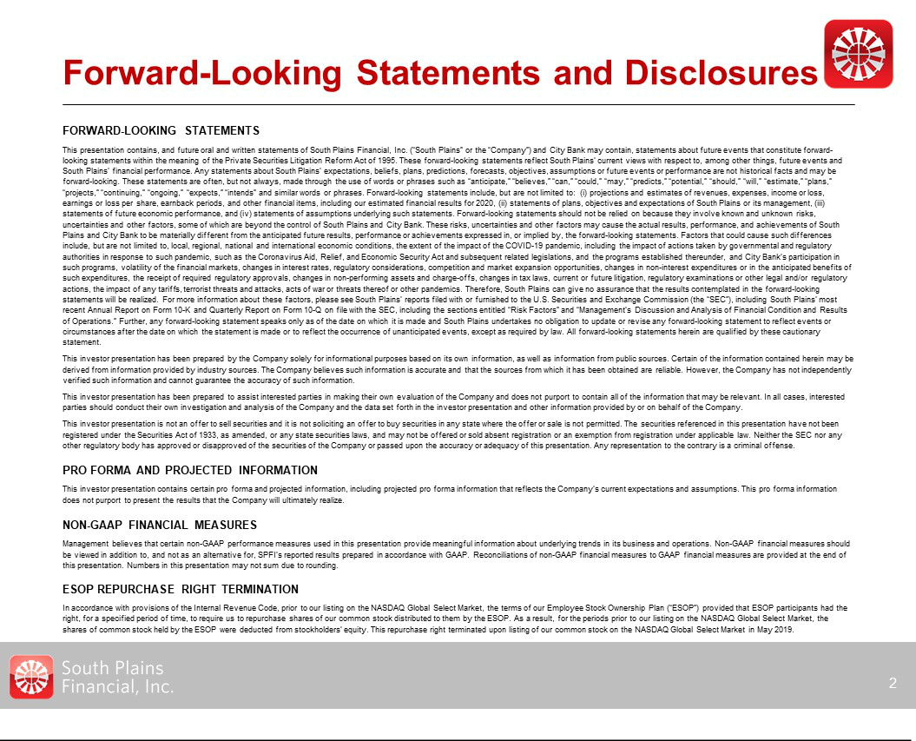

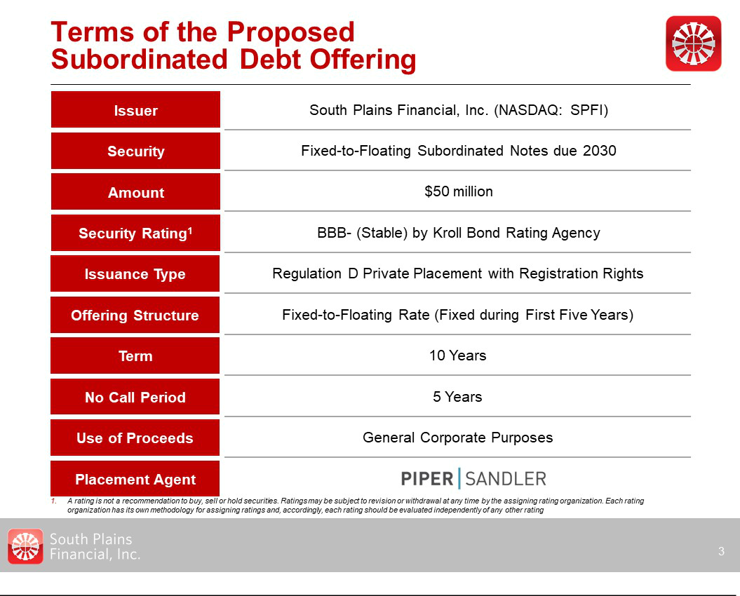

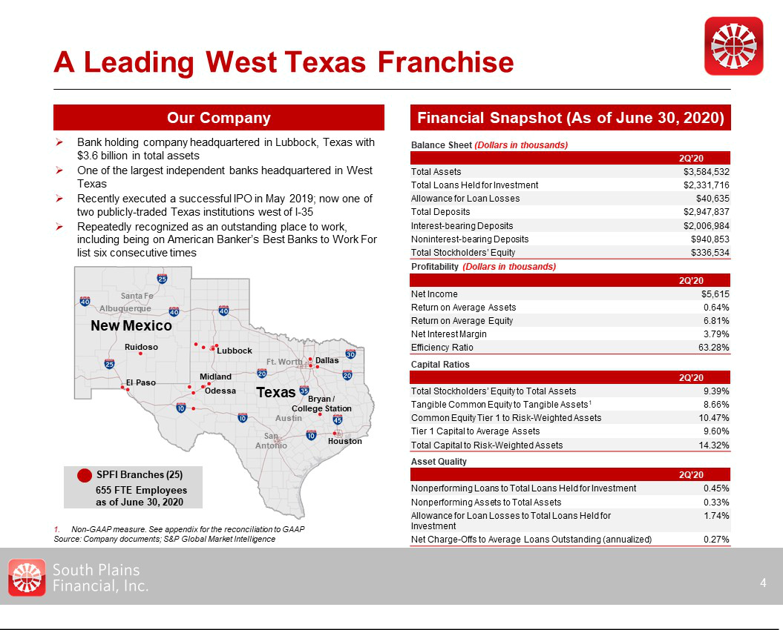

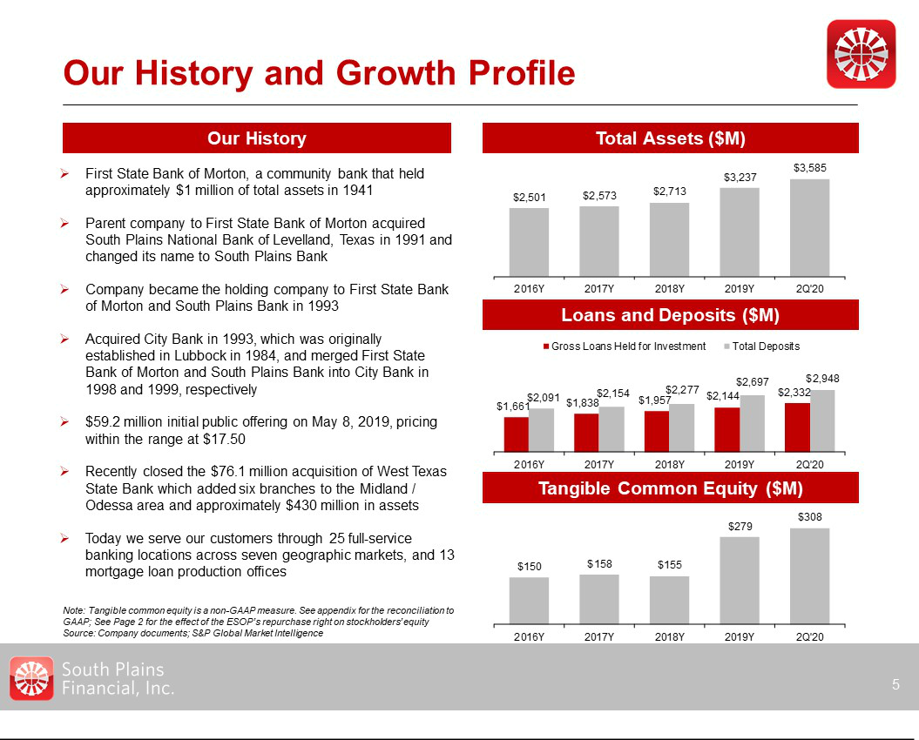

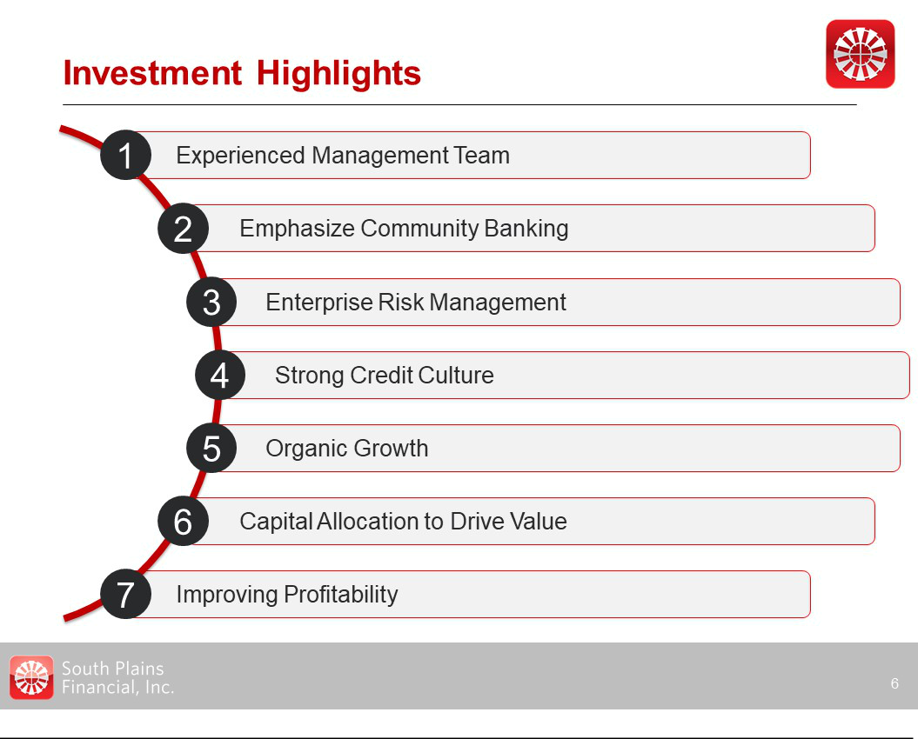

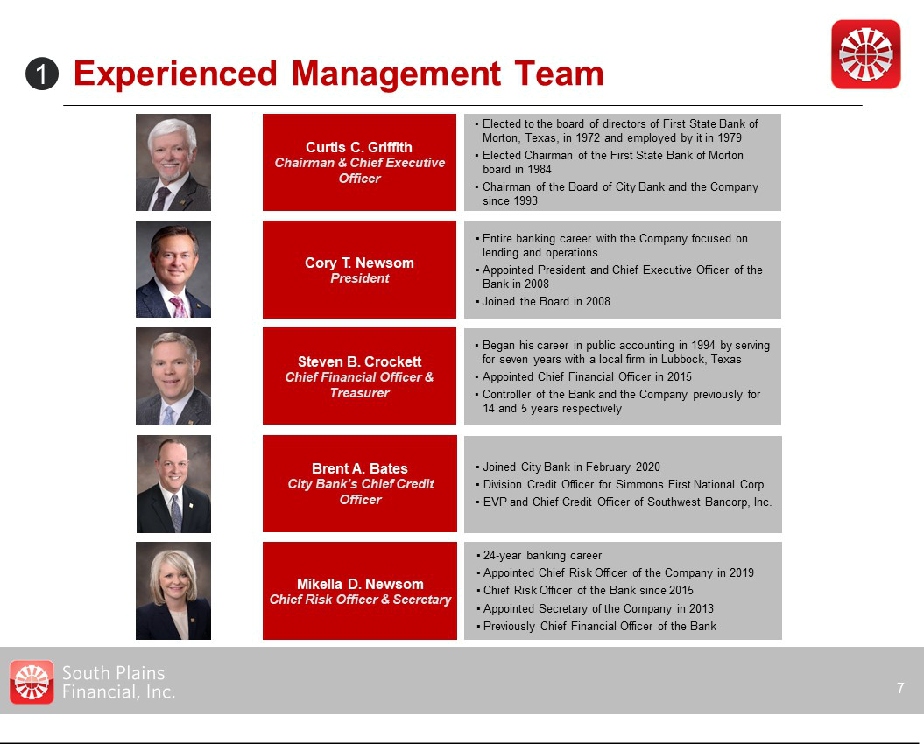

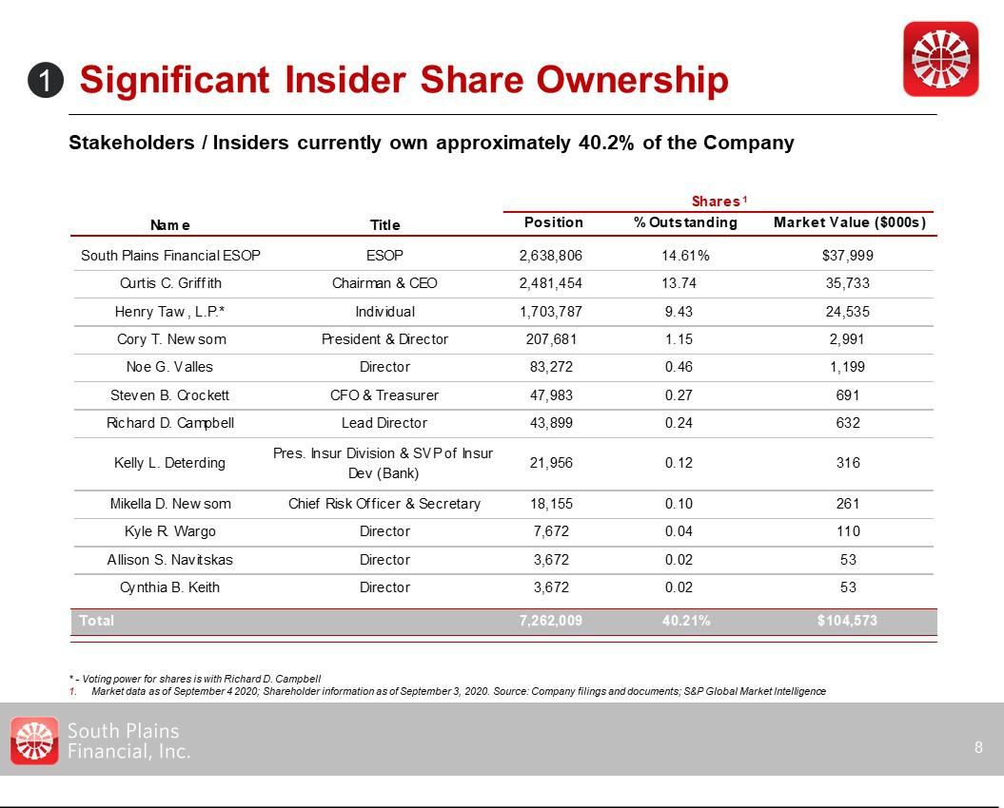

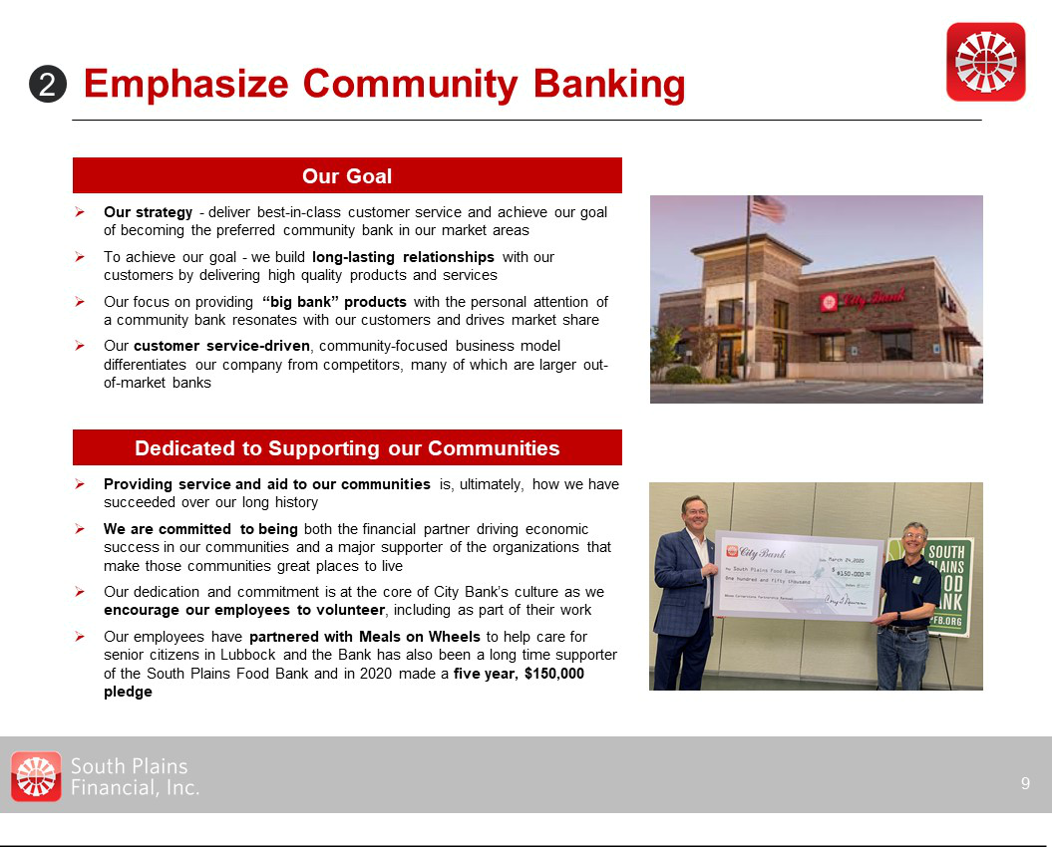

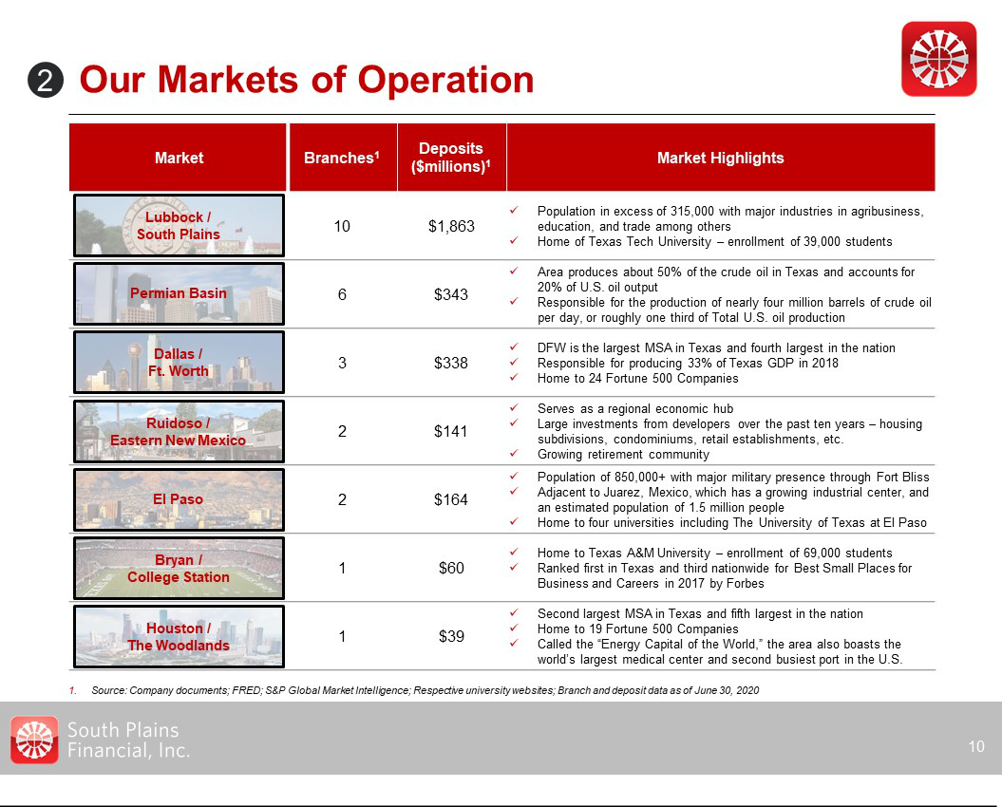

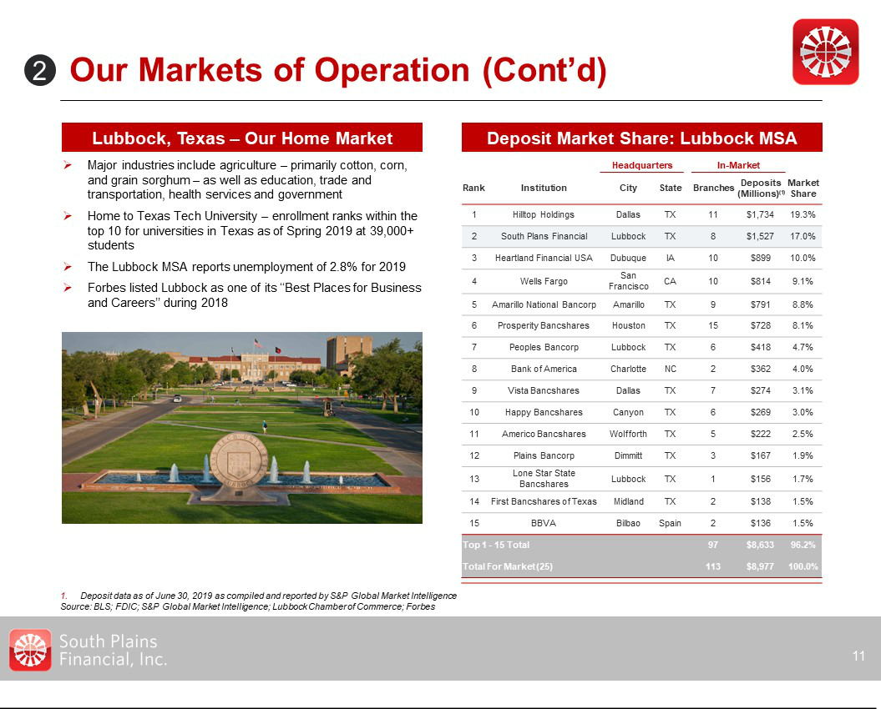

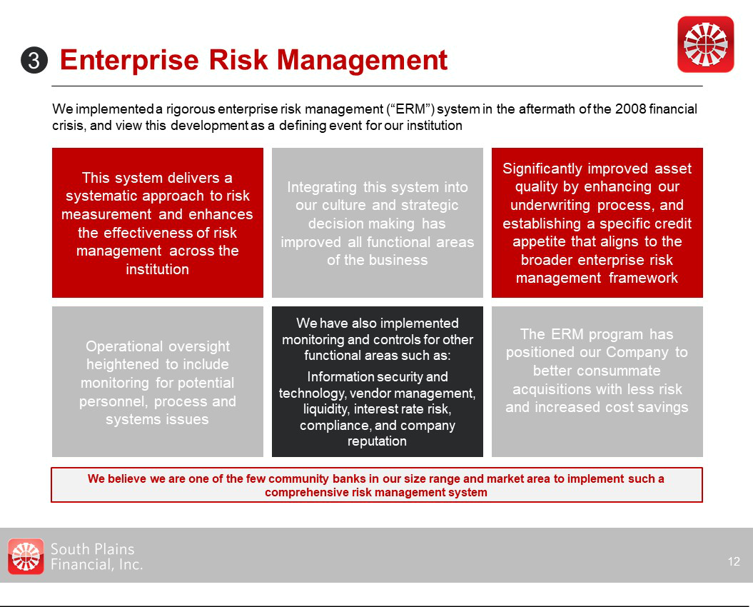

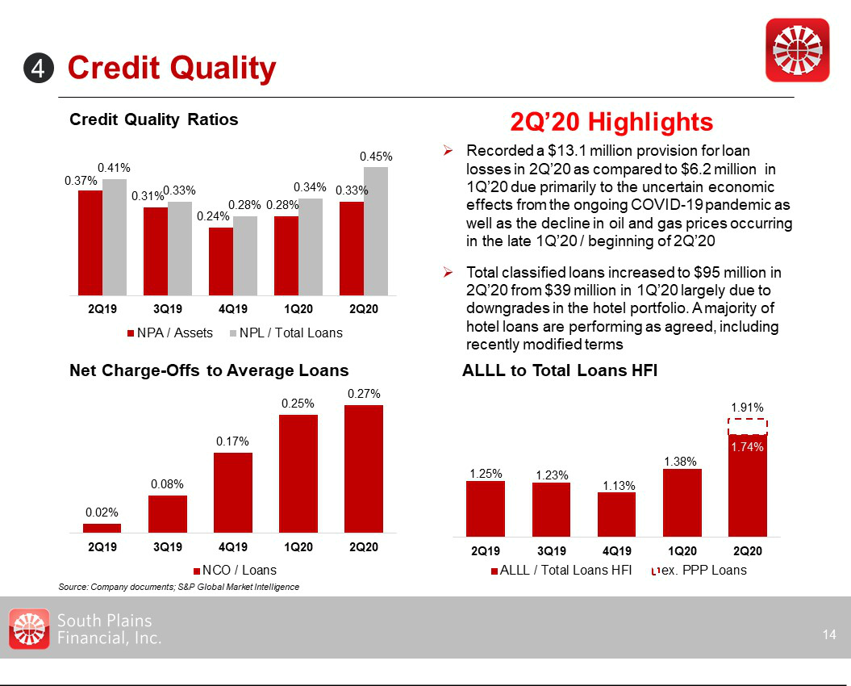

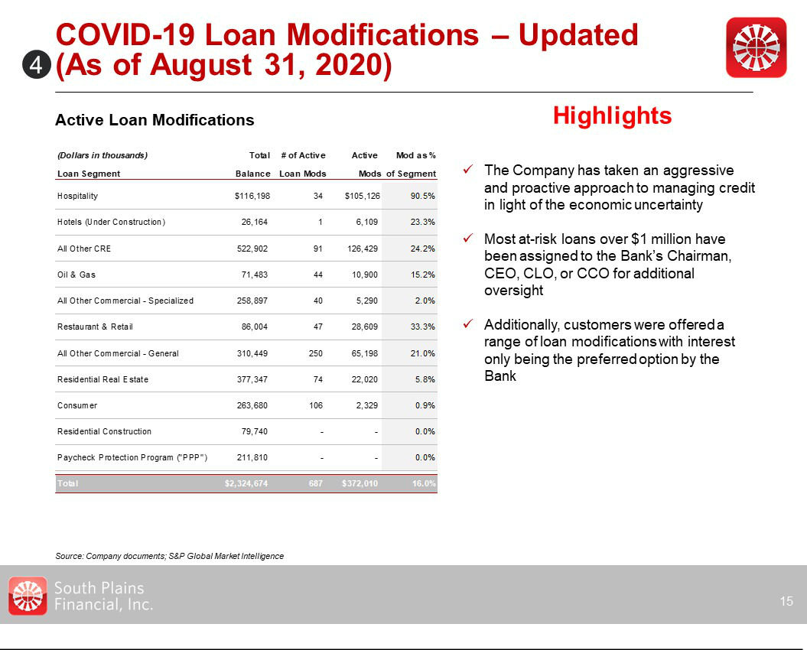

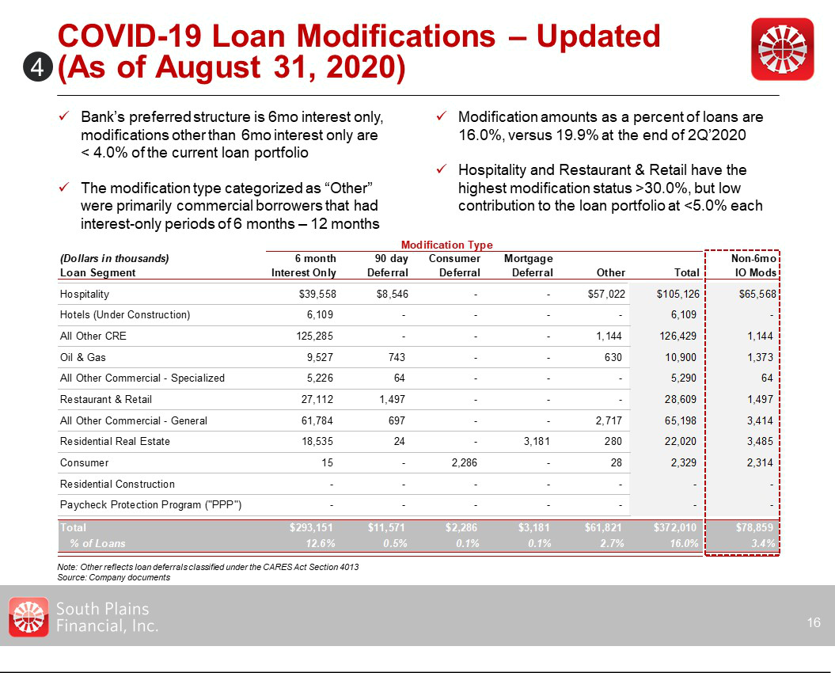

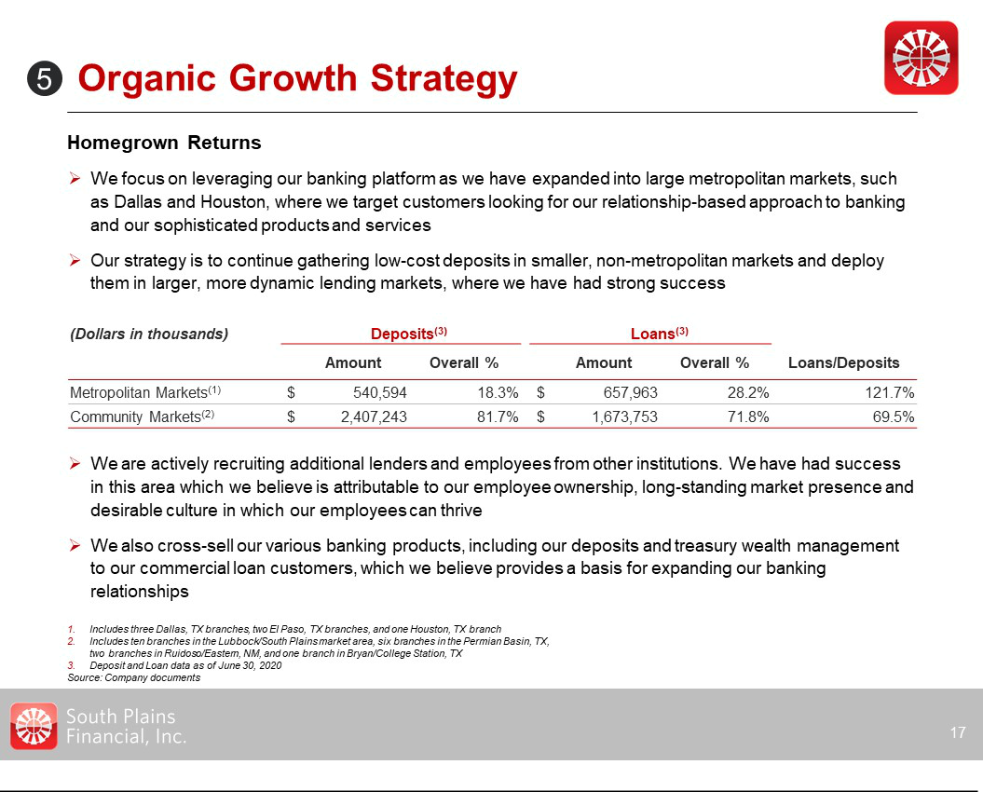

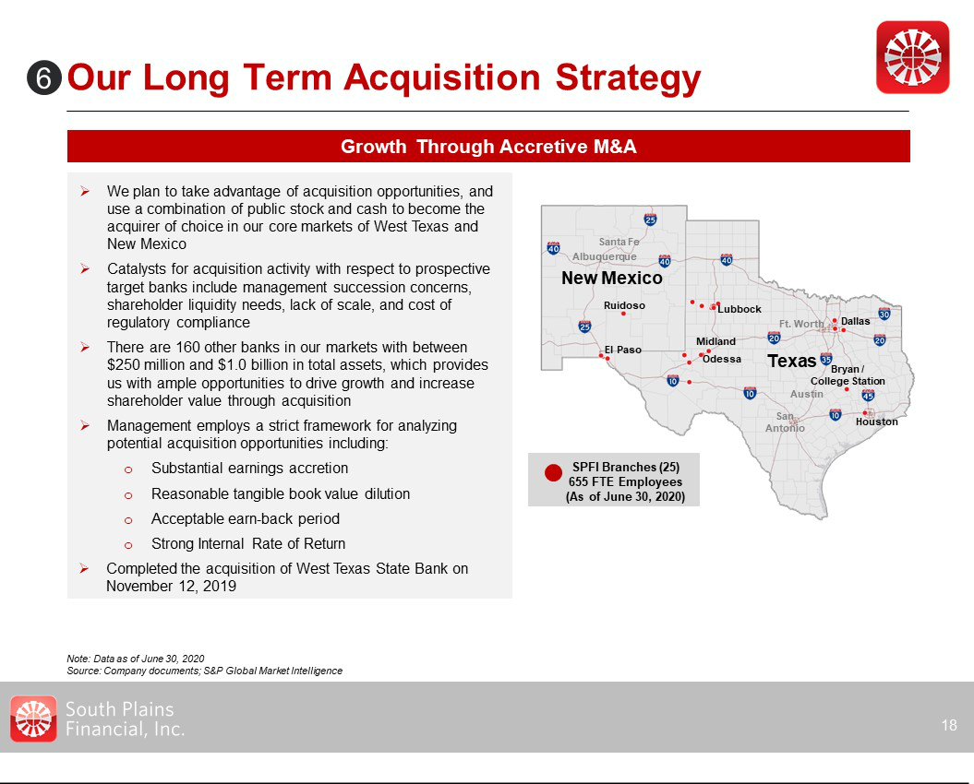

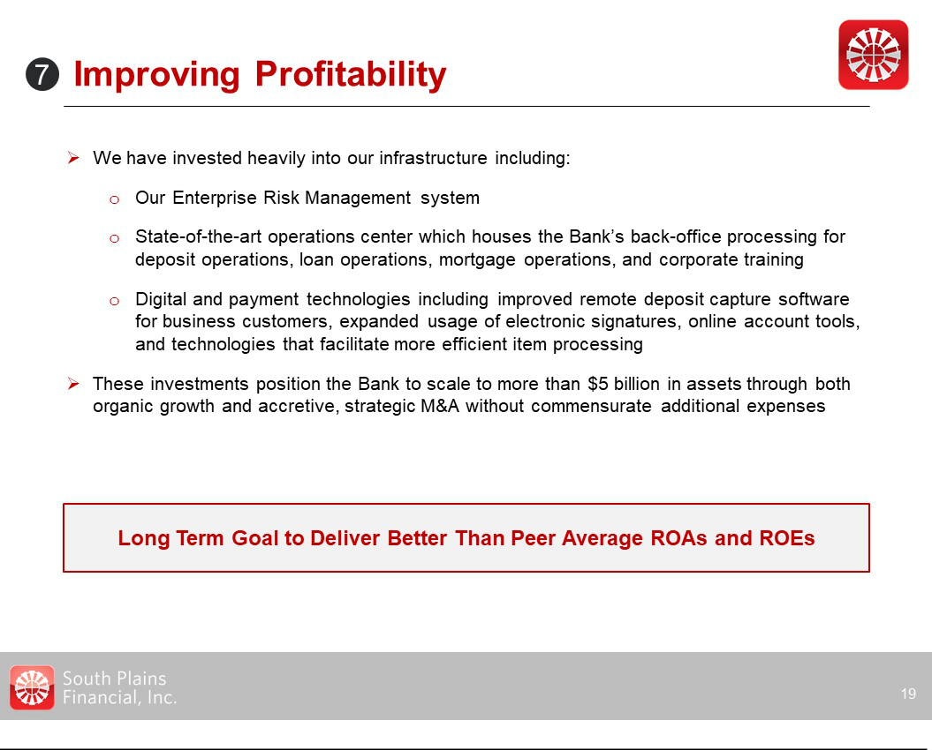

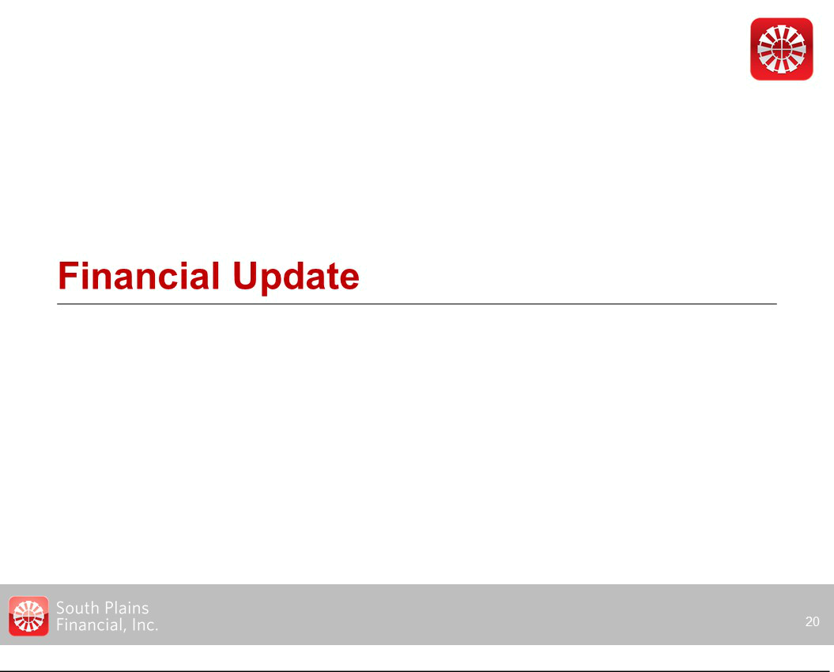

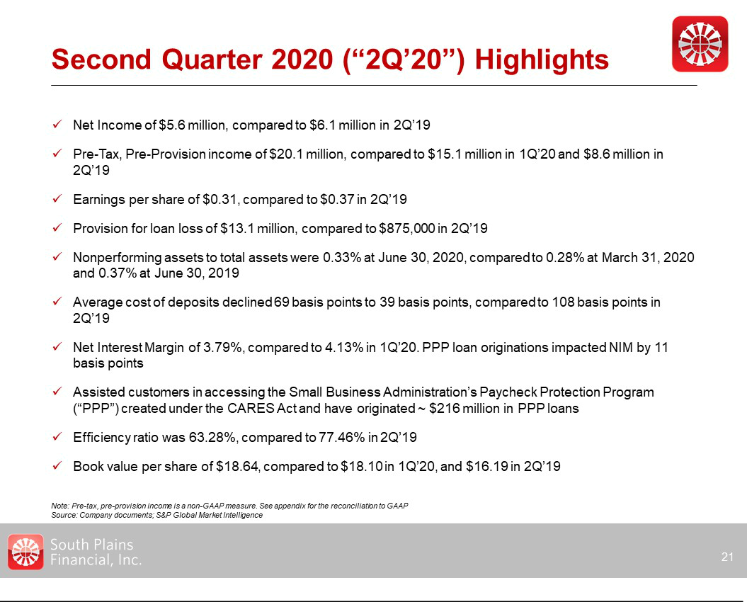

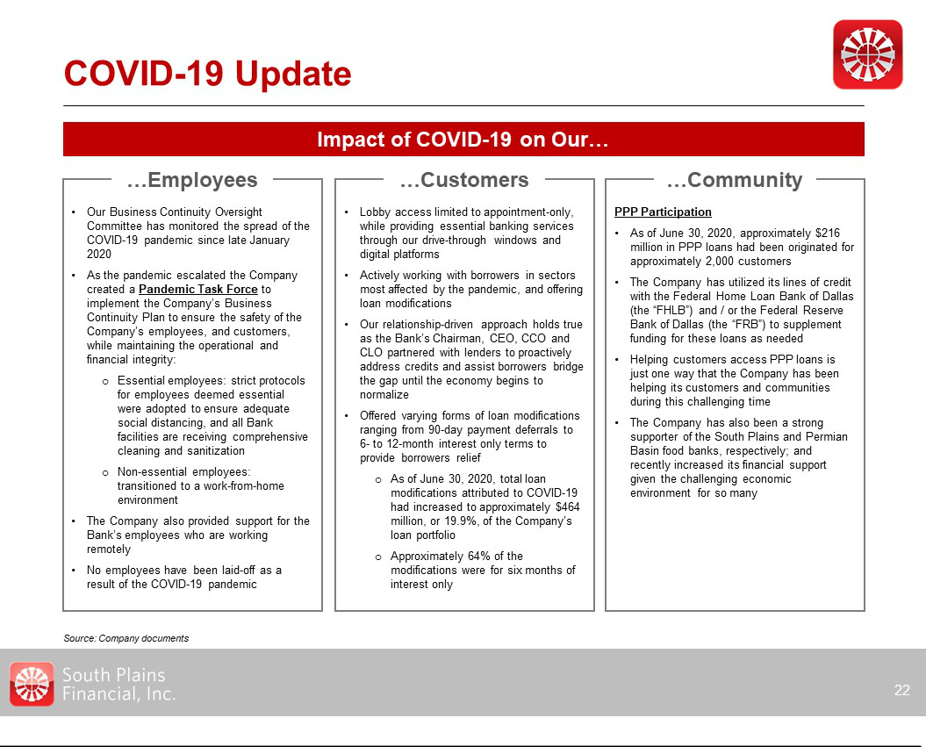

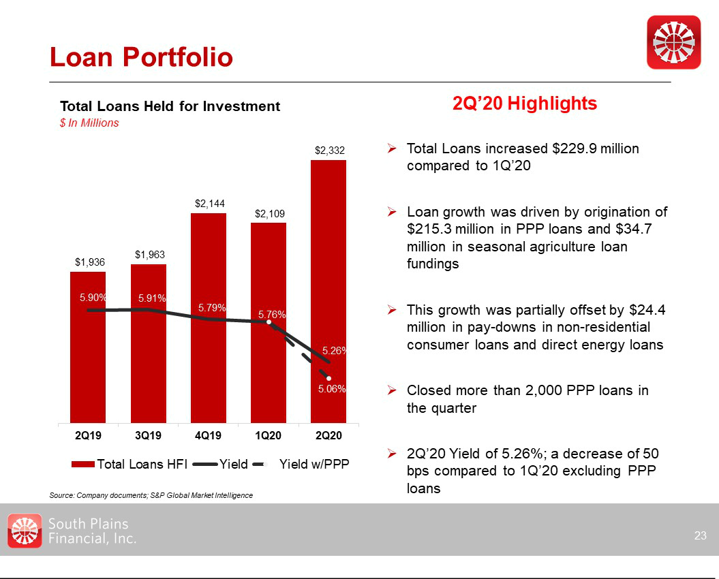

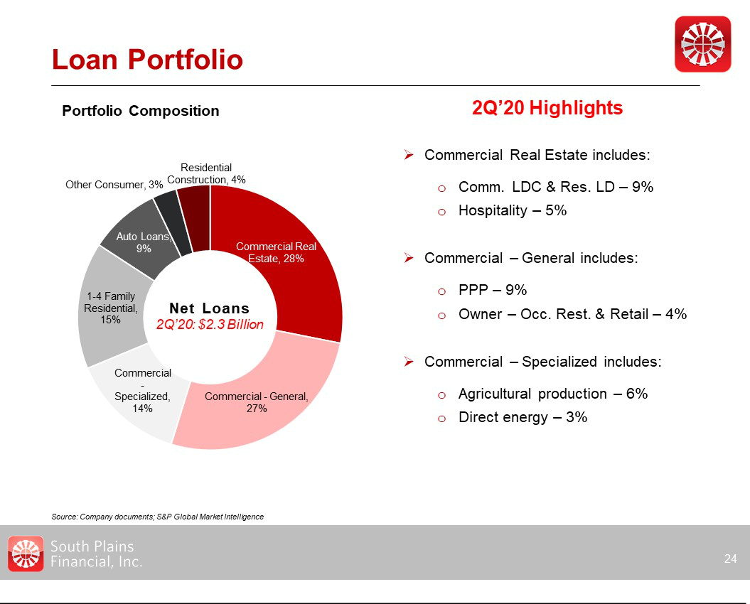

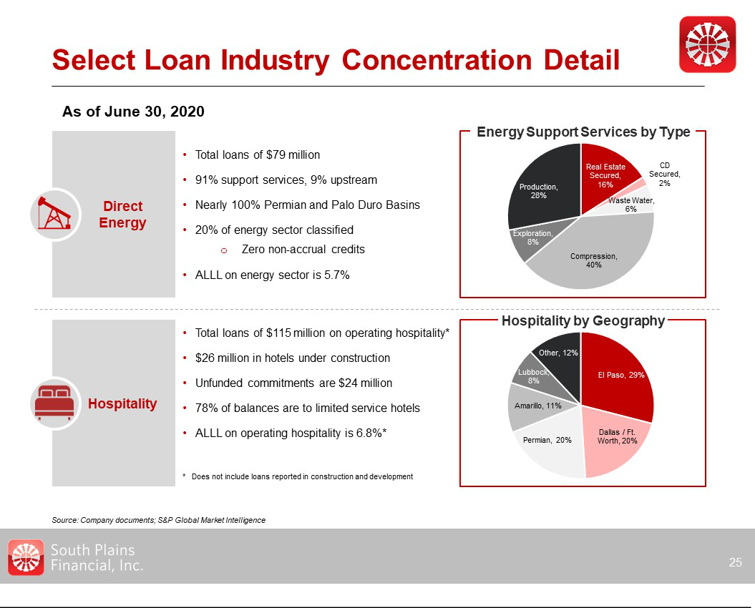

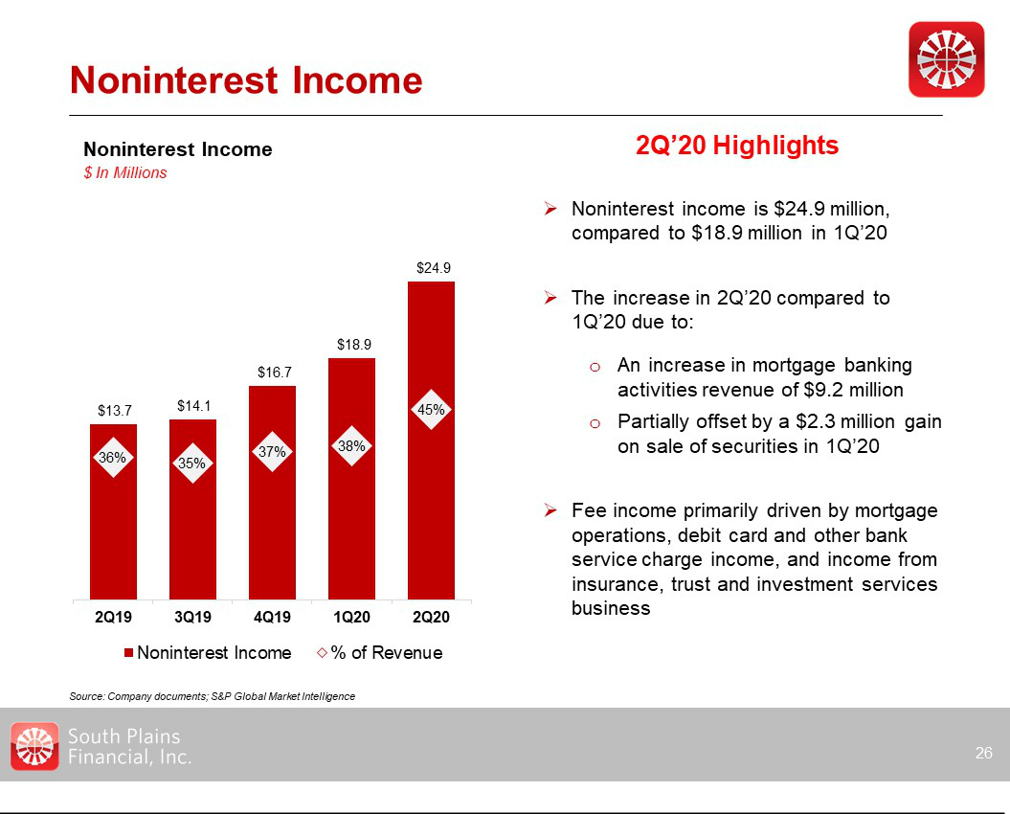

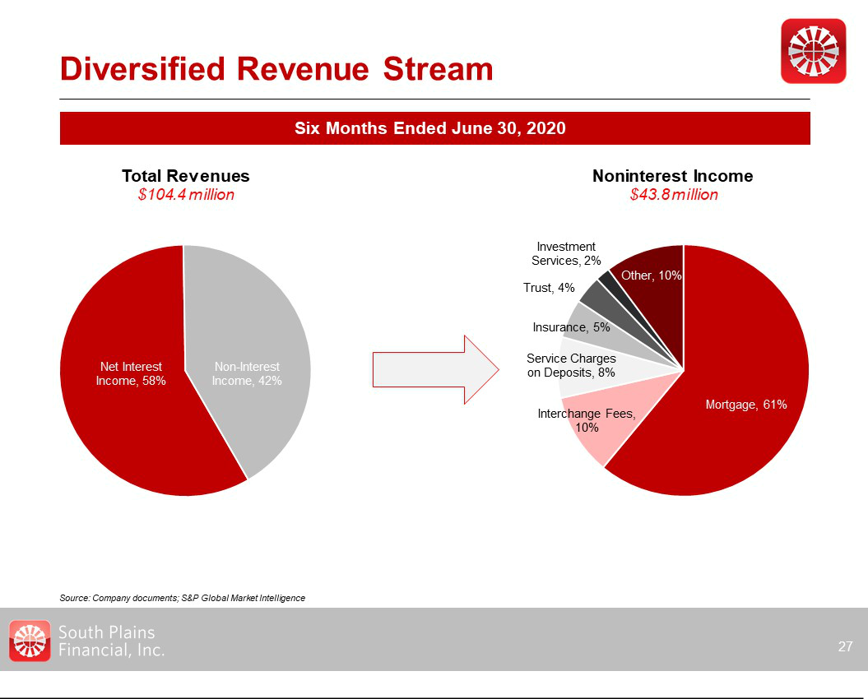

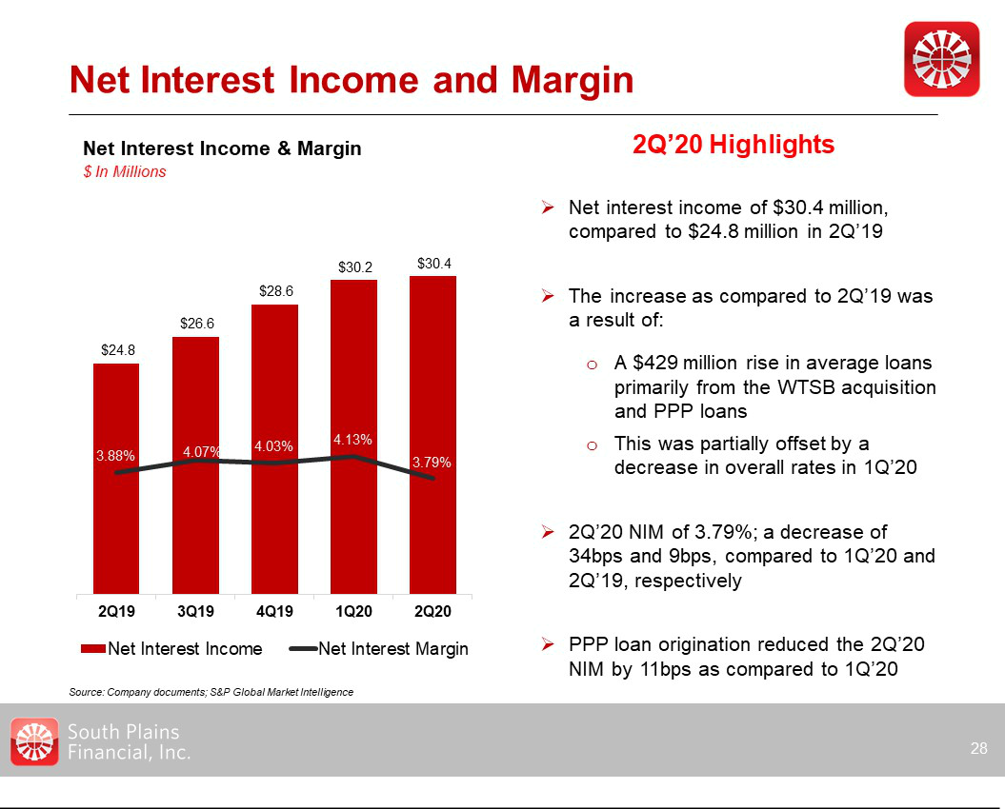

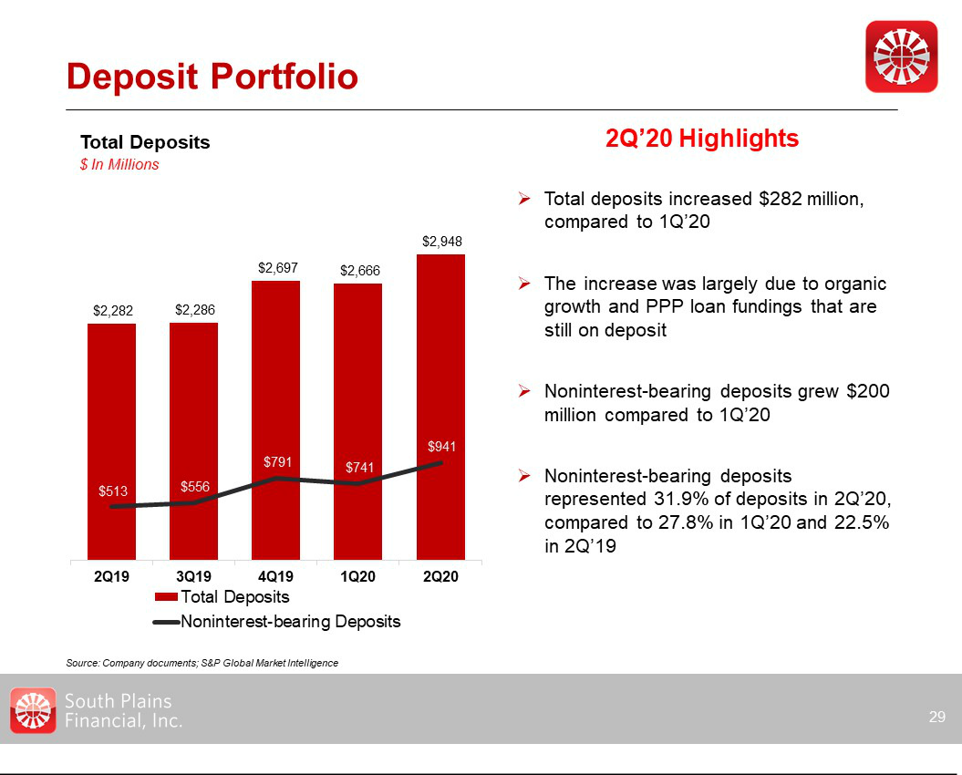

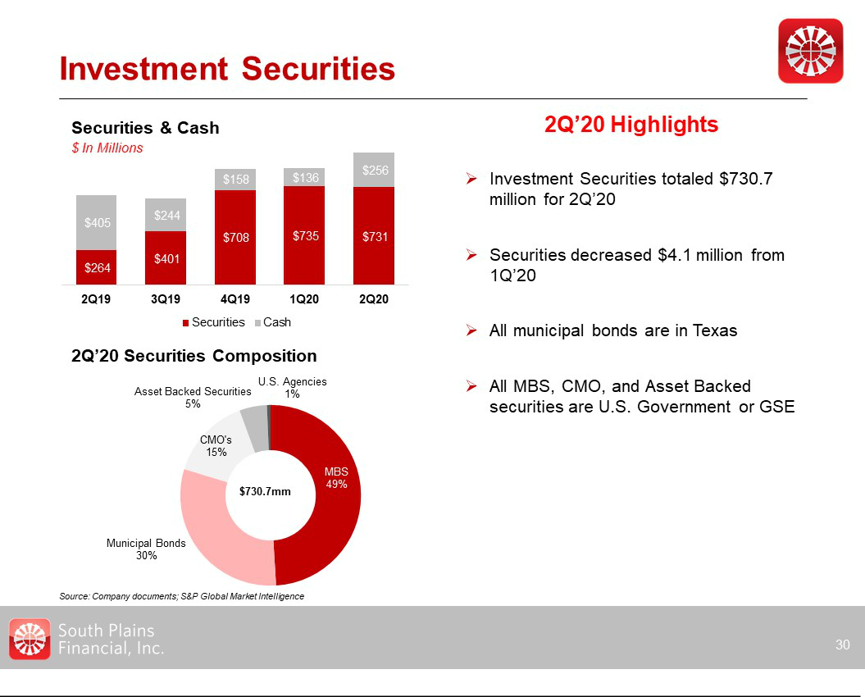

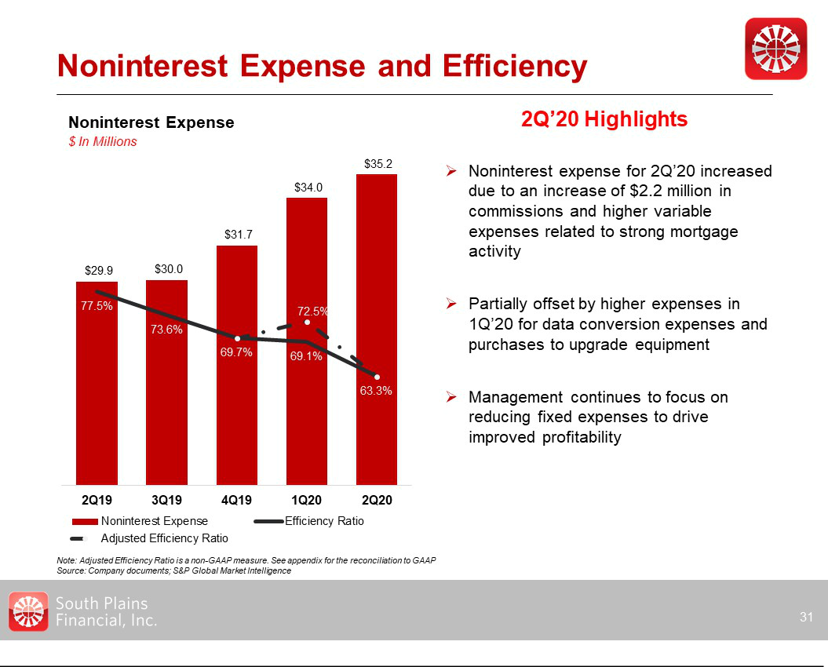

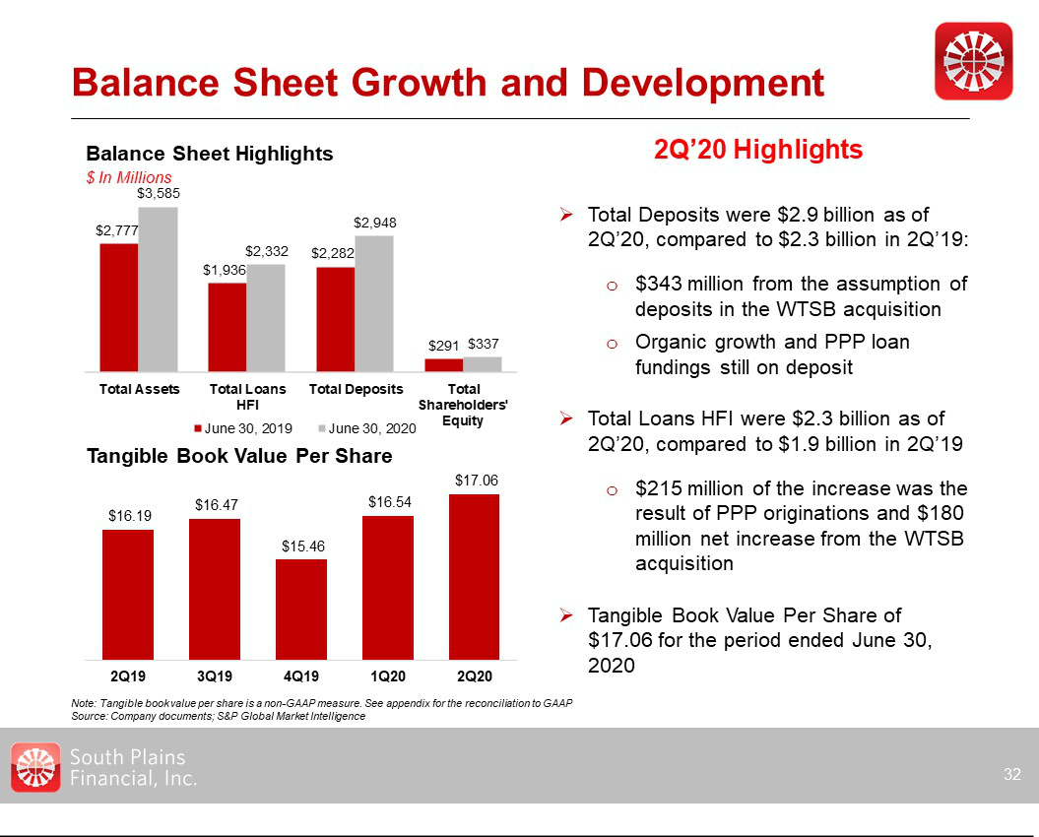

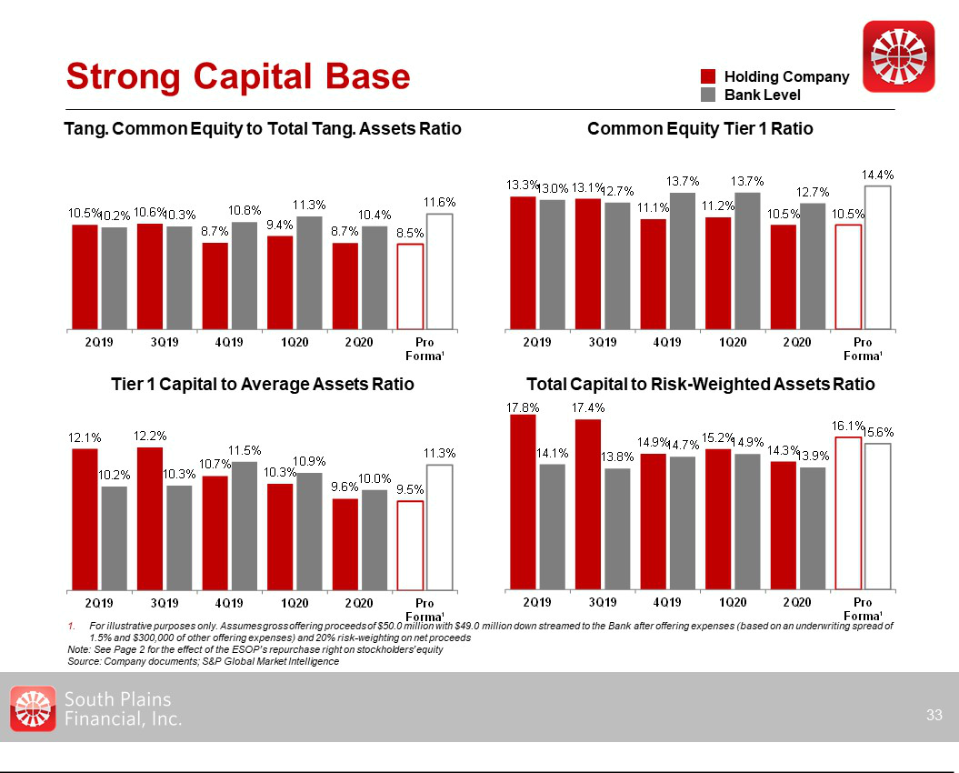

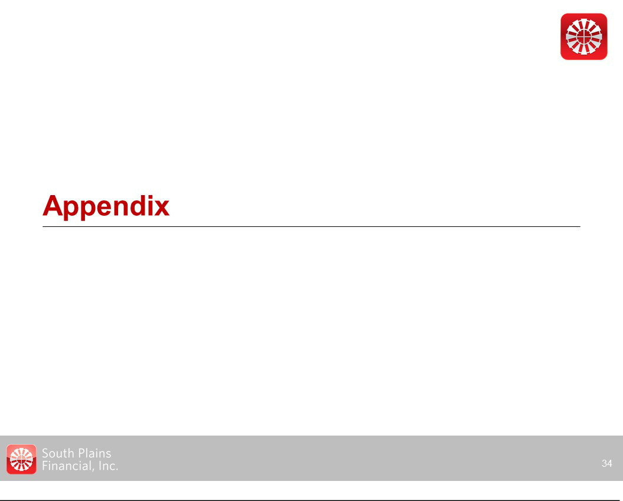

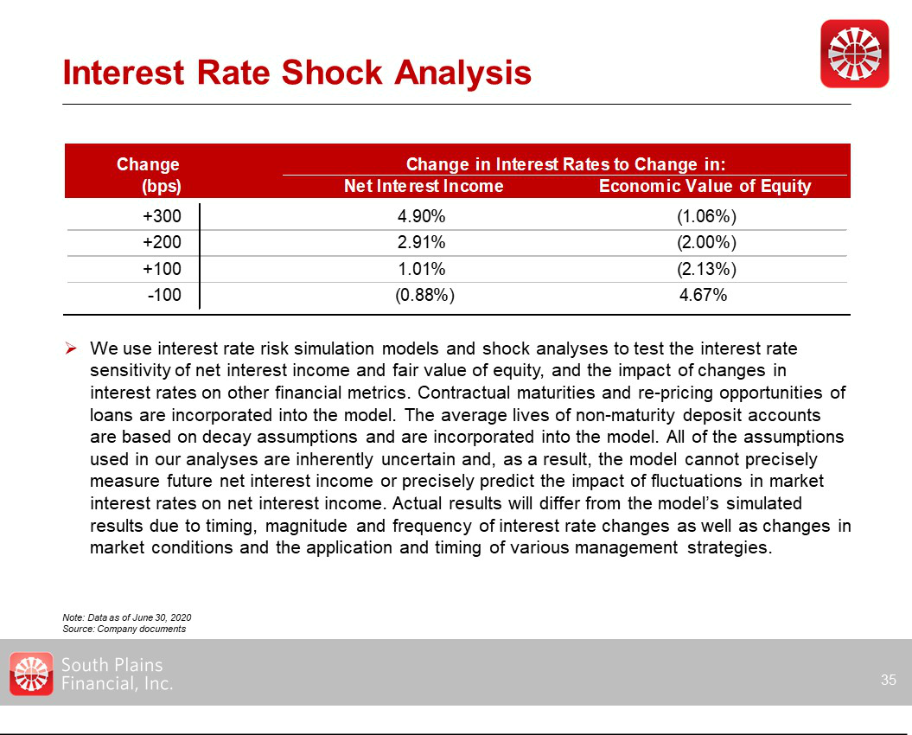

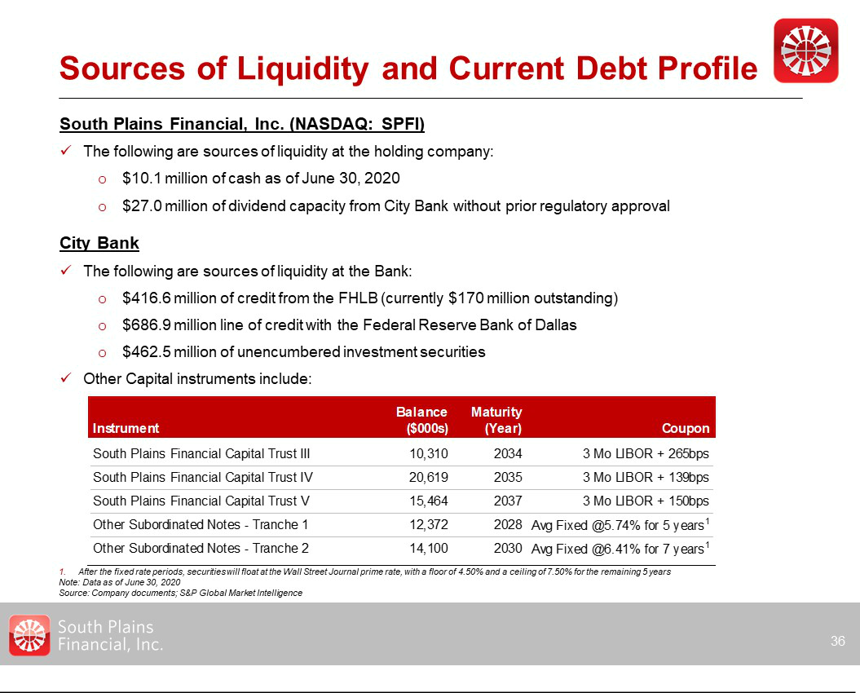

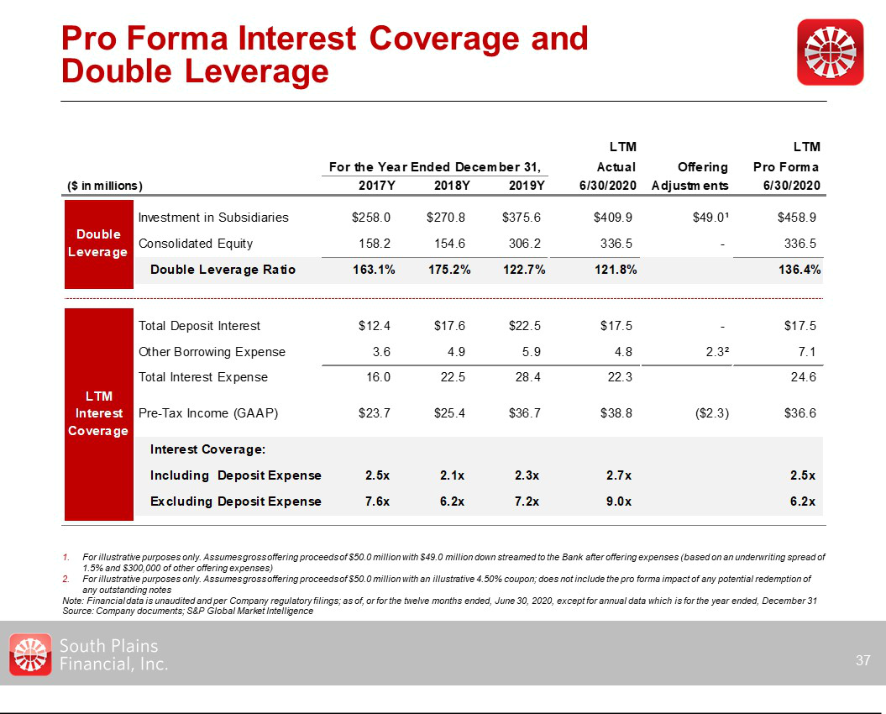

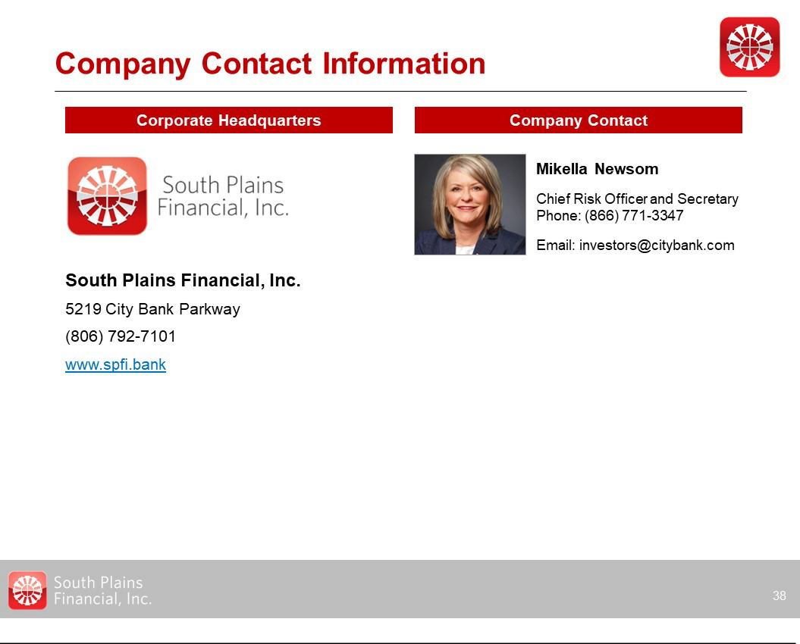

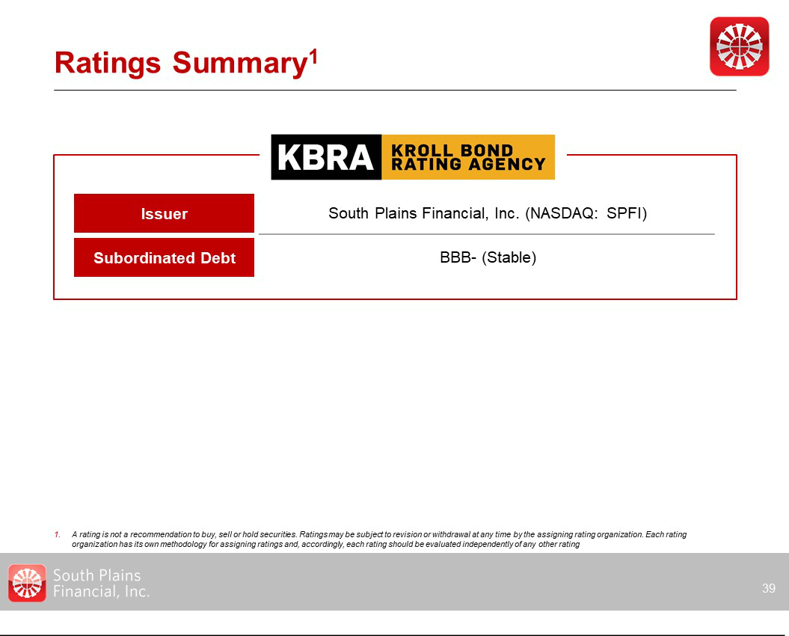

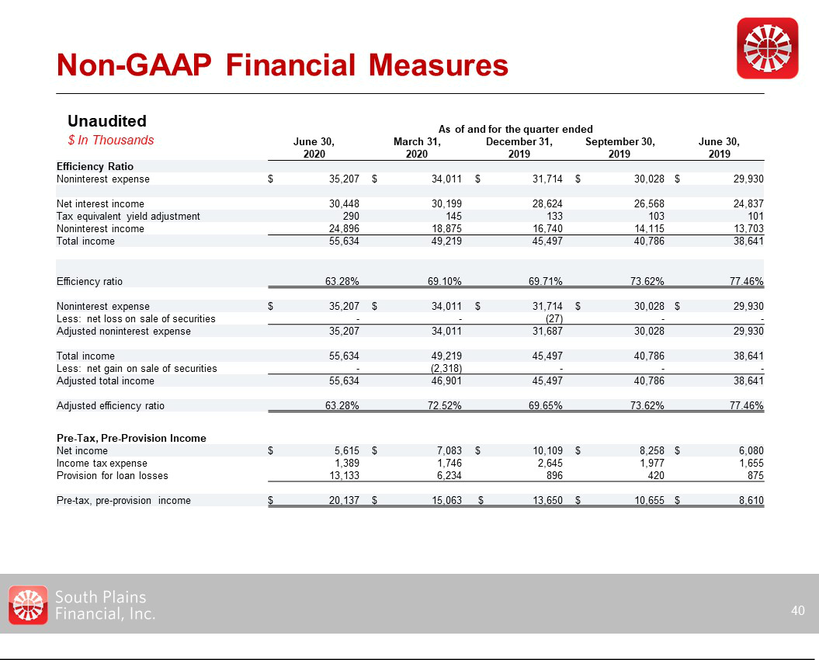

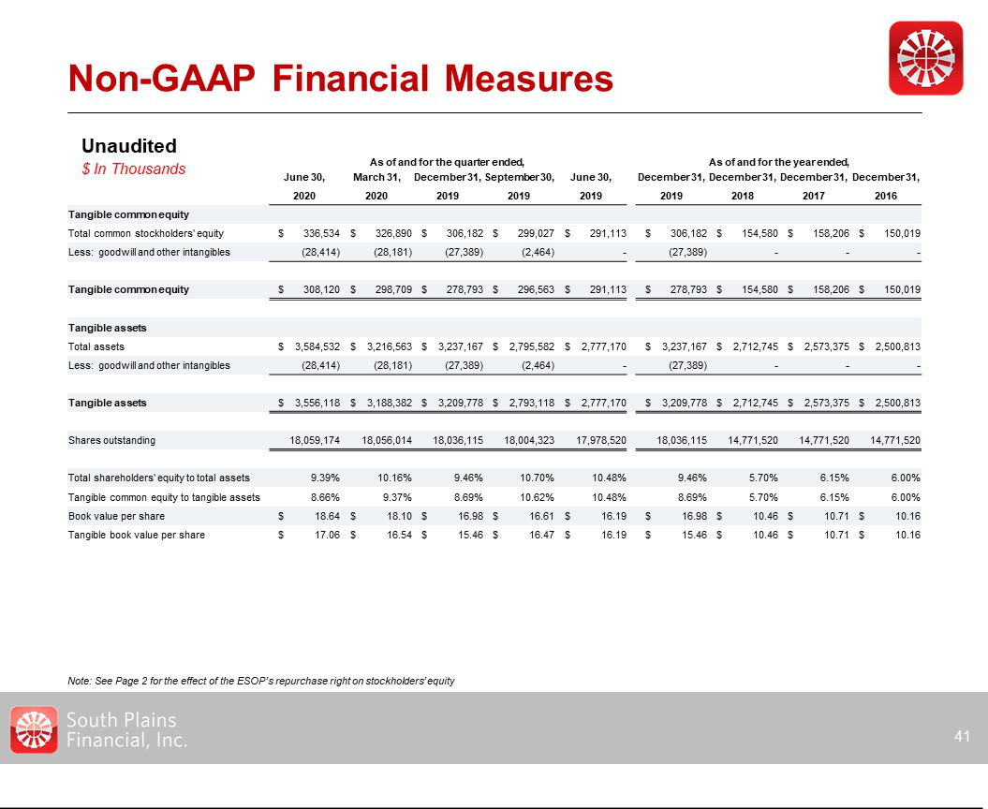

Exhibit 99.3

SETTLEMENT AGREEMENT

AND FULL AND FINAL MUTUAL RELEASE

This SETTLEMENT AGREEMENT AND FULL AND FINAL MUTUAL RELEASE (“Settlement Agreement”) is entered into and made effective as of September 4, 2020 (the “Effective Date”), by and between South Plains Financial, Inc. (“SPFI”) and City Bank (collectively, the “Plaintiffs”), on the one hand, and R. Jay Phillips (“Respondent” or “Mr. Phillips”) on the other hand. Plaintiffs and Respondent may be referenced in this Settlement Agreement singularly as a “Party” and collectively as the “Parties.”

RECITALS

WHEREAS, SPFI, SPFI Merger Sub, Inc., City Bank, and West Texas State Bank (“WTSB”) entered into an Agreement and Plan of Merger, dated as of July 25, 2019 (the “Merger Agreement”);

WHEREAS, on or about April 8, 2020, Plaintiffs filed a petition in the 72nd District Court of Lubbock County, Texas, Cause No. 2020539381, against Mr. Phillips (the “Lawsuit”);

WHEREAS, in the Lawsuit, Plaintiffs asserted claims against Mr. Phillips for common law fraud, fraudulent inducement, Texas securities fraud, fraud in a stock transaction, and for declaratory relief;

WHEREAS, Mr. Phillips filed counterclaims against City Bank on May 6, 2020, and asserted claims for declaratory judgment, specific performance for payment of expenses, and attorney’s fees;

WHEREAS, Mr. Phillips and City Bank vigorously deny and dispute all claims and factual allegations made against them in connection with the Lawsuit;

WHEREAS, Plaintiffs and Mr. Phillips held a mediation on August 20, 2020;

WHEREAS, as further described herein, the Parties wish to settle any and all claims of any kind or nature relating to the negotiation, execution and consummation of the transactions contemplated under or in connection with the Merger Agreement, including without limitation, the matters, claims, or counterclaims that were asserted or could have been asserted in the Lawsuit, and to avoid the risk, inconvenience, and expense of continued litigation of the Lawsuit or other potential litigation;

WHEREAS, the Parties desire to enter into this Settlement Agreement in order to provide for a certain settlement payment to be made by Mr. Phillips as full and final satisfaction, settlement, and discharge of all claims asserted in the Lawsuit and all other potential claims by and between the Parties relating to or arising out of the negotiation, execution, and consummation of the Merger Agreement; and

WHEREAS, the Parties desire through this Settlement Agreement to further provide for the release of all claims and potential claims by and between the Parties and specified others relating to or arising out of the negotiation, execution, and consummation of the Merger Agreement.

NOW, THEREFORE, in consideration of the foregoing recitals and the mutual promises, payments, and covenants set forth herein, and for other good and valuable consideration, the receipt and sufficiency of which is hereby fully acknowledged by all Parties to this Settlement Agreement, the Parties agree as follows:

AGREEMENTS

- Settlement Payment

1.1Settlement Amount. Subject to and in consideration for the releases of all claims described in Section 2 below, and in consideration of the parties’ dismissals of claims with prejudice described in Section 3 below, and all other good and valuable consideration described herein, Mr. Phillips shall pay or cause to be paid the Settlement Amount as set forth and in the manner indicated in Subsections 1.2 and 1.3 below. .

1.2 Payment. Mr. Phillips agrees to make a single payment equaling a total sum of One Million Dollars ($1,000,000.00) (the “Settlement Amount”), by wire transfer to the following account:

Hunton Andrews Kurth LLP

Trust Payments

Bank:

Account Name:

Account Number:

ABA Transit Routing Number for WIRES:

ABA Transit Routing Number for ACH Payments:

Swift Code (International):

Information with Wire:

1.3 Timing and Method of Payments. The Settlement Amount described in Subsection 1.2 shall be paid on or before September 15, 2020.

1.4 Taxes. Plaintiffs are solely responsible for the payment of any and all taxes that may be due as a result of receiving payment of the Settlement Amount.

SETTLEMENT AGREEMENT AND FULL AND FINAL MUTUAL RELEASE – PAGE 2

- Full and Final Mutual Releases Between the Parties

2.1Releases of the Parties. Subject to and in exchange for the consideration described or otherwise provided for herein, Plaintiffs, on the one hand, and Mr. Phillips, on the other hand, hereby completely and mutually release, acquit, and forever discharge, on behalf of themselves and their predecessors, successors and assigns, any and all claims and potential claims of any kind, nature, or description, whether known or unknown, now existing or hereafter arising, relating to the negotiation, execution, and consummation of the transactions contemplated under or in connection with the Merger Agreement, including, but not limited to, a release of such matters, claims, counterclaims, third-party claims, amended claims, new claims, demands, actions, causes of action, alleged damages, attorneys’ fees, and costs that were asserted or could have been asserted in the Lawsuit against each other or against any of their parent companies, related companies, affiliates, subsidiaries, owners, officers, directors, stockholders, private investors, principals, partners, employees, predecessors and successors in interest, assigns, heirs, lienholders, indemnitors, attorneys, agents, representatives, trustees, receivers, executors, and administrators. Notwithstanding the foregoing, the Parties reserve and do not waive any claims arising from rights or obligations within this Settlement Agreement.

2.2Releases of WTSB Officers, Directors, and Shareholders. Without limiting the foregoing Subsection 2.1, the Releases described in Subsection 2.1 include the release of all claims and potential claims of any kind, description, or nature, whether known or unknown, now existing or hereafter arising, relating to the negotiation, execution, or consummation of the transactions contemplated under or in connection with the Merger Agreement that the Plaintiffs could have asserted against any person who, prior to the Effective Date of the Merger Agreement, was an officer, director, partner, member, employee, agent, or shareholder of WTSB (collectively, the “WTSB Released Parties”; individually a “WTSB Released Party”). Notwithstanding the foregoing and any release herein, Plaintiffs reserve and do not release any claims or counterclaims either may have or come to have against a WTSB Released Party should such WTSB Released Party assert a claim against Plaintiffs related in any way to the Merger Agreement, as such claims and counterclaims are expressly preserved.

2.3Acknowledgement of Releases. The Parties acknowledge and agree that the releases and discharges set forth above constitute binding releases. Each of the Parties knowingly waives, and assumes the risk of waiving, any and all claims of any nature whatsoever that are released or discharged by the Settlement Agreement, but which such Party does not know or suspect to exist as of the Effective Date, including without limitation all claims which, if known, would have materially affected each Party’s decision to enter into this Settlement Agreement. Each Party hereby confirms that he or it understands that facts relating to the Lawsuit or the Merger Agreement may turn out to be other than or different from the facts now known or believed to be true. Each Party knowingly assumes such risks and acknowledges and agrees that this Settlement Agreement shall remain in full effect and shall not be subject to termination or revocation by discovery of any such facts.

- Dismissal of the Lawsuit with Prejudice

Immediately after, but no later than three (3) business days of the full execution of this Settlement Agreement by all Parties and receipt by Plaintiffs (or their counsel) of the Settlement Amount, Plaintiffs and Mr. Phillips will file a joint motion for dismissal and a proposed order of dismissal, in the form as the attached Exhibits A and B to this Settlement Agreement, and request that the Court dismiss with prejudice all claims asserted by, between, or against each other in the Lawsuit, with all costs and attorneys’ fees to be taxed against and borne by the Party incurring same. Plaintiffs’ counsel will be responsible for filing the dismissal papers with the Court.

SETTLEMENT AGREEMENT AND FULL AND FINAL MUTUAL RELEASE – PAGE 3

- Authority and Competence

The Parties represent, and their respective representatives who execute this Settlement Agreement on their behalves, represent and warrant that they

(i) are legally competent to enter into this Settlement Agreement; and (ii) possess the authority to enter into this Settlement Agreement.

- Entire Agreement

The Parties agree that this Settlement Agreement reflects the entire agreement between the Parties and supersedes any and all prior agreements, arrangements, representations, warranties, assurances, or understandings between the Parties with respect to the Lawsuit or any other matters covered by this Settlement Agreement.

- Understanding and Construction of This Settlement Agreement

6.1Understanding of Settlement Agreement. The Parties represent that they have read this Settlement Agreement prior to its execution and have discussed it with their respective counsel and fully understand it. The Parties also represent that, in agreeing to enter into this Settlement Agreement, they are not relying on any representations of any Party or third-party regarding the Settlement Agreement or its terms, unless such representation has been expressly set forth and described in its entirety within the four corners of the Settlement Agreement itself.

6.2Construction of Settlement Agreement. This Settlement Agreement shall be construed without regard to which of the Parties drafted it, and the language in this Settlement Agreement shall be deemed to be the language chosen by all Parties to express their mutual intent. No rule of strict construction against any Party shall be applied to any term or provision of this Settlement Agreement.

- No Admissions by Any Party to this Settlement Agreement

The Parties expressly deny any and all allegations made against them in the Lawsuit. The Parties agree that this Settlement Agreement is made to buy peace, to settle vigorously contested claims, and to avoid the expense and inconvenience of further litigation concerning the Lawsuit or potential future suits related to facts alleged in the Lawsuit or related to the Merger Agreement. No payment, agreement, statement, representation, or warranty contained in this Settlement Agreement, nor the simple existence of the Settlement Agreement itself, is intended to be or should be construed as an admission of fault or liability by any Party.

SETTLEMENT AGREEMENT AND FULL AND FINAL MUTUAL RELEASE – PAGE 4

- Modification

This Settlement Agreement may not be amended, supplemented, modified, or altered in any way except in writing and signed by all Parties who are affected by such future amendment, supplementation, modification, or alteration.

- Severability

The unenforceability or invalidity of any provision in this Settlement Agreement shall not render unenforceable or invalidate any other provision of this Settlement Agreement, and, provided that any remaining provisions collectively reflect the overall bargain of the Parties, such remaining provisions shall remain in full force and effect, shall not be affected by the severance of any illegal, invalid, or unenforceable provision from this Settlement Agreement, and shall be interpreted to the full extent possible to reflect the intention of the Parties as of the Effective Date of this Settlement Agreement.

- Governing Law, Venue, and Jurisdiction

This Settlement Agreement shall be governed by, construed in accordance with, and enforced by the laws of the State of Texas, and the Parties hereby submit to the exclusive jurisdiction of the respective federal and state courts in and of the State of Texas, and irrevocably waive and agree not to assert whatever rights they may have to challenge or dispute such jurisdiction or venue therein, in the event of any dispute arising out of or related to this Settlement Agreement. The Parties agree that any action brought to enforce, challenge, interpret, or set aside this Settlement Agreement, may be brought only in Lubbock County, Texas; provided, however, that any judgment entered by a Texas court may be transferred to any other jurisdiction if necessary to enforce or collect upon such judgment or order.

- Benefit and Burden

This Settlement Agreement shall be binding upon and inure to the benefit of the Parties and their respective heirs, administrators, successors, assigns, executors, beneficiaries, parent companies, affiliated companies, employees, agents, attorneys, directors, officers, insurers, and legal representatives, whether a signatory or not.

- Multiple Counterparts

This Settlement Agreement may be executed in multiple, identically worded counterparts, and each counterpart shall be deemed an original, but all of which together shall constitute one and the same instrument.

- Representations and Warranties by Hance Scarborough LLP Regarding Payment

The following representations and warranties are made by Hance Scarborough LLP:

SETTLEMENT AGREEMENT AND FULL AND FINAL MUTUAL RELEASE – PAGE 5

13.1 The Settlement Amount of $1,000,000.00 is currently being held in Hance Scarborough LLP’s IOLTA account;

13.2 Hance Scarborough LLP is prepared to release the $1,000,000.00 in its IOLTA account to Hunton Andrews Kurth LLP in accordance with the terms of Section 1.2 of this Settlement Agreement upon the execution of this Settlement Agreement by all Parties; and

13.3 Once the Settlement Agreement is signed and executed by all Parties, Hance Scarborough LLP will promptly and no later than September 15, 2020, transmit the $1,000,000.00 in its IOLTA account to Hunton Andrews Kurth LLP in accordance with the terms of Section 1.2 of this Settlement Agreement.

IN WITNESS WHEREOF, the Parties hereto have caused this Settlement Agreement to be executed by their duly authorized representatives as set forth

below:

SOUTH PLAINS FINANCIAL, INC.:

 | /s/ Cory T. Newsom |  |  | 09-04-2020
 | Cory Newsom, Authorized Representative |  |  | Date
CITY BANK:
 | /s/ Cory T. Newsom |  |  | 09-04-2020
 | Cory Newsom, Authorized Representative |  |  | Date
R. JAY PHILLIPS:
 | /s/ R. Jay Phillips |  |  | 09-04-2020
 | R. Jay Phillips |  |  | Date
HANCE SCARBOROUGH LLP (FOR SECTION 13 ONLY):
 | /s/ Terry Scarborough |  |  | 09-04-2020
 | Terry Scarborough |  |  | Date
SETTLEMENT AGREEMENT AND FULL AND FINAL MUTUAL RELEASE – PAGE 6

Exhibit 99.3

EXHIBIT A

Exhibit 99.3

CAUSE NO. 2020539381

SOUTH PLAINS FINANCIAL, INC. and CITY BANK | § | IN THE DISTRICT COURT OF
 | §
Plaintiffs, | §
 | § | 72nd JUDICIAL DISTRICT
v. | § | 72nd JUDICIAL DISTRICT
 | §
R. JAY PHILLIPS and WEST TEXAS STATE BANK, | §
 | §
Defendants. | § | LUBBOCK COUNTY, TEXAS

JOINT MOTION TO DISMISS WITH PREJUDICE

Plaintiffs South Plains Financial, Inc. and City Bank (collectively, “Plaintiffs”) and Defendant R. Jay Phillips file this Joint Motion to Dismiss with Prejudice all claims and counterclaims asserted against each other in the above-styled cause. No further controversy remains that requires resolution by the Court. Accordingly, Plaintiffs and Mr. Phillips jointly request that the Court dismiss this case in its entirety with prejudice.
.

Dated: September ____, 2020 |  | Respectfully Submitted,
/s/ DRAFT |  |  | /s/ DRAFT
Eric R. Hail |  | Nathaniel R. Lee
State Bar No. 24047579 |  | State Bar No. 24092677
ehail@huntonak.com |  | nathan.lee@alston.com
Ted A. Huffman |  | ALSTON & BIRD LLP
State Bar No. 24089015 |  | 2200 Ross Avenue, Suite 2300
thuffman@huntonak.com |  | Dallas, Texas 75201
HUNTON ANDREWS KURTH LLP |  | Telephone: (214) 922-3400
1445 Ross Avenue, Suite 3700 |  | Facsimile: (214) 922-3899
Dallas, Texas 75202 |  | nathan.lee@alston.com
Telephone: (214) 979-3000
Facsimile: (214) 880-0011 |  | -and-
ATTORNEYS FOR PLAINTIFFS |  | Terry L. Scarborough
 |  | State Bar No. 17716000
 |  | tscarborough@hslawmail.com
 |  | V. Blayre Peña
 |  | State Bar No. 24050372
 |  | bpena@hslawmail.com
 |  | HANCE SCARBOROUGH, LLP
 |  | 400 W. 15th Street, Suite 950
 |  | Austin, Texas 78701
 |  | Telephone: (512) 479-8888
 |  | Facsimile: (512) 482-6891
 |  | ATTORNEYS FOR
 |  | DEFENDANT/COUNTER-PLAINTIFF R.
 |  | JAY PHILLIPS

CERTIFICATE OF SERVICE

The undersigned hereby certifies that a true and correct copy of the foregoing document was served in accordance with the Texas Rules of Civil Procedure on this ____ day of September 2020:

/s/ DRAFT

Eric R. Hail

JOINT MOTION TO DISMISS WITH PREJUDICE – PAGE 2

Exhibit 99.3

EXHIBIT B

CAUSE NO. 2020539381

SOUTH PLAINS FINANCIAL, INC. and CITY BANK | § | IN THE DISTRICT COURT OF
 | §
Plaintiffs, | §
 | § | 72nd JUDICIAL DISTRICT
v. | § | 72nd JUDICIAL DISTRICT
 | §
R. JAY PHILLIPS and WEST TEXAS STATE BANK, | §
 | §
Defendants. | § | LUBBOCK COUNTY, TEXAS

ORDER GRANTING JOINT MOTION TO DISMISS WITH PREJUDICE

Having considered Plaintiffs and Defendant R. Jay Phillips’s Joint Motion to Dismiss with Prejudice, the Court hereby finds that it should be GRANTED.

It is therefore ORDERED, ADJUDGED, AND DECREED that all of Plaintiffs and Mr. Phillips’s claims and counterclaims asserted against each other, or that could have been asserted in the above captioned action, are hereby DISMISSED WITH PREJUDICE. Each party to this action is to bear its own attorneys’ fees and costs.

Signed this ____ day of September, 2020.

JUDGE PRESIDING

APPROVED AS TO FORM AND SUBSTANCE:

/s/ DRAFT |  |  | /s/ DRAFT
Eric R. Hail |  | Nathaniel R. Lee
State Bar No. 24047579 |  | State Bar No. 24092677
ehail@huntonak.com |  | nathan.lee@alston.com
Ted A. Huffman |  | ALSTON & BIRD LLP
State Bar No. 24089015 |  | 2200 Ross Avenue, Suite 2300
thuffman@huntonak.com |  | Dallas, Texas 75201
HUNTON ANDREWS KURTH LLP |  | Telephone: (214) 922-3400
1445 Ross Avenue, Suite 3700 |  | Facsimile: (214) 922-3899
Dallas, Texas 75202 |  | nathan.lee@alston.com
Telephone: (214) 979-3000
Facsimile: (214) 880-0011 |  | -and-
ATTORNEYS FOR PLAINTIFFS |  | Terry L. Scarborough
 |  | State Bar No. 17716000
 |  | tscarborough@hslawmail.com
 |  | V. Blayre Peña
 |  | State Bar No. 24050372
 |  | bpena@hslawmail.com
 |  | HANCE SCARBOROUGH, LLP
 |  | 400 W. 15th Street, Suite 950
 |  | Austin, Texas 78701
 |  | Telephone: (512) 479-8888
 |  | Facsimile: (512) 482-6891
 |  | ATTORNEYS FOR
 |  | DEFENDANT/COUNTER-PLAINTIFF R.
 |  | JAY PHILLIPS

